**Prognostic value of serum Leptin ∕ Adiponectin ratio in patients with chronic hepatitis C virus**

Fathy Ghamry Abd El Razik1, Yusuf Nassar1, Mostafa Sabrah1and Ahmed Fathy Abd El Aziz2

1Department of Internal Medicine, Alazhar University, Cairo, Egypt

2Department of Clinical Pathology, Alazhar University, Cairo, Egypt

[yusuf_nassar2000@yahoo.com](mailto:yusuf_nassar2000@yahoo.com)

**Abstract: Background:** Leptin and adiponectin are the main metabolic products of adipose tissue. There is an increasing interest in the role of these adipokines in the development of hepatic steatosis, and fibrosis, particularly in patients with non-alcoholic fatty liver disease and chronic hepatitis C virus (HCV) infection. **Objective:** To evaluate the utility of serum leptin/adiponectin ratio in predicting disease progression in chronic HCV patients. **Methods:** Thirty chronic hepatitis C patients and 10 healthy controls were enrolled. They were subjected to: Complete blood count, fasting and post prandial blood sugars, serum aspartate aminotransferase (AST), serum alanine aminotransferase (ALT), prothrombin time, serum proteins, albumin, total bilirubin, direct bilirubin, alkaline phosphatase, blood urea, serum creatinine, HCV-Ab, HBs-Ag, Thyroid Stimulating Hormone (TSH), serum leptin, serum adiponectin, leptin/ adiponectin ratio, abdominal ultrasound and liver biopsy for HCV patients. Patients were classified according to Child Turcotte Pugh (CTP) classification in to three groups A, B and C. **Results:** Univariate analysis showed that leptin, adeponectin and leptin/adeponectin ratio were correlating to CTP class and fibrosis stage in HCV patients. Also there were significant correlations between: albumin, ALT/AST ratio, body mass index, platelet count, prothrombin time and total bilirubin with CPT class in HCV patients. Multivariate analysis was used to formulate a collective score “Factor Score” to predict CTP class. Factor Score was able to differentiate different CTP classes A, B and C. Mean values of Factor Score were 0.682, -0.315, -1.291 and 0.925 for CTP class A, B, C and control group respectively. **Conclusion:** leptin/adeponectin ratio is a good predictor of disease progression in HCV patients. Factor Score is a useful new score for prediction of CPT class in HCV patients.

[Fathy Ghamry Abd El Razik, Yusuf Nassar, Mostafa Sabrahand Ahmed Fathy Abd El Aziz.**Prognostic value of serum Leptin ∕ Adiponectin ratio in patients with chronic hepatitis C virus.** *N Y Sci J* 2016;9(1):106-112]. ISSN 1554-0200 (print); ISSN 2375-723X (online). <http://www.sciencepub.net/newyork>. 15. doi:[10.7537/marsnys09011615](http://www.dx.doi.org/10.7537/marsnys09011615).

**Key Words:** Leptin, Adiponectin, Fibrosis, HCV.

**1. Introduction**

Egypt has a very high prevalence of HCV and a high morbidity and mortality from chronic liver disease, cirrhosis, and hepatocellular carcinoma. Approximately 20% of Egyptian blood donors are anti-HCV positive (Lavanchy and McMahon, et al, 2000).

Chronic HCV genotype-4 (HCV-4) is known to be clear endemic in Egypt, Central Africa and in the Middle East. However, several recent studies carried out in Europe have indicated changes in genotype distribution and have underlined the increasing prevalence of HCV-4(van Asten, et al, 2004).

In any chronic liver disease (CLDs), whatever the aetiology, reiteration of liver injury results in persisting inflammation and progressive fibrogenesis, with chronic activation of the wound healing response in CLDs, representing a major driving force for progressive accumulation of Extracellular matrix (ECM) components, eventually leading to liver cirrhosis. (Davide Povero, et al, 2010).

Discussion of hepatitis C prognosis necessitates careful consideration of all factors that could affect that disease and its treatment, and then trying to predict what might happen (Arthur Schoenstadt, 2013).

Leptin and adiponectin are the main metabolic products of adipose tissue. The former is expressed also in the stomach, placenta and mammary gland, while the latter is also secreted by hepatocytes (Saxena, et al, 2010).

Currently, there is an increasing interest in the role of these adipokines in the development of hepatic steatosis, and fibrosis, particularly in patients with non-alcoholic fatty liver disease (NAFLD) and chronic hepatitis C virus (HCV) infection (Tsochatzis, et al, 2006).

Therefore, the aim of this study was to measure serum leptin and adiponectin levels and to evaluate the utility of leptin/adiponectin ratio, as a potential predictor of disease progression in chronic HCV patients. Moreover, a correlation between these predictors and different clinical and laboratorydata of the study patients were evaluated.

**2. Patients and Methods**

**Patients:**

This study was carried out on a total of 40 persons (30 patients with evidence of chronic HCV, and 10 normal control group), recruited from the inpatient sector & outpatient Internal Medicine clinic of Al-hussien hospital. Informed consents were obtained from all participants (after explanation of the nature and details of the study).

The 30 patients with evidence of chronic HCV were selected and dividedinto:

Group(A) 10 patients of child-A.

Group(B) 10 patients of child-B.

Group(C) 10 patients of child-C.

**Inclusion Criteria:**

- All patients are seropositive for HCV antibodies.

- No previous treatment with antiviral therapy.

- No other comorbidity or known other hepatic pathology.

- Body mass index (BMI) less than 30.

**Exclusion criteria:**

- Other chronic liver disease (ashepatitis B virus infection, alcoholism, Wilson’s disease, haemochromatosis, and autoimmune hepatitis).

- History of heart failure, diabetes mellitus, thyroid diseases, or abnormal renal functions.

- Obesity (BMI ≥ 30).

- Use of drugs known to induce liver steatosis (corticosteroids, amiodarone, tamoxifen, valproic acid) within the last 6 months.

* In addition,a control group comprised of 10 healthy people matched for age and BMI was included. They were considered healthy on the basis of history, physical examination and laboratory tests.

**Methods**:

**1- Full medical history including duration of HCV infection& drug history.**

**2- Full clinical examination including signs of chronic HCV.**

BMI was calculated according to the following equation: BMI = weight (in kilograms)/height2 (in meters) and obesity was defined as a BMI ≥ 30 kg/m. (Turner & Wass, 2002).

**3- Laboratory investigations including:**

- Routine Investigations including C.B.C, F.B.S, 2h P.P.B.S. & kidney function tests (blood urea and serum creatinine), and TSH.

- Liver investigations (serum aspartate transaminase (AST), alanine transaminase (ALT), prothrombin time, serum total proteins and albumin, serum total and direct bilirubin and alkaline phosphatase (ALP).

- HCV-Ab. using third generation commercially available enzyme-linked immunosorbent assay kit.

-Serum leptin, serum adiponectin levels and leptin/adiponectin ratio:

**Principle andProcedure:**

* Leptin kit is a solid phase sandwich Enzyme-Linked Immunosorbent Assay (ELISA). A monoclonal antibody specific for human leptin has been coated onto the wells of the microtiter strips provided. Samples, including standards of known leptin content, control specimens, and unknowns, are pipetted into these wells followed by the addition of a secondary biotinylated monoclonal antibody. During the first incubation, the human leptin antigen in samples as controls binds to the immobilized (capture) antibody on one site and to the solution phase biotinylated antibody on a second site. After removal of excess second antibody, Streptavidin-Peroxidase (enzyme) is added. This binds to the biotinylated antibody to complete the four-member sandwich. After a second incubation and washing to remove all the unbound enzyme, a subsbate solution is added, which is acted upon by the bound enzyme to produce colour. The colour produced is read on an ELISA reader at two different wave lengths (492 & 623 nm). The intensity of this colored product is directly proportional to the concentration of human leptin present in the original specimen.

**Kits:** Biosource Europe S. A.

**Analyzer:** Stat fax-2600 (ChroMate)

**Human Adeponectin Serum Assay:** the same as mentioned for leptin assay.

**4-Abdominal ultrasound:** After 6 hours fast, the whole patients examined by using a real time gray-scale device by a transducer having frequency of 2.5-5 MHZ with a single experienced hand. Criteria of cirrhosis were determined from the coarse nodular appearance, shrunken size with prominent caudate lobe. (Cales et al, 2003).

Criteria of portal hypertension included portal vein diameter more than 13 mm measured at point of crossing IVC, splenic bipolar diameter > 130mm & splenic vein diameter 10 or more mm. (Ali & Sumatra, 2002).

**5-Liver Biopsy:** (only for group A patients after interpretation of all Lab. tests).

A liver biopsy spicemen of at least 2 cm length was taken for all patients and fixed in 10% formalin buffer. After staining with hematoxylin-eosin detection of the histological grading of the chronic hepatitis based on histological activity index (HAI) of Knodell et al (1981) was done. The grading of the severity of the necroinflamatory process was devided into 4 groups (excluding fibrosis).

1: minimal (score 1-3), 2: mild (score 4-8), 2: moderate (score 9-12) & severe (score 13 -18).

Fibrosis staging according to Metavir scoring system: F0 = non, F1=portal expansion, F2= bridging fibrosis, F3= bridging fibrosis with lobular distortion, and F4= cirrhosis.

Steatosis was identified and graded according to the histopathological criteria described by Burnt et al. Based on the percentage of hepatocytes containing fat droplets, steatosis was graded as mild (< 33% of hepatocytes affected), moderate (33%-66% of hepatocytes affected) and severe (> 66% of hepatocytes affected).

**Statistical analysis**

Results were collected, tabulated and statistically analyzed using SPSS -16 (statistical package for Social sciences - version 16 (SPSS Inc. Chicago, Illinois, United States). Student’s t test was used for comparison between two groups having quantitative variables. ANOVA (F) test was used for comparison among three groups having quantitative variables. Pearson correlation (r) was used to detect association between quantitative variables. χ2 test to compare the qualitative data between different groups. A P-value of < 0.05 was considered statistically significant. Tukey's method, is used in conjunction with an ANOVA (Post-hoc analysis) to find means that are significantly different from each other and is based on a studentized range distribution (q). Receiver operating characteristic (ROC curve) analysis was used to find out the overall predictivty of parameter in and to find out the best cut-off value with detection of sensitivty and specificty at this cut-off value.

**3. Results**

Descriptive analysis of the demographic data of patients and control groups revealed non significant difference regarding sex and age.

The results showed that there was a statistically significant elevation of serum leptin levels in patient groups more than the control group. These higher levels were decreasing significantly with progression of CTP class. This is clear on comparing patient groups A, B & C.

Table (1): shows comparison between patient's groups and control group according to serum Leptin(ng/ml).

|  |  |  |  |  |  |  |  |  |  |  |  |  |  |
| --- | --- | --- | --- | --- | --- | --- | --- | --- | --- | --- | --- | --- | --- |
| **Groups** | **Leptin (ng/ml)** | | | | | | | | | | **ANOVA** | | |
| **Range** | | | | | **Mean** | | **±** | **SD** | | **F** | | **P-value** |
| **Group A** | 12.410 | | - | 15.300 | | 13.912 | | ± | 0.928 | | 207.530 | | <0.001* |
| **Group B** | 11.660 | | - | 13.830 | | 12.794 | | ± | 0.747 | |
| **Group C** | 7.050 | | - | 9.150 | | 8.251 | | ± | 0.619 | |
| **Controls** | 5.810 | | - | 8.150 | | 6.693 | | ± | 0.734 | |
| **TOUKEY'S Test** | | | | | | | | | | | | | |
| **A&B** | | **A&C** | | | **A& Controls** | | **B&C** | | | **B& Controls** | | **C& Controls** | |
| 0.012* | | <0.001* | | | <0.001* | | <0.001* | | | <0.001* | | <0.001* | |

As regarding serum adiponectin levels, there was a statistically significant elevation of serum adiponectin levels in patient groups more than the control group. This elevation was decreasing significantly only on comparing group B & C patients (in spite of no statistical significance between groups A&B patients serum adiponectin levels).

Table (2): shows comparison between patient's groups and control group according to serum Adiponectin (µg/ml).

|  |  |  |  |  |  |  |  |  |  |  |  |  |  |
| --- | --- | --- | --- | --- | --- | --- | --- | --- | --- | --- | --- | --- | --- |
| **Groups** | **Adiponectin (µg/ml)** | | | | | | | | | | **ANOVA** | | |
| **Range** | | | | | **Mean** | | **±** | **SD** | | **F** | | **P-value** |
| **Group A** | 26.400 | | - | 28.300 | | 27.130 | | ± | 0.655 | | 215.607 | | <0.001* |
| **Group B** | 24.600 | | - | 27.600 | | 26.409 | | ± | 0.949 | |
| **Group C** | 17.100 | | - | 21.800 | | 18.883 | | ± | 1.363 | |
| **Controls** | 8.800 | | - | 16.300 | | 12.271 | | ± | 2.435 | |
| **TOUKEY'S Test** | | | | | | | | | | | | | |
| **A&B** | | **A&C** | | | **A& Controls** | | **B&C** | | | **B& Controls** | | **C& Controls** | |
| 0.711 | | <0.001* | | | <0.001* | | <0.001* | | | <0.001* | | <0.001* | |

The results pointed to a statistically significant difference with higher L/A ratio in group B patients compared to control persons and also in group C patients compared to control persons, otherwise the higher L/A ration in group A patients failed to reach the statistical significance on comparison with other groups. Also there was no statistically significant difference between groups B & C patients.

Table (3): shows comparison between patient's groups and control group according to Leptin/adiponectin ratio:

|  |  |  |  |  |  |  |  |  |  |  |  |  |  |
| --- | --- | --- | --- | --- | --- | --- | --- | --- | --- | --- | --- | --- | --- |
| **Groups** | **leptin/adiponectinratio** | | | | | | | | | | **ANOVA** | | |
| **Range** | | | | | **Mean** | | **±** | **SD** | | **F** | | **P-value** |
| **Group A** | 0.440 | | - | 0.580 | | 0.513 | | ± | 0.041 | | 6.590 | | 0.001* |
| **Group B** | 0.420 | | - | 0.530 | | 0.485 | | ± | 0.032 | |
| **Group C** | 0.350 | | - | 0.490 | | 0.440 | | ± | 0.039 | |
| **Controls** | 0.370 | | - | 0.770 | | 0.560 | | ± | 0.105 | |
| **TOUKEY'S Test** | | | | | | | | | | | | | |
| **A & B** | | **A & C** | | | **A & Controls** | | **B & C** | | | **B & Controls** | | **C & Controls** | |
| 0.744 | | 0.057 | | | 0.341 | | 0.379 | | | 0.049* | | 0.001* | |

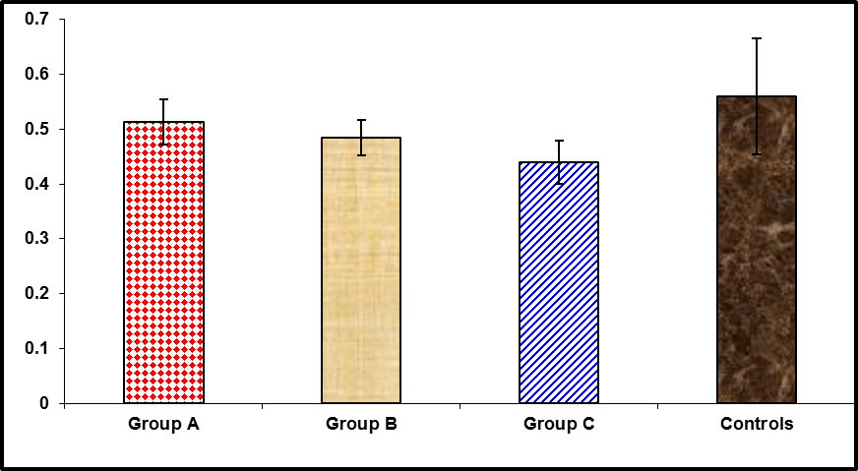

Figure (1): shows comparison between patient's groups and control group according to leptin /adiponectin ratio:

There was no statistically significant difference between patient's groups & control group according to correlation between leptin/adiponectin ratio and ultrasound findings. Also, there was no statistically significant difference between activity stages as regard to liver biopsy in group (A) in correlation toleptin/adiponectin ratio.

Correlation study of serum leptin, serum adiponectin and leptin/adiponectin ratio of the patient groups with other parameters was done and revealed the followings. As regard to serum leptin, there was a negative correlation between serum levels of leptin and BMI, AST, prothrombin time (PT), Total bilirubin (T.bil), Direct bilirubin(D.bil) and S. creatinine. On the other hand, there was positive correlation with serum albumin and platelet count (PLT). Other parameters including age, ALT, total protein concentration (TP), ALP, blood urea, Hb. concentration, RBCs count, WBCs count, FBS, 2h. P.P.B.S. and T.S.H., showed no significant correlation with serum leptin level.

Regarding serum adiponectin, we have found that there was a negative correlation between serum levels of adiponectin and BMI, AST, PT, T.bil., D.bil., blood urea and S.creatinine. On the other hand, there was positive correlation with s.albumin, Hb. concentration and PLT. Other parameters including age, ALT, TP, ALP, RBCs, WBCs, FBS, 2h.P.P.B.S. and T.S.H., showed no significant correlation with serum adiponectin

Regarding leptin/adiponectin ratio, we have found that there was a negative correlation between leptin/adiponectin ratio and AST, PT, T.bilirubin and D.bilirubin. On the other hand, there was Positive correlations betweenleptin/adiponectin ratio and s.albumin and PLT. Other parameters including age, BMI, ALT, TP, ALP, blood urea, S.creatinine, HB, RBCs, WBCs, FBS, 2h.P.P.B.S. and T.S.H. showed no significant correlation with leptin/adiponectin ratio.

Table (4): shows Correlations between Leptin, Adiponectin and leptin/adiponectin ratiowith other data of patients.

| **Correlations** | | | | | | |
| --- | --- | --- | --- | --- | --- | --- |
|  | **Leptin (ng/ml)** | | **Adiponectin (µg/ml)** | | **Lep/adiporatio** | |
| **R** | **P-value** | **R** | **P-value** | **R** | **P-value** |
| **Age(Yr)** | -0.321 | 0.084 | -0.311 | 0.094 | -0.237 | 0.207 |
| **BMI (K/m²)** | -0.454 | 0.012* | -0.418 | 0.022* | -0.332 | 0.073 |
| **AST (U/L)** | -0.456 | 0.011* | -0.382 | 0.037* | -0.433 | 0.017* |
| **ALT (U/L)** | 0.030 | 0.875 | 0.030 | 0.874 | 0.013 | 0.945 |
| **PT (%)-sec** | -0.773 | <0.001* | -0.727 | <0.001* | -0.612 | <0.001* |
| **TP (gm/dl)** | -0.117 | 0.538 | -0.071 | 0.709 | -0.144 | 0.447 |
| **Albumin (gm/dl)** | 0.653 | <0.001* | 0.601 | <0.001* | 0.497 | 0.005* |
| **ALP (U/L)** | -0.215 | 0.253 | -0.107 | 0.572 | -0.299 | 0.109 |
| **T.bil (mg/dl)** | -0.627 | <0.001* | -0.512 | 0.004* | -0.625 | <0.001* |
| **D.bil (mg/dl)** | -0.586 | 0.001* | -0.464 | 0.010* | -0.619 | <0.001* |
| **urea (mg/dl)** | -0.347 | 0.060 | -0.375 | 0.041* | -0.184 | 0.330 |
| **S.creatinine (mg/dl)** | -0.483 | 0.007* | -0.496 | 0.005* | -0.281 | 0.133 |
| **Hb (gm/dl)** | 0.353 | 0.056 | 0.375 | 0.041* | 0.202 | 0.285 |
| **RBCs (m/ml)** | 0.296 | 0.113 | 0.207 | 0.273 | 0.345 | 0.062 |
| **WBCs (k/ml)** | -0.228 | 0.225 | -0.347 | 0.060 | 0.019 | 0.921 |
| **PLT(k/ml)** | 0.649 | <0.001* | 0.542 | 0.002* | 0.579 | 0.001* |
| **F.B.S (mg/dl)** | -0.166 | 0.380 | -0.173 | 0.361 | -0.091 | 0.633 |
| **2h-P.P (mg/dl)** | 0.061 | 0.749 | 0.071 | 0.709 | -0.003 | 0.987 |
| **T.S.H (µIu/L)** | -0.159 | 0.401 | -0.178 | 0.348 | -0.065 | 0.732 |

**ROC curve** analysis of the most significant data according to sensitivity, specificity and cut off point between patients and control groups where sensitivity predicts the disease andspecificity predicts the controls (normal), was done. This included the following 7 itemss. albumin, ALT/AST ratio, BMI, Leptin/Adiponectinratio, PLT, PT andT.bil.

Table (4): shows ROC curveanalysis of the significance of leptin/adiponectin ratio according to sensitivity, specificity and cut off point in relation to progression of the disease.

|  |  |  |  |  |  |
| --- | --- | --- | --- | --- | --- |
| ROC curve | | | | | |
| Cut off | Sens. | Spec. | PPV | NPV | Accuracy |
| <=0.49 * | 70.0 | 90.0 | 95.5 | 50.0 | 0.813 |

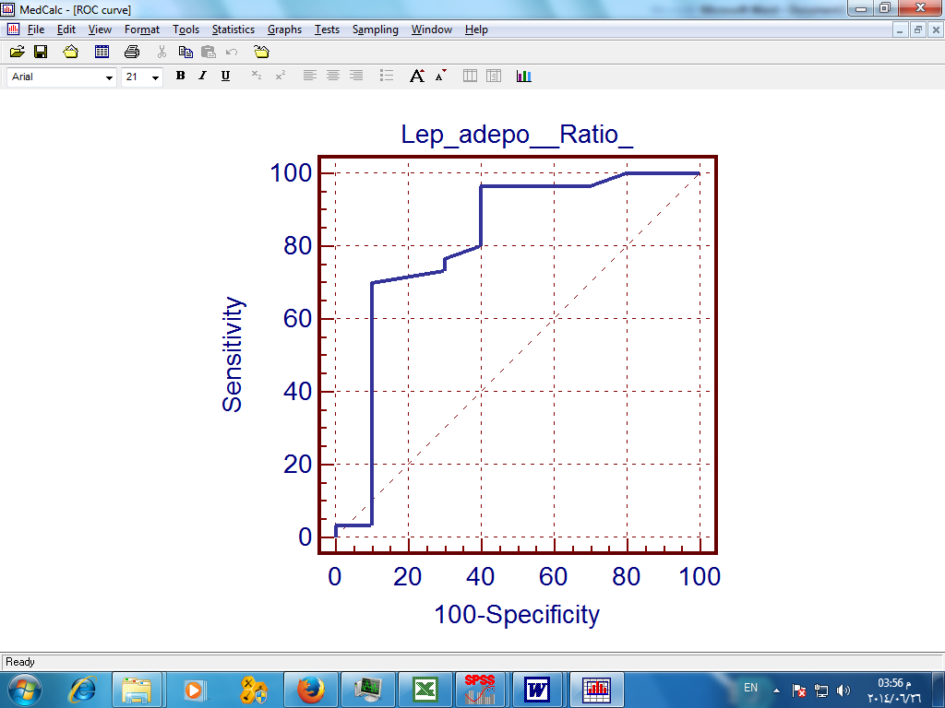

Figure (2): shows ROC curve for Leptin/Adipo_Ratio

As regard to these7 items, we can suggest a new score from these component to asses the progression of the disease through "factor score", which make this items as one factor to compare the progression of the disease between different groups.

There was a statistical significance between patient's groups & control group according to "factor score" which occurred between the following groups: (A&B), (A&C), (B&C), (B & controls) and (C & controls). In spite of no statistical significance between group A & controls.

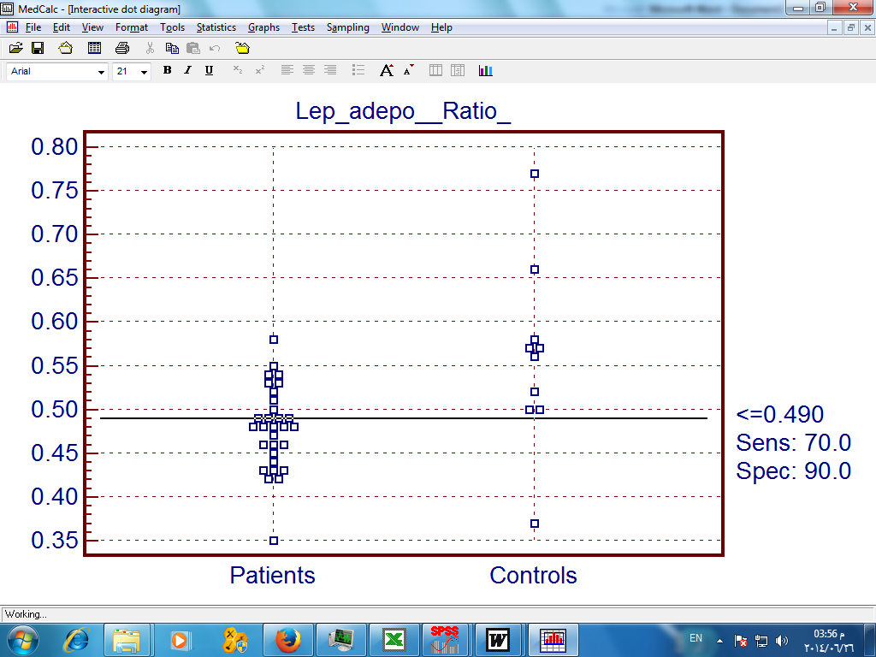

Figure (3): shows comparison between patients & controls according to Leptin/Adiponectin Ratio via ROC curve.

Table (5): shows comparison between patient's groups and control group according to " factor score ".

|  |  |  |  |  |  |  |  |  |  |  |  |  |  |
| --- | --- | --- | --- | --- | --- | --- | --- | --- | --- | --- | --- | --- | --- |
|  | **Factor score** | | | | | | | | | | **ANOVA** | | |
| **Range** | | | | | **Mean** | | **-** | **SD** | | **F** | | **P-value** |
| **Group A** | 0.499 | | : | 1.147 | | 0.682 | | - | 0.209 | | 45.506 | | <0.001* |
| **Group B** | -0.767 | | : | 0.363 | | -0.315 | | - | 0.363 | |
| **Group C** | -2.810 | | : | -0.757 | | -1.291 | | - | 0.639 | |
| **Controls** | -0.108 | | : | 2.065 | | 0.925 | | - | 0.566 | |
| **Tukey's test** | | | | | | | | | | | | | |
| **A&B** | | **A&C** | | | **A&controls** | | **B&C** | | | **B&controls** | | **C&controls** | |
| <0.001* | | <0.001* | | | 0.665 | | <0.001* | | | <0.001* | | <0.001* | |

**4. Discussion**

The role of leptin in hepatic fibrosis is still not clear. Moreover, the levels of adiponectin in patients with different stages of liver disease particularly those with NAFLD and chronic HCV infection, have been partly unrevealed (Berg, et al, 2001).

Still, liver biopsy is a gold standard technique for evaluation of liver fibrosis and degree of inflammation, but because it is invasive technique all are looking to find out accurate non invasive test for assessing progression of liver disease. (Nezam Afdhal, et al, 2004).

The behavior of leptin concentrations in the course of liver disease due to HCV infection is still under investigation. (Manolakopoulos et al., 2007)

In the current study we have found that serum leptin levels were significantly higher in fibrotic patients with chronic HCV infection and decreased with progression of the disease as regard to Child-Pugh classification but still higher than in normal peoples. These findings are in agreement with (Ishak, et al, 1995, Testa, et al, 2000, Lin, et al, 2002 & Korah, et al, 2013).

Another study showed a significant association between serum leptin and fibrosis stage in HCV- infected patients (Manolakopoulos et al., 2007).

On the other hand, Comlekci, et al, 2003 &Muzzi, et al, 2005 postulated that there were no correlation between serum leptin and liver fibrosis.

The cause of this discrepancy may be due to the difference in the studying methods as we compared serum leptin levels in liver diseasedpatients classified according to Child-Pugh classification and other studies designed to study leptin in specific types of patients (chronic HCV infection with fibrosis).

Another possible cause is the suggested role of leptin level inside the hepatocytes (where intrahepatic leptin was searched and not the serum levels) (Giannini, et al, 2000).

Adiponectin has a hepatoprotective and antifibrogenic effect in cases of liver injury and protects against liver steatosis (Xu et al., 2003).

In the current study also we have found that there was a statistically significant difference between liver diseased patients and healthy controles as regarding the serum adiponectin levels (with higher levels in class A) and decreased with progression of the disease as regard to Child-Pugh classification but still higher than normal people. These findings meet with Derbala, et al, 2009 &Tiftikci, et al, 2009 were serum levels of adiponectin found to be higher in patients with chronic HCV infected patients than in controls.

Korah, et al, 2013 saied that, Hypoadiponectinemia may be a good predictor for hepatic steatosis in chronic HCV infected patients and by increasing the serum level of adiponectin the patient is more in favour to develop fibrosis. But in this context we found that serum adiponectin levels were significantly higher in class A liver diseased patients than in class B & class C. The cause of this discrepancy may be the difference in the sample gender, hence they included only male patients in their study, beside the difference in the studying method.

In the current study, a new ratio was designed to be compared in between the chronic liver-diseased patients and the normal controles, Leptin/Adiponectin ratio.

We have found that there were a statistically significant difference in between Leptin/Adiponectin ratio in liver-diseased patients in class B & C and in normal controles. Unlike patients in class A where no statiscally significant difference was found.

In the current study, a new score was designed by statistical analysis of the most sensitive parameters in the progression of the chronic liver disease including the following 7 items, s. albumin, ALT/AST ratio, BMI, Leptin/Adiponectin ratio, PLT, PT and T.bil.

Factor Score was able to differentiate different CTP classes A, B and C. Mean values of Factor Score were 0.682, -0.315, -1.291 and 0.925 for CTP class A, B, C and control group respectively.

This new score may be important in detection the progression of the underling hepatic affection after validation on large group of patients.

**Conclusion**

Significant correlation of serum leptin and serum adiponectin levels to progression of chronic liver disease were studied but still having controversy with other studies. Leptin/adeponectin ratio is a good predictor of disease progression in HCV patients. Factor Score is a useful new score for prediction of CPT class in HCV patients. Still we are in need for more studies in this context for more evaluation of this ratio & Factor score especially in specific hepatic pathogenic conditions.

**References**

1. Ali N. and Sumatra M. (2002): Portal Hypertension. J. Gastrointestinal Radiol.; 23:234. Coated from: [WWW.E-medicine.com](http://WWW.E-medicine.com).
2. Arthur Schoenstadt, MD (2013): Hepatitis C Prognosis, _ <http://hepatitis-c.emedtv.com/hepatitis-c/hepatitis-c-prognosis.html> (Electronic searsh at 27_10_2013).
3. Berg AN, Combs TP, Dux et al. (2001): The adipocyte secreted protein Acrp 30 enhances hepatic insulin action. Nature Medicin; 7:947-953.
4. Cales P., Gberti F., Bernard B., et al. (2003): Evaluation of Baveno recommendations for grading of oesophagealvarices. J. Hepatol.; 39:658-659.
5. Comlekci A, Akpinar H, Yesil S, Okan I, Ellidokuz E, Okan A, Ersoz G, Tankurt E, Batur Y (2003). Serum leptin levels in patients with liver cirrhosis and chronic viral hepatitis. Scand J Gastroenterol; 38: 779-786.
6. DavidePovero, Chiara Busletta, Erica Novo, Lorenzo Valfrè di Bonzo, StefaniaCannito, Claudia Paternostro and Maurizio Parola (2010): Histol Histopathol 25, 1075-1091.
7. Derbala M, Rizk N, Al-Kaabi S, Amer A, Shebl F, Al Marri A, Aigha I, Alyaesi D, Mohamed H, Aman H, Basem N (2009): Adiponectin changes in HCV-Genotype 4: relation to liverhistology and response to treatment. J Viral Hepat; 16:689-696.
8. Giannini E, Ceppa P, Boita F et al. (2000): Leptin has no role in determining severity of steatosis and fibrosis in patients with chronic hepatitis C. Am J Gastroenterl; 95: 3211-3217.
9. Ishak KG, Baptista A, Bianchi L et al. (1995): Histological grading and staging of chronic hepatitis. J Hepatol; 22: 696-699.
10. Korah TE, El-Sayed S, ElShafie MK, Hammoda GE, Safan MA (2013). Significance of serum leptin and adiponectin levels in Egyptianpatients with chronic hepatitis C virus associated hepatic steatosisand fibrosis. World J Hepatol; 5(2): 74-81.
11. Knodell R., Ishak K., Black W., et al. (1981): Formulation and application of anumerical scoring system for assessing histological activity in asymptomatic chronic active hepatitis. Hepatology;1:431-435.
12. Lavanchy D, McMahon B (2000): Worldwide prevalence and prevention of hepatitis C. In: Liang TJ, Hoofnagle JH, eds. Hepatitis C. San Diego, Academic Press:185-202.
13. Lin SY, Wang YY, Sheu WH (2002). Increased serum leptin concentrations correlate with soluble tumour necrosis factor receptor levels in patients with cirrhosis. Clin Endocrinol (Oxf) 2002; 57: 805-811.
14. Manolakopoulos S, Bethanis S, Liapi C, Stripeli F, Sklavos P, et al. (2007): An assessment of serum leptin levels inpatients with chronic viral hepatitis: a prospective study. BMC Gastroenterol.; 7:17.
15. Muzzi A, Leandro G, Rubbia-Brandt L, James R, Keiser O, Malinverni R, Dufour JF, Helbling B, Hadengue A, Gonvers JJ, Müllhaupt B, Cerny A, Mondelli MU, Negro F(2005). Insulin resistance is associated with liver fibrosis in non-diabetic chronic hepatitis C patients. J Hepatol; 42: 41-46.
16. Nezam H Afdhal MD, FRCPI and David Nunes MD, FRCPI (2004): The American Journal of Gastroenterology 99, 1160–1174.
17. Saxena NK, Fu PP, Nagalingam A, Wang J, Handy J, Co-hen C, Tighiouart M, Sharma D, Anania FA. Adiponectin modulates C-jun N-terminal kinase and mammalian target of rapamycin and inhibits hepatocellular carcinoma. Gastro-enterology 2010;139: 1762-1773, 1773. e1-e5 [PMID: 20637208]
18. Testa R, Franceschini R, Giannini E et al. (2000): Serum leptin levels in patients with viral chronic hepatitis or liver cirrhosis. J Hepatol; 33:33-37.
19. Tiftikci A et al. (2009): Serum levels of adipokines in patients with chronic HCV infection: relationship with steatosis and fibrosis. Arch. Med. Res. 40:294–8.
20. Tsochatzis E, Papatheodoridis GV, Archimandritis AJ.The evolving role of leptin and adiponectin in chronic liver diseases. Am J Gastroenterol 2006; 101: 2629-2640 [PMID:16952281].
21. Turner H.E. and Wass J.A.H. (2002): Menopause. In: Oxford handbook of endocrinology and diabetes textbook, 1st edition. Editors: Turner H.E. and Wass J.A.H., Copright 2002 Oxford university press. part IV:399-412.
22. Van Asten L, Verhaest I, Lamzira S, Hernandez-Aguado I, Zangerle R, Boufassa F, Rezza G, Broers B, Robertson JR, Brettle RP, McMenamin J, Prins M, Cochrane A, Simmonds P, Coutinho RA, Bruisten S. Spread of hepatitis C virus among European injection drug users infected with HIV: a phylogenetic analysis. J Infect Dis 2004;189: 292-302 [PMID: 14722895].
23. Xu A, Wang Y, Kershaw H et al., (2003): The fat derived hormone adiponectin alleviates alcoholic and NAFLD in mice. Journal of clinical Investigation; 112:91-100.

1/25/2016