Thromboxane (TX), Prostaglandins (PG) and Atorvastatin (Liptor) Literatures

Ma Hongbao ¹, Margaret Young ², Yang Yan ¹

¹ Brookdale Hospital, Brooklyn, New York 11212, USA; ² Cambridge, MA 02138, USA
ma8080@gmail.com

Abstract: Thromboxane (TX) is a vasoconstrictor, potent hypertensive agent, and facilitates the clumping of platelets, which is produced in platelets by TX synthetase from the endoperoxides by the cyclooxygenase (COX) enzyme. Atorvastatin (Lipitor) belongs to a group of drugs called HMG CoA reductase inhibitors (statins), which reduces levels of bad cholesterol (low-density lipoprotein) and triglycerides in the blood, while increasing levels of good cholesterol (high-density lipoprotein). Lipitor acts by inhibiting the ability of the COX enzyme to synthesize the precursors of TX within platelets that could be influenced by the obstruction damage of the kidney. Prostaglandins (PG) are a group of physiologically active lipid compounds having diverse hormone-like effects in animals. Prostaglandins have been found in almost every tissue in humans and other animals. They are derived enzymatically from fatty acids. Every prostaglandin contains 20 carbon atoms, including a 5-carbon ring. They are a subclass of eicosanoids and form the prostanoid class of fatty acid derivatives.
[Ma H, Young M, Yang Y. Thromboxane (TX), Prostaglandins (PG) and Atorvastatin (Liptor) Literatures. N Y Sci J 2015;8(10):93-100]. (ISSN: 1554-0200). http://www.sciencepub.net/newyork. 18

Keywords: thromboxane (TX); prostaglandin; partial ureteral obstruction (PUO); atorvastatin (Lipitor); cyclooxygenase (COX); platelet; vasoconstriction

This paper is a literature review collection from Internet and other articles, just offer a description of thromboxane (TX), prostaglandin (PG) and atorvastatin (Liptor).
TX is a vasoconstrictor, potent hypertensive agent, and facilitates the clumping of platelets, which is produced in platelets by TX synthetase with the endoperoxides by the cyclooxygenase (COX) enzyme from arachidonic acid. TX is in homeostatic balance in the circulatory system with prostacyclin, a related compound. Aspirin acts by inhibiting the ability of the COX enzyme to synthesize the precursors of TX within platelets.
TX is a member of the family of lipids known as eicosanoids. The two major TXs are thromboxane A2 (TXA2) and thromboxane B2 (TXB2). The distinguishing feature of TXs is a 6-membered ether-containing ring. TX is named for its role in clot formation (thrombosis). TX is a substance made by platelets that causes blood clotting and constriction of blood vessels. It also encourages platelet aggregation. TXA2 is active but is very unstable and has a half-life of only 30 seconds before it undergoes hydrolysis to form TXB2 which is inactive.
TXA2 has prothrombotic properties by stimulating activation of new platelets as well as increased platelet aggregation. The latter is achieved by mediating expression of the glycoprotein complex GP IIb/IIIa in the cell membrane of platelets. Circulating fibrinogen binds these receptors on adjacent platelets, further strengthening the thrombosis. The vasoconstriction caused by TX plays a role in Prinzmetal angina.
TXA2 is unstable and its measurement deduced by TXB2 detection. Briefly, for the detection the tissues are weighed and homogenized in 100 mM KPhos buffer (pH 7.4). The homogenates are spun at 2000 rpm for 15 minutes and the supernatant transferred to a clean tube. The supernatants are assayed using the TXB2 EIA kit following the enzyme immunoassay (EIA) method using the kits from Cayman Chemical Company (Ann Arbor, Michigan 48108, USA). Protein concentrations of the supernatants were performed using the Cayman Protein Determination kit (based on the Bradford method). TXA2 is linear related to TXB2.
TX acts by binding to any of the TX receptors, G-protein-coupled receptors coupled to the G protein Gq. TX is a vasoconstrictor and a potent hypertensive agent, and it facilitates platelet aggregation. It is in homeostatic balance in the circulatory system with prostacyclin, a related compound. The mechanism of secretion of TXs from platelets is still unclear. They act in the formation of blood clots and reduce blood flow to the site of a clot. TXA2, produced by activated platelets, has prothrombotic properties, stimulating activation of new platelets as well as increasing platelet aggregation.
Platelet aggregation is achieved by mediating expression of the glycoprotein complex GP IIb/IIIa in the cell membrane of platelets. Circulating fibrinogen binds these receptors on adjacent platelets, further strengthening the clot. It is believed that the vasoconstriction caused by TXs plays a role in Prinzmetal's angina. Omega-3 fatty acids are metabolized to produce higher levels of TXA, which is relatively less potent than TXA2 and PGI3; therefore, there is a balance shift toward inhibition of vasoconstriction and platelet aggregation. It is believed that this shift in balance lowers the incidence of myocardial infarction and stroke. Vasoconstriction and, perhaps, various proinflammatory effects exerted by TXA on tissue microvasculature, is probable reason why the TXA is pathogenic in various diseases, such as ischemia-reperfusion injury, hepatic inflammatory processes, acute hepatotoxicity, etc. TXB2, a stable degradation product of TXA2, plays a role in acute hepatoxicity induced by acetaminophen.
TX inhibitors are broadly classified as either those that inhibit the synthesis of TX, or those that inhibit the target effect of it. The widely used drug aspirin acts by inhibiting the ability of the COX enzyme to synthesize the precursors of TX within platelets. Low-dose, long-term aspirin use irreversibly blocks the formation of TX A2 in platelets, producing an inhibitory effect on platelet aggregation. This anticoagulant property makes aspirin useful for reducing the incidence of heart attacks. 40 mg of aspirin a day is able to inhibit a large proportion of maximum TXA2 release provoked acutely, with the PG I2 synthesis being little affected; however, higher doses of aspirin are required to attain further inhibition. TX synthase inhibitors inhibit the final enzyme (TX synthase) in the synthesis of TX. Ifetroban is a potent and selective TX receptor antagonist. Dipyridamole antagonizes this receptor too, but has various other mechanisms of antiplatelet activity as well.
High-dose naproxen can induce near-complete suppression of platelet TX throughout the dosing interval and appears not to increase cardiovascular disease (CVD) risk, whereas other high-dose NSAID (non-steroidal-anti-inflammatory) regimens have only transient effects on platelet COX-1 and have been found to be associated "with a small but definite vascular hazard". The inhibitors of the target effects of TX are the TX receptor antagonist, including terutroban. Picotamide has activity both as a TX synthase inhibitor and as a TX receptor antagonist.
The PG are a group of physiologically active lipid compounds having diverse hormone-like effects in animals. PGs have been found in almost every tissue in humans and other animals. They are derived enzymatically from fatty acids. Every PG contains 20 carbon atoms, including a 5-carbon ring. They are a subclass of eicosanoids and form the prostanoid class of fatty acid derivatives.
The structural differences between PGs account for their different biological activities. A given PG may have different and even opposite effects in different tissues. The ability of the same PG to stimulate a reaction in one tissue and inhibit the same reaction in another tissue is determined by the type of receptor to which the PG binds. They act as autocrine or paracrine factors with their target cells present in the immediate vicinity of the site of their secretion. PGs differ from endocrine hormones in that they are not produced at a specific site but in many places throughout the human body.
PGs have two derivatives: prostacyclins and TXs. Prostacyclins are powerful locally acting vasodilators and inhibit the aggregation of blood platelets. Through their role in vasodilation, prostacyclins are also involved in inflammation. They are synthesized in the walls of blood vessels and serve the physiological function of preventing needless clot formation, as well as regulating the contraction of smooth muscle tissue. Conversely, TXs (produced by platelet cells) are vasoconstrictors and facilitate platelet aggregation. Their name comes from their role in clot formation (thrombosis).
Specific PGs are named with a letter (which indicates the type of ring structure) followed by a number (which indicates the number of double bonds in the hydrocarbon structure). For example, PG E1 is abbreviated PGE1 or PGE1, and PG I2 is abbreviated PGI2 or PGI2. The number is traditionally subscripted when the context allows, but as with many similar subscript-containing nomenclatures, the subscript is simply forgone in many database fields that can store only plain text, and readers are used to seeing and writing it without subscript.
The name PG derives from the prostate gland. When PG was first isolated from seminal fluid in 1935 by the Swedish physiologist Ulf von Euler, and independently by M.W. Goldblatt, it was believed to be part of the prostatic secretions. (In fact, PGs are produced by the seminal vesicles). It was later shown that many other tissues secrete PGs for various functions. The first total syntheses of PG F2α and PG E2 were reported by E. J. Corey in 1969, an achievement for which he was awarded the Japan Prize in 1989.
In 1971, it was determined that aspirin-like drugs could inhibit the synthesis of PGs. The biochemists Sune K. Bergström, Bengt I. Samuelsson and John R. Vane jointly received the 1982 Nobel Prize in Physiology or Medicine for their research on PGs.
Biosynthesis of eicosanoids PGs are found in most tissues and organs. They are produced by almost all nucleated cells. They are autocrine and paracrine lipid mediators that act upon platelets, endothelium, uterine and mast cells. They are synthesized in the cell from the essential fatty acids (EFAs).
An intermediate arachidonic acid is created from diacylglycerol via phospholipase-A2, then brought to either the cyclooxygenase pathway or the lipoxygenase pathway to form either PG and TX or leukotriene respectively. The cyclooxygenase pathway produces TX, prostacyclin and PG D, E and F. Alternatively, the lipoxygenase enzyme pathway is active in leukocytes and in macrophages and synthesizes leukotrienes.
PGs were originally believed to leave the cells via passive diffusion because of their high lipophilicity. The discovery of the PG transporter (PGT, SLCO2A1), which mediates the cellular uptake of PG, demonstrated that diffusion alone cannot explain the penetration of PG through the cellular membrane. The release of PG has now also been shown to be mediated by a specific transporter, namely the multidrug resistance protein 4 (MRP4, ABCC4), a member of the ATP-binding cassette transporter superfamily. Whether MRP4 is the only transporter releasing PGs from the cells is still unclear.
PGs are produced following the sequential oxidation of arachidonic acid, DGLA or EPA by cyclooxygenases (COX-1 and COX-2) and terminal PG synthases. The classic dogma is as follows: COX-1 is responsible for the baseline levels of PGs, COX-2 produces PGs through stimulation. However, while COX-1 and COX-2 are both located in the blood vessels, stomach and the kidneys, PG levels are increased by COX-2 in scenarios of inflammation and growth.
PG E2 (PGE2) is generated from the action of PG E synthases on PG H2 (PG H2, PGH2). Several PG E synthases have been identified. To date, microsomal PG E synthase-1 emerges as a key enzyme in the formation of PGE2.
Terminal PG synthases have been identified that are responsible for the formation of other PGs. For example, hematopoietic and lipocalin PG D synthases (hPGDS and lPGDS) are responsible for the formation of PGD2 from PGH2. Similarly, prostacyclin (PGI2) synthase (PGIS) converts PGH2 into PGI2. A TX synthase (TXAS) has also been identified. PG-F synthase (PGFS) catalyzes the formation of 9α,11β-PGF2α,β from PGD2 and PGF2α from PGH2 in the presence of NADPH. This enzyme has recently been crystallized in complex with PGD2 and bimatoprost (a synthetic analogue of PGF2α).
There are currently ten known PG receptors on various cell types. PGs ligate a sub-family of cell surface seven-transmembrane receptors, G-protein-coupled receptors. These receptors are termed DP1-2, EP1-4, FP, IP1-2, and TP, corresponding to the receptor that ligates the corresponding PG (e.g., DP1-2 receptors bind to PGD2).
The diversity of receptors means that PGs act on an array of cells and have a wide variety of effects such as:
- cause constriction or dilation in vascular smooth muscle cells
- cause aggregation or disaggregation of platelets
- sensitize spinal neurons to pain
- induce labor
- decrease intraocular pressure
- regulate inflammation
- regulate calcium movement
- regulate hormones
- control cell growth
- acts on thermoregulatory center of hypothalamus to produce fever
- acts on mesangial cells (specialised smooth muscle cells) in the glomerulus of the kidney to increase glomerular filtration rate
- acts on parietal cells in the stomach wall to inhibit acid secretion
- brain masculinization (in rats)
PGs are potent but have a short half-life before being inactivated and excreted. Therefore, they send only paracrine (locally active) or autocrine (acting on the same cell from which it is synthesized) signals.
The following is a comparison of different types of PG, prostacyclin I2 (PGI2), PG E2 (PGE2), and PG F2α (PGF2α).
Atorvastatin, marketed under the trade name Lipitor among others, is a member of the drug class known as statins, which are used primarily for lowering blood cholesterol and for prevention of events associated with cardiovascular disease. Like all statins, atorvastatin works by inhibiting HMG-CoA reductase, an enzyme found in liver tissue that plays a key role in production of cholesterol in the body.
Atorvastatin was discovered by Bruce Roth and coworkers at Parke-Davis, since acquired by Warner-Lambert and then Pfizer. Although atorvastatin was the fifth drug in the class of statins to be developed, clinical trials showed that atorvastatin caused a more dramatic reduction in LDL-C than the other statin drugs. From 1996 to 2012 under the trade name Lipitor, atorvastatin became the world's best-selling drug of all time, with more than US$125 billion in sales over approximately 14.5 years.
Pfizer's patent on atorvastatin expired in November 2011.
The primary uses of atorvastatin is for the treatment of dyslipidemia and the prevention of cardiovascular disease:
- Hypercholesterolemia (heterozygous familial and nonfamilial) and mixed dyslipidemia (Fredrickson types IIa and IIb) to reduce total cholesterol, LDL-C, apo-B, triglycerides levels, and CRP as well as increase HDL levels.
- Heterozygous familial hypercholesterolemia in pediatric patients
- Homozygous familial hypercholesterolemia
- Hypertriglyceridemia (Fredrickson Type IV)
- Primary dysbetalipoproteinemia (Fredrickson Type III)
- Combined hyperlipidemia
- Primary prevention of heart attack, stroke, and need for revascularization procedures in patients who have risk factors such as age, smoking, high blood pressure, low HDL-C, and a family history of early heart disease, but have not yet developed clinically evident coronary heart disease.
- Secondary prevention of myocardial infarction, stroke, unstable angina, and revascularization in people with established coronary heart disease.
- Myocardial infarction and stroke prophylaxis in patients with type II diabetes.
- There have been recent studies suggesting that high-dose statin therapy plays a plaque-stabilizing role in patients suffering from acute coronary syndrome and thrombotic stroke.
Atorvastatin may be used in combination with bile acid sequestrants and ezetimibe to increase the reduction in cholesterol levels. However, it is not recommended to combine statin drug treatment with certain other cholesterol-lowering drugs, particularly fibrates, because this may increase the risk of myopathy-related adverse effects.
While many statin medications should be administered at bedtime for optimal effect, atorvastatin can be dosed at any time of day, as long as it is continually dosed once daily at the same time.
Geriatric: Plasma concentrations of atorvastatin in healthy elderly subjects are higher than those in young adults, and clinical data suggests a greater degree of LDL-lowering at any dose for patients in the population as compared to young adults.
Pediatric: Pharmacokinetic data is not available for this population.
Gender: Plasma concentrations are generally higher in women than in men, but there is no clinically significant difference in the extent of LDL reduction between men and women.
Renal impairment: Renal disease has no influence on plasma concentrations of atorvastatin and dosing need not be adjusted in these patients.
Hemodialysis will not significantly alter drug levels or change clinical effect of atorvastatin.
In patients with chronic alcoholic liver disease, levels of atorvastatin may be significantly increased depending upon the extent of liver disease.
Markedly elevated CPK levels or if a myopathy is suspected or diagnosed after dosing of atorvastatin has begun. Very rarely, atorvastatin may cause rhabdomyolysis, and it may be very serious leading to acute renal failure due to myoglobinuria. If rhabdomyolysis is suspected or diagnosed, atorvastatin therapy should be discontinued immediately. The likelihood of developing a myopathy is increased by the co-administration of cyclosporine, fibric acid derivatives, erythromycin, niacin, and azole antifungals.
Myopathy with elevation of creatinine kinase (CK) and rhabdomyolysis are the most serious side effects, occurring rarely at a rate of <1% of patients taking atorvastatin. As mentioned previously, atorvastatin should be discontinued immediately if this occurs.
Liver enzyme abnormalities occurred in 0.7% of patients who received atorvastatin in clinical trials. It is recommended that hepatic function be assessed with laboratory tests before beginning atorvastatin treatment and repeated as clinically indicated thereafter. If evidence of serious liver injury occurs while a patient is taking atorvastatin, it should be discontinued and not restarted until the etiology of the patient's liver dysfunction is defined. If no other cause is found, atorvastatin should be discontinued permanently.
Interactions with clofibrate, fenofibrate, gemfibrozil, which are fibrates used in accessory therapy in many forms of hypercholesterolemia, usually in combination with statins, increase the risk of myopathy and rhabdomyolysis.
Co-administration of atorvastatin with one of CYP3A4 inhibitors such as itraconazole, telithromycin, and voriconazole, may increase serum concentrations of atorvastatin, which may lead to adverse reactions. This is less likely to happen with other CYP3A4 inhibitors such as diltiazem, erythromycin, fluconazole, ketoconazole, clarithromycin, cyclosporine, protease inhibitors, or verapamil, and only rarely with other CYP3A4 inhibitors, such as amiodarone and aprepitant. Often, bosentan, fosphenytoin, and phenytoin, which are CYP3A4 inducers, can decrease the plasma concentrations of atorvastatin. Only rarely, though, barbiturates, carbamazepine, efavirenz, nevirapine, oxcarbazepine, rifampin, and rifamycin, which are also CYP3A4 inducers, can decrease the plasma concentrations of atorvastatin. Oral contraceptives increased AUC values for norethindrone and ethinyl estradiol; these increases should be considered when selecting an oral contraceptive for a woman taking atorvastatin.
Antacids can rarely decrease the plasma concentrations of statin drugs, but do not affect the LDL-C-lowering efficacy.
Niacin also is proved to increase the risk of myopathy or rhabdomyolysis.
Statins may also alter the concentrations of other drugs, such as warfarin or digoxin, leading to alterations in effect or a requirement for clinical monitoring.
Vitamin D supplementation lowers atorvastatin and active metabolite concentrations, yet synergistically reduces LDL and total cholesterol concentrations. Grapefruit juice components are known inhibitors of intestinal CYP3A4.
Co-administration of grapefruit juice with atorvastatin may cause an increase in Cmax and AUC, which can lead to adverse reactions or overdose toxicity.
A few cases of myopathy have been reported when atorvastatin is given with colchicine.
As with other statins, atorvastatin is a competitive inhibitor of HMG-CoA reductase. Unlike most others, however, it is a completely synthetic compound. HMG-CoA reductase catalyzes the reduction of 3-hydroxy-3-methylglutaryl-coenzyme A (HMG-CoA) to mevalonate, which is the rate-limiting step in hepatic cholesterol biosynthesis. Inhibition of the enzyme decreases de novo cholesterol synthesis, increasing expression of low-density lipoprotein receptors (LDL receptors) on hepatocytes. This increases LDL uptake by the hepatocytes, decreasing the amount of LDL-cholesterol in the blood. Like other statins, atorvastatin also reduces blood levels of triglycerides and slightly increases levels of HDL-cholesterol.
Recent studies have shown that in patients suffering from acute coronary syndrome, high-dose statin treatment may play a plaque-stabilizing role. At high doses, statins have anti-inflammatory effects, incite reduction of the necrotic plaque core, and improve endothelial function, leading to plaque stabilization and, sometimes, plaque regression. However, there is an increased risk of statin-associated adverse effects with such high-dose statin treatment. There is a similar thought process and risks associated with using high-dose statins to prevent recurrence of thrombotic stroke.
The liver is the primary site of action of atorvastatin, as this is the principal site of both cholesterol synthesis and LDL clearance. It is the dosage of atorvastatin, rather than systemic drug concentration, which correlates with extent of LDL-C reduction.
Absorption[edit]Atorvastatin undergoes rapid absorption when taken orally, with an approximate time to maximum plasma concentration (Tmax) of 1–2 h. The absolute bioavailability of the drug is about 14%, but the systemic availability for HMG-CoA reductase activity is approximately 30%. Atorvastatin undergoes high intestinal clearance and first-pass metabolism, which is the main cause for the low systemic availability. Administration of atorvastatin with food produces a 25% reduction in Cmax (rate of absorption) and a 9% reduction in AUC (extent of absorption), although food does not affect the plasma LDL-C-lowering efficacy of atorvastatin. Evening dose administration is known to reduce the Cmax and AUC by 30% each. However, time of administration does not affect the plasma LDL-C-lowering efficacy of atorvastatin.
The mean volume of distribution of atorvastatin is approximately 381 L. It is highly protein bound (≥98%), and studies have shown it is likely secreted into human breastmilk.
Atorvastatin metabolism is primarily through cytochrome P450 3A4 hydroxylation to form active ortho- and parahydroxylated metabolites, as well as various beta-oxidation metabolites. The ortho- and parahydroxylated metabolites are responsible for 70% of systemic HMG-CoA reductase activity. The ortho-hydroxy metabolite undergoes further metabolism via glucuronidation. As a substrate for the CYP3A4 isozyme, it has shown susceptibility to inhibitors and inducers of CYP3A4 to produce increased or decreased plasma concentrations, respectively. This interaction was tested in vitro with concurrent administration of erythromycin, a known CYP3A4 isozyme inhibitor, which resulted in increased plasma concentrations of atorvastatin. It is also an inhibitor of cytochrome 3A4.
Atorvastatin is primarily eliminated via hepatic biliary excretion, with less than 2% recovered in the urine. Bile elimination follows hepatic and/or extrahepatic metabolism. There does not appear to be any entero-hepatic recirculation. Atorvastatin has an approximate elimination half-life of 14 h. Noteworthy, the HMG-CoA reductase inhibitory activity appears to have a half-life of 20–30 h, which is thought to be due to the active metabolites. Atorvastatin is also a substrate of the intestinal P-glycoprotein efflux transporter, which pumps the drug back into the intestinal lumen during drug absorption.
In hepatic insufficiency, plasma drug concentrations are significantly affected by concurrent liver disease. Patients with A-stage liver disease show a four-fold increase in both Cmax and AUC. Patients with B-stage liver disease show a 16-fold increase in Cmax and an 11-fold increase in AUC.
Geriatric patients (>65 years old) exhibit altered pharmacokinetics of atorvastatin compared to young adults, with mean AUC and Cmax values that are 40% and 30% higher, respectively. Additionally, healthy elderly patients show a greater pharmacodynamic response to atorvastatin at any dose; therefore, this population may have lower effective doses.
Several genetic polymorphisms have been found to be associated with a higher incidence of undesirable side effects of atorvastatin. This phenomenon is suspected to be related to increased plasma levels of pharmacologically active metabolites, such as atorvastatin lactone and p-hydroxyatorvastatin. Atorvastatin and its active metabolites may be monitored in potentially susceptible patients using specific chromatographic techniques.
Atorvastatin synthesis in commercial production chemistry. The key step of establishing this drug's stereocenters, through initial use of an inexpensive natural product.
Atorvastatin synthesis during discovery chemistry. The key step of establishing stereocenters, using of a chiral ester auxiliary approach. The first synthesis of atorvastatin at Parke-Davis that occurred during drug discovery was racemic followed by chiral chromatographic separation of the enantiomers. An early enantioselective route to atorvastatin made use of an ester chiral auxiliary to set the stereochemistry of the first of the two alcohol functional groups via a diastereoselective aldol reaction. Once the compound entered pre-clinical development, process chemistry developed a cost-effective and scalable synthesis.[3] In atorvastatin's case, a key element of the overall synthesis was ensuring stereochemical purity in the final drug substance, and hence establishing the first stereocenter became a key aspect of the overall design.
Pack and tablet of Lipitor 40mg atorvastatin calcium tablets are marketed by Pfizer under the trade name Lipitor for oral administration. Tablets are white, elliptical, and film-coated. Pfizer also packages the drug in combination with other drugs, such as with Caduet. Pfizer recommends that patients do not break tablets in half to take half-doses, even when this is recommended by their doctors.
Pfizer's U.S. patent on Lipitor expired on 30 November 2011. Initially, generic atorvastatin was manufactured only by Watson Pharmaceuticals and India's Ranbaxy Laboratories. Prices for the generic version did not drop to the level of other generics—$10 or less for a month's supply—until other manufacturers began to supply the drug in May 2012.
In other countries, atorvastatin calcium is made in tablet form by generic drug makers under various brand names including Stator, Atorvastatin Teva, Litorva, Torid, Atoris, Atorlip, Mactor, Lipvas, Sortis, Torvast, Torvacard, Totalip, and Tulip. Pfizer also makes its own generic version under the name Zarator, which is the sole Pharmac-subsidised brand of atorvastatin in New Zealand.
On 9 November 2012, Indian drugmaker Ranbaxy Laboratories Ltd. voluntarily recalled 10-, 20- and 40-mg doses of its generic version of atorvastatin in the United States. The lots of atorvastatin, packaged in bottles of 90 and 500 tablets, were recalled due to possible contamination with very small glass particles similar to the size of a grain of sand (less than 1 mm in size). The FDA received no reports of injury from the contamination.
Thromboxane A2 and B2 structure and thromboxane synthesis are shown in Figures 1-6.

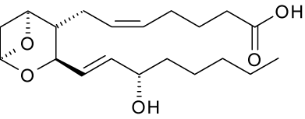
Figure 1. Thromboxane A2 structure.
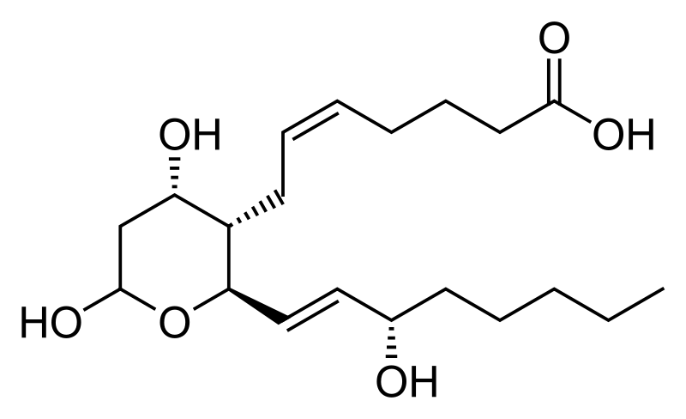
Figure 2. Thromboxane B2 structure.

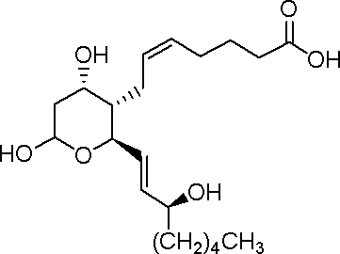
Figure 3. Structure of Thromboxane B2

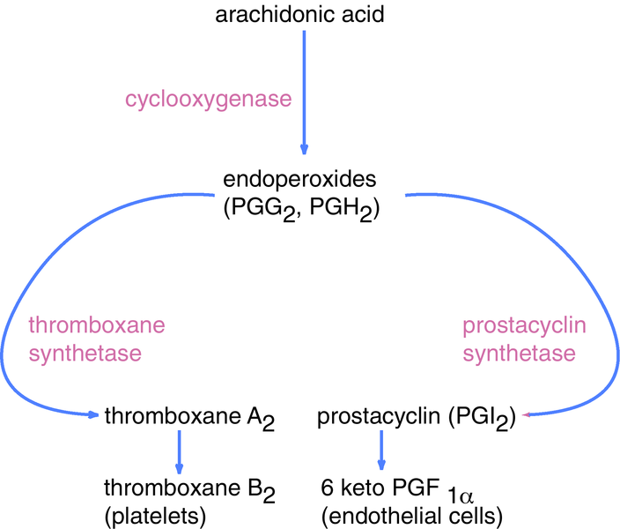
Figure 4. Thromboxane synthesis

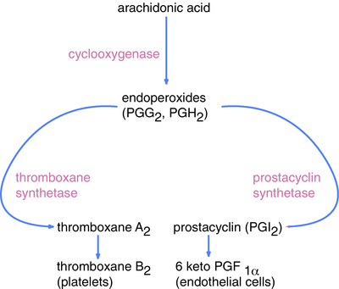

Figure 5. Enzymes and substrates associated with thromoboxane and prostacyclin synthesis.

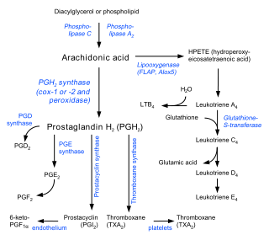
Figure 6. Eicosanoid synthesis

Thromboxane B2:
Synonym: (5Z,9α,11RS,13E,15S)-9,11,15-Trihydroxythromboxa-5,13-dien-1-oic acid
Abbrievation: TXB₂
Molecular Formula: C₂₀H₃₄O₆
Molecular weight: 370.48.

Prostaglandin E₂:
Synonym: (5Z,11α,13E,15S)-11,15-Dihydroxy-9-oxoprosta-5,13-dienoic acid
Abbrievation: PGE₂
Molecular Formula: C₂₀H₃₂O₅
Molecular Weight: 352.47

TXA2 is produced from arachidonic acid by many cells and causes irreversible platelet aggregation and vascular and bronchial smooth muscle contraction. TXA2, like most lipid mediators, is not a circulating hormone. It is formed in response to local stimuli and exerts its effects within a short distance of its biosynthesis. TXA2 is rapidly hydrolyzed non-enzymatically to form TXB2, which is then quickly metabolized (t1/2 = 5-7 minutes) to urinary metabolites for clearance by the kidneys. Because of the transient nature of this compound it is difficult to accurately measure circulating levels in whole-animal experimental models. In fact, it has been shown that plasma and urine levels of TXB2 are primarily due to ex vivo platelet activation and intra-renal production, respectively. There is neither commercial TXA2 antibody nor regular way for a laboratory to quantify TXA2 in samples. Therefore, measurement of TXB2 is the normal way to predict TXA2 level. For the detection of TXA2, it can use the TXB2 Enzyme Immunoassay (EIA) Kit from Cayman Chemical (Catalogue number 519031, US$242/96 wells, Cayman Chemical, Ann Arbor, Michigan, USA). The protocol of the measurement is followed by the company’s introduction (Cayman Chemical TXB2, 2006). Also, measurement of TXB2 metabolites such as 11-dehydro TXB2 and 2,3-dinor TXB2 (Catalog No. 519051, Cayman Chemical, Ann Arbor, Michigan, USA) in urine and plasma may give better estimates of in vivo TXA2 production. TXB2 measurement is better suited towards samples that are not expected to undergo extensive metabolism such as perfusates, lavage samples, tissue/cell culture, etc.
Partial ureteral obstruction (PUO) produces a well documented triphasic response in the renal hemodynamics. This response is characterized by an early increase in renal blood flow, following by a decrease to approach the baseline level, and later progressive profound renal ischemia.

References
- Atsushi Jinno-Oue, Susan G. Wilt, Charlotte Hanson, Natalie V. Dugger, Paul M. Hoffman, Michiaki Masuda, Sandra K. Ruscetti. Journal of Virology, 2003;77(9):5145-5151.
- Cavar I (2011). "Anti-thromboxane B2 antibodies protect against acetaminophen-induced liver injury in mice". Journal of Xenobiotics 1 (1): 38–44. doi:10.4081/xeno.2011.e8.
- Coxib and traditional NSAID Trialists' (CNT) Collaboration (30 May 2013). "Vascular and upper gastrointestinal effects of non-steroidal anti-inflammatory drugs: meta-analyses of individual participant data from randomised trials". Lancet, Early On-line Publication 382 (9894): 769–79. doi:10.1016/S0140-6736(13)60900-9. PMC 3778977. PMID 23726390.
- Dockens, RC; Santone, KS; Mitroka, JG; Morrison, RA; Jemal, M; Greene, DS; Barbhaiya, RH (Aug 2000). "Disposition of radiolabeled ifetroban in rats, dogs, monkeys, and humans.". Drug metabolism and disposition: the biological fate of chemicals 28 (8): 973–80. PMID 10901709.
- Galea, E., D. L. Feinstein, and D. L. Reis. Induction of calcium-independent nitric oxide synthase activity in primary rat glial cultures. Proc. Natl. Acad. Sci. USA 1992;89:10945-10949.
- http://www.medicinenet.com/script/main/art.asp?articlekey=32482.
- http://www.medicinenet.com/script/main/art.asp?articlekey=32482.
- Ito Y (2003). "Effects of selective cyclooxygenase inhibitors on ischemia/reperfusion-induced hepatic microcirculatory dysfunction in mice". Eur Surg Res 35 (5): 408–16. doi:10.1159/000072174. PMID 12928598.
- Katagiri H (2004). "Role of thromboxane derived from COX-1 and -2 in hepatic microcirculatory dysfunction during endotoxemia in mice". Hepatology 39 (1): 139–150. doi:10.1002/hep.20000. PMID 14752832.
- Ma H, Chen G. Stem cell. The Journal of American Science 2005;1(2):90-92.
- Ma H, Cherng S. Eternal Life and Stem Cell. Nature and Science. 2007;5(1):81-96.
- Ma H, Cherng S. Nature of Life. Life Science Journal 2005;2(1):7 - 15.
- Ma H, Yang Y. Turritopsis nutricula. Nature and Science 2010;8(2):15-20. http://www.sciencepub.net/nature/ns0802/03_1279_hongbao_turritopsis_ns0802_15_20.pdf.
- Ma H. The Nature of Time and Space. Nature and science 2003;1(1):1-11.Nature and science 2007;5(1):81-96.
- Manish M. Tiwari, Kurt J. Messer and Philip R. Mayeux. Inducible Nitric Oxide Synthase and Apoptosis in Murine Proximal Tubule Epithelial Cells. Toxicological Sciences 2006;91(2):493-500.
- National Center for Biotechnology Information, U.S. National Library of Medicine. http://www.ncbi.nlm.nih.gov/pubmed. 2015.
- Ratti, S; Quarato, P; Casagrande, C; Fumagalli, R; Corsini, A (1998). "Picotamide, an antithromboxane agent, inhibits the migration and proliferation of arterial myocytes". European Journal of Pharmacology 355 (1): 77–83.
- Tohgi, H; S Konno; K Tamura; B Kimura; K Kawano (1992). "Effects of low-to-high doses of aspirin on platelet aggregability and metabolites of thromboxane A2 and prostacyclin". Stroke 23 (10): 1400–1403. doi:10.1161/01.STR.23.10.1400. PMID 1412574.
- Wikipedia. The free encyclopedia. http://en.wikipedia.org. 2015.
- Yaping E, Samantha C Golden, Alan R Shalita, Wei-Li S Lee, Daniel H Maes, Mary S Matsui. Neuropeptide (Calcitonin Gene-Related Peptide) Induction of Nitric Oxide in Human Keratinocytes in vitro. Journal of Investigative Dermatology advance online publication, 18 May 2006. http://www.nature.com/jid/journal/vaop/ncurrent/abs/5700349a.html.
- Yokoyama Y (2005). "Role of thromboxane in producing hepatic injury during a hepatic stress disorder.". Arch Surg. 140 (8): 801–7. doi:10.1001/archsurg.140.8.801. PMID 16103291.

9/18/2015

