**Effect of the Two Types of the Gunning Splint Used For Treatment of the Jaws Fracture**

Dr Ebadri T DafallahFFD RCS Ireland

Cons. Oral Max. Facial Surgeon, Alnoor Sp. Hosp. Makkah

Email: [albadridafallah@gmail.com](mailto:albadridafallah@gmail.com)

**Abstract:** Treating edentulous mandibular fracture is difficult in elderly patients due to compromised medical condition of the patient and various contraindications for the surgical approach. The complication rate of infection or malunion is higher compared to fractures in younger, dentulous patients. For such conditions, ‘Gunning splint’ is a better option as it provides close reduction and stabilization of mandibular fracture, thus improving the prognosis Traumatic injuries may cause anatomic deficiencies in soft and hard tissues. These defects often result in the loss of attached mucosa and alveolar processes, which might reduce potential prosthesis support and require bone and skin grafting. As a result of major maxillofacial trauma, complete or partial avulsion of the palate may require extensive surgical and prosthodontic rehabilitation. The appropriate treatment for the maxillary defect demands a multidisciplinary approach by a team which consists of various fields of dentistry and medicine. The planning prostheses should replace not only missing teeth but also lost soft tissues and bone, and they should include the hard palate, residual alveolar ridges, and, in some instances, the soft palate. This paper describes the treatment procedures including plastic surgery operation procedures and prosthetic rehabilitation. Material and Methods Fifty patients who had severe facial trauma was referred for dental rehabilitation after a series of esthetic surgery operations. Result. the gunning splints in two groups. bony healing of the gunning splints used first group by flexible acrylic resin heat curing acrylic resin slow bone healing from one month,3 months,and6months.while the bony healing of the gunning splints used first group by heat curing acrylic resin rapid bone healing from one month, 3 months, and 6months.

[Ebadri T Dafallah. **Effect of the Two Types ofthe Gunning Splint Used For Treatment of the Jaws Fracture.** *N Y Sci J* 2015;8(10):77-81]. (ISSN: 1554-0200). <http://www.sciencepub.net/newyork>. 15

**Key words**: trauma, splint, flexible, jaw fracture

**1. Introduction**

Intraoral trauma occurs in isolation or in combination with maxillofacial trauma and other serious body injuries. Along with the expense involved in rehabilitation; patients affected with trauma bear the burden of temporary or lifelong morbidity.(1) When limited to the trauma of oral and maxillofacial region the morbidity may range from as simple as fracture of a part of tooth structure and the injury may have an impact lasting for life Glossary of prosthodontics terms (2) defines trauma as an injury or wound, whether physical or psychic. Extensive trauma especially in the maxillofacial region involve both, however the latter component dominates once the physical aspect of the injury is taken care of. Choice of the intraoral prosthesis depends upon the amount of lost hard and soft tissue and the quality and quantity of the remaining supporting tissues. The compensation for the lost tissues is feasible by using gingival colored ceramics and heat cure polymethylmethacrylates denture bases (acrylic resin) in respectively based prosthesis Both materials can further be stained to match with the patient’s gingival and skin color and pigmentation. Extraoral prosthesis may be fabricated with silicones alone or a combination of silicone and acrylic resin. Silicones can further be internally colored and/or externally stained to achieve normal skin tone and color for a pleasing facial appearance

Immediate Surgical Obturation: Immediate surgical oburator is a base plate type of appliances which is constructed from the preoperative impression cast and inserted at the time of resection of the maxilla in the operating room. Advantages: 1. Prosthesis provides a matrix on which the surgical packing can be placed. 2. Prosthesis reduces the oral contamination of the wound thus reducing the incidence of local infection. (3). Prosthesis enables the patient to speak more effectively postoperatively by reproducing the normal palatal contours. (4) Prosthesis permits deglutition thus the nasogastric tube may be removed at an earlier date. (5) Prosthesis may reduce the period of hospitalization (cost reduced).

Goal of a prosthodontist is the perpetual preservation of what is present, achieving the realistic treatment goals and maintaining the outcome which should be acceptable to the patient and family. While achieving and maintaining satisfactory treatment results for trauma in maxillofacial rehabilitation; esthetic and functional outcomes must be considered when determining the proper treatment method.(6) Loss of hard and soft tissue both intraoral and extra oral inpatients with extensive trauma lead to marked compromised intraoral function and loss of an important facial organ and subsequent facial disfigurement. (7) Once the acute phase of trauma is over and remaining tissues have stabilized, the primary concern for the patient is restoring the lost function and esthetics by means of intraoral and/or extra oral prosthesis.(8)

**2. Material and Methods**

Fifty patients who had severe facial trauma was referred for dental rehabilitation after a series of esthetic surgery operations. The patient’s history revealed a blow to her face after falling off a cliff during mountain biking. Her initial evaluation in Emergency Service reported that her general condition was poor, and hemoglobin value was 6 mg/dL with severe maxillofacial trauma and bleeding. The patient had an emergency consultation at the Department of Plastic and Reconstructive Surgery after a rapid hemodynamic stabilization and CT scans. According to the medical records obtained from her physician, she had a severe soft tissue injury and accompanying comminuted bone fractures on bilateral maxilla, zygoma, per orbital area, mandible, and nasal bones. Bone fragments were fixed with titanium plates and screws without bone grafting. There was also a posterior vertical split fracture on the hard palate extending interiorly to both sides creating a mobile free bone fragment on the anterior maxilla. Those fractures were also fixed after reconstruction and then soft tissue repair was done. Complications were not seen in the early postoperative period; however, follow-up of the patient indicated bone necrosis on the anterior maxilla including the alveolar process extending to the palate. After debridement of the necrosis process, the defect was reconstructed with mucosal flaps and bony reconstruction was postponed. The patient refused the bone graft surgery planned for the repair of the defect on the anterior maxilla and had been consulted for prosthetic treatment.

**Prosthetic Splints**

Treatment of fractured jaw(s) in completely edentulous patients, who do not have a complete denture, may be done with the aid of Gunning splints. This appliance is fabricated on a cast which is sectioned and corrected at a determined vertical dimension specific to the patient. It is used to stabilize the jaws by aiding in in termaxillary fixation. Opening in the anterior region is given toaid in feeding and hooks are attached for the wires to be placed. two types of the gunning splints used first group by heat curing acrylic resin (3M, ESPE,LOT N515882,USA) twenty five patients rather group twenty five patients by flexible acrylic resin(vertex, thermosens rigid xy 373s02, Netherland) Overall oral hygiene maintenance and also around the hooks should be taught and reinforced at follow-up appointments. By x-ray (Panoramic mashinpax400ceph sensor x-ray control mgup4 1g04 digital panoramic x ray, USA) and see the tissue reaction.

**3. Result**

From the Table 1.and fig.1 Mean of bony healing of the gunning splints used first group by heat curing acrylic resin rapid bone healing from one month, 3 months, and 6 months.

Table 1. Mean and standard deviation of bony healing the gunning splints used first group by heat curing acrylic resin.

|  |  |  |  |  |  |  |  |  |
| --- | --- | --- | --- | --- | --- | --- | --- | --- |
|  | At the day | | 1 month | | 3 months | | 6 months | |
| Mean | ±S.D | Mean | ±S.D | Mean | ±S.D | Mean | ±S.D |
| Group one | 0.00 | 0.00 | 0.05 | 0.01 | 0.10 | 0.04 | 0.20 | 0.07 |

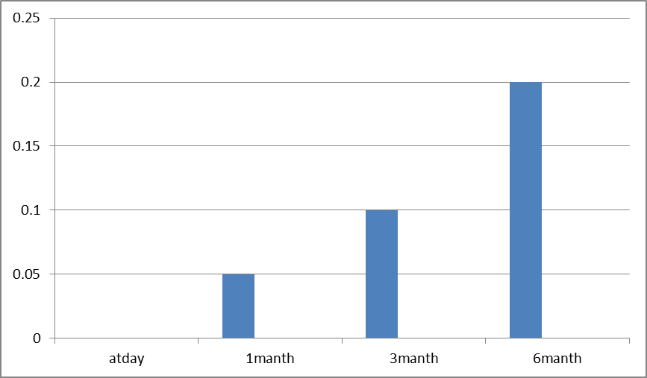

Fig(1) The mean of bony healing the gunning splints used first group by heat curing acrylic resin.

From the Table 2 and Fig. 2 Mean of bony healing of the gunning splints used first group by flexible acrylic resin heat curing acrylic resin slow bone healing from one month, 3 months, and 6 months.

Table 2. Mean and standard deviation of bony healing the gunning splints used second group flexible acrylic resin.

|  |  |  |  |  |  |  |  |  |
| --- | --- | --- | --- | --- | --- | --- | --- | --- |
|  | At the day | | 1 month | | 3 months | | 6months | |
| Mean | ±S.D | Mean | ±S.D | Mean | ±S.D | Mean | ±S.D |
| Group one | 0.00 | 0.00 | 0.03 | 0.01 | 0.06 | 0.02 | 0.10 | 0.05 |

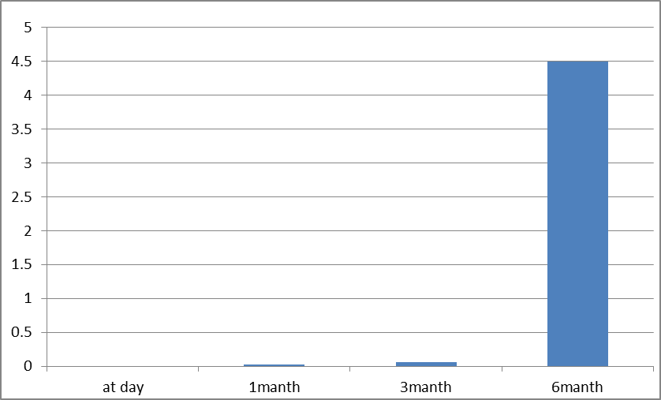

Fig(2) Mean of bony healing the gunning splints used second group flexible acrylic resin.

Table 3. Mean of bony healing the gunning splints in two groups. bony healing of the gunning splints used first group by flexible acrylic resin heat curing acrylic resin slow bone healing from one month, 3 months, and 6 months, while the bony healing of the gunning splints used first group by heat curing acrylic resin rapid bone healing from one month, 3 months, and 6 months.

Table 3. Mean and standard deviation of bony healing the gunning splints in two groups

|  |  |  |  |  |  |  |  |  |
| --- | --- | --- | --- | --- | --- | --- | --- | --- |
|  | At day | | 1months | | 3 months | | 6 months | |
| Mean | ±S.D | Mean | ±S.D | Mean | ±S.D | Mean | ±S.D |
| Group one | 0.00 | 0.00 | 0.05 | 0.01 | 0.10 | 0.04 | 0.20 | 0.07 |
| Group two | 0.00 | 0.00 | 0.03 | 0.01 | 0.60 | 0.02 | 0.10 | 0.05 |

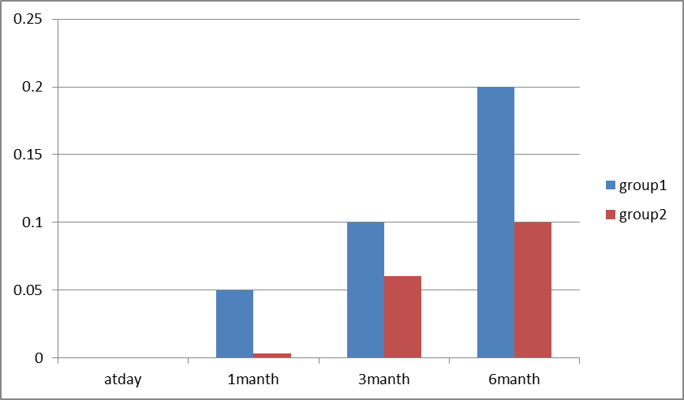

Fig(3)Mean of bony healing the gunning splints in two groups

**4.Discussion**

Wide maxillofacial defects may create functional and esthetic difficulty as a result of congenital malformations, tumor resections, or trauma. The loss of teeth leads to resorption and remodeling of the alveolar bone and may eventually end with an atrophic residual alveolar ridge (9) Prosthetic rehabilitation aims to restore anatomic, functional, and esthetic functions when serious soft and hard tissue defects are seen.

Various treatment approaches are often indicated in the planning and treatment of these patients who have severe maxillofacial trauma with acquired maxillary defects. These patients usually can be treated to gain normal function and appearance. They are different from patients with congenital maxillary defects only in the abrupt alteration in the physiological processes associated with surgical or traumatic resection of the maxilla [[10](http://www.hindawi.com/journals/crid/2012/267143/#B3)].

When trauma causes significant defects in the maxillofacial region, fabrication of over dentures is preferred as both hard and soft tissue loss, and lip support can be compensated by means of acrylic resin (11)However, hard acrylic resin may create a problem through irritation of the fragile mucosa in the mouth after surgical operations. As a treatment procedure, we applied gingival colored porcelain to compensate soft tissue on the anterior maxilla fused to fixed zirconia prosthesis to our patients who had lost their teeth along with bone defect due to facial injury. This kind of modified prosthesis has some advantages such as stability retention and also conforms with the underlying to the hard tissues and supports soft tissues and lip as well.

Patients with such defects experience functional and aesthetic problems which are caused by the edentulous area. Dealing with bone loss in the maxilla and/or mandible, bone grafting of the defect may be necessary in case of implant treatment planning. Extensive soft and hard tissue loss usually requires an implant-supported or retentive prosthesis to obtain adequate facial support and restoration of the oral functions [[12](http://www.hindawi.com/journals/crid/2012/267143/#B10)]. This treatment option offers an opportunity to enhance the prosthodontic support with advantages such as increased retention, stability, and the preservation of existing hard and soft tissues(13). Although implant-retained fixed prostheses were desired for this type of large trauma, in this case patient denied the vertical bone augmentation due to repeated surgical procedures which would be needed to provide implant therapy. Therefore, alternative modified combination prosthesis with tissue ceramic and zirconia-based crown prosthesis is applied.

High-strength, full-ceramic system has been recommended with increasing frequent usage for both anterior and posterior restorations. Zirconia has good chemical and physical properties such as high corrosion resistance and low thermal conductivity, high flexural strength (900–1200 MPa), and hardness (1200 Vickers) and also excellent biocompatibility, and optimized esthetics. The adhesion of bacteria on its surface is low. Due to superior flexural strength compared with aluminum oxide, zirconia frameworks for fixed partial dentures for anterior and posterior teeth and for implant-supported restorations are currently being employed. Several in vitro reports have demonstrated the superior flexural strength of zirconia, when being compared to other ceramic materials, such as aluminum oxide. In the literature, few long-term clinical studies evaluated systems with zirconium oxide (zirconia) frameworks whose 3 and 4 posterior units have been performed [[14](http://www.hindawi.com/journals/crid/2012/267143/#B12), [15](http://www.hindawi.com/journals/crid/2012/267143/#B14)]. Some authors also have published about an implant supported fixed denture recently. In this case, rehabilitation including 11-unit anterior and posterior tooth supported zirconia fixed prosthesis has been illustrated with 5-year follow-up period; however, in the literature long-term clinical data on longevity of zirconia prostheses are still lacking.

For appropriate treatment procedures of the patients who had wide maxillofacial defects, additional planning, modifications, and treatment considerations are required to evaluate conditions conducive to rehabilitation of both function and esthetics. This includes the establishment of soft tissue support and contour, in addition to tooth and bone health [[16](http://www.hindawi.com/journals/crid/2012/267143/#B15)]. Among the methods for improving soft tissue deficiencies, tissue compatible porcelain might supply natural mucogingival esthetic appealing and functional lip support on maxillary anterior area. In this case, the desired result in the anterior maxilla as esthetically and functionally and reestablishment of soft tissue support and contour in addition with the teeth and bone health was obtained according to the radiologic and clinical examination resulting in patient’s esthetic expectations.

This paper confirms that patients with traumatic injuries have specific treatment needs. Modified prosthetic rehabilitation can enhance the esthetic of the final restoration and provide support for dental rehabilitation, supplying missing teeth, and hard and soft tissue. Through the follow-up period of 6 years, the applied prosthesis was stable and there was no need for additional adjustments nor dysmorphology was observed according to panoramic and periapical radiographs. The patient adapted well to her prosthesis and was satisfied with the final esthetic and functional outcome and reported improvements in both speech and mastication as well.(17)

**Conclusion**

In the large defects of the maxilla, detailed presurgical planning and evaluation of each case individually can minimize the difficulty of the prosthetic rehabilitation. It is often necessary for many dental disciplines, including prosthodontics, oral, and maxillofacial surgery and orthodontics to interact in the planning and treatment of patients who have severe maxillofacial trauma. The treatment options should be evaluated according to the patient’s need and appropriate case selection with the dental team by careful treatment planning and interdisciplinary cooperation. Prior to finalizing the esthetic design, a treatment plan should include detailed case evaluation and smile analysis as well as patient’s expectations.

**References**

1. Kraft A, *et al.* Craniomaxillofacial trauma synopsis of 14654 with35, 129 injuries in 15 years. Craniomaxillofac Trauma Reconstruction 2012;5:41-50.
2. Glossary of prosthodontic terms. J Prosthetic Dent 2005;94(1):13-92.
3. Olsburgh S, Jacoby T, Krejci I. Crown fractures in the permanentdentition: pulpal and restorative considerations. Dent Traumatol, 2002;18:103-115.
4. Bhandari S, Chaturvedi R. Natural tooth pontics: a viable yettemporary treatment option: a patient reported outcome. IndianJ Dent Res 2012;23(2):59-63.
5. Brady FA, Tupac RG. Prosthodontic implications of oral and maxillofacial surgery. In: Maxillofacial rehabilitation: prosthodontics and surgical considerations. Beumer J, Curtis TA, Firtell DN, editors. CV Mosby Company. p 413-415.
6. Erich JB, Austin LT. Traumatic Injuries of the Facial Bones: An Atlas of Treatment. Philadelphia, PA: WB Saunders Co; 1944:203 ff.
7. Gilardino MS, Chen E, Bartlett SP. Choice of internal rigid fixation materials in the treatment of facial fractures. Craniomaxillofac Trauma Reconstr. 2009;2(1):49-60.
8. Moon H. Mechanical appliances for treatment of fracture of the jaws. Br J Dent Sci. 1874; 17:303.
9. Spiessl B. Rigid internal fixation of fractures of the lower jaw. Reconstr Surg Traumatol. 1972;13:124-40.
10. MacLennan WD. Consideration of 180 cases of typical fractures of the mandibular condylar process. Br J Plast Surg. 1952;5:122-128.
11. Bradley PF. Injuries of the condylar and coronoid processes. In: Rowe NL, Williams JL, eds. Maxillofacial Injuries. Edinburgh, Scotland: Churchill Livingstone; 1985:337-362.
12. Luc MH, Smets PA, Van Damme PJ, Stoelinga W. Non-surgical treatment of condylar fractures in adults: A retrospective analysis. Journal of Cranio-Maxillofacial Surgery. June 2003;31(3):162-167.
13. Spiessl B, Schroll K. Gesichtsschadl. In: Nigst H, ed. Spezielle Fracturen- und Luxationslehre. Vol.I, Ch. 1. Stuttgart, Germany: Thieme; 1972.
14. Krenkel C. Treatment of mandibular condylar fractures. Atlas OralMaxillofacSurgClin North Am. 1997;5(1):127-155.
15. Neff A, Mühlberger G, Karoglan M, *et al.* Stability of osteosyntheses for condylar head fractures in the clinic and biomechanical simulation. Mund Kiefer Gesichtschir. 2004;8(2):63-74 [German].
16. Ellis E 3rd, Moos KF, el-Attar A. Ten years of mandibular fractures:An analysis of 2,137 cases. Oral Surg Oral Med Oral Pathol. Feb 1985;59(2):120-129.
17. Zide MF, Kent JN. Indications for open reduction of mandibularcondyle fractures. J Oral Maxillofac Surg. Feb 1983;41(2):89-98.

10/20/2015