Causes of TMJ Ankylosis in Anterior Sindh: An Observational Study

Qaimuddin Shaikh¹, Muhammad Shahzad², Usman Qadir Khan³

¹Department of Oral and Maxillofacial Surgery Bibi Aseefa Dental College, Shaheed Mohtarma Benazir Bhutto Medical University, Larkana
² Department of Oral & Maxillofacial Surgery, Liaquat University of Medical & Health Sciences Jamshoro
³ Department of Oral and Maxillofacial Surgery Shaikh Zayed Medical College/ Hospital, Rahim Yar Khan

Abstract: Objective: To identify the causes of TMJ in anterior Sindh and to observe the maximum recurrent cause of TMJ ankylosis. Materials and Method: Study was conducted at the Department of Oral & Maxillofacial Surgery at Larkana, Pakistan from January 2013 to April 2015. In the current study 100 patients having TMJ Ankylosis were included. History of patients was RTA, middle ear infection, and autoimmune diseases. Data were analyzed using descriptive statistics. Results: The maximum ratio of the patients belonged to 9-17 years and history of RTA was the main cause in the progression of TMJ. Conclusion: The main cause of TMJ ankylosis is Trauma in the patients in anterior Sindh.
[Qaimuddin Shaikh, Muhammad Shahzad, Usman Qadir Khan. Causes of TMJ Ankylosis in Anterior Sindh: An observational study. N Y Sci J 2015;8(9):30-32]. (ISSN: 1554-0200). http://www.sciencepub.net/newyork. 6

Keywords: TMJ, Causes, Anterior Sindh

- Introduction
Incidence of TMJ ankylosis is high in worldwide especially in Anterior Sindh, Pakistan. It was noticed that trauma is the main cause of TMJ ankyloses and concerns with anemia and malnutrition.^{(1, 2)}. Ankylosis of the Temporomandibular joint is a state distressing the masticatory structure which assortments from restriction to complete limitation of opening mouth,^{(3, 4)} further characteristic consist unformed mandible growth leads to facial asymmetry is common because of trauma, like fissure with contribution of the inner articular, trauma from obstetric pincers, contaminations such as progressive arthritis and certain systemic diseases. ⁽⁵⁻⁸⁾
The three main causes of TMJ anklyosis are trauma, inflammation and contamination. Damage to the fragile vasculature at the condylar heads during intrauterine fetal movement is a possible etiology for congenital ankylosis. Trauma sustained by the newborn during a difficult forceps delivery and trauma inflicted by an abusive adult have been implicated. Both untreated fractures and badly comminuted condylar head fractures treated by immobilization for extended periods have resulted in ankylosis ⁽⁹⁻¹²⁾

2. Methodology
Study was conducted at the Department of Oral & Maxillofacial Surgery at Larkana, Pakistan from January 2013 to April 2015. In the current study 100 patients having TMJ Ankylosis were included. The patients were in different age group (60 males and 40 females). History of patients was RTA, middle ear infection, and autoimmune diseases. Data were analyzed using descriptive statistics.

3. Results & Discussion
The maximum ratio of the patients belonged to 9-17 years and history of RTA was the main cause in the progression of TMJ.
Males were majority with 60% rather than females age distribution where 9-17 years leads in males and females. Left side was on 18 males, 12 on right and 30 bilateral and 10 unilateral. In females, left side on 12, right side on 8, 15 bilateral and 5 unilateral. Trauma was present in 10 bilateral ankyloses cases. (Fig: 1-3)

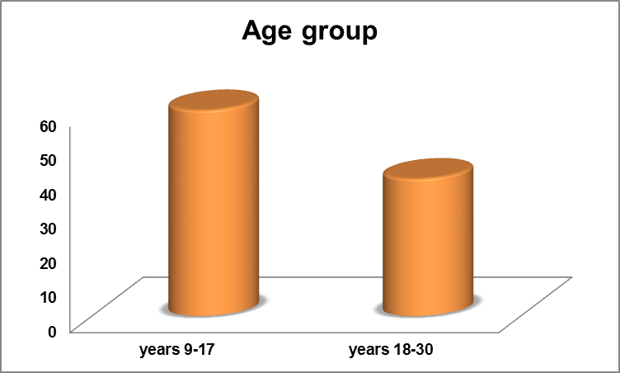
Fig: 1 Age Distribution Of Patients

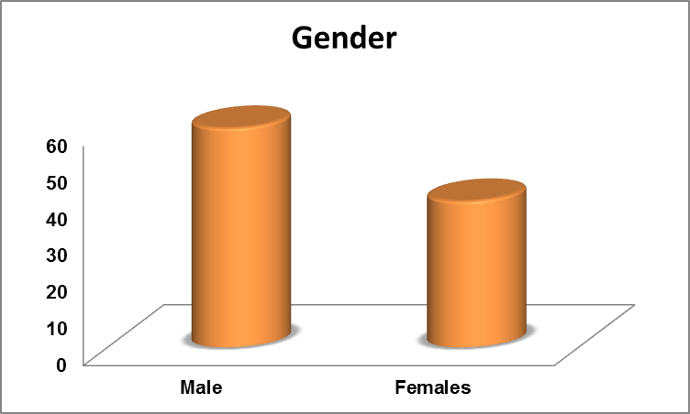
Fig: 2 Gender Distribution Of Patients

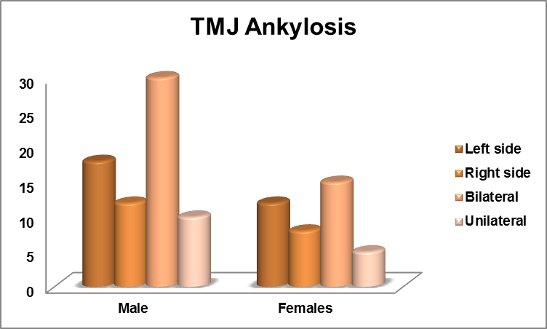
Fig: 3 TMJ Ankylosis in Patients

The present study showed that trauma was the main etiological factor that is parallel to hospital-based studies ^{(13, 14)} lead in various portions. The trauma is commonly consequence in ankylosis of the TMJ is mostly veteran in infantile. Uncertainty the assessment of controlling is not taken in time the facial aspects are pretentious as facial alteration is higher once the emancipation is done in infantile. ⁽¹⁵⁻¹⁸⁾. in the present study revealed that the cause behind higher prevalence of ankylosis in male than females which could be related to the differentiation in the anatomy of the neck of the condyle. The occurrence of TMJ ankylosis was increase in the present study.

Conclusion
The main cause of TMJ is Trauma in the form of RTA in Anterior Sindh.

Corresponding Author:
Dr. Qaimuddin Shaikh
Department of Oral and Maxillofacial Surgery Bibi Aseefa Dental College, Shaheed Mohtarma Benazir Bhutto Medical University, Larkana.

References
- McFadden LR, Rishiraj B. Temporomandibular joint ankylosis: a case report. J Can Dent Assoc 2001; 67: 659–63.
- Kobayashi R, Utsunomiya T, Yamamoto H, Nagura H. Ankylosis of the temporomandibular joint caused by rheumatoid arthritis: A pathological study and review. J Oral Sci. 2001;43:97–101.
- Baykul T, Aydin MA, Nasir S. Avascular necrosis of the mandibular condyle causing fibrous ankylosis of the temporomandibular joint in sickle cell anemia. J Craniofac Surg. 2004;15:1052–6.
- Herford AS, Boyne PJ. Ankylosis of the jaw in a patient with fibrodysplasia ossificans progressiva. Oral Surg Oral Med Oral Pathol Oral Radiol Endod. 2003;96:680–4.
- Su-Gwan K. Treatment of temporomandibular joint ankylosis with temporalis muscle and fascia flap. Int J Oral Maxillofac Surg. 2001;30:189–93.
- Erol B, Tanrikulu R, Görgün B. A clinical study on ankylosis of the temporomandibular joint. J Cranio Maxillofac Surg. 2006;34:100–6.
- Qudah MA, Qudeimat MA, Al-Maaita J. Treatment of TMJ ankylosis in Jordanian children-a comparison of two surgical techniques. J Craniomaxillofac Surg. 2005;33:30–6.
- Kumar N, Shekhar C, Kumar P, Kundu AS. Kuppuswamy's Socioeconomic Status Scale-Updating for 2007. Indian J Pediatr. 2007;74:1131–2.
- Manganello-Souza LC, Mariani PB. Temporomandibular joint ankylosis: Report of 14 cases. Int J Oral Maxillofac Surg. 2003;32:24–9.
- Vasconcelos BC, Bessa-Nogueira RV, Cypriano RV. Treatment of temporomandibular joint ankylosis by gap arthroplasty. Med Oral Patol Oral Cir Bucal. 2006;11:E66–9.
- García-Aparicio L, Parri FJ, Sancho MA, Sarget R, Morales L. Temporomandibular joint ankylosis (TMA) in children. Cir Pediatr. 2000;13:62–3.
- Ajike S, Adebayo E, Amanyiewe E, Ononiwu C. temporomandibular joint ankylosis: Analysis of 65 patients. Int J Oral Maxillofac Surg. 2005;34(Suppl 1):12.
- Abbas I, Jamil M, Jehanzeb M, Ghous SM. Temporomandibular joint ankylosis: Experience with interpositional gap arthroplasty at Ayub Medical College Abbottabad. J Ayub Med Coll Abbottabad.2005;17:67–9.
- Belmiro C, Ricardo V, Rafeal V. Treatment of TMJ ankylosis. Oral Med Oral Pathol Oral Radiol. 2005;11:66–9.
- He, D., Yang, C., Chen, M. et al, Traumatic temporomandibular joint ankylosis: Our classification and treatment experience. J Oral Maxillofac Surg. 2011;69:1600.
- Yan, Y.B., Zhang, Y., Gan, Y.H. et al, Surgical induction of TMJ bony ankylosis in growing sheep and the role of injury severity of the glenoid fossa on the development of bony ankylosis. J Craniomaxillofac Surg. 2013;41:476.
- Duan, D.H., Zhang, Y. A clinical investigation on disc displacement in sagittal fracture of the mandibular condyle and its association with TMJ ankylosis development. Int J Oral Maxillofac Surg. 2011;40:134.
- He, D., Yang, C., Chen, M. et al, Effects of soft tissue injury to the temporomandibular joint: Report of 8 cases.Br J Oral Maxillofac Surg. 2013;51:58.

9/8/2015

