**Consumption and Utilization of Food by Different Instars of Oak Tasar worm *Antheraea proylei* (jolly) Fed on *Quercus serreta (*Thunb) Leaves**

Pashupati Nath1 and P.C. Joshi2

1, 2Dept. of Zoology & Environmental Science, Gurukula Kangri Vishwavidyalaya, Haridwar, 73988640341, 98370629922

1[nathpashupati53@gmail.com](mailto:nathpashupati53@gmail.com), **2**[prakash127@yahoo.com](mailto:prakash127@yahoo.com)

**Abstract:** During this study the ecological efficiencies of *Antheraea proylei* (Jolly) was studied in the laboratory. Total duration of instar stages is 4.80±0.418, 4.00±Nil, 4.80±0.418, 8.00±Nil, 11.46±1.12 days for 1st, 2nd, 3rd, 4th and 5th larval instars, respectively. The food consumption was 0.612±0.33, 1.05±0.155, 1.405±0.2383.212±0.789and 5.923±1.38 g insect-1 day-1 in 1st, 2nd, 3rd, 4th and 5th larval instars, respectively. In all five stages leaf assimilation was 0.600±0.33, 1.03±0.154 1.329±0.2270, 2.88±0.800, and 5.066±1.26 g insect-1 day-1, respectively. The tissue growth was 0.0112±0.002, 0.053±0.072, 0.213±0.068, 0.359±0.21 and 0.536±0.20 g insect-1 day-1 in all respective stages. The maximum value (97.518±0.476) of approximate digestibility was recorded for 2nd instar larvae, while the minimum value (85.726±0.286) was recorded for fifth instar larvae. The value of ECD was minimum (1.899±0.99) in 1st instar and maximum (16.126±1.320) for 3rd instar larvae. The minimum value (1.863±0.97) of ECI was recorded in 1st instar larvae, while maximum value (15.243±1.09) was recorded in 3rd instar larvae.

[Pashupati Nath and P.C. Joshi. **Consumption and Utilization of Food by Different Instars of Oak Tasar worm *Antheraea proylei* (jolly) Fed on *Quercus serreta (*Thunb) Leaves.** *N Y Sci J* 2015;8(8):93-97]. (ISSN: 1554-0200). <http://www.sciencepub.net/newyork>. 14

**Keywords**: *Antheraea proylei; Q. serreta*, Consumption; Approximate digestibility; Conversion of ingested food; Conversion of digested food.

**Introduction**

Order Lepidoptera is the most diverse and large group of insects and includes butterflies and moths. It is among the most successful groups of insects and inhabits all terrestrial habitats (*viz* desert to rainforest, lowland grasslands, montane plateaus).These insects are associated with higher plants or flowering plants (Gullan and Cranston 2004). Some species ofLepidoptera damage plants, which are useful to humans, like fruit trees, crops, fabrics, fodder, and timber. The larval stages of many species of moths are very injurious, and damage the leaves, stems, roots, or fruits. Many species of this order are valuable in biological research, including work in physiology, systematics, ecology, biogeography and genetics. Many factors like quantity and quality of food, various climatic conditions and presence of predators, parasites and disease can be regarded as the index of the physiological potential of life performance of the insect (Slansky and Scriber 1985). The vital physiological activities viz. metabolism, enzyme synthesis, nutrient storage etc. are influenced by consumption and efficiency of utilization of consumed food. Studies on ecological energetics and feeding potential of different insects have been carried out by many workers (Slansky and Scriber 1985; Kaushal *et al.* 1988; Kaushal and Joshi 1991; Joshi *et al.* 2003; Sharma and Joshi 2010,Sudhansu 2010). Tasar, the commercial silk is produced by a variety of species of *Antheraea*. In the present study, energy budget of *Antheraea proylei* has been studied using its natural food plant, *Quercus serreta* (Thunb).

**Materials And Methodology**

The eggs of *Antheraea proylei* were collected from Regional Tassar Research Station, Bhimtal and placed in different petridishes, covered with plastic sieves of 12 meshes/cm to maintain a stock culture in the laboratory. These were kept at a room tempetrature of 20-250 C and a relative humidity of 60- 65%. On emergence, the larvae were transferred to the food plants. Ecological efficiency of 1st, 2nd, 3rd, 4th and 5th instar of oak tasar moth were determined. Larvae of this insect feed on leaves of oak plant *Quercus serreta* (Manipuri banjh). For removal of faecal matter from alimentary canal, actively feeding caterpillars were kept away from food source for about one hour before the start of the experiment. Before the start of experiment, each larva was weighed and kept in petri dish covered with plastic seives. After that larvae were allowed to feed on preweighed portion of oak leaves for 24 hrs, thereafter, the remaining portion of leaves and faeces were dried to a constant weight at 80oC. A wet/dry mass ratio was determined for the leaves and the amount of leaves ingested by each larva was estimated.

Food consumption was calculated as the difference between the initial weight of the leaves provided and unconsumed leaves at the end of experiment. Ecological efficiency was calculated using Waldbauer’s (1968) expressions:

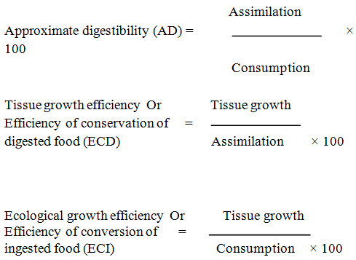

Different parameters of energy budget viz. food consumption, assimilation and tissue growth of, *Antheraea proylei* were studied in the laboratory. This moth produces silk during March- April and October - November. A generation can be completed in 40 to 42 days under ideal conditions. The eggs are nearly spherical in shape. Eggs hatch in five to six days. There are five instars in complete life cycle of this moth. At the time of hatching, the larvae were about 2 mm in length, brown in color, and bear numerous long hairs over the entire length of the body. During this stage, and the subsequent instars, larvae feed on the leaf surface. Second to fifth instar larvae appears greenish in colour.

**Results And Discussion**

The relative values of assimilation and tissue growth as percent of consumption have been presented in **Tables 1, 2** and **Figs. 1- 2**.

**Duration of instars:** During this study total duration of instar stages was 4.80±0.418, 4.00±Nil, 4.80±0.418, 8.00±Nil, 11.46±1.12 days for 1st, 2nd, 3rd, 4th and 5th larval instars, respectively.The shortest stage is 2nd instar stages (4.00days), while longest instar stage is fifth stage (11.46±1.12 days).Total duration of all instars was (42± 1) days.

**Food Consumption:** The food consumption was 0.612±0.33, 1.05±0.155, 1.405±0.2383.212±0.789and 5.923±1.38 g insect-1 day-1 in 1st, 2nd, 3rd, 4th and 5th larval instars, respectively.

**Assimilation:** In all five stages leaf assimilation was 0.600±0.33, 1.03±0.154 1.329±0.2270, 2.88±0.800, and 5.066±1.26 g insect-1 day-1, respectively. the assimilation increased from 0.600 g insect-1 day-1 in the first instars to 5.066 g insect-1 day-1 in fifth instars. More than 72% assimilation occurred in the last two instars. A positive linear relation -ship was obtain between consumption and assimilation(fig.1).

Many workers have reported an increase in amount of food assimilation with increased food consumption (Bailey and Mukerji 1971; Delvi and Pandian 1971; Axelllson *et al.* 1975, Vats *et al*. 1977; Vats and Kaushal, 1981; Kohler *et al.* 1987; Bisht *et al.* 2012).

Goel *et. al* (2005) have studied food energy budget in 4 Lepidopteran pest namely (*Lymantria marginata, Trabala vishnou*, *Spilosoma oblique* and *Plusia orichalcea*) and revealed that the approximate digestibility decreases, whereas the efficiencies of conversion of ingested food and digested food increase during first to last instar larvae. They also reported that later instars are more efficient in transforming assimilated energy into the caterpillar biomass. Kumar and Ahmad (2000) also reported that CI decreased from (28.60±1.84) first instar to fifth instar (0.72±0.02) of *Orgyia postica* (Walk.) (Lepidoptera: Lymantriidae) larvae on *Paulownia* leaves.

**Tissue growth:** The tissue growth was 0.0112±0.002, 0.053±0.072, 0.213±0.068, 0.359±0.21 and 0.536±0.20 g insect-1 day-1 in all respective stages.Tissue growth in all stages increased with increased consumption, increased production of egesta and assimilation. The minimum tissue growth (0.053±0.072) was observed in 2nd instar larvae, while the maximum tissue growth (0.536±0.20) was recorded in fifth instar stage. Fourth and fifth instars larvae accounted for 70% of the total tissue growth .Tissue growth did not follow any particular trend as has also been reported Yadava et. al.(1983).A linear regression was obtained when tissue growth was plotted against food consumption (fig 2) .

Bisth *et al.* (2012) have reported 70%, 67.37% and 71.64% tissue growth in fourth and fifth instar of *Pieris brassicae* (Lepidoptera: Pieridae) on cabbage, cauliflower and mustard, respectively.

**Approximate digestibility (AD):** The maximum value (98.091±0.516) of approximate digestibility was recorded for 1st instar larvae, while the minimum value (85.726±0.286) was recorded for fifth instar larvae.

Waldbauer (1968) reported that approximate digestibility (AD) declines with age in *Bombyx mori* (Linn.)*.* Sangha (2011) worked out on feeding performance of *Clostera fulgurita* (Walk.) (Lepidoptera: Notodontidae)on three clones of *Populus deltoids* (Bartram)and observed a gradual decline in AD in successive instars. He recorded the maximum value of AD in third instar (55.28%), followed by fourth instar (52.48%) and 5th instar (48.05%). Bisht *et al.* (2012) have studied energy budget of *Pieris brassicae* (Linn.) (Lepidoptera: Pieridae) and reported, the maximum values of approximate digestibility (AD) for the first instar and minimum for the fourth instar larvae.

**Efficiency of conservation of digested food (ECD):** The ECD gives a measure of the efficiency with which absorbed food material is used in promoting growth by expressing the increase in dry weight as a proportion of the weight of food assimilated.

The value of ECD was minimum (1.899±0.99) in 1st instar and maximum (16.126±1.320) for 3rd instar larvae. The minimum value (1.863±0.97) of ECI was recorded in 1st instar larvae, while maximum value (15.243±1.09) was recorded in 3rd instar larvae.

Vats *et al*. (1977) have reported a gradual increase in ECD for young fifth instar larvae of *Pieris brassicae*. Sangha (2011) in his study revealed that efficiency of conversion of digested food (ECD) increased with increase in age of the larvae. He reported minimum value of ECD (37.42%) for the 3rd instar and maximum (41.54%) for the 5th instar larvae.

**Efficiency of Conversion of Ingested food (ECI**): The efficiency of conversion of ingested food to unit of body substance (ECI, also termed "growth efficiency") is an index measure of food fuel efficiency in animals. The ECI is a rough scale of how much of the food ingested is converted into growth in the animal's mass. It can be used to compare the growth efficiency as measured by the weight gain of different animals from consuming a given quantity of food relative to its size. The ECI effectively represents efficiencies of both digestion (Approximate Digestibility or AD) and metabolic efficiency, or how digested food is converted to mass (Efficiency of Conversion of Digested food or ECD).

During present study, the minimum value (1.863±0.97) of ECI was recorded in 1st instar larvae, while maximum value (15.243±1.09) was recorded in 3rd instar larvae.

Baily and Singh (1977) studied the energy budget of *Mamestra configurata* (Walk.) (Lepidoptera: Noctuidae) and reported no set pattern for ECI. Sangha (2011) has made studies on feeding performance of *Clostera fulgurita* on clones of *Populus deltoids* and reported that efficiency of conversion of ingested food (ECI) decreased with the increase in the age of the larvae. Sudhansu (2010) has studied food utilization efficiency in *Anthraea mylitta* fed on *Terminalia arjuna* leaves and reported that absolute values for dry matter ingested, digested, efficiency of conversion of digested food and biomass gain were increased with the advancement of larval development, while, the the relative consumption rate was declined. He also reported that the relative growth rate was maximum in 2nd instar (0.488) and declined significantly thereafter.

**Table 1. Consumption, assimilation and tissue growth in *Antheraea proylei***

|  |  |  |  |  |  |
| --- | --- | --- | --- | --- | --- |
| **S. N.** | **Stage** | **Duration(Days)** | **Consumption**  **(g insect-1 day-1)** | **Assimilation**  **(g insect-1 day-1)** | **Tissue growth**  **(g insect-1 day-1)** |
| 1. | 1st  instar | 4.80±0.418 | 0.612±0.33 | 0.600±0.33 | 0.0112±0.002 |
| 2. | 2rd instar | 4.00±Nil | 1.05±0.155 | 1.03±0.154 | 0.053±0.072 |
| 3. | 3rd  instar | 4.80±0.418 | 1.405±0.238 | 1.329±0.2270 | 0.213±0.068 |
| 4. | 4th instar | 8.00±Nil | 3.212±0.789 | 2.88±0.800 | 0.359±0.21 |
| 5. | 5th instar | 11.46±1.12 | 5.923±1.38 | 5.066±1.26 | 0.536±0.20 |

**Table 2. Efficiency of food utilization in *Antheraea proylei***

|  |  |  |  |  |
| --- | --- | --- | --- | --- |
| **S. N.** | **Stages** | 1. **D.** | **E. C. D.** | **E. C. I.** |
| 1. | 1st instar | 98.091±0.516 | 1.899±0.99 | 1.863±0.97 |
| 2. | 2nd instar | 97.518±0.476 | 4.928±0.86 | 4.804±0.83 |
| 3. | 3rd instar | 94.572±1.03 | 16.126±1.320 | 15.243±1.09 |
| 4. | 4th instar | 89.54±0.89 | 13.018±2.92 | 11.65±2.64 |
| 5. | 5th instar | 85.726±0.286 | 10.61±1.250 | 9.104±1.09 |

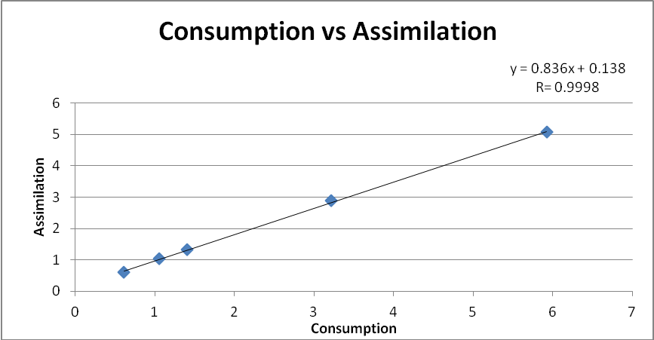

Fig.1: Relationship between Food Consumption and Assimilation Y=0.836x+0.138

(r = 0.9998, P < 0.001)

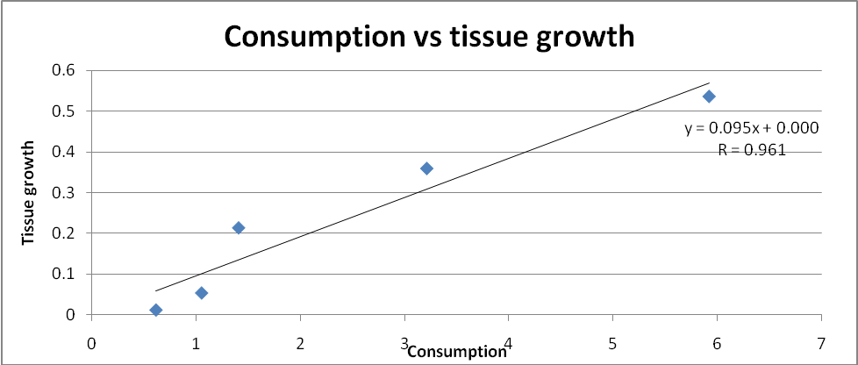

Fig. 2: Relationship between Food Consumption and Tissue growth Y=0.095x+0.000

(r =0.961, P < 0.05)

**Summary**

Food consumption, assimilation and tissue growth values were determined quantitatively to construct the energy budget of *Antheraea proylei* fed on *Quercus serrata* leaves. The maximum values of each of these parameters were recorded in the last instars. The approximate digestibility declines, while ecological growth efficiency and tissue growth efficiency randomly increase and decrease with age.

**Acknowledgements**

The authors express their thanks to scientists and laboratory staff of Tasar Research Station, Bhimtal for providing necessary lab facilities during our research work.

**References**

1. Axellson B., Lohm U., Pearson T. and Tenow O. 1975. *Zoon*, 3:71.
2. Barah A, Goswami M C and Samson M V. Consumption and utilization of food in different instars of muga silkworm *Antberses assama* Westwood. Proc. Indian Acad. Sci. (Anim. Sci.), Vol. 98, No.2, March 1989, pp. 99-103.
3. Bailey C. G. and Mukerji M. K. Consumption and utilization of various host plants by *Melanoplus bivittatus* (Say) and *M. Femurrubrum* (De Gedr) (Orthoptera: Acrididae). *Canadian Journal of Zoology,* 1976; 54:1044-1050.
4. Bailey C. G. and Singh N. B. An energy budget for *Mamestra configurata* (Lepidoptera: Noctuidae). *Canadian Entomol*. 1977; 109:687.
5. Bisht N. S., Bhandari K., Tripathi R. and Kaushal B. R. Energy budget *of Pieris brassicae* (Linn.) larvae (Lepidoptera: Pieridae) fed on three host plant species. *Journal of Environment and Bioscience,* 2012; 26(2):93-97.
6. Delvi M. R. and Pandian T. J. Ecophysiological studies on utilization of food in paddy field grasshopper *Oxya velox*. *Oecologia* (Berl.), 1971;8:267-275.
7. Goel S. C., Kumar A., Singh J., Kumar, V. and Rao P. K. Food-energy budget for different Lepidopteran moths. In: Advances in Indian entomology: productivity and health (a silver jubilee supplement No.3, Volume I) 2005 pp. 187-194. ISBN- 81-900101-7-9.
8. Gullan, P. J. and Cranston, P. S. (2004). ‘‘7’’. *The insects: an outline of entomology* (3rd ed.). Wiley-Blackwell. pp. 198–199. ISBN 1-4051-11135.
9. Joshi, P.C., Lockwood, J. A. Vashishth, N. (2003). Food consumption and assimilation efficiency in *Oxya velox* (Fabr.) (Orthoptera: Acrididae). *Himalayan Journal of Environment and Zoology* Vol. 17 (1). 39-44.
10. Kaushal, B. R. and Joshi P.C. (1991). Energy dynamics of grasshopper population in a temperate grassland ecosystem. *Australian Journal of Ecology, Australia,* Vol. 16, 295-300.
11. Kaushal B.R., Joshi Rajiv, Kalia Shamila and Joshi P. C. (1988). Energy budget of *Antheraea proylei* Jolly fed on *Q. floribunda* Lindle (Lepidoptera: Saturnidae). *Himalayan Journal of Environment and Zoology.* Vol. 2, No.1, 24-30.
12. Kohler, G., Brodhum, H. P. and Schaller, G. (1987). Ecological energetic of central European Grasshoppers. *Oecologia* (Berlin). 74:112.
13. Kumar, M. and Ahmad, M. (2000). Consumption and utilization of leaves of *Paulownia fortunei* by the larvae of *Orgyia postica* Walker (Lepidoptera: Notodontidae). *Annals of Forestry*, 8(2): 192-204.
14. Sangha, K. S. (2011). Feeding performance of *Clostera fulgurita on* three clones of *Populus deltoids*. *Journal of Forestry Research*, 22(1):83-86.
15. Sharma, P. K. and Joshi, P. C. (2010). Biology of a predatory coccinellid *Coccinella septumpunctata* Linn. (Coleoptera: Coccinellidae). *Journal of Environmental Bioscience* 24(2): 239-242.
16. Slansky, F. Jr. and Scriber, J. M. (1985). Food consumption and utilization: comprehensive insect physiology, biochemistry and pharmacology vol. 4, Regulation digestion, Nutrition, Excretion, Eds. Kerkut, G. A. and L.I. Gilbert, Peragamon Press, Oxford, pp:87-163.
17. Sudhansu Sekhar Rath (2010). Food utilization efficiency in *Antheraea mylitta* fed on *Terminalia arjuna* leaves. *Academic Journal of Entomology* 3(1): 23-28. ISSN 1995-8994.
18. Vats, L. K. and Kausal, B. R. (1981). Population dynamics, secondary productivity and energy budget of *Paraheiroglyphus bilineatus* Bol. (Orthoptera: Acrididae) *Acta Oecol./Gener*., 2(4):355-369.
19. Vats, L. K., Singh, J. S. and Yadava, P. S. (1977). Food energy budget of *Pieris brassicae* a pest of cruciferous agro-ecosystems. *Agro-Ecosystems*, 3:303-312.
20. Waldbaur, G. P. (1968). The consumption and utilization of food by insects. *Advances in Insect Physiology,* 5:229-282*.*
21. Yadava, P.S., Bhattacharjee, N and Kakati, L.N. 1983. Food consumption assimilation,tissue growth and ecological efficiencies in the larvae of *Antheraea proylei* jolly. *Proc. Sym. Ecol. and Resource. Manage,* pp 204-214*.*

8/23/2015