Integrated Geophysical Survey For Pre-Foundation Study At A Proposed School Site In Ibadan, Southwestern Nigeria

Olatunde Isaiah Popoola and Sanmi Olanrewaju Odeyemi

Department of Physics, University of Ibadan, Nigeria.

Abstract: Structural failure could result from laying the foundation of a building without proper consideration of the load bearing capacity of the subsurface soil strata. Hence the need for quality and reliable site characterization becomes increasingly important for public and private buildings. The aim of this work was to use integrated geophysical method to investigate the competence of the subsurface layers and homogeneity of the soil strata at the proposed site of a Model School at Bashorun area Ibadan, South-western Nigeria. Very Low Frequency Electromagnetic (VLF-EM) profiling, Vertical Electrical Sounding (VES) and soil particle size analysis were conducted. Five VLF traverses were conducted to determine appropriate locations for VES. A total of nine VES stations were established. Top soil samples excavated were subjected to particle size analysis to determine the composition of soil constituents. The VLF-EM anomalies identified shallow conductive zones and predominantly stable zones in the site. The geoelectric sections delineated two to three subsurface layers: top soil which was mainly sand and clayey sand, weathered layer which comprised sand and gravel and the resistive basement which was a rocky basement. Particle size analysis indicated high percentage of sandy soil in all the samples. The sand material and rocky sand indicated high load bearing capacity suitable for shallow foundation.
[Olatunde Isaiah Popoola and Sanmi Olanrewaju Odeyemi. Integrated Geophysical Survey For Pre-Foundation Study At A Proposed School Site In Ibadan, Southwestern Nigeria. N Y Sci J 2015;8(8):82-92]. (ISSN: 1554-0200). http://www.sciencepub.net/newyork. 13

Key words: VLF-EM, VES, soil particle analysis, pre-foundation study

Introduction
Geophysical investigations and assessment of soil and subsoil for site characterization for construction, engineering, design, urban planning, development and environmental remediation among others, have become standard practice for geoscientists, environmental scientists even professional engineers, and other related professionals (Barrett, 2002). It has become expedient in recent years going by the number of structures which have failed due to insufficient knowledge about the bedrock of the site, inaccurate top soil profile information; failure to identify groundwater levels, subsurface voids or solution cavities in carbonate rocks (e.g. limestone or dolomite) and the competence of the soil strata among others (Robert et al., 2010; Oyedele et al., 2011). This understanding will help to provide adequate design data information; determine potential for failure prior to design and suitability of the site and then the design of a structure which is safe, durable and have low maintenance costs can be made.
Electromagnetic surveys are suitable for detecting conductive materials such as clay, waterlogged ground and buried metallic objects. The presence of these conductive materials in subsoil generates an eddy current which is sensed by electromagnetic equipment (William, 2007). Generally, VLF-EM method is inexpensive as the output data from the instrument provides a direct indication of linear conductor anomalies of the surveying area (McNeill and Labson 1991). Covel et al. (1996) used VLF-EM method to locate bedrock wells in water bearing fracture zones for contaminant migration prevention. Also, VLF method is commonly used as a reconnaissance tool which serves as a pointer for other follow-up techniques (William, 2007; Ogungbemi and Ademilua 2013).
Electrical resistivity method is useful in determining the competence of the subsoil layers. The resistivity value of soil strata is proportional to its competence and this value is governed by the amount of pore space and the arrangement of the pores, soil particle arrangement and size among others (Wightman. et.al 2003). Using Schlumberger array VES, detailed information about the deep subsurface lithology can be obtained as the total current that flows to the depth layers is dependent on the electrode separation (Telford et al., 1990).
Both methods however complement each other in subsurface investigation of soil lithology. Robert (2010) emphasized on the use of VLF and resistivity survey methods among other methods as being economical, fast, less tedious and reliable for field investigation in anticipating and identifying subsurface conditions to manage risk. Electromagnetic and resistivity methods were combined by Ogungbemi and Ademilua (2013) for post-foundational investigation in part of Afe Babalola University, Ado Ekiti; Nigeria. In their work, VLF traverses were established in other to determine appropriate location of anomalies which was further investigated using VES technique and a correlation between the two methods was established. Popoola and Okhaifo (2012) used electromagnetic and resistivity methods to study the cause of failure of certain portions of a major road in Ibadan.
In the present study, Very Low Frequency Electromagnetic and Vertical Electrical Sounding measurements together with soil sample analysis were carried out to assess the competence of the subsurface layers and homogeneity of the soil strata at a proposed site of a school in Ibadan.
The Study Area
The study area is located near Islamic Higher School Bashorun, Ibadan North Local Government (7°25'11.67"N, 3°55'57.34"E). It is an enclosed land that is being prepared for the construction of a Model School in Oyo State. The investigated section is approximately 50m x 50m in dimension. Geologically, Oyo state is located within the basement complex (Fig. 1) of the South-western Nigeria which is basically underlain by banded gneiss.

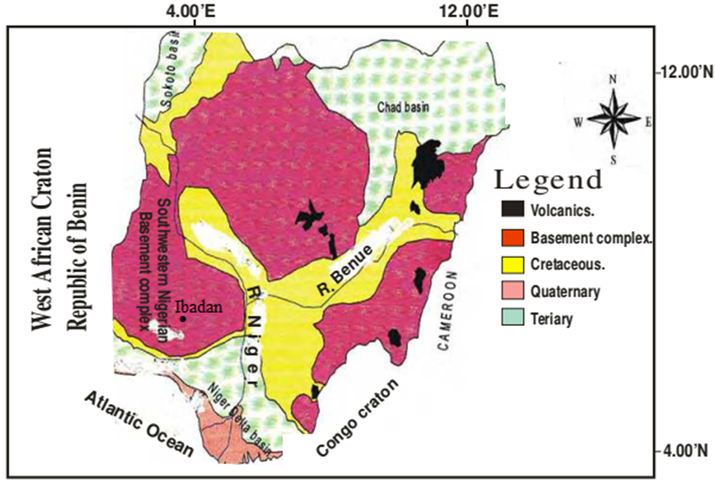
Fig. 1: Geological map of Nigeria showing the study area (Ibadan) (Akindele, 2011).

Methods And Materials
VLF-EM Survey
Very Low Frequency electromagnetic survey was carried out on the site for the purpose of determining the conductive zone using ABEM Wadi VLF meter which utilizes the radio signals transmitted from worldwide transmitters, used for navigation purposes in the frequency range of 5-30 kHz are used as a source for the primary field in a VLF survey. Such type of transmitting source makes VLF instrument very light and portable, and can be useful to survey a large area quite quickly (ABEM 1990). The VLF WADI instrument displays the filtered real anomaly on the screen, and this anomaly can be roughly interpreted on site. For further detailed information of the subsurface, the measured real and imaginary anomalies were re-discretized at 5 m interval and filtered using the approach of Karous and Hjelt (1983).
This process yields pseudo-section of relative current density variation with depth. A higher value of relative current density corresponds to conductive subsurface structures which are presented in a contour map using Karous-Hjelt filtering.
Five profiles were conducted to obtain the transverses; profiles one to four are along the perimeter of the survey area while profile five (5) is along its diagonal and data were obtained at distance of 3m interval for each profile. (Fig. 2).
Electrical Resistivity Survey
Nine Vertical Electrical Sounding (VES) stations using Schlumberger array were acquired at and around points of response peaks obtained from the VLF-EM profiles. Maximum current electrode spacing of 130m was maintained.
Sounding curves obtained from the field data were subjected to manual interpretation using partial curve matching technique. Modelled curves calculated from the curve matching was then refined through automatic computer iteration using a resistivity inversion program, WINRESIST base on the Gosh (1971) linear filtering theory. The geoelectric parameters of different layers were obtained. These results were then presented as geologic sections along each profile to map the region. The types of curve within the study area are the A- and H- curves.
Engineering competence of the soil can be qualitatively evaluated from layer resistivity. The higher the layer resistivity value, the higher the competence of a layer. The 2-D geoelectric reveals the type of the soil and thickness of the layer.
Particle Size Analysis (clay, silt, sand)
Five top soil samples excavated from various locations to a maximum depth of 0.7m were obtained. Particle size analysis using hydrometer method was carried out on each sample to determine their percentage composition.

Results And Discussion
- VLF-EM Profiles
Qualitative and semi-quantitative interpretations of the VLF-EM profiles were made to map occurrence of localized alterations of conductive and resistive rocks as well as contacts among materials of different conductivity (Figures 3 (a-e)). They also show typical inverted current density pseudo sections and smoothened real components obtained using the Karous-Hjelt’s 2D-inversion program. The pseudo sections are displays of the equivalent current density estimated from the filtered real component of the VLF data. The colour pane indicates a bluish to green colour for the resistive medium, while yellowish to red colour range indicates conductive medium.
Along profile 1, the current density profile shows existence of four anomalies located at 10, 20, 35 and 50m. A shift in the location of the 10 m anomaly is indicated in the in-phase component plot. The first anomaly has the appearance of an anomaly over a conductive zone with southward orientation and is shallower in depth. The other anomaly is indicative of boulder-like resistive materials with northward orientation. While between 22-50 m a spread of the conductive anomaly can be observed. The corresponding filtered real using Fraser filter helps to delineate the location of these anomalies as well as collapsing the false cross over points that make interpretation of the measured data difficult. Series of shallow and near surface bodies, which were recognized as conductive bodies on the pseudo section (Figure 3a) have low amplitude.
Along profile 2 three conductive anomalies were obtained at approximately distances 5, 10 and 40m (fig 3b) corresponding to 3 broad positive peaks and a resistance anomalies between 25 to 29 m pointing northward. Fig. 2b also reveals the pattern in the conductive anomaly zone spreads between 30 to 40m and conductive anomaly observed at 5 and 10m near the surface.
Profile 3 reveals a major peak between 25 and 30 m distance. Smaller amplitudes were also identified between 30 to 50m (Figure 3c). The characteristic amplitudes of these anomalies are indicative of conductors that are relatively nearer to the surface and spread downward.
Profile 4 shows occurrence of conductive materials close to 10m from the southern end, while another presumed to originate from a surface source has characteristic positive anomaly peak between 40 and 50 m distance (Figure 3d).
Profile 5 shows occurrence of conductive materials at 25, 55 and 75m from the southern end. At 75m the conductive anomaly is close to the surface. Also observed is a resistive anomaly boundary between the conductive zones (Figure 3e).
- Electrical Resistivity Sounding Curves and Geoelectric Sections
Vertical Electrical Sounding curves revealed from 3-layers to 2-layers types with 8 type A- curves and 2 type H- curves which may typify a rapid resistivity progression (Table 1).
The geoelectric parameters (resistivity and depth) as obtained from the iteration of the electrical resistivity sounding data, presented as geoelectric sections and map along the profiles (fig. 4(a-e)) and on each VES gives an insight into the structural disposition of subsurface rock units. The geoelectric sections delineated a maximum of three geoelectric subsurface layers comprising the top soil, weathered layer and fresh basement.
Top soil
The topsoil constitutes the first layer with resistivity values ranging from 69 to 39 Ωm, indicating that it is mainly sand and sandy clay soil, with thickness range of 0.4 to 2.5m.
Weathered Layer
The weathered layer is the second layer with resistivity values ranging from 209 to 326 Ωm, indicating that the material composition is largely sandy to rocky soil with thickness of 2 to 9 m. The highest thickness value is around VES 5 (fig. 4e).
Fresh Basement
The fresh basement is the last layer with the resistivity values ranging from 376 Ωm to infinity at most of the VES stations; it is infinitely resistive because of its crystalline nature
Both the weathered layer and the basement layer are viewed as a competent geo-material for the proposed engineering foundation due to the high resistivity value which delineates the layers has been predominantly sand and rocky materials. The layers are not inimical to the foundation of any engineering structure to be sited in the study area.
- Soil Particle Analysis
The result of the soil particle analysis (Table 2) indicates that the soil samples have relatively low percentage of clay soil with an average of 13.7%, Silt constituting 16.5% and sand 69.8% across the whole site area. This is in correlation with the VES geoelectric result.
Sandy soil has low retention of moisture or liquid compared to clay soil which is liable to shrink or swell with change in soil moisture. Therefore the probability of occurrence of cyclic foundation movement and an increased chance of significant damage occurring to the foundation or other components of the house is very low (Curtin & Seward, 2006).

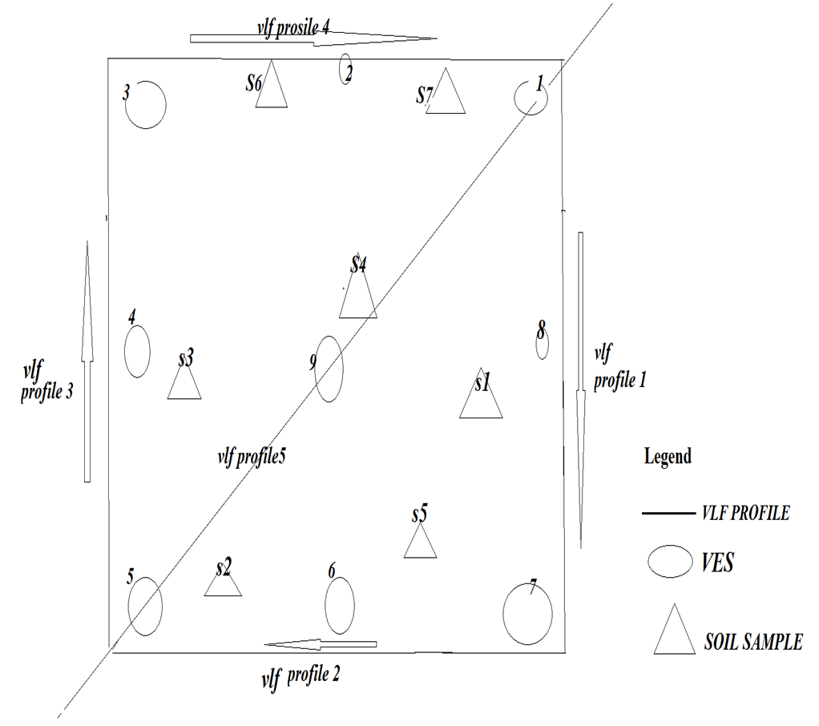
Fig. 2: Survey Layout

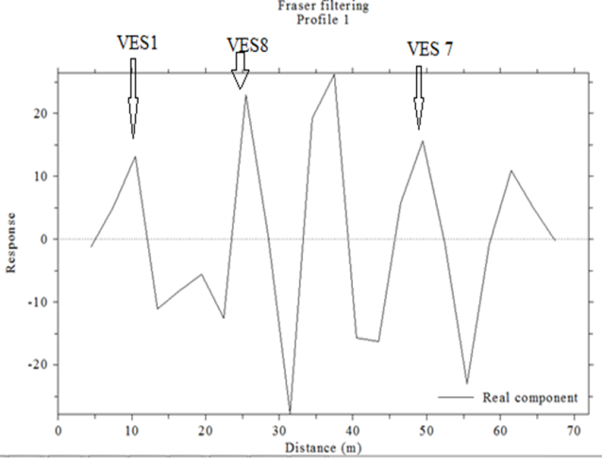
(a)

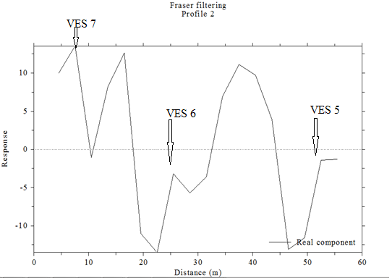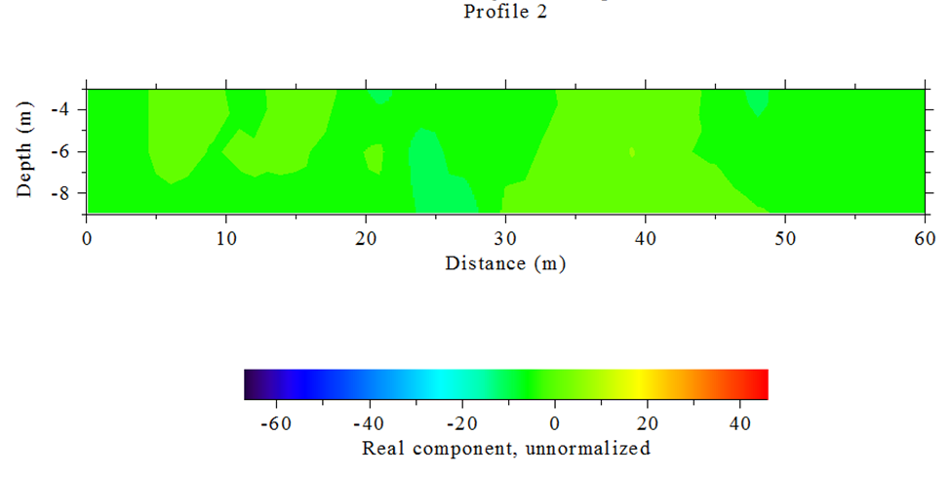
(b)
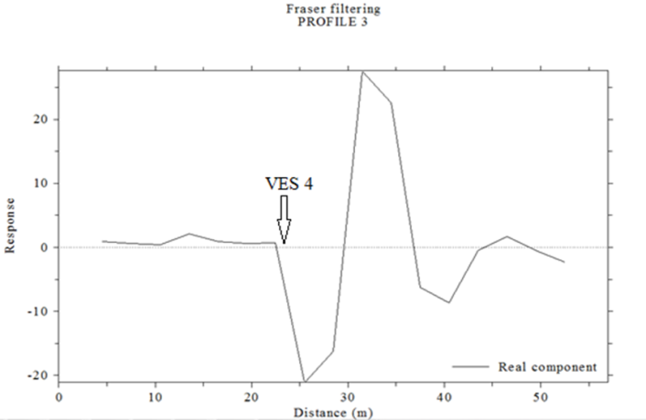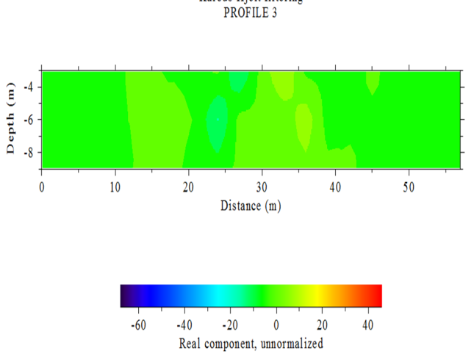
(c)
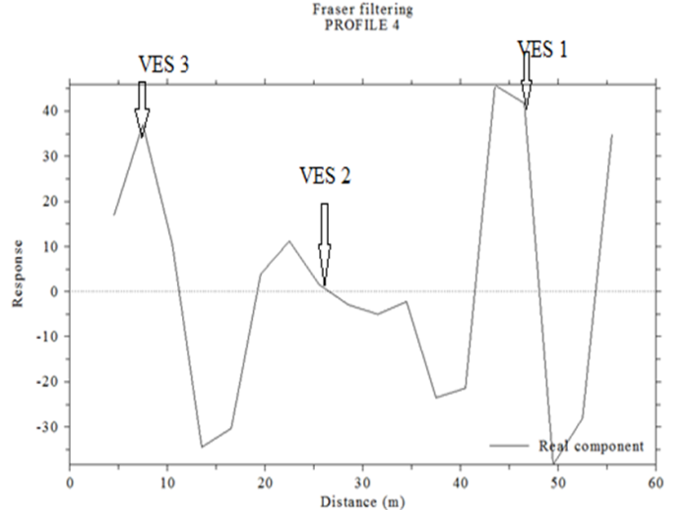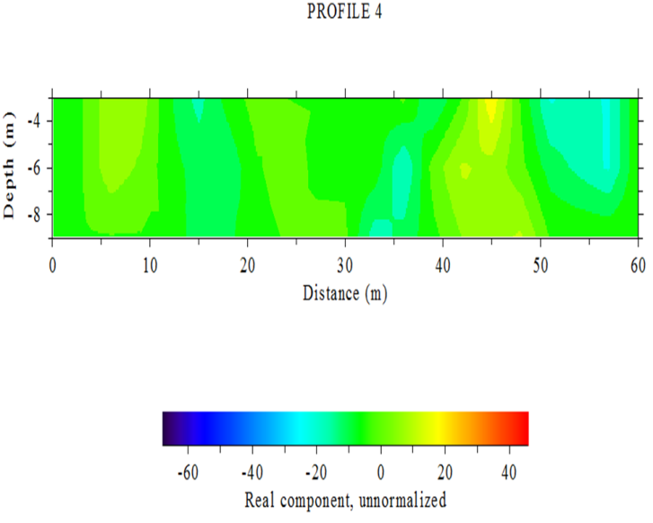
(d)
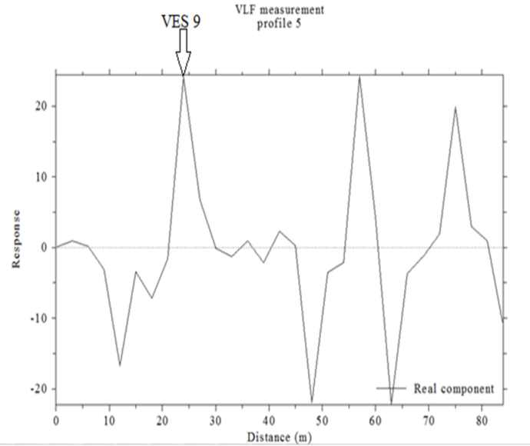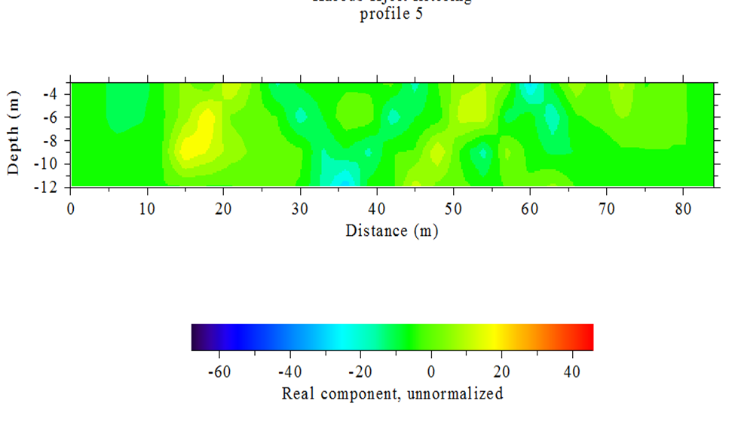
(e)
Fig. 3(a-e): Inverted 2-D pseudo sections and smoothed in-phase Fraser filter of the VLF-EM real component data of the study area

Table 1: Summary of VES Result and Lithological Interpretation
VES | Location | Layer | Apparent Resistivity  ρ (ohm-m) | Thickness(m) | Depth(m) | Lithological  Description | Curve  Type
1 | 7°25'12.7''N  3°55'58.1''E | 1 | 395 | 0.8 | 0.8 | Top Soil | H
 |  | 2 | 209.1 | 3.4 | 4.2 | Weathered Basement
 |  | 3 | 469.2 |  |  | Fresh Basement
2 | 7°25'12.5''N  3°55' 57.6''E | 1 | 730.3 | 0.7 | 0.7 | Top Soil | H
 |  | 2 | 326 | 2.9 | 3.6 | Weathered Basement
 |  | 3 | 547.3 |  |  | Fresh Basement
3 | 7°25'12.1''N  3°55' 57.1''E | 1 | 184.9 | 1.1 | 1.1 | Top Soil | A
 |  | 2 | 600.8 |  |  | Fresh Basement
4 | 7°25'11.4''N  3°55' 57.8''E | 1 | 155.8 | 1.8 | 1.8 | Top Soil | A
 |  | 2 | 471.7 |  |  | Fresh Basement
5 | 7°25'10.8''N  3°55' 58.1''E | 1 | 68.7 | 0.4 | 0.4 | Top Soil | A
 |  | 2 | 300.3 | 9.0 | 9.4 | Weathered Basement
 |  | 3 | 601.9 |  |  | Fresh Basement
6 | 7°25'12.4''N  3°55' 58.6''E | 1 | 96.9 | 2.0 | 2.0 | Top Soil | A
 |  | 2 | 475.2 |  |  | Fresh Basement
7 | 7°25'12.4''N  3°55' 58.7''E | 1 | 71.4 | 0.6 | 0.6 | Top Soil | A
 |  | 2 | 490.3 |  |  | Fresh Basement
8 | 7°25'12.4''N  3°55' 58.7''E | 1 | 70.2 | 0.8 | 0.8 | Top Soil | A
 |  | 2 | 376.3 |  |  | Fresh Basement
9 | 7°25'1.9''N  3°55' 58.2''E | 1 | 85.1 | 1.0 | 1.0 | Top Soil | A
 |  | 2 | 377.8 |  |  | Fresh Basement

Table 2: Soil Analysis Result
Soil Sample | GPS Location | Colour | %  Clay | %  Silt | %  Sand
Sample 1 | 7°25'12.3''N  3°55' 58.4''E | Heu 2.5 YR 4/2 | 10.8 | 19.4 | 69.8
Sample 2 | 7°25'11.4''N  3°55' 58.4''E | Heu 2.5 YR 6/2 | 10.8 | 15.4 | 73.8
Sample 3 | 7°25'11.7''N  3°55' 58.3''E | Heu 2.5 YR 4/2 | 12.8 | 13.4 | 73.8
Sample 4 | 7°25'12''N  3°55' 58.3''E | Heu 2.5 YR 6/6 | 16.8 | 13.4 | 69.8
Sample 5 | 7°25'11.6''N  3°55' 58.9''E | Heu 5 YR 7/4 | 16.8 | 13.4 | 69.8
Sample 6 | 7°25'12.6''N  3°55' 57.6''E | Heu 5 YR 5/6 | 14.8 | 11.4 | 73.8
Sample 7 | 7°25'12.4''N  3°55' 57.7''E | Heu 5 YR 6/3 | 12.8 | 15.4 | 71.8

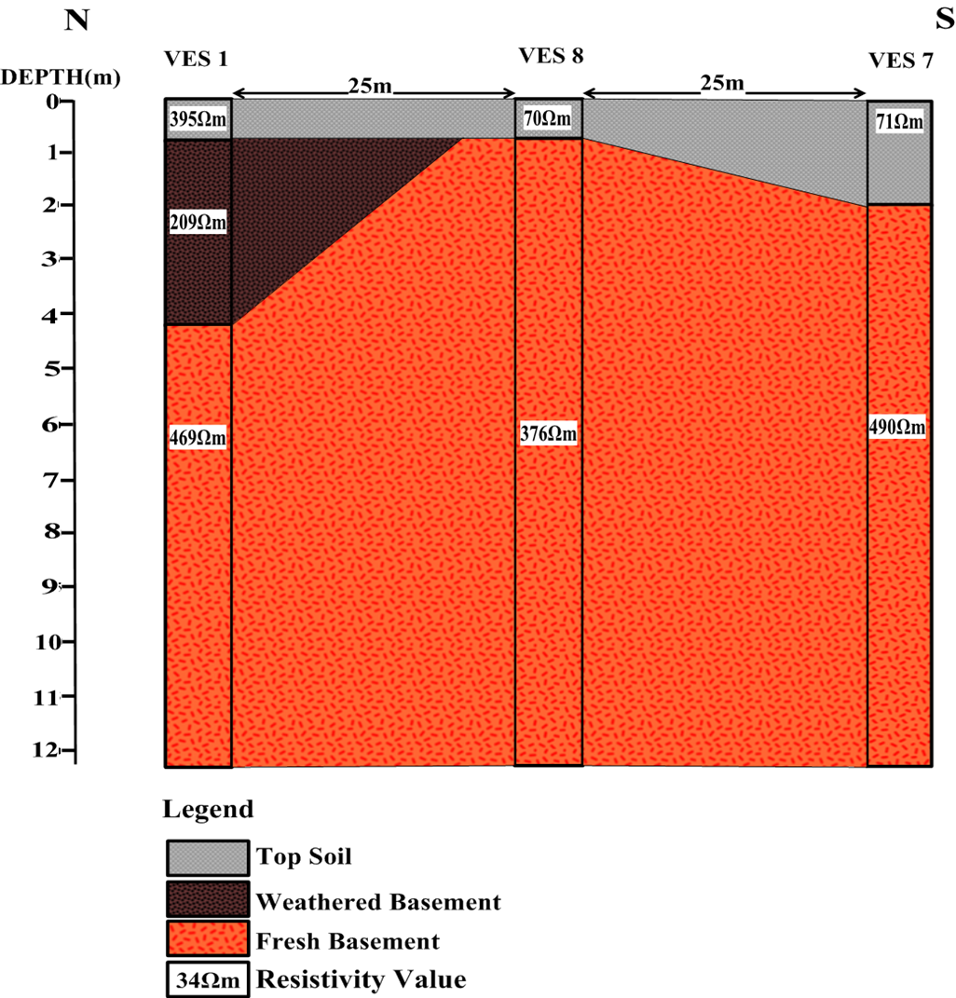

(a)

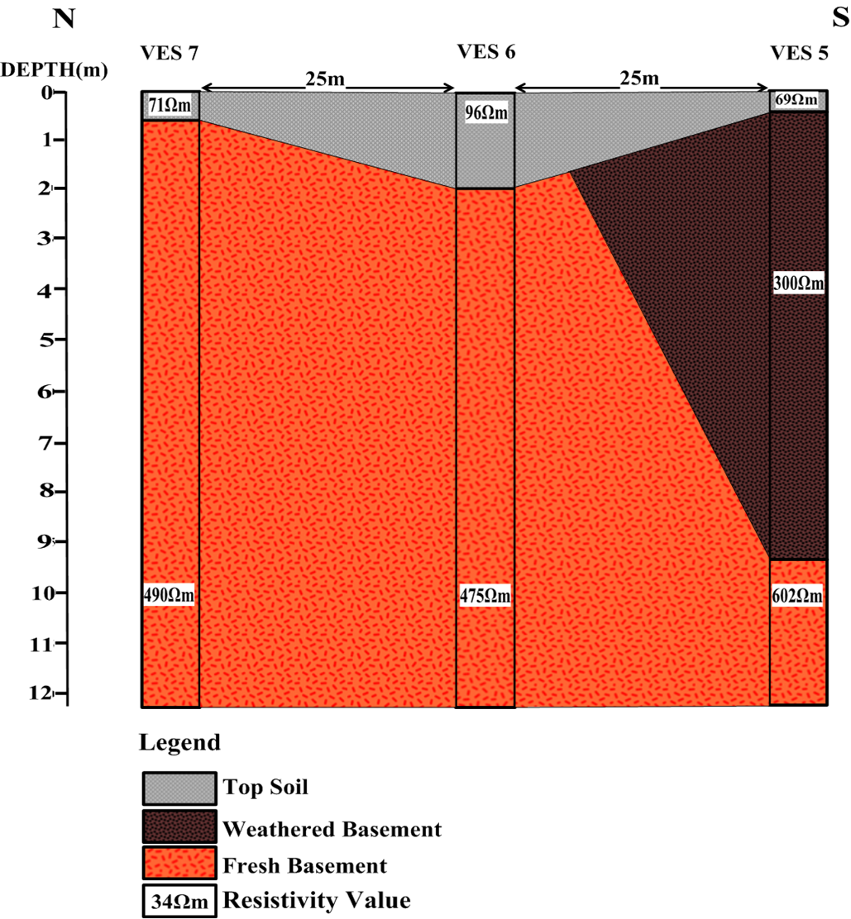
(b)

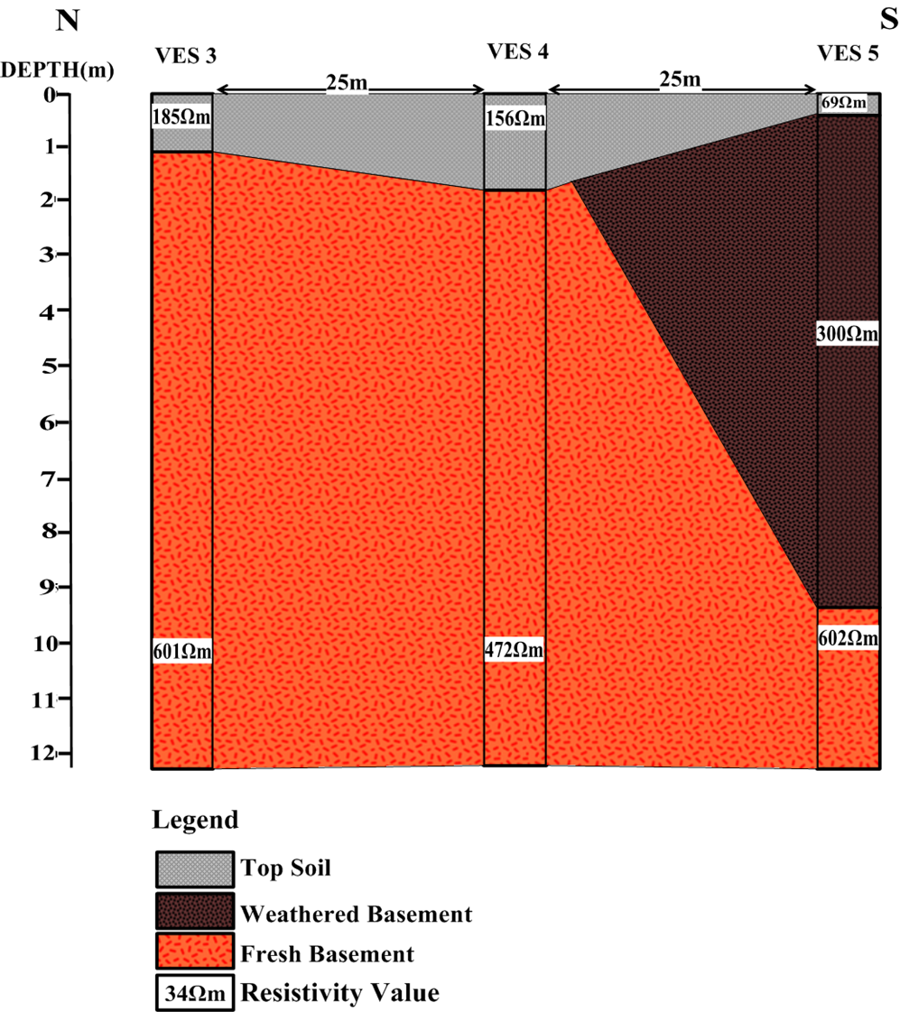
(c)

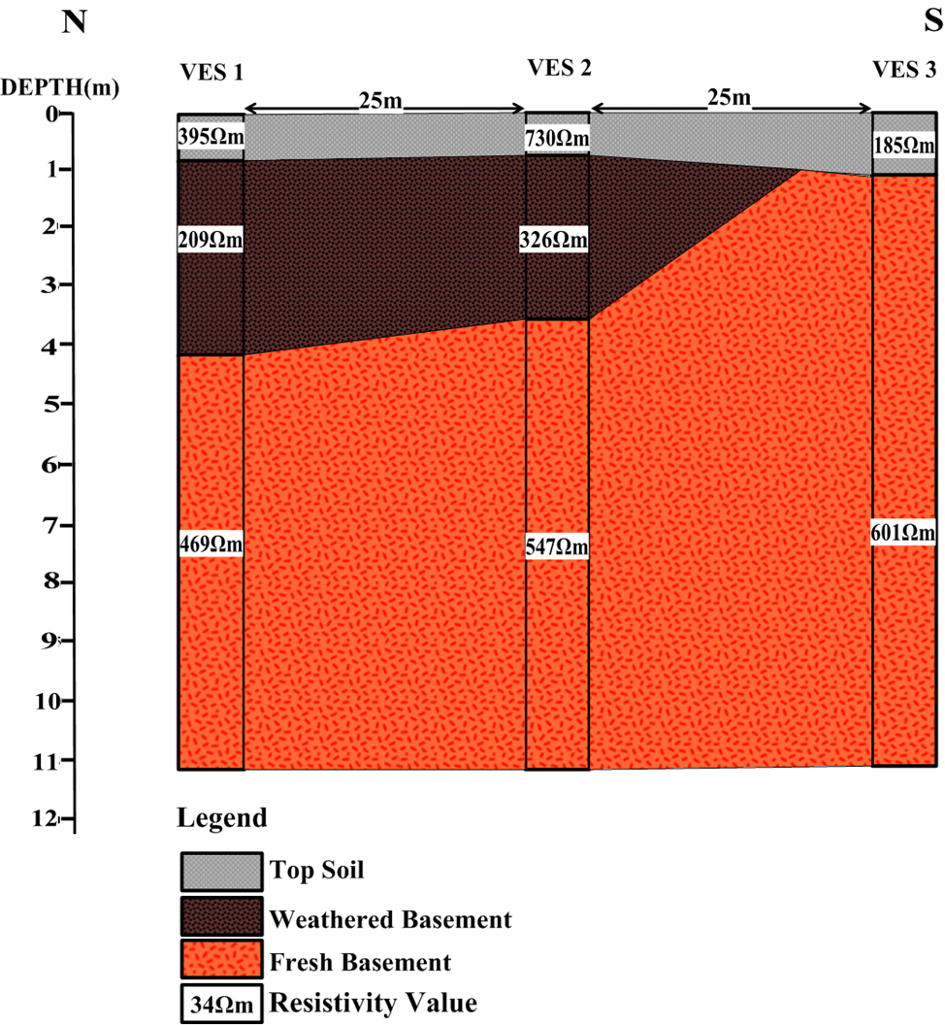
(d)
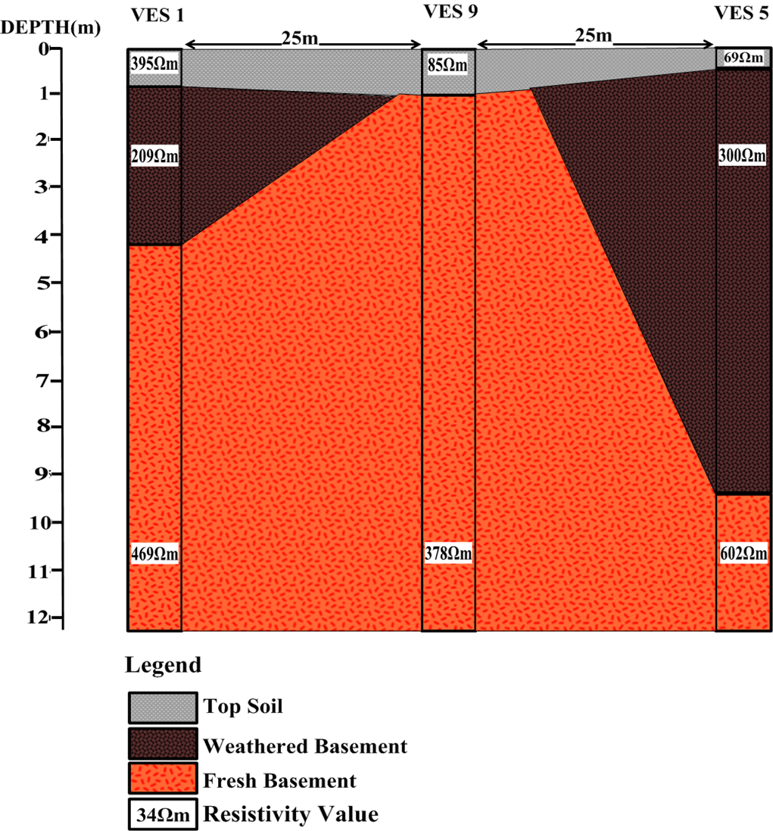
(e)
Fig. 4(a-e): 2D-Geoelectric section along profile 1-5 respectively

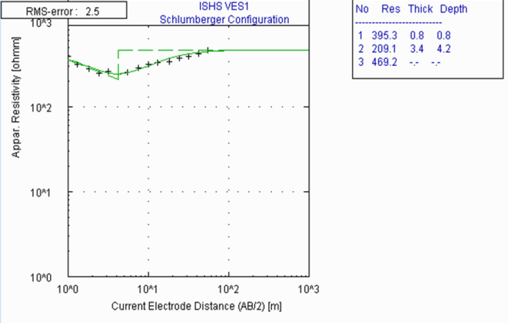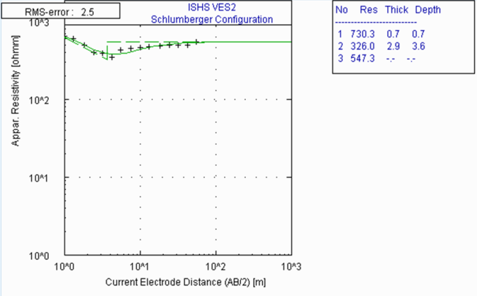
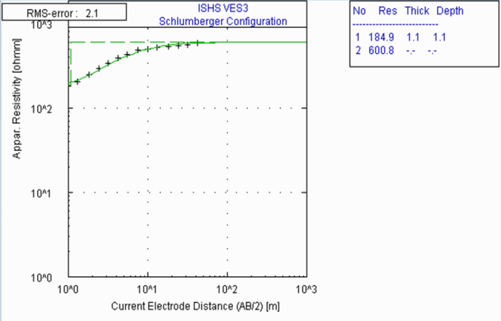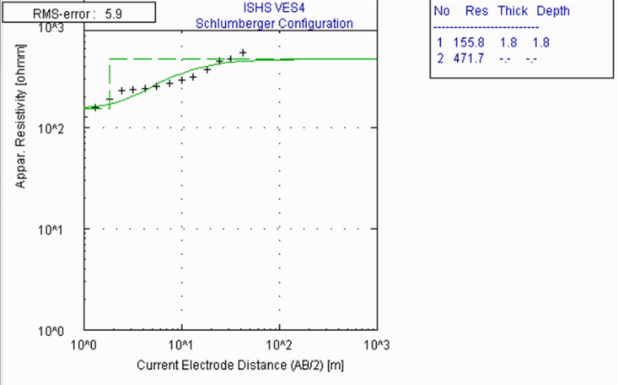

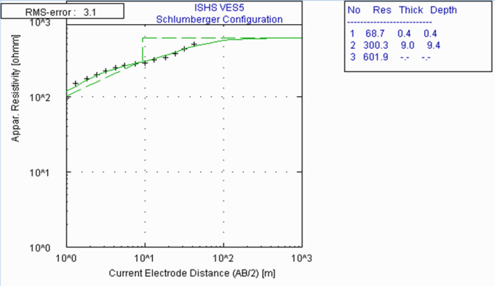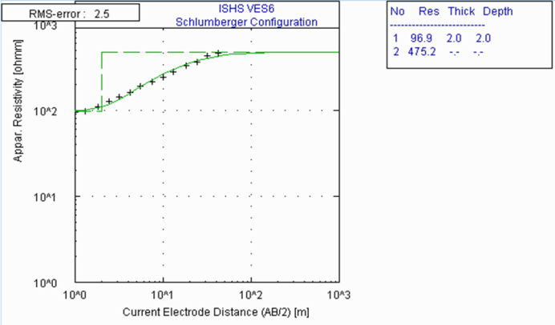

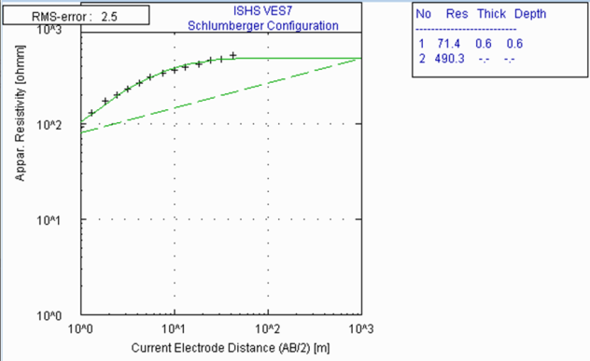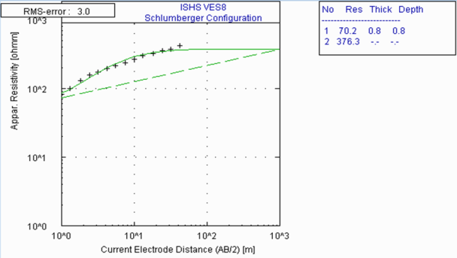
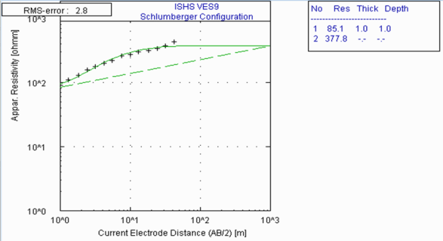
Fig. 5: Typical Sounding curves of VES 1-9

Conclusion
The three geophysical methods revealed similar soil layering consisting of sand and clayey sand layer, sandy and rocky sand layer without a fractured zone. The layers are therefore mechanically stable, the sand material and rocky sand which are dominant on the site indicate high load bearing capacity suitable for both shallow and deep foundation without the need for reinforcement. However, reinforcement may be required in the design and construction of the foundation in the deep weathered layer as observed in VES 5.

References
- Abem A.B (1990): ABEM instructional manual: ABEM AB, Bromma, Sweden.
- Akindele O. O (2011): Geology and Geotectonic Setting of the Basement Complex Rocks in South Western Nigeria: Implications on Provenance and Evolution. Earth and Environmental Sciences, Dr. Imran Ahmad Dar (Ed.), dio: 10.5772/26990. Retrieved from: http://www.intechopen.com/books/earth-and-environmental-sciences/geology-and-geotectonic-setting-of-the-basement-complex-rocks-in-south-western-nigeria-implications- on 27/07/2015.
- Barrett L. Kays (2002): Environmental Site Assessment: Site Characterization Methodologies. Landis. Incorporation Raleigh, North Carolina.
- Beohar, R. R. (2005): Basic Civil Engineering. New Delhi: Laxmi Publications.
- Covel C.L., Kaymen D.T., Phillips I.M., Harrison J.C. (1996): Very Low Frequency (VLF). In Ogungbemi, O.S and Ademilua, O.L. (2013): Integrated Geophysical Studies for Post-Foundational Investigation in Part of Afe Babalola University, Ado Ekiti, Nigeria. Journal of Emerging Trends in Engineering and Applied Sciences (JETEAS): 4(4): 654-660.
- Curtin, W. G., Seward, N. J. (2006): Structural foundation designers’ manual, 2nd ed., UK: Blackwell Publishing.
- McNeill, J. D., Labson, V. F. (1991): Geological Mapping using VLF Radio-fields. In Nabighian, M.C. (Ed.) (2005): Geotechnical and Environmental Geophysics. Society of Exploration Geophysicists; vol. 1, Tulsa, pp. 191-218.
- Ogungbemi, O. S. and Ademilua, O. L. (2013): Integrated Geophysical Studies for Post-Foundational Investigation in Part of Afe Babalola University, Ado Ekiti, Nigeria. Journal of Emerging Trends in Engineering and Applied Sciences (JETEAS): 4(4): 654-660.
- Oyedele K. F., Oladele S. and Adedoyin O. (2011): Application of Geophysical and Geotechnical Methods to Site Characterization for Construction Purposes at Ikoyi, Lagos, Nigeria; Journal of Earth Sciences and Geotechnical Engineering; vol.1, no.1, 2011, 87-100.
- Popoola O. I. and Okhaifo B.O. (2012): Evaluation of Highway Failure of a portion of Ibadan Iwo Road, South Western Nigeria, using very low frequency electromagnetic and Resistivity methods. Electronic Journal of Geotechnical Engineering, vol.17, Bund Q, 2541 – 2554.
- Robert J. Niber, (2010): Geotechnical Site Characterization and Field Investigation Methods; Anticipate and Identify Subsurface Conditions to Manage Risks. Whitlock dalrymple poston & associates, p.c.
- Telford W.M, Geldart L.P, Sheriff R.E (1990): Applied Geophysics, 2nd ed., Cambridge University Press, 770 p.
- William L. (2007): Fundamentals of Geophysics. 2nd ed., UK; Cambridge University Press.
- Wightman, W.E.; Jalinoos, F., Sirles, P., Hanna, K. (2003): Application of Geophysical Methods to Highway Related Problems. Lakewood: Federal Highway Administration, Central Federal Lands Highway Division, Publication.

8/23/2015

