‘Sabha’ Ritual: Cultural Heritage of Shaukas of Rang Society of Chaudas Valley and its Importance Status of Rang Society in Uttarakhand

Rakesh Singh Phakaliyal

Department of History, Kumaun University, Soban Singh Jeena Campus, Almora

Abstract: The tribes of Dahrachula tehsil of Pithoragarh District of Uttarakhand are known as Shaukas and rang is a society of the Shaukas. This tribe primarily habitat at 7000ft to 12000ft altitude of hilly region of Dharchula tehsil of Pithoragrh district, Uttrakahand. Pithoragarh is a border district for two countries Tibet and Nepal. The entire region is situated between the two major rivers of the region called Kali and Dhauli. These tribes more commonly known as Rang tribes are inhabitants of the three valleys namely Darma, Vyas and Chaudas. The tribals of Darma, Vyas and Chaudas are also called Darmani, Vyakhopa and Bangbani respectively. They all have similar food habits, life style, tradition and dresses. The tradition like Sabha ritual is a common in all these three valleys. However, these have different names in the three valleys. In Darma valley it is called Mundan, Vyas valley it is called Badani and in Chaudas valley it is called Sabha.
[Rakesh Singh Phakaliyal. ‘Sabha’ Ritual: Cultural Heritage of Shaukas of Rang Society of Chaudas Valley and its Importance Status of Rang Society in Uttarakhand. N Y Sci J 2015;8(8):77-81]. (ISSN: 1554-0200). http://www.sciencepub.net/newyork. 12

Keywords: ‘Sabha’ Ritual; Cultural Heritage; Shaukas; Rang Society; Chaudas Valley; Uttarakhand

The tribes of Dahrachula tehsil of Pithoragarh District of Uttarakhand are known as Shaukas and rang is a society of the Shaukas. This tribe primarily habitat at 7000ft to 12000ft altitude of hilly region of Dharchula tehsil of Pithoragrh district, Uttrakahand. Pithoragarh is a border district for two countries Tibet and Nepal. The entire region is situated between the two major rivers of the region called Kali and Dhauli (Joshi 1999). These tribes more commonly known as Rang tribes are inhabitants of the three valleys namely Darma, Vyas and Chaudas. The tribals of Darma, Vyas and Chaudas are also called Darmani, Vyakhopa and Bangbani respectively. They all have similar food habits, life style, tradition and dresses. The tradition like Sabha ritual is a common in all these three valleys. However, these have different names in the three valleys. In Darma valley it is called Mundan, Vyas valley it is called Badani (Raypa 2015) and in Chaudas valley it is called Sabha.
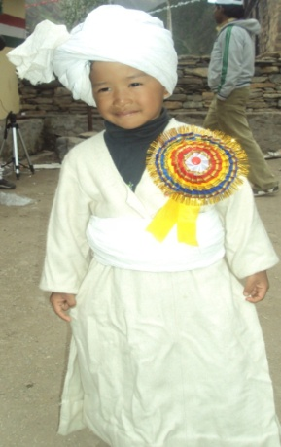

The Chaudas means fourteen and therefore the Chaudas valley means a valley comprising of fourteen villages. Some of the main villages of Chaudas valley are named as Sausa, Pangu, Dharpangu, Himkhola, Sirdang, Sirkha, Rung, Tija, Babala, Pasti, Makhe, Makam, Nayana, Gala and Jipti. The ritual of Sabha is performed by the inhabitants of the village only. In fact the main festival is Shyangthang, which is celebrated on Dashera. It has the same significance for the tribals of this region as Chhat Puja in Bihar. For Shyangthang festival, all the people, belonging to the region come to their ancestral villages in the valley and celebrate this festival performing various cultural rituals, rites. Immediately after the Shyangthang, the Sabha ritual is performed.
Sabha- A Ritual
It’s a ritual, which is performed on the eldest son of the family in his childhood. If any family has more than one son then the eldest son is given Sabha rite and the second and other sons are not given this rite. In all these rituals, there is no involvement of Brahmins as in case of rituals unlike Mundan in other areas of the country where one can see the importance of involvement of Brahmins. The old and senior male members of the village and the family perform Sabha ritual where they remember their friends and the nature Gods. Though it looks like Mundan ritual but the cutting of hairs of the child is not mandatory in Sabha ritual. Its optional.
Age of the child for the Sabha ritual:
The Sabha rites are performed for the eldest male child of a family at their odd age such as at the age of 1, 3, 5, 7, 9, 11 etc. This rite is considered mandatory for each family for its life time. Sometime due to inability of the family being poor, this ritual gets passed on to the next generation.
Time of Sabha ritual:
Every year during Shyangthang festival, the families performing Sabha in the next year are decided in every village. The Sabha ritual starts from the immediate next day of the Dashera festival every year and on Dashera day the Shyanthang festival is celebrated. Every year in each village maximum eight family are allowed to perform the Sabha ritual. The families, which are to perform Sabha in the coming year, make all necessary preparation for the function and the ritual throughout the year. That is the reason the families are given one year time for the ritual.
Dresses:
The male child for the Sabha is named as ‘Bala’ and the ‘Bala’ is put on white dress. The outer dress is called Ranga which is hand knitted craft out of wool of sheeps and a jyu jung (white cotton clothe) stripes is wrapped and tied over the waist. The lower portion is a generally a normal Jens Pant or a trousers. A white cotton turban is put on over the head. The white turban bears significant importance and generally used by the males on all special occasion in the Rang society. While performing the Sabha rituals, the parents of the Bala wear traditional dresses. The father wears white Ranga which is nicely hand knitted from the wool of sheeps and white turban over the head and Jyu Jung (white cotton clothe) at the waist and pant. The mother wears Chungbhala, which is a traditional dress for the women of Rang society, and all the ornaments like necklace called Chandrahaar, ornament for the hair called Beera Baali, ornament for the arm called Baah and Wuldung made out of silver. Wearing Gold jewelry like Beera, garland prepared from small round gold well beaded corals are considered pious on such occasions (Pandey 1990). The women folk of the Rang society called Rangsya are very fond of all these ornaments and jewelry, which they put on special occasions like Sabha etc.
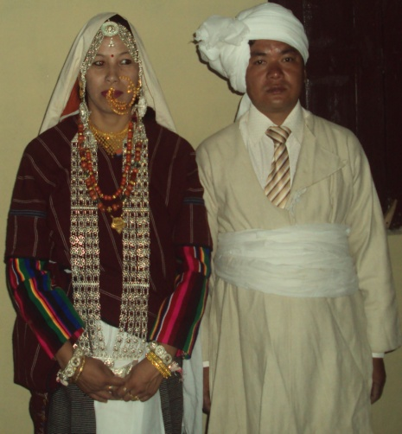

Dalang
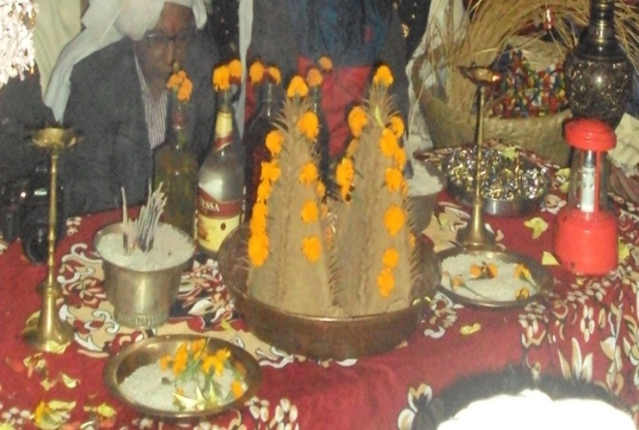

Dalang is conically shaped article made out of a special kind of flour made out of a grain crop called faafar, which grows in the hilly region especially at a very high altitudes (above 10000ft). This is used in twins and meant to represent Ganesha and therefore used at the start of every good work. Two Dalangs are used at every such pious occasion. These Dalangs which are conical in shape are placed over a copper plate and the top of the cone is well decorated by small wick shaped articles made out of the same material as Dalang. The conical surface of the Dalang is also decorated with currency coins and also the curd yogurt.
Accessory Required for Worship
The general accessory for worship at occasions like Sabha are insense (Dhoop), incense sticks (agarbatti), earthen lamps, match sticks, flowers, cow urine, whole grains of rice, bronze plates, Chakti (wine) , flower, flower pots and lamp stands etc.
Syarjae
Syarjae is nothing but whole grains of rice. It plays very important role to perform worship throughout. It is not possible to perform worship without this article. The whole grains of rice are distributed to all the guests present during the worship and thereafter chanting and various other activities of worship were done.
Cow Urine
The urine of cow is considered most sacred thing for worship in Hindu rituals and religion. The Vedas and Puranas have special mention of the cow urine. In the Rang Society to the cow urine is used for worship purposes.
Dressed and Fry Cooked Dishes
The main dressed and fry cooked dishes for the occasion like Sabha is Markuto which is nothing but a kind of Puri. The Markuto is generally round in shape with ear type structure of the same material attached. The Markuto are then placed in a dumble shaped baskets made out of the fine bamboo material and distributed to all the members of the family and guest as eatable. The fried flour crumble is also made at the occasion of Sabha.
Importance of Gura (Maternal uncles of Bala)
Gura is called for maternal uncle in the dialect spoken by tribal of the region. On the occasion of Sabha, maternal uncles of the Bala, for whom the Sabha ritual is performed, are given utmost importance. It is considered a matter of great pride and honour that all the relatives from the side of maternal uncle present themselves before all the villagers where Sabha ritual is performed. It gives an opportunity to them to know all the villagers at such occasions.
Tisya (Sisters and Daughters of the family)
Tisya is nothing but a name given to the sisters and daughters of the families of the villagers, where Sabha is performed. For the Bala, Tisya is a sister and sister of his father. They are required put on the dresses that Rangsya (the women folk of the Society) wear at such occasion. They wear silver ornaments and Jewelry also. The Tisyas are generally three, five or seven in numbers. It is a belief that the association of Tisyas with the Balas is always good and it helps in preventing any untoward happening.

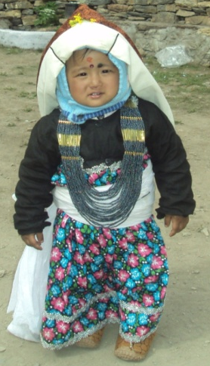

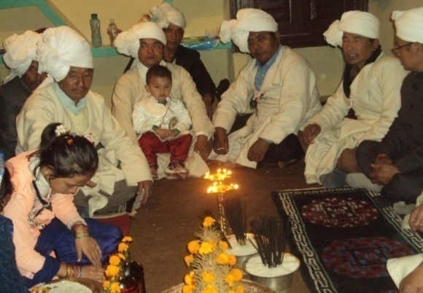

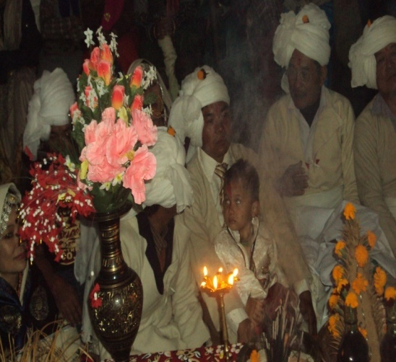

Traditional Method to Conduct Sabha ritual
The Sabha ritual is religiously performed by the tribalsof Chaudas valley. Only the eldest son in family is given the Sabha ritual. Shyangthang is the main festival for Bambanis (the tribals of Chaudas valley), which is celebrated on the day of Dashera every year and the very next day is performed Sabha ritual. The Sabha ritual to be performed by a family for the eldest son is decided one year in advance during the Shyngthang. The maternal uncles, called Gura by bambanis in their local dialect, are given utmost importance and respect during Sabha ritual. They are given invitation for Sabha well in advance by the families to be performing Sabha. The Guras are treated as chief guests in the village during Sabha ritual.

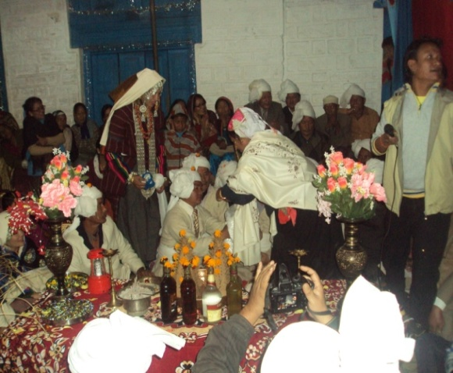

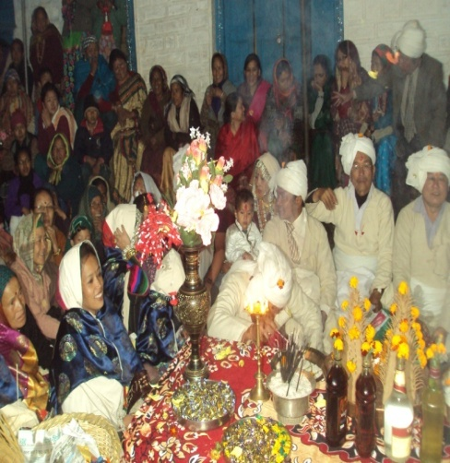

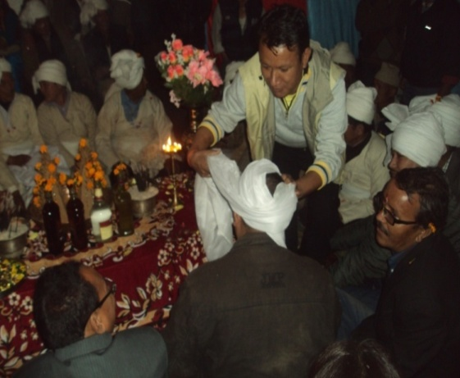

The Child for whom Sabha ritual is to be performed is given bath in the morning and put on the new dresses. All the preparations are made for the Sabha ritual to be performed in the evening. In the evening the child- Bala is put on the traditional dresses like white clothe called Ranga, white turban called Byathalo, white cotton stripe for the waist called Jyu Jung and Pant. The forehead of the child-Bala is given a small mark of sandal wood paste called annotation. All the family members carrying earthen lamps, flower pots, incense, sticks, hand bells dressed and fried food made for the occasion in dumble shaped baskets made of fine bamboo grass walk down to the place of worship with full fan fair playing the drum sounds all the way. The Bala the child is carried on the back by the father or a person in the village who’s all the kin relatives like father and son are alive, along with Tisyas to the place of worship, where the villagers and the Guras are already present. . This tradition a carrying the Bala the child is called ‘Butchi’. The Bala is kept on the lap of the mother, who is required to be seated on the side at the east direction of the place of worship.
A person amongst the villagers acts as convener for conducting the Sabha ritual as per tradition. At the very beginning, the Guras-maternal uncles and all the males from their side are put on white turbans and the ladies are dressed up with white shawls as a mark of respect to them. Thereafter, the Bala is put on white turban (Byantalo) by the Guras and the other people from the side of Gura. They are also required to present some cash to Bala as per their capability. They are also required to present some cash for the development of the village as per their capacity. The cash presented for the village development is called ‘Dhalang’. The convener is required to announce the cash amount and the name of the donor in the assembly at the place of worship. Similarly the villagers and other guests present there also donate cash for the Bala as well as for the village development and accordingly announcement is also made. All the donations made are endorsed in a Register being maintained for this purpose so that the donation given for the development of the village is utilized in the future as required. In the Sabha one can donate special sums separately for the development of the village.
After all the above activities, the worship for the Sabha ritual starts. The senior persons of the village start the worship. All the people present at the place of worship are distributed akshyat-whole grains of rice. The senior persons who start the worship spray cow urine all over the place as process of purifying the place and surroundings. The God and Godesses worshiped by the villagers are worshiped by the senior people facing east using water taken from original source, curd, whole grains of rice and the Dhalang (Hyanki 1999). Dhalang, Markuto-the dishes made for the occasion and toffees and sweets are offered to the Gods and Goddesses worshiped and thereafter distributed among all the people present there. At night they song ‘Jhumko Geet’. Finally food is served to all. On the very next day all the villagers bid farewell to the guest, Tisyas and others by offering them with farewell gifts like Sarees, Suits, Bedsheets, Towels etc. Acording to Raypa this cerermony in a way resembles the christening ceremation of christians (Raypa*).
Even today, the Sabha ritual in Chaudas valley is celebrated with great fan fair. The Bambanis-the people of Chaudas valley, living all over the places outside their native villages, make it a point that they attend Shyngthang festival at their native village so that the tradition is kept alive and maintained. The people who are outside their native villages for being in Government organizations, various business etc, living in various other cities and towns, even today take off from their respective professions and attend Shyangthang and Sabha function at their native villages to ensure that they remain part of their tradition and culture. They make full contribution to their valley for maintaining the traditions that they inherit. The Bangabanis the people of Chaudas valley are as curious and aware even today as they were in the past for celebrating their traditional festivals and maintaining their traditions.
The Sabha ritual is such a tradition of Rang society that it has remained all the same since the beginning of this tradition. This is because of the significant contribution made by all the people who belong to this valley. No matter there have been significant changes over a period in the living standards and other walks of life of mankind all over the world but it is always a good thinking and thought that one should not forget its place of origin, tradition and the culture inherited. This will help in keeping the traditions and culture alive and this will also help in making a strong bond with the ancestors. The people of Chaudas valley have this feeling and that is the reason the cultural bond of the people this region is quite strong and the traditions continuing since ages are still alive.

Reference
- Joshi, R. C. 1999, Rung Samaj Par Dristi, Himalaya Dipti, pp 26.
- Raypa. R.S 2015 Shouka. Pp120-121.
- Pandey, P. 1990, Kumaun Ka Itihas, pp. 525-528.
- Hyanki, B. S. 1999, Himalay kae Rung Sukao Kae opekchit Chetra mae Chaudas Ki Barah Varsiya Kangdali Vijay Yatra, pp. 20.
- *Raypa, R.S- Budi, A Geographical survey of a border village, typed thesis. p.104.

8/23/2015

