**Ambulance Management System using GUI MATLAB**

Taha Darwassh Hanawy Hussein 1, Hakan Maraş 2

1Department of Computer Engineering University of Çankaya, Turkey

[taha_hanawy@yahoo.com](mailto:taha_hanawy@yahoo.com)

2Department of Computer Engineering University of Çankaya, Turkey

[hhmaras@cankaya.edu.tr](mailto:hhmaras@cankaya.edu.tr)

Abstract: An efficient emergency ambulance service must be provided in order to reach injured persons and transport them to the nearest hospital as rapidly as possible. To do so, the ambulance driver must select the shortest road network to reach the accident site, followed by the shortest path to the nearest hospital. Over the last few decades, a variety of different GIS-based systems have been developed to aid in the selection of such a path. This paper aims to introduce an ambulance management system (AMS) to the city of Kirkuk, Iraq. A MATLAB graphical user interface (GUI) is used as a platform with which to manage a transportation path on the map by calculating all possible paths between accident and ambulance, and between accident and hospital. The shortest overall path can then be selected based on the obtained map coordinates*.*

[Taha Darwassh Hanawy Hussein, Hakan Maraş. **Ambulance Management System using GUI MATLAB.** *N Y Sci J* 2015;8(8):59-68]. (ISSN: 1554-0200). <http://www.sciencepub.net/newyork>. 10

Keywords: Ambulance Management System (AMS), GPS, GSM, MATLAB GUI.

# **Introduction**

Kirkuk, a metropolitan city with approximately one million inhabitants, is currently facing the impending threat of a catastrophic war. During and in the aftermath of such an event, thousands of injured people would likely be seeking medical assistance and would need to be transported by ambulance from the accident site to a hospital. Patient transportation in daily emergency situations is a widely studied problem, with the initial deployment and dispatch of ambulances a particular focus in the literature. In everyday emergencies, since the number of injuries is not so high, patients are typically served on a first-come-first-served (FCFS) basis. However, in a mass-casualty incident such as those experienced during war, the sudden surge in requests to the emergency services, often beyond the latter’s response capacity, complicates the problem. The present study area encompasses the city of Kirkuk, which contains 49 residential districts. According to the latest census of 2012, the city has a population of 844,811 inhabitants [1]. In the present paper, the most likely war scenarios are identified and damage estimates given. Accident data in the GPS report are employed to estimate the likely number of injuries; injury data are also sent to hospitals via ambulance. This system was designed via the use of a Graphical User Interface (GUI). The rapid transportation of the injured to hospital is essential in order to save lives. In the present study, a method with which to achieve this is investigated via simulation based on a MATLAB GUI.

The combined use of this GUI and GPS should enable patients’ locations to be established rapidly, potentially covering the entire urban area of Kirkuk. This paper comprises 5 sections. Section 1 contains an introduction to the issue. Section 2 contains a literature review, including previous studies examining ambulance management systems. As the city of Kirkuk has thus far been subject to very little investigation, a considerable amount of information was obtained via experimental research carried out in the municipality.

Section 3 discusses the role of the Geographic Information System (GIS) in transport planning.

Section 4 discusses the methodology employed in the present study, including work on MATLAB programming languages. Finally, Section 5 contains the conclusions reached.

**Literature Review**

The most basic deterministic model is the Set Covering Model (SCM) described in [4]. The objective of this model is to find the minimum number of EMS stations covering all demand points. One of the main characteristics of SCM is its ability to geographically cover all demand points by at least one service station, without taking into account the populations of these points. Due to the importance of SCM in the literature, all other deterministic models are generally based on this model. However, as stated by Brotcorne et al. [5], there are some circumstances that SCM does not consider, such as the fact that when an ambulance departs in response to a call for aid, other demand points serviced by this ambulance are no longer covered (at least until the ambulance is available once more).

Church and ReVelle’s [6] Maximum Coverage Location Model (MCLM) was developed for EMS planning involving a limited number of stations. The aim of this model is to maximize the total population or number of demand points covered by the stations. By using MCLM, the efficiency of the available services (rate of total coverage) can be easily measured. Moreover, the extra cost of establishing more stations and extra coverage offered by these new stations may be compared as part of a strategic decision-making process. Various models based on SCM and MCLM are discussed in the literature. Schilling et al. [7] proposed the Tandem Equipment Allocation Model (TEAM) as an extra add-on for MCLM. TEAM is aimed at maximizing the population covered by two dissimilar service types, where the number of stations for both service types is limited. This model also includes a constraint with respect to the precedence relationship of the two types of service; if a service type is assigned to a demand point, the other service must also be assigned. SCM, MCLM and TEAM all imply single coverage of demand points by the emergency service system. Therefore, if an ambulance is full/busy serving a demand point, other demand points covered by this ambulance will no longer be covered, as stated earlier. To overcome this drawback, multiple handling models are outlined in the paper, considering both location planning and ambulance-related constraints. The Improved Maximal Covering Location Model (MMCLM) developed by Daskin and Stern [8] is aimed at maximizing both population coverage and demand points covering multiple time periods. Two dissimilar alternatives for MMCLM are presented in Hogan and Revelle’s [9] Double Coverage Model (DCM). In the first DCM variant, the populace covered at least twice is maximized given a limited number of stations. In the other variant, given a limited number of both stations and ambulances, the demands covered once or multiple times are maximized according to the weights assigned to demand points. As can be seen from the above review, all three types of MMCLM are based on the multiple coverage of demand points with a single critical travel-time restriction. Gendeau et al. [10] introduced the Double Standard Model (DSM), which maximizes the demand covered multiple times via the use of two dissimilar travel-time limitations, with the overall objective being to maximize the demand provided for at least twice in the shorter travel-time boundary. The constraints include a set covering requirement of all demand points within the longer travel-time limit and a given percentage of the population to be covered within the shorter travel-time limit. An important difference between DSM and other deterministic models is the assignment of multiple ambulances to the same station. However, there is an upper bound on the number of ambulances assigned to each station. Probabilistic models in the literature vary according to their objective functions and constraints. Daskin [11] proposed the stochastic model known as the Maximal Expected Covering Location Problem (MEXCLP). In this model, an equal busy probability is assigned to all vehicles. This probability depends on the frequency of calls per day and the total service time needed to answer these calls. There is also a limit on the service provided per day by the limited number of vehicles. Thus, the expected coverage of demand points is maximized for a given number of ambulances, where the objective function increases in a diminishing way as the coverage number for each demand point increases. ReVelle and Hogan [12] developed two different probabilistic simulations. The Maximal Availability Location Problem (MALP) is characterized by a reliability factor which depends on the busy probability assigned to all ambulances equally, as in MEXCLP. In this case, the probability of having at least one service respond to the demand point is equal to or greater than this factor. Thus, the lowest number of ambulances needed by each demand point is determined using the reliability factor, with this number being equal for all demand points. As in the other models, MALP restricts the total number of stations and ambulances. The objective of MALP is to maximize the total population or demand points covered using the fewest ambulances. The second type of MALP differs from the first in terms of the minimum number of ambulances required by every demand point. Both MEXCLP and MALP assume that ambulances are independent of each other while assigning busy probabilities. Batta et al. [13] extended MEXCLP by taking into consideration ambulance inter-dependency, assigning different busy probabilities to each demand point.

**AMS using a MATLAB GUI**

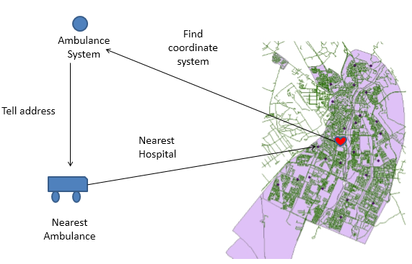

**Figure 1** Kirkuk Ambulance Dispatch System

In the Kirkuk ambulance dispatch system, calls are connected to the ambulance phone or mobile phone. Once the patient’s location has been established, the system works via GPS or the Internet to determine the x-axis and y-axis coordinates of the nearest ambulance. If this ambulance is busy the system connects to the next nearest. This system is represented graphically in Figure 1.

After collecting the patient, the ambulance connects to the nearest hospital via GPS and GSM. This is shown graphically in Figure 2.



**Figure 2** Ambulance Management Communication System

In this section we present a road map of Kirkuk and discuss how it can be displayed in a MATLAB GUI. The road map used here was obtained from the Kirkuk Municipal Authorities. Figure 3 shows a map simply illustrating the road network in Kirkuk.

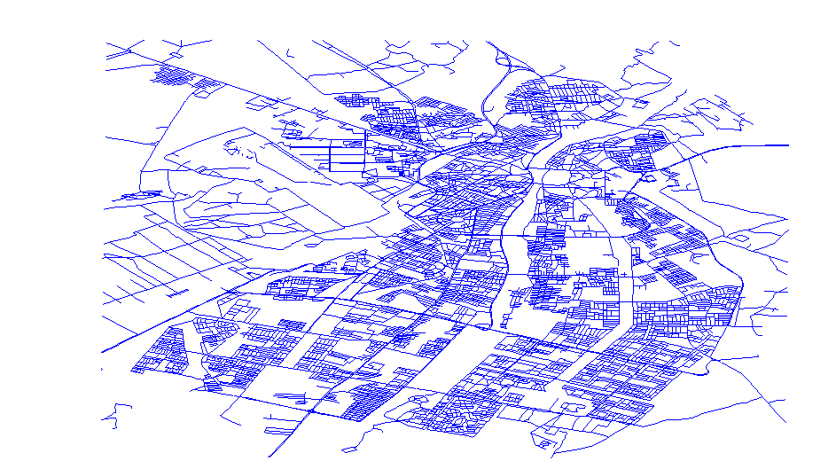

Figure 3 Map of the road network in Kirkuk

Figure 4 illustrates the relationship between routes and districts in Kirkuk; the right-hand map displays only the districts, while the left-hand map shows both the routes and districts.

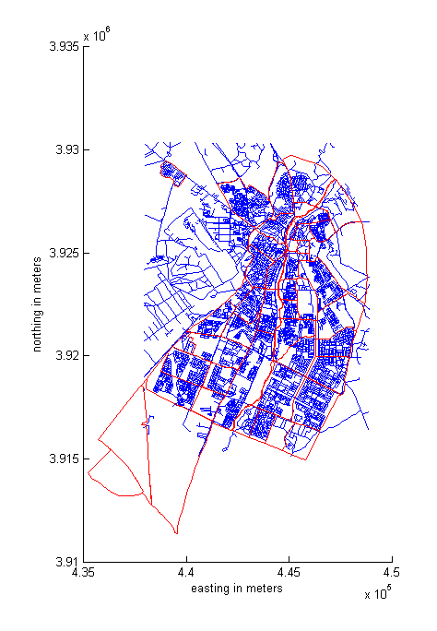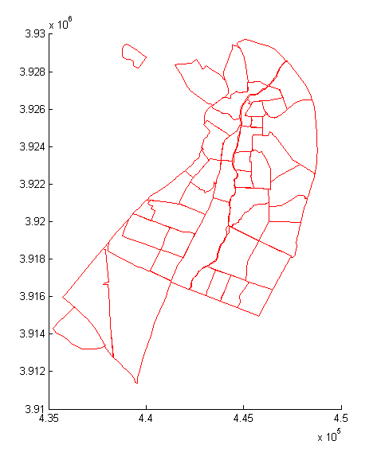

**Figure 4** Routes and districts in Kirkuk

Figure 5 shows the locations of hospitals in Kirkuk, represented in red.

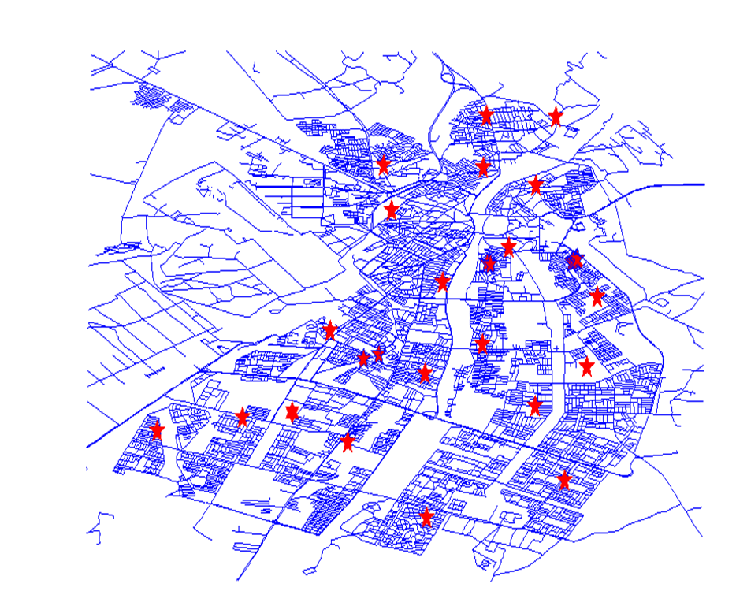

**Figure 5** Hospital Locations in Kirkuk

This section describes the location of the city and its relationship with other adjacent cities in Iraq. A city’s location has a significant impact on its growth, including the number of jobs provided, depending on the size of its region [47]. Two types of location system are typically recognized: astronomic and geographic [45]. Kirkuk is situated astronomically at 44°26'27 "E - 44°17'10 "E longitude and 35°30'34 "N - 35°20'5 "N latitude [48]. Geographically, the city (also known as AL-Tammeem) lies at the center of Kirkuk province in northeastern Iraq, as shown in Figure 6.



Figure 6. Maps of Iraq showing the relative locations of Kirkuk Province and Kirkuk City

**Use Case Diagram for AMS**

The developed Ambulance Management System has been designed not only for use in Kirkuk city, but also for other cities and countries currently experiencing similar problems. The structure of the Ambulance Management System is shown in Figure 7.

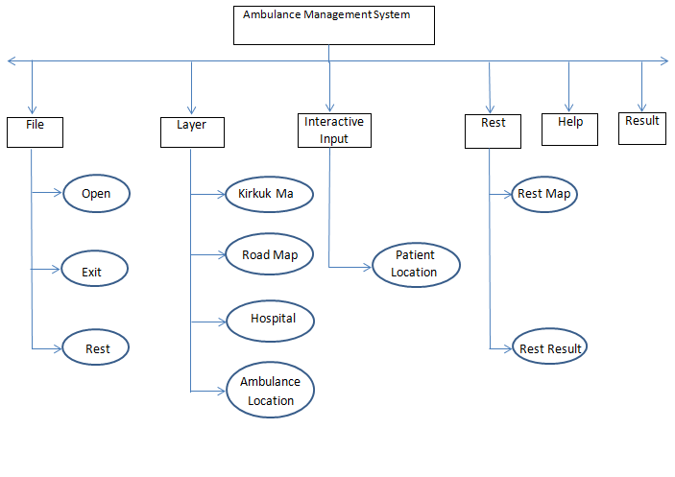

**Figure 7.** Ambulance Management System Structure

* Software System Attributes
* Easy Installation

An executable file was created for easy installation of the system on any computer without significant effort. High computer specifications are not required; only the data to be used must be available in order to obtain the results.

* Usability

The system is designed for all typs of user; no specialized qualifications are necessary. Unlike ArcGIS, which requires at least a computer engineering certificate to be understood in detail, the proposed AMS is helpful for those working in the education service fields who may not possess such knowledge.

* Reliability

The AMS can be completely trusted; wrong information is never declared, only correct results. The system interface is shown in Figure 8.

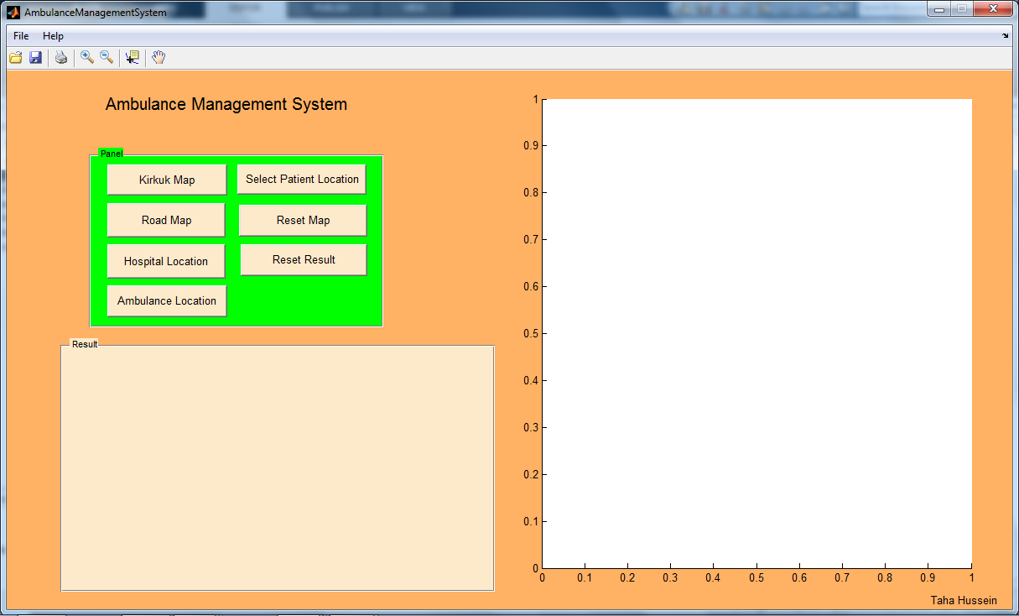

Figure 8 The proposed software system, designed in MATLAB

This GUI was created for the simulations by writing code in MATLAB.

When an accident occurs in any district in the city, the municipal traffic authorities are made aware of the coordinates of the accident location, which are then used in communication with hospitals, police and fire stations.

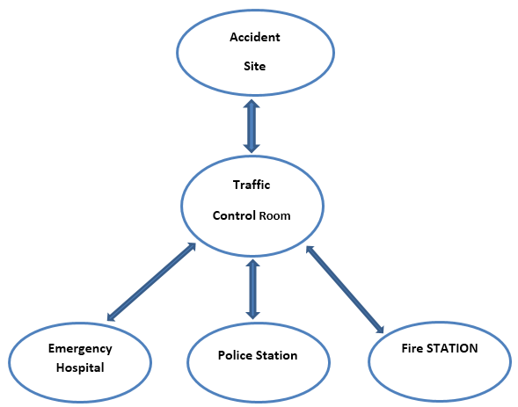

**Figure 9.** Information flow after an accident occurring on the road network [43]

Figure 10 below shows the on-screen display after running the developed AMS program. The first step is to select the Kirkuk Road Map button, and then from personal computer the Kirkuk map is selected as the shape file; this loads the Kirkuk road map (here shown in blue) into the axes section of the GUI. The user then loads the hospital locations (here shown in red), which are determined via GPS and saved in shape file format, followed by the ambulance locations (magenta).

Finally, the user selects the “Select Patient Location” button and inputs the appropriate data.

After selecting this button the locations of the nearest ambulance and nearest hospital appear on the map; the user can then inform the ambulance and hospital centers.

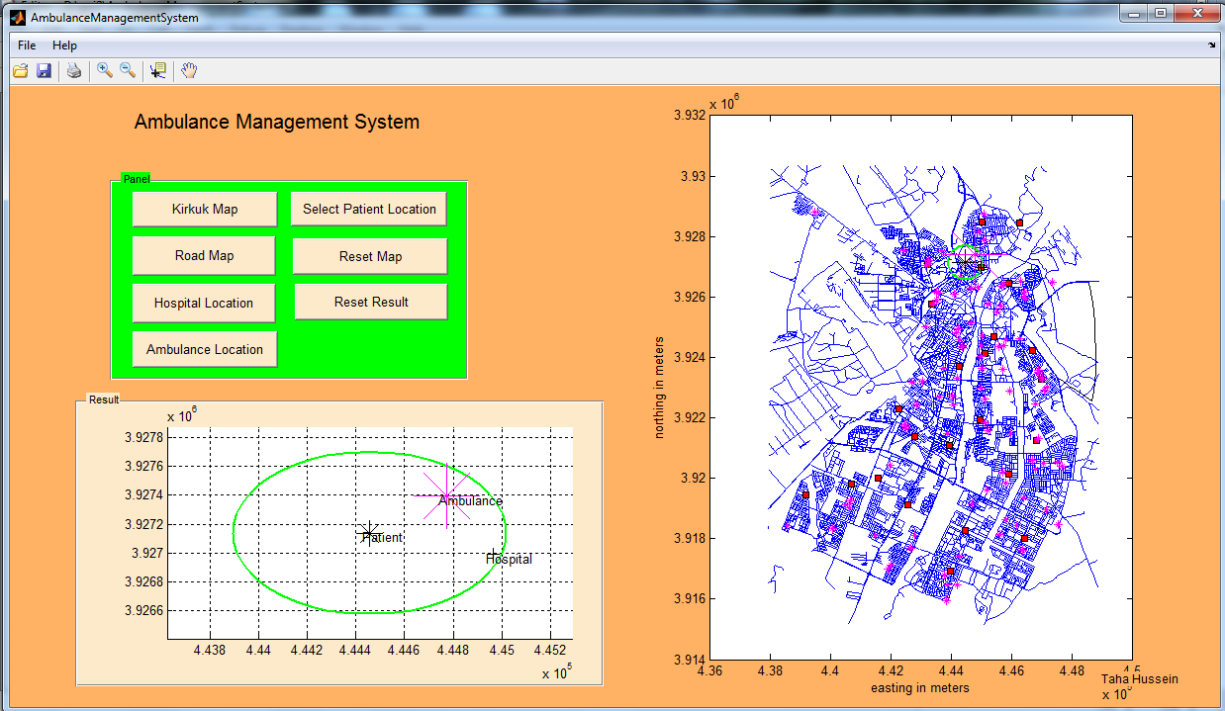

Figure 10 Map showing ambulance, hospital and road locations after running the system

Users can also zoom in on the location of the patient (as well as that of the nearest ambulance and hospital) by pressing the zoom button. This feature is illustrated in Figure 11.

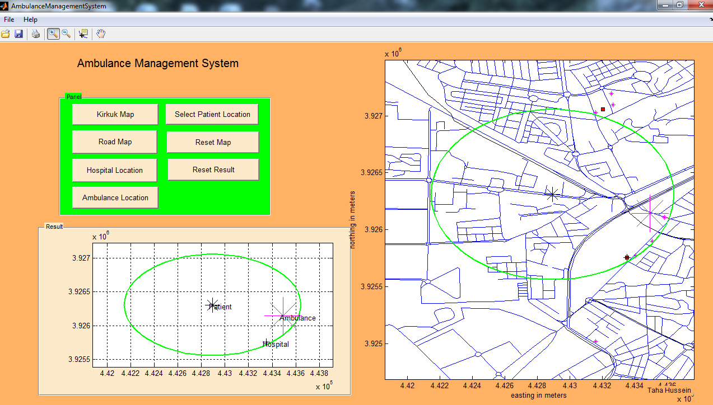

Figure 11. AMS display after zooming

Exact GPS location data (i.e., object coordinates) can be observed by selecting the data cursor button. This feature is shown in Figure 12.

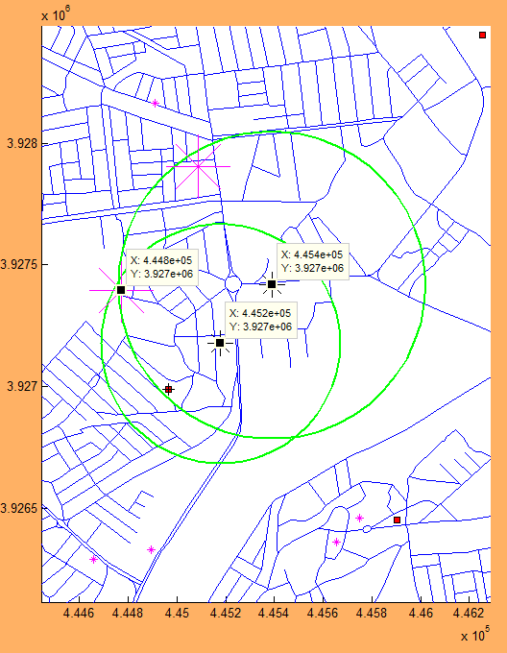

Figure 12 AMS display after selecting the data cursor button

# **Conclusion**

During the course of the present paper it was found that the number of hospitals and small health units currently serving Kirkuk is insufficient. As a result, the ambulance service cannot carry out its duties efficiently. New hospitals and/or small health units must be built in many of the city’s districts, especially in the south and southwest. New criteria should be applied to ambulance distribution, similar to those used in other Middle Eastern and European countries. Ambulances should also be supplied with new GPS instruments in order to enable the service to make better decisions, thereby increasing the chances of saving patients’ lives. A new database should be built containing city data such as schools, infrastructure and police stations, etc. to help health institutions find the best way of serving citizens. Field research undertaken in the city has revealed that Kirkuk lacks many of the immediate resources required for an effective ambulance system; indeed, the present paper is aimed at overcoming these obstacles to proper service provision and as such is the first study in the province to do so. Effective emergency services must be able to perform to the highest level in the minimum time. As patients’ lives are at stake, emergency hospitals must be available at all times. The present paper used a road map of Kirkuk to assist in directing ambulances to accident locations. Many GIS applications are now available that have been developed specifically for such a purpose based on GPS and other real-time technologies. Such technologies are highly beneficial and play a major role in explaining the routing problem. Here the MATLAB software program was used to construct a GUI system with which to identify the nearest ambulance and hospital on Kirkuk’s road network. This interface is designed so that it finds the accident location on the road map, and uses this information to locate the nearest ambulance and hospital using real-time technologies. The proposed system identifies the shortest route from the nearest ambulance to the accident site, with the fastest route on both major and minor roads then formed.

Table 1 shows the difference in patient distance between the nearest and farthest ambulances. In this case the ambulance furthest from the patient is located inside the hospital.

Table 1. Difference in patient distance between nearest and farthest ambulances

|  |  |  |  |  |
| --- | --- | --- | --- | --- |
| Coordinate  Name | X (m) | Y (m) | Distance to patient (m) | Total Distance between patient ambulance and hospital |
| Patient | 4.448*105 | 3.925*106 | - | - |
| Hospital | 4.454*105 | 3.925*106 | 600 | - |
| Ambulance | 4.447*105 | 3.925*106 | 100 | 600 + 100 = 700 |
| Ambulance in Hospital | 4.447*105 | 3.925*106 | 600 | 600 + 600 = 1200 |

Figure 13 shows the above comparison presented in map form.

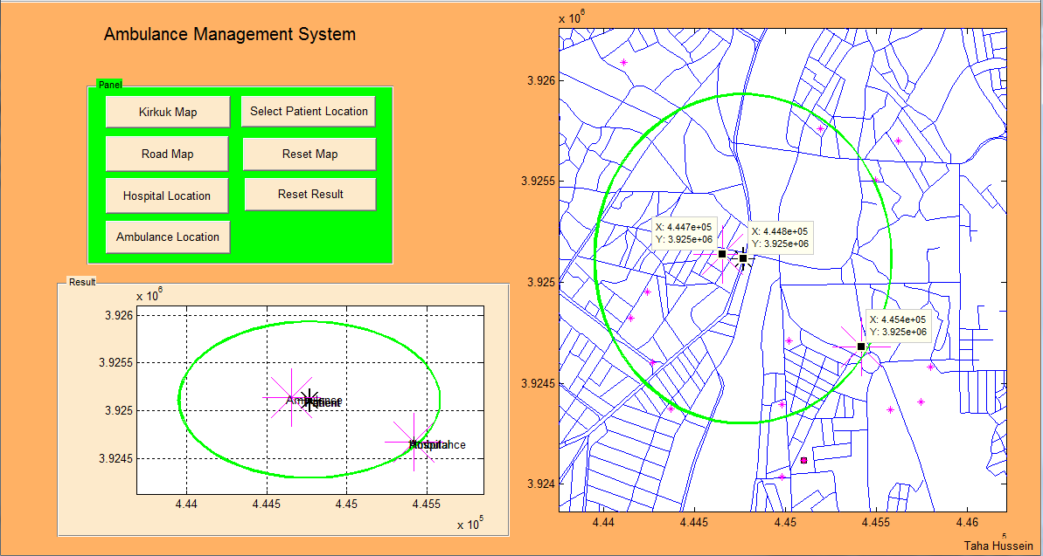

Figure 13 Map-based comparison of difference in patient distance between nearest and farthest ambulances

**References**

1. Rebawr S. M., (2013), “Spatial Analysis for the Secondary Schools Service in Kirkuk City”, Iraq, Master Paper, Erbil University, vol. 1, pp. 1-96.
2. Knights M., Ali A., (2010), “Kirkuk in Transition Confidence Building in Northern Iraq”, Apri, pp. 1-70.
3. Altay N., Green W. G., (2006), “III. Or/ms research in disaster operations management”, European Journal of Operational Research, vol. 175, pp. 475-493.
4. Toregas C. R., Swain R., ReVelle C. S., Bergman L., (1971), “The location of Emergency Service Facilities”, Operations Research, vol. 19, pp. 1363-1373.
5. Brotcorne L., Laporte G., Semet F., (2003), “Ambulance Location and Relocation Models”, European Journal of Operational Research, vol. 147, pp. 451-463.
6. Church R. L., ReVelle C.S., (1974), “The Maximal Covering Location Problem”, Papers of the Regional Science Association, vol. 32, pp. 101-118.
7. Schilling D. A., Elzinga D. J., Cohon J., Church R. L., ReVelle C. S., (1979), “The TEAM/FLEET Models for Simultaneous Facility and Equipment Sitting”, Transportation Science, vol. 13, pp. 163-175.
8. Daskin M. S., Stern E. H., (1981), “A Hierarchical Objective Set Covering Model for Emergency Medical Service Vehicle Deployment”, Transportation Science, vol. 15, pp. 137-152.
9. Hogan K., ReVelle C. S., (1986), “Concepts and Applications of Backup Coverage”, Management Science, vol. 34, pp. 1434-1444.
10. Gendreau M., Laporte G., Semet F., (1997), “Solving an Ambulance Location Model by Tabu Search”, Location Science, vol. 5, 75-88.
11. Daskin M. S., (1983), “A Maximum Expected Location Model: Formulation, Properties and Heuristic Solution”, Transportation Science, vol. 7, pp. 48-70.
12. Revelle C. S., Hogan K., (1989), “The Maximum Availability Location Problem”, Transportation Science, vol. 23, pp. 192-200.
13. Batta R., Dolan J. M., Krishnamurty N. N., (1989), “The Maximal Expected Covering Location Problem: Revisited”, Transportation Science, vol. 23, pp. 277-287.
14. Ball M. O., Lin L. F., (1993), “A Reliability Model Applied to Emergency Service Vehicle Location”, Operations Research, vol. 41, pp. 18-36.
15. Marianov V., ReVelle C. S., (1994), “The Queueing Probabilistic Location Set Covering Problem and Some Extensions”, Socio-Economic Planning Sciences, vol. 28, pp. 167-178.
16. Harewood S. I., (2002), “Emergency Ambulance Deployment in Barbados: A Multi-Objective Approach”, Journal of the Operational Research Society, vol. 53, pp. 185-192.
17. Doerner K. F., Gutjahr W. J., Hartl R. F., Karall M., Reimann M., (2005), “Heuristic Solution of an Extended Double-Coverage Ambulance Location Problem for Austria”, Central European Journal of Operations Research, vol. 13, pp. 325-340.
18. Jia H., Ordonez F., Dessouky M., (2005), “A Modeling Framework for Facility Location of Medical services for Large-Scale Emergencies”, ILE Transactions, vol. 39, pp. 41-55.
19. Rajagopalan H. K., Saydam C., Xiao J., (2008), “A Multiperiod Set Covering Location Model for Dynamic Redeployment of Ambulances”, Computers and Operations Research, vol. 35, pp. 814-826.
20. Gendreau M., Hertz A., Laporte G., (1994), “A Tabu Search Heuristic for the Vehicle Routing Problem”, Management Science, vol. 40, pp. 1276-1290.
21. Ferland J. A., Ichoua S., Lavoie A., Gagneh E., (1999), “Scheduling Using Tabu search Methods with Intensification and Diversification”, Computers and Operations Research, vol. 28, pp. 1075-1092.
22. Gendreau M., Laporte G., Vigo D., (1999), “Heuristics for the Traveling Salesman Problem with Pickup and Delivery”, Computers & Operations Research, vol. 26, pp. 699-714.
23. Osman I. H., (2005), “A Tabu Search Procedure Based on a Random Roulette Diversification for the Weighted Maximal Planar Graph Problem”, Computers and Operations Research, vol. 33, pp. 2526-2546.
24. Bock S., Rosenborg O., (2000), “A New Parallel Breadth First Tabu Search Technique for Solving Production Planning Problems”, International Transaction in Operational Research, vol. 7, pp. 625-635.
25. Brandeau M. L., McCoy J. H., Hupert N., Holty J. E., Bravata D. M., (2009), “Recommendations for modeling disaster responses in public health and medicine: A position paper of the society for medical decision making”, Medical Decision Making, vol. 29, pp. 1-23.
26. Haghani A., Tian Q., Hu H., (2004), “Simulation model for real-time emergency vehicle dispatching and routing”, Transportation Research Record, vol. 18, pp. 176-183.
27. Andersson T., Varbrand P., (2007), “Decision support tools for ambulance dispatch and relocation”, Journal of Operational Research Society, vol. 58, pp. 195-201.
28. Maxwell M. S., Restrepo M., Henderson S. G., Topaloglu H., (2010), “Approximate dynamic programming for ambulance redeployment”, Informs Journal on Computing, vol. 22, pp. 266-281.
29. Derekenaris G., Garofalakis J., Makris C., Prentzas J., Sioutas S., Tsakalidisan A., (2000), “Information System for the Effective Management of Ambulances”, IEEE, pp. 32-41.
30. Rajesh Kumar V., Benedict, P., (2011), “Development of Route Information System for Ambulance Services using GPS and GIS – A study on Thanjavur town”, International Journal of Geomatics and Geosciences, vol. 2, pp. 22-31.
31. Haghani A., Oh. S., (1996), “Formulation and solution of a multi-commodity, multi-modal network ow model for disaster relief operations”, Transportation Research, vol. 30, pp. 231-250.
32. Fiedrich A., Gehbauer F., Rickers U., (2000), “Optimized resource allocation for emergency response after earthquake disasters”, Safety Science, vol. 35, pp. 41-57.
33. Barbarosoglu G., Arda Y. A., (2004), “Two-stage stochasting programming framework for transportation planning in disaster response”, Journal of the Operational Research Society, vol. 55, pp. 43-53.
34. Yi W., Kumar A., (2007), “Ant colony optimization for disaster relief operations”, Transportation Research, vol. 43, pp. 660-672.
35. Gong Q., Jotshi A., Batta R., (2009), “Dispatching and routing of emergency vehicles in disaster mitigation using data fusion”, Socio-Economic Planning Sciences, vol. 43(1), pp. 1-24.
36. Gong Q., Batta R., (2007), “Allocation and reallocation of ambulances to casualty clusters in a disaster relief operation”, IEEE Transactions, vol. 39, pp. 1-27-39.
37. Gong Q., Batta R., (2005), “Responding to casualties in a disaster relief operation: Initial ambulance allocation and reallocation, and switching of casualty priorities”, PhD paper, The State University of New York, Buffalo, United States, pp. 1-80.
38. Jenkins L. E., McCarthy M. L., Sauer L. M., Green G. B., Stuart S., Thomas T. L., Hsu E. B., (2008), “Mass casualty triage: Time for evidence-based approach”, Prehospital and Disaster Medicine, pp. 1-85.
39. Batta R., Mannur N. R., (1990), “Covering-location models for emergency situations that require multiple response units”, Management Science, vol. 36, pp. 16-23.
40. Simpson N. C., Hancock P. G., (2009), “Fifty years of operational research and emergency response”, Journal of Operational Research Society, vol. 60, pp. 126-139.
41. Larson R. C., (1974), “A hypercube queuing model for facility location and redistricting in urban emergency services”, Computers and Operations Research, vol. 1, pp. 67-95.
42. Larson R. C., (1975), “Approximating the performance of urban emergency service systems”, Operations Research, vol. 23, pp. 845-868.
43. Pasha I., (2006), ”Ambulance management system using GIS”, Master paper, Linköping University, Sweden, pp. 1-78.
44. Forkuo E. K., Quaye-Ballard J. A., (2013),“GIS Based Fire Emergency Response System”, International Journal of Remote Sensing and GIS, vol. 2, pp. 32-40.
45. Quick Bird for Kirkuk City, (2010), “Requirements for ArcGIS”, vol. 10, pp. 20-30.
46. <http://kenanaonline.com/users/ahmedkordy/posts/197005>, (Data Download Date: 22-03-2014), pp. 1-5.
47. Abid Alrazaq A. H., (1977), “Cities Geography’’, Baghdad, Al Aney for Printing and Publishing, vol. 1, pp. 35.
48. Arshad K. A., (2012), “Mapping Representation for the Inside Network Road in Kirkuk City and Measure the Efficiency Using GIS Technology”, Iraq, Master Paper, Tikrit University, vol. 1, pp. 1-33.
49. Raheem M. A., (2007), “The Respond of the Population Job to Growth the Population in AL-Najif city (1977-1987-1997) and the Expecting in 2017”, Iraq, Master Paper, AL-Najif University, vol. 1, pp. 21.

8/23/2015