Variability in the Geophysical Properties of Three Termitaria in Lagos, Nigeria

Olowofoyeku, Adeoye Moses PhD, Aletan Ajumobi Owolabi

Department of Civil Engineering, Yaba College of Technology, Lagos, Nigeria

Abstract: The geophysical properties of three inhabited termite mounds in different locations of Lagos (Yaba, Festac and Ayobo) was studied in this paper. The Sieve analysis, Atterberg Limits (Liquid, Plastic and Shrinkage limits), shear strength, California bearing ratio, and Specific gravity are the geotechnical tests performed on each soil sample. Simple physical tests based on colour and texture of samples was also carried out. Chemical properties such as the metallic content, pH, organic carbon (OC), organic matter (OM) etc. were also examined. The results showed that the geotechnical, physical and chemical properties of termitaria varied from one location to another.
[Olowofoyeku, Adeoye Moses, Aletan Ajumobi Owolabi. Variability in the Geophysical Properties of Three Termitaria in Lagos, Nigeria. N Y Sci J 2015;8(8):55-58]. (ISSN: 1554-0200). http://www.sciencepub.net/newyork. 9

Keywords: geotechnical properties, physical properties, chemical properties, termitaria, location

Introduction
Termites are social insects living in colonies. They are sometimes called white “ants”; however they are not ants, because the true ants belong to the Order Hymenoptera, while termites belong to the Order Isoptera (Grimaldi and Engel, 2005). Engel and Krishna (2004), grouped termites into 6 families, 170 genera and about 2600 species, of which 300 species are said to be of economic importance.
Termites live in nests (termitaria) of their own construction. Nests are commonly located in larger timber or in the soil in location such as growing trees, inside fallen trees, underground and in above the ground mounds which they construct commonly called Termitaria / Termite mounds. The Termitaria are elaborate structures made using a combination of oil, mud, chewed wood/ cellulose, saliva and faeces. Termite workers build and maintain nest from their own droppings and soil. They also gather all the faeces produced by the other castes by eating the faeces. Worker then moves to an area where the colony is building a structure (e.g. nest enlargement, shelter tube, mud tunnel) and deposits their dropping as the building block of structure. The ability of termites to build highly complex structures is one of the wonders of nature.
In Nigeria, the most dominant species of mound building termites are the wood feeding and fungus growing Macrotermes bellicosus and the grass-harvesting Trinevitermes germinatus. However, M. bellicosus constitute the dominant species and has a wider distribution in the south-western zone of the country (Ata et al, 2006).
According to Lee and Wood (1971), Termites process considerable quantities of material in their building activities, strongly influencing the soil properties as compared to surrounding soils. This suggests that the activities of termites alter the soil leading to soil development.
Leepage et al (1998) found that the soil texture and structure on the termite mound were strongly modiﬁed as compared to the surrounding control soil. The soil on termite mound exhibited a higher proportion of ﬁne particles. The repacking of soils (selection and importation of ﬁnest soil particles from deep to upper soil horizons) by termites has been shown to be responsible for this change in the properties of the termitaria as compared to the surrounding soil (Grassé, 1984; Lee and Wood, 1971; Malaka, 1977).
The influence of activities of termites on the index properties of termite reworked soils and non-reworked surrounding soils from Ado-Ekiti, Southwestern Nigeria was investigated by Abe and Oladapo (2014). Some index parameters such as specific gravity, grain size distribution, consistency limits and linear shrinkage of the soils were determined. The results showed that the specific gravity of grain of the termite reworked soils are higher than those of the surrounding soils. The plasticity indices and linear shrinkage of the termite reworked soils were however significantly lower than those of the surrounding soils. Findings from this work indicated that reworking by termites had improved the index properties of the studied termite reworked soils.
The foundation of most civil engineering structures is the soil on the earth’s crust. The question therefore arises when a termitaria is found on site whether to remove it completely from site or to use it for some other purposes such as levelling the ground level. This study centres on determining if such a termitarium is good enough as an engineering material by ascertaining if there is significant difference in the geotechnical, physical and chemical properties of termitaria in different locations.

Materials And Method
The test samples were taken from three randomly selected areas of Lagos state Nigeria. They are, Ayobo, Festac and Yaba areas of Lagos.
At each location, one termitaria was selected. A total of about 30kg of soil sample was taken from each location. Furthermore, a representative sample of termitaria soil from each location was taken to the soil chemistry laboratory to determine its chemical constituents.
In accordance with BS 1377 1991, the geotechnical properties such as particle size analysis, liquid limit, plastic limit, and shrinkage limit, California bearing ratio (CBR), compaction test, specific gravity and shear strength of each selected sample were carried out. Prior to the CBR and shear strength tests, the compaction test was carried out. This was in order to get the values of the optimum moisture content. These values were then used to prepare samples for the CBR and shear strength tests. Only unsoaked CBR test was carried out. Also, the shear strength test was carried out using a shear box machine.
The percentages of organic carbon (OC) and organic matter (OM) present in all samples was determined in the chemistry laboratory. Also levels of mineral elements such as iron (Fe), potassium (K), calcium (Ca), aluminum (Al), magnesium (Mg), soil pH, and nitrate (NO₃) level was determined.
The infrared Fourier transform spectroscopy method was used to determine the organic carbon in the soil. Furthermore, the level of organic matter was achieved through the reduction of potassium dichromate by OC compounds and subsequent determination of the unreduced dichromate by oxidation-reduction titration with ferrous ammonium sulphate.
The level of nitrate present was measured by ultraviolet spectrophotometers. The exchangeable cations such as Ca, Mg, and Al were determined by atomic absorption spectrophotometer. The level of K was determined using ion – selective electrode method, while Na level was obtained through flame atomic absorption spectrometry method.

Results And Discussions

The colour of the termitaria varied across all three locations. The termitarium at location A has a lateritic red colour while location B has a dark brown colour with black patches. The termitarium at location C was characterized by a light brown colour. Furthermore, the termitarium at location B had a high straw content. This was seen after the termitarium was opened up for sample collection.
The particle size distributions for all samples varied significantly. It can be observed that all the soil samples are fairly graded. At location A, The size of particles of termitaria was in the range of 0.075 to 1.16mm, while locations B and C were in the range of 0.075 to 1. The liquid and plastic limits of termitaria at location C was highest at 49.00 and 20.99 respectively as compared to 39 and 16.67, 17 and 2.94 of locations A and B respectively. These variation is reflected in Figure two below. The percentage variation from one termitarium to another was very small; the highest being 4.17% for liquid limit and 2.86% for plastic limit.
Compaction test was carried out to determine both the maximum dry density (MDD) and optimum moisture content (OMC). Both OMC and MDD values were not uniform for all termitaria as shown in Table 1. Variations in values occurred from one termitarium to the next in all the zones considered. The values of OMC obtained were used to prepared samples for shear strength and CBR tests.

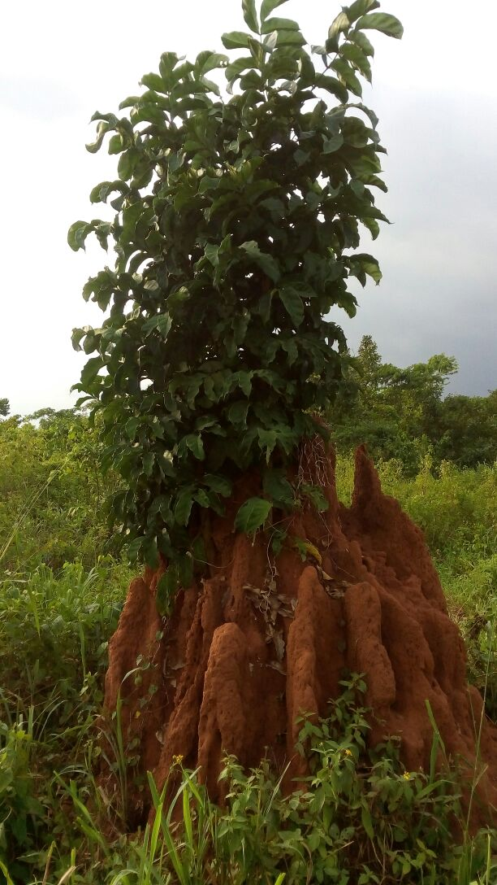
Figure 1: One of the Termitaria Prior to Sampling.

Figure 2: Variations in PL, LL, PI and SL

The stress was also measured using a shear box machine. This test produced the results shown in Table 1. The values of cohesion c' were very high for all the termitaria in the range of 38 to 58kN/m². The cohesion value for termitarium B was however the lowest with 38.0 kN/m². The highest percentage variation was 34.48kN/m². The angle of friction φ' values of termitaria differed from one to another and were in the range of 21 to 25º. Table 1 shows the specific gravity of the samples with evident variations in the values obtained. The highest percentage variation in specific gravity is 3.88%.

Table 1: showing results for cohesion (C) and angle of friction (Φ) from the shear box test
Site ID | Cohesion [C(kN/m²)] | Angle of Friction [Φ(º)] | Specific Gravity | Coeff. of Permeability X 10⁻⁴  mm/s
A | 58 | 25 | 2.50 | 7.74
B | 38 | 23 | 2.48 | 6.27
C | 52 | 21 | 2.58 | 6.85

The results of the chemical properties of the termitaria is displayed in Table 2. The pH values indicated that the termitaria A and B are acidic while termitarium C is alkaline. The Organic carbon content and Organic matter percentage content varied from one termitarium to the other. There was no variation in the organic matter and organic carbon content of termitarium C. The nitrate values as well as the value of metals also varied between locations. The values of Magnesium (Mg) and Iron (Fe) were however considerably higher than other metals across all termitaria.

Table 2: showing results of Chemical Properties of Termitaria
Termitaria  Location | pH | OC  % | OM  % | NO3 * | Mg * | Fe * | Ca * | K * | Si * | Al *
 |  |  |  | (cmol / g)
A | 7.2 | 0.26 | 0.35 | 0.012 | 1.38 | 1.40 | 0.41 | 0.45 | 0.13 | 0.52
B | 7.4 | 0.58 | 0.62 | 0.020 | 1.24 | 1.41 | 0.41 | 0.48 | 0.14 | 0.60
C | 6.8 | 0.50 | 0.50 | 0.042 | 1.28 | 1.46 | 0.44 | 0.58 | 0.13 | 0.62
* measured in cmol / g

CBR values ranging from 3 to 7% are considered as a poor to fair consistency. Table 4 shows that the CBR value of the termitaria at locations A1, B1 and C1 with values 9.25, 9.16, and 9.25% respectively are better than the adjacent surrounding soils. The values of the adjacent surrounding soils range from 7.04 to 7.13%.

Table 3: CBR values for all site locations
Location | A | B | C
CBR % | 9.25 | 9.16 | 9.25

Conclusion
Haven carried out studies on the geophysical properties of these three termitaria, the study has shown that the geotechnical properties of the termitaria soil is better than that of the adjacent surrounding soil. It is therefore advised that if termitaria are encountered on construction sites, they can be used as earthwork or backfill materials rather than discard them.

References
- Engel, M.S. and Krishna, K. (2004). “Family-group names for Termites (Isoptera)”. American Museum Novitates 3432: 1-9.
- Grimaldi, D. and Engel, M.S. (2005). Evolution of the Insects. Cambridge University Press. 145pp.
- S. Konat´e, X. Le Roux, D. Tessier, and M. Leepage (1998), “Inﬂuence of large termitaria on soil characteristics, soil water regime, and tree leaf shedding pattern in a West African savanna,” Plant and Soil, vol. 206, no. 1, pp. 47–60.
- Abe, O.E. and Oladapo, S.A (2014). “Investigation of the Index Properties of Lateritic Soil Reworked By Termite for Road Construction”, International Journal of Engineering Research & Technology (IJERT), Vol. 3 Issue 4, pp. 1032-1034, 2014.
- Grasse, P.P Termunologia foundation dee societee et construction. Tome 11: Masson, pp:613
- Malaka, S.L.O, (1977), “A study of the chemistry and hydraulic conductivity of mounds materials and soils from different habitats of some Nigerian termites.” Aust. J. Soil Res., 15: 87-92.
- Lee, K. E. and T. G. Wood (1971). "Physical and chemical effects on soils of some Australian termites, and their pedobiological significance." Pedobiological 11: 376-409.
- Olusola E.A., Olanipekun O., Ata and O.T. Olateju (2006): “Studies on Termite Anthill and Lime as Partial Replacement for Cement in Plastering”. Building and Envirinmental, Vol. 41, Issue 3, Page 302-306.
- BS 1377 Methods of test for Soils for civil engineering purposes (England: British Standards Institution, 1998).

8/23/2015

