**Fluid flow modeling and optimizing heat transfer from a pin fin surface, with changing the fin density**

Emran Nasiri1, Mehran Khaki Jamei2, Morteza Abbasi2

1. MSc in Mechanical Engineering, Energy Conversion, Islamic Azad University, Sari Branch, Mazandaran, Iran

2. Assistant Professor in Mechanical Engineering, Energy Conversion, Islamic Azad University, Sari Branch, Mazandaran, Iran

**Abstract:** This paper presents a computational study analyzes the performance and characteristics of thermal stability and resistance to air flow through a rectangular channel with pin fins, a circular shape with a smooth surface endothermic, by Staggered connection. The main purpose of these levels, increase heat transfer by increasing the surface. Fluid temperature and inlet pressure constant and uniform speed progressive, passes perpendicular to the fins. Three kinds of manufacturer named fin aluminum, nickel and steel fins have been used to study the effect of thermal conductivity material and heat transfer is assumed to be duales. In this article endothermic performance in the form of numerical, three-dimensional modeling software Catia and Ansys Fluent software is analyzed. Simulation models until they converge. The distance between the fins of the fin diameter along the direction of flow is concerned so that the distance fins along with steady steps. Turbulent flows with Reynolds number between 500 to 1100 using the finite volume method and SIMPLE algorithm and the model is solved. The results show that the heat transfer fins with any increase in density in the direction of flow is increased and the gap between the fins and fin increases heat transfer by reducing the pressure is high, but that depends on the Reynolds number. In this study we have shown that by changing the density of Huckleberry fin circular needle and sex selection and lowest pressure drop and heat transfer fin can be equipped.

[Emran Nasiri, Mehran Khaki Jamei, Morteza Abbasi. **Fluid flow modeling and optimizing heat transfer from a pin fin surface, with changing the fin density.** *N Y Sci J* 2015;8(8):1-9]. (ISSN: 1554-0200). <http://www.sciencepub.net/newyork>. 1

**Keywords:** heat exchanger, cross-flow, turbulent flow, fin density, pressure drop

**1. Introduction**

In this paper, numerical methods using Ansys Fluent for computation and simulation of heat transfer and turbulent flow is used.With the development of advanced semiconductor techniques, are coated small size electronic devices while significantly better performance is squarely addressed. As a result, it tends to increase the rate of heat production in volume has led pieces. If the heat cannot be removed properly, life can be very short piece, and overheating can even damage the normal functioning of the piece. Although various methods have been proposed to avoid excessive heating mode, by far the easiest and most effective way to improve the heat dissipation fins piece of cooling air.

The development orientation, the cooling fins on the air to disperse the heat has attracted the attention of an acceptable design techniques have been proposed in recent decades. The following are the articles related to the topic of our discussion are:

Kays [1] conducted an extensive study on compact heat exchangers and thermal performance of heat exchangers and multiple correlation between the flow properties to be concluded.Khan et al. [2] average heat transfer coefficient for tanks in the cross tube transverse and longitudinal distance, Reynolds and Prandtl numbers depends.Dense cases (parallel or triangular) heat transfer rates greater than those that are widely spaced show and mode of heat transfer rate is higher than the parallel mode.Ko-Ta Chiang et al. [3]. The most important parameter affecting the overall thermal performance characteristics, height and diameter of Huckleberry Finn is. Both the design parameters for the amount of heat and remove heat absorption coefficient of influence.Kai-Shing Yang et al. [4] in the triangular arrangement, with increased density fins, increasing heat transfer coefficient than circular needle and Huckleberry Finn needle-shaped oval shows the lowest pressure drop.Tzer-Ming Jeng [5] looked at the number of fins increases or decreases width to length ratio, dimensionless pressure drop through the heat absorbing fin needle will increase**.** In addition, by increasing the heat transfer fin density increases. Leon and others [6] The performance of a scheme of arrangement (triangular) and parallel (side by side) were compared cooling fins.The results showed that the model offers many advantages in comparison with the parallel model, because for a given input speed, the use of an endothermic by ordering an always maximize the heat transfer flux.

Sahiti et al. [7] showed that the use of cylindrical fin heat exchangers significantly improve heat transfer.Potter and others [8] The numerical results with the use of turmoil, the two examples of circular shape and the triangular fin needle, and to achieve good results were compared.Ames and Dvorak [9] experimental studies to clarify the physics of fluid dynamics rows of needle Finn did improve heat transfer.They observed that in the front row where turbulence is low, the power flow dramatically increases with Reynolds number.Profile of slow out of the fins, signs of separation unstable show in the front rows. In the third row and beyond the laminar boundary layer off the fins are quite similar. Dvinsky and others [10] Benefits rows interlaced (triangular) to a row (parallel) was shown.Mon and Gross [11] In a comment on the effects of heat exchangers with duct Faslhg let Fynha has studied Fin ring.Yang et al [12] studies did not examine the hydraulic performance thermal heat storage. They compare the heat transfer performance-related and spacing Finn took effect.Sahin [13] The effect of air velocity, thermal properties and fluid needle fins, relative height and shape of the lateral cross section of the needle fins using a fin for heat exchangers mile circular needle investigated. Goldstein and others [14] extraordinary review of a pin fin heat transfer have provided enhancement of theoretical, analytical and empirical.Sara et al. [15] experimental studies on acupuncture triangular fin dimensions 10 × 10 × 40 mm square were cut fin.The study compared numerous specific distance away from the fin needle.Sara et al. [16] reported a similar phenomenon and additional surface exposed to fluid, due to increased heat transfer to the spacing of the it.Larson and Sparrow [17] compared the performance needle Finn rows that are different in terms of geometry and longitudinal flow path progressively been placed. Ames et al. [18] carried on an experimental study for a row of pin fins (triangle) at Reynolds numbers 3000, 10000 and 30000 was based on the maximum speed between the cylinders.Measurements of turbulence and velocity, at the entrance and near the row of pins using the barometer was hot wire.Teeth with various angles and compare the results of experimental and theoretical data had showed that shear stress transition turbulence model for convective heat transfer in such channels is appropriate.

Incropera [20] experimentally observed that the flow around a cylinder roughly the equivalent of around a single needle in cross-flow (the fluid that flows perpendicular to) be taken into account.Tahat and others [21] The experimental hydraulic and thermal steady state performance, the Finn made on the basis of the horizontal needle was investigated.The effects of changing the geometric structure of the needle Finn and studied music airflow. Zukauskas [22] at low Reynolds number Re<103, mainstream fluid channels in the side walls of the Pacific, as well as areas of turbulent flow rotary large-scale work on the boundary layer viscous forces within the front channels to the desired pressure is achieved.This flow pattern within the channel side Re<103, that happens to be a very significant flow of calm with large-scale vortices in the areas of recycling, should be considered.Mon and Gross [23] in a comment on the effects of spacing fin heat exchangers with fins annular channel has studied.Babus’Haq [24] the experimental cooling using forced convection in a building on the steady-state Finn horizontal needle investigated.Sunderland [25] In vitro evaluation of forced convective heat transfer fin for a needle in a row arrangement (parallel) have done and achieved good results.

**Heat Exchangers**

Heat exchangers to transfer heat from one fluid equipment that warm to a cold fluid, which in most cases this is done by a metal wall interface. Convective heat exchangers in the original equipment (movement) is heat, because it is convective transfer function governed. Convection in a heat exchanger is always subject to compulsory military or without phase change may be one or more fluid. Compact heat exchanger (CHEs) surface area to volume ratio of the offer, which is usually used for gas-gas more than 700 m2/m3 and more than 400 m2/m3 are used for liquid-gas. This means that CHEs must have developed a number of levels. Needle fins are commonly developed as levels are used to enhance heat transfer and turbulence. CHEs in a wide range of applications, including air conditioning condensers, evaporators and radiators for cars and many other items used. Pin fin heat exchangers on the basis that are considered in this paper, the kind that is widely used to cool electronic devices.

**Fins**

Fins are widely used in industry, including the cooling fins on the body of the motorcycle, lawnmowers, power transformers cooling fins, super heaters, gas turbines, chemical industry, aircraft industry, finned tubes and heat exchange between air and fluid (Fig. 1) have to strengthen the ventilation system is used, as well as pre-cooling of computer components and so on. The spread of the heat exchanger for maximum heat exchange also are used. Fin also benefited from the phenomenon of nature, fox ears of mice and rats as fin who wants to heat the blood that flows through it to air transport. Another application of fins to increase surface area is in the tube. Depending on the application, may be used Finn inside or outside pipes are installed. In any application, select the type of fin on factors such as size, weight, manufacturing process, costs of production, reduction of conductivity and increase the pressure drop depends on the fin. Electronic components which must be cooled using a small sample of fluid heat exchangers are to be confined in a small volume and cooling operations are performed on it. Although the use of acupuncture in some types of heat exchanger fins are not common, this type spread widely in the electronics industry have been used.

In the electronics industry due to the increase in speed and performance parts, thus increasing the heat output and space constraints (in computers and netbooks) application is very important.



Fig. 1: Various use of fins in industies

**Heat Sinks**

As you know, we can Huckleberry Finn to short and long, depending on the ratio of fin height to diameter divide H/D. Short fin H/D are between 0.5 and 4 when H/D is greater than 4. The long fins in very high heat transfer coefficient of the short-fin industry, especially for thermoelectric cooling devices used in endothermic [7]. Heat sinks Finn needle of a base and an array of fins attached to its integrated form. They can be classified in many ways the contract, such as under (i) or heavy and (ii) parallel or checkered. Efficient cooling fin design for thermal gravitational needle is forced displacement, in which the displaced air causes the formation of large amounts of air through the fins and heat-absorbing efficiency is improving.

Embedded efficient design of the cooling fins on the heat meters due to the movement of the needle while imported air cause significant air between Fynha formation and thus in turn increase the efficiency endothermic.

Many of the experiments carried out on tube bank, result in a better understanding of the flow behavior in needle fins are endothermic. Tests have shown that the pressure gradient, fluid viscosity and Reynolds number on pipeline control. This lack of uniformity of speed, turbulence and other factors, including the step of longitudinal and transverse step more complex than the current separate tube.



Fig. 2: Schematic pin fin heat absorbers grid (triangular)

**Transverse flow tube bundle**

Two triangular tubes for fluid velocity V (raster - one in the middle) and rectangular (in line). This tube diameter D and a step by step longitudinal cross-ST and SL, as measured from the center of the pipe is determined. Flow conditions in the category affected by the boundary layer separation and interaction of Vic, which affect heat transfer switch.







The heat transfer coefficient of the tube is a tube depends on its location. Factor related to a pipe in the front row is almost a factor only in the cross-flow pipes, and pipe heat transfer coefficient larger than the inner row.

First row turbulence act like a network pipes and tube heat transfer coefficient increases in the next row. However, in most situations, heat transfer conditions to be established, so that the rate of displacement in the pipes after the fourth or fifth row is a little change. Because the temperature of the fluid flow in the pipeline very varies categories, using the following equation can be expressed as temperature difference between Newton's law of cooling, heat transfer rate can be determined.



And logarithmic mean temperature difference equation is as follows:



Where Ti and TO, respectively, were fluid inlet and outlet temperatures and  logarithmic average temperature difference. Outlet temperature, which is required for , the following equation can estimate [20].



Where N is the number of tubes in batches and NT the number of tubes in the transverse plane.

During the cross-section of the tube is usually high pressure drop and the overall coefficient of heat transfer is much reduced. The rectangular arrangement of four phones in the next step without bending,  and , are equal to each other. In general, the average coefficient of heat transfer tubes in row 10 or row of the above categories related to it [27].



While *C1* and *m* is constant and Reynolds number listed in relations on the basis of the maximum speed of the fluid in the fin tube bundle is defined. Maximum speed in the configuration in horizontal cross may cross the A1 or A2 at the bottom happen. If the rows are placed in such a way that the , the *A2*will happen; Figure (3), in this case:



If value of Vmax be constant in A1; so we have:



Zukauskas suggests relationship more generally in the form of [3].



In the above equation, , , .

Because fluid properties should average inlet temperatures (Ti), and the output (T0) is calculated that the temperature of the heat transfer fluid with lower fins and heat transfer tubes increases.

While all properties other than constant  and , *C* and *m* are evaluated and listed in the table below. [25]

Have noticed a pressure drop in the pipe assembly pin fin heat transfer rates is expected. Or be required to move the body fluid power hose assembly usually has high operating costs and is proportional to the amount of pressure drop. Zukauskas [23] also noted the most reliable and most stable relationship for a given pressure drop. Tahat et al. [18] and Sara [19] of the relationship benefit analysis of their experiments. The relationship is as follows:



Fig. 3: Finn needle makeup line (parallel) (a) Stragged (b)

Table 1: constant for the equation (10) in a fluid pipe in two perpendicular [27]

|  |  |  |  |
| --- | --- | --- | --- |
| Staggered formation |  | **C** | **m** |
|  |  |  |  |
|  |  |  |  |



Coefficient of friction *f*  and correction factor *x* for a fin among the (triangular) diagram as shown in Fig. (4) is obtained. [20]

It must be understood that the shape of the Reynolds number in Fig. (4) and (5) will be entered on the basis of maximum fluid velocity (Vmax).

**Analysis of the results**

This chapter reviews density fins with the correct configuration and choosing the input and output temperature and velocity fin and heat flux, to obtain Nusselt value, up to the maximum heat transfer and minimal pressure drop comes.

For each model, the equations governing the flow and heat transfer in three dimensions using the finite volume method simultaneously been solved. SIMPLE algorithm is used to determine the pressure-speed. To achieve accurate simulation solution stable, the second order upstream scheme for the discrete equations. The discrete method is useful for handling sentences. Equations are solved to repeat the procedure until the full convergence. Simulations were performed for each model for the turbulent regime. To do the calculations, computational memory of a computer with four GB, 64 GB and a quad-core processor was used.

To simplify the analysis, two rows of fins, have been considered. Two in the middle of the two rows of fins spent and features thermal and flow between the two is assumed to be symmetric. With laminar flow over the heat exchanger, the symmetric boundary conditions may be more rational than if the flow is turbulent. Under turbulent flow conditions, initiate vortices in circular flow around the needles cause, enhance the flow asymmetry, so if cases of carelessness may be applied symmetrically. However, symmetric boundary conditions applied to calculations done better.

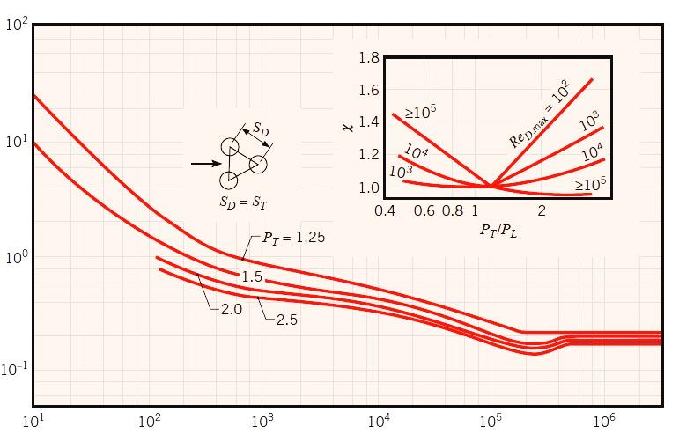

Fig. 4: Coefficient of friction *f*  and correction factor *x* in parallel arrangement (aligned)

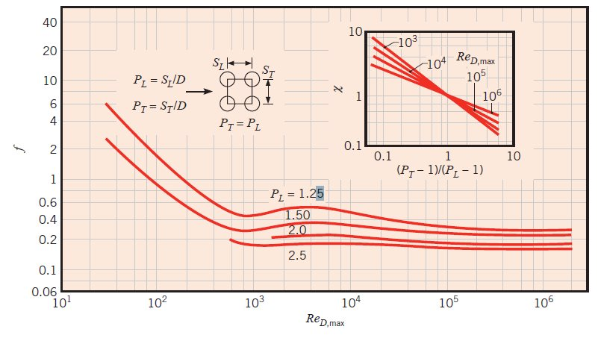

Fig. 5: Coefficient of friction *f*  and correction factor *x* in Triangular arrangement (diagonal)

**Effect of fin material**

Three kinds of manufacturer named fin aluminum, nickel or stainless steel thermal conductivity fin to study the effect of acupuncture on heat exchanger performance were considered. As previously mentioned, conjugated heat transfer fin rows of needle when considering material effect fin is assumed. Convective heat transfer properties of the rows of needles and the solid lines show the temperature in the area of computational fluid can be removed.

Heat from the heated floor (bottom) of the fins and the fin by conduction through turbulent fluid motion passed. Temperature difference between the Finn and downstream fluid flow direction is reduced. Fluid takes heat from the fins is that the fluid temperature increases. Observed that for aluminum fins, fluid outlet temperature maximum and minimum temperatures for the steel fins. Temperature differences between the fins and the fluid around the computational domain decreases. Heat transfer to aluminum fins Fin more than the other two types.

Table 2: heat transfer and pressure drop for aluminum fins

|  |  |  |  |  |  |
| --- | --- | --- | --- | --- | --- |
| Reynolds number | 200 | 400 | 550 | 700 | 800 |
| Nusselt number | 4.75 | 7.35 | 9 | 11.16 | 12 |
| Total pressure drop | 19.70 | 65.98 | 109.64 | 163.46 | 223.51 |

Table 3: heat transfer and pressure drop for Nickel fin

|  |  |  |  |  |  |
| --- | --- | --- | --- | --- | --- |
| Reynolds number | 200 | 400 | 550 | 700 | 800 |
| Nusselt number | 3.75 | 6.1 | 7.32 | 9.27 | 10 |
| Total pressure drop | 19.61 | 66.16 | 109.53 | 163.64 | 222.73 |

Table 4: heat transfer and pressure drop for Steel fin

|  |  |  |  |  |  |
| --- | --- | --- | --- | --- | --- |
| Reynolds number | 200 | 400 | 550 | 700 | 800 |
| Nusselt number | 2.53 | 3.69 | 4.58 | 5.1 | 5.39 |
| Total pressure drop | 19.56 | 64.98 | 108.84 | 162.30 | 221.36 |

Output for all modes due to convective heat transfer in high input speed is reduced. Nusselt numbers and total loss of Fshardr Reynolds Finn for three genera is provided.

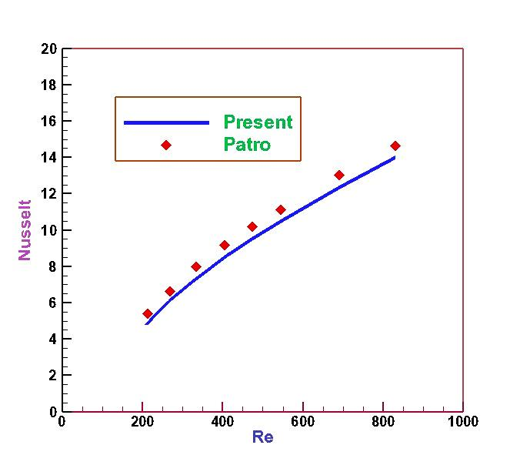

Fig. 6: validation of calculations with the numeric data Potter

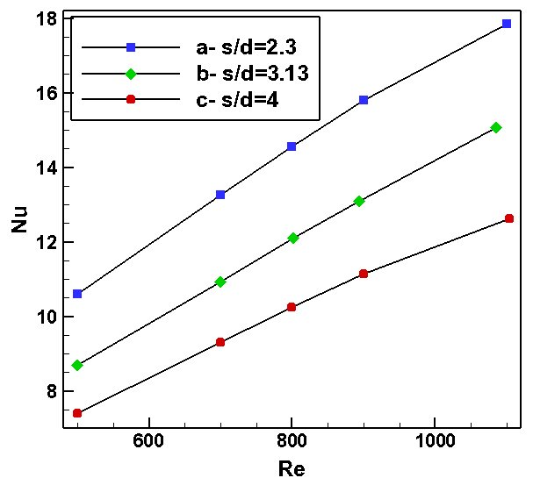

Fig. 7: changes of Nusselt number with Reynolds number for three shapes



**Conclusion:**

The increase in step with decreasing temperature difference because with the use of fins with more dense step, the set of pipes and then increase the heat transfer area. An increase in the pressure difference is because the reduction step, more compact heat exchanger and also narrows the flow ducts, duct obstruction and congestion is more current, it can be increased by changing the density fin heat transfer and pressure drop at the same time is also significantly reduced, thus:

Taking into account various factors to a compact heat exchanger such as heat, pressure drop, and density aluminum fin was recognized as the best material.

Reynolds numbers from 500 to 700 the numbers to work out a compact heat exchanger. Although more than 700 increases heat transfer by increasing the ratio Re corresponding to heat transfer increases in proportion to the pressure drop increase is small.

As far as heat transfer is important, fin spacing with S/d = 2.3 greater increase than the S/d = 3.13 and creates 4.0. The results show that by increasing the heat transfer fin spacing is reduced. These differences by interacting with reduced ring currents are caused by increased fin distance.

**Suggestions:**

Optimize heat transfer fin surface of a needle, by varying the density and changing the shape of the fins;

Optimize heat transfer fin surfaces with a needle, taking into account the radiation heat transfer;

Optimize heat transfer fin surface of a needle, by taking nanofluid.

**References:**

1. Kays,W. M. Pin fin heat exchanger surfaces. Trans. ASME,1955, 77, 471–83.
2. W.A. Khan a, J.R. Culham b, M.M. Yovanovich, Convection heat ransfer from tube banks in crossflow: Analytical approach(2006)
3. Ko-Ta Chiang, Fu-Ping Chang, Te-Chang Tsai, Optimum design rameters of Pin-Fin heat sink using the grey-fuzzy logic based on the orthogonal arrays(2006)
4. Kai-Shing Yang a, Wei-Hsin Chu b, Ing-Yong Chen b, Chi-Chuan Wang, A comparative study of the airside performance of heat sinks having pin fin configurations(2007)
5. Tzer-Ming Jeng, A porous model for the square pin-fin heat sink ituated in arectangular channel withlaminar side-bypass flow(2008)
6. Leon, O., Mey, G. D., Dick, E., and Vierendeels, J. Comparison between the standard and staggered layout for cooling fins in forced convective cooling. J. Electron. Pack., 2003, 125, 442–446.
7. Sahiti, N., Durst, F., and Dewan, A. Heat transfer enhancement by pin elements. Int. J. Heat Mass Transf., 2005, 48, 4738–4747.
8. Patro, P. Mathematical modeling and computation of three-dimensional, turbulent, convective heat transfer in a heat exchanger with circular pin fins. In Applied mathematical modeling, pp. 273–296
9. Ames, F. E. and Dvorak, L. A. Turbulent transport in pin fin arrays: xperimental data and predictions.J. Turbomach., 2006, 128, 71–81.
10. Dvinsky, A., Bar-Cohen, A., and Strelets, M. Thermofluid analysis of taggered and inline pin fin heat sinks. In Proceedings of the Inter Society Conference on Thermal phenomena, 2000, pp. 157–164.
11. Mon, M. S. and Gross, U. Numerical study of fin-spacing effects in annular-finned tube heat exchangers. Int. J.HeatMass Transf., 2004, 47, 1953–1964.
12. Yang, K. S.,Chiang, C., Lin,Y., Chien, K., and Wang, C. On the heat transfer characteristics of heat sinks: influenceof fin spacing at low Reynolds number region. Int. J. Heat Mass Transf., 2007, 50, 2667–2674.
13. Sahin, B. A Taguchi approach for determination of optimum design parameters for a heat exchanger having circular-cross sectional pin fins. Int. J. HeatMass Transf.,2007, 43, 493–502.
14. Goldstein, R. J., Ibele,W. E., Patankar, S.V., Simon, T. W., Kuehn, T. H., Strykowski, J., Kulacki, F. A., Kortshagen, U., Garrick, S., and Srinivasan, V. Heat transfer – are view of 2003 literature.
15. Sara ON. Performance analysis of rectangular ducts with staggered square pinfins. Energy Conversion and Management 2003;44:1787–803.
16. N. Sara, S. Yapici, M Yilmaz. Second law analysis of rectangular channel with square pin-fins. Int. comm. Heat and mass transfer, Vol 28. no. 5. pp 617-630,2001.
17. Larson, E. D. and Sparrow, E. M. Performance comparison among geometrically different pin fin arrayssituated in an oncoming longitudinal flow. Int. J. HeatMass Transf., 1982, 25, 723–725.
18. Ames, F. E., Dvorak, L. A., and Morrow, M. J. Turbulentaugmentation of internal convection over pinsin staggered pin-fin arrays. J. Turbomach., 2005, 127,183–190.
19. Lu, B. and Jiang, P. X. Experimental and numerical investigation of convection heat transfer in a rectangular channel with angled ribs. Exp. Therm. Fluid Sci., 2006,30, 513–521.
20. Incropera, F. P. Liquid cooling of electronic devices by single phase convection, 1999 (John Wiley, New York).
21. Tahat, M. A., Babus’Haq, R. F., and Probert, S. D. Forcedsteady-state convections from pin-fin arrays. J. Appl. Energy, 1994, 48, 335–351.
22. Zukauskas, A. and Ulinskas, R. Efficiency parameters forheat transfer in tube banks. Heat Transf. Engng, 1983, 36,19–25.
23. Mon, M. S. and Gross, U. Numerical study of fin-spacingeffects in annular-finned tube heat exchangers. Int. J.HeatMass Transf., 2004, 47, 1953–1964.
24. Babus’Haq, R. F., Akintunde, K., and Probert, S.D. Thermalperformance of a pin-fin assembly. Int. J. Heat Fluid Flow, 1995, 16, 50–55.
25. Maudgal, V. K. and Sunderland, J. E. An experimentalstudy of forced onvection heat transfer from inline pinfin arrays. In Proceedings of the 13th IEEE Semi-Therm Symposium, Austin, Texas, USA, 1997, pp. 149–157.
26. Zukauskas, A., “Heat Transfer from Tubes in Cross Flow,”in J. P. artnett and T. F. Irvine, Jr., Eds., Advances in HeatTransfer, Vol. 8, Academic Press, New York, 1972.
27. Tahat M, Kodah ZH, Jarrah BA, Probert SD. Heat transfers from pin-fin arrays experiencing forced convection. Appl Energy 2000;67/4:419–42.
28. Sahiti, N., Lemouedda, A., Stojkovic, D., Durst, F., and Franz, E Performance comparison of pin fin in-duct flow arrays with various pin cross-sections. Appl. Therm. Engng, 2006, 26, 1176–1192.
29. W. A. Khan, J. R. Culham, M. M. Yovanovich. Modelling of Cylindrical Pinfin Heat Sinks for Electronic Packaging. 21st IEEE semi-therm mposium.
30. F. P. Incropera, D. P. Dewitt, Fundamentals of Heat and mass transfer, Second Edition, Wiley, New York 1985.
31. Zukauskas, Heat transfer from tubes in cross-flow, Adv. Heat Tran. 18(1987) 87.
32. L. Tian, Y. He, Y. Tao, W. Tao, A comparative study on the air-side performance ofwavy fin-and-tube heat exchanger with punched delta winglets in staggered and in-line arrangements, Int. J. Therm. Sci. 48 (9) (2009) 1765–1776.

7/27/2015