In-vitro antimicrobial activities of crude and diluted Nigerian honey against some bacteria isolated from infected wound

Yahaya Usman ¹, Idris Abdullahi Nasir ², Nafiu Ahmed ³

^{1.}Faculty of Medicine, Ahmadu Bello University, PMB 05 Zaria, Kaduna state, Nigeria
^{2.}Department of Medical Microbiology, University of Abuja Teaching Hospital, PMB 228, Gwagwalada, FCT Abuja, Nigeria
^{3.}Department of Medical Laboratory Science, College of Medical Sciences, University of Maiduguri, PMB 1069 Maiduguri, Nigeria
(eedris888@yahoo.com)

Abstract: Wound infections have become a leading cause of frequent hospital visits and antimicrobial agents are crucial in their management. Regrettably, most incriminating bacteria are largely resistant to readily available conventional antibiotics. This study aimed to evaluate the antimicrobial activities of Nigeria honey on some frequently isolated bacteria from wounds swabs at University of Maiduguri Teaching Hospital, Nigeria. The in-vitro antimicrobial activities of the honey and comparative activity of pefloxacin against Staphylococcus aureus, Escherichia coli, Pseudomonas aeruginosa, Klebsiella pneumonia and Proteus mirabilis, were conducted using standard broth dilution and disc diffusion methods. Our finding showed that all pathogens were susceptible to the honey. Staphylococus aureus exhibited increasing zones of inhibition (ZI) in a dose- dependent gradient of honey but less sensitive than pefloxacin with complete ZI of 6mm. Klebsiella pneumonia showed partial ZI at 100% (3.5mm), with no ZI seen at other dilutions, it was also resistant to pefloxacin. Pseudomonas aeruginosa showed increasing ZI as concentration of honey increases, honey was also more effective than pefloxacin. Escherichia coli only exhibited ZI was at 100% (1.8mm) and was sensitive to pefloxacin with ZI of 3mm. Proteus mirabilis showed no ZI at all dilution except at 100%. It was also resistant to pefloxacin. Based on our findings, Nigerian honey produced significant in-vitro antibacterial activities against all test bacteria and it’s more efficacious than pefloxacin. This supports the use of honey for the management of infected wounds especially in resource-limited communities.
[Yahaya Usman, Idris Abdullahi Nasir, Nafiu Ahmed. In-vitro antimicrobial activities of crude and diluted Nigerian honey against some bacteria isolated from infected wound. N Y Sci J 2015;8(7):66-71]. (ISSN: 1554-0200). http://www.sciencepub.net/newyork. 11

Keywords: Bee honey; Antimicrobial effects; Wound infections; pathogens; Nigeria

1.0 Introduction
Wound healing is a complex and multi-stage process that is influenced by many intrinsic and extrinsic factors. The development of wound infection negatively impacts on this processes; delaying healing. In some cases, the effects are life-threatening (Siddiqui and Bernstein, 2010). The increasing prevalence of chronic wounds together with the emergence of antibiotic-resistant bacteria warrants further efforts to improve wound management practices and prevent complicated wound infection (Wolcott et al., 2010). This is intricate primarily because most wound infections are associated with nosocomial pathogens. Wound bacterial colonization and biofilms formation are influenced by the health of the host and the characteristics of the microbes (Church et al., 2006).
Microorganisms are present in all chronic wounds; they are acquired from the indigenous flora of the human host or from the external environment (Schultz et al., 2003). Polymicrobial wounds thus contain several potential pathogens, in which anyone of can cause infection. This delays wound healing and worsen morbidity thus causing patients great distress (Halcón and Milkus, 2003).
Honey is a thick sweet liquid made by honey bees (Apis mellifera) gotten from nectar of flowers. It is a popular sweetener, nontoxic, nonirritant and a common household product. Honey has high nutritive value as it contains several physicochemical and minerals (Al-waili, 2005). It is rich in both enzymatic antioxidants and non-enzymatic antioxidants including catalase, ascorbic acid, flavonoids and alkaloids however, all honeys are not chemically equal and new bioactive components are still being discovered (Kwakman, 2011).
Ever since ancient times, honey has been used not only as a natural sweetener but also as healing agent. However, scientific opinion of its nutritive and medical uses has differed and clashed with folklore Publications on the antibacterial activity and therapeutic use of honey have helped to establish scientific support for, and renewed interest in this ancient remedy (Subrahmanyam, 1991). One potential application of the antibacterial activity attributed to honey is in the treatment of wounds (Murray, 2010). The organisms most likely to cause wound infection include but not limited to Staphylococcus aureus, Streptococcus spp and pseudomonas aeruginosa. Composition of the microbiological flora present in a wound varies with the site of the wound, but polymicrobial infections are not uncommon. Various studies on the effects of honey in healing have been undertaken; however, not all honey samples show the same degree of antibacterial activities because a number of variables are involved (Molan, 1992).
These factors include sugar concentration (giving high osmotic pressure and low available water), acidity (pH 3.4–6.1 may contribute to the antibacterial activity of honey as the optimum for growth of many pathogens is pH 7.2–7.4) and hydrogen peroxide (glucose oxidase is present in honey and catalyzes glucose + H₂O+O₂→ gluconic acid + H₂O₂). In addition, non-peroxide microbial factors also appear to play an important role in antimicrobial activity. Honey with catalase added to remove peroxide activity and honey heat-treated to inactivate glucose oxidase still exhibit antibacterial properties (Molan, 1992).
The emergence and spread of antibiotic resistance is a worrisome public health issue. As such, there is need to revert back to natural extracts as alternative or adjunctive to conventional antibiotics. Biopharmaceutical evaluations of honey showed various physicochemical, antimicrobial properties and its possible utility for treatment of microbial infection as alternatives to orthodox synthetic drugs that pathogens have increasingly become resistant against. However, conventional antibiotics are not accessible to the most rural communities in underdeveloped and developing countries. For many years it has been known that honey demonstrates broad-spectrum antibacterial activity (Molan, 2006). Medical grade honey is recommended for use on open wounds because non-sterilised honeys can contain pathogenic organisms that have the potential to further infect vulnerable patients (Cooper and Jenkins, 2009).
This present study aimed to evaluate the antimicrobial activities of Nigeria honey against some bacterial isolated from wound swabs submitted for microbiological investigations at the university of Maiduguri teaching hospital, determine the minimum inhibitory concentration (MIC) of honey against each clinical isolates and to compare the efficacy of honey against pefloxacin; a commonly used synthetic antibiotic for wound infections. Since bee honey is readily available in several communities in Nigeria thus, this study sought to affirm the antimicrobial use of honey on wound especially in resource limited settings.

2.0 Materials and method
Source of test organisms
A total of 100 bacterial isolates were collected from medical microbiology laboratory, University of Maiduguri Teaching Hospital within April and June 2013. They comprised of 20 each of Staphylococcus aureus, Escherichia coli, Proteus mirabilis, Klebsiella pneumonia and Pseudomonas aeruginosa. The organisms were isolated from swabs taken from in-patients with infected wounds. Pure colonies of each of the bacterial isolates was obtained by culturing the bacterial isolates on their selective media. Bacteria biochemical test were performed to confirm identity of all isolates.
Preparation of test honey
The honey used in this study was obtained from Bama park market at Maiduguri metropolis, Borno state, Nigeria. The honey sample was cultured onto blood agar and MacConkey agar plates and incubated at 37⁰C for 24 hours. This was done to ascertain the microbial sterility of the honey. Thereafter, the honey sample was diluted to 10%, 20%, 50% (v/v) of its original concentration using sterile distilled water and 100.0% honey was referred to as ‘neat’.
Source of standard pefloxacin
A concentration of 0.5% pefloxacin; 5 mg/ml (ampoule) and dried circular discs was obtained for use. For MIC determination, 500 mg was emptied into 10 ml sterile distilled water to make up the stock solution of 5 mg/ml.
Preparation of the test bacterial isolates
Fresh plates of the test bacteria were prepared from the isolates culture obtained on agar slants. Three colonies of each of the isolates were picked with an inoculating loop and suspended in 5ml of peptone water and incubated at 37⁰c for 3 hours. This is to activate the organism. This was diluted with sterile distil water to a turbidity that matches 0.5 McFarland standard (10⁵ CFU/ml). 1ml of the standard inoculum of the different bacterial isolates, was used in flooding nutrient agar plates in the agar diffusion method for in-vitro antimicrobial susceptibility testing.
Agar Diffusion Test (Punch Hole Method)
Nutrient agar plates were prepared aseptically, allowed to set and dry. A loopful (4mm diameter) of the prepared standard inoculum dilution of the test bacterial isolates were separately applied to the center of the sterile nutrient agar and spread evenly using a sterile spreader. With the aid of the sterile standard cork borer 4 wells of 8mm in diameter were punched at different sites on the plates. The bottom of the wells was sealed with one drop of the sterile nutrient agar, to prevent diffusion of the honey under the agar. The first well was filled with 10%, second well with 20% third well with 50% and the fourth well with 100%. (Well 1 to 4). pefloxacin was used as the positve control.
The plates were allowed on the bench for 40 minutes, for pre-diffusion and then incubated at 37ºC overnight. The resulting zones of inhibition were measured in millimeters. The diameter of the zone of inhibition of the bacterial isolates in question was taken at that particular concentration.
Assessment of the antimicrobial activities of honey
The susceptibility of the test organism was identified by zones of inhibitions, which were indicated by clear zone around the wells to which different concentrations of honey were added.
Minimum inhibitory concentration (MIC)
The minimum inhibitory concentration gave the lowest (highest dilution) of the honey that can inhibit the growth of the test bacteria. This was determined by using the broth tube dilution method as describe by Ceyhan and Ugar (2001).
Freshly prepared nutrient broth was used in sterile tubes.1ml of nutrient broth was put into test tubes number two (2) to test tube number twelve.1ml of the honey was added to tubes 1 and 2.The honey in tube 2 was therefore diluted 1:2. It was properly mixed then 1ml was transferred to tube 3 giving 1:4 dilution this was continued until the 11th tube from which 1ml was discarded. The tube 12 which contain only nutrient broth, served as control. 1ml of the standard inoculum of each of the organism was then added to all tubes.
The entire procedure was repeated for all test organisms that were susceptible to honey. The tubes were thoroughly mixed and incubated at 37ºC for 24 hours. Thereafter, they were visually observed for turbidity after incubation by comparing with control tube.

3.0 Results
Our test honey had varied antimicrobial activities against all the bacteria isolates used in the experiment. Staphylococus aureus showed zone of inhibition at 10% (2.4mm), 20% (3.2mm), 50% (3.8mm) and neat (4.5mm) was sensitive to pefloxacin with complete zone of inhibition (6mm). Klebsiella pneumoniae shows partial zone of inhibition only at the neat with (3.5mm), no zone of inhibition was seen at 10%, 20% and 50% and was resistant to pefloxacin (0mm).
Pseudomonas aeruginosa showed zone of inhibition at 10% (4mm), 20% (4.7mm), 50% (5.0mm) and 100% (5.7mm) and was also sensitive to pefloxacin with complete zone of inhibition of 3.5mm. Escherichia coli showed no zone of inhibition at 10%, 20% and 50%. Zone of inhibition was only seen at 100% that gave 1.8mm, was sensitive to pefloxacin with zone of inhibition of 3mm. Proteus mirabilis showed no zone of inhibition at 10% (0mm), 20% (0mm), 50% (0mm) and neat 100% (1mm) and was also resistant to pefloxacin (Table 1).
The MICs of crude Nigerian honey on Staphylococus aureus was 1/16 (6.25%), Klebsiella pneumonia; 1/1 (100%), Pseudomonas aeruginosa; 1/16 (6.25%), Escherichia coli; 1/16 (6.25%) and Proteus mirabilis; 1/1 (100%) (Table 2).

4.0 Discussion
In general, all types of honey have an established potential to prevent microbial growth. Besides this property, honey clears infection in a number of ways, including boosting the immune system, inducing anti-inflammatory and antioxidant activities, and via stimulation of cell growth (Seckam and Cooper, 2013).

Table 1: Distribution and comparison of zones of inhibition at different dilutions of honey with the positive control on the bacteria isolates
Organism | 10% | 20% | 50% | 100% | Positive control | Negative control
Staphylococus aureus | 2.4mm | 3.2mm | 3.8mm | 4;.5mm | 6mm | NZI
Kebsiella pneumoniae | 0mm | 0mm | 0mm | 3.4mm | 0mm | NZI
Pseudomonas aeruginosa | 4mm | 4.7mm | 5.0mm | 5.7mm | 6mm | NZI
Escherichia coli | 0mm | 0mm | 0mm | 1.8mm | 3mm | NZI
Proteus mirabilis | 0mm | 0mm | 0mm | 1mm | 0mm | NZI
Key NZI: No Zone of Inhibition

Table 2: Minimum Inhibitory Concentration (MIC) of Nigerian honey on test organisms
Isolates | Neat | ½ | 1/4 | 1/8 | 1/16 | 1/32 | 1/64 | 1/128 | 1/256 | 1/572 | 1/1024
Staphylococus aureus | _ | _ | _ | _ | _ | + | + | + | + | + | +
Klebsiella pneumoniae | _ | + | + | + | + | + | + | + | + | + | +
Pseudomonas aeruginosa | _ | _ | _ | _ | _ | + | + | + | + | + | +
Escherichia coli | _ | _ | _ | _ | _ | + | + | + | + | + | +
Proteus mirabilis | _ | + | + | + | + | + | + | + | + | + | +
Key - = No visible growth (not turbid).
+ = Visible growth (turbid)

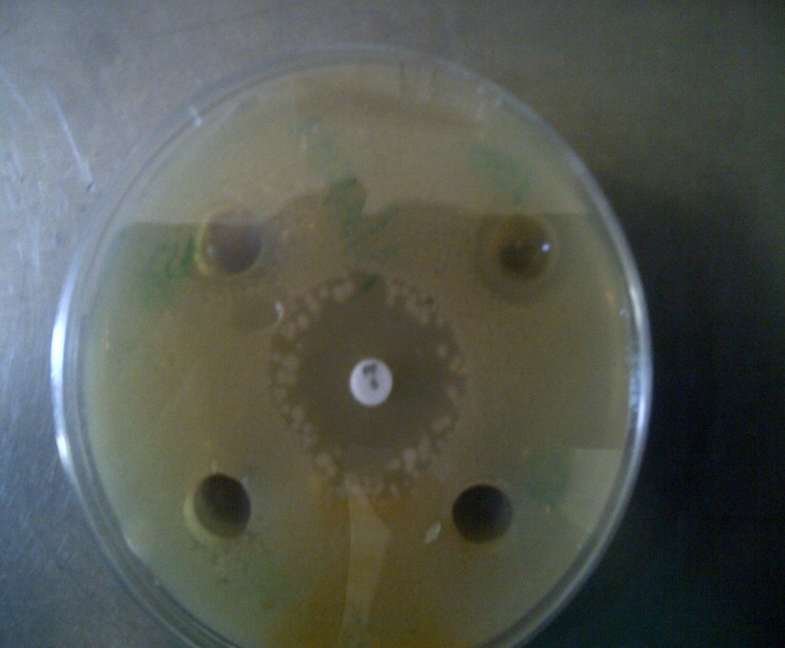
Fig. 1: Antimicrobial effects of test honey on Escherichia coli with pefloxacin at center

Fig. 2: Antimicrobial effects of test honey on Pseudomonas aeruginosa with pefloxacin at center

The results of our in-vitro susceptibility and minimum inhibitory concentration of diluted and crude honey had varying degree of antibacterial activities against Gram-positive as well as Gram-negative bacteria in a dose- dependent gradient. Our finding is in consonance with previous studies (Oyeleke et al., 2010; Allen and Hutchinson 2000; Agbaje et al., 2006). They found that honey inhibited the growth of Staphylococcus aureus, Escherichia coli, and Pseudomonas aeruginosa and 100% concentrated honey is more effective than other dilutions (Hamza et al., 2015).
Fig. 3: Antimicrobial effects of test honey on Proteus mirabilis with pefloxacin at center

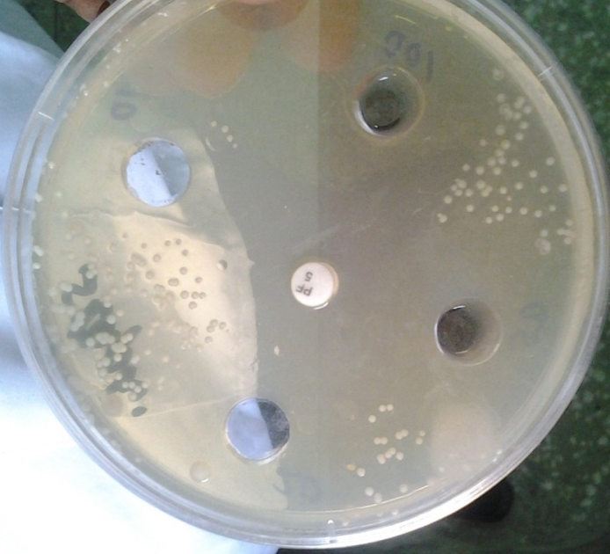
Fig. 4: Antimicrobial effects of test honey on Escherichia coli with pefloxacin at center

In the case of Proteus mirabilis and Klebsiella pneumoniae, antimicrobial activity was achieved only on crude honey (i.e. 100%), this observation was also reported from studies done by Nagaraj et al (2012) and Agbagwa and Frank – Peterside (2010) but differ from the result of other studies who showed that at low concentrations, the pathogens had cleared zone of growth (Chauhan et al., 2010; Miorin et al., 2003; Mullai and Menon, 2007; Sherlock et al., 2010). The difference in sensitivity could be due to different growth rate of bacteria, nutritional requirements, inoculums’ size, temperature and the test methods (Gail and Jon, 1995).
Our results also showed that Proteus mirabilis and Klebsiella pneumoniae was exhibited completely antibiotic resistance to pefloxacin, however, none of the bacterium resisted antimicrobial effect of honey. This is in conformity other studies (Agbaje et al., 2006; Petal, 2010; Mullai and Menon, 2005). The possible explanation for this phenomenon could be the test bacterium exhibit different modes of susceptibility to pefloxacin while honey contains several active antimicrobial ingredients that produce various effects/ targets on individual bacterium, as such they will rarely exhibit resistance to honey (Lusby et al., 2005).
It was clear that the MICs of honey on S. aureus and P. aeruginosa was 1/16 dilution of crude honey. These two pathogens are much frequently encounter in wound infection. At this concentration, it is interesting to know that infections by these bacteria may easily be cleared without necessarily consuming conventional antibiotic. While it could be said that honey when used in vivo might produce a greater effect than the in-vitro study, the antimicrobial profile might compare favourably with the present observation (Cooper et al., 2010). Users therefore need to be enlightened that honey, being a natural product with very few side effects could offer better alternative to conventional antibiotic therapies especially considering other human physiological activities honey enhances which aid rapid wound healing.

Source of Support: None

Acknowledgement
We will like to appreciate Mr. Babajidda Umar, Department of Medical Microbiology, University of Maiduguri Teaching Hospital, Nigeria for technical guide proof-reading the final draft manuscript before submission.

Corresponding author
Idris Abdullahi Nasir
Department of Medical Microbiology
University of Abuja Teaching Hospital
PMB 228 Gwagwalada, FCT Abuja, Nigeria
Email: eedris888@yahoo.com
Phone number: +2348030522324

Conflict of interest
Author declares that there is no conflict of interest associated with this manuscript.

References
- Agbagwa OE, Frank – Peterside N. Effect of raw commercial honeys from Nigeria on selected pathogenic bacteria. African Journal of Microbiology Research. 2010; Vol. 4(16) pp. 1801-1803.
- Agbaje EO, Ogunsanya T, Aiwerioba OIR. Conventional Use of Honey as Antibacterial Agent. Annals of African Medicine. Vol. 5, No. 2; 2006: 78 – 81.
- Allen KL, Hutchinson G, Molan PC. The potential for using honey to treat wounds infected with MRSA and VRE. First World Healing Congress, Melbourne, Australia 2000; 10-13.
- Al-waili NS. Investigating the antimicrobial activity of honey and its effect on the pathogenic bacterial infections of surgical wound and conjunctiva. J Med. Food. ;2005;7(2):210-222.
- Bansal V, Medhi P, Pandhi P. Honey a remedy rediscovered and it’s therapeutic utility. Kathmand University Med J. 2005; 3(3):305-309.
- Ceyhan N, Ugar A. Investigation into Invitro Antimicrobial Activity of Honey. Revista di Biologica. 94 (2) ; 363-352.
- Chauhan A, Pandey V, Chacko KM, Khandal RK. Antibacterial activity of raw and processed honey. Electron J Biol. 2010;5:58–66
- Church D, Elsayed S, Reid O, Winston B, Lindsay R. Burn wound infections. Clin Microbiol Rev 2006; 19: 403-434.
- Cooper R, Molan PC. The use of honey as an antiseptic in managing Pseudomonas infection. Journal of wound care. 1999; 8 (4); 161-164.
- Cooper R, Jenkins J. A comparison between medical grade honey and table honeys in relation to antimicrobial efficacy. Wounds. 2009; 21(2):29-36.
- Cooper R, Jenkins L, Henriques A, Duggan R, Burton N. Absence of bacterial resistance to medical grade manuka honey. Eur J Clin Microbiol Infect Dis. 2010; 29(10):1237-4.
- Gail W, Jon AW. Antibacterial Susceptibility Test; dilution and disk diffusion methods. Manual of Clinical Microbiology. 1995; 6th Ed; 1327-1332.
- Halcón L, Milkus K. Staphylococcus aureus and wounds: a review of tea tree oil as a promising antimicrobial. Am J Infect Control. 2004; 32(7):402-8.
- Hamza ASA, Aliyu AAM, Ibrahim FMA. Evaluation of Antibacterial Activity of Sudanese Bee honey Against Four Species of Bacteria. American Journal of Research Communication 2015: Vol 3(4) 132-142.
- Kwakman K. Two major medicinal honeys have different mechanisms of bactericidal activity. PloS ONE. 2011; 6(3): e17709.
- Lusby PE, Coombes AL, Wilkinson JM. Bactericidal activity of different honeys against pathogenic bacteria. Arch Med Res. 2005; 36:464-7.
- Molan PC. The antibacterial activity of honey. 2. Variation in the potency of the antibacterial activity. Bee World. 1992;73: 59–76 (http://hdl.handle.net/10289/2140).
- Molan PC. The evidence supporting the use of honey as a wound dressing. Lower Extremity Wounds. 2006; 5(1):40–54.
- Mullai V, Menon T. Antibacterial activity of honey against Pseudomonas aeruginosa. Indian J Pharmacol. 2005. 37: 403-7.
- Mullai V, Menon T. Bactericidal activity of different types of honey against clinical and environmental isolates of Pseudomonas aeruginosa. J Alternat Complement Med. 2007;13:439–441.
- Miorin PL, Levy NC, Custodio AR, Bretz WA, Marcucci MC. Antibacterial activity of honey and propolis from Apis mellifera and Tetragonisca angustula against Staphylococcus aureus. J Applied Microbiol. 2003;95:913–920.
- Murray M. Effect of honey against bacterial isolates from surgical wounds. Poster presentation. The biomedical scientist. 2010; 99-101.
- Nagaraj K, Suvarna VC, Gayathri D. In-vitro Antibacterial Activity of Honey on Health Hazardous Microorganisms. Research Journal of Pharmaceutical Sci. 2012; 3: 382- 384.
- Oyeleke SB, Dauda BEN, Jimoh T, Musa SO. Nutritional analysis and antibacterial effect of honey on bacterial wound pathogen Journal of applied Sciences research. 2010; 6 (11):1561-1565.
- Petal K. Two major medicinal honeys have different mechanisms of bactericidal activity. PloS ONE. 2011; 6(3): e17709 Pharmaceutical Sci. 2012; 3: 382- 384.
- Schultz G, Sibbald G, Falanga V. Wound bed preparation: a systematic approach to wound management. Wound Repair Regen 2003; 11: 1-28.
- Seckam A, Cooper R. Understanding how honey impacts on wounds: an update on recent research findings. Wounds International. 2013. 4 (1): Page 20 -24.
- Sherlock O, Dolan A, Athman R, Power A, Gethin G, Cowman S, et al. Comparison of the antimicrobial activity of ulmo honey from Chile and manuka honey against methicillin-resistant Staphylococcus aureus, Escherichia coli and Pseudomonas aeruginosa. BMC Complement Alternat Med. 2010;10:47.
- Siddiqui A, Bernstein J. Chronic wound infection: facts and controversies. Clin Dermatol.. 2010; 28(5):519-26.
- Subrahmanyam M. Topical application of honey in treatment of burns. Br J Surg 1991; 78:4978.
- Wolcott R, Cutting K, Dowd S, Percival S. Types of wounds and infections. In: S.L. Percival KFC, editor. The Microbiology of Wounds. Boca Raton, FL, USA: CRC Press, Taylor and Francis Group, 2010.

7/17/2015

