**Toxicological Evaluation of Graded Levels of *Areca catechu* seed flour on Performance of Albino Rats**

Ajayi Ibironke A., Ifedi Emmanuel N. and Ayinde Folakemi T.

Industrial Unit, Chemistry Department, Faculty of Sciences, University of Ibadan,

Ibadan, Nigeria

**Abstract:** The toxicological evaluation of graded levels of *Areca catechu* seed flour (ACSF) on albino rats was investigated in order to determine its suitability as an additive in feed supplement. The proximate analysis of ACSFshowed that it had high carbohydrate and crude fibre values of 79.18±0.64% and 34.25±0.01% but low protein, moisture, and ash contents of 4.20±0.08%, 6.79±0.02%, and 1.76 ± 0.03% respectively. The ACSF also contains iron, magnesium, copper and zinc at high concentrations. The result of the phytochemical analysis revealed that ACSF contains tannins, flavonoids and alkaloids. Twenty eight rats with an average weight of 40-60g were randomly allotted to four dietary treatment containing 0, 10, 20 and 30% of ACSF incorporated into the feed. During the rat experiment which lasted for eight weeks, rats in both the control and experimental groups appeared to suffer no major toxicological effect and weekly monitoring showed good physical appearance. Histopathological analysis of the organs of the rats showed no visible lesion in both the kidney and liver in the 10% incorporation. ACSF might be a good additive in feed supplemented at 10% level of inclusion.

[Ajayi Ibironke A., Ifedi Emmanuel N. and Ayinde Folakemi T. **Toxicological Evaluation of Graded Levels of *Areca catechu* seed flour on Performance of Albino Rats.** *N Y Sci J* 2015;8(7):5-13]. (ISSN: 1554-0200). <http://www.sciencepub.net/newyork>. 2

**Keywords:** *Areca catechu* seeds; mineral element; proximate; phytochemical; rats feed and toxicological evaluation

**Introduction**

Various parts of African savanna and forest tree species are used for food, wood or traditional and medicinal purpose. Still the lack of chemical knowledge for many species impedes a rational use of this biomass to contribute to sustainable development (Ambe, 2001; Cook *et al*., 2000).

*Areca* nut (*Areca catechu*), a family of Arecaceae, popularly known as betel nut, is one of the oldest known masticatories amongst Asia (Trease & Evan, 2009). It is the seed of the Areca palm which grows in much of the tropical Pacific, Asia, and parts of east Africa and even in Nigeria. It is a medium sized tree growing to 30m tall and with a trunk having 20-30cm in diameter. The leaves are 1.5-2cm long, pinnates, with a rigid and segments closely packed. Fruits are hard, ovoid, red-orange colored. They possess a fibrous mesocarp and a thin woody endocarp enveloping a seed (William et *al*., 2002).

The chemical constituents of *Areca* nut are mainly polyphenols including tannins, flavonoids and nine closely related alkaloids (George *et al.,* 2006) which include arecoline, arecaidine, arecaine, arecolidine, guvacine, isoguvacine, guvacoline, conine, norarecoline to pyridine group 6,7 besides carbohydrates, fats and minerals. Among the alkaloids, arecoline (0.12-0.24% in ripe nut) has been reported to be the main alkaloid having cholinergic muscarinic agonistic activity and mostly present in the seed as salt of tannic acid (Jayalakshmi *et al.,* 1982). *Areca catechu* extract has being reported to have central nervous stimulating effect which is mostly due to presence of these alkaloids (Dhinegra & Sharma, 2006; Azeez *et al.*, 2007).It was cited for its various medicinal properties, specially antibacterial and antiviral activities (Reena *et al.*, 2009).

Studies have been conducted on the use of a "pure" paan preparation: areca nut, betel leaf, and lime only. One animal study that was carried out in 1989 found that unprocessed areca nuts, even at high doses, displayed only a very weak carcinogenicity in mice, whereas use of processed areca nuts, as commonly used in paan preparations, caused cancer (Rao *et al.,* 1989). Since 1971, many studies have showed areca nut extracts to cause cancer in rodents, and other study further determined that paan, when consumed with and without tobacco, increased oral cancer risk by 8.4 and 9.9 times, respectively compared to those who do not consume paan*. Areca* nut powder extract has been reported to be capable of reducing silver ions to silver nanoparticles, which may be useful as antimicrobial agents (Bath *et al.,* 2012).

In rural communities and regions where there is food deficit, it is used as an appetite suppressant (Strickland *et al*., 2003). Lopez-Vilchez *et al*. (2006) reported a case of neonatal withdrawal syndrome in an infant born to a woman who was a chronic *A. catechu* nut user. Arecoline, the principal neuroactive alkaloid in *A. catechu* seed, was found in the mother's placenta. The habit of chewing *A. catechu* nut independently contributes to the risk of both hyperglycaemia and type-2 diabetes in Taiwanese men. This association is dose-dependent with respect to the duration of *Areca* nut use and the quantity of *areca* nut chewed per day (Tung *et al*., 2004). The utilization of ACSF in livestock diets has not been investigated. This study therefore aims at carrying out toxicological evaluation of graded levels of *Areca catechu* seed flour on performance of albino rats.

**Materials and Methods**

**Materials**

Mature *Areca catechu* seeds were picked from the trees within the University of Ibadan, Ibadan in Oyo State, Nigeria. The thin layers covering the seeds were manually decorticated to remove the kernels. Only healthy looking kernels, without infection or damage, were chosen for the analysis. The kernels of *Areca catechu* after being dried under the sun were grounded using a mechanical grinder to give the coarse seed flour. The flour obtained was further dried under the sun, reduced to a fine powder and then stored at room temperature until needed for analysis.

**Proximate analysis**

Moisture, crude fat, crude protein, ash and crude fibre contents of ACSF and the compounded feeds were analyzed using the method of AOAC (1990). Carbohydrate content was determined by difference [100 - (moisture content + crude protein + crude fat + ash + crude fibre)] (Ajayi *et al.,* 2013).

**Analysis of mineral elements**

Mineral composition of ACSF was determined following the method used by Ajayi *et al.* (2006) and Idouraine *et al*. (1996). 1g of the seeds was ashed in a muffle furnace at 550oC for 5h until a white ash was obtained. The minerals were extracted from ash by adding 3ml of concentrated HNO3 (63%). The digest was carefully filtered into 100ml standard bottle and made up to mark with deionized water. All the minerals were estimated with the use of an atomic absorption spectrophotometer (Perkin Elmer model 703, USA) with the exception of sodium which was determined by flame photometric method.

**Phytochemical screening**

ACSF was subjected to phytochemical screening for the identification of carbohydrates (Molisch test), reducing sugars (Fehling’s test), alkaloids (Dragendorff’s, Mayer’s, and Wagners’s tests), glycosides (hydrolysis test), flavonoids (ammonia and aluminium chloride tests), saponins (using frothing and emulsion), tannins (ferric chloride and lead acetate tests), steroids and terpenoids following the methods of Ajayi *et al*. (2011) and Harbone (1984).

**Feed compounding**

Four groups of animals were used for this study. The control rats were fed with diet containing 0 % ACSF while the other groups were fed with feed containing ACSF incorporated at different levels (10%, 20% and 30%) i.e. the diet of the test groups is the control diet substituted with ACSF at 10%, 20% and 30% (Table 2). The diets were prepared according to the procedure described by Souza *et al*. (2007) with slight modification. Each of the diet was pelletized, dried for two days and packed in four separate transparent plastic buckets.

**Animal, diets and feeding**

Twenty eight Wister rats of about eight weeks old weighing between 45g-60g were bought from the animal house, Veterinary Extension Unit, University of Ibadan, Nigeria. The rats were grouped according to their body weight into four groups of seven rats each, housed in perforated plastic cages for the study. They were weighed at the beginning of the experiment as zero (0) day. Their feed intake was monitored daily while their body weight was noted weekly. The rats had access to feed and water *ad-libitum* throughout the period of the study.

**Analysis of Haematological and biochemical parameter**

3ml of rat blood was collected into Ethylene Diamine Tetra Acetic Acid bottles through ocular puncture and used for haematological analyses. The packed cell volume, haemoglobin concentration, red blood cell, white blood cell, differential counts, mean corpuscular volume and mean corpuscular haemoglobin concentration were determined according to the methods of Jain (1986). Albumin and globulin were determined by colorimetry. The albumin/globulin ratio was obtained by dividing the calculated albumin value by the calculated globulin value. Aspartate aminotransferase and alanine aminotransferase were also determined (MAFF, 1984).

**Tissue pathology**

Small portions of heart, liver, kidney, lungs and brain were harvested and stored in 10% formalin for histological analyses. These tissues were fixed and put through series of dehydration in graded concentration of xylene. They were embedded in wax, sectioned at 5μ and transferred to clean glass slides. The thin sections were stained with haemotoxylin and eosin (H and E) dyes for examination under the light microscope for histological changes following the method described by Jain (1986).

**Statistical analysis**

Numerical data obtained from this study were expressed as mean values±standard error. Organ weights, biochemical and haematological determinations were analyzed using two ways ANOVA. A probability level less than 5 % (p <0.05) was considered significant.

**Results**

Tables 1-5 and figures1- are shown below**:**

Table 1. Physical properties/Phytochemical screening/Mineral composition of ACSF

|  |  |
| --- | --- |
| **Properties** | **Values** |
| Weight of 20 seeds(g) | 75.6 |
| Weight of a seeds(g) | 3.78 ± 0.33 |
| Seed length (cm) | 3.58 ± 0.28 |
| Seed width (cm) | 2.91 ± 0.10 |
| Colour of unripe seed | Green |
| Colour of ripe seed | Orange |
| State of the seed | Very hard |
| **Parameters** | **Designation** |
| Saponin | Present |
| Tannins | Absent |
| Flavonoids | Present |
| Steroids | Present |
| Cardiac glucoside | Present |
| Alkaloids | Present |
| Reducing sugar | Absent |
| Phenol | Absent |
| Anthraquinones | Absent |
| Glycosides | Absent |
| Phlobatannins | Absent |
| **Parameters** | **Concentration(mg/Kg)** |
| Potassium | 3170.00 |
| Calcium | 2170.00 |
| Magnesium | 674.00 |
| Sodium | 220.00 |
| Iron | 74.20 |
| Manganese | 18.00 |
| Copper | 9.95 |
| Zinc | 5.90 |
| Phosphorus | 1.25 |

Table 2. Percentage composition of the experimental diets

|  |  |  |  |  |  |  |
| --- | --- | --- | --- | --- | --- | --- |
| **Ingredients** | **%** | **Control (g)** | **0%** | **10%** | **20%** | **30%** |
| Maize | 40 | 3200 | 3200 | 2880 | 2560 | 2240 |
| Soy bean | 18.21 | 1,456.8 | 1456.8 | 1311.12 | 1165.44 | 1019.76 |
| Bone | 3.30 | 264 | 264 | 237.6 | 211.2 | 184.8 |
| Salt | 0.79 | 63.2 | 63.2 | 56.88 | 50.56 | 44.24 |
| Groundnut cake | 14.2 | 1,136 | 1,136 | 1022.4 | 908.8 | 795.2 |
| Corn bran | 7.08 | 566.4 | 566.4 | 509.76 | 453.12 | 396.48 |
| Palm kernel cake | 7.08 | 566.4 | 566.4 | 509.76 | 453.12 | 396.48 |
| Oyster shell | 2.26 | 180.8 | 180.8 | 162.72 | 144.64 | 123.56 |
| Wheat | 7.08 | 566.4 | 566.4 | 509.76 | 453.12 | 396.48 |
| ACSF | ---- | 0.00 | 0.00 | 800 | 1600 | 2400 |
| Total (g) | 100 | 8000 | 8000 | 8000 | 8000 | 8000 |

Table 3. Proximate composition of ACSF and experimental diets

|  |  |  |  |  |  |
| --- | --- | --- | --- | --- | --- |
|  |  | **Control** | **Experimental** | | |
| **Parameter** | ACSF | **0%** | **10%** | **20%** | **30%** |
| Moisture | 6.79± 0.02c | 10.14±0.01a | 09.12±0.02b | 8.80 ±0.06b | 8.39±0.05b |
| Ash content | 1.76±0.03c | 14.10 ±0.02 a | 15.61±0.02 a | 10.89±01b | 12.18±0.03b |
| Crude protein | 4.20±0.08 | 19.23±0.05a | 20.06±0.13a | 16.93±0.5b | 15.39±0.13b |
| Crude fat | 8.40 ±0.08c | 15.46± 0.6a | 13.60 ±0.03b | 13.68±0.01b | 13.64±0.04b |
| Crude fibre | 34.25±0.01a | 7.580 ±0.14d | 11.01±0.03c | 15.91±0.04b | 15.77±0.03b |
| Carbohydrate | 79.18±0.64 a | 41.07±0.06c | 41.61±0.14c | 49.70 ±0.09b | 47.41±0.14b |

Mean±SD for three replicate analyses

Values in the same row with the same superscripts are not significantly different at (P< 0.05)

Table 4. Serum biochemistry and haematological analysis of rats fed with of ACSF

| **Parameter** | **0%** | **10%** | **20%** | **30%** |
| --- | --- | --- | --- | --- |
| **Serum biochemistry** |  |  |  |  |
| Total protein | 7.86± 0.3 a | 6.8±0.79b | 6.6±0.2b | 6.7±0.10b |
| Albumin | 5.07±0.22 a | 4.03±0.97b | 3.73±0.15c | 3.78±0.05c |
| Globulin | 2.33±0.60b | 2.8±0.2 a | 2.3±0.56b | 2.9±0.00 a |
| Al/glob | 2.17 ± 0.57 a | 1.44 ±0.46b | 1.67± 0.35b | 1.3±0.00b |
| AST | 40.0 ± 1.00b | 39.33±1.36b | 43±1.22 a | 44.33±0.58 a |
| ALT | 28.33±0.94c | 28.67±0.58c | 30.3±0.58b | 32.00 ±1.00 a |
| ALP | 80.33±6.67 | 79.34 ± 3.80 | 85.00 ±16.52 | 91.33±9.02a |
| Urea | 14.67±0.71a | 14.33±0.58a | 14.33±0.58a | 14.33±0.57a |
| Creatine | 0.73±0.11 a | 0.7 ±0.10 a | 0.5± 0.00b | 0.57±0.06b |
| **Haematology** |  |  |  |  |
| PVC (%) | 48.86±2.54 a | 46.57±3.10b | 41.85±2.26c | 44.86±3.63 |
| MCH (%) | 20.1±0.53a | 19.87±0.69 a | 20 b.00±0.62 a | 19.84±0.64 a |
| MCHC (%) | 33.11±0.66a | 33.42±0.70a | 33.44±1.18a | 33.42±1.04a |
| MCV (%) | 60.72±1.48 a | 59.37±1.57 a | 59.81±1.30 a | 60.18±1.21 a |
| Hb (mg/dl) | 16.73±1.05a | 15.38±1.07 a | 14.00±0.79 a | 15.00±1.30 a |
| RBC (w6/ul) | 8.14±0.60 a | 7.75±0.73 a | 7.00±0.48c | 7.56±0.67b |
| WBC (w3/ul) | 8792.85±2794.55a | 9957.14±2,457.75a | 8464.28±1902.88a | 6678.57±3.05b |
| Lymphocytes (%) | 79±19.35a | 79.14±12.75 a | 73.43±19.44b | 74.85±7.19b |
| Neutrocyte (%) | 20.57±8.83b | 27.54±12.96 a | 22.00±948b | 17.17±7.40c |
| Eosinocyte (%) | 2.00±1.15a | 1.28±0.83b | 1.14±0.89b | 2.00±1.15 a |
| Monocyte (%) | 2.43±1.27a | 2.00±1.41b | 2.00±1.5b | 1.86±2.87 |
| Platelet(cell/cu.mm) | 149714.28±70,554 b | 166428.57±57,616 a | 139857.1±39,180 c | 111,514±55,820 b |

Means ± SD for seven rats per group AST- Aspartate aminotransferases ALT- Alanine aminotransferases, A/G Ratio- albumin globulin ratio. Values in the same row with the same superscripts are not significantly different at (P< 0.05)

Table 5. Histological result on the kidney and liver of the rats in the control and experimental groups

|  |  |  |  |  |
| --- | --- | --- | --- | --- |
| **Control group** | | **Experimental group** | | |
| **Tissues** | **0%** | **10%** | **20%** | **30%** |
| Kidney | There is moderate cellular infiltration and hemorrhage into the interstitium. | No visible lesions seen. | There is severe portal and central venous congestion. | No visible lesions seen. |
| Liver | No visible lesions seen. | No visible lesions seen. | No visible lesions seen. | The hepatocytes appear shrunken. There is moderate periportal and diffuse cellular infiltration by macrophages and few lymphocytes. |

Fig. 1. A chart showing the weekly feed consumption by rats fed with graded level of ACSF

Fig. 2. A chart showing the weekly body weight of the rats fed with graded level of ACSF

Fig. 3. A chart showing the weight of the brain, liver, kidney, heart, lung, spleen and intestine of the rats fed with graded levels of ACSF

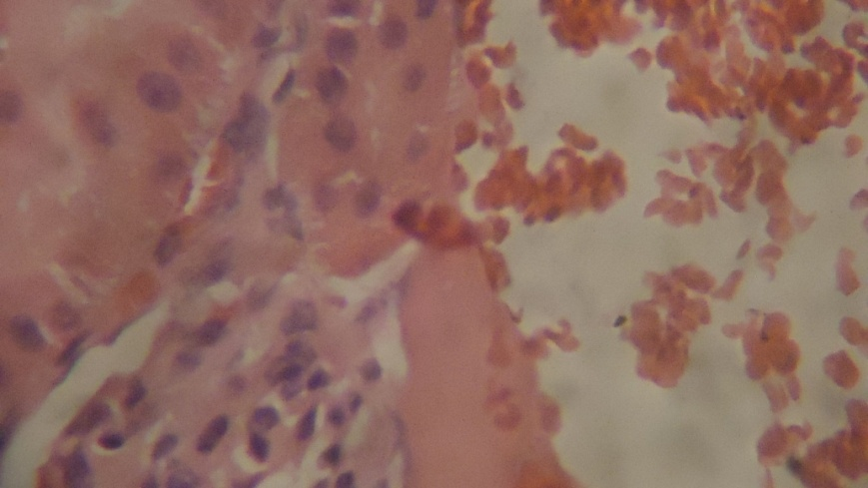

Fig. 4. Photomicrograph of the kidney of a control rat showing moderate cellular infiltration and hemorrhage into the interstitial (x550)

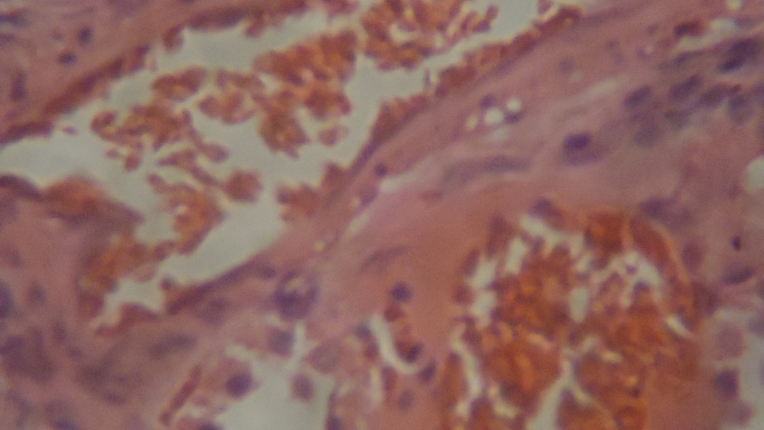

Fig. 5. Photomicrograph of the kidney of 20% rat experimental rat showing severe portal and central venous congestion (x550)

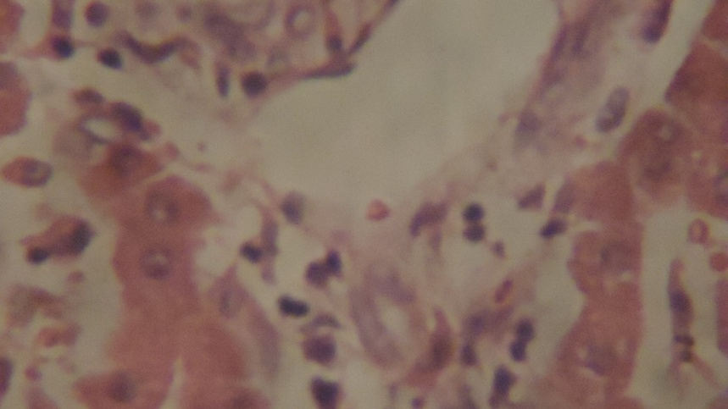

Fig. 6. Photomicrograph of the liver of 30% experimental rat showing hepatocytes that appears shrunken. There is moderate periportal and diffuse cellular infiltration by macrophages and few lymphocytes (x550)

**Discussion**

**Physical characteristics**

The physical characteristics of *Areca catechu* seeds is presented on Table 1. The seed has an average weight of 3.78 ± 0.33g; an average length of 3.58 ± 0.28 cm and an average width of 2.91 ± 0.10 cm. The seed is green when unripe but becomes orange when ripe.

**Phytochemical analysis**

ACSF were screened for phytochemical properties and the result on Table 1 showed that it contained saponin, phenols, steroids, flavonoids, cardiac glucoside and carbohydrate. These phytochemicals exhibit diverse pharmacological and biochemical actions when ingested by animals. Alkaloids are known to show medicinal as well as physiological activities (Sofowora, 1993).

**Mineral elements**

ACSF is very rich in potassium, calcium and magnesium (Table 1). Potassium (3170.00 mg/Kg) had the highest value followed by calcium (2170.00 mg/Kg), magnesium (674.00 mg/Kg) and slightly sodium (220.00 mg/Kg). These minerals in the diet are generally required for metabolic reactions, transmission of nerve impulse and rigid bone formation among others (Egwin *et al*., 2010). Other elements present in ACSF such as iron (74.20 mg/Kg), phosphorus (1.25 mg/Kg), manganese (18.00 mg/Kg), copper (9.95 mg/Kg) and zinc (5.90 mg/Kg) are low.

**Proximate composition**

The proximate analysis of ACSF is presented in Table 3. The ash content is 1.76±0.03% and it is higher than the value reported for *Propolis africana* seeds (Aremu *et al.,* 2007). The crude fibre content was found to be 34.25±0.01%. The carbohydrate content is very high; 79.18±0.64%. This high carbohydrate content and crude fibre values are in accordance with the report of IARC (2004). These values suggest that the seeds could serve as source of roughage and the suitability of compounding it in animal feed (Abighor *et al*., 1997). The protein content of ACSF is very low 4.20±0.08%. It is lower in comparison to the values of (11-27.8±0.04%) reported for wheat flour and defatted wheat germ flour (Muhammad *et al.,* 2007). The ash content, 1.76±0.02% is lower than the value reported for *A. heterophyllus* and *T. africana* (Ajayi *et al*., 2008), and greater than the values determined for seeds such as kolanut, coconut, and melon seeds (Onyeike & Acheru, 2002). Addition of ACSF resulted in an increase in the ash values of the feed compounded up to 15.61±0.02%, crude protein content up to 20.06±0.13% and fat content up to 13.69±0.03%. Higher values were obtained at the 10% inclusion.

**Feed intake and body weight changes**

There was a gradual increase in the quantity of feed consumed by rats in the 4 groups (0%, 10%, 20% and 30%) throughout the feeding trial that lasted for eight weeks (Figs. 1 & 2). There was steady but not rapid increment in the body weight of the rats during the experiment period. The control (0%) was found to have the highest weight gain followed by the 10% when compared to 20 and 30%.

**Physical appearance**

The physical appearance of the rats was normal in all the groups throughout the eight weeks of the experiment. The eyes, mouth and hair of the animals used in their respective groups appeared to be normal throughout the period of the study.

**Organ weights**

The weight of the seven organs collected for tissue pathology did not differ significantly from each other in both groups. An average kidney weight of 0.99±0.19g; 0.84±0.5g; 0.85±0.10g and 0.82±0.09g was obtained for the rats in the 0%, 10%, 20% and 30% groups while that of the heart was 0.60±0.15g, 0.62±0.27g, 0.48±0.15g and 0.48±0.07g respectively (Fig. 3).

**Haematological and biochemical parameters**

The results of the haematological and the biochemical studies of the rats used for the experiment were presented. Platelets had the highest value of 166,428.57±57,616 in 10% against the observed 149,714.28±70,554 in the control (0%) while all other haematological parameters such as neutrophil, WBC, RBC, HB, PVC, MCHC are also with higher values in 10% incorporation when compared to other levels of incorporations but are similar to that control. The absence of significant differences as shown among the control and 10% groups for the haematological parameters is an indication that ACSF may not be toxic and had no adverse effect on the blood of the rats under study at 10% incorporation. The haematological values from this study are similar to the report given by Vishnu *et al*. (2010) for the toxicity study of *Garcinia mangostana* pericarp extract in rats. The serum protein values are comparable to each other in the experimental groups but found to be lower than the control. The AST, ALT, ALP values appear to be increased gradually from 10% inclusion to the highest level of inclusion. These values in 10% inclusion though lower than others but are still comparable to the values obtained for the control group. Alanine aminotransferases enzyme activity examined was 80.33±6.67 in the control group feed as against 79.00±3.80, 85±16.52 and 91.33±9.02 that was obtained for the 10%, 20% and 30% groups respectively. The increase in the activities of ALT, AST and AST in 20% and 30% may probably be attributed to the dietary treatment effect of higher ACSF inclusion levels. It could be that as the inclusion level increased, the tendency of increase in the anti-nutritional factor in the experimental ingredient increased. Ewuola and Egbunife (2008) observed in the separate studies that increase in ALT and AST are clinical indication of diagnosing state of damage done to visceral organ by toxic substance or infection. Michael *et al*. (2012) reported a similar case with rabbit fed with kenaf seed meal at different levels of inclusion.

**Histopathology**

The histopathology study of the liver and the kidney of the rats used as experimental model revealed no major complications in the tissues of all the rats in the 10% groups (Table 5). For the other test groups, there is moderate periportal and diffuse cellular infiltration by macrophages and few lymphocytes in the liver of the 30% experimental group while no visual lesion were observed for both the 0%, 10%, and 20% respectively. There were severe portal and central venous congestion in the kidney of the 20% group while no lesion was observed in the 10% group. The 10% group was found to be normal during this study since no visual lesion was observed in both the kidney and liver.

**Conclusion**

ACSF may find usefulness in rat feed for livestock due to its high carbohydrate content. The feed however has to be supplemented with other high protein residue such as groundnut cake because it is in low protein. The presence of tannins, flavonoids and alkaloids in ACSF ascertained that it contains some major compounds that have remarkable biological activities hence it might be helpful in preventing various diseases. The metals that are found in ACSF are all useful in making the body strong. The incorporation of ACSF at 10% level into rat diet did not produce any significant changes in haematological parameters as well as in the heart and kidney of the rats; it can therefore be concluded that ACSF might be a good additive in rat feed at 10% level of inclusion.

**Acknowledgement**

The authors thank the Department of Chemistry, Faculty of Science and Department of Veterinary Pathology, Faculty of Veterinary of University of Ibadan, Ibadan, Nigeria for making their facilities available.

**References**

1. Ambe, G.A. (2001). Les fruits sauvages comestibles des savanes Guinéennes de Côte-d’Ivoire, état de la connaissance par une population locale, les Malinké. *Journal of Biotechnology Agronomic and Environment*, 5, 43–58.
2. William, S.E., Maillard J.Y., Russel A.D., Catrenich C.E., Charbonneau, A.L. & Bartolo, R.G(2002). Activity and mechanism of action of selected biocidal agents on gram - positive and negative bacteria. *Journal of Applied Microbiology*, 94, 240-247.
3. Cook, J., VanderJagt, D.J., Pastuszyn, A., Mounkaïla, G., Glew, R.S., Millson, M. & Glew, R.H. (2000). Nutritional and chemical composition of 13 wild plant foods of Niger. *Journal of Food Analysis*, 13, 83–92.
4. Trease, G.S. & Evans, H.C. (1978) Textbook of Pharmacognosy*.* 9th edition. Bailiar Zindall and Co., London, (1978).
5. George, W., Staples & Robert, F.Bevacqua: *Areca catechu* (betel nut palm) Species Profiles for Pacific Island Agroforestry. www.traditionaltree.org: August 2006 ver. 1. 3.
6. Jayalakshmi, A. & Mathew, A.G. (1982). Chemical composition and processing. In: Bavappa KVA, Nair MK. & kumar TP. eds. The areca nut palm, Kerala. *Central Plantation Crops Research Institute*. Pp 225-244.
7. Dhinegra, D. & Sharma, A. (2006). A review on antidepressant plants, Nature products radiance. *National Institute of Science, Communication and Information Resources*, 5, 146-168.
8. Azeez, S., Amudhan, S., Adiga, S., Rao, N. & Laxminarayana, A. (2007). Wound Healing Profile of Areca catechu Ex-tracts on Different Wound Models in Wistar Rats. *Kuwait Medical Journal*, 39, 48-52.
9. Reena, R., Authikat, N. & Michael, A. (2009). Study on the Areca nut for its antimicrobial properties. *Journal of Pharmacognosy*, 1, 42-45.
10. Rao, A.R. & Das, P. (1989). Evaluation of the carcinogenicity of different preparations of areca nut in mice. *International Journal of Cancer*, 43, 728-732.
11. Bath, R., Ganachari, S., Deshpande, R., Ravindra, G. & Venkataraman, A. (2012). "Rapid biosynthesis of silver nanoparticles using areca nut (Areca catechu) extract under microwave assistance". *Journal of Cluster Science,* 24, 107-122.
12. Strickland, S.S., Veena, G. V., Houghton,P.J.,Stanford. S.C. & A.V. Kurpod, 2003. Areca nut, energy metabolism and hunger in Asian men. Ann. Human Biol., 30, 26-52.
13. Lopez-Vilcez, M. A., Seidel, V., Farre, M., Garcia-Algar, O., Pichini, S. & Mur, A. (2006). Areca nut abuse and neonatal withdrwal syndrome. *Pediatrcs*, 117, 129-131.
14. Tung, T.H., Chiu, Y.H., Chen, L.S., Wu, H.M., Boucher, B.J. & Chen, T.H. (2004). A population based study of the association between areca nut chewing and 2 diabetes mellitus in men (Keelung Community based Intergrated Screening programme No. 2), *Diabetologia*, 47, 1776-1781.
15. AOAC (1990). Official Methods of Analysis, 15th ed. Association of Official Analytical Chemists, Washington, D.C., USA.
16. Ajayi, I.A., Ifedi, E.&Vivian, N.A. (2013). Amino acid analysis and preliminary toxicological evaluation of *Garcinia mangoatana* seed cake*. Global Journal of Science Frontier Research,* 13, 1, 17-21.
17. Ajayi, I.A., Oderinde, R.A., Kajogbola, D.O. & Uponi J.I. (2006). Oil content and fatty acid composition of some underutilized Legumes from Nigeria. *Food Chemistry*, 99, 115-120.
18. Idouraine, A., Kohlhepp, E.A. & Weber, C.W. (1996). Nutrient constituents from eight lines of naked seed squash. *Journal of Agricultural Food Chemistry,* 44, 721–724.
19. Ajayi, I.A., Ajibade, O. & Oderinde, R.A. (2011). Preliminary phytochemical analysis of some plant seeds. *Research Journal of Chemical Sciences*, 1, 58-62.
20. Harbone, J.B. (1984). Phytochemical Methods: a guide to modern techniques of plant analysis. 2nd edition. London: Chapman and Hall.
21. Jain, N.L. (1986). Schalmes Veterinary Haematology. Volume III, 4th Edition, Lea and Ferbiger, Philadelphia. Pp. 281.
22. Maff (1984). Ministry of Agriculture and Food Manual of Veterinary investigation. Laboratory Techniques. Volume 2. Reference Book 390. Third edition.
23. Sofowora, A. (1979). Medicinal plants and traditional medicine in Africa. Spectrum books Ltd. Ibadan, Nigeria, Pp. 289.
24. Egwim, E.C., Elem, R.C. & Egwuche, R.U. (2011). Proximate composition, phytochemical screening and antioxidation activity of ten selected edible Nigeria mushroom. American *Journal of Food and Nutrition*, 1, 2, 89-94.
25. Aremu, M.O., Olonisakin, A., Atolaye, B.O. & Ogbu, C.F. (2007). Some nutritional composition and functional properties of *Prosopis africana.* Bangladesh *Journal of Science Industrial Research*, 42, 269-280.
26. IARC Monograph Programme finds betel quid and areca nut chewing carcinogenic to human.World Health Organization. 2003.
27. Abighor, R.D., Okpefa, E., Bafor, M.E., Udia, P.O. & Osagie, A. (1997). The physicochemical properties of the seed and seed oil of *Jatropha curcas*. La Riv. Italy Grasse. 74, 465-466.
28. Muhammad, U.A., Faqir, M.A. & Tahir, Z. (2007). Nutritional assessment of cookies supplemented with defatted wheat germ. *Food Chemistry*, 102, 123-128.
29. Ajayi, I.A., Oderinde, R.A., Taiwo, V.O. & Agbedana, E.O. (2008). Short-term toxicological evaluation of *Terminalia catappa, Pentaclethra macrophylla and Calophyllum inophyllum* seed oils in rats. *Food Chemistry*, 106, 458-465.
30. Onyeike, E.N. & Acheru, G.N. (2002). Chemical composition of selected Nigerian oil seeds and physicochemical properties of the oil extracts. *Food Chemistry*, 77, 431-437.
31. Vishnu, P.V., Sankari, G., Mallika, J., Surapaneni, K.M., Aishwarya, T.S., Saraswathi, P., Chandra, S. & Gopan,V.S. (2010). Auto fluorescence and fourier transform – infra red (FTIR) spectral investigation on diethyl nitrosamine (Den) induced hepatocellular carcinoma, treated with pericarp extract of Garcinia mangostana Linn. in rats*. Journal of Clinical and Diagnostic Research*, 4, 3289-3297.
32. Ewuola, E.O. & Egbunife, G.N. (2008). Haematological and serum biochemistry response of growing rabbit bucks fed with dietary fumnisin B1. *African Journal of Biotechnology*, 7, 4304-4309.
33. Michael, O.O., Emmanuel, O.F. & Olufemi, A.A. (2012). Haematology, Serum Biochemistry and Organ Histopathology of Rabbits fed graded levels of whole Kenaf (*Hibiscus canabinus*) seed meal. *International Journal of Agricultural Research*, 7, 2, 86-92.

7/9/2015