Identification of Stem Cells in Liver Tissue of Patients with HCV-induced Chronic Liver Disease Versus Hepatocellular Carcinoma: Immunohistochemical Study

Mohammed S. Rozaek1, Elsayed G. Ammar1, Olfat A. Hammam3, Bahy EL Deen E. Elbahnasawy2, Mohammed Salah Ali2, HendawyA.Zedan2, Hosam Eldeen S. Shabana2 and Farag Khalil2

Tropical Medicine Department1, Internal Medicine Department2, Faculty of Medicine, Al Azhar University, Egypt
Pathology DepartmentTheodorBilharz Research Institute3, Egypt
drsaidammar@yahoo.com

Abstract: Hepatitis C virus infection is a worldwide problem; people are chronically infected and at risk of developing liver diseases including cirrhosis and cancer. In recent years, a variety of stem cell markers such as CD34, CD133, CK7, CKl9, and OV6 have been found to be expressed in tumors along with intensive studies of stem cells, some of which are correlated with poor postoperative prognosis. High expression of OCT4 in tumors such as breast cancer, bladder cancer, and oral squamous cell carcinoma predicts a poor prognosis. Aim of the work-To evaluate hepatic expression of OV6, Cytokeratin 19 and (Oct3/4) in patients with HCV-induced chronic liver disease versus HCC and its correlation with the histologic activity, laboratory and clinical parameters. Patients and Methods: The present study was conducted on 75 selected patients and10 normal (age and sex matched) subjects were included as control group. The studied patients were divided into 4 groups: Group I: 20 patients with chronic viral hepatitis C. GroupII: 25 patients with post hepatitis (C) cirrhosis, GroupIII: 30 patients with hepatocellular carcinoma, Group IV: 10 healthy individuals as control., liver biopsies were taken from all groups and in control group from individuals subjected to cholecystectomy after receiving their consent. Immunohistiochemistry: Paraffin sections on positive charged slides were pretreated for antigen retrieval, then with supersensitive monoclonal human antibodies against OV6, CK19 and OCT3/4 with blockage of internal peroxidase activity. Streptavidin biotin peroxidase detection system was used, utilizing DAB as a chromogen and hematoxylin as a counter stain results. The mean values of OV6 level showed a highly significant increase in groups II and III compared to group I (p value < 0.01) and a highly significant increase in group III compared to group II (p value < 0.01). Tissue expression of CK19 were significantly increased in hepatitis, cirrhosis and HCC groups compared to control group (p value < 0.01), and there is significance in expression of CK19 in HCC compared to cirrhosis and hepatitis group (p value < 0.01). immunohistochemical stain OCT3/4 in HCC group revealed staining of OCT3/4 in all of HCC sections (83.3%) compared to cirrhotic (44%) and (20%) in hepatitis patients without cirrhosis while it was undetectable in normal control which is highly significant, also there is significant difference of tissue expression of OCT3/4 between different grades of HCC tissues.
[Mohammed S. Rozaek, Elsayed G. Ammar, Olfat A. Hammam, Bahy EL Deen E. Elbahnasawy Mohammed Salah Ali, Hendawy A. Zedan, Hosam Eldeen S. Shabana and Farag Khalil. Identification of Stem Cells in Liver Tissue of Patients with HCV-induced Chronic Liver Disease Versus Hepatocellular Carcinoma: Immunohistochemical Study. N Y Sci J 2015;8(6):110-119]. (ISSN: 1554-0200). http://www.sciencepub.net/newyork. 17

Key words: Stem Cells in Liver Tissue, HCV-induced Chronic Liver Disease,HepatocellularCarcinoma: OV6, Cytokeratin 19 and OCT3/4Immunohistochemical

1. Introduction
Estimates indicate that 3-4 million persons are newly infected each year, 170 million people are chronically infected and at risk of developing liver diseases including cirrhosis and cancer with 350,000 deaths annually due to HCV related causes The highest HCV prevalence in the world occurs in Egypt, where the prevalence rates reached up to 15% (WHO), (2004): Sievert W, AltraifI., et al. (2011). Stem cells (SCs) are undifferentiated cells capable of renewing themselves throughout their life and of generating one or more types of differentiated cells. Some molecular markers have been found to be useful for evaluating the prognosis of the patients with hepatocellular carcinoma (HCC) after surgery. In recent years, a variety of stem cell markers such as CD34, CD133, CK7, CKl9, and OV6 have been found to be expressed in tumors along with intensive studies of stem cells, some of which are correlated with poor postoperative prognosis. OCT4 (OCT3/4, POU5F1), as one of embryonic stem cell markers, plays an important role in maintaining the stemness properties Nichols J, et al.(1998). High expression of OCT4 in tumors such as breast cancer, bladder cancer, and oral squamous cell carcinoma predicts a poor prognosis Ezeh UI, et al.(2005)., Chiou SH, et al.(2008). Oval cell marker (OV6) is a monoclonal antibody prepared against ratoval cells and is useful in identifying oval cells. OV-6 has become widely used as a marker for lineage pathways in rat models of hepatocarcinogenesis and in the proliferative response to liver injury Crosby HA (1998). Cytokeratin19 (CK19) is a biliary epithelial cell marker and is generally expressed in intrahepatic cholangiocarcinoma (ICC) cells Corcelle V, et al. (2006)). Studies have shown that the expression of CK19 in primary HCC is associated with poorer outcome Yamamoto T, Uenishi T, et al. (2005): There have also been studies demonstrating that CK19 expression in primary HCC is a significant risk factor for developing lymph node metastasis. Uenishi T, et al. (2003), Zhuang PY, et al.(2008):
Aim of the work
To evaluate hepatic expression of OV6, Cytokeratin 19 and (Oct3/4) in patients with HCV-induced chronic liver disease versus HCC and its correlation with the histologic activity, laboratory and clinical parameters

2. Patients and Methods
The present study was conducted on 75 selected patients referred to tropical medicine department El-Hussein university hospital and TBRI. Also, 10 normal subjects were included as control group.The studied patients were divided into 4 groups: Group I: 20 patients with chronic viral hepatitis C. GroupII: 25 patients with post hepatitis (C) cirrhosis. GroupIII: 30 patients with hepatocellular carcinoma. Group IV: 10 healthy individuals as control, liver biopsies were taken from individuals subjected to cholecystectomy after receiving their consent they were 6 males and 4 female with mean age (46.6 ± 10.01), their liver function tests were within normal and had no serological evidence of hepatitis C and or B and no significant pathological changes.
Inclusion criteria:
Patients with; 1- Chronic hepatitis C proved clinically,biochemically and serologically. 2- Cirrhosis due to HCV diagnosis was based upon clinical, biochemical, serological, ultrasonographic and histopathological findings3-Hepatocellular carcinoma on top of post-viral chronic liver disease either with elevation in AFP (>200ng according to American Association for the study of liver diseases (Bruix and Sherman, 2005), and /or subjected focal lesion by ultrasound diagnosis with characteristic features of HCC by spiral abdominal CT.
Exclusion criteria: Patients with;
Positive serology for HBs-Ag and HIV-Ab., Schistosomiasis, Decompensated cirrhosis, Patients with other causes of liver disease (Auto-immune hepatitis, Hemochromatosis, Wilson’s disease and Budd Chiarri). Patients with advanced systemic disease as heart failure, renal failure or any depleting disease that will affect life expectancy.,Metastatic liver disease.
All the studied cases were subjected to the following
- Full history, Clinical examination, Laboratory investigations including CBC, ALT, AST, serum albumin, serum bilirubin (total and direct), prothrombin time and international normalization ratio (INR), HCV Ab and HBs Ag. blood urea and serum creatinine, serum alpha-fetoprotein (AFP).
-Abdominal ultrasonography, Abdominal Triphasic Spiral Computed Tomography (CT): FOR All patients with ultrasonographic detected hepatic focal lesion(s) were subjected to abdominal triphasic spiral CT
Ultrasound guided liver biopsy
Histopathological procedure:
Liver tissues were processed into paraffin blocks and were stained with Haematoxylin and Eosin for histopathological diagnosis and with Masson Trichrom for assessment of fibrosis. Grading of inflammation and staging of fibrosis were assessed for pathological evaluation of cases using the METAVIR system (French Metavir Cooperative study group, 1994). Unstained paraffin sections from each case were subjected to immunohistochemical procedures using monoclonal antibodies for OV6 purchased from (R&D, USA), CK19 and OCT3/4 purchased from (Santa Cruz biotechnology, USA).
Immunohistiochemistry:
Paraffin sections on positive charged slides were pretreated for antigen retrieval, then with supersensitive monoclonal human antibodies against OV6, CK19 and OCT3/4 with blockage of internal peroxidase activity. Streptavidin biotin peroxidase detection system was used, utilizing DAB as a chromogen and hematoxylin as a counter stain (Ultra Vision Detection Kit DAKO, Denmark).

3. Results
There was statistically significant increase in age in HCC group in comparison to hepatitis group (P value < 0.01), while, no statistically significance in age distribution between control and other groups and no significance between cirrhosis and HCC.
Table (2): The mean values of WBCs, RBCs, Hb and platelet count show a high statistically significant decrease in cirrhotic, HCC groups compared to control group (p value < 0.01). The mean values of WBCs, RBCs, Hb and platelet count show a high statistically significant decrease in cirrhosis, HCC groups compared to hepatitis group (p value < 0.01). The mean value of RBCs count show a statistically significant decrease in HCC group compared to cirrhosis group (p value < 0.05). The mean values of Hb and platelet count show a high statistically significant decrease in HCC group compared to cirrhosis group (p value < 0.01).The mean value of ESR show a high statistically significant increase in HCC group compared to all groups (p value < 0.01) and in cirrhosis group compared to hepatitis group (p value < 0.05).

Table (1): Demographic data of the studied groups
Variables | Control  N=10 |  | Group I  N=20 |  | Group II  N=25 |  | Group III  N=30 |  | P value
Age  Mean ±SD | 46.6 ±10.1 |  | 41.7 ± 8.4 |  | 48.3±10.2 |  | 53.7 ± 15.3*
Gender  Male  Female | N | % | N | % | N | % | N | % | 0.143
 | 6 | 60 | 8 | 40 | 10 | 40 | 20 | 66.7
 | 4 | 40 | 12 | 60 | 15 | 60 | 10 | 33.3
*P value <0.01compared to hepatitis group

Table (2): Hematological findings of the studied groups
Normal values | Control  N=10 | Group I  N=20 | Group II  N=25 | Group III  N=30
 | Mean ± SD | Mean ± SD | Mean ± SD | Mean ± SD
WBCs count(4-11) thousand/cmm | 5.6±0.75 | 5.39±0.78 | 4.32±0.43*^ | 4.16±0.28*^
RBCs count(4.5-5.5) mil/cmm | 5.2±0.24 | 5.23±0.4 | 3.96±0.26*^ | 3.72±70.38*^$
Haemoglobin(11-16) g/dl | 13.8±0.27 | 13.7±0.35 | 12.75±0.42*^ | 11.73±0.36*^!!
Platelet count(150-350) thousand/cmm | 187.±8.28 | 192.73±16.14 | 153.03±32.52*^ | 98.83±12.18*^!!
ESR (1st h.Male:3-7, Female:5-10 | 13.8±3.61 | 12.4±4.17$ | 18.57±4.22^ | 50.18±16.93*^!!
AFP | 0 | 0.82±.55 | 0.34±.31 | 88.35±88.11*^!!
* P value <0.01 compared to control group,^P value <0.01 compared to chronic hepatitis group,$ P value <0.05 compared to cirrhosis group.!! P value <0.01 compared to cirrhosis grou,As regard hematological findings of the studied groups

Table (3): Tissue levels of OV6 in the studied groups
Variables | Control  N=10 | Group I N=20 | Group II  N=25 | Group III  N=30
Mean ± SD | .000 ±.0000 | 13.7 ±10.18 * | 34.92 ± 11.80 *^ | 62.23 ± 17.26*^"
* P value <0.01compared to control ^ P value <0.01compared to hepatitis "P value <0.01compared to cirrhosis

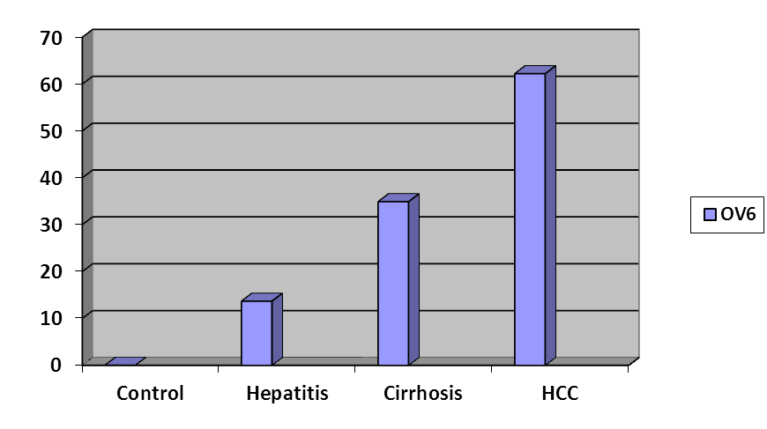
Figure (1): Showing tissue expression of OV6 in the studied groups.

There is increase in the number of the hepatocytes expressing OV6 from hepatitis cirrhosis and HCC, the mean values of OV6 expression were significantly increased in hepatitis, cirrhosis and HCC groups compared to control group ( p value < 0.01) and in cirrhosis, HCC groups compared to hepatitis group (p value < 0.01) and in HCC group compared to cirrhosis group (p value < 0.01).

Table (4) Relation between grade of inflammation of chronic hepatitis group with or without cirrhosis and tissue levels of OV6:
histological grades of activity | N | Mean ± SD
A1 | 13 | 18.46 ±10.005
A2 | 9 | 9.88 ± 9.61
A3 | 23 | 35.56 ±12.7 *^
*P<.01 compared to A1; ^P<.01 compared to A2

The mean values of OV6 level were significantly increased in A3 compared to A2 and A1 (p<0.01), while no significance of OV6 expression in A2 compared to A1.

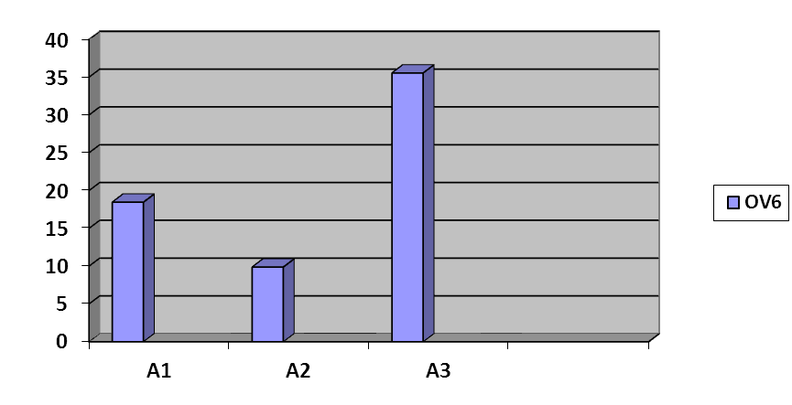
Figure (2): showing tissue expression of OV6 in different histological grades of activity.

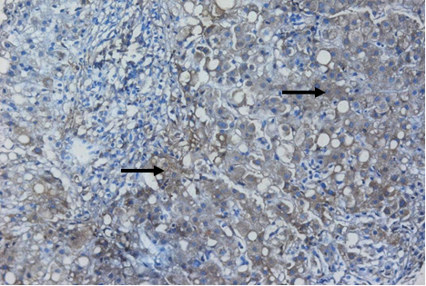

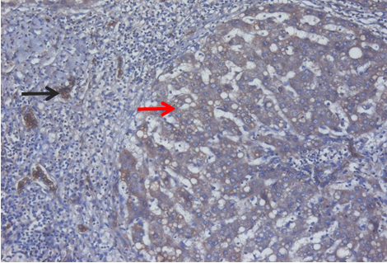
Figure (3): liver section from HCV case, A2activity and F2 fibrosis with mild expression of OV6 monoclonal antibody in hepatocytes as cytoplasmic brownish stain (arrow)(IHC, DAB, OV6 x200.)

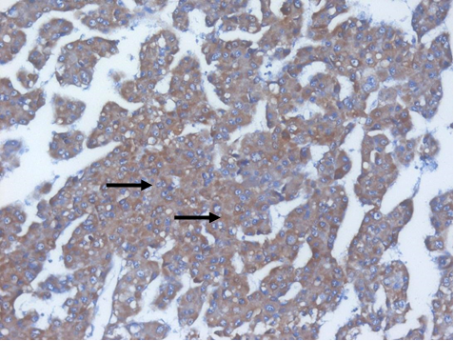
Figure (4): liver section from HCV case, A3 activity and F4 fibrosis with formation of regenerating nodule, with moderate expression of OV6 monoclonal antibody in hepatocytes (red arrow) and lining cells of bile duct as cytoplasmic brownish stain(black arrow) (IHC, DAB, OV6 x200.)

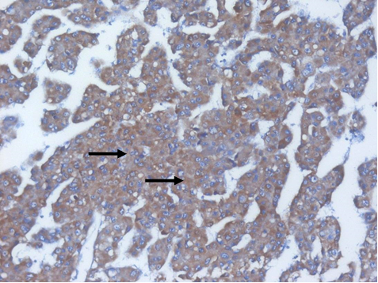
Figure (5): liver section from HCC, with 90 % expression of OV6 monoclonal antibody in hepatocytes as cytoplasmic brownish stain (IHC, DAB, OV6 x200.)

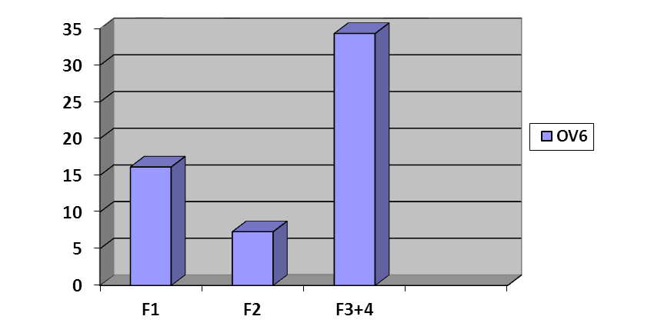
Figure (6): showing tissue expression of OV6 in different histological stages of fibrosis:

Table (5): Relation between stage of fibrosis of chronic hepatitis (with or without cirrhosis and tissue levels of OV6)
Variables | F1  N=13 | F2  N=6 | F3+4  N=26
Mean ± SD | 16.15 ± 10.56 | 7.33 ± 7.36 | 34.34 ± 11.92*^
*p< 0.01 compared to f1; ^p< 0.01compared to f2

The mean values of OV6 level were significantly increased in (F3+4) compared to F1and F2 (p<0.01), but no significance increase in F2 compared to F1.

Table (6): Relation between histopathological grades of HCC and tissue levels of OV6
Grades of HCC | N | Mean ± SD
I | 10 | 67.30 ±16.20*
II | 11 | 63.81 ±15.89*
III | 9 | 54.66 ±19.20*
P<0.01 compared to chronic hepatitis.

The mean values of OV6 levels showed no significant difference in HCC grades as regards levels of OV6.

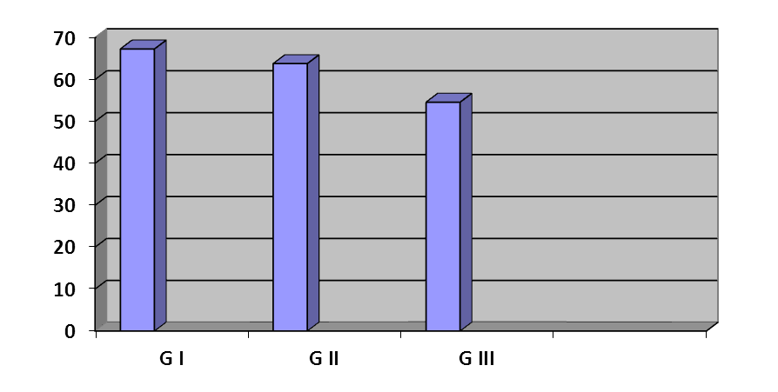
Figure (7): Showing tissue expression of OV6 in different grades of HCC

Table (7): Tissue expression of CK 19 in the studied groups
Group | CK 19 |  |  |  | P-value
 | -Ve  N - % | 1+  N - % | 2+  N - % | 3+  N - % | <.01
Control | 10 - 100 | 0 -.0 | 0 -.0 | 0 -.0
Hepatitis | 0 -.0 | 9 - 45 | 11 - 55 | 0 -.0
Cirrhosis | 0 -.0 | 4 - 16 | 10 - 40 | 11 - 44
HCC | 0 -.0 | 0 -.0 | 0 -.0 | 30 - 100
Cross tables, Pearson Chi-Square.

As regards control group all were -vefor CK 19 expression, but in hepatitis 9 patients (45%) were (1+) and 11 patients (55%) were (2+), In cirrhosis 4 patients (16%) were (1+),10 patients (40%) were (2+) and 11(44%) were (3+),while in HCC group all patients are (3+) "positive for expression of CK 19.Tissue expression of CK 19 were significantly increased in hepatitis cirrhosis, HCC groups compared to control group ( p value < 0.01) and there is significance in expression of CK 19 in HCC compared to cirrhosis and hepatitis group (p value < 0.01).CK 19 was expressed as cytoplasmic stain in hepatocytes and bile ducts.

Table (8): Tissue expression of CK19 in different grades of inflammation
Grades of inflammation/N | CK19 |  |  |  | P-value
 | -Ve  N - % | 1+  N - % | 2+  N - % | 3+  N - % | <.001
A1 (13) | 0 -.0 | 5 - 38.5 | 8 - 61.5 | 0 -.0
A2 ( 9) | 0 -.0 | 4 - 44.4 | 5 - 55.6 | 0 -.0
A3 (23) | 0 -.0 | 4 - 17.4 | 8 - 34.8 | 11 - 47.8
Cross tables, Pearson Chi-Square.

Cytokeratin19was highly significantly expressed in A3 compared to A2 and A1, as in A1 five patients were (1+) and eight were (2+), in A2 four patients were (1+) and five were (2+), while in A3 four patients were (1+), eight were (2+) and eleven patients were (3+) (p value < 0.01).
As regards CK19valuein (F3+4) were highly significantly expressed compared to F2 and F1 but there were no significant difference in F2 compared to F1 (p value > 0.05), as in F 1 seven patients (53.8%) were (1+) and six patients (46.2%) were (2+),in F2 tow patients (33.3%) were (1+) and four patients (66.7%) were (2+), while in F3+4 four patients (15.4%) were (1+) and eleven patients (42.3%) were (2+, 3+) which is significant (p value < 0.01).

Table (9): Tissue expression of CK 19 in different stages of fibrosis
Stage of fibrosis/ N | CK19 |  |  |  | P-value
 | -Ve  N - % | 1+  N - % | 2+  N - % | 3+  N - % | <.001
F1 (13) | 0 - 0 | 7 - 53.8 | 6 - 46.2 | 0 -.0
F2 (6) | 0 -.0 | 2 - 33.3 | 4 - 66.7 | 0 -.0
F3+4 (26) | 0 -.0 | 4 - 15.4 | 11 - 42.3 | 11 - 42.3
Cross tables, Pearson Chi-Square.

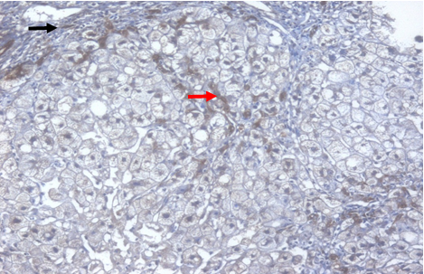
Figure (8): liver section from HCV case, A2 activity and F2 fibrosis with mild expression of cytokeratin 19 monoclonal antibody in hepatocytes (red arrow)and lining cells of bile duct for as cytoplasmic brownish stain (black arrow) (IHC, DAB, cytokeratin 19, x200.)

Table (10): Tissue expression of CK19 in different grades of HCC
Grade of HCC /N | CK19 |  |  |  | P-value
 | -Ve  N - % | 1+  N - % | 2+  N - % | 3+  N - % | > 0.05
I (10) | 0 -.0 | 0 -.0 | 0 -.0 | 10 - 100
II (11) | 0 -.0 | 0 -.0 | 0 -.0 | 11 - 100
III (9) | 0 -.0 | 0 -.0 | 0 -.0 | 9 - 100
Cross tables, Pearson Chi-Square; P<0.01

There is no significant difference of tissue expression of CK19 between different grades of HCC, (p value > 0.05).

Immunohistochemical Detection of OCT 3/4

Table (11): Tissue expression of OCT3/4 in different groups
Groups | OCT3/4 |  |  |  |  | P-value
 | -Ve  N - % | 1 -25  N - % | 26 – 50  N - % | 51 – 75  N - % | 76-100  N - % | <.001
Control | 10 - 100 | 0.0 | 0.0 | 0.0 | 0.0
Hepatitis | 16 - 80 | 4 - 20 | 0.0 | 0.0 | 0.0
Cirrhosis | 14 - 56 | 1 - 4 | 10 - 40 | 0.0 | 0.0
HCC | 5 - 16.6 | 1 - 3.3 | 3 - 10 | 8 - 26.6 | 13 - 43.3

Cross tables, Pearson Chi-Square.There is significant difference of tissue expression of OCT3/4 between different groups OCT3/4 was over expressed in HCC group.
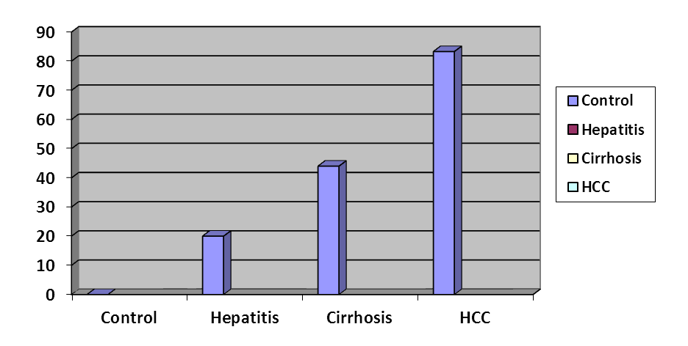
Figure (9): Showing comparison between tissue expression of OCT3/4 in the studied groups

Table (12): Tissue expression of OCT3/4 in different grades of inflammation of chronic hepatitis patients with or without cirrhosis:
Grades /N | OCT3/4 |  |  |  |  | P-value
 | -Ve  N - % | 1 - 25  N - % | 26 - 50  N - % | 51 - 75  N - % | 76 - 100  N - % | <.001
A1 (13) | 11 - 84.61 | 2 - 15.38 | 0 -.0 | 0 -.0 | 0 -.0
A2 ( 9) | 6 - 66.66 | 1 - 11.1 | 2 - 22.2 | 0 -.0 | 0 -.0
A3 (23) | 10 - 43.47 | 0 - 0 | 5 - 21.73 | 8 - 34.78 | 0 -.0
Cross tables, Pearson Chi-Square.

There is significant difference of tissue expression of OCT3/4 between different grades of inflammation as in A1 only two patient of thirteen (15.38 %) was staining +ve for OCT3/4 (1- 25 ), in A2 three patients of nine were +ve for OCT 3/4 one of them at (1-25) and two at (26-50), while in A3 thirteen patients from twenty three were +ve for OCT3/4 five and eight in (26-50) and (51-75) respectively.
Expression of OCT3/4 increase with increasing grades of activity.

Table (13): Tissue expression of OCT3/4 in different Stages of fibrosis
Stages /N |  |  |  | OCT3/4 |  |  |  |  |  | P-value
 |  |  |  | -Ve  N - % | 1 - 25  N - % |  | 26 - 50 N % | 51 - 75  N - % | 76 -100  N - % | <.001
F1 (13) |  |  |  | 11 - 84.61 | 0 - 0 |  | 2 - 15.38 | 0 - 0 | 0 - 0
F2 ( 6) |  |  |  | 3 - 50 | 1 - 16.66 |  | 2 - 33.33 | 0 - 0 | 0 - 0
F3+4 -(26) | 14 - 53.84 | 1 - 3.84 | 3 - 11.53 | 8 - 30.76 |  | 0 - 0
Cross tabs, person Chi-square (p<0.01)

There is significant difference of tissue expression of OCT3/4 between different stages of fibrosis, as in F1 two patients (15.38%) was staining positive for OCT3/4 at (26-50), while in F2, one patients (16.66%) was staining positive for OCT3/4 at (1-25), and at (26-50) were two patients (33.33%), While in F3 one patient (3.84%), was staining positive at (1- 25),three patients (11.53%) at (26-50) and seven (30.76%) patients at (51-75).

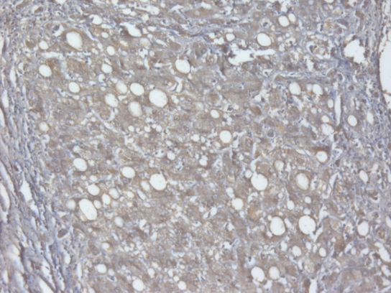
Figure (10): liver section from HCV case, A2 activity and F3 fibrosis with moderate expression of Oct3/4monoclonal antibody in hepatocytes as cytoplasmic brownish stain (IHC, DAB, Oct3/4, x200)

Table (14): Tissue expression of OCT3/4 in different grades of HCC
Grades/N | OCT3/4 |  |  |  |  | P-value
 | -Ve  N - % | 1 - 25(1+)  N - % | 26 - 50(2+)  N - % | 51 - 75(3+)  N - % | 76 - 100(4+)  N - % | <.001
I (10) | 5 - 50 | 3 - 30 | 2 - 20 | 0 -.0 | 0 -.0
II (11) | 0 -.0 | 2 - 18.18 | 3 - 27.27 | 6 - 54.54 | 0 -.0
III (9) | 0 -.0 | 0 -.0 | 1 - 11.11 | 1 - 11.11 | 7 - 77.78
Cross tables, Pearson Chi-Square.

There is significant difference of tissue expression of OCT3/4 between different grades of HCC tissues Poorly differentiated HCC tissues (Grade III) show high expression of OCT3/4 than moderate and well differentiated ones.

4. Discussion
Stem cells (SCs) are undifferentiated cells capable of renewing themselves throughout their life and of generating one or more types of differentiated cells. Different types of SCs with hepatic differentiation potential are theoretically eligible for liver cell replacement. These include embryonic and fetal liver SCs, induced pluripotent SCs, hepatoblasts, annex SCs (pluripotent SCs obtained from umbilical cord and umbilical cord blood, placenta and amniotic fluid), and adult SCs, such hepatic progenitor cells, hematopoietic SCs, and mesenchymal stem cell Gamal et al., (2013). One potential mechanism of HCC resistance to chemotherapy may lie in the plasticity of the cell of origin, which is often a dysfunctional progenitor or stem cell. As many as 40% of HCCs are clonal and thus are considered to originate from progenitor/ stem cells. In addition, several signaling pathways, such as STAT3 (signal transducer and activator of transcription 3) and transforming growth factor-beta (TGF-β) are commonly deregulated in HCC Tang Y, et al. (2008).
Hepatocytes proliferation rate increased in hepatitis C with increasing histological damage until cirrhosis is reached when the proliferation rate falls overwhelming liver injury, chronic liver injury or large scale hepatocytes senesce result in a potential stem cell compartment being activated from the smallest branches of the intrahepatic biliary tree. This reduction in hepatocytes proliferation in chronic hepatitis occurs concurrently with the activation of this potential stem cell compartment Alison MR, et al. (2009):
Demonstration of oval cells in human liver disease is based on the presence of cells with the typical histologic appearance of their counterparts in rodents combined with an appropriate immunohistochemical marker Lowes KN, et al. (1999) Progenitor cells are labeled by oval cell markers OV6 and OV1, biliary type cytokeratins (CK) CK7 and CK19, neuroendocrine markers, neural cell adhesion molecule and others Fotiado A, et al. (2004). Oval cell marker (OV6) is a monoclonal antibody prepared against ratoval cells and is useful in identifying oval cells. OV-6 has become widely used as a marker for lineage pathways in rat models of hepatocarcinogenesis and in the proliferative response to liver injury Crosby HA (1998).
Hepatocellular carcinoma should not express CK19 if they originate from hepatocytes. However, several previous reports showed that some HCC can express CK19, the marker specific for biliary epithelial cells Uenishi T, et al. (2003) and-Yamamoto T, et al. (2005). These consistent findings suggested that some HCC may develop from, instead of hepatocytes directly, but hepatic progenitor cells which express CK19-Yamamoto T, et al. (2005). OCT4 (OCT3/4, POU5F1), as one of embryonic stem cell markers, plays an important role in maintaining the stemnessproperties (-Nichols J, et al.(1998). In our study, expression of OV6 was cytoplasmic brownish stain in the cells lining bile ducts, hepatocytes at the periphery of portal tracts and hepatocytes at the periphery of cirrhotic nodule. This was in agreement with Roskams T, et al. (2004) who reported bipotential progenitor cells residing in most terminal branches of biliary tree, ductules and / or canals of Hering. Also this goes with Ikeda, et al. (2009) who found hepatic progenitor cells were scattered at the interface or within periportal or periseptal hepatic parenchyma, particularly in liver cirrhosis. In the present study mean values of OV6 level showed a highly statistically significant increase in group II and III compared to group I (p value < 0.01) and a highly statistically significant increase in group III compared to group II (p value < 0.01). This coincides with Lowes KN, et al. (2003): who concluded that oval cells are frequently found in subjects with chronic HCV. Moreover, there is association between severity of liver disease and number of oval cells and their number increased as disease severity increased. Oval cells were located predominantly in the periportal region and were occasionally observed to form ductularstructures.and also in agreement with Bird T G, et al. (2008): In our study expression of CK19 were significantly increased in hepatitis, cirrhosis and HCC groups compared to control group (p value < 0.01). Study has been shown that a proportion of precursor lesions and hepatocellular carcinomas express markers that are not present in mature hepatocytes. About half of the small cell dysplastic foci, the earliest pre-malignant lesions in human hepatocellular carcinoma, have been shown to be LPC-derived as judged by expression of markers such as CK7, C19 and OV-6. In agreement with our results Oliva J, et al. (2010): Conducted a study to investigate HPC in HCC and their clinical significance, about 29% (12/42) and 19% (8/42) of the HCC patients, in non-tumor and tumor part respectively, have positive expression of one or more markers of progenitor cells such as alfa-fetoprotein, OV-6, CD133 andCK-19.In our study there is significance in expression of CK19 in HCC compared to cirrhosis and hepatitis group (p value < 0.01). This coincide with Oliva J, et al. (2010), who state that a panel of liver stem cell markers, such as OV6, glutathione S transferase placental (GST-P) and CK-19, was found to be positive for both HCC and cirrhotic tissues. Interestingly, HCC tissues had a higher positivity than cirrhotic tissues in liver stem cell marker staining, and these markers were positive in non-tumor liver tissues, such as alcoholic steatohepatitis, non-alcoholic steatohepatitis (NASH), HBV or HCV infection (non cirrhotic).
In our study expression of OV6 was cytoplasmic brownish stain in the cells lining bile ducts, hepatocytes at the periphery of portal tracts and hepatocytes at the periphery of cirrhotic nodule. The mean values of OV6 level showed a highly significant increase in group II and III compared to group I (p value < 0.01) and a highly significant increase in group III compared to group II (p value < 0.01).Tissue expression of CK19 were significantly increased in hepatitis, cirrhosis and HCC groups com. In the present study mean values of OV6 level showed a highly statistically significant increase in group II and III compared to group I (p value < 0.01) and a highly statistically significant increase in group III compared to group II (p value < 0.01). This coincides with Lowes KN, et al. (1999): who concluded that oval cells are frequently found in subjects with chronic HCV. Moreover, there is association between severity of liver disease and number of oval cells and their number increased as disease severity increased. Oval cells were located predominantly in the periportal region and were occasionally observed to form ductular structure spared to control group (p value < 0.01), and there is significance in expression of CK19 in HCC compared to cirrhosis and hepatitis group (p value < 0.01). In our study immunohistochemical staining of OCT3/4 in HCC group revealed staining of OCT4 in most of HCC sections (83.3%) compared to cirrhotic (44%) and (20%) in hepatitis patients without cirrhosis while it was undetectable in normal control which is highly significant. Our results is higher than Huang GW, et al. (2005): who found that the positive rate of OCT4 A in HCC tissues was 72.0%, which was higher than that in the corresponding adjacent non tumorous liver tissues (30.8%); the expression of OCT4A mRNA in normal non cirrhotic liver tissues was undetectable. These results suggest that the expression of OCT4 gene may be associated with liver carcinogenesis. This also in agreement with Zhuang PY, et al. (2008): who found that Immunohistochemical staining of OCT4 in HCC sections revealed clear staining of OCT4 in most of the tumor sections (67.8%) compared to cirrhosis sections (35.5%), The HCC samples had significantly stronger staining of OCT4 than that of the adjacent nontumoral and cirrhosis tissues. In our study the high rate of expression of OCT4 was in HCC group this coincides with PinZhu Huang, et al. (2010): who reported that OCT4 was highly expressed in HCC. Its expression was correlated with the tumor size, vascular invasion, and TNM stage of HCC. This suggests that OCT4 gene may play an important role in carcinogenesis and progression of HCC and the expression of OCT4A mRNA in HCC may be used as an indicator of postoperative prognosis.In our study we found that there is significant difference of tissue expression of OCT3/4 between different grades of HCC tissues, this also in agreement with Zhuang PY, et al. (2008): who found that poorly differentiated HCC tissues showed higher expression of OCT4 than the well-differentiated ones.
As regard relation between grades of inflammation and stages of fibrosis in chronic hepatitis group (with or without cirrhosis) and tissue levels of OV6 and CK19 and OCT3/4: In our study mean values of OV6, CK19 and OCT3/4 levels in A3 were highly significantly increased compared to A2 and A1 (p value < 0.01) and there were no significant difference in A2 compared to A1 (p value > 0.05). This was in agreement with -Fotiado A, et al. (2004): who reported that progenitor cell activation correlates with the degree of inflammation in chronic hepatitis.This also was in agreement with Lowes KN, et al. (1999): and Roskams T (2003): who reported that progenitor cell activation correlates with the degree of fibrosis in chronic hepatitis.

Conclusion
In our study of OV6 was expressed in the cells lining bile ducts, hepatocytes at the periphery of portal tracts and hepatocytes at the periphery of cirrhotic nodule, and intrahepatic OV6 expression was significantly increased with progression of liver disease being higher in patients with HCC than those with liver cirrhosis and in liver cirrhosis than chronic hepatitis. The combined immunohistochemechal staining with CK19 and OCT3/4(as stem cell marker) is useful for characterization of HCC. Cytokeratin 19 was considered a marker of hepatic progenitor cells and biliary epithelial cells, the subset of HCC expressing CK19may represent an HCC category that originates from HPC or by metaplasia.We found in our study that there is highly significant increase in OV6, CK19, and OCT3/4 level in HCC compared to chronic hepatitis with or without cirrhosis and so our study demonstrated that HCCs are enriched with progenitor hepatic stem cell, which in turn may be involved in the process of carcinogenesis and transformation of hepatocytes to malignant cells.

References
- Alison MR, Islam S, Lim S., et al. (2009): Stem cell in liver regeneration, fibrosis and cancer: the good the bad and the ugly. J. Pathol; 217(2):282-98.
- Bird T G, Lorenzini S, Forbes S J, et al. (2008): Activation of stem cells in hepatic diseases. Cell Tissue Res; 331: 283–300.
- burix J and Sherman M (2005): Practice Guidelines Committee, American Association for the Study of Liver Diseases. Management of hepatocellular carcinoma. Hepatology; 42: 1208 -1236.
- Chiou SH, Yu CC, Huang CY, et al. (2008): Positive correlations of Oct 4 and Nanog in oral cancer stem like cells and high grade oral squamous cell carcinoma [J]. Clin Cancer Res, 14(13): 4085-4095.
- Corcelle V, Stieger B, Gjinovci A, et al. (2006): Characterization of two distinct liver progenitor cell subpopulations of hematopoietic and hepatic origins. Exp Cell Res,312:2826-2836.
- Crosby HA (1998): Liver Research Laboratories, Queen Elizabeth Hospital, Birmingham; B15 2TH, UK. 10.1002/hep;5/1280/ 412.
- Ezeh UI, Turek PJ, Reijo RA, et al.(2005): Human embryonic stem cell genes OCT4, NANOG, STELLAR, and GDF3 are expressed in both seminoma and breast carcinoma [J]. Cancer, 104(10):2255-2265.
- Fotiado A, TzioufaV,Vrettou E, et al.(2004): Progenitor cell activation in chronic viral hepatitis. Liver Int;24(3):268-74.
- Gamal MAH, Sliem H, Ellethy AT, et al. (2013): Chronic Liver Disease: Stem Cell Therapy. Journal of Gastroenterology and Hepatology Research; 2(3): 434-438.
- Huang GW, Yang LY, Lu WQ, et al.(2005): Expression of hypoxia-inducible factor 1alpha and vascular endothelial growth factor in hepatocellular carcinoma: impact on neovascularization and survival. World J Gastroenterol. 11:1705–1708.
- Ikeda H, Sasaki M, Sato Y, et al. (2009): Bile ductular cell reaction with sesescent hepatocytes in chronic viral hepatitis is lost during hepatocarcinogenesis. Pathology International; 59-7:471-478.
- Lowes KN, Croager EJ, Abraham LJ, et al. (2003): Upregulation of lymphotoxin beta expression in liver progenitor cells in chronic hepatitis C. Gut; 52(9)1327-1332.
- Lowes KN, Brennan BA, Yeoh GC, et al. (1999): Oval cell numbers in human chronic liver diseases are directlu related todiseaseseverity.Am J Pathol; 154:537-541.
- Nichols J, Zevnik B, Anastassiadis K, et al (1998): Formation of pluripotent stem cells in the mammalian embryo depends on the POU transcription factor Oct4 [J]. Cell; 95(3):379-391.
- Oliva J, French B, Qing X, et al.(2010): The identification of stem cells in human liver diseases and hepatocellular carcinoma. Experimental and Molecular Pathology. June; 88(3): 331-340.
- PinZhu Huang, CanLiang Lu, Bin Kui Li, et al. (2010): OCT4 expression in hepatocellular carcinoma and its clinical significance. Chinese Journal of Cancer; Vol.29 Issue 1
- Roskams T (2006b): Liver stem cells and their implication in hepatocellular and cholangiocarcinoma Oncogene; 25: 3818–3822.
- Roskams T, Theise N, Balabaud C, et al.(2004): Nomenclature of the finer branches of the biliary tree: canals, ductules and ductular reactions in human livers. Hepatology; 39:1739–1745.
- Roskams T (2003): Progenitor cell involvement in cirrhotic human liver diseases: from controversy to consensus. J Hepatol; 39:431–434.
- Sievert W, Altraif I, AhmEd EA, et al. (2011): A systematic review of hepatitis C virus epidemiology in Asia, Austalia and Egypt. Liver Int; 31(2): 61-80.
- Takahashi K and Yamanaka S. (2006): Induction of pluripotent stem cells from mouse embryonic and adult fibroblast cultures by defined factors [J]. Cell, 126(4):663-676.
- Tang Y, Kitisin K, Jogunoori W, et al. (2008): Progenitor stem cells give rise to liver cancer due to aberrant TGF-beta and IL-6 signaling. Proc Natl Acad Sci USA; 105:2445–2450.
- Uenishi T, Kubo S, Yamamoto T, et al. (2003): Cytokeratin 19 expression in hepatocellular carcinoma predicts early postoperative recurrence. Cancer Sci, 94:851-857.
- World Health Organization (WHO), (2004): Global burden of disease (GBD) for hepatitis C. J Clin Pharmacol; 44: 20–9.
- Yamamoto T, Uenishi T, Ogawa M, et al.(2005): Immunohistologic attempt to find carcinogenesis from hepatic progenitor cell in hepatocellular carcinoma. Dig Surg; 22:364–370.
- Zhuang PY, Zhang JB, Zhu XD, et al. (2008): Two pathologic types of hepatocellular carcinoma with lymph node metastasis with distinct prognosis on the basis of CK19 expression in tumor. Cancer; 112:2740-2748.

6/25/2015

