Airborne Mycodiversity in the Indoor environments of Dhanvantri Library of Jammu University (India).

S.P. Pourush Shrikhandia and Geeta Sumbali*

University of Jammu, B.R. Ambedkar Road, Jammu-180006 (India).
* corresponding author: geetasumbalippl@yahoo.co.in

Abstract: Mycobial contamination in the indoor environments of libraries is a world-wide problem. These buildings are not only the store house of knowledge in the form of books, manuscripts, etc., but may also serve as conducive habitat for proliferation of this diverse group of fungal organisms due to ambient environment of temperature and humidity. These airborne bioparticles are not only responsible for deterioration and ageing of books and other important documents in the library but may also significantly affect the health of library users. In view of this, aeromycological studies were conducted to enumerate the mycodiversity that is associated with three indoor sites viz., stack areas, reading rooms and newspaper section of Dhanvantri library, which is the central library of University of Jammu. The main objective of the study was to find out the fungal flora at these places and its impact on the library materials, which are stored/processed there. By using settle plate method and modified Czapek Dox Agar medium with rose bengal and streptomycin sulphate, 17 fungal species belonging to 8 genera were recovered. Four measures of diversity are considered viz., species richness (S), Shannon-Wiener’s diversity index (H'), Simpson Diversity index (1-D) and Sorenson’s similarity index. The values so obtained showed that there is homogenity in the mycodiversity of all the three sites.
[S.P. Pourush Shrikhandia and Geeta Sumbali. Airborne Mycodiversity in the Indoor environments of Dhanvantri Library of Jammu University (India). N Y Sci J 2015;8(4):76-81]. (ISSN: 1554-0200). http://www.sciencepub.net/newyork. 15

Key words: Mycodiversity, indoor air, library, mycoflora, diversity indices.

1. Introduction
Mycoflora constitutes an essential part of biological diversity on this planet. Among the various known groups of microorganisms, fungi occupy a prime place as these are ubiquitous, frequently airborne, highly variable, constituting a significant fraction of the airborne bioparticles (Abu-Dieyeh et al., 2010). They are almost inevitable in most of the enclosed environments like museums, homes, libraries, industries, hospitals, schools, almirahas, humidifiers, cooling towers, etc.,(Jones and Harrison, 2004). However, transport and ultimate settling of fungal spores is affected by their physical properties and the environmental parameters that it encounters. In recent years, sampling and analysis of airborne fungi has received lot of attention due to the fact that their spores frequently contaminate indoor environments and significantly affect the health of residing individuals. Lack of incoming fresh air due to increased insulation of buildings, poorly maintained or operated ventilation systems, poorly regulated temperature and relative humidity levels contribute to the presence and multiplication of fungal spores.
In view of the increased awareness, study of fungi present in the air has become important and the study of aerobiology has acquired a prominent place in the field of environmental science. Two main features of fungi, that is, their ease of dispersion and their hydrolytic enzyme activity makes them one of the chief agents of deterioration. The physical characteristics of fungal spores (size, shape and density), presence of airborne water droplets and congenial environmental factors, which include magnitude of air currents, relative humidity and temperature, are some of the important factors, which determine the capacity of fungal spores to be airborne. However, their pathogenic ability depends on the quality and condition of the buildings as well as on the time of exposure to these airborne spores. In case of libraries, which are huge collection of books and periodicals and have a high human occupancy, the presence of fungal spores in their environment have a direct influence on the condition of the books as well as on the library users (Karvala et al., 2010). Apart from these, human beings are also an important source of airborne microorganisms in the indoor environments (Pastzuska et al., 2000).The exposure to airborne fungal spores may lead to allergic reactions like allergic sinusitis and asthma (Kurup and Banerjee, 2000; Crameri et al., 2006) and diseases like sick building syndrome (Takigawa et al., 2009). Among the allergy causing indoor fungi are included many common airborne species of Aspergillus, Penicillium, Cladosporium and Alternaria (Shen et al., 2007).
The Central Library of University of Jammu, which is called Dhanvantri Library, was set up in 1969. It is the largest library of Jammu and is the hub of academic activities where hundreds of students spend several hours studying from morning to evening throughout the year. It is centrally located, four storey building, with spacious reading halls and compact stack areas. The library has three main reading halls and additional reading space in the textbook section, periodical section, reference section and newspaper section. All these areas provide reading facilities for about 500 readers. This library is one of the largest repositories, being the main research source for historians, politicians, scientists, writers and students of Jammu.
In view of the fact that Dhanvantri Library is the Central Library of University of Jammu, an investigation on the mycodiversity of indoor air was conducted to characterize the indoor mycobiota in a library building, to identify the most abundant species and to assess fungal biodiversity.

2. Materials And Methods
Sampling of indoor air was done at three different sites, that is, stack areas, reading halls and newspaper section. A total of 72 samples were collected, 24 from each site during survey period by using culture plate exposure method as done by Stryjakowska-Sekulska et al. (2007). In this method, Petri-plates containing modified Czapek Dox Agar (CDA) medium with rose bengal (0.2g) and supplemented with streptomycin sulphate were exposed for 5 minutes at 3, 5 and 7 feet above the ground level, brought to the laboratory in sterilized polythene bags and then incubated at 28 ± 2º C. After an incubation period of 5 days, the Petri-plates were examined periodically for any sign of fungal growth. The colonies appearing on agar plates (Figure 1) were counted and recorded as percentage for individual species employing standard formula (Kalbende et al., 2012). Isolation and purification of the fungal species trapped from the air was done by streaking on the potato dextrose agar (PDA) medium plates, supplemented with streptomycin sulphate. The species were identified on the basis of cultural and morphological characters and finally authenticated by authority.

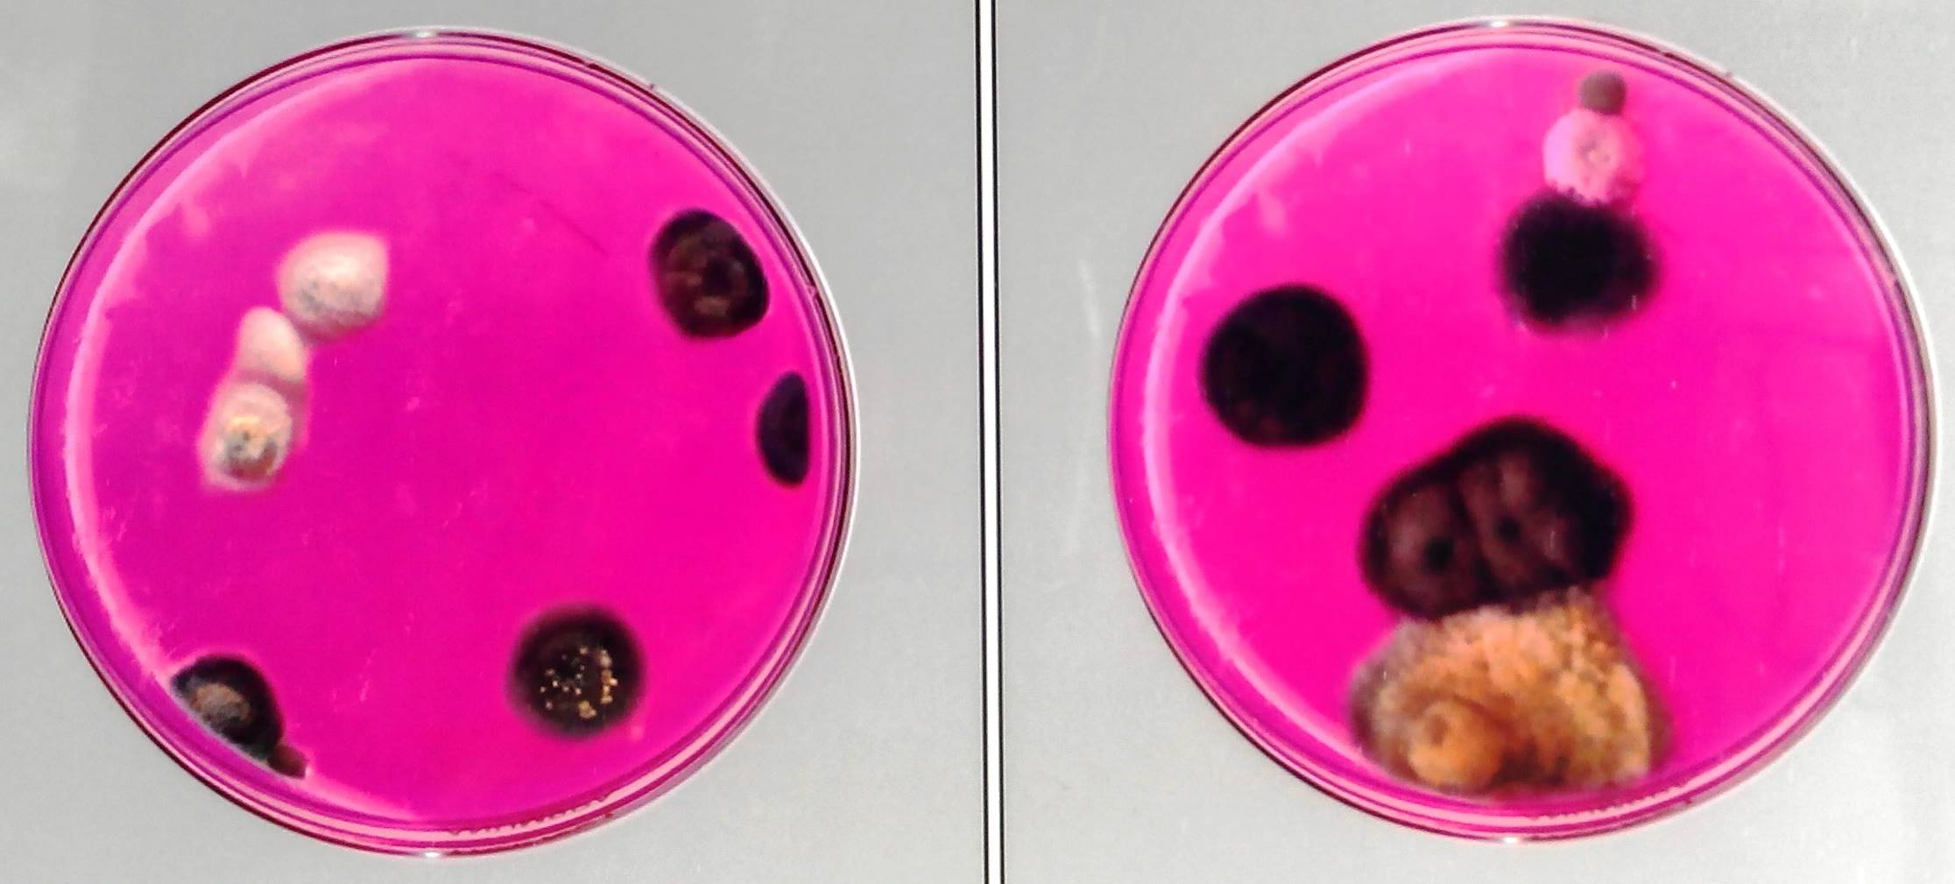
Figure 1: Fungal colonies appearing on the Petri-plates

Percentage colonization frequency (CF %), relative abundance and colony forming units (cfu/m³) were calculated for each fungal species from various sites by using the following formulae:

CF(%) = | 100xNumber of positive samples
 | Total number of samples

Relative abundance = | 100xNumber of occurrence of species
 | Total number of occurrences

Colony forming units (cfu/m³) were calculated by following Koch sedimentation method recommended by Polish Standard (Stryjakowska-Sekulska et al., 2007).

cfu / m³= a x 10000/p x t x 0.2
where,
a – the number of colonies on the Petri-plate.
p – the area of the Petri-plate.
t – the time of exposure of the Petri-plate.

The data was used in making comparison of different diversity indices (Table1). Shannon–Wiener index (H′) (Shannon and Wiener, 1963) and Simpson’s diversity index (1-D) (Simpson, 1949) were calculated to determine the heterogeneity of sampled area. The similarity between the sites was also calculated on the basis of fungal flora by applying Sorenson’s similarity index (Krebs, 1989).

Table 1: Diversity indices
Diversity indices | Formula used
Shannon–Wiener index (H′) | - -
Simpson’s diversity index (1-D)
Sorensen’s similarity index | 2C / S1 + S2
where p_{i} is the relative importance value of species i ; H´_{max} is the maximum value of H´; C is the number of common species and S1 and S2 are the total number of species in two sites.

3. Results And Discussion
During the survey, a total of 36 indoor air samples, 12 each from three sites viz., stack areas, reading rooms and newspaper section were screened for mycodiversity. In all 17 fungal species belonging to 8 genera (Alternaria, Aspergillus, Cladosporium, Curvularia, Fusarium, Mucor, Penicillium and Rhizopus) were recovered. Of these, Aspergillus was represented by maximum number of species (8), which accounted for the bulk of the recovered mycodiversity in all the three sites (Figure 2), with maximum distribution in the reading rooms (54.13%), followed in decreasing order by stack areas (47.38%) and newspaper section (45.95%). Burge et al. (1978) who made an aerometric survey of fungi in eleven libraries at the University of Michigan also found the predominance of Aspergillus species. In fact, the predominance of Aspergillus species in the indoor atmosphere has been attributed to their ability to grow on many substrates (Adams et al., 2013; Luka et al., 2014)). Cladosporium species were next in decreasing order showing maximum distribution in newspaper section (14.64%). Cladosporium is a cosmopolitan genus, which is abundant in air samples collected in many areas of the world (Kayarkar and Bhajbhuje, 2014). High concentrations of Cladosporium spores in the indoor air are known to cause allergic diseases in a number of people (Gonclaves et al., 2010). Similarly, two species of Penicillium, that is, P. brevicompactum and P. chrysogenum were recovered from all the three sites of indoor air sampling. In addition to Aspergillus, Cladosporium and Penicillium species, other fungal species trapped from indoor air of Dhanvantri Library included Fusarium solani, Alternaria alternata, Curvularia lunata, Mucor hiemalis and Rhizopus stolonifer (Table 2).

Table 2: Colonization frequency (CF%), abundance and colony forming units (cfu/m³) of the recovered mycodiversity.
Recovered fungal species | Stack areas |  |  | Reading rooms |  |  | Newspaper section
 | CF(%) | Abundance | cfu/m³ | CF (%) | Abundance | cfu/m³ | CF (%) | Abundance | cfu/m³
Alternaria alternata | 75 | 8.74 | 32.24 | 66.67 | 6.79 | 19.66 | 58.33 | 7.07 | 15.27
Aspergillus flavus | 83.33 | 6.96 | 25.68 | 83.33 | 8.11 | 23.46 | 58.33 | 4.54 | 9.82
Aspergillus fumigatus | 75 | 5.90 | 21.82 | 66.67 | 6.60 | 19.13 | 58.33 | 5.30 | 11.47
Aspergillus japonicus | 91.67 | 6.07 | 22.41 | 83.33 | 7.92 | 22.94 | 66.67 | 7.07 | 15.27
Aspergillus nidulans | 83.33 | 3.11 | 11.47 | 58.33 | 3.20 | 9.31 | 58.33 | 4.80 | 10.35
Aspergillus niger | 75 | 9.19 | 33.88 | 75 | 10.19 | 29.49 | 75 | 9.60 | 20.77
Aspergillus ochraceus | 83.33 | 5.19 | 19.13 | 75 | 5.28 | 15.27 | 58.33 | 4.04 | 8.72
Aspergillus parasiticus | 58.33 | 5.48 | 20.18 | 66.67 | 7.74 | 22.41 | 41.67 | 4.80 | 10.35
Aspergillus versicolor | 75 | 5.48 | 20.18 | 83.33 | 5.09 | 14.74 | 66.67 | 5.80 | 12.58
Cladosporium cladosporoides | 83.33 | 7.11 | 26.21 | 75 | 6.60 | 19.14 | 58.33 | 6.56 | 14.22
Cladosporium oxysporum | 75 | 6.96 | 42.27 | 66.67 | 5.47 | 15.86 | 66.67 | 8.08 | 17.50
Curvularia lunata | 83.33 | 8.89 | 32.76 | 83.33 | 6.98 | 20.18 | 58.33 | 8.08 | 17.50
Fusarium solani | 83.33 | 6.96 | 42.27 | 75 | 6.98 | 20.18 | 75 | 8.59 | 18.54
Mucor hiemalis | 58.33 | 2.52 | 9.31 | 75 | 3.58 | 10.35 | 50 | 2.53 | 5.44
Penicillium brevicompactum | 75 | 4.15 | 15.27 | 75 | 3.58 | 10.35 | 50 | 3.79 | 8.19
Penicillium chrysogenum | 66.67 | 3.56 | 13.11 | 66.67 | 3.20 | 9.31 | 58.33 | 4.80 | 10.35
Rhizopus stolonifer | 66.67 | 3.70 | 13.63 | 58.33 | 2.64 | 7.67 | 58.33 | 4.55 | 9.82
Total |  |  | 401.82 |  |  | 289.45 |  |  | 216.16

All these fungal species have been reported earlier also from the indoor air of libraries and archives situated in Cuba (Rojas et al., 2002; Borrego et al., 2010), Ethiopia (Hayleeyesus and Manaye, 2014), Poland (Pastuszka et al., 2000; Stryjakowska-Sekulska et al., 2007; Zielinska-Jankiewicz et al., 2008), India (Vittal and Glory, 1985; Tripathi, 1985; Singh et al., 1995; Jain, 2000; Kayarkar and Bhajbhuje, 2014). Among the recovered mycodiversity, Mucor and Rhizopus were the only two genera representing Zygomycetes and they showed least distribution in all the investigated sites. Most of the fungal species recovered during the present investigation could have adverse effect on the health of library staff and library users through allergy or infection or by mycotoxin production. An interaction with the staff of Dhanvantri Library showed that atleast a dozen of them had problems of naso-bronchial allergies or simple sneezing and these allergic problems started only after working in the library. The affected individuals often experienced relief when they leave the building for several days.
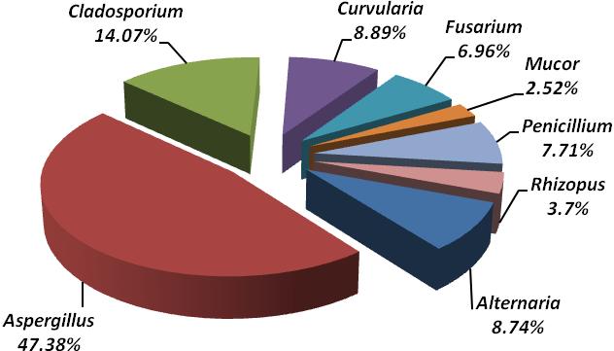
Stack areas
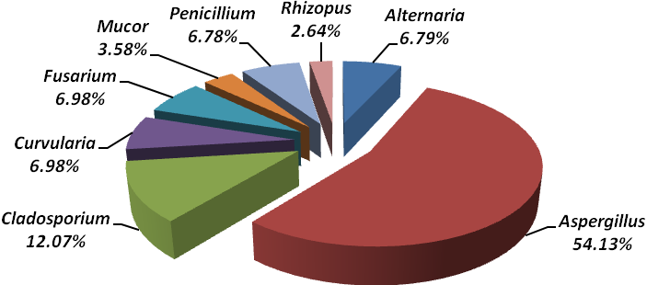
Reading rooms

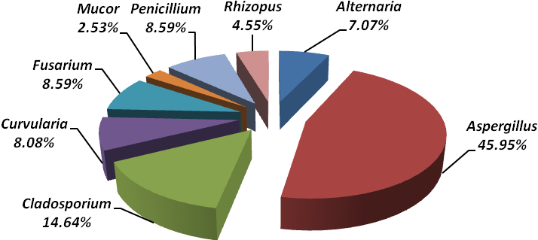
Newspaper section
Figure 2: Distribution of recovered fungal species from indoor air

Mean cfu / m³ | 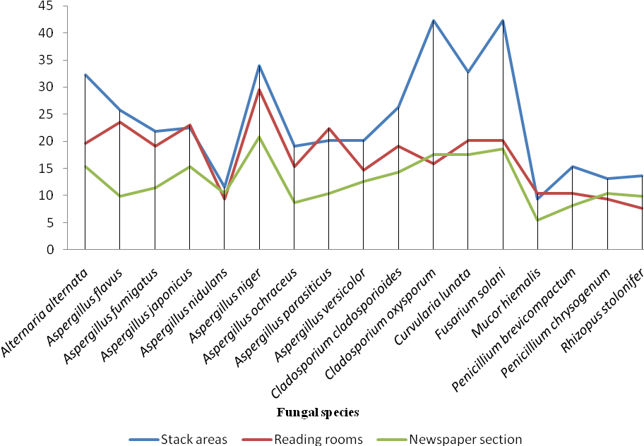
Figure 3: Comparison of mean cfu/m³ of fungal species recovered from three indoor air sites.

Mean number of colony forming units (cfu/m³) of the recovered mycodiversity from all the sites were also calculated. Among the three sites of indoor air sampling, stack areas possessed highest value (401.82 cfu/m³), followed in decreasing order by reading rooms (289.45 cfu/m³) and newspaper section (216.16 cfu/m³). So far, there are no Indian standards or guidelines for microbiological quality of indoor air. But, according to Swedish requirements, 500 cfu/m³ of bacteria and 300 cfu/m³ of fungal spores can be accepted in an indoor environment (Abel et al., 2002). In the present investigation, as depicted in figure 3, maximum colony forming units were of Fusarium solani (42.27 cfu/m³) from stack areas and that of Aspergillus niger from both newspaper section (20.77 cfu/m³) and reading rooms (29.49 cfu/m³). Similar results were obtained by Stryjakowska-Sekulska et al. (2007) who found colony forming units of fungi varying from 90 to 800 cfu/m³ during the different periods of investigation.
Diversity indices computed for the fungal species recovered from the three library sites are given in table 3. These diversity indices show similarities in values of species richness (S), Shannon-Wiener’s diversity index (H'), Simpson diversity index (1-D) and Sorensen’s similarity index. These sites have same species richness (17). Simpson diversity index, a measure of heterogeneity of a site, shows that the indoor air of both stack areas and newspaper section have same value (0.94 each), which was slightly different from that of reading rooms (0.93) and the values are approaching towards 1. This indicates that these sites are homogenous, that is, less diverse in mycodiversity. Similarly, values of Shannon-Wiener index for stack areas (2.77), reading rooms (2.76) and newspaper section (2.78) showed that there is homogeneity between these three sites (Table 3). The similarity between these three sites was also calculated with Sorenson’s index and it comes out to be 1, which means that the fungal species present in stack areas are also prevalent in reading rooms and newspaper section (Table 4).

Table 3: Diversity indices computed for the fungal species of three sites of indoor air of Dhanvantri Library.
S. No. | Diversity indices | Indoor air  Stack  Areas  Reading rooms  Newspaper section
 |  | Stack areas | Reading halls | Newspaper section
1.  2.  3.  4. | No. of colonies  Species richness (S)  Simpson’s diversity index (1-D)  Shannon’s diversity index (H’) | 675  17  0.94  2.77 | 530  17  0.93  2.76 | 396  17  0.94  2.78

Table 4: Sorenson’s similarity index of indoor air.
Sites | Stack areas | Reading halls | Newspaper section
Stack areas | - | 1 | 1
Reading halls | 1 | - | 1
Newspaper section | 1 | 1 | -

4. Conclusion
In conclusion, our study indicates that indoor recreational facilities like libraries are reservoirs of mycodiversity. The prevalence of huge mycodiversity in these sites may be attributed to their tolerance and adaptation to various abiotic and biotic factors such as ventilation of the buildings, ecological conditions, number of users and their activities.

5. Acknowlegement
The authors wish to thank Head, Department of Botany, University of Jammu for providing necessary laboratory facilities.

References
- Abel, E., Andersson, J.V., Dawidowicz, N., Christophersen, E., Hanssen, S.O., Linden, A.l., Lindvall, T. and Pasanen, A.l., (2002). The Swedish key action “the healthy building” - research results achieved during the first three years period 19982000. In: Indoor Air (Eds. Levin H). Proceedings: 9th International Conference on Indoor Air Quality and Climate. Monterey, California. pp. 996-1001.
- Abu-Dieyeh, M.H., Barham, R., Abu-Elteen, K., Al-Rashidi, R. and Shaheen, I., (2010). Seasonal variation of fungal spore populations in the atmosphere of Zarqa area, Jordan. Aerobiologia 16: DOI 10.1007/s10453-010-9162-2.
- Adams, R.I., Miletto, M., Taylor, J.W., and Bruns T.D., (2013). Dispersal in micobes: fungi in indoor air is dominated by outdoor air and show dispersal limitation at short distance. International Society for Microbial Ecology 7: 1262-1273.
- Borrego, S., P., Guiamet, Gómez de Saravia, S., Batistini, P., Garcia, M., Lavin, P., and Perdomo, I., (2010). The quality of air at archives and the biodeterioration of photographs. International Journal of Biodeterioration and Biodegradation 64: 139145.
- Burge, H.P., Boise, J.R., Solomon, W.R. and Bandea, E., (1978). Fungi in libraries: An aerometric survey. Mycopathologia 64: 67-72.
- Crameri, R., Weichel, M., Flueckiger, S., Glaser, A.G. and Rhyner, C., (2006). Fungal allergies: a yet unsolved problems. Chemical Immunology and Allergy 91: 121-133.
- Gonclaves, F.L.T., Bauer, H., Cardoso, M.R.A., Pukinskas, S., Matos, D., Melhem, M. and Puxbaum, H., (2010). Indoor and outdoor atmospheric fungal spores in the Sao Paulo metropolitan area (Brazil): species and numeric concentration. International Journal of Biometeorology 54: 347-355.
- Hayleeyesus, S.F. and Manaye, A.M., (2014). Microbiological quality of indoor air in University Libraries. Asian Pacific Journal of Tropical Biomedicine 4: S312.
- Jain, A.K., (2000). Survey of bioaerosol in different indoor working environments in central India. Aerobiologia 16: 221-225.
- Jones, A.M. and Harrison, R.M., (2004). The affects of meteorological factors on atmospheric bioaerosol concentrations. Science of the Total Environment 326: 151-180.
- Karvala, K., Toskala, E., Luukkonen, R., Lappalainen, S., Uitti, J. and Nordman, H., (2010). New-onset adult asthma in relation to damp and moldy workplaces. International Archives of Occupational and Environmental Health 83: 855-865.
- Kalbende, S., Dalal, L., and Bhowal, M., (2012). The monitoring of airborne mycoflora in indoor air quality of library. Journal of Natural Product and Plant Resources 2: 675-679.
- Kayarkar A. and Bhajbhuje, M.N., (2014). Biodiversity of aeromycoflora from indoor environment of library. International Journal of Life Sciences, Special issue A2: 2124.
- Krebs, C.J., (1989). Ecological methodology. Harper Collins Publishers, New York. pp. 654.
- Luka, R.S., Sharma, K., and Tiwari, P., (2014). Aeromycoflora of Jackman Memorial Hospital, Bilaspur. Scholar Academic Journal of Pharmacy (SAJP), 3: 6-8.
- Pastuszka, J.S., Tha Paw, U.K., Lis, D.O., Wlazlo, A. and Ulfig, K., (2000). Bacterial and fungal aerosol in indoor environment in Upper Silesia, Poland. Atmospheric Environment 34: 3833 – 3842.
- Rojas, T.I., Martínez, E., Gómez, Y., and Alvarado, Y., 2002. Airborne spores of Aspergillus species in cultural institutions at Havana University. Grana 41: 190-193.
- Singh, A., Ganguli, M. and Singh, A.B., (1995). Fungal spores are an important component of library air. Aerobiologia 11: 231-237.
- Shannon, C.E. and Wiener, W., (1963). The Mathematical theory of communities. University of Illinois Press, Urbana. pp. 117.
- Shen, H.D., Tam, M.F., Tang, R.B. and Chou, H., (2007). Aspergillus and Penicillium allergens: focus on proteases. Allergy Asthma Report 7: 351-356.
- Simpson, E.M., (1949). Measurement of diversity. Nature 163: 688.
- Stryjakowska-Sekulska, M., Piotraszewska- Pajak, A., Szyszka, A., Nowicki, M. and Filipiak, M., (2007). Microbiological quality of indoor air in University rooms. Polish Journal of Environmental Studies 16: 623-632.
- Takigawa, T., Wang, B.L., Sakano, N., Wang, D.H., Ogino, K. and Kishi, R., (2009). A longitudinal study of environmental risk factors for subjective symptoms associated with sick building syndrome in new dwellings. Science of the Total Environment 407: 5223-5228.
- Tripathi, R.N., (1985). Fungal air-spora inside the Central Library of Gorakhpur University. Water, Air and Soil Pollution 34: 125-134.
- Vittal, V.P.R. and Glory, L.A., (1985). Airborne fungus spores of a library in India. Grana 24: 129-132.
- Zielinska-Jankiewicz, K., Kozajda, A., Piotrowska, M. and Szadkowska- Stanczyk, I., (2008). Microbiological contamination with moulds in work environment in libraries and archive storage facilities. Annals of Agricultural and Environmental Medicine 15: 71-78.

4/18/2015

