Hydrographic Characteristics of Two Estuaries on the South Western Coast of Ghana

Margaret F. A. Dzakpasu¹ (corresponding author), Kobina Yankson²

¹Department of Fisheries and Aquatic Sciences, School of Biological Sciences, University of Cape Coast,
Cape Coast, Ghana, Email: mfad1994@gmailcom
²Department of Fisheries and Aquatic Sciences,School of Biological Sciences,University of Cape Coast, Cape Coast, Ghana, Email: kyankson201@yahoo.com

Abstract: This paper investigates the hydrographic characteristics of the Kakum and Nyan estuaries located on the southwestern coast of Ghana in order to gather baseline information for subsequent monitoring. Surface and bottom measurements of temperature, salinity, dissolved oxygen (DO), pH and turbidity were taken using a water quality checker (TOADK – 22 A) at various sampling stations from August 2011 to July 2012 during low tides. Depth was also measured. During the “peak” dry and wet seasons (February and July respectively), measurements were taken at high and low tides and the extent of saltwater penetration into the estuaries was determined. Temperature and DO were generally similar in both estuaries, but turbidity and pH were higher in Nyan estuary than Kakum estuary for some months. Salinity was higher at the mouths than the other stations. Both estuaries showed characteristics of positive estuaries with higher bottom salinities than surface ones at most stations except the mouths. Turbidity showed similar vertical variations as salinity. Temperature, salinity and DO values were higher during peak dry season than wet season in both estuaries. Saltwater penetrated farther in the Nyan estuary than the Kakum estuary at both dry and wet seasons and over a longer distance in the dry season than the wet season. The results have been interpreted with reference to seasons, differences in the size and shallowness of the estuaries and also compared with other studies. There is the need for regular monitoring of our water bodies in the wake of rising environmental issues.
[Margaret F. A. Dzakpasu, Kobina Yankson. Hydrographic Characteristics of Two Estuaries on the South Western Coast of Ghana. N Y Sci J 2015;8(4):60-69]. (ISSN: 1554-0200). http://www.sciencepub.net/newyork. 13

Keywords: Positive estuaries, vertical variations, peak dry season, peak wet season, saltwater penetration

1.0 Introduction
The value of estuaries as sources of fisheries, recreation, conservation, transport routes and locations for harbours, towns and cities are well documented (McLusky 1989; Blaber 2000; Plavan et al. 2011; Dahanayaka and Aratne 2006; Woke and Wokoma 2007). Their ecological role as nurseries for economically important marine fish species as well as migratory routes for both catadromous and anadromous fish has also been documented (Fincham, 1984; Blaber, 2000; Plavan et al., 2011). The proximity of estuaries to intensive human settlements render them prone to anthropogenic influences such as discharges of domestic and industrial effluents, agricultural wastes, salt mining, sand winning and resource exploitation. These have the potential of overexploitation, pollution and degradation of estuarine ecosystems. Consequently, it is important to understand the dynamics of estuaries and continually monitor their ecological health in order to take remedial measures whenever it becomes necessary.
The West African coastline is characterised by the presence of marginal estuaries of diverse morphologies and origins and are surrounded by high human population densities the (Amadi, 1990). Estuaries in the temperate regions have been extensively studied (Harkantra, 1982; Ysebaert et al., 1993; Ysebaert et al., 2002; Guo and Valle-Levinson, 2007; Martinho et al., 2007). Substantial amount of work has also been done on some tropical estuaries such as Cochin Estuary (Kumar et al., 2011; Shivaprasad et al., 2013), Cross River Estuary (Akpan, 1999; Ama-Abasi et al., 2004; Ekwu and Sikoki, 2006) and Gambia Estuary (Albaret et al., 2004; Guillard et al., 2004). In the sub-Saharan African countries however, such studies are relatively few. Some estuaries on the Ghanaian coast have been studied for their fish fauna (Dankwa et al., 2004; Aheto et al., 2011)and chemical components (Fianko et al., 2007; Tufuor et al., 2007). No extended systematic studies have been conducted on the ten estuaries recorded on the coast of Ghana (Yankson and Obodai, 1999). The Kakum estuary drains a rapidly urbanized area near Cape Coast, the Central Regional capital but only studies on its heavy metal content (Fianko et al., 2007) and the adjoining mangrove forest (Sackey et al., 1993; Aheto et al., 2011) have been reported. The Nyan estuary on the other hand, drains an area in the Western Region with high mining activities, but so far there is no report of a study on it. As part of an extended study of the ecology of these two estuaries, their hydrographic profiles were monitored over a period of one year to form the basis of this paper.
2.0Materials and Methods
2.1 Study areas
The study was carried out in the Kakum and Nyan estuaries (Figure1). The Kakum estuary (5°5' N, 1°19' W) is located at Iture village, 8 km west of Cape Coast in the Central region of Ghana. The estuary is formed by two rivers: the Kakum and the Sweet (Sorowie) and is located in the dry equatorial zone with an average annual rainfall of about 1,000 mm. The vegetation type is coastal savannah with grassland and few trees. Five different species of mangroves (red mangroves: Rhizophora mangle, R. racemosa, R. harrisonii and white mangroves: Laguncularia racemosa and Avicennia germinans) are found along this estuary. The inhabitants of the fringing communities depend on the estuary as a source of fish and water for domestic activities. Sand winning is common in this estuary. Four sampling stations were established, namely Station I: close to the mouth; Station II: confluence of the two rivers; Station III: 300 m into the Kakum river arm from Station II and Station IV: 300 m into the Sweet river arm from Station II.
The Nyan estuary (4º47' N, 2º8' W) is located at Princess Town, about 40 km west of Takoradi in the Western region of Ghana. The estuary is located within the South - Western Equatorial Climatic Zone with the average annual rainfall of 1600 m. The area falls within the High Rainforest Vegetation zone and the estuary is bordered by a mangrove forest consisting of three different species, namely Rhizophora mangle, Laguncularia racemosa and Avicennia germinans. The estuary serves as a source of fish and a transport route for the inhabitants living on either side of it. Three sampling stations were established in this estuary as Station I: close to the mouth; Station II: 300 m from Station I; and Station III: 300 m from Station II.

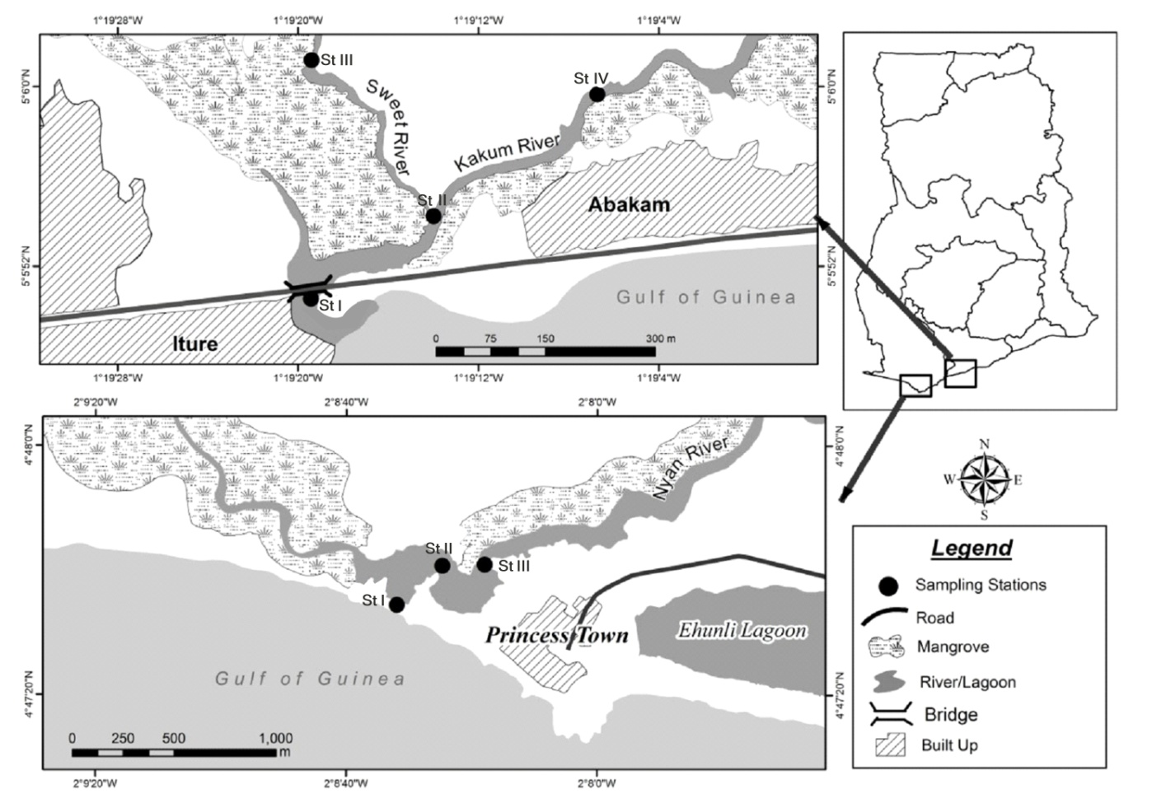
Figure 1 Map of the Kakum and Nyan estuaries showing the various sampling stations

2.2 Sampling
At every station in both estuaries, triplicate measurements of temperature (°C), dissolved oxygen concentration (mg/l), pH and turbidity (NTU) were taken monthly at daytime low tides from August 2011 to July 2012 using a multiparametric water quality checker (TOADK – 22 A) by immersing the probe into the water at the desired depth. Salinity (‰) was measured with a refractometer (Eclipse 45 – 65) and depth (cm) with a measuring tape (attached to a weight).
For vertical profiles of the above parameters, triplicate measurements were taken at two levels (surface and bottom) at every station in the two estuaries. For every parameter, monthly mean values were calculated from the measurements at of the surface and bottom for each station.
At the “peak” dry and wet seasons (February and July 2012 respectively), the hydrographic factors were measured at high tides in addition to the regular low tide sampling. The extent of salt water penetration at high and low tides was also determined in both estuaries by measuring salinity along the lengths of the rivers till the point where salinity below 0.5 ‰ was recorded.

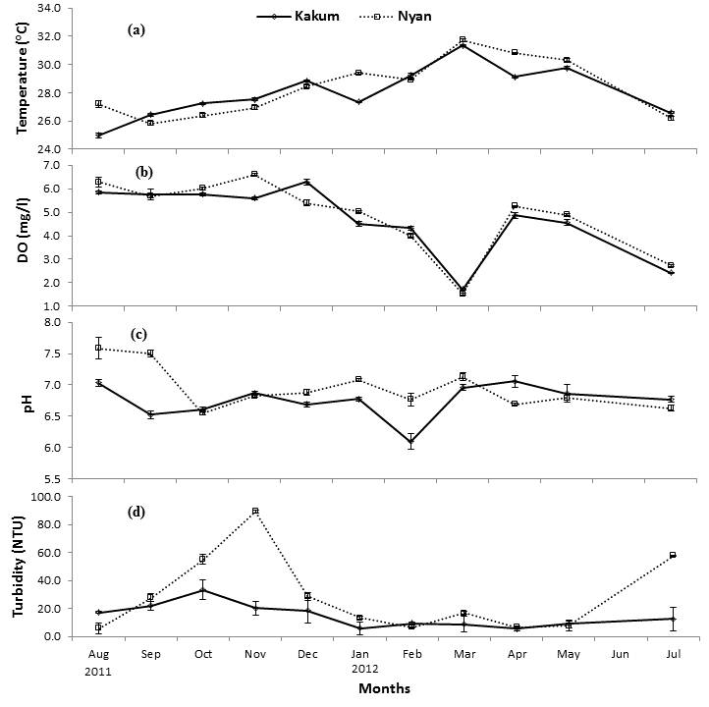
Figure 2 Monthly variations in some hydrographic parameters (mean ± S.E.) in the Kakum and Nyan estuaries

3.0 Results

3.1 Monthly variations in hydrographic factors
An initial appraisal of the data revealed that with the exception of salinity and depth, the remaining hydrographic factors did not show appreciable horizontal variations at the sampling stations in most of the months. The means of monthly values of water temperature, dissolved oxygen, pH and turbidity at the stations were therefore plotted for the two estuaries (Figure 2), while the monthly variations with respect to stations are shown in Figures 3 and 4 for salinity and depth respectively.
The water temperature showed a general trend of gradual increase from August, 2011 to peaks of 31.34 °C and 31.72 °C for Kakum and Nyan estuaries respectively in March, 2012 followed by a decrease till July (Figure 2a). The Kakum estuary recorded its lowest value of 24.98 °C in August, 2011 while Nyan estuary had its lowest temperature of 25.82 °C in September of the same year.
Dissolved oxygen (DO) concentration also fluctuated in a similar pattern in the two estuaries, decreasing gradually from August, 2011 to March, 2012 followed by a sharp increase and then a decrease till July (Figure 2b). Kakum estuary attained its highest value of 6.29 mg/L in December, 2011 while that of Nyan estuary (6.61 mg/L) was recorded in November of the same year. The lowest DO values of 1.72 mg/L and 1.53 mg/L for Kakum and Nyan estuaries respectively were both recorded in March, 2012.
The highest pH values of 7.03 and 7.59 were recorded for Kakum and Nyan estuaries respectively in August, 2011 (Figure 2c). Both showed a general minimal fluctuation throughout the rest of the study period except in February 2012 when Kakum estuary dipped significantly to record its lowest value of 6.10. Nyan estuary on the other hand, attained its lowest pH of 6.55 in October, 2011.
Turbidity in the two estuaries increased from August, 2011 and peaked at 33.27 NTU in October, 2011 for Kakum estuary and 89.29 NTU in November of the same year for Nyan estuary (Figure 2d). In Kakum estuary, the peak was followed by minimal fluctuation for the rest of the study period with the lowest value of 5.61 NTU recorded in April, 2012. The Nyan estuary however, showed a sharp decline in December, 2011 followed by minimal fluctuations to the lowest value of 6.42 NTU also in April, 2012 and an increase to 57.67 NTU in July.
Figure 3 shows that station I (the mouth) of both estuaries consistently had the highest salinity (0 – 34.50 ppt for Kakum estuary and 1.08 – 33.67 ppt for Nyan estuary) except for February, 2012 in Kakum estuary and August and September, 2011 in Nyan estuary. In the Kakum estuary station IV (the Sweet river arm) had the lowest salinity throughout the period (0 – 33.67 ppt) except April, 2012, but in the Nyan estuary stations II and III had similar values (0.28 – 30.67 ppt and 0 – 30.89 ppt respectively). The general pattern of monthly salinity variations in the two estuaries was similar with October and November of 2011 recording the lowest values (< 2.0 ppt) followed by an increase which plateaued from January (11.78 – 34.50 ppt and 22.67 – 33.67 ppt for Kakum and Nyan estuaries) and decreased from May, 2012 to 0 ppt and < 7.0 ppt in July in the Kakum and Nyan estuaries respectively.

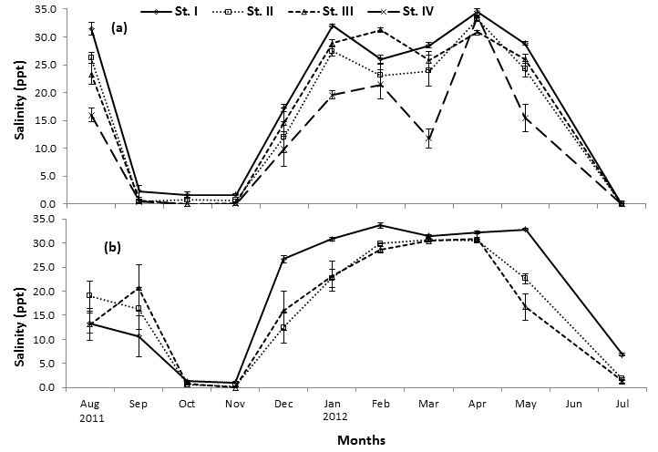
Figure 3 Monthly variations in mean (±S.E) salinity in the (a) Kakum and (b) Nyan estuaries
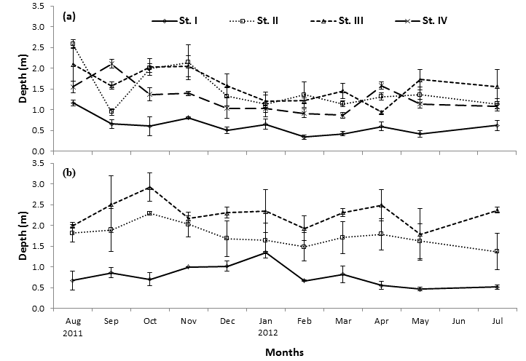
Figure 4 Monthly variations in mean (±S.E) depth in the (a) Kakum and (b) Nyan estuaries

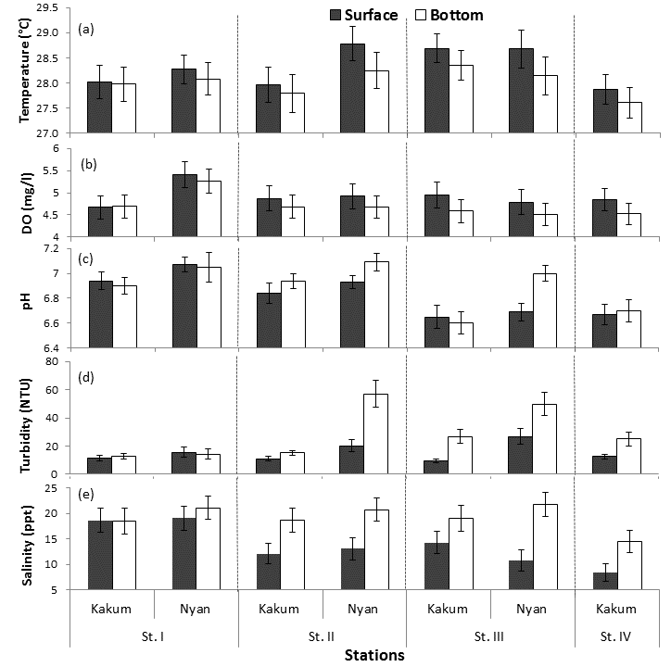
Figure 5 Vertical variations in hydrographic parameters (mean ± SE) at the various stations in the two estuaries

Both estuaries were shallow at low tide (Figure 4). Station I (the mouth) was the shallowest in both estuaries with depth remaining below 1 m except August, 2011 in Kakum estuary and January, 2012 in Nyan estuary when 1.17 m and 1.34 m were recorded respectively. There was no clear cut pattern in depth variations with respect to the remaining stations in the Kakum estuary, but in the Nyan estuary station II maintained intermediate depth with station III being the deepest consistently throughout the study period ranging from 1.79 m in May, 2012 and 2.92 m in October, 2011.
Vertical variations in hydrographic factors
Vertical variations in the hydrographic parameters are presented in Figure 5. In both estuaries, temperature was generally higher at the surface than the bottom at all stations but the differences were not statistically significant as indicated by the standard error bars (Figure 5a). Similarly, DO was generally higher at the surface than the bottom at all the stations but the differences were not significant statistically (Figure 5b). Except at station III in the Nyan estuary where pH at the bottom was significantly higher than the surface, all the other stations in both estuaries did not show significant vertical variations in pH (Figure 5c). No significant difference was recorded in turbidity at station I in both estuaries but at all the other stations, turbidities at the bottom were significantly higher than the surface ones (Figure 5d). Similarly, salinities at the bottom were higher than the surface in both estuaries except at station I where vertical stratification was not evident (Figure 5e).
Hydrographic factors at the peak dry and wet seasons
Tables 1(a) and (b) show the Duncan’s pair-wise multiple tests (95 % confidence interval) of hydrographic parameters at the peak dry season high tide (DS – HT), dry season low tide (DS – LT), wet season high tide (WT – HT) and wet season low tide (WT – LT) in Kakum and Nyan estuaries respectively. Mean temperatures were significantly higher at low tide than high tide during both peak dry and wet seasons in the two estuaries. Furthermore, mean temperatures were significantly higher at the peak dry season than the peak wet season.

Table 1(a): Hydrographic parameters at the peak dry and wet seasons in the Kakum estuary
Parameter | DS - HT | DS - LT | WS - HT | WS - LT
Temperature (°C) | 27.08 (± 0.11) ª | 29.21 (± 0.04) ^{b} | 25.06 (± 0.06) ^{c} | 26.59 (± 0.12) ^{d}
Salinity (‰) | 34.48 (± 0.66) ª | 25.39 (± 1.11) ^{b} | 2.27 (± 0.75) ^{c} | 0.00 (± 0.00) ^{d}
DO (mg/l) | 4.38 (± 0.05) ª | 4.31 (± 0.05) ª | 2.74 (± 0.03) ^{b} | 2.43 (± 0.03) ^{c}
pH | 6.05 (± 0.16) ª | 6.10 (± 0.10) ª | 6.66 (± 0.05) ^{b} | 6.77 (± 0.04) ^{b}
Turbidity (NTU) | 9.52 (± 1.58) ª | 9.33 (± 0.63) ª | 10.15 (± 0.31) ^{a, b} | 12.36 (± 0.21) ^{b}
Depth (cm) | 134.83 (± 10.80) ^{a, b} | 96.00 (± 13.77) ª | 153.42 (± 18.74) ^{b} | 110.17 (± 14.12) ^{a, b}
Same alphabets indicate homogenous means

Table 1(b): Hydrographic parameters at the peak dry and wet seasons in the Nyan estuary
Parameter | DS - HT | DS - LT | WS - HT | WS - LT
Temperature (°C) | 26.82 (± 0.14) ª | 28.91 (± 0.15) ^{b} | 25.67 (± 0.04) ^{c} | 26.19 (± 0.05) ^{d}
Salinity (‰) | 34.50 (± 0.47) ª | 30.38 (± 0.50) ^{b} | 17.92 (± 1.86) ^{c} | 2.88 (± 0.51) ^{d}
DO (mg/l) | 4.42 (± 0.07) ª | 3.99 (± 0.09) ^{b} | 2.75 (± 0.01) ^{c} | 2.73 (± 0.02) ^{c}
pH | 5.30 (± 0.23) ª | 6.77 (± 0.13) ^{b} | 6.80 (± 0.08) ^{b} | 6.63 (± 0.05) ^{b}
Turbidity (NTU) | 12.17 (± 4.22) ª | 6.17 (± 1.09) ª | 34.08 (± 6.33) ^{b} | 57.67 (± 8.42) ^{c}
Depth (cm) | 157.89 (± 29.51) ª | 136.00 (± 22.77) ª | 197.44 ( ±33.16) ª | 141.44 (± 29.78) ª
Same alphabets indicate homogenous means

Mean salinities recorded at high tide were significantly higher than at low tide during the peak dry and wet seasons in the two estuaries. Both high and low tide salinities in the peak dry season were significantly higher than their counterparts in the peak wet season in the two estuaries.
In the Kakum estuary, at the peak dry season, no significant difference was recorded in DO between high and low tides, but at the peak wet season, DO at high tide was significantly higher than low tide. In the Nyan estuary however, DO values during the peak dry season high tide (DS – HT) was significantly higher than the low tide (DS – LT) while during the peak wet season, DO values at both tides were not significantly different. The peak dry season DO values were significantly higher than the wet season ones in both estuaries.
No significant differences were recorded in the mean pH at high and low tides in both the peak dry and wet seasons in Kakum estuary. However, mean pH values during the peak wet season were significantly higher than their counterparts in the peak dry season. In Nyan estuary, mean pH at peak dry season low tide (DS – LT) was significantly higher than high tide (DS – HT) but no difference was recorded between the two tides in the peak wet season. Also, pH at peak dry season high tide (DS – HT) was significantly lower than peak wet season high tide (WS – HT) pH but no significant difference occurred between pH at the two low tides.
Mean turbidities at wet season low tide (WS – LT) were significantly higher than dry season low tide (DS – LT) in both estuaries. Turbidity values at the two high tides (DS – HT and WS – HT) did not show any significant difference in Kakum estuary but were significantly different in Nyan estuary.
No significant difference was recorded in the mean depths at the both high and low tides in peak dry and wet seasons in the two estuaries.

Extent of saltwater penetration in the two estuaries
Table 2 show the extent of saltwater penetration in the two estuaries studied. In the Kakum estuary, seawater penetrated to a distance of 1.39 km at high tide and 1.00 km at low tide during the peak dry season in the Sweet river arm while the penetration of seawater into the Kakum river arm of the estuary was over a distance of 5.47 km at high tide and 3.33 km at low tide. At high tide during the peak wet season, the influence of saltwater in the Kakum estuary diminished 0.00 ‰ at the confluence which is 0.20 km from the mouth of the estuary while at low tide, 0.00 ‰ was recorded even at the mouth.
Seawater penetrated the Nyan estuary to a distance of 12.27 km at high tide and 8.31 km at low tide during the peak dry season. At the peak wet season, the influence of saltwater was felt over a distance of 5.03 km at high tide and 3.19 km at low tide.

Table 2: Saltwater penetration in the Kakum and Nyan estuaries at peak dry and wet seasons
 |  | Distance from the sea (km)
 |  | DS - HT | DS - LT | WS - HT | WS - LT
Kakum estuary | Kakum river arm | 5.5 | 3.3 | 0.2 | 0.0
 | Sweet river arm | 1.4 | 1.0 | 0.2 | 0.0
Nyan estuary |  | 12.3 | 8.3 | 5.0 | 3.2

Table 3 illustrates the extent of saltwater penetration in some selected estuaries with respect to their size. This table shows that the bigger the mouth of an estuary, the further saltwater is able to penetrate into it.

Table 3: The influence of the size of estuarine mouth on the extent of saltwater penetration
Estuary | Average width of mouth (km) | Extent of saltwater penetration (km) | Source
Kakum | 0.02 | 5.5 | This study
Nyan | 0.05 | 12.3 | This study
Vellar | 0.2 | 18 | Jagadeesan at el. (2011)
Scheldt | 25 | 60 | Van Rijn (2010)
Amazon | 150 | 735 | Tomczak (1996 – 2000)

Discussion
Estuarine environments are dynamic in terms of their hydrographic factors. The key factors considered in this study are temperature, DO, pH, turbidity, salinity and depth.
The highest and lowest temperatures recorded in March and August/September respectively for both estuaries could be attributed to their respective climatic zones which experience their highest temperatures around March/April and lowest temperatures in August (Government of Ghana Official Portal – Central region n. d.; Ahanta West climate and vegetation n. d.). Temperatures were higher during the dry season months compared to the wet season in both estuaries, similar to the findings in Akpan et al. (2002) and Sushanth and Rajashekhar (2012). The significantly higher low tide temperatures than the high tide temperatures at both the peak dry and wet seasons in the two estuaries could be possibly due to the time of sampling. The high tide for the peak dry and wet seasons occurred in the morning while the low tide occurred in the afternoon when the sun was overhead on the sampling days. Furthermore, at low tides, the estuaries were shallower and therefore more amenable to warming by the sun. The absence of distinct vertical variations in temperature in both estuaries could be attributed to their shallowness (depth ranging from 0.35 m to 2.58 m in the Kakum estuary and 0.46 m to 2.92 m in the Nyan estuary) apparently exposing the water to uniform heating or cooling and tidal mixing resulting in thermal uniformity.
The higher salinities recorded at the mouths (station I) of both estuaries for most part of the period could be due to their proximity to the sea and hence more seawater influence. Very low salinities occurred in both estuaries during the periods of the minor (September/October) and major (June/July) rainy seasons. The amount and seasonal distribution of rainfall has a strong influence on the salinity and flow patterns of estuaries (Blaber, 2000). More rains result in land drainage in addition to the river inflow which increases the volume of freshwater entering the estuary and therefore reducing salinity drastically. This was so evident in the Kakum estuary when all stations recorded no salinity (0 ‰) in July. In the dry season, high evaporation and limited land drainage could have resulted in high salinities. The results in the two estuaries could be likened to those in the Vellar estuary where higher salinities were recorded for post monsoonal months (dry season) than monsoonal months (wet season) (Jagadeesan et al., 2011). Similar results were obtained in Tapi estuary on the west coast of India (Nirmal et al., 2009).
The two estuaries studied showed characteristics of positive estuaries with higher salinities at the bottom than the surface at all the stations except the mouth. Positive estuaries are usually associated with temperate regions while the tropics are characterized by negative estuaries (McLusky 1989; Yankson and Kendall 2001). The absence of vertical salinity stratification at the mouth is similar to the stronger stratification away from the entrance of the Chesapeake Bay which they attributed to tidal forcing appeared stronger around the entrance thereby increasing mixing and weakening stratiﬁcation (Guo and Valle-Levinson, 2007).
Tidal forcing (tidal pumping) is responsible for the penetration of saltwater into estuaries (Geyer and Nepf, 1996; Guo and Valle-Levinson, 2007; Robinson et al., 2007). It appears the wider the mouth of the estuary, the farther the extent of saltwater penetration. Saltwater penetrated a longer distance in the larger Nyan estuary (average width of mouth: 45 m) than the smaller Kakum estuary (average width of mouth: 20 m) in this study. Also, the relatively larger Kakum river arm (average width: 18 m) permitted saltwater penetration over a longer distance (5.5 km) at high tide compared to the 1.4 km penetration in the smaller Sweet river arm (average width: 8 m). The examples in Table 3 further explain that the larger the size of the estuary, the farther seawater penetrates into them.
The lowest dissolved oxygen (DO) values in both estuaries were recorded in March 2012, the same month when the highest temperature was recorded. Solubility of oxygen in water decreases as temperature increases (Wetzel, 2001). The low DO recorded in July (the peak wet season) could probably be due to surface runoff bringing organic materials into the estuaries which used the DO for decomposition. The shallowness of the two estuaries could explain the observed minimal vertical variations in DO. The higher DO values recorded at the peak dry season than in the peak wet season corroborate the findings in the Great Kwa River estuary (Akpan et al., 2002). This is however contrary to the findings in the Vellar estuary where higher DO in the wet monsoonal months than the dry post monsoonal months (Jagadeesan et al., 2011). According to Jagadeesan et al. (2011), the lesser DO noticed in non-monsoonal months in the Vellar estuary was associated to lesser river runoff and neritic water incursions from Bay of Bengal.
pH values in the Kakum and Nyan estuaries were in the slightly acidic to slightly basic range throughout the study period. The pH of estuaries is influenced by the nature of bedrock of the river, carbonate ions in seawater and also humus. According to National Estuarine Research Reserve [NERR] (1997), most aquatic organisms are adapted to live in pH between 5.0 and 9.0. Mean pH values in this study fluctuated between 6.1 and 7.6 showing a wider range than the 7.2 – 8.5 in the Tapi estuarine system (Nirmal et al., 2009) which was attributed to the buffering effect of seawater. A narrower range of 7.77 – 8.53 was recorded in the Pra estuary in Ghana (Tufuor et al., 2007). The pH recorded at the peak dry season in this study was significantly lower than the peak wet season. Higher pH values during the dry season than the wet season contrary to the findings in this study have been recorded in other estuarine systems (Akpan et al., 2002; Jalal et al., 2012 and Sushanth and Rajashekhar, 2012). Minimal vertical variations in pH could be the result of the shallowness and constant mixing of the estuarine water.
One of the most noticeable characteristics of tropical estuaries is their relatively high turbidity (Blaber 2000). The higher turbidity during the minor and major rainy seasons in both estuaries could be attributed to land runoff bringing along suspended matter which is in agreement with the assessment that turbidity is generally inversely related to salinity and that turbidity is usually low in the dry season (Blaber 2000). Bioturbation at the bottom of the estuaries as well as sinking of particles from the surface could explain the higher turbidities at the bottom compared to the surface values recorded in the present study.

Conclusions
The seasonal variations in temperatures in both estuaries reflect the climatic conditions the two estuaries are subjected to. The progressive decrease in salinity from the mouth of the estuaries upstream is typical of estuaries and the higher dry season salinities compared to the wet season reflect characteristics of tropical estuaries. Higher salinities at the bottom than the surface suggest that these two estuaries are positive. Saltwater penetrated over a longer distance in the larger Nyan estuary than the smaller Kakum estuary at the peak dry and wet seasons supporting the assertion that the size of the estuary plays a role in tidal forcing. Temperature and DO concentration were uniform vertically in both estuaries. The pH of the two estuaries ranged between slightly acidic to slightly basic range which is typical of estuarine systems. Turbidity was higher in the wet season months than the dry season months and higher at the bottom than the surface. With the exception of salinity and turbidity which exhibited some degree of vertical variations, the shallowness of the two estuaries could account for the lack of vertical stratification in the other hydrographic factors. The emerging oil industry off the west coast of Ghana requires periodic monitoring of the hydrography of these and other similar water bodies as a means of checking its possible impact.

Acknowledgements
The work was financially supported by Coastal Resource Center (Sekondi-Takoradi, Ghana) and the USAID. The University of Cape Coast provided logistics and other laboratory facilities for the work.

References
- Ahanta West climate and vegetation (n. d.) http://ahantawest.ghanadistricts.gov.gh/?arrow=dnf&_=133&r=5&rlv=climate. Accessed 2 May 2012.
- Aheto DW, Aduomih AAO, Obodai EA. Structural parameters and above-ground biomass of mangrove tree species around the Kakum river estuary of Ghana. Annals of Biological Research. 2011. 2: 405 – 514.
- Akpan ER. Spatio-seasonal trends of physicochemical characteristics of the Cross River Estuary, Nigeria. Progress in Meteorology. 1999. 13: 127 – 131.
- Akpan ER, Offem JO, Nya AE. Baseline ecological studies of the Great Kwa River, Nigeria 1: Physicochemical studies. African Journal of Environmental Pollution and Health. 2002. 1(1): 83 – 90.
- Albaret JJ, Simier M, Darboe FS, Ecoutin JM, Raffray J, Tito de Morais L. Fish diversity and distribution in the Gambia estuary, West Africa, in relation to environmental variables. Aquatic Living Resources. 2004. 17: 35 – 46.
- Ama-Abasi D, Akpan ER, Holzlohner S. Factors influencing the juvenile bonga from the Cross River Estuary. Proceedings of the annual conference of fisheries of Nigeria (FISON), Illorin, Nigeria. 2004. pp 737 – 743.
- Amadi AAA. Comparative ecology of estuaries in Nigeria. Hydrobiologia. 1990. 208: 27 – 38.
- Blaber SJM. Tropical Estuarine Fishes Ecology, Exploitation and Conservation. Queensland, Australia: Blackwell Sciences. 2000.
- Dahanayaka DDGK, Aratne MJSW. Diversity of macrobenthic community in the Negombo estuary, Sri Lanka with special reference to environmental conditions. Sri Lanka Journal of Aquatic Sciences. 2006. 11: 43 – 61.
- Dankwa HR, Blay J, Yankson K. Potential for culture of grey mullets (Pisces: Mugilidae) in Ghana. Ghana Journal of Science. 2004. 44: 19 – 27.
- Ekwu AO, Sikoki FD. Phytoplankton diversity in the Cross River Estuary of Nigeria. Journal of Applied Science and Environment Management. 2006. 10: 89 – 95.
- Fianko JR, Osae S, Adomako D, Adotey DK, Serfor-Armah Y. Assessment of heavy metal pollution of the Iture Estuary in the Central Region of Ghana. Environmental Monitoring and Assessment. 2007. 131: 467 – 473.
- Fincham AA. Basic Marine Biology. London, British Museum (Natural Science). 1984.
- Geyer WR, Nepf H. Tidal pumping of salt in a moderately stratified estuary. Coastal and Estuarine Studies. 1996. 53: 213 – 226.
- Government of Ghana official portal – Central region (n. d.) http://www.ghana.gov.gh/index.php/about-ghana/regions/central/1199-introduction. Accessed 2 May 2012.
- Guilard J, Albaret JJ, Simier M, Sow I, Raffray J, Tito de Morais L. Spatio-temporal variability of fish assemblages in the Gambia estuary (West Africa) observed by two vertical hydroacoustic methds: Moored and mobile sampling. Aquatic Living Resources. 2004. 17: 47 – 55.
- Guo X, Valle-Levinson A. Tidal effects on estuarine circulation and outﬂow plume in the Chesapeake Bay. Continental Shelf Research. 2007. 27: 20 – 42.
- Harkantra SN. Studies on sublittoral macrobenthic fauna of the Inner Swansea Bay. Indian Journal of Marine Science. 1982. 11: 75 – 78.
- Jagadeesan L, Manju M, Perumal P, Anantharaman P. Temporal variations of water quality characteristics and their principal sources in tropical Vellar estuary, South East Coast of India. Research Journal of Environmental Sciences. 2011. 5: 703 – 713.
- Jalal KCA, Azfar MA, John BA, Kamaruzzaman YB, Shahbudin S. Diversity and community composition of fishes in tropical estuary Pahang Malaysia. Pakistan Journal of Zoology. 2012. 44: 181 – 187.
- Kumar AA, Dipu S, Sobha V. Seasonal variation of heavy metals in Cochin estuary and adjoining Periyar and Muvattupuzha Rivers, Kerala, India. Global Journal of Environmental Research. 2011. 4: 15 – 20.
- Martinho F, Leitao R, Neto JM, Cabral HN, Marques MA, Pardal MA. The use of nursery areas by juvenile fish in a temperate estuary, Portugal. Hydrobiologia. 2007. 587: 281 – 290.
- McLusky DS. The Estuarine Ecosystem (2nd ed.). Glasgow, Blackie Academic and Professional Ltd. 1989.
- National Estuarine Research Reserve. Estuary-net: A Water Quality Monitoring Project – Estuarine Ecology In: North Carolina National Estuarine Research Reserve in cooperation with NOAA – Washington, DC (ed) Beaufort, North Carolina. 1997, p 99.
- Nirmal Kumar JI, George B, Nirmal Kumar R, Sajish PR, Viyol S. Assessment of spatial and temporal fluctuations in water quality of a tropical permanent estuarine system - Tapi, west coast of India. Applied Ecology and Environmental Research. 2009. 7: 267 – 276.
- Plavan AA, Passadore C, Gimenez L. Fish assemblage in a temperature estuary on the Uruguay coast: seasonal variation and environmental influence. Brazilian Journal of Oceanography. 2011. 58(4): 299 – 314.
- Robinson C, Li L, Barry DA. Effect of tidal forcing on a subterranean estuary. Advances in Water Resources. 2007. 30: 851 – 865.
- Sackey I, Laing E, Adomako JK. State of mangroves in Ghana. In: Diop ES, Field CD, Vannucci M. (eds) Proceedings of a workshop on Conservation and Sustainable Utilization of Mangrove Forests in Latin America and Africa Regions, Vol. 2, Dakar, 20 - 22 January 1993. ITTO/ISME Project PD114/90(F).
- Shivaprasad A, Vinita J, Revichandran C, Manoj NT, Jayalakshmy KV, Muraleedharan KR. Ambiguities in the classification of Cochin estuary, West Coast of India. Hydrology and Earth System Sciences. 2013. 10: 3595 – 3628.
- Sushanth VR, Rajashekhar M. Seasonal variation in diatoms in response to physico-chemical characteristics of coastal waters of Uttara Kannada District, West coast of India. International Journal of Environmental Sciences. 2012. 2: 1543 – 1552.

Tomczak M. Tides in shallow seas and estuaries. Retrieved September 20, 2012, from http://www.es.flinders.edu.au/~mattom/ShelfCoast/chapter05.html. 1996 – 2000.
- Tufuor JK, Dodoo DK, Armah AK, Darpaah GA, Essumang DK. Some chemical characteristics of the river Pra estuary in the western region of Ghana. Bulletin of the Chemical Society of Ethiopia. 2007. 21: 341 – 348.
- Wetzel RG. Limnology: Lake and River Ecosystems. 3rd edition. San Diego: Elsevier Academic Press. 2001, p
- Woke GN, Wokoma IPA. Effect of organic waste pollution on the macrobenthic organisms of Elechi creek Port Harcourt. African Journal of Applied Zoology and Environmental Biology. 2007. 9: 26 – 30.
- Yankson K, Kendall M. A student’s Guide to the Fauna of Seashores in West Africa. Newcastle: Darwin Initiative. 2001.
- Yankson K, Obodai EA. An update of the number, types and distribution of coastal lagoons in Ghana. Journal of Ghana Science Association (Special edn). 1999. 3: 26 – 31.
- Ysebaert T, Meire P, Herman PMJ, Verbeek H. Macrobenthic species response surfaces along estuarine gradients: prediction by logistic regression. Marine Ecology Progress Series. 2002. 225: 79 – 95.
- Ysebaert T, Meire P, Maes D, Buijs J. The benthic macrofauna along the estuarine gradient of the Schelde estuary. Netherlands Journal of Aquatic Ecology. 1993. 27: 327 – 341.

4/18/2015

