A comparative study on phenological events in two populations of Peganum harmala

* Nida Aslam¹, Aijaz A Wani¹, Irshad A Nawchoo¹, Khaleefa Aslam¹ and Mohd Aslam Bhat²

^{1.} Department of Botany, University of Kashmir, Srinagar- 190006, J&K, India.
^{2.} Department of Botany, Degree College Sopore, Baramulla-193201, J&K, India
*Corresponding Author: nidabhat42@gmail.com

Abstract: The aim of present work was to study comparative phenological events in diploid and tetraploid populations of Peganum harmala. In this paper an attempt has been made to record data regarding Sprouting, Flowering, Fruiting, and Senescence. This was done for a period of two years and it was carried out in two provinces (Kasmir and ladakh) of Jammu and Kashmir. Diploid and tetraploid individuals show divergent phenologies but the duration of different phases was similar. The different phases started approximately 1 month earlier in diploids than in tetraploids. Such phenological separation may arise because of genetically based differences between the two as a consequence of chromosome doubling or selection subsequent to the chromosome doubling event. Alternatively, phenological separations may arise if diploids and tetraploids occupy slightly different environments, which affect the timing and rate of growth.
[Nida Aslam, Aijaz A Wani, Irshad A Nawchoo, Khaleefa Aslam and Mohd Aslam Bhat. A comparative study on phenological events in two populations of Peganum harmala. N Y Sci J 2015;8(4):56-59]. (ISSN: 1554-0200). http://www.sciencepub.net/newyork. 12

Keywords: Phenology, population, flowering, fruiting

Introduction
Peganum harmala L. (2n = 24) is a perrenial herb growing in Africa, the Middle East, India, Pakistan, South America, Maxico and several other countries (Kartal et al., 2003). The plant grows normally in semi-arid conditions, steppe areas and sandy soils. The plant is known as “Espand” in Iran, “Harmel” in North Africa and “African Rue”, “Maxican Rue” or Turkish Rue” in the United States (Mahmoudian et al., 2002) and “Izband” in Kashmir. In Jammu and Kashmir State, as per the KASH Herbarium records, the plant is found wild in Ladakh, where as in Kashmir, it is found common in graveyards, dry banks and mountain deserts.
Phenological studies unravel the pattern of vegetation and reproduction status of a plant (Manjikola et al., 2005). Different researchers have endorsed and identified various environmental factors and correlated them with different phenological events such as initiation of flowering, synchronization of flowering, length of flowering and variation of flowering abundance (Beaubien and Johnson, 1994; Domengnez and Dirzo, 1995; Inouye et al., 2003). Plant phenologies are the result of interactions among biotic (plant morphological and physiological adaptations and pollinators), climate (photoperiod, temperature and rainfall) and phylogenetic factors that through natural selection determine the most efficient timing for growth and reproduction (Wright and Calderson, 1995).
Study site
In the present study the plant material was collected from 2 different site populations; one in Kashmir valley and one in Ladakh region of J&K state. These study sites and their characteristic are given in Table 1.

Table 1: Salient features of selected sites for studies of Peganum harmala in J and K- India
Study site | Province | District | Location | Altitude (m-asl) | Latitude and longitude | Habitat
Malkhah | Kashmir | Srinagar | 8km NW of Srinagar | 1595 | 34^{0 .}08′48″N  74⁰ 52′51″E | Sandy slopes
Skampary* Leh | Ladakh | Leh | 438km E of Srinagar | 3400 | 34^{0 .}04′33″N  77⁰ 38′74″E | Sandy slopes

Material methods
The phonological developments starting from sprouting to senescence were recorded in several selected individual plants tagged randomly in various populations and were monitored throughout growing season to record various phenophases. Phenological events viz. vegetative phase, sexual phase and senescence of aerial shoots were recorded over a period of two growing seasons (2010 and 2011).
The two populations showed high variations between individuals so that a given phenological event extended over a longer period for a population than for an individual plant. Plants were considered vegetatively active at the first signs of vegetative bud break, in bloom as the first flowers opened, and in fruit as first fruits appeared. The results were based on observations on 15–25 marked individuals per population for the studied plant. Peak flowering and peak fruiting in this study refer to those dates on which a maximum number of individuals of each species were active. In order to determined whether the patterns observed over the 2010 period were maintained from one year to the next, observations were repeated during the 2011 season.

Result
The phonological events were monitored from sprouting of young shoots up to the senescence in all the selected populations. The phenological events studied include, initiation and duration of sprouting, initiation of sexual phases, anthesis, fruit development and senescence (Plate 1).

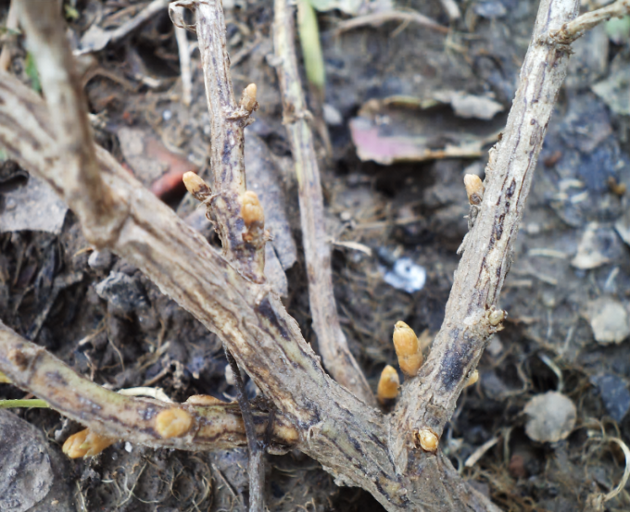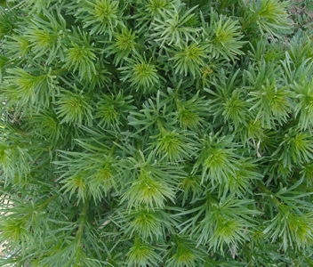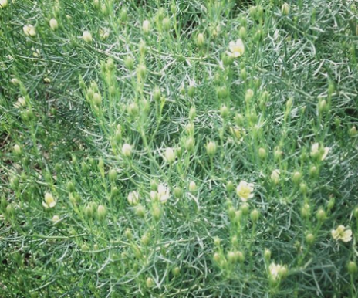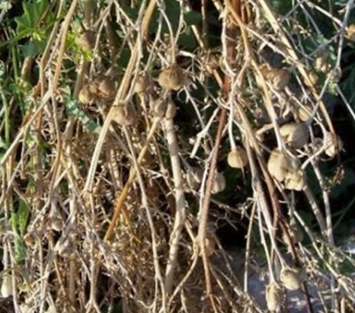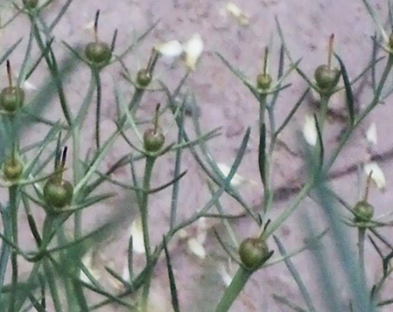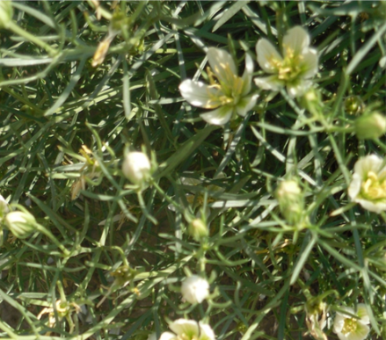
B
D
C
F
E
A
Plate 1: Different phenophases in Peganum harmala
A. Sprouting; B. Vegetative phase;
C. Flowering phase; D. Flowering phase
E. Fruiting phase; F. Senescence

4.5.1: Sprouting
The plants remain dormant in the form of underground root bearing several shoot buds throughout the chilling winter months (November to March). In Diploids with the advent of favorable climatic conditions in March, the buds on the underground roots resume growth and start sprouting from 1st week of March and lasts up to 3rd week of March. While in Tetraploids, the roots remain dormant from November to April and sprouting starts from 1st week of April and continues to do so till 3rd week of April.
4.5.2: Vegetative phase
In Diploids, the vegetative growth commences from 2nd week of March and continues to do so up to 2nd week of April, where as in Tetraploids, the plants remain in vegetative phase from 2nd week of April up to 1st week of May.
4.5.3: Floral bud formation
The vegetative phase of the species is simultaneously accompanied by the sexual phase. The floral bud formation starts from 1st week of April and continues up to 1st week of June in Diploids, while in Tetraploids, the plants enter the sexual phase during 2nd week of May and continue to do so up to 3rd week of June. The floral bud formation reaches its peak in 2nd week of April in Diploids and 1st week of May in Tetraploids
4.5.4: Anthesis
The species shows asynchrony in anthesis from flower to flower, plant to plant in a population and across populations. Diploids depict anthesis during 1st week of May which continues up to 4th week of June. Tetraploids show first sign of anthesis in 4th week of May and continued this process up to 3rd week of July.
4.5.5: Fruit formation and maturation
Asynchrony was also observed in case of fruit formation and fruit maturation. In Diploids fruit formation starts during 1st week of June and matures up to 2nd week of August. In Tetraploids fruit formation starts from 3rd week of June and matures up to 3rd week of September.
4.5.6: Senescence of the aerial shoots
High asynchrony was observed in senescence of the above ground shoots of the species during the present investigation. In Diploids senescence occurs in two phases, the first phase starts from 2nd week of August and lasts up to 3rd week of September, after which new shoot development starts from 2nd October which senesce up to 4thweek of October. Similarly in Tetraploids senesces occur in two phases, the first phase starts in 3rd week of September and lasts up to 2nd week of October, after which new shoots develops which senescence up to 2nd week of November. It has been found that two Populations show variation in phonological events (Table 2 and Fig. 1).

Table 2: Phenophases in two Populations of Peganum harmala
Phenophases | Diploids | Tetraploid
 | Srinagar | Leh
Sprouting | 1(3)* - 3 (3) | 1(4) - 3(4)
Vegetative phase | 2(3) - 2(4) | 2(4) - 2(5)
Bud formation  N | 1(4) - 3(6)  96 | 1(5) - 2(7)
Anthesis | 1(5) - 4(6) | 4(5) - 3(7)
Seed formation and maturation and maturation  And maturation | 1(6) - 2(8) | 3(6) - 3(9)
Senescence | 3(8) - 3(9) | 3(9) - 2(10)
Regrowth | 2(10) - 4(10) | 3(10) - 2(11)
Total life span(days) | 245 | 225
*Number outside the parenthesis is week and inside parenthesis is month

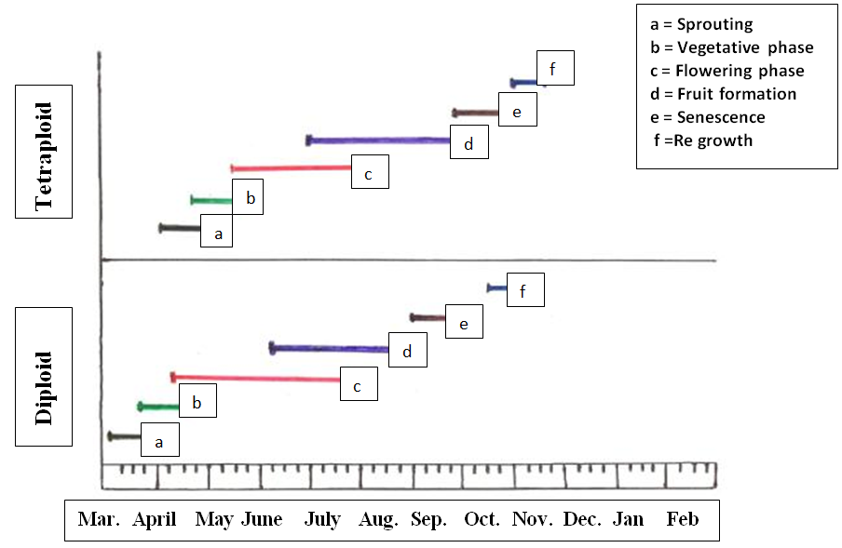

Fig. 1: Phenogram of Diploid and tetraploids population of Peganum harmala

Discussion
During the present study two Populations studied in two geographically different regions of J&K state differed in their Phenology. Sprouting in Diploids starts one month before Tetraploids. Floral bud formation starts in 1st and 2nd week of April in diploid and continuous to do so for 60 days, while in tetraploid floral bud formation starts from 4th week of April and lasts up to 50- 60 days. To complete the anthesis within all the flowers of a plant it takes about 50-60 days in both the populations.
Stebbins (1971) reported that retardation in mitotic cycle in polyploids brings about later flowering and fruiting compared with their diploid counterparts, which supports the observation of present study. Stebbins (1950) suggested that late initiation and prolonged flowering in tetraploids can be attributed to slower growth rate. Although it has been suggested that higher DNA content and thus cell size may be associated with slower growth and later flowering. The slower growth of autotetraploids may result in their flowering later or over a longer period of time than their diploid progenitors (Datta, 1963; Roy and Dutta, 1972; Jinno, 1958). In autotetraploid Ocimum kilimandscharicum flowering occurs 30-45 days later than the diploid, with the flowering period of the former being about one and a half month longer than that of the latter (Bose and Choudhury, 1962). A shift of 1 week or more in flowering and fruiting time may significantly alter a plant's relationship with pollinators, seed dispersers, and predators. Whether such a change was advantageous would depend on circumstances specific to the area in which the polyploids occurred.
Another reason for the late flowering in Tetraploid may also because it grows at high altitude than Diploid. In general plant growing at relatively higher altitude enter a bit later into a particular phenophase and register a longer duration of each phase and there by long lifespan than their counterparts at lower altitudes, similar observations were observed by Kalisz and Wardle, 1994.

References
- Beaubien, E. G. and Johnson, D. L. 1994. Flowering phenology and weather in Alberta, Canada, Int. Journal of Biomet., 38: 23 – 27.
- Bose, R. B., and Choudhury, J. K. 1962. A comparative study of the cytotaxonomy, palynology, physiology of diploid plants from Ocimum kilimandscharicum Guerke and their yield of raw material and volatile contents. Caryologia 15:435-453.
- Datta, R. M. 1963. Investigations on the autotetraploids of the cultivated and wild types of jute (Corchorus olitorius L. and C. capsularis L.) Zuchter, 33: 17-33.
- Dominguez, C. A. and Dirzo, R. 1995. Rainfall and flowering synchrony in a tropical shrub: variable selection on the flowering time of Erythroxylum havanense. Evolutionary Ecology, 9: 204-216.
- Inouye, D. W., Saavedra, F. and Lee-Yang, W. 2003. Environmental influences on the phenology and abundance of flowering by Androsace septentrionalis (Primulaceae). Amer. J. Bot., 90: 905–910.
- Jinno, T. 1958. Cytogenetic and cytoecological studies on some Japanese species of Rtbuls. IV. Relation of polyploidy to flowering time and growth rate. Bot. Mag. Tokyo. 71: 359-365.
- Kalisz, S. and Wardle, G. M. 1994. Life history variation in Campanula americana (Campanulaceae): population differentiation. Amer. J. Bot., 81: 521–527.
- Kartal, M., Altun, M. L. and Kurucu, S. 2003. HPLC method for the analysis of harmol, harmalol, harmine and harmaline in the seeds of Peganum harmala L. J. Pharmaceut. Biomed. Anal., 31: 263–269.
- Mahmoudian, M., Jalilpour, H. and Salehian, P. 2002. Toxicity of Peganum harmala: Review and a case report. Iran. J. Pharmacol. Therapeut., 1: 1–4.
- Manjikola, S., Dhar, U. and Rawat, R. S. 2005. Phenology and biology of Arnebia benthami a critically endangered medicinal plant of Kashmir Himalaya. Proc. Nat. Acad. Sci., India, 75 (B) part IV: 283 – 287.
- Roy, R. P. and Dutta, B. 1972. Cytomorphological studies in induced tetraploids of Luffa acutangula Roxb. Nucleus, 15: 171-180.
- Stebbins, G. L. 1950. Variation and Evolution in Plants. New York: Columbia Univ. Press.
- Stebbins, G. L. 1971. Chromosomal Evolution in Higher Plants. (Edward Arnold (Publisher) Ltd. London), 87-88 pp.
- Wright, S. J. and Calderon, O. 1995. Phylogenetic patterns among tropical flowering phenologies. Journal of Ecology, 83: 937–948.

4/18/2015

