Impacts of beehive stands’ heights and hives’ types on the ergonomics of honey harvesting in Port Harcourt, Nigeria

¹Aiyeloja, A. A., ¹Adedeji, G. A. and ²Emerhi, E. A.

¹Department of Forestry and Wildlife Management, University of Port Harcourt, Nigeria
²Department of Forestry and Wildlife, Delta State University, Asaba, Nigeria

Abstract: Beekeeping has a great ecological and economic importance across the globe. In Nigeria, sustainable harvesting of honey presents wide range of possibilities for ergonomic conditions improvement. Yet, most of the reported ergonomic studies largely utilized secondary information given by the respondents working in wood conversion and processing industries. More so, no ergonomic study on beekeeping and honey harvesting has been reported in relation to hive stand heights and hive types. This study was therefore designed to assess the impacts of beehive stands’ heights and hives’ types on the ergonomics of honey harvesting based on participatory and on-site experiences of the honey harvesting crews. A total number of eight experimental hives were used; consisting of four Kenyan Top Bar hives and four Langstroth frame hives mounted on two varying iron stands’ heights of 40cm and 70cm in the Apiary Unit of the Department of Forestry and Wildlife Management, University of Port Harcourt respectively. The study showed that the most impactful task of harvesting was the cutting of the honey combs which demanded much bending of the waist, wrist, neck, and awkward postures. This result indicated height as the most important factor influencing extent body parts bending. Moreover, utilization of Langstroth frame hives impacted more negatively to ergonomic harvesting conditions on the harvesting crews than Kenyan Top bar because of the manner in which the inner bars were constructed making it difficult for easy removal and placement. Dehydrating effects of the protective clothes (bee suite) was also recognized as contributing factor to the debility of harvesting crews. Experiences in the two stand heights and hive types showed that 70cm stand height and Kenyan Top bar hive seemed moderately adequate to improve ergonomic conditions in honey harvesting for an average human height (1.5 – 1.8 metres). The study recommended ergonomic guideline of 80-84cm stand height and Kenya Top bar hive with felling buffer for beekeeping.
[Aiyeloja, A. A., Adedeji, G. A. and Emerhi, E. A. Impacts of beehive stands’ heights and hives’ types on the ergonomics of honey harvesting in Port Harcourt, Nigeria. N Y Sci J 2015;8(4):23-27]. (ISSN: 1554-0200). http://www.sciencepub.net/newyork. 5

Keywords: Appropriate work design; fatigue; musculoskeletal diseases; productivity; work load

1. Introduction
Ergonomics comprises primarily, the adaptation of the working environment to the physiological and psychological capability of the workers and prevention of stress and fatigue including health aspect of work organizations. Adapting tasks, work stations, tools, and equipment to fit the worker can help reduce physical stress on a worker’s body and eliminate many potentially serious, disabling work related musculoskeletal disorders (MSDs) (OSHA, 2000). The aim of ergonomics study is to maximize the productivity of the workers while at the same time protecting their safety and health as well as providing for their satisfaction and fulfillment in performing the work in line with the economic resources available for achieving an appropriate job design.
The art and techniques of beekeeping have evolved over the years from traditional to modern industry in Africa. The heavy manual work and physically challenging requirements of honey harvesting has not received ergonomic attention in Nigeria. This can be largely explained by the economy which dictates the technologies to be applied or adopted. Ergonomic studies in the wood industries have been largely carried out primarily in advanced countries especially in Sweden and Finland where technology is sophisticated and attention is paid to working conditions. Surprisingly, in those climes too, it has been documented that a large number of workers complained of physical heavy work, uncomfortable working posture, poor lighting and unfavourable working climate as regard cold in winter, heat in summer and excessive drought (Meagher, 1986; Silverstein et al. 1986; Kuorinka et al. 1987; Konz, 1990; Waters et al. 1993; Christensen et al. 1995; Marras et al. 1995; Kroemer and Grandjean, 1997; Yen and Radwin, 1997; Bjoring and Hagg, 1998).
Beekeeping industry and its extraction of honey have always had economic importance for the global society at large but its ergonomic improvement conditions have not been given adequate consideration. Ruschioni et al. (2011) in Marche and Tuscary regions of Italy only assessed the comparative presence of risk situation for the musculoskeletal system between amateur and professional beekeepers. Despite beekeeping wide range of possibilities for ergonomic conditions improvement requirement, no ergonomic study on honey harvesting has been linked with stand heights and hive types. Iron stands are widely used to raise honeybees’ hives above soil contact primarily for protecting the hives from degradation agents. However, for economic reason, many existing stands are not ergonomically designed because they require a lot of back, waist, neck, wrist bending and awkward posture during honey harvesting. Information about the experiences of beekeepers might not be enough to determine their productivity and honey yield during harvesting schemes. Therefore, ergonomic efficiency of hive stand’s height and hive types is principally necessary to improve the harvesting conditions and to reduce the stress-load on beekeepers as well as ensuring higher bees’ products.

2. Materials and methods
2.1 Study area
Impacts of beehive stands’ heights and hives’ types on the ergonomic improvement requirements of honey harvesting schemes were assessed for three consecutive harvesting periods between 2013 and early, 2015 in the Apiary Unit (Latitude 4.90794 and 4.90809 N and longitude 6.92413 and 6.92432 E) of the Department of Forestry and Wildlife Management Arboretum, University of Port Harcourt, Rivers State. The University is located on a land area of about 400 hectares in Obio/Akpor Local Government Area of Rivers State. The area is within the Mangrove/swamp freshwater forest zone characterized with two seasons, the dry season (November to March) and wet season (April to October). The rainfall distribution is nearly all year round though its intensity is seasonal and variable (Aiyeloja et al. 2014). The monthly mean maximum temperature ranges from 28ºC to 33ºC while the monthly minimum temperature ranges from 17ºC to 24ºC (Ogbonna, et al., 2007). The vegetation is a mixture of disturbed fallow land and secondary forest growth with planted Gmelina arborea, Tectona grandis, Irvingia spp. and Nauclea diderrichii trees dominating. The dominant foraging/pollinating plants in the area include Aspillia africana, Tridax procumbens, Manihot esculentus in disturbed fallow land and Pycnantus angolensis, Elaeis guineensis in secondary forest (Aiyeloja et al. 2014).
2.2 Study design
The study technique was participatory research, designed to compare the impacts of varying stand heights and hive types on beekeepers. A total numbers of eight experimental hives were used; consisted four each of the two hives’ types: Kenyan Top Bar and Langstroth frames hives mounted on two varying iron stands heights (40cm and 70cm) in Apiary Unit of the Department of Forestry and Wildlife Management, University of Port Harcourt. Comparative assessments using two replicates between two varying hive stand heights (40cm and 70cm), and two hive types (Kenyan Top Bar and Langstroth frames hives) were carried out by three harvesting crew members consisted of the team leader (the harvester), one main smoker handler, and one assistant. Hive stands of 40cm height were improvised discarded iron chairs while 70cm height stands were designed at the rate of $15 each. The impacts of these parameters on harvesting screw members over three consecutive harvesting periods were reported.

3. Results
3.1 Impacts of hive heights and hive types on harvesting screws
Classification of impacts (Musculoskeletal Disorders) of hive heights and hive types on harvesting crew members was presented in Table 1.

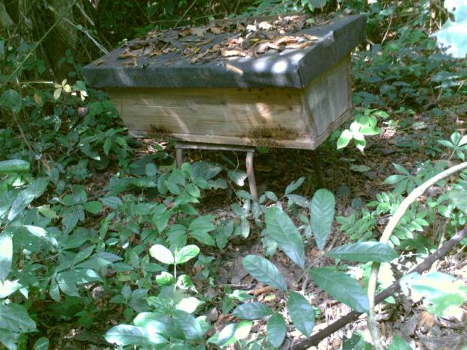
Fig. 1: Kenyan Top Bar hive mounted on 40cm height iron stand

Table 1: Impacts Classification of Musculoskeletal Disorders experienced during harvesting schemes
Classifications | Musculoskeletal Disorders experienced
Short term impacts | Wrist pain, upper hand pain
Medium term impacts | Shoulder pain, back pain, waist pain, neck pain, debility

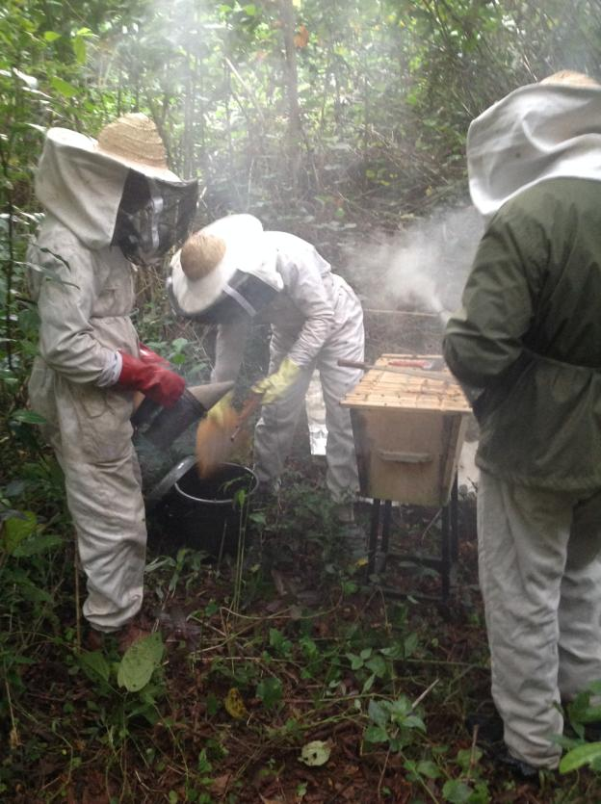
Fig. 2: Harvesting of honey in KTB hive mounted on 70cm height iron stand

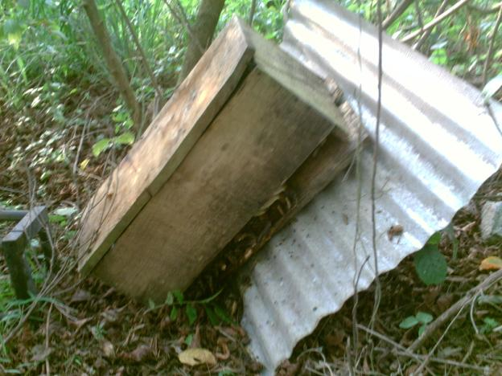
Fig. 3: Felled colonized KTB hive mounted on 70cm height iron stand

Fig 4: Langstroth hive mounted on 70cm height iron stand

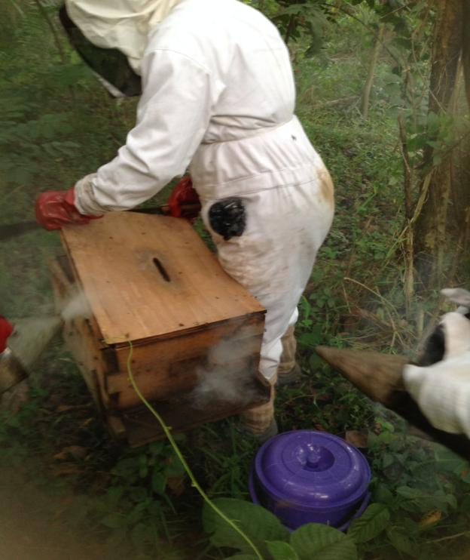
Fig. 5: Harvesting of honey in Langstroth hive mounted on 70cm height iron stand

Fig. 6: A typical frame from Langstroth hive

Fig. 7: Cutting of the ripe honey comb from Kenyan hive bar

4. Discussion
Harvesting of honey from hives is technically energy demanding and many times impactful. Beekeeping requires regular hives inspection and sanitation as it usually helps to reduce the aggressiveness of bees, honey harvesting screws drudgery, and saves time during honey harvesting operation. Two of the harvesting screws had previously been involved in beekeeping and honey harvesting for at least 5 years. Many factors may influence the efficiency of harvesting honey and how the beekeepers feel afterward. Some factors are avoidable while some are not. The avoidable factors can be manipulated or redesigned for more efficiency and reducing occupational disorders. The bee suites impacted dehydration effects which constantly resulted to the debility of all the harvesting crews. The dehydration effect was likely due to thickness and non-porosity of the suite material. Despite the medium impact of dehydrating effects of the bee suites, its influence was considered ergonomically efficient because it ensured safety and security of the crews against the risk of bee’s sting and death. Since honey harvesting coinciding with intense heat period (dry season) is unavoidable, honey harvesting should be done in the evening period in order to reduce the effects of the bees’ suites
Bee hives are usually 30 cm in height, therefore the total height of mounted hives are expected to be 70cm and 100cm for 40cm and 70cm stand heights respectively. Hives’ stands usually sink (Figs. 1 and 2) into the ground as hives become heavy thus reducing the expected total heights. This observation was expected because of the porosity of the ground, or/and weight of the hives more importantly when honey is stored. Wrist and upper arm pain were consequential effects associated with harvesting in respect of the variation of stand height and these effects were classified short termed impacts. Energy exerted by hand movement and wrist for honey harvesting could not practically be differentiated from the routine activities we put hands to before and after harvesting. The hands have acclimatized to regular varying activities involvement like writing, marking script. The gripping effect of honey harvesting materials had impacts but the period of relieving was relative shorter compared with shoulder, waist, back, and neck pains impacts. The frequent awkward movement of body parts especially waist and neck consequently resulted to sharper back and neck pains which often took several hours or few days to be relieved. Apart from these impacts on the health of harvesting crews, the 70cm height stand had no buffer to resist felling of stable colonized Kenyan Top bar hive (Fig. 3). Though, we recovered the absconded colony but lost annual honey yield.
The impacts of hive types were closely related to the heights impacts but the impacts were prolonged in the case of Langstroth hive (Figs. 4 and 5). The delay time in frames removal and fixing back in the Langstroth hives was the major causative factor of prolonged bending (Fig. 6). Cutting of honey comb from Langstroth hive frames was not as easy as from bar(s) (Fig. 7) in Kenyan hives. This was in agreement with the assertion of Taylor (1978) that, the best hive for African honey bee is the KTB hive. The delay time in harvesting honey from Langstroth hives aggravated more profuse sweating in particular, on the part of team leader. The impacts on the crews differed slightly. Together, these impacts corroborated those ergonomic studies’ findings in wood based and related industries previously reported across the globe (Bjoring, 1998; Bjoring and Hagg, 1998; OSHA, 2000; Chhokar, 2006; Balimunsi et al. 2011; Jerie, 2012; Albizu-Urionabarrenetxea et al. 2013; Jazani and Mousavi, 2014).

5. Conclusion
This study has clearly revealed that beekeeping in Nigeria lacks improved ergonomic conditions and it is characterized by loss of honeybees’ genetic and wood resources, loss of yield and low productivity. Appropriate beekeeping principles and harvesting technologies should be geared towards improvement of ergonomic conditions using time efficient hives and ergonomic standard stand height. The study recommended ergonomic guideline of 80-84cm stands height with hives felling buffer for beekeeping.

References
- Aiyeloja, A. A., Adedeji, G. A. and Larinde, S. L. 2014. Influence of seasons on honeybee wooden hives attack by termites in Port Harcourt, Nigeria. International Journal of Biological Veterinary, Agricultural and Food Engineering, 8(8):734-737.
- Albizu-Urionabarrenetxea, P. M., Tolosana-Esteban, E. and Roman-Jordan, E. 2013. Safety and health in forest harvesting operations: Diagnosis and preventive actions - A review. Forest Systems 22(3): 392-400.
- Balimunsi, H. K., Kaboggoza, J. R. S., Abeli, S. W., Cavalli, R. and Agea, J. G. 2011. Working conditions and productivity of logging companies in Mafuga Forest Plantation, Western Uganda. Journal of Tropical Forest Science, 23(3): 232-238.
- Bjoring, G. 1998. Ergonomics in the wood-working industry. Ph.D. thesis, Department of Industrial Economics and Management, Royal Institute of Technology, Sweden, 70pp.
- Bjoring, G. and Hagg, G. M. 1998. Musculoskeletal exposure of manual spray painting in the woodworking industry – an ergonomic study on painters. International Journal of Industrial Ergonomics 26: 603-614.
- Chhokar, R. 2006. Back injuries among sawmill workers. MSc. Dissertation, Department of Health Care and Epidemiology, University of British Columbia, Columbia, 100pp.
- Christensen, H., Pedersen, M. B. and Sjogaard, G., 1995. A national cross sectional study in the Danish wood and furniture industry on working postures and manual materials handling. Ergonomics, 38(4): 793-805.
- Jazani, R. K. and Mousavi, S. 2014. The Impacts of Ergonomic Aspects on the Quality. Open Journal of Safety Science and Technology, 4: 15-21.
- Jerie, S. 2012. Occupational health and safety problems among workers in the wood processing industries in Mutare, Zimbabwe. Journal of Emerging Trends in Economics and Management Sciences (JETEMS) 3(3): 278-285.
- Konz, S., 1990. Design of handtools. In: Saenger, E. L. and M. Kirkpatrick, M. (Eds.), Proceedings of the Human Factors Society 18th Annual Meeting, Human Factors Society, Santa Monica, USA, pp. 293-300.
- Kroemer, K. H. E. and Grandjean, E., 1997. Fitting the task to the human A textbook of occupational ergonomics. Taylor & Francis, London, 416 pp.
- Kuorinka, I., Jonsson, B., Kilbom, A., Vinterberg, H., Biering-Sorensen, F., and Andersson, G. 1987. Standardised Nordic questionnaires for the analysis of musculoskeletal symptoms. Applied Ergonomics, 18: 233-237.
- Marras, W. S., Lavender, S. A., Leurgans, S. E., Fathallah, F. A., Ferguson, S. A., Allread, G. and Rajulu, S. L., 1995. Biomechanical risk factors for occupational related low back disorders. Ergonomics, 38(2): 377-410.
- Meagher, S. W., 1986. Hand tools: cumulative trauma disorders caused by improper use of design elements. In: Karwowski, W. (Ed.), Proceedings of the Trends in Ergonomics/human Factors III, Elsevier, Amsterdam, Netherlands, pp. 111-115.
- Ogbonna, D. A., Amangabara, G. T. and Ekere, T. O. 2007. Urban solid waste generation in Port Harcourt metropolis and its implications for waste management. Management of Environmental Quality, 18 (1): 71-88. DOI: 10.1108/14777830710717730.
- OSHA, 2000. Ergonomics: The study of work. Occupational Safety and Health Administration Boolet 3125 of US Department of Labor, 14pp.
- Ruschioni, A., Montesi, S., Spagnuolo, L. M., Rinaldi, L., Fantozzi, L. and Fanti, M. 2011. Beekeeping: study of organization, general hazards assessment, pre-assessment of risk for mechanical overloaded using a new tool for easy application. La Medicina del lavoro, 102(1): 70-88.
- Silverstein, B., Fine, L. J. and Armstrong, T. J., 1986. Hand wrist cumulative trauma disorders in industry. Br. J. Ind. Med., 43: 779-784.
- Taylor, J. E. 1978. Bibliography of tropical apiculture; part II. 18.
- Waters, T. R., Putz-Anderson, V., Garg, A. and Fine, L. J., 1993. Revised NIOSH equation for the design and evaluation of manual lifting tasks. Ergonomics, 36:749-776.
- Yen, T. Y. and Radwin, R. G., 1997. A comparison between time to perform job analysis for physical stress using spectral analysis and posture classification. In: Seppala, P., Luopajarvi, T., Nygard, C. H and M. Mattila, M. (Eds.), Proceedings of the 13th Triennial Congress of the International Ergonomics Association, Finnish Institute of Occupational Health, Helsinki, 4, pp. 240-242.

3/31/2015

