The Study of Emerging Fungal Diseases of Some Important Medicinal Plants in West Bengal - A Threat

Subhankar Banerjee & Swapan Kumar Ghosh

Molecular Mycopathology Lab, P.G. Department of Botany, Ramakrishna Mission Vivekananda Centenary College, Rahara, Kolkata 700118, India
Corresponding Author: swapan.krghosh@yahoo.com

Abstract: A survey was conducted on the fungal diseases of medicinal plants for two consecutive years of 2013 and 2014 in and around different places of North 24 Parganas, West Bengal and also recorded the climatic condition of this period. During survey, eight fungal diseases namely leaf spot (Alternaria brassicae) and rot (Fusarium oxysporum) of Aloe vera, leaf blight (Alternaria sp.) of Ocimum sanctum, leaf shot hole (Phomopsis sp) and blight (Alternaria alternata) of Bacopa monnieri, leaf blight (Alternaria tenuis), blotch (Cercospora serpentinae) and anthracnose (Colletotrichum gleosporiodes) of Rauvolfia serpentine were recorded. Leaf spot & rot diseases of Aloe vera and leaf blight of Ocimum sanctum were found all though two consecutive years. Among all these diseases shot hole and leaf blight disease of Bacopa monnieri are first recorded. Anthracnose, blotch and blight disease of Rauvolfia serpentina were found mainly between June to October. Shot hole disease of Bacopa monnieri was recorded June to December but leaf blight disease occurred between May to October. With the spreading of these fungal diseases on medicinal plants may be a set back to the industry associated with the formulation of it’s medicinal products. Therefore, this work may encourage other workers to study these diseases and their proper management.
[Banerjee S, Ghosh SK. The Study of Emerging Fungal Diseases of Some Important Medicinal Plants in West Bengal - A Threat. N Y Sci J 2015;8(3):98-104]. (ISSN: 1554-0200). http://www.sciencepub.net/newyork. 17

Key words: Medicinal plants; Fungal disease; Disease occurrence

1. Introduction
The plants are an important source of medicine since ancient time and they are an important component of the health care system in human culture. In the Indian systems of medicine, most practitioners formulate and dispense their own recipes, hence this requires proper documentation and research. In west also the use of herbal medicines is growing with approximately 40 per cent of population reporting use of herb to treat medical diseases within the past year. General Public, academic and government interest in traditional medicines is growing rapidly due to the increase side effects of the adverse drug reactions and cost factor of the modern system of medicine. There are about 45,000 medicinal plant species in India, with concentrated spots in the region of Eastern Himalayas, Western Ghats and Andaman & Nicobar Island. The officially documented plants with medicinal potential are 3000 but traditional practitioners use more than 6000. India is the largest producer of medicinal herbs and is called the botanical garden of the world. It is one of the very important facts that although we are heavily dependent on these plants for preparation of different herbal drugs by using their active principles but we are not that focused about the “health of these healthy plants”. These medicinally important plants are facing serious problems of the fungal attack. Various pathogens adversely affect the medicinal plant parts and decrease the medicinal value of the their plant part. It may be harmful to the human body while using these infected parts as a medicine. (Chavan and Korekar, 2011). The pathogen, pathogentic regularity of disease of introducing medicinal plants in South China Botanical Garden were reported. And it is suggested that some measures should be taken to control them.(Liu et al.,2003). But in West Bengal the research in diseases of medicinal plants is very few or nil.
Particularly many fungal pathogens are responsible for the production of mycotoxins which alter the potentiality of these economically essential plants (Anthony, 2009). In our research we have surveyed the fungal diseases of medicinal plants like Ocimum sanctum, Aloe vera, Rouvolfia serpentina and Bacopa monnieri for two consecutive years of 2013 and 2014 and also recorded the climatic condition in order to trace out the correlation between the occurrence of disease and weather condition.

2.Materials and methods
An extensive survey was carried out in order to record the disease occurrence by monitoring cultivation of Ocimum sanctum, Rauvolfia serpentina, Aloe vera and Bacopa monnieri from January 2013 to December 2014 at few selected areas of North 24 Parganas (Fig: 1). The fields were visited once in a week regularly throughout the year for the purpose.

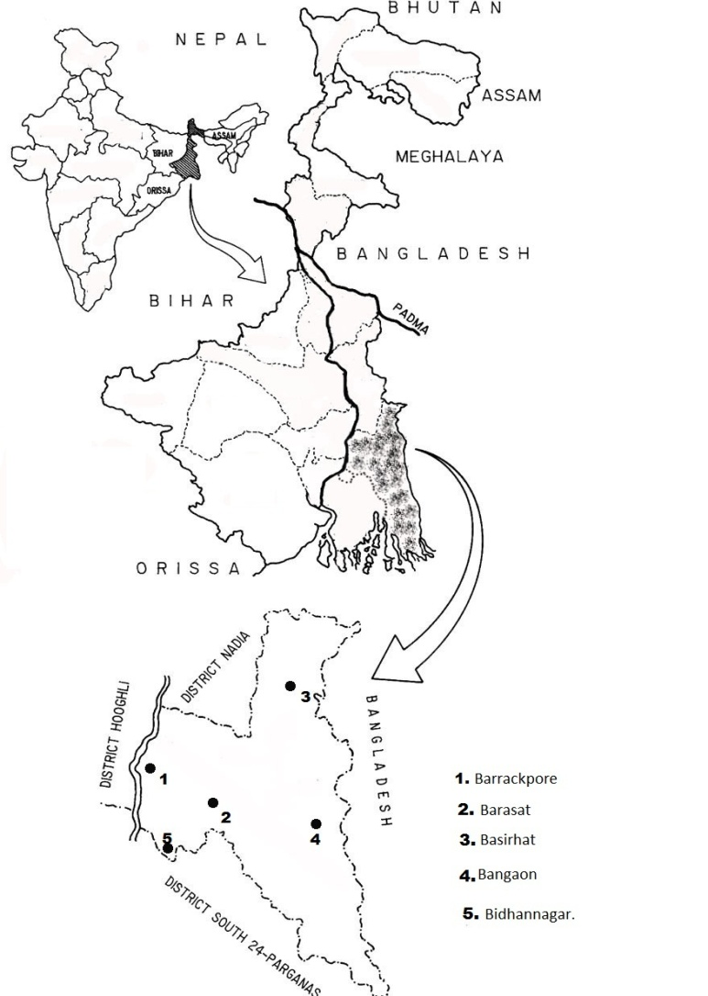
Subdivisions and some study spots:
1. Barrackpore a) Naihati b) Halishahar
2. Basirhat a) Hasnabad b) Hingalgunj
3. Barasat a) Badu b) Nilgunj
4. Bongaon a) Duttafulia b) Gopalnagar
5. Bidhannagar a) Rajarhat b) Mohishbathan
Fig 1 Map of North 24 Parganas showing different collection zones in five subdivisions

The temperature (Minimum &maximum) and humidity (minimum & maximum) of every day were recorded in the study area and they were averaged month wise.
Study of Symptoms
The infected leaves were carried to the laboratory in sterilized biodegradable polythene bags and the symptoms studied under hand lens and simple microscope.
Isolation and purification of pathogen from diseased parts
The diseased leaves of medicinal plants were carried into the laboratory in air tight sterilized biodegradable polythene bags. The collected leaf samples were washed in sterile distilled water and soaked in alcohol to remove the surface impurities. The leaf samples were cut into small pieces of 3-5 mm in size from the diseased portion. Then they are passed through 0.1% of HgCl₂ solution for one minute for surface sterilization and washed in three changes of sterile distilled water. These leaf cuttings were blotted between sterile filter papers and aseptically plated on Potato Dextrose Agar (PDA). In each plate a single piece was placed and incubated at BOD (28± 2°C) for 7 days. After appearance of mycelial growth it was transferred on to fresh PDA slant. For purification of isolated pathogen, single hyphal tip method was taken. The purified isolate of the fungal pathogen was labelled. The entire procedure for isolation of the disease was done under laminar air flow.
Pathogenecity test of the pathogen
Pathogenecity test was done following the Koch postulate.
Characterization and Identification of the pathogen
The identification of the pathogen was done phenotypically following Dhingra & Sinclair (1986), & Nagamoni et al.(2006)

3.Results
The data represented in the Table 1 and 2 revealed that in case of Ocimum sanctum, leaf blight (Fig 2) was present everywhere while leaf spot was absent in all studied zones. The leaf spot (Fig 3) and rot of Aloe vera (Fig 4) were present in all places in 2013 and 2014. The survey revealed two new diseases of Bacopa – shot hole (Fig 5) and blight (Fig 6) Among all these diseases shot hole and leaf blight diseases of Bacopa monnieri are first recorded in this work. There are no previous reports of any fungal diseases on Bacopa monnieri all over the world. Blotch (Fig 7). blight (Fig 8) and anthracnose (Fig 9) of Rauvolfia sp were present in maximum places. The occurrence of disease in four selected hosts in different zones of North 24 Parganas is almost similar to the result of previous year with only exception in the absence of shot hole disease in Bacopa monnieri at few regions namely Basirhat, Barrackpore, Nahata and Gopalnagar.
Data available from Table 3 clearly revealed that leaf spot (Alternaria brassicae) & rot (Fusarium oxysporum) of Aloe vera were found all though two consecutive years. Leaf blight of Ocimum sanctum (Alternaria sp) also present throughout both the years among the studied areas. Anthracnose disease (Colletotrichum gleosporiodes) of Rauvolfia serpentina was found between June to October in both the years. Whereas for leaf blight disease (Alternaria tenuis) the occurrence was recorded in July to September. Leaf blotch disease (Cercospora serpentinae) in this was found between July to September (2013) & June to October (2014). Shot hole disease (Phomopsis sp)of Bacopa monnieri was recorded from June to December for 2013 & 2014. But leaf blight disease (Alternaria alternata) has its effect between May to October(2013) & June to September(2014).

Table 1. Occurrence of disease in Aloe vera and Bacopa monnieri at our survey areas
Places | Aloe vera |  |  |  | Bacopa monnieri
 | Spot |  | Rot |  | Shot hole |  | Blight
 | 2013 | 2014 | 2013 | 2014 | 2013 | 2014 | 2013 | 2014
Barasat | + | + | + | + | - | - | - | -
Noihati | + | + | + | + | - | - | - | -
Basirhat | + | + | + | + | + | - | - | -
Moishbathan | + | + | + | + | - | - | - | -
Barrackpore | + | + | + | + | + | + | + | +
Nilgunj | + | + | + | + | + | + | + | +
Haroa | + | + | + | + | - | - | - | -
Basanti | + | + | + | + | - | - | - | -
Duttapukur | + | + | + | + | + | - | - | -
Bongaon | + | + | + | + | - | - | - | -
Habra | + | + | + | + | + | + | + | +
Kalyani | + | + | + | + | + | + | + | +
Halishahar | + | + | + | + | - | - | - | -
Taki | + | + | + | + | + | - | - | -
Hingalgunj | + | + | + | + | - | - | - | -
Nahata | + | + | + | + | + | + | + | +
Gopalnagar | + | + | + | + | + | - | - | -
*(+) indicates occurrence of disease and (–) indicates absence of disease

Table 2. Occurrence of disease in Ocimum sanctum and Rauvolfia serpentina at our survey areas
Places | Ocimum sanctum |  |  |  | Rauvolfia serpentina
 | Spot |  | Blight |  | Anthracnose |  | blotch |  | blight
 | 2013 | 2014 | 2013 | 2014 | 2013 | 2014 | 2013 | 2014 | 2013 | 2014
Barasat | - | - | + | + | + | + | + | + | - | -
Noihati | - | - | + | + | + | + | + | + | + | +
Basirhat | - | - | + | + | + | + | - | - | + | +
Moishbathan | - | - | + | + | + | + | - | - | + | +
Barrackpore | - | - | + | + | + | + | - | - | - | -
Nilgunj | - | - | + | + | + | + | + | + | - | -
Haroa | - | - | + | + | + | + | + | + | + | +
Basanti | - | - | + | + | + | + | - | - | + | +
Duttapukur | - | - | + | + | + | + | - | - | + | +
Bongaon | - | - | + | + | + | + | - | - | - | -
Habra | - | - | + | + | + | + | - | - | - | -
Kalyani | - | - | + | + | + | + | + | + | + | +
Halishahar | - | - | + | + | + | + | + | + | + | +
Taki | - | - | + | + | + | + | + | + | + | +
Hingalgunj | - | - | + | + | + | + | + | + | - | -
Nahata | - | - | + | + | + | + | - | - | + | +
Gopalnagar | - | - | + | + | + | + | - | - | + | +
*(+) indicates occurrence of disease and (–) indicates absence of disease.

Table 3. Medicinal plants and its disease with causal organism at a glance
Serial no. | Host | Disease | Pathogen | Time of Occurrence
 | Ocimum sanctum | Leaf blight | Alternaria sp | January- December, 2013& 14
 | Rouvolfia serpentina | Anthracnose | Colletotrichum gleosporiodes | June –October, 2013 & 14
 | Rouvolfia serpentina | Leaf blight | Alternaria tenuis | July-September, 2013 & 14
 | Rouvolfia serpentina | Leaf blotch | Cercospora serpentinae | July-September, 2013  June –October, 2014
 | Aloe vera | Leaf spot | Alternaria brassicae | January- December, 2013& 14
 | Aloe vera | Leaf rot | Fusarium oxysporum | January- December, 2013& 14
 | Bacopa monnieri | Shot hole disease | Phomopsis sp | June- December, 2013& 14
 | Bacopa monnieri | Leaf blight disease | Alternaria alternata | May-October, 2013 June-September, 2014
Data presented in Table 4 also indicates that Temperature and moisture supports disease occurrence

Table 4. Month wise report of temperature and humidity in our study area
Month | Temperature ⁰C |  | Humidity (%)
 | 2013 | 2014 | 2013 | 2014
January | 13-26 | 10-26 | 71-84 | 70-78
February | 18-29 | 16-27 | 75-86 | 72-82
March | 25-34 | 19-33 | 79-88 | 78-90
April | 32-42 | 30-41 | 76-90 | 79-96
May | 30-43 | 33-43 | 75-94 | 80-98
June | 28-38 | 28-39 | 78-96 | 77-100
July | 28-37 | 26-38 | 96-100 | 94-100
August | 30-36 | 25-36 | 89-92 | 86-96
September | 30-35 | 25-35 | 85-92 | 89-95
October | 25-35 | 22-31 | 80-9 | 86-92
November | 20-25 | 20-25 | 70-80 | 70-80
December | 10-20 | 10-20 | 65-70 | 65-70

4. Discussion
Alam et. al. (2007) have also surveyed the diseases of medicinal plants in U.P. They have also found all these diseases which have been reported by us except leaf shot hole and leaf blight disease of Bacopa monnieri. Fungi associated with base rot disease of Aloe vera (syn. Aloe barbadensis) were investigated in Niger Delta Area of Nigeria. The frequency percentage of associated fungal propagules were Aspergillus verocosa 28.03%, Fusarium oxysporium 24.24%, Plectosphaerella cucumerina 16.67%, Mammeria ehinobotryoides 15.91% and Torula herbarium 15.15%. None of the fungi isolated have been previously reported on Aloe vera in Nigeria (Ayodele and. Ilondu.2008). The leaf spot disease on Aloe plant first came into limelight as purple spot disease on Aloe arboescens Mill. caused by Fusarium phyllophilum (Kinshi et al, 1999) and later Haematonectria haematococca (anamorph: Fusarium sp.) causing ring spot disease on Aloe barbadensis (Hirooka et. al., 2007). From other states of India the disease with same type of symptoms was reported by other workers(Kamalakannan et. al., 2008). The disease was also reported from Osmanabad district, Maharashtra (Chavan and. Korekar, 2011). In abroad this disease of Aloe vera has been reported from Lousinia (Silva et. al., 2012) and from Pakistan (Bajwa et. al., 2010). Beside that a Fusarium rot disease of Aloe vera was reported from Bali (Kuwari et. al., 2012). Some instances of anthracnose disease of Aloe vera caused by Colletotrichum sp was also reported from Lucknow (Alam et. al.,2007).In our previous work we have also found Aloe vera as a new host for Alternaria brassicae (Ghosh & Banerjee, 2008)
Basil suffers from several plant pathogens that can ruin the crop and reduce yield. Fusarium wilt is a soil-borne fungal disease that will quickly kill younger basil plants. Seedlings may also be killed by Pythium damping off. A common foliar disease of basil is gray mold caused by Botrytis cinerea; it can also cause post-harvest infections and is capable of killing the entire plant. Black spot can also be seen on basil foliage and is caused by the Colletotrichum. Leaf blight of Basil,caused by C. capsici has been causing considerable damage to the commercial field of basil during August–September, when it appears in severe form (Alam et al 1980).
Leaf Blight disease of Rauvolfia sepentina (sarpagandha) caused by Macrophomina phaseolina was reported by Mahrotra (1976). Colletotrichum blight (bloom blight) caused by C. capsici was recorded by Shukla et al (2006). Curvularia leaf spot of sarpagandha has been reported from Jammu and Kashmir by Thakur et al (1974). Wilt is one of the most important and serious diseases of Sarpagandha. The disease was first reported from jammu & Kashmir (Janardhanan et. al, 1964). Alternaria leaf blight of ashwagandha (W. somnifera), caused by A. alternata and root rot wilt is one of the serious diseases of ashwagandha in the nursery as well as in the commercial fields at Lucknow and its adjoining areas in North India (Gupta et al 2004). Alam et al (2007) in their Book ‘Healthy Plants for Health ‘recorded some important diseases of some important medicinal plants and their management. Ghosh and Chakraborty (2012) recorded the anthracnose of sarpagandha and tried to control it by biological agents.
As per literature survey, there are no previous report for any disease on Bacopa monnieri. Our work establishes that even the plant Bacopa monnieri, with enormous medical importance, without having any past record of getting infected by any fungal pathogen, first time got victimized through fungal invasion. This work indicates that leaf blight of Bacopa monnieri occurs in numerous places of 24 Parganas, West Bengal in 2013 and 2014 during the summer and rainy season.

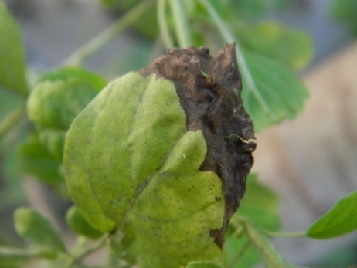
Fig 2. Leaf blight symptom on Ocimum sanctum

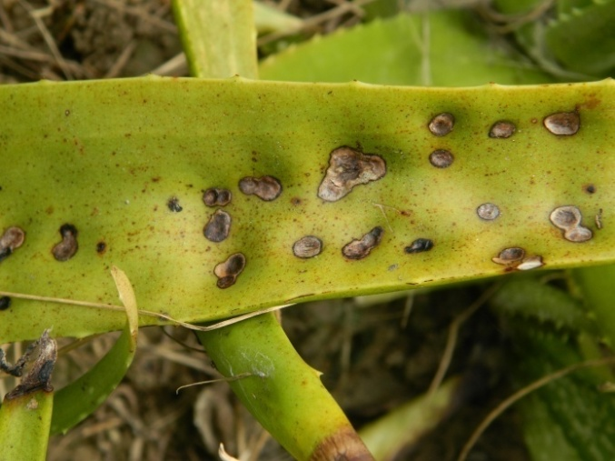
Fig 3. Leaf spot symptom of Aloe vera

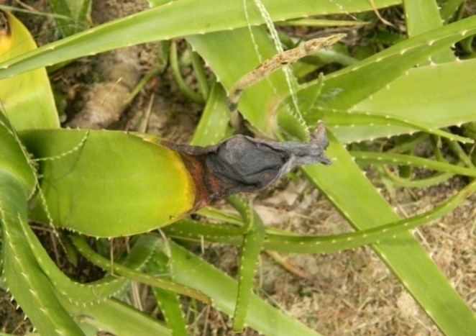
Fig 4 Leaf rot symptom on Aloe vera

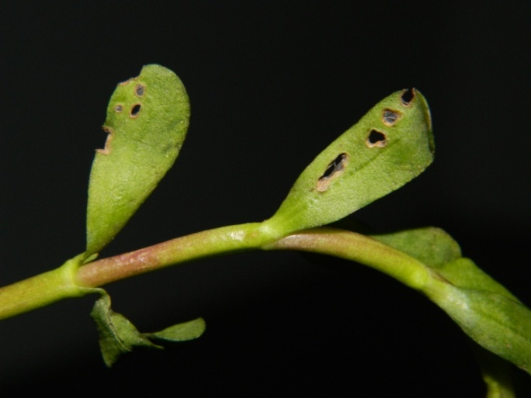
Fig 5. Shot hole symptom of Bacopa monnieri

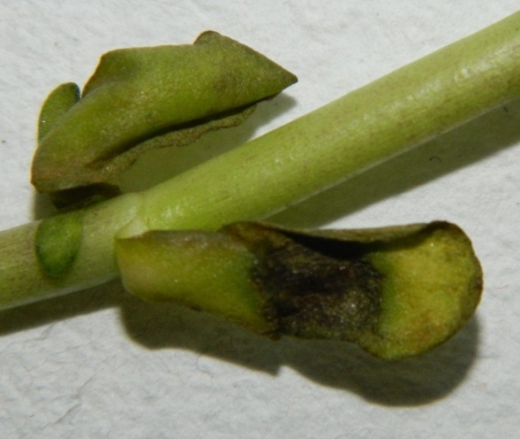
Fig 6. Leaf blight symptom on Bacopa monnieri

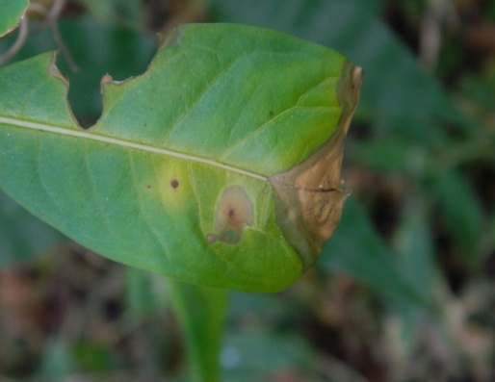
Fig 7. Lleaf blotch symptom on Rauvolfia serpentina

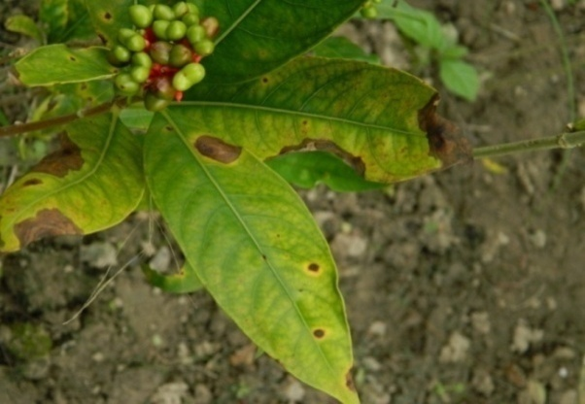
Fig 8. Leaf blight symptom on Rauvolfia serpentina

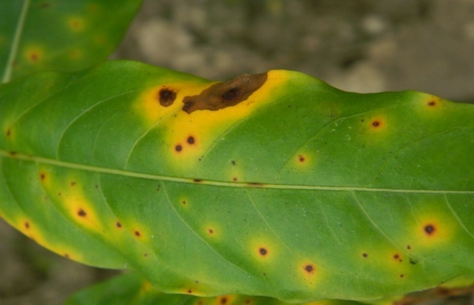
Fig 9. Anthracnose symptom on Rauvolfia leaf

5. Conclusion
In conclusion from our research, eight new diseases namely leaf spot and rot of Aloe vera, leaf blight of Ocimum sanctum, leaf shot hole and blight of Bacopa monnieri, leaf blight, blotch and anthracnose of Rauvolfia serpentina were recorded in and around different places of North 24 parganas district of West bengal. Among all these diseases shot hole and leaf blight disease of Bacopa monnieri are first recorded by us. There are no reports of any fungal diseases on Bacopa monnieri all over the world. The spreading of these fungal diseases on medicinal plants may causes a set back to the industry associated with the formulation of it’s medicinal products. So this work may encourage other workers to study these diseases and their proper management.

6.Acknowledgement:
Authors are grateful to National Medicinal Plant Board (AYUSH, Ministry of Health And Family Welfare, Govt of India) to provide the essential financial support and Principal, RKMVC college to conduct this research work.

Corresponding Author:
Dr. Swapan Kumar Ghosh
Associate Professor
Ramakrishna Mission Vivekananda Centenary College
Rahara, Kolkata 118
West Bengal, India
E mail: swapan.krghosh@yahoo.com
Mobile: + 91 9433203463

Reference:
- Alam M, Khaliq A, Shukla RS, Sattar A, Singh HN, Sambad A, Gupta ML, Pandey R, Ajaykumar PV, Sharma A, Khanuja SPS. Healthy Plants for Health. CIMAP. Lucknow, India, 2007,184.
- Alam M. Jannerdhan K.K.Singh H.B.and A. Hussain. A new leaf blight of French basil by colletotrichum capsi in India. Indian J. of Myco. Pl. Pathol. 1980; 10:99.
- Anthony MH, Ayinla GT, Helnina AO. Ezekiel SA, Haruna OG. Health implication of toxigenic fungi found in two Nigerian staples: guinea corn and rice. African J. Food Sci. 2009; 3(9): 250-256.
- Ayodele SM, Ilondu EM. Fungi associated with base rot disease of Aloe vera (Aloe barbadensis) African Journal of Biotechnology 2008; 7 (24): 4471-4474,
- Bajwa R, Mukhtar I, Mushtaq S. New report of Alternaria alternata causing leaf spot of Aloe vera in Pakistan. Canadian Journal of Plant Pathology 2010; 32(4): 490-492.
- Chavan SP, Korekar SL. Survey of some medicinal plants for fungal diseases from Osmanabad district of Maharashtra state. Recent Research in Science and Technology 2011; 3(5): 15-16.
- Dhingra OD, Sinclair JB. Basic Plant Pathology Methods 1986; CRC press, Inc.
- Ghosh SK, Banerjee S. First report of Alternaria brassicae leaf spot disease ofAloe vera and it’s disease intensity in West Bengal. European Journal of Biotechnology and Bioscience 2014; 2(1):37-43.
- Ghosh S K, Chakraborty N. In vitro biological control of Colletotrichum gloeosporioides, causal organism of anthracnose of Sarpagandha (Roulvolfia serpentina) Agri. Biol. J. of N. America 2012; 3 (8): 306-310.
- Hirooka Y, Kobayashi T, Takeuchi J, Ono T, Ono Y, Natsuaki, K.T. Aloe ring spot, a new disease of Aloe caused by Haematonectia haematococca (Berg.&Broome) Samuels and Nirenberg (anamorph:Fusarium sp.). J. Gen. Plant Pathol. 2007; 73: 330-335.
- Janardhan KK, Gangully D, Hussain A. Fusarium wilt of Rauvolfia serpentina. Curr.Sci.1964; 33:313.
- Kamalakannan A, Gopalakrishnan C, Rebnuka R, Kalpana K. First report of Alternaria alternata causing leaf spot on Aloe barbadensis in India. Australasian Plant Dis. 2008; Notes 3: 110-111.
- Kawuri R, Suprata DN, Nitta Y, Homma H. Destructive Leaf Rot Disease Caused by Fusarium oxysporum on Aloe barbadensis Miller in Bali. Agricultural Science Research Journal 2012; 2(6): 295 – 301.
- Kinshi K, Furukawa T, Aoki T. Purple spot of Aloe (Aloe arborescens Mill) caused by Fusarium phyllophylum Nirenberg et O’Donnell (NewDisease). Ann.Phytopathol.Soc.Jpn. 1999; 65: 576-587.
- Liu D, Zeng Q, Chen H, Wu Y, Xing F. Common disease of medicinal plants in South China Botanical Garden.Zhong Yao Cai. 2003; 26(12):851-3.
- Mehrotra M.D. Studies of some interesting diseases of Rouvolfia serpentina from India :! Contribution to the knowledge of disease development in relation to environment. Indian Forester 1976; 102 :119-125.
- Nagamoni A, Kunwar IK, Monahorachary C. Hand Book of Soil Fungi 2006 ; I.K. International Pvt. Ltd. New Delhi.
- Shukla RS, Alam M, Khaliq A, Bahl JR, Singh HN, Khanuja SPS. Blossom blight, A new Disease of Roulvolfia serpentine. Indian J. of Mycol. Pl Pathol. 2006; 36:(3)
- Silva WL DE, Singh R. First Report of Alternaria Causing Leaf Spot on Aloe vera in Lousinia. Plant Disease 2012; 96(9):1379.1-1379.1
- Thakur RN, Singh KP, Husain A. Curvularia leaf spot of Japanese Mint in India. Indian J. of Mycol. Pl Pathol. 1974; 4:199

3/21/2015

