Structure Modeling and Petrophysical Analysis in the Ras El Ush Field, Gulf Of Suez, Egypt

Adel A.A. Othman and M. Fathy

Al Azhar University, Faculty of Science, Geology Department, Cairo, Egypt
green_geophysics@yahoo.com

Abstract: Ras El Ush Field is located in the southern structural province of Gulf of Suez. Ras El Ush Field was discovery by Marathon, in the offshore area of Gebel El Zeit Concession. Sandstone within the Matulla and Nubia formations are hydrocarbon producing units in this field (the main reservoir is Field). The present work is aims to study the subsurface structure setting and reservoir characteristics to evaluate the hydrocarbon potential of these units, based on 3D seismic and well log data. The subsurface structural setting was studied through constructing structural depth structure maps, structure modeling which revealed that the area is affected by ten fault trends; NW-SE (clysmic cycle) and NE-SW ( transform fault), evaluation of hydrocarbon potentialities at downthrown side and calculation of volumetric hydrocarbon to new leads.
[Adel A.A. Othman and M. Fathy. Structure Modeling and Petrophysical Analysis in the Ras ElUsh Field, Gulf Of Suez, Egypt. N Y Sci J 2015;8(3):73-87]. (ISSN: 1554-0200). http://www.sciencepub.net/newyork. 14

Keyword: Ras El Ush Field. Structure model, estimated OOIP.

1. Introduction
Ras El Ush is located 80km north of Hurghada in the offshore zone of Gebel El Zeit area, Gulf of Suez, Egypt Figure (1). Discovered Ras El Ush oil field in 1995, by drilling the exploratory wells REU-2, REU-2st1 prouced oil from Matulla sandstone reservoir while REU-3 produced oil from Nubia sandstone with total production about 700BOPD.

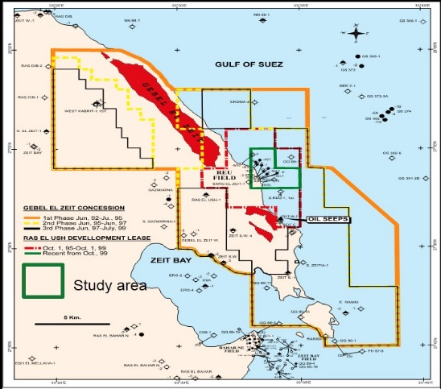
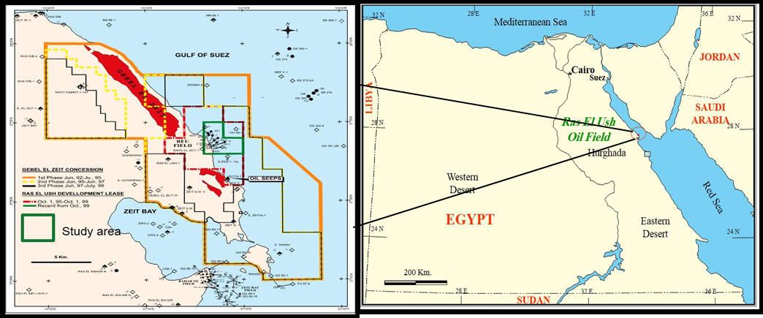
Figure 1: Location map of study area.

Geologic Setting
The lithostratigraphic units in the Gulf of Suez area range from Precambrian to Holocene in age and have been divided into three major sequences relative to the Miocene rifting event:Pre rift lithostratigraphic unit (pre Miocene unit), Synriftlithostratigraphic unit (Miocene unit) and Post rift lithostratigraphic unit (post Miocene unit) show that in figure (2).
Pre rift lithostratigraphic unit:
The pre rift stratigraphic sequence is composed of strata range from pre Cambrian to upper Eocene and contains sand, shale and carbonate facies that were laid down under terrestrial and marine platform environments. This period of sedimentation was affected by a major unconformity representing non-deposition or erosion at different geologic times. Said, 1962. Darwish & ElAraby, 1993, Darwish, 1994, Rashed, 1999) and Zico et al, 1993.
Syn rift stratigraphic unit:
Interbeded Oligocene limestone, sandstone, and shale are present in the southern Gulf of Suez where they rest unconformity on the Eocene rock. The Miocene sequence was previously subdivided into two main groups "the Ghrandal group" and "RasMalaab group" (Said1962).
Post rift lithostratigraphic unit:
The post rift sedimentary fill of the Gulf of Suez is Pliocene – Holocene in age. The thickness and lithology of these strata shows marked variation from one area to another. (Evans, 1988).
Tectonic Setting
The Gulf of Suez extensional rift initiated with the ancestral Red Sea in Oligo-Miocene time.it is one of the interior rift basins that proved so far an approximately seven billion barrels of oil reserve. The Suez rift is younger than the late cretaceous Syrian Arc fold belt. It is located between the Sinai Peninsula and the northern part of the eastern desert. This rift basin has a width of about 50-90 km between its shoulders, and a length of about 350 km. The Red Sea-Gulf of Suez rift system developed because of the northeastward divergent movement of the Arabian from the African plate (Coleman, 1974, 1993; Hempton, 1987). The opening of both the red sea and the Suez rift resulted by the extension in (Afro-Arabian plate) leading to the separation of the African, Sinai and Arabian plate during the late Eocene to Oligocene (Youssef, 1968; Robson, 1971; Grafunkel and Bartov. 1977; Colletta et al., 1988; Barakat et al., 1988; Moustafa, 1996,1997; Patton et al., 1994). Synchronous fault growth and cross faults trends were active until lower and middle Miocene times. Tectonism continued, although rifting was less intensive until late Miocene times. Renewed rifting took place during the Pliocene to recent times (Mc Clay et al., 1998). Rifting occurred during the Late Oligocene to Early Miocene separation of the African and Arabian plates (Grafunkel & Bartov, 1977; Richardson & Arthur, 1988; Patton et al., 1994) show that in figure (3).

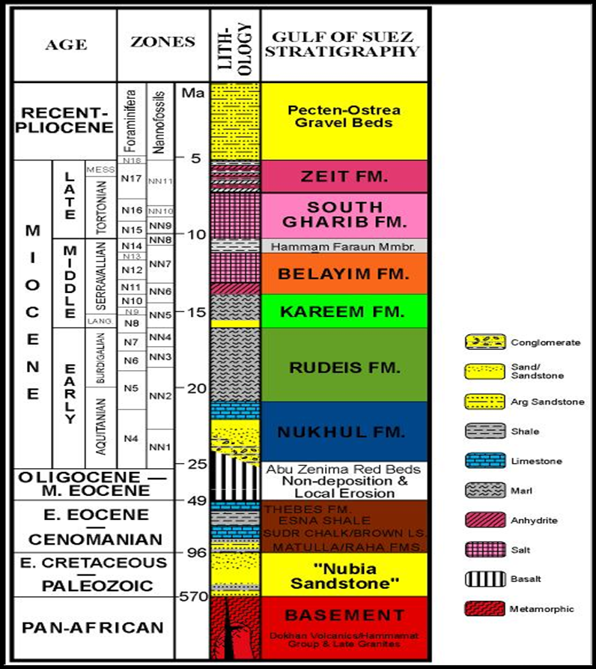
Figure 2: Generalized stratigraphy and microfossil zonations of the southern Gulf of Suez. (modified from Evens 1988 And Richardson and Arther 1988)

Structural Framework
Meshref, (1990) pointed that the structure of the Gulf of Suez area was developed due to its subjection to three phases of Tectonism. The first phase prevailed in the Pre-Cambrian to Early Mesozoic and have three cycles of deformation:
- The Erythrian cycle (Precambrian-Early Cambrian) where the basement complex was deformed by at least 4 sets of fracture, NW, EW, WNW and ENE.
- The clysmic cycle (Early Cambrian to Early Carboniferous) where NW-SE fracture took place.
- The Hercynian (Late Carboniferous to Early Triassic) where the E-W trending fracture rejuvenated.
The second phase prevailed during the Jurassic and Cretaceous time and resulted in a system of the rejuvenation WNW, EW fracture with the development of N35º W and N85º E strike slip conjugates.
The third phase started between the late Cenozoic and Plio-Pleistocene, Aqaba (N15º E) and (N45º W) strike slip conjugates were developed.
Said (1962) suggested that the Gulf of Suez structural pattern is a huge graben associated with successive block faulting on both sides of its center and parallel to its axis.

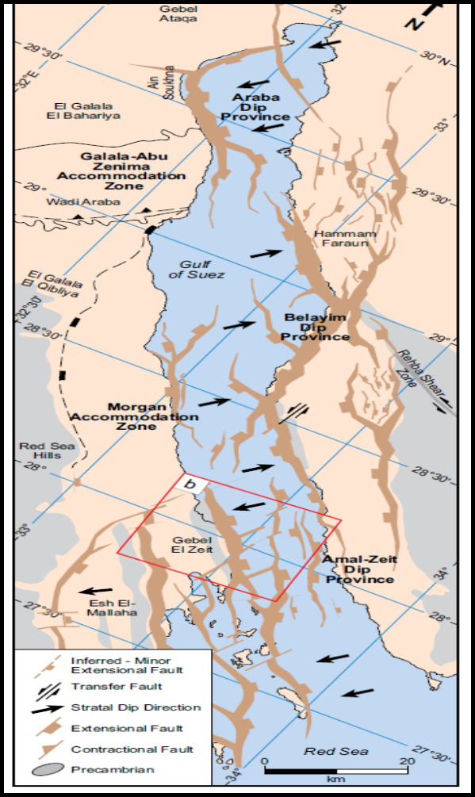
Figure 3: Tectonic map of the Gulf of Suez Rift (modified after Bosworth and McClay, 2001; Abd El-Naby et al., 2009)

2. Material and method
- Seismic data to construct structure modeling and evaluating the hydrocarbon potentials in the study area.
- Reservoir characterization to estimate the formation bearing hydrocarbon and calculate petrophysical characteristic.
- Estimated OOIP
Seismic interpretation
Well to seismic tie
Seismic interpretation is a process of transforming the physical responses displayed by the seismic lines into geologic information of interest, such as the structure. The initial step in the seismic interpretation process is to tie of geological horizons to seismic reflectors, the next step is to pick the seismic horizons by continuity and or by character of interest and interpret the structural elements as shown in figure(4).

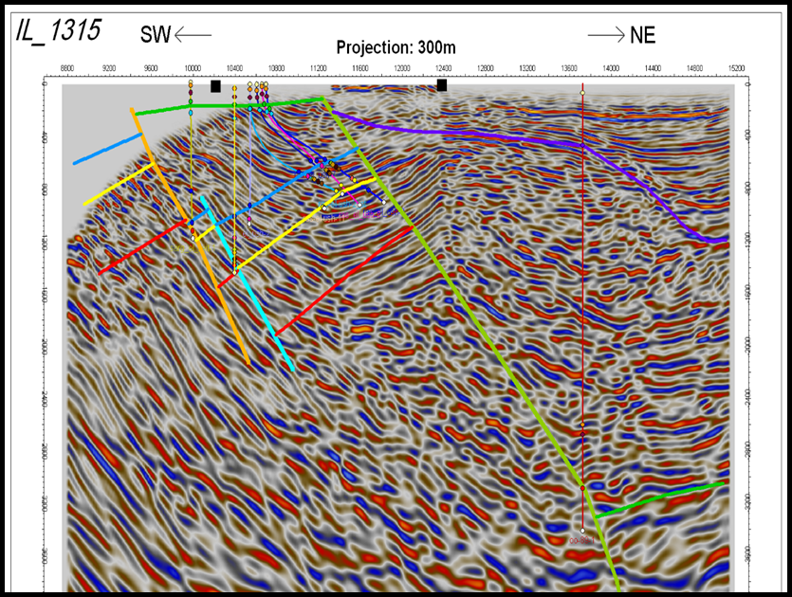
Figure 4: Inline 1315 shows Synthetic seismogram tie with seismic section.

Depth structure maps
Ras El Ush is located between East Gebel Zeit to the east and Gemsa Basin to the west. The study area is affected by series faults group of them take clysmic trends and another group NE-SW trends (cross faults). From seismic data constructed surface horizon from oldest to youngest at top of the Basement and Nubia sandstone, Matulla, Nukhul Formation, Rudeis Formation and South Gharib Formation figure (5&6&9&11&12&14)
Depth structure map on the top Basement rock.
Figure (5) shows that the study area was affected by five faults three faults at NW-SE trends related to the clysmic cycle (Early Cambrian to Early Carboniferous) where NW-SE fracture took place and two trend at NE-SW related to the Erythrian cycle (Precambrian-Early Cambrian) where the basement complex was deformed by at least 4 sets of fracture, NW, EW, WNW and ENE Meshref, (1990). The depth Basement ranges about 4500 to 9000 ft. And high area at eastern part and deep area at western part of the study area.
Depth Structure map on the top Nubia Formation.
Figure (6) showing that the study area under tectonic force however, consists of two sets of major trends longitudinal faults, parallel to the rift axis and created in an extensional regime trending NW-SE most of longitudinal faults were created during the Neogene times in a purely extensional regime transverse faults NNE-SSW shown in figure (7) dominated trend pointed that during Oligocene-Early Miocene, the Gulf of Suez as an area was intensively faulted, the general uplift took place by NW-SE trending faults and most of the blocks showing in figure(8), which formed due to this uplift the transverse faults can show horizontal strike-slip components and act as major normal faults (Colletta et al., 1988 and Patton et al., 1994). The depth the Nubia Formation ranges value about 3000 to 5000ft. with the main basin at western part and decrease gradually at eastern part. The structure of the Gulf of Suez area is governed by normal faults and tilted blocks. Both sets were simultaneously active producing a zigzag pattern and rhombic shaped blocks and at the Nubia Formation some well drilled and reached the target at an updip position near the rotated fault block produced oil (REU-3& REU6ST2& REU4ST& REU6). The two faults trends to perform rhombic shape essential to trapment of the hydrocarbon.

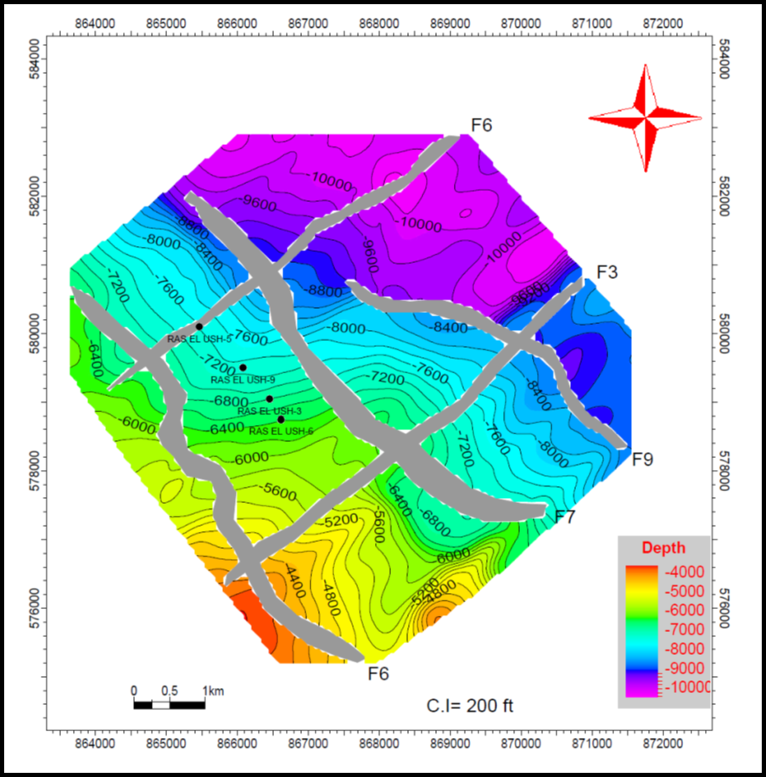
Figure 5: depth structure map on the top Basement rocks showing that the study area affected by two trends NW-SE and NE-SW.
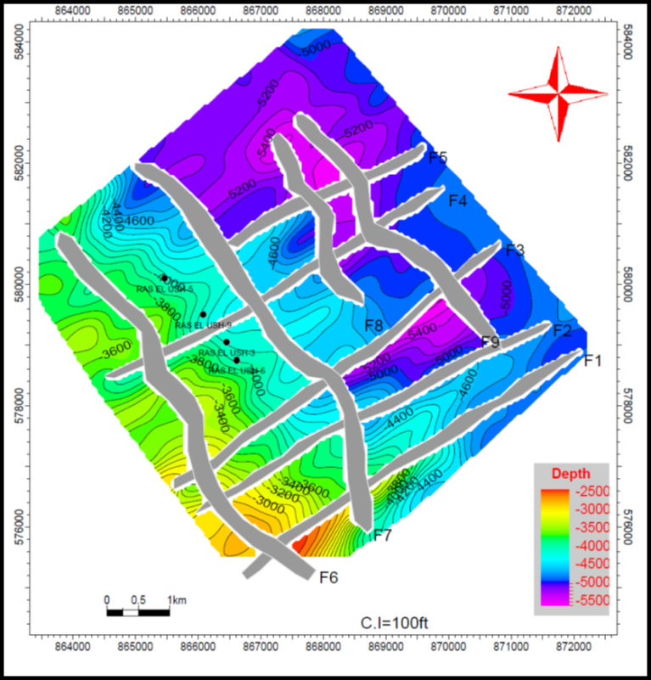
Figure 6: depth structure map on the top Nubia Formation showing that the depth the Nubia Formation ranges value about 3000 to 5000ft, rhombic shaped blocks andthe study area affected by two trends NW-SE and NE-SW.

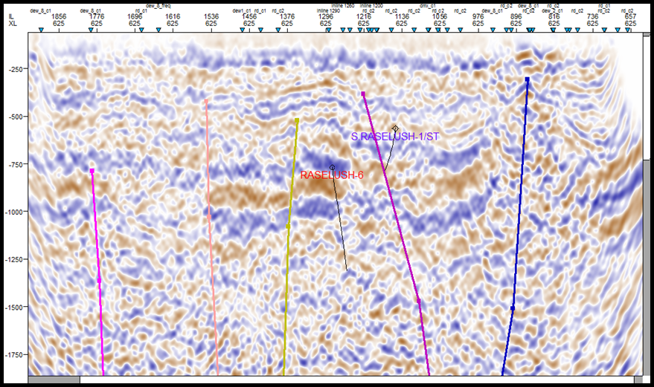
Figure 7: Seismic line showing that NE-SW trend at xline trend from seismic data.
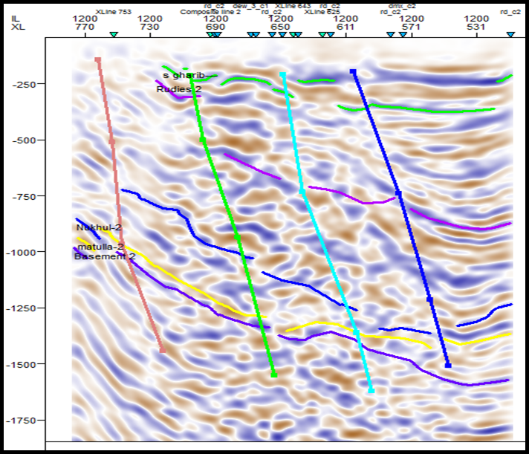
Figure 8: Seismic line showing that NW-SE trend at inline trend from seismic data.

Depth structure map on the top Matulla Formation.
Figure 9 shows the study area still under the same effect on Nubia Formation the main trend at NW-SE and NE-SW both of sets, create rhombic shape and the Matulla Formation in the study area first target to produce the hydrocarbon most of wells drilled at this level produced oil at eastern part. The depth Matulla Formation ranges about 2000 to 4500 ft. The main basin trend at western part and depth decrease at eastern part shown on seismic line in figure (10).
Depth structure map on the top Nukhul andRudeis formations.
Figure (11&12) showing that the effect tectonic forced decrease gradually from Nubia to Rudeis formations and the main trends at NW-SE and cross faults NE- SW. The basin trend still in the western part of the study area and to shrink at Rudeis Formation and eastern part the main platform and shown in figure (13).

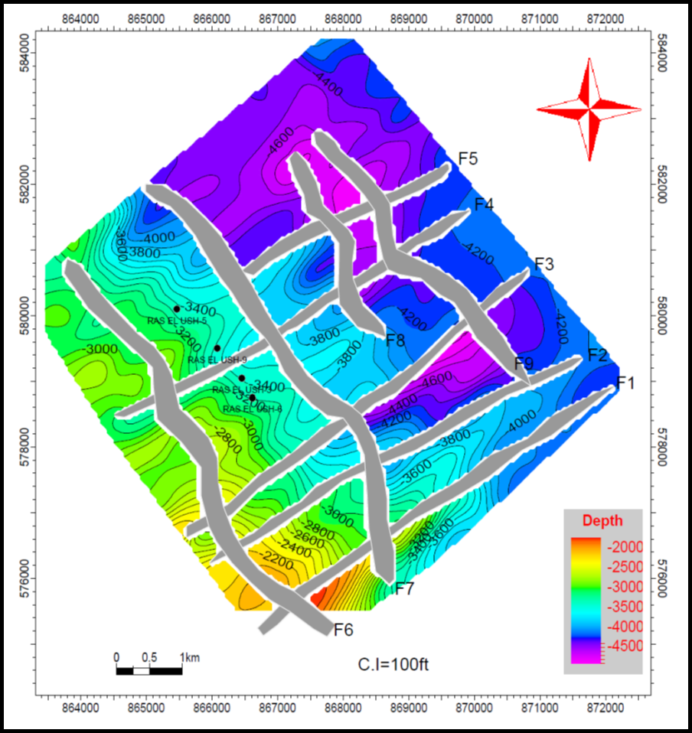
Figure 9: depth structure map on the top Matulla Formation showing that the depth the Matulla Formation ranges value about 2000 to 4500ft., rhombic shaped blocks andthe study area affected by two trends NW-SE and NE-SW.

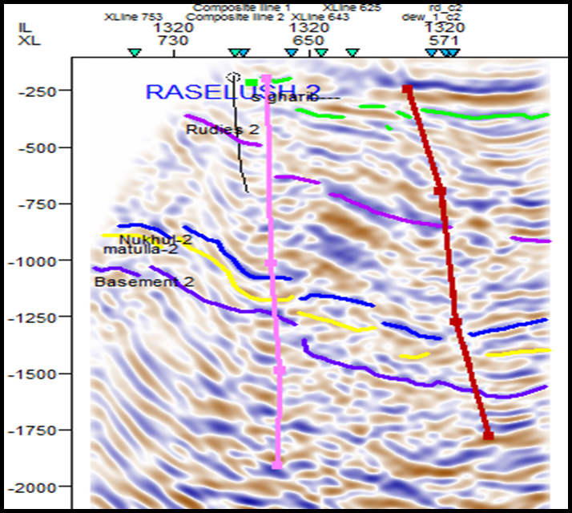
Figure 10: Seismic line showing that the NW- SE trend at the inline trend from seismic data and platform in the eastern part of the study area.

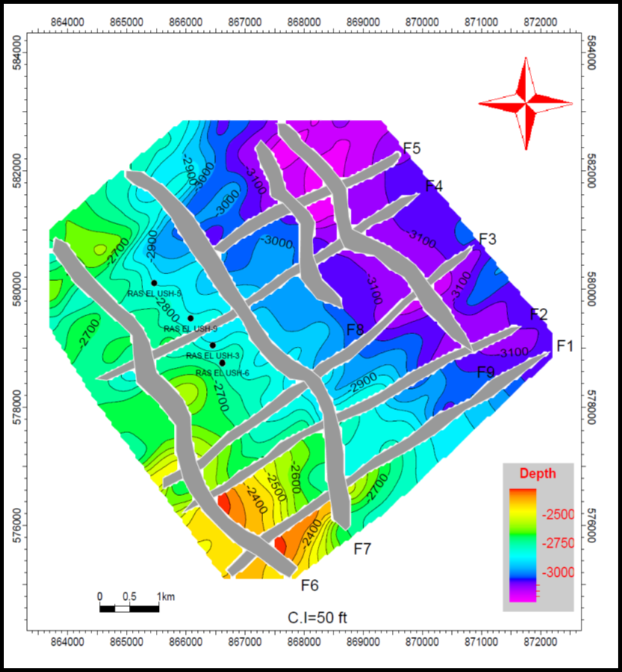
Figure 11: depth structure map on the top Nukhul Formation showing that the depth the Nukhul Formation ranges value about 2500 to 3000ft andthe study area affected by two trends NW-SE and NE-SW.
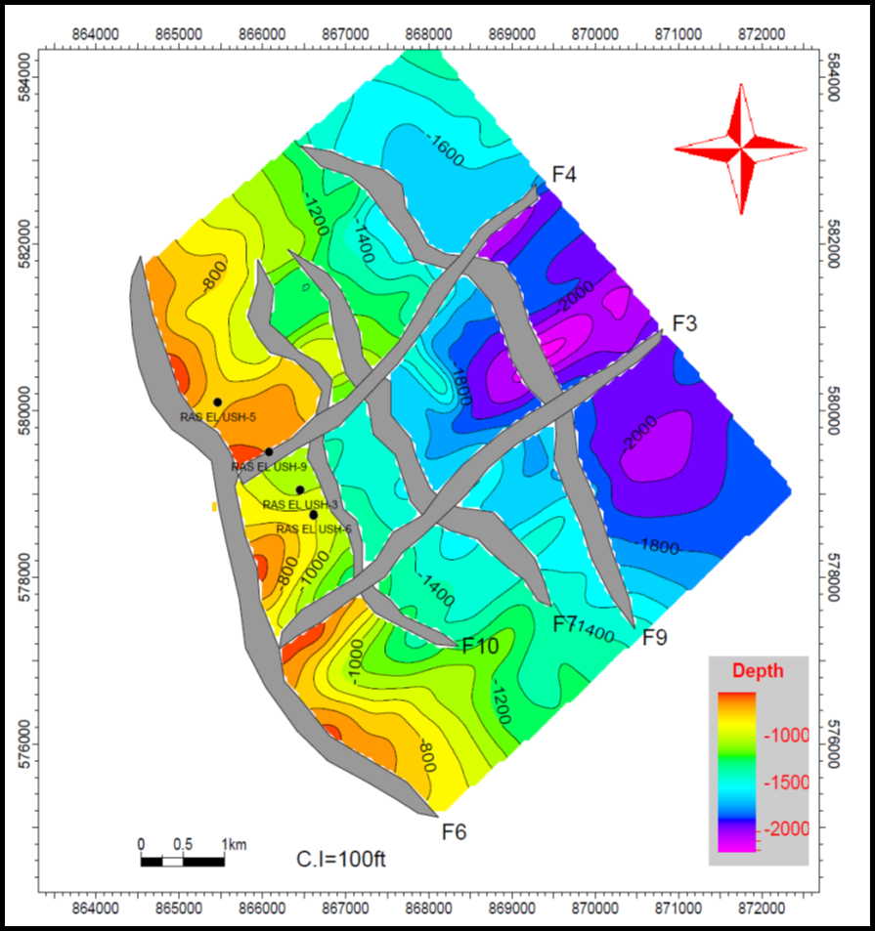
Figure 12: depth structure map on the top Rudeis Formation showing that the depth the Rudeis Formation ranges value about 1000 to 2000ft., andthe study area affected by two trends NW-SE and NE-SW.
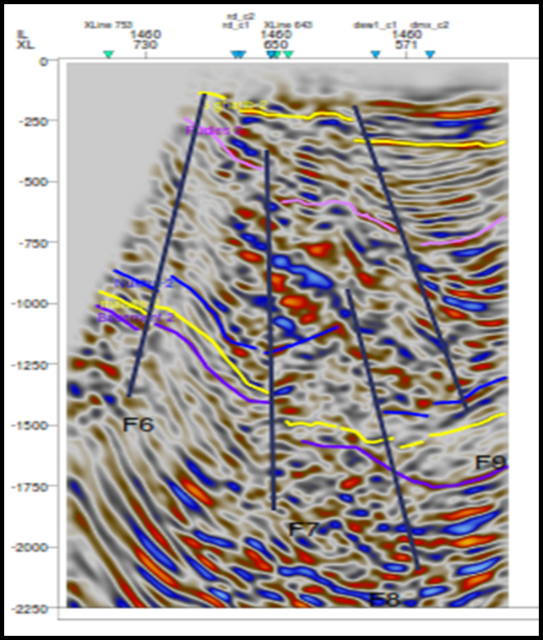
Figure 13: Seismic line showing that the NW- SE trend at the inline trend from seismic data at the study area.

Depth structure map on the top South Gharib Formation.
Figure (14) shows that the South Gharib effected by one fault at trend NW-SE. The depth the South Gharib ranges about 250 to 1000 ft. As the trend of the basin in the western part shown in figure (15).

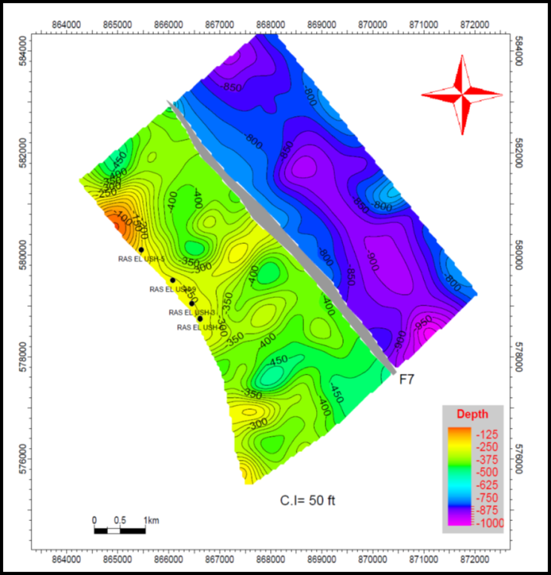
Figure 14: depth structure map on the top Gharib Formation showing that the depth the Gharib Formation ranges value about 250 to 1000ft andthe study area affected by one trend NW-SE.
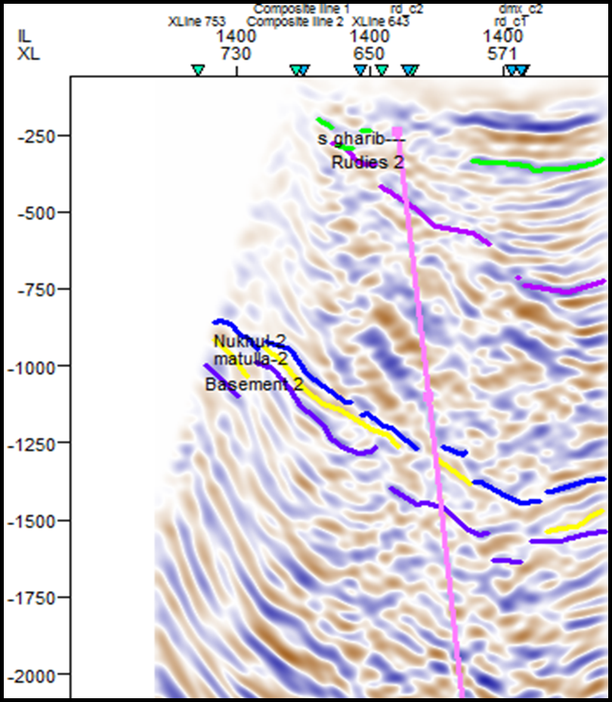
Figure 15: Seismic line showing that the NW- SE trend at inline trend.

Reservoir Characteristics
The vertical and horizontal variations of the Matulla and Nubia formations, conclude the Porosity (18 to 28%), Net pay (60 to 300 ft (MD)) and Water saturation (20 to 60%) are shown in figure (16) and figure (17) through constructing the litho-saturation crossplot (CPI) computer processed interpretation.
Reservoir Characteristics
The vertical and horizontal variations of the Matulla and Nubia formations, conclude the Porosity (18 to 28%), Net pay (60 to 300 ft (MD)) and Water saturation (20 to 60%) are shown in figure (16) and figure (17) through constructing the litho-saturation crossplot (CPI) computer processed interpretation.

4. Results:
Building the 3D structural model
It is obvious that the Ras El ush area is structurally complex. Many of the faults shows (rhombic shape) that makes the construction of the structural model a challenging task figure (18).The purpose of which was for him to build a structure model to determine the possible presence of hydrocarbons in the downthrown side at direction NW-SE with intersections NE-SW these intersections were formed rhombic shape
Prospect Evaluation
According to Magoon et al. (1994), prospects were first used by the exploration geologists to describe the present-day structural or stratigraphic features that could be mapped and drilled. A series of related prospects is called play. As a result of the present study, by using the subsurface and petrophysical evaluation, four locations are proposed to be prospects in the Matulla and Nubia formations, as shown in Figure (19) was arranged according to, prospect area (A, D, B and c). These locations are structurally located on a three-way dip closure that is a very attractive place for hydrocarbon accumulation. In the study area, a three-way dip closure is developed along the NW-SE clysmic cycle at downthrown side. This closure is bisected by NE-SW transforms faults. The closure is well defined on top the Matulla Formation down to the Nubia Formation. Based on the well data, the average oil-water contacts were detected in the Matulla Formation at 4150 ft. and Nubia Formation at 4470 ft. respectively.
Volumetric study to new leads
Therefore, volumetric methods are primarily used to evaluate the in-place hydrocarbons in new, non-producing wells and pools and new petroleum basins was estimated OOIP to Matulla Formation in (table (1)) and Nubia Formation in (table (2)) by using equation Lisa Dean (2007).
OOIP (STB) =
Rock Volume * 7,758 * ɸ* (1- Sw) * 1/Bo

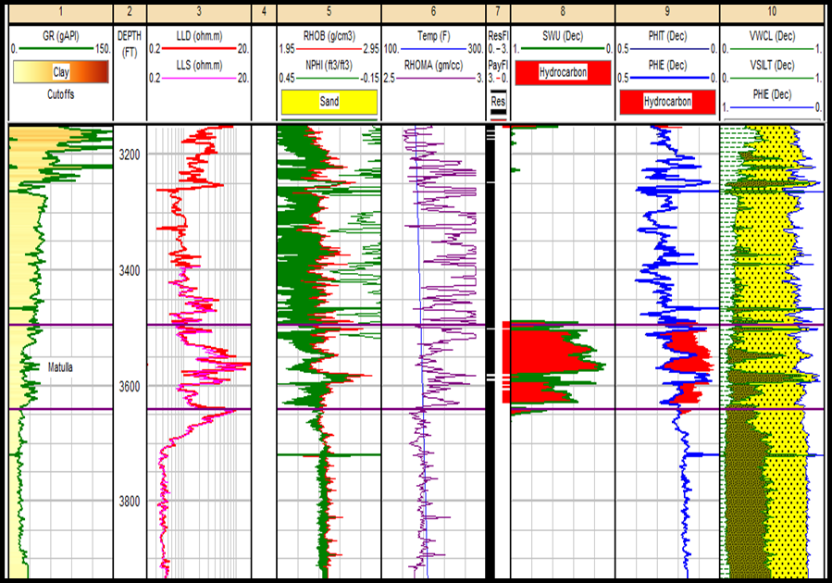
Figure 16: Computer processed interpretation (C.P.I.) plot for Matulla interval (3500 to 3600 ft) in REU-9 well.

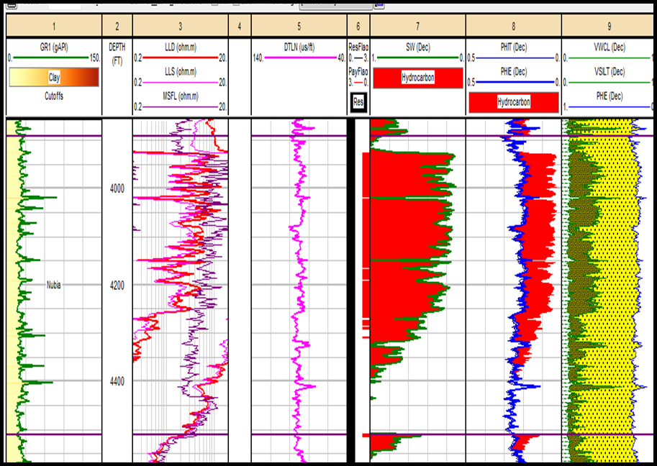
Figure 17: Computer processed interpretation (C.P.I.) plot for Matulla interval (3300 to 4300 ft) in REU-3 well.
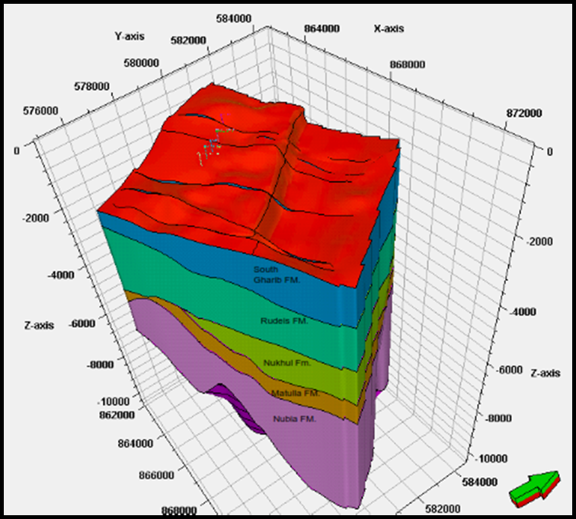
Figure18: Structural model of Ras El Ush Field, showing the surface distribution all over the study area. It also illustrates that, the faults affecting the Field with NW-SE and NE-SW trends.

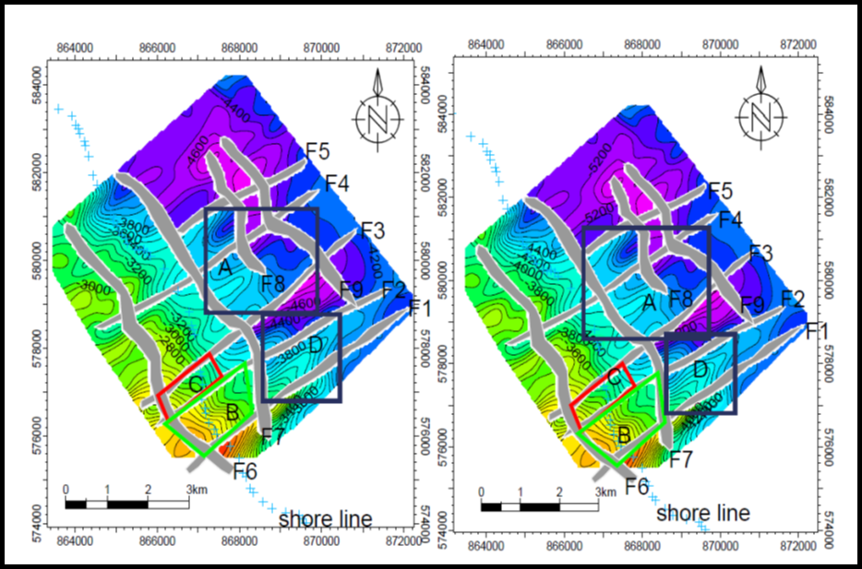
Figure19: Depth structure map on top Matulla and Nubia formations shown that location of prospect area.

Structurale cross section passes from E-W and pass through prospect (A) black circle new lead and red circle area where production, hydrocarbon which, Confirm the location of lead at the downthrown side shown that in Figure (20).
Structurale cross section passes from S-N and pass through prospect (A and D) black and red circles new leads which, Confirm the location of lead at the downthrown side shown that in Figure (21).

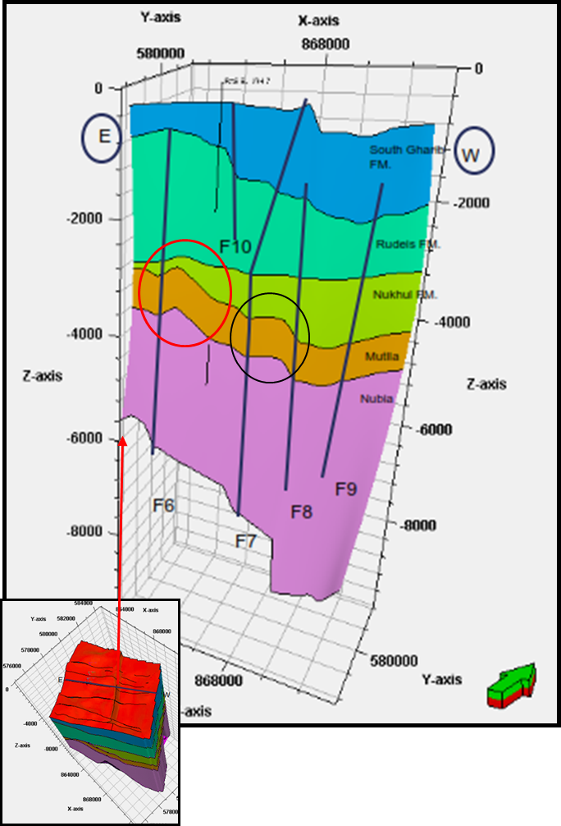
Figure 20: cross section from E-W trend showing the main faults NW-SE direction and locate prospect area.

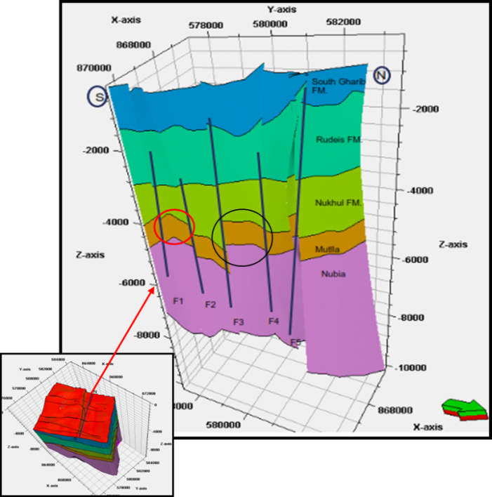
Figure21: cross section from S-N trend showing the main faults NE-SW direction and locate prospect area.

Table (1): Volumetric study of Matulla and Nubia formations.
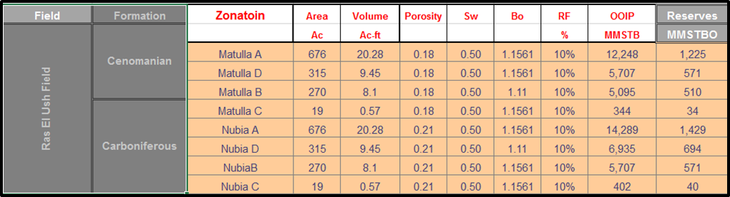

Conclusions
As a result of this study, we can conclude the following. The area is affected by ten faults (F1 to F5 at the direction NE-SW and F6 to F10 at the trend NW-SE). The study area has all criteria to make it of considerable hydrocarbon potential. It is characterized by having the hydrocarbon generating source rocks, seal rocks, reservoir rocks, with reasonable porosity and structural closure. Also, as a result of the present study, and based on the subsurface and petrophysical evaluation, four locations are proposed to be new prospects. These locations are found on downthrown side and intersection transform faults construction rhombic shape it a rollover and construction three-way dip closure and are characters by good petrophysical parameters.

Acknowledgments
The authors would like to express their gratitude to the Egyptian General Petroleum Corporation (EGPC) for permission to publish this study and for providing the data.

References
- Abd El-Naby, A., M. Abd El-Aal, J. Kuss, M. Boukhary and A. Lashin (2009): Structural and basin Accommodation zone in the northern part of the Suez rift. Jour. Struct. Am. Ass. Petrol. Geol. 52, 601-614.
- Bosworth, W. and K. McClay (2001): Structural and stratigraphic evolution of the Gulf of Suez Rift,
- COLEMAN, R.G., (1993): Geologic evolution Of the Red Sea. Oxford University Press, Oxford University Press, Oxford Monographs on Geology And Geophysics 24, Oxford: 1-186.
- COLEMEN, R.G., (1974): Geologic Background of the Red Sea. In: C.A. Burke& C.L Drake (Eds), the Geology of Continental Margins. Springer, Berlin: 743-751.
- Colletta, B., Le Quellec, P., Letouzey, J. and Moretti, I. (1988): Longitudinal Evolution of the Suez Rift Structure, Egypt: Tectonophysics. V. 153, PP221-233.
- d’Histoirenaturelle de Paris, Memoirs, v. 186, p. 567-606.
- Darwish, M. (1994): Cenomanian - Turonian sequence stratigraphy along basin evaluation and hydrocarbon potentialities of Northern Egypt. 2nd International Conference. Geology of Arab World. Cairo University.
- Darwish, M. and El Araby, A., (1993): Petrography and digenetic aspects of some siliciclastic hydrocarbon reservoir in relation to rifting of the Gulf of Suez, Egypt. The geol. Soc. Egypt, Spec. pub. No.1 p. 155-187. Digenetic environments AAPG. Bull.64, p 461-487. Egypt: a synthesis. In P.A. Ziegler, W. Cavazza, A.H.F Robertson and S. Crasquin-Soleau (Eds.).
- Evans, A. L. (1988); Neogene Tectonic and Stratigraphic Events in the Gulf of Suez Rift Area, Egypt. Tectonophysics, V. 153, PP235-247. Evolution in Miocene time, southwestern Gulf of Suez, Egypt. Neues Jahrbuchfür Geologie und.
- Garfunkel, Z. and Bartov, Y. (1977): The tectonics of the Suez rift. Geol. Surv. Israel Bull. 71: 44 pp. Geology, 18 (1), 93-107. Influence of basement structures and sedimentary thickness in the Gulf of Geology, 18 (1), 93-107.
- Hempton, M., (1987): Constraints on Arabian Plate Motion and Extensional History of the Red Sea. Tectonics, 6(6):687-705.
- Lisa Dean, Fekete Associates Inc (2007): Reservoir Engineering For Geologists Part 3 – Volumetric Estimation Reservoir Issue 11 • December 2007.
- Magoon, L.B. and Dow, W.G. (1994): The petroleum system from source to trap, AAPG, Tulsa, Oklahoma, U.S.A. 637P.
- Meshref, W. M., (1990): Tectonic Framework of Global Tectonics. In: The Geology of Egypt. (Ed. R. Said, 1990).
- Moustafa, A.R. (1996): Internal structure and deformation of an Accommodation zone in the northern part of the Suez rift. Jour. Struct.
- Moustafa, A.R. (1997): Controls on the development and transfer zones: The Influence of basement structures and sedimentary thickness in the Gulf of Suez and Red Sea. Jour. Structural Geology, 19, 755-768.
- Patton, T.L., A.R. Moustafa, R.A. Nelson and S.A. Abdine (1994): Tectonic evolution and structural Peri-Tethys Memoir 6: Peri-Tethyan rift/wrench basins and passive margins. Museum National Petroleum Geologists Memoir No. 59, p. 7-55.
- Rashed, A. (1999): Tectonic Frame Work and Roles Controlling Oil Traps in the Gulf of Suez, Egypt. Ph.D. Thesis, Al-Azhar University, Cairo, Egypt.
- Richardson, M. and Arthur, M.A., (1988): The Gulf of Suez–Northern Red Sea Neogene Rift: A quantitive Basin Analysis. Marine and Petroleum Geology 5, PP247–270. Rift, with Special Reference to the Eastern Side”. Q. Jlgeol.
- Robson, D. A. (1971): The Structure of the Gulf of Suez (Clysmic) Rift, with Special Reference to the Eastern Side. Q. Jlgeol. Soc. Lond. 115, PP41-47.
- Said, R., (1962): The geology of Egypt. Elsevier pub. Co., New Yourk p. 377.
- setting of the Suez Rift. In S.M. London (Ed.), Interior rift basins. American Association of Soc. Lond. 115, PP41-47. Suez and Red Sea. Jour. Structural Geology, 19, 755-768.
- Youssef, M. I. (1962): Structural pattern of Egypt and its interpretation. Bull. Am. Ass. Petrol. Geol. 52, 601-614.
- Zico, A., Darwish, M. and Eweida, ah. (1993): The cretaceous-early tertiary stratigraphy of thermal area, East Central Egypt, NeuesJahrbruch Geologic and palaantologie 3, p. 135-149.

3/15/2015

