An Investigation into the Effect of Emotional Intelligence on Staff Performance Rate: A case of Islamic Republic of Iran Sport TV

Seyyed Mahdi Sharifi¹, Narges Hassan Moradi², Ali Mohammad Saberi³

^{1.} Assistant Professor, public administration, Tehran University
^{2.} Assistant Professor, public administration, Islamic Azad University, Tehran north branch
^{3.} Master of Public administration, Islamic Azad University, Tehran north branch

Abstract: The management of each organization needs change and flexibility in order to adapt to changes, survive and grow in new environments. When one has the ability to understand and analyze emotional experiences, he manages to understand and improve his relation to environment; and this fact fosters emotion and goodness. Emotional intelligence deals with the difference among people in processing, perception, regulation and management of emotion. So it seems that these differences have clear effects on our lives such as physical and mental health, job performance and social relations. This study has been taken place in a quantitative mode and with 140 people of the staff of Islamic Republic of Iran Sport TV. The results show the emotional intelligence and its four aspects have a direct and significant relationship with staff performance; that means an increase in each aspect leads to an improvement in staff performance. In other words, if there happens an increase in self-awareness, relationship management, social-awareness and self-regulation, there will be also an increase in staff performance.
[Seyyed Mahdi Sharifi, Narges Hassan Moradi, Ali Mohammad Saberi. An Investigation into the Effect of Emotional Intelligence on Staff Performance Rate: A case of Islamic Republic of Iran Sport TV. N Y Sci J 2015;8(3):62-69]. (ISSN: 1554-0200). http://www.sciencepub.net/newyork. 12

Keywords: Emotional Intelligence, Self-awareness, Relationship management, Social-awareness and self-regulation, Performance

1. Introduction
In this new approach to the management of organizational culture: teamwork and the way staff cooperate are very important. In fact, the main focus is on improving and fostering people in order to increase organization efficiency. Selecting employees is a very significant step in realizing organization good performance. So, the candidates who would be chosen by organization should have social abilities and communicate skills. They should be both good speakers and listeners, and by understanding both their and others feeling, they can transfer his feeling and perform well. In one word, they make a suitable environment for people to grow. The efforts of people to handle stressful and challenging situations have an effect on success of practice and behavior. Each manager should reach to organizational goals through people; managers have been trained that their ability to reach organizational goals has a direct relationship with the ability of people affecting people around them. The fact has a lot more significance today as human issues, communication and relationship between manager and staff increase, especially as individual works are decreasing and the importance of team work is increasing. It can be said that this issue is shaping the new approach to management.

Theoretical Foundations:
Emotional Intelligence
People with high EQ are able to affect organization at all levels; moreover, they have an important role in quality and efficiency of social interaction with others. Emotional intelligence is necessary for job success and it includes 60 percent of performance rate in each job. (Bradbury & Greaves, 2007, p. 33) Employees with low emotional intelligence have a little ability in understanding their emotions; as a result, they do not manage to deal with their feelings. Therefore, facing with stressful situations, their performance will decrease. (Yang, 2007, p.215).
Today since the worth of human communication goes up, EQ theory has grown and it turns to one of the popular issues for organizations and commercial firms. It seems that as time passes and we enter communication era, some strategic situations occurs which can only be understood by creative managers with high emotional intelligence; as a result EQ theory has become more important and significant. In contrast, the traditional managers were mostly relied on their technical skills and rational intelligence.
Emotional intelligence comes from social intelligence which was first introduced in 1920 by Thronondaic.
Psychologists have identified different kinds of intelligence and categorized them in 3 main groups:
- Abstract Intelligence: the ability to understand and apply both mathematical and verbal symbols skillfully.
- Objective Intelligence: the ability to understand and deal with issues skillfully.
- Social Intelligence: the ability to understand and contact with people (emotional intelligence).
(Johnson and Indivike, 1999, 85) One scientist who has the biggest name in EQ is Daniel Goleman, a psychology professor who has different articles for psychology department of Time Magazine and after that New York Times Newspaper. In 1995, he started writing a book entitled “Emotional Literacy” and to complete his information and knowledge he visited various universities. In his studies, he got to know Mayer and Salovey and changed the title of his book to Emotional Intelligence. He participated in different TV programs and talked about EQ. As a result, he published his book in 1995 which became the best selling international book. “Goleman” and his publisher made a million profit.
Goleman Combined Model (with an emphasis on organizational performance)
Self-awareness
This component is the basis of emotional intelligence and it means: the ability to understand one’s self feelings and emotions as they appear and affect others. Each person may have an exact vision of his feelings and by using them correctly reach both social and individual success. Self-awareness reflects the importance of one’s feelings and the way they affect one’s action. At other levels, self-awareness deals with getting to know one’s powers and weaknesses. People with high self-awareness have a thorough knowledge of both their ability and limitations; they learn from their mistakes and in work relationship they are both situation wise and punctual. Self-awareness is the basis for self-confidence; it means that people who know their feelings confidently, know their weaknesses and powers, can evaluate themselves truly and in one word they believe in themselves so they can control their emotions better, and when it comes to personal decisions they have more self-confidence. (Wannamaker, 2005).
Self-management (Emotion Control)
Dealing with emotions and controlling them appropriately in each situation is a skill which is based on self-management and it means: the ability to manage emotional reactions and control life’s turbulence. Those who are unable to control their feelings are always overly stressed and depressed. While those who are more powerful in this field, can free themselves from sadness very soon. Moreover, the ones with high self-management are able to pass the problems quickly and they are more successful in relieving themselves and avoiding hasty emotional reactions. (Goleman, 1997)
Kent study (2000) showed that pretending the positive feelings by smiling or acting happily did really increase self satisfaction. It also decreased job leaving desires. In addition this study revealed that positive emotions make a better workplace. Emotional intelligence is related to this fact that in workplace one knows how and when to express a feeling as he knows how to control that feeling.
Self-management is a great wealth which enables a person to know how, when and where express his feelings; therefore, it gives someone the ability to reach his goals and express his emotions without ruining his relationships with others.
Social awareness (Empathy)
Social awareness or empathy is another ability which is based on self-awareness and it is a very significant public skills. Empathy is being emotionally sensitive to others, having the ability to analyze others’ feelings and reading their unspoken messages. This component has more relation with a sense of responsibility for others, because the more the people around us matter, the more we try to show appropriate reactions. And showing appropriate reactions comes from a correct understanding of others. Among the components relating to EQ, recognising empathy is easier than other components; because we have all experienced the empathy of a friend or a teacher and we understood that how appropriate and relaxing was his action. Empathy does not mean to confirm and appreciate all of the others feelings, but it means considering others’ feelings. (Goleman, 1997) Goleman believes that one can learn empathy and his learning starts from the very first stages of his life. Even the child who comes from a kind family and has been noticed emotionally, most of the time try to relieve his sad friend. So people with high empathy can hear and accept different emotional states of others (such as stress, sadness, happiness and so on), as a result they are more successful in contacting others efficiently. The talent of those who has been excelled in conflict management is in considering the problem as it is and acting to mitigate conflict; here the real art is listening to and empathising with people and dealing with problems by using diplomacy. Open discussion, debate, coordinating “win-win” management situations and effective negotiations are significant for a commercial relationship and a long standing coexistence.
Social Skills (Relationship management)
Social skills mean the ability to control our emotions, easily contact others proportional to each situation, negotiate with others instead of arguing in team works and reach better results with the help of others. (Goleman, 1997).
Social skills or relationship management is an ability which is shaped based on self-management and empathy, both of which need awareness. The skill of controlling others’ feelings and acting in a way which inspires more emotion enables a person to contact others, evoke their emotions and inspire them.
Although social skills in not only about finding friends, people who have a high potentiality in finding friends can quickly make a friendly atmosphere, this skill deals with targeted friend finding. People with powerful social skills can easily change and guide both others’ minds and behavior. Wether others greed to create a new behavior, or to motivate the others to create a new behavior with a new product. (Goleman, 1995) People who are blessed with high potentiality of social skills always seek to find information and very fast they identify common points in people, then they make an effective relationship. This fact shows that the actions of these people is based on calculated assumptions. These people will make a very powerful communication network quickly. (Goleman, 1995).
Only persons with high social skills know where and when to show their emotions; and it is clear this is the problem of many people in each society especially in today lives in which people need to contact others in order to fulfil their needs.
From one point of vies: social skills are the most important components of EQ, because if one has other components of EQ at high levels, but does not have its operational skills, that person is still low in emotional intelligence; as a result that person can not use his emotional abilities sufficiently. In order to have a highly qualified and efficient communication this skill needs its internal tool.
Performance management
Performance management is one of the most significant recent growths which have been occurred in Human Resource Management go organizations.
This expression has been introduced by Beer & Ruth in 1976. Although this concept was the result of a continuous and integrated approach to management and reward based on performance, it has not been noticed till mid 1980s.
As the evaluation and payment systems which were based on performance designed without much thought and ran hastily, most of them could not realise the expected results of organizations (most of which were silly).
Performance points at the result or the effect of an individual activity during a specified time. Staff performance management is necessary for reaching organizational goals and is directly connected with organization success. (Shahzad et al, 2010) Staff performance management is a significant component is strategic management of human resources. The performance of an organization is a result of the performance of its sections and sections’ performance comes from staff performance. Therefore, staff performance should line up with organisations’ strategies. (Millmore et al., 2007, p.319) Performance management is defined as organizational approach to crystallisation, evaluation, implementation and developing organizational strategies. So this component goes further than definitions such as gathering information and reporting and it is something more than staff management. Performance management includes understanding, measurement and then managing the important issues in order to develop efficiency and performance of the whole organization. (Marr, 2008, p.3) Evaluation is a group in which a list of individual, behavioural and performance indices is provided and for each of them a weight will be considered; then all people whether directly related or indirectly related to a person such as the boss, co-workers, subordinates and clients will be asked to evaluate that person based on the determined indices. The evaluated person, himself, also participates in the process of evaluating. The derived results from all of the evaluations are gathered and reported back to that person; the report includes the scores obtained in each index and these scores show the points that can be developed. This process includes a complete cycle which presents a summary of feedback from all staff (including supervisors, subordinates and colleagues) about different aspects of leadership styel, management and their performance. 360-degree evaluation and feedback help people to compare their perception of workplace with other significant evaluators. Evaluators are including: colleagues, subordinates, head managers, supervisors and clients. (Armstrong, 2006, 66-67) In this research, Goleman Theory and 360-degree performance evaluation process have been used.
Research Hypothesis
Main Hypothesis
P1: There exists a significant relationship between emotional intelligence of media staff and their performance.
Sub Hypothesis
H1: Self-awareness affects the performance of the staff of Islamic Republic of Iran Sport TV.
H2: Social awareness affects the performance of the staff of Islamic Republic of Iran Sport TV.
H3. Relationship management affects the performance of the staff of Islamic Republic of Iran Sport TV.
H4: Self-control/ Self management affects the performance of the staff of Islamic Republic of Iran Sport TV.
Based on research hypothesis, the conceptual model of the research has been shown as follow:

(Diagram 1: Conceptual Model)
Self-awareness (H1)
Social awareness (H2)
Relationship management (H3)
Staff Performance
Self management (H4)

Research Methodology
This is an applied research, and it gathers all its data through survey; moreover, the relationship between its variables is causal.
Research Sample and Population: it includes the staff of Sport TV which was selected through random sampling. Sample size has been estimated 140 people by Cochran Formula.
Data Collection, Reliability and Validity Tools: the main tool for data collection has been questionnaire. Goleman EQ Test has been used for measuring EQ and researcher-made questionnaire has been applied for staff performance. To validate the questionnaire, Chronbach’s alpha was applied in which all of the indices with coefficient higher than 70 have suitable condition. Moreover, for testing reliability of performance questions, both construct validity and factorial validity was used. And to evaluate construct validity of the questionnaire the views of relevant experts were applied. In this step, through performing various interviews and gathering the above mentioned comments, necessary modifications have been made and so we made sure that the questionnaire evaluates the same features as the features which researcher has in mind. Factorial validity test of the questionnaire was also taken using Lisrel Statistics Package with the help of approved factorial analysis. The results taken from approved factorial analysis are reflected in the following tables. Taking the presented Fitting Index into account, the estimated (x2/df) amount is 1.76; and an x2/df less than 3 shows that Fitting is suitable for the model. In addition, Root-Mean-Square-Error (RMSEA) amount should be less than 0.08, and in this model it is 0.056. With respect to indices and outputs of EQ evaluation model along with its components and items, it can be said that the reagents chosen to evaluate EQ have necessary credibility and they can measure EQ well. Moreover, with respect to Fitting Index, the calculated amount of (x2/df) is 1.10 and an (x2/df) less than 3 shows that Fitting is suitable for the model. RMR amount which should be less than 0.05 is 0.031 in this model. Noting indices and outputs of staff performance evaluation model and its component and items, it can be concluded that the reagents chosen to measure staff performance have enough credibility and they can evaluate it well.
Methods of data and results analysis: to test the hypothesis, first with using SPSS software, Spearman Correlation Test was applied to measure the correlation among variables. Then the causal relationship between independent and dependant variables was tested by SEM with the help of Lisrel Software. In order to investigate the relation between the two variables of the research and its amount Correlation Test is used. As variables in this research are qualitative, Spearman Correlation Test has been used and its results have been reflected.
Structural Equation Modelling (SEM)
In order to measure the causal relationship which was mentioned in the hypothesis section SEM is applied. This work not only is the last step in Factorial Analysis which before was done on research scale but also shows the credibility of suggested conceptual model though Fitting Index.
Main Hypothesis: There exists a positive relationship between emotional intelligence of media staff and their performance.

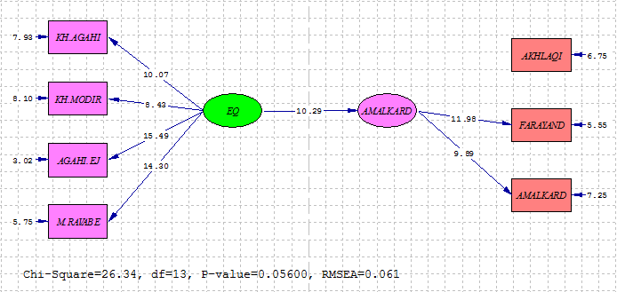

With respect to t=10.29, and as the above table has not been ranged from -1.96 to 1.96; it can be concluded that there is relationship between media staff EQ and their performance. In other words, the research hypothesis is approved. As β=0.92, it can be said that there exists a powerful positive relationship between media staff EQ and their performance. Putting in other words, if staff EQ changes one single unit, a change of 0.92 unit will occur in their performance.
Sub Hypothesis 1 (H1): Self-awareness affects the performance of the staff of Islamic Republic of Iran Sport TV.

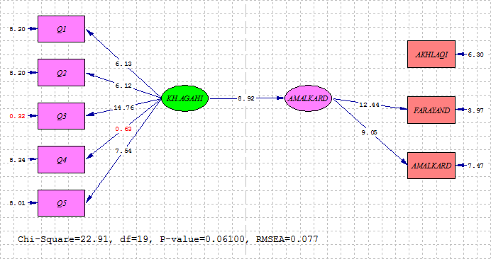

The statistical significance (t=8.92) reflects that there is a relationship between media staff self-awareness and their performance, in other words the research hypothesis is approved. With respect to β=0.82 it can be inferred that there exists a powerful positive relationship between media staff self-awareness and their performance; that means if staff self-awareness changes one single unit, there will be a change of 0.82 unit in their performance.
Sub Hypothesis 2 (H2): Social awareness affects the performance of the staff of Islamic Republic of Iran Sport TV.

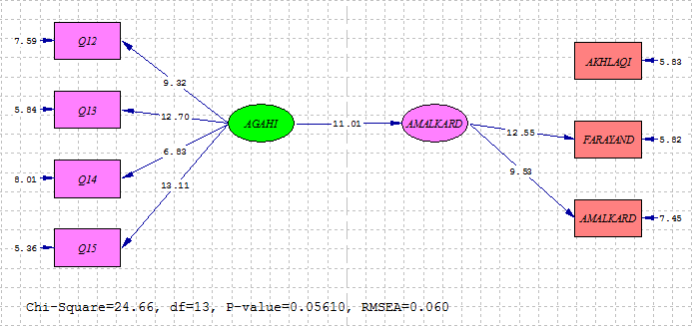

Taking the statistical significance (t=11.01) into account, there is a relationship between media staff social awareness and their performance. Or in other words H2 is approved. As β=0.93, it can be concluded that there exists a strong positive relationship between media staff social awareness and their performance.
Sub Hypothesis 3 (H3): Relationship management affects the performance of the staff of Islamic Republic of Iran Sport TV.

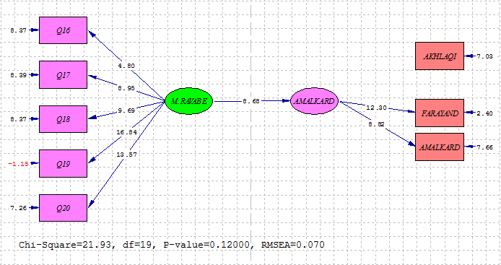

As the above table shows that there is a relationship between media staff relationship management and their performance (t=8.68), which means that the research hypothesis is approved. Given β=0.80 into consideration, it can be said that there is a powerful positive relationship between media staff relationship management and their performance. That means if staff relationship management changes one single unit, their performance will change 0.80 unit.
Sub Hypothesis 4 (H4): Self-control/ Self-management affects the performance of the staff of Islamic Republic of Iran Sport TV.

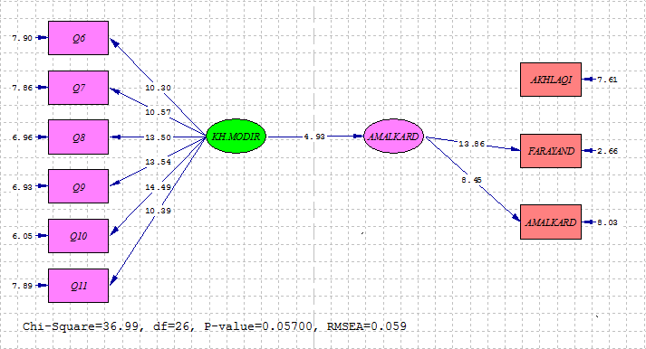

With respect to the significance rate of t equals 4.93, and as the above table has not been ranged from -1.96 to 1.96; it can be concluded that there is relationship between media staff self-management and their performance. In other words, the research hypothesis is approved. As the effect of β=0.45, it can be said that there exists an average positive relationship between media staff self-management and their performance. Putting in other words, if staff self-management changes one single unit, a change of 0.45 units will occur in their performance.
Discussion and conclusion:
About the relationship between emotional intelligence, its four aspects (self-awareness, self-management, social awareness and self-control and the performance of Sport TV staff it can be said that EQ and its four components have a direct and significant relationship with staff performance; that means with an increase in each of them, staff performance improves. The evidence from this research shows that self-awareness in media staff has a powerful positive relationship with their performance; in other words if self-awareness changes one single unit, there will be a change in media staff performance. Such an organization can easily deal with problems and issues; it will also be able to present better solutions. This organization is not inflexible in its decisions and it will create passion, trust and sense of cooperation among its followers. This factor reflects that any increase in EQ will lead to an increase in staff performance and vis versa. This issue is also intensified in Goleman model (1995) that recognizing the staff emotions leads to correct decision making. People, who have more confidence in understanding their feelings, know both theirs powers and weaknesses; they have real self-evaluation and they have a powerful sense of goodness; so they lead their feelings better and when it comes to decision making they are more self-confident. As it was mentioned before empathy in workplace affects performance output. This component has more relation with a sense of responsibility for others, because the more the people around us matter; the more we try to show appropriate reactions. And showing appropriate reactions comes from a correct understanding of others. With respect to the significance rate, there exists a relationship between media staff social awareness and their performance or in other words research hypothesis is approved. As β=0.93 it can be said that there is a strong positive relationship between media staff social awareness and their performance in a way that persons ,who have been the best in recognizing others’ emotions, were more successful both in work and life. There is a relationship between media staff relationship management and their performance; in other words research hypothesis is approved. This effect leads to be able to easily guide others’ thoughts and they may agree to create a new behavior or they are inspired to make a new behavior and product. So with an improving relationship management, one can reach the ability of organizing a group for solving problems and having efficient relationships. Empathy is a basic and necessary art for dealing with people and abstaining success through using diplomacy. Open discussion, debate, coordinating “win-win” management situations and effective negotiations are significant for a commercial relationship and a long standing coexistence. With respect to the statistical significance of t (equals 4.93), it can be said that a relationship exists between self-management in media staff and their performance; in other words research hypothesis is approved. Also there exists an average positive relationship between staff self-management and their performance; that means it self-management in staff changes one unit, their performance will change 0.45 units. Providing emotional tools can make a workplace happy and acceptable. When people strengthen their self-awareness, they get to know their abilities and limitations; in this way they become more situation wise in their work relationships. Moreover, those who have this ability in a great amount are able to pass problems quickly and they are more successful in relieving themselves, avoiding hasty emotional reactions and balancing their stress and depression after any loss. Generally speaking, it can be inferred from the above mentioned hypothesis that in Sport TV one witnesses strong interrelationships between different components of EQ and performance; therefore, one can modify the performance of the employees by educating and strengthening this variable in them.
Intelligence in not the only indicators of our success in life and work environment; emotions do play a significant role in organizational success. People who are emotionally intelligent can affect the organization at all levels; and they play an important role in the quality and efficiency of social interactions. EQ, in itself, is the biggest factor in predicting a person’s performance in a workplace and it is a strong power for leadership and success. So emotional states and their effects can lead people to different goals and as a result they are able to be effective in an organization performance. Enhancing positive emotions in groups will facilitate cooperation and teamwork, decrease conflict and improve group members’ efficiency. EQ is an organising mediator factor which can lead to group performance improvement; because it can help a group to be harmonised effectively, so the group members need less time to experience efficient working atmosphere in a harmonised group.
Practical Suggestions:
As it has been concluded from the results of this research that there exists a relationship between EQ and media managers performance, and with respect to today importance and positive effects that Emotional Intelligence and its components have on different fields especially media organization managers, it has been suggested that:
- Increase the skills of self-awareness, self-management, social awareness and relationship management among a TV channel staff
- Strengthen the ability to understand emotions, control them, recognize clients’ emotions and make a mechanism for making staff relationship
- Invest on establishing the culture of paying attention to EQ
- Pay attention to selecting and requiting people who have both technical and teamwork skills
- Continues evaluation of staff efficiency and heed to staff improvement
- Strengthen teamwork among staff
- Thorough examination of self-management and emotion control among staff
- Explain and offer necessary education for self and others evaluation
- Extract competency characteristics appropriate for office work
- Pay attention to the proportion between staff recruitment and job duties
- Teach negotiation and solving problem techniques to staff
- Teach crisis management and conflict decrease techniques
- Implement a reward and punishment system to strengthen both powerful and weak point based on staff performance evaluation
- Periodical staff ranking and job promotion based on suggestion and punishment system
- Invest on establishing the culture of paying attention to EQ as a skill that can be effective in improving performance; and encourage people to work on these skills and use them in workplace to realize organizational goals
- Analyze the information from staff performance measurement and compare them with performance standards; then take necessary actions such as reward, punishment, appropriate feedbacks and using 360-degree feedback
- Explain self-management and emotion control to staff
- Strengthen empathy and social awareness among staff
- Prepare competency profile for strategic jobs: the reason behind preparing competency profile of jobs is that one can identify all required knowledge, skills, behaviors, values and characteristics for doing an organizational job. With this action, the organization will specify jobs’ needs with complete details. This activity is done by human resource department; this department uses different methods such as interviewing knowledgeable people who know job needs. Competency profile is a reference for HR department, and this department can use this to appoint, recruit or educate people in specified positions.

References:
- Bradbury, T. & Greaves, A.J. (2007) The Emotional Intelligence (skills and testes) , Translated by M. Ganji ,Tehran, Savalan .
- Yang, F., & Chang, C. (2007). “Emotional labor, job satistifaction, organizational commitment amongst clinical nurses”: A questionnaire survey. Journal of Int. Jnurs. Stud, 35(7), 215.
- Johnson, R. P. and Indvik, J. (1999). Organization benefit of having emotionally intelligenct managers and employees. Journal of workplace Learning. Vol. 11,No.3,PP: 84-88.
- Wannamaker, Candace M.,A(2005) study of Emotional intelligence in university judicial officer.
- Goleman (1997) Emotional Intelligence, Compressed Knowledge bantam books.
- Goleman (1995) Human Resource management trends and ssues (in U.S.A weekend) and time magazine (October 2).
- Shahzad, K., Rehman, K.U. and Abbas, M. (2010). HR Practices and Leadership Styles as Predictors of Employee Attitude and Behavior: Evidence from Pakistan. Eur. J. Soc. Sci., 14(3), 417-426.
- Millmore, M., Saunders, M., Lewis, P., Thornhill, A. and Morrow, T. (2007) Strategic Human Resource Management: Contemporary Issues, Edition 1, London: Financial Times Press.
- Marr, Bernard (2008), Managing and delivering performance, Oxford: Butterworth- Heinemann/Elsevier.
- Armstrong, Michael(2006), Handbook of Human Resource Management Practice (10th Edition).

3/13/2015

