Investigating the filtration rate of the Pretty-blocked Venus Circenita callipyga by the microalga Isochrysis aff galbana at different temperatures and salinities

FatemehNesa Vojdani¹*, Alireza Salarzadeh¹; Hossein Rameshi²; and Hassan Sareban²

¹ Department of Fishery , Bandar Abbas Branch, Islamic Azad University, Bandar Abbas, Iran, PO Box 79159–1311
²Molluscs Fisheries Research Station in Bandar-e-Lengeh, Bandar-e-Lengeh, Iran. PO Box: 33579-79719
sahelsadaf56@yahoo.com

Abstract: The Pretty-blocked Venus Circenita callipyga belongs to the family Veneridae and is one of the endemic species of the Persian Gulf and Oman Sea. The study has been conducted from February 2013 to May 2014 at molluscs fisheries research station in Bandar-e-Lengeh. The filtration rate of the venus calm was evaluated by the microalga Isochrysis aff galbana in six temperature treatments of 15, 20, 24, 28, 32 and 36 ° C and six salinity treatments of 6, 20, 25, 30, 35, 40 and 45 parts per thousand (ppt). Each treatment includes 10 Pretty-blocked Venus with thoraco-abdominal length (DVM) of 24±2 mm in a 15-litre aquarium. The Pretty-blocked Venus has not been fed 24 hours before the experiment. Moreover, an aquarium was considered as a control (without venus clams) to evaluate the potential growth or death of the microalga Isochrysis aff galbana. The obtained results from the Pretty-blocked Venus filtration in six temperature treatments and six salinity treatments by the microalga Isochrysis aff galbana showed that the highest filtration rate occurred during treatment at 28° C with 3588695±300141 ml/h/venus clam, and the lowest rate of filtration occurred in temperature treatment of 20° C with 1451848±300141 ml/h/venus clam. The filtration rates in the temperature treatments at 28° C and 20° C were not significantly different from those in the temperature treatments at 32° C and 15° C, respectively (P> 0/05). In the salinity treatments of 20 and 25, the venus clams have not performed any filtration, which has resulted in a rate equal to zero. The maximum filtration rate has occurred in 40 ppt salinity, which is equivalent to 2374067±997049 ml/h/venus clam. The filtration rate at a salinity of 35 ppt has not been significantly different from that at a salinity of 40 ppt (P> 0/05). However, a significant difference was observed infiltration rates of salinities of 30 and 45 ppt (P <0/05). The overall results indicated that the optimal temperature and salinity for biological activities such as feeding, respiration and growth of the Pretty-blocked Venus are 28-32° C and 40 ppt, respectively.
[Vojdani F, salarzadeh A.R, Rameshi H,Sareban H. Investigating the filtration rate of the Pretty-blocked Venus Circenita callipyga by the microalga Isochrysis aff galbana at different temperatures and salinities. N Y Sci J 2015;8(3):56-61]. (ISSN: 1554-0200). http://www.sciencepub.net/newyork. 11

Keywords: temperature, salinity, Pretty-blocked Venus, filtration, Circenita callipyga

1. Introduction
In recent years, the use of marine mollusks, especially bivalves by the massive influx of humans has been increased due to its various aspects including wood carving, button making, ornaments, jewellery, poultry feed (its shell), and most important of all, using the muscles as food, resulting in its reserves to be dwindling. In addition to having a special place in the food chain ecologically, Bivalves play an important role in the food chain of other marine animals. These organisms are considered as biological indicators of aquatic ecosystems, capable of cleansing the aquatic environment from petroleum contamination, heavy metals, radioactive materials, etc. (Lie, 1993; Robert, 1976). Today, moreover, the bivalve mollusks are used for the removal of nitrogen and phosphorus in fresh water (Javanshirand Jondaqi, 2006; Jandaqi,2006, Sarikhany and Javanshir, 2010). In addition, the use of some bivalves to remove or reduce the concentration of algae in pools of hydrothermal vent shrimps and fish was proved successful to some extent (Wanninayake et al., 1998; Shpigel and Blaylock, 1991). Bivalve venus clams of the family Veneridae are considered as one of these mollusks, which have a high frequency distribution in the south coast of the country, from Chabahar to Khuzestan (AshjaeArdalan, 995; Hosseinzadeh Sahafi, 2006). The family has more than 500 species, most of which belong to Circenita callipyga, called Pretty-blocked Venus (Baqernabavy, 2007; Hosseinzadeh Sahafi, 2006). The venus clam varies from 18 to 50 mm in size and resides in tidal areas between the cobblestones and sand (Hosseinzadeh Sahafi, 2006). Research conducted on Circenita callipyga were mostly limited to the identification and distribution of them on the south coasts of the country and there has not been any research on filtration of the venus clam, especially in the country. Furthermore, the majority of filtration studies conducted abroad were mostly on oysters and mussels, which made the studies on clams less in number (Riisgard et al., 2001). In addition, the filtration rate of each venus clam is directly related to its vital functions, including respiration, feeding and even its growth rate (Sprung, 1995). Several factors affect the filtration rate of clams such as temperature, salinity, the clam size, the availability of nutrients, the size of nutrients and water flow (Rajesh et al., 2001). Among these, temperature is the most influential factor on the filtration rate, decrease or increase (moving away from normal range) of which will result in a substantial decrease in filtration rate (Albentosa, 1994; Abdolaliyan, 2007; Qorbani, 2006). Another factor affecting the filtration rate is salinity of water; the salinity of water is involved in osmoregulation and hemolymph of a clam, and even any decrease or increase in it does not cause a clam to open its hinged parts (McFalland al., 2013; Riisgard al., 2012). Therefore, in this study the filtration rate of Pretty-blocked Venus was investigated in various temperature and salinities, as two influential environmental factors, in order for the best temperature and salinity to be obtained in the filtration process.

Materials and Method
The Pretty-blocked Venus Circenita callipyga was collected from the mid-tidal zone in Bandar-e-Lengeh coast. The venus clams were transferred to the laboratory at molluscs fisheries research station in Bandar-e-Lengeh, and were washed with clean and filtered salt water. The thoraco-abdominal length (DVM) were measured by Vernier (caliper). The venus clams with thoraco-abdominal length of 24±2 mm were selected and kept in filtered and ultraviolet (UV) exposed sea water 24 hours before the experiment began for expelling consumed foods (Abdolaliyan, 2007). The microalga Isochrysis aff galbana after passing the culture stages, including stock, containers 250, 500, 1000 and 5000 cc in Gillard F2 medium, was used during the explosive phase of growth in this experiment (Abdolaliyan, 2007). Temperature treatments consisted of 15, 20, 24, 28, 32 and 36 ° C and salinity treatments included 20, 25, 30, 35, 40, 45 ppt. Each treatment was repeated four times, one of which was without the venus clam in order to control the potential growth or death of the microalga Isochrysis aff galbana (Abdolaliyan, 2007; Doroudi et al., 2003). Ten Pretty-blocked Venus were placed in each aquarium with the dimensions of 40 × 20 × 25 cm, which only contained 15 litres of filtered and ultraviolet (UV) exposed sea water, and three replications were dedicated to each treatment, and making the whole number of venus clams equal to 30 in each treatment. Gentle aeration systems were used to keep the microalgae suspended using Airstones. The initial concentration of alga used in all treatments was 100,000 cells/ml (Abdolaliyan, 2007). Therefore, prior to the beginning of the experiment, the initial concentration of the microalga Isochrysis aff galbana was counted using hemocytometer lam and Nikon optical microscope with a 10x objective lens. After one and two hour intervals, the concentration of the microalga Isochrysis aff galbana was counted within the iterations. A pipette was used to make a 10 cc sample from each iteration, which was stabilized by 5% formalin to prevent any probable growth, and finally counted using hemocytometer lam.
To obtain the filtration rate based on the filtered volume and the consumed cell, the following two formulas were used (Abdolaliyan, 2007; Doroudi et al., 2003):
(V/(n×t)) × ((Ln (C₀/CT) -Ln (C/₀/C/_{t}))) =filtration volume (ml/venus clam/h)
(V/(n×t)) × ((C₀-C_{t}) -(C/₀-C/_{t})) =the number of consumed cells (cell/venus clam/h)
V = volume of container per microliter
N = number of venus clams in each container
T = time (hour)
C₀ = initial concentration in treatment or iteration containers (cell per microliter)
Ct = secondary concentration in treatment or iteration containers (cell per microliter)
C/₀= initial concentration in the control container (cell per microliter)
C/_{t} = secondary concentration in control container (cell per microliter)
Correction factor in the above two formulas includes ln (C/₀/C/_{t}) and (C/₀-C/_{t}), which minimizes the error rate obtained from growth or death of microalga using concentration discrepancy in the control container (Vanderploeg, 2001). The gathered data were put in Excel 2010, which was also used to plot tables and charts of filtration rate. One-way ANOVA was utilized to compare the filtration rate among different temperature and salinity treatments, and the means were compared by Tukey test at a 5% significance level .

3. Results
The highest filtration rate of the Pretty-blocked Venus in the first hour occurred at 28°C, which was equivalent to 3107304±600283 ml/h/venus clam and 130000000±8660254 cell/h/ venus clam (Figures 1 and 2). The lowest filtration rate of the venus in the first hour, on the other hand, occurred at 15°C, which was equivalent to 215946±618508ml/h/venus clam and 15000000±52500000cell /h/ venus clam (Figures 1 and 2). However, in the second hour the highest filtration rate, based on the consumed volume, occurred at 32° C, which was equivalent to 530736±4793703ml/h/venus clam and based on the consumed cell, occurred at 15°C, which was equivalent to8660254±87500000 cell/h/ venus clam (Figures 1 and 2). The lowest filtration rate in the second hour, based on the consumed volume, occurred at 20°C, which was equivalent to 538970±1881950ml/h/venus clam and based on the consumed cell, occurred at 28° C, which was equivalent to 8452071±11250000cell/h/venus clam (Figures 1 and 2).
The filtration rate in the first hour and based on the consumed volume (ml/h/venus clam) at 28° C was significantly different from other temperature treatments (P <0/05). However, this rate, in the second hour (the consumed volume), was significantly different at 32° C from other temperature treatments (P <0/05). Moreover, the filtration rate in the first hour and based on the consumed cell at 28° C was significantly different from other temperature treatments except for 24° C (P <0/05). However, this rate, in the second hour (the consumed cell), was significantly different in the treatment of 15° C from other temperature treatments (P <0/05).

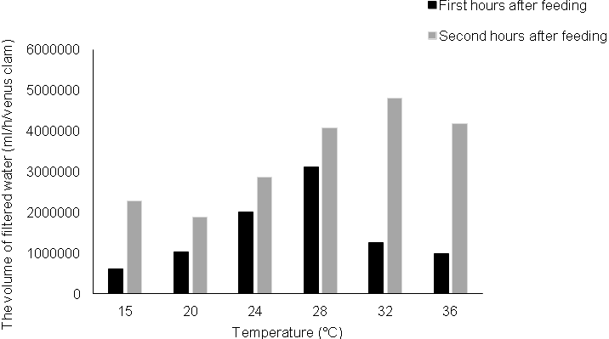
Figure 1. The rate of filtration on the basis of the volume of filtered water per hour after the first and second feeding in different temperature treatments

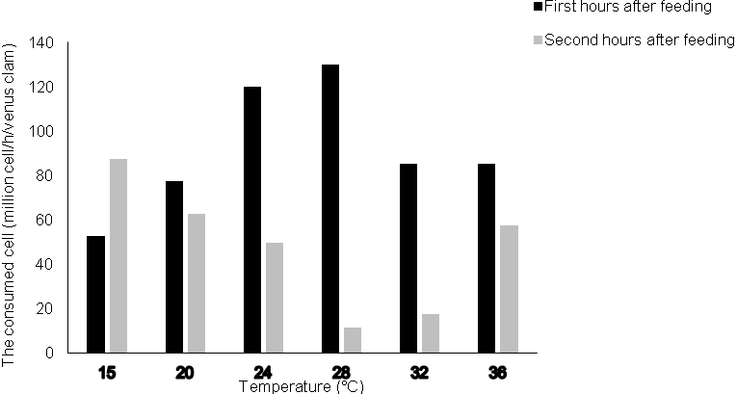
Figure 2. The rate of filtration on the basis of the consumed cell in the first and second hours after feeding in different temperature treatments

The Pretty-blocked Venus did not open its hinged parts on salinities of 20 and 25 ppt and no filtration was performed both in terms of the filtered volume and the consumed cell (Figures 3 and 4). The highest filtration rate of the Pretty-blocked Venus in the first hour occurred on the salinity of 35 ppt, which was equivalent to 304612±2173038ml/h/venus clam and 7500000±120000000cell/h/ venus clam (Figures 3 and 4). Furthermore, the lowest filtration rate of the Pretty-blocked Venus in the first hour occurred on the salinity of 30 ppt, which was equivalent to 46824±131007ml/h/venus clam and 4330127±12500000cell/h/ venus clam (Figures 3 and 4). However, in the second hour the highest filtration rate of the Pretty-blocked Venus occurred on the salinity of 40 ppt, which was equivalent to1744957±315667 ml/h/venus clam and 866025±52000000cell/h/ venus clam (Figures 3 and 4). The lowest filtration rate in the second hour, based on the consumed volume, occurred on the salinity of 30 ppt, which was equivalent to53891±257470 ml/h/venus clam. However, the lowest filtration rate based on the consumed cell, was observed on the salinity of 45 ppt, which was equivalent 7927254±16500000cell/h/venus clam, and did not differ significantly from the salinity of 30 ppt (P> 0.05).
The filtration rate in the first hour and based on the filtered volume on the salinity of 35 ppt was significantly different from other salinity treatments (P<0/05). However, no significant difference was observed between the salinities of 40 and 45 ppt (P> 0.05). Moreover, the filtration rate in the first hour, and based on the consumed cell was not proved to be significant among the salinities of 35, 40, and 45 ppt (P> 0.05). In addition, the filtration rate in the second hour was not statistically different among the salinities of 30, 35, and 45 ppt (P> 0.05).

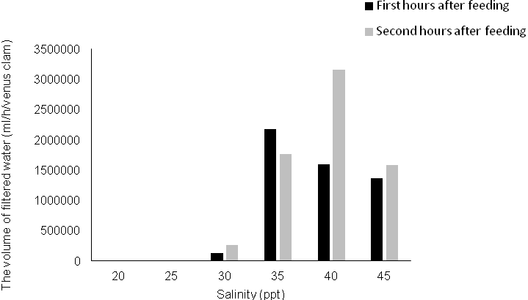
Figure 3. The rate of filtration on the basis of the volume of filtered water in the first and second hours after feeding in different the salinity treatments

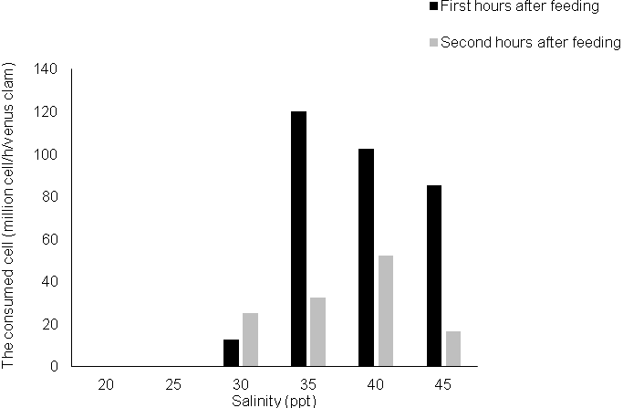
Figure 4. The rate of filtration on the basis of the consumed cell in the first and second hours after feeding in different the salinity treatments

4. Discussion
The results obtained from the filtration of the Pretty-blocked Venus in various temperature showed that the venus could tolerate a temperature range between 15° to 36° C, in which the venus opened its hinged parts and the filtration occurred. The lowest filtration rate occurred at 15° C, and raising the temperature up to 28° C caused the filtration rate to be increased (Figures 1 and 2). Then, with increasing temperature, the filtration rate decreased, and at the temperature of 36° C, the filtration rate was close to 20° and even 15° C. Similar behaviour was observed in The golden mussel Limnoperna fortune, so that through examining the filtration rate of the mussel at temperatures of 10, 15, 20, 25, 28 and 30° C, the maximum filtration rate was proved to be at 28° C, and the filtration rate decreased again at 30° C (Pestana et al., 2009). In the bivalves belonging to the cold areas (average annual temperature below 20° C), higher filtration rate takes place at lower temperatures. For example, investigating the filtration rate in clam species of the genus Corbicula at temperatures of 15, 22 and 24° C indicated that the highest rate of filtration occurs at temperature of 15° C (Silverman et al., 1997; Sylvester et al., 2005).In some bivalves, the filtration rate is the same throughout the temperature range and no significant difference was observed among the filtration rates at different temperatures.For example, the filtration rate of the mussel Dreissena bugensis was studied at 8 to 22° C and the results showed that the filtration rate varied between 200 to 300 ml/h/venus clam, and there has not been any significant difference between treatments (Diggins, 2001). The Black-Lip Pearl Oyster Pinctada margaritifera is one of the endemic species in the Persian Gulf, the filtration rate of which was measured by the microalga Isochrysis aff galbana at different temperatures (Abdolaliyan, 2007). Similar to The Pretty-blocked Venus, the highest filtration rate in The Black-Lip Pearl Oyster occurred at temperature of 27.5° C, and the amount of filtered volume and consumed cell were identical at 27.5° C in both clams.However, different reports have been obtained on the filtration rate of one species. For example, the filtration rate of the mussel Dreissena polymorpha at 20°C, is obtained114-84 (Vanderploeg, 2001), 77-22ml/h/venus clams (9). The existing errors in the filtration rate in different species of bivalves are due to discrete and periodic filtration of the clams. Therefore, in calculating the outcome of evaluation, the filtration rate has lots of errors and is highly deviated (Helfrich et al., 1995). Such a discontinuity was observed in the filtration rate of the Pretty-blocked Venus, so that the filtration rate in the second hour has been greater at lower temperatures than in the first hour (Figure 1 and 2).
Different results are obtained studying the filtration rate of the Pretty-blocked Venus Circenita callipyga in different salinities, so that the venus is extremely sensitive to the salinity below 30 ppt and does not open its hinged parts.This reaction was easily observed on salinities of 20 and 25 ppt, so that none of the clams opened their hinged parts during a 2 hour experiment (Figures 1 and 2). Similar behavior was observed in the green mussel Perna viridis, so that in the first hour on the salinity of 10 ppt all the venus clams, and on the salinity of 15 ppt, half of the venus clams did not open their hinged parts (McFalland, et al., 2013). Moreover, the mussel Mytilus edulis, on the salinity of 10 ppt, did not open its hinged parts, and even after 2 hours from the beginning of the experiment, some losses were observed (Riisgard et al., 2012).
It seems that any decrease in salinity causes an increase in the metabolism within the gill cells of the oyster Crassisterea virginica. The reason for this increased metabolism, is the increased levels of ammonia excretion (Ballantyne, 1987). Salinity also affects daily activities of the bivalves such as sinking to the bottom so that by lowering salinity from 20 ppt, the filtration rate of the clams Mactra veneriformis, Ruditapes philippinarum, and Meretrix lusoria is reduced, and they sink deeper into the sand (Nakamura et al., 2005). However, unlike the Pretty-blocked Venus, the oyster Crassostrea madrasensis, and the clam Paphiam alabarica kept their hinged parts open on the salinity of 15 ppt, and the continued the filtration process (Rajesh et al., 2001). By increasing salinity from 40 ppt, the filtration rate of the Pretty-blocked Venus was reduced, so that the filtration rate on salinity of 45 ppt was close to treatments of 30 and 35 ppt, especially in the second hour (Figure 1 and 2). Similar behavior was observed in the study of the clam Meretrix casta, and examining the filtration rate on salinities of 8, 15, 25, 34, 45, 56 and 64 ppt showed that the filtration rate on salinity of 64 ppt is equal to filtration rate on salinity of 8 ppt (Durve, 1963).

5. Conclusion
In general, the Pretty-blocked Venus is capable of performing filtration in the temperature range of 15 to 36° C, and the best temperature for physiological activities to be done was observed to be at 32-28° C. Thus, according to the results obtained with the hope that we can work with other research in the field of reproduction and breeding the species investment

Acknowledgement
We would like to express our gratitude to MrGholamreza Arganjy, the head of molluscs fisheries research station in Bandar-e-Lengeh and other personnel who cooperated with us to accomplish this project.

References
- AbdolaliyanA. An investigation of the filtration rate ofthe Black-Lip Pearl Oyster on the Phytoplankton speciesIsochrysis aff galbana and Cheatoceros calciterans at different temperatures. Master thesis, Islamic Azad University, Bandar Abbas Branch 2007.67p.
- Albentosa M., Beiras R.and Perez Camacho A. Determination of optimal thermal condition for growth of clam (Venerupis pullastra) seed. Aquaculture 1994. 126: 315-328.
- Ashjae ardalan A. Identifying and investigating the dispersion of the bivalves in the tidal zones of Chabahar Bay and its surrounding coasts. Master thesis, Islamic Azad University, North Tehran Branch 1995.243p.
- Baqernabavy S., Qotbaldin M ., kuchnin N. and Dehqan Madiseh P. Studyingthe dominant bivalves populationof Hendijan coast (Persian Gulf). Journal of Marine Biology 2007. 1-13.
- Ballantyne J.S., The effects of salinity acclimation on the osmotic proportion of mitochondria from the gill of Crassostrea virginica. Journal Experimental Biology 1987. 133:449-456.
- Diggins T.P. A seasonal comparison of suspended sediment filtration by Dreissena bugensis and Dreissena polymorpha.Journal of Great Lakes Research 2001. 27:457-466.
- Doroudi M.S., Southgate P.C. and Lucas J.S. Variation in clearance and ingestion rates by larvae of the black-lip pearl oyster Pinctada margaritifera feeding on various microalgae. Aquaculture Nutrition 2003. 9:11-16.
- Durve V. S. A study on the rate of the filtration of the clam Meretrix casta (Chemnitz). Journal of the Marine Biological Association of India 1963. 5(2): 221-231.
- Helfrich L.A., Zimmerman M. and Weigman D.L., Control of suspended solid and phytoplankton with fishes and mussel.Water resources Bulletin. American Water Resources Association 1995. 31(2): 307-316.
- Hosseinzadeh Sahafi H.,Daquqi B.andRameshi H. The Atlas of Persian Gulf mollusks. Fisheries Research Institute of Iran,Tehran, first edition 2006..248 P.
- Javanshir A. and Jondaqi M. Evaluating the ability of the bivalve Anodonta Cygnea and the microalgae Chlorella sp. and Scenedesmus sp. in the absorption of soluble Phosphate and Nitrate in the effluent (in closed system). Journal of Environment 2006. 55: 45-53.
- Jandaqi, M. An investigation of the ability of the mussel Anodonta Cygneain reducing the concentration of Nitrate and Phosphate in urban wastewater. Master thesis of Environmental Sciences, Islamic Azad University, Science and Research Branch 2006..60-62 p.
- Lie J., Estimated of filtration rate of zebra mussel. Published by the zebra mussel research program 1993..1-3.
- Lucas J.S. Quantitative studies of feeding and nutrition during larval development of the coral reef asteroid Acanthaster planci. Journal Experimentation Marine Biology and Ecology 1982. 65:173-193
- McFalland K., Donaghy L. and Volety A.K. Effect of acute salinity changes on hemolymph osmolality and clearance rate of the non-native mussel, Perna viridis, and the native oyster, Crassostrea virginica, in Southwest Florida. Aquatic Invasions 2013. 8(3):299-310.
- Nakamura Y., Hashizume K., Koyama K., Tamaki A. Effects of salinity on burrowing activity, feeding and growth of the clams Mactra venerifomis, Ruditapes philippinarum and Meretrix lusoria. Journal of Shell fish Research 2005. 24(4):1053-1059.
- Pestana D., Ostrensky A., Antonio W., Boeger P. and Pie M.R. The Effect of Temperature and Body Size on Filtration Rates of Limnoperna Fortunei (Bivalvia, Mytilidae) under Laboratory Conditions. Brazilian Archives of Biology and Technology 2009. 52(1): 135-144.
- Qorbani, S. An investigation of the filtration rate the bivalve polymorpha Dreissena at two different temperatures of Anzali Lagoon. Scientific Journal of Fisheries 2006.15: 163-166.
- Rajesh K.V., Mohamed K.S. and Kripa V. Influence of algal cell concentration, Salinity and body size on filteration and ingestion rates of cultivable Indian bivalves. Indian Journal of Marine Science 2001. 30: 87-92.
- Riisgard H.U., Bottiger L. and Pleissner D. Effect of Salinity on Growth of Mussels, Mytilus edulis, with Special Reference to Great Belt (Denmark). Open Journal of Marine Science 2012. 2: 167-176.
- Robert D. Mussels and pollution. In: B.L. Bayne (ed). Marine mussels: their ecology and physiology. Cambridge University Press.1976. PP: 132-143.
- Sarikhany L. and Javanshir A. The performance evaluation of the bivalve Anadonta Cygnea in the filtration of Nitrogen and Phosphorus compounds. Journal of Environmental Studies 2010. 36 (55): 119-126.
- Shpigel M. and BlaylockR.A. The Pacific oyster Crassostrea gigasas a biological filter for marine fish aquaculture pond. Aquaculture 1991.92: 187-197.
- Silverman H., Cherry J. S., Lynn J. W., Dietz T. H., Nichols S. J. and Achberger E. Clearance of laboratory-cultured bacteria by freshwater bivalves: differences between lentic and lotic unionids. Canadian Journal of Zoology 1997. 75(11): 1857-1866.
- Sprung M.Physiological energetics of the zebra mussel Dreissena polymorpha in lakes I. Growth and reproductive effort.Hydrobiologia 1995 . 304: 117-132.
- Sylvester F., Dorado J., Boltovskoy D., Juarez A. and Cataldo D., Filtration rates of the invasive pest bivalve Limnoperna fortune as a function of size and temperature. Hydrobiologia 2005 . 534:71–80.
- Vanderploeg H.A. Zebra mussel Dreissena polymorpha selective filtration promoted toxic bloom in Saginaw Bay (Lake Huron) and lake Erie. Can. Journal Fisheries Aquatic Science 2001 .28: 12-18.
- Wanninayake W.M.T.B., Hewavitharana M.H., Jayasinghe J.M.P.K. and Edirisinghe U. Oyster Crassostrea madrasensisis controlling suspended solid loading and chlorophyll concentration in effluent water of semi-intensive shrimp culture system in Sri lanka. Paper presented at the Fifth Asian Fisheries Forum. Chiang Mai, Thailand. 1998 .Nov.pp: 11-14.

3/10/2015

