**Impact of different levels of salinity and pressure on emitter performance and clogging**

Pirooz far, V. R.1 Boroomand-Nasab, S.2 Jahani, B.3

1. Department of Irrigation and Drainage, Faculty of Water Sciences Engineering, Shahid Chamran University of Ahvaz, Iran
2. Department of Irrigation and Drainage, Faculty of Agriculture, Islamic Azad University Ahwaz Branch, Iran
3. Department of Irrigation and Drainage, Faculty of Water Sciences Engineering, Shahid Chamran University of Ahvaz, Iran

[Vahidrezapiroozfar@gmail.com](mailto:Vahidrezapiroozfar@gmail.com)

**Abstract:** This study was conducted at the experimental hall of Shahid Chamran university of Ahvaz to assess the performance and clogging of two auto-regulator emitters (A) Eurodrip and (B) Netafim, under (1) three levels of salinity (3, 4 and 5 ds/m) which were obtained by solubolizing calcium-chloride and magnesium-chloride salts with water obtained from river of Karoun in Ahvaz, and by keeping sodium absorption ratio fixed, and (2)three levels of pressure (1, 1.5 and 2 bar). The experiment was accomplished with a three day irrigation frequency and the system worked for approximately three hour at each day of irrigation. Then, once the irrigation was completed, the discharge of each single drip was measured for eight times. The statistical analysis of the results indicated that, the rate of discharge, discharge variety coefficient and Christensen variety coefficient of both emitter types decreased in all treatments. However, the discharge variety coefficient of Eurodrip was rather larger than Netafim, when pressure was fixed and salinity was increased.

[Pirooz far, V. A., Boroumand Nasab, S. and Jahani, B. **Impact of different levels of salinity and pressure on emitter performance and clogging.** *N Y Sci J* 2015;8(1):17-21]. (ISSN: 1554-0200). <http://www.sciencepub.net/newyork>. 3

**Keywords:** Drip irrigation, saline water, auto pressure regulator, clogging.

**Introduction**

Despite the fact that, the impacts of human activities have decreased and limited the amount and quality of fresh water recourses, but, due to the increasing rate of population growth, demands for industry, food and agriculture, and naturally fresh water has risen in current years. In addition, since most of the water is used by agriculture sector, various types of irrigation systems and water management procedures have been developed to save water and increase the rate of irrigation and water use efficiencies. Among which, Applying effluent water, reclaimed and recycled wastewater, and specially saline water, as an alternative for fresh water to the crop lands by means of irrigation is considered as one of the most effective water management methods. In addition, drip irrigation is considered asone of the most effective irrigation system which has attracted more attention compared with other types of irrigation systems and also plays animportant role in modern irrigation (Dazhuang et al. 2009). However, this method has limitations, of which emitter clogging is determined as one of the major problems in drip irrigation which limits the application of drip irrigation by declining distribution uniformity and increasing maintenance costs (Ravina et al. 1997). Clogging is closely related to the quality of the irrigation water, the structure of the flow path, water pressure, temperature and also discharge of each emitter (Pitts *et al*., 1990; Adin and Sacks, 1991; Coelho and Resende, 2001).Applying effluent water through drip irrigation is a combination of both water management and irrigation techniques which not only does increase the water saving efficiency but also uses low quality water instead of fresh water. Yet, drip clogging is the most important disadvantage of this technique. Specially, when applied to arid and semi-arid regions. This experiment has been performed to assess the clogging and discharge varieties of two most used drips namely Netafim and Eurodrip under three levels of irrigation water salinity and three levels of water pressure.

**2. Materials and methods**

**2.1. Treatments**

To evaluate the effects of salinity of irrigation water and water pressure on the clogging and discharge rate of emitters, three levels of salinity and three levels of pressure were applied through 18 treatments. A summary of the treatments is illustrated in table 1.

**2.2. Experimental design**

The experiment was performed during autumn and winter in the experimental hall of Shahid Chamran University of Ahvaz, Iran. To conduct the test, two models of auto-regulator emitterNetafim and Eurodrip, and a3.5m line of piping with a diameter of about 2in was used. On which eight discharging points were considered and at each discharging point two emitters were placed 30 cm apart. The studied emitter models were selected based on the representative of the current technology. The characteristics of both emitter models are indicated in table2. In addition, in order to apply the desired pressures meaning 1, 1.5 and 2 bars, an electro pump with a pressure regulator valve at the bottom end of the pipe was used.

Table 1. Treatments conducted in the study

|  |  |  |  |
| --- | --- | --- | --- |
| Treatment | Salinity (ds/m) | Pressure (bar) | Emitter model |
| N1 | 3 | 1 | Netafim |
| E1 | 3 | 1 | Eurodrip |
| N2 | 3 | 1.5 | Netafim |
| E2 | 3 | 1.5 | Eurodrip |
| N3 | 3 | 2 | Netafim |
| E3 | 3 | 2 | Eurodrip |
| N4 | 4 | 1 | Netafim |
| E4 | 4 | 1 | Eurodrip |
| N5 | 4 | 1.5 | Netafim |
| E5 | 4 | 1.5 | Eurodrip |
| N6 | 4 | 2 | Netafim |
| E6 | 4 | 2 | Eurodrip |
| N7 | 5 | 1 | Netafim |
| E7 | 5 | 1 | Eurodrip |
| N8 | 5 | 1.5 | Netafim |
| E8 | 5 | 1.5 | Eurodrip |
| N9 | 5 | 2 | Netafim |
| E9 | 5 | 2 | Eurodrip |

Table 2. Features of the two auto-regulator emitters

|  |  |  |  |
| --- | --- | --- | --- |
| Emitter | Junction | Pressure (m) | Discharge (l/h) |
| Netafim | on line | 5-40 | 4 |
| Eurodrip | on line | 5-40 | 4 |

**2.3. Water quality**

The saline irrigation water was produced by mixing the water of Karoun river in Ahvaz (KW) with different percentages of NaCl, CaCl2 and MgCl2 salts.Before mixing the mentioned salts, the chemical parameters of the KW, such as amount of EC, Ca, Mg, Na and PH were determined, and then the rate of SAR was calculated.Once the chemical parameters of the KW were determined, the desired ECs with a similar SAR to the KW were obtained by adding a specific ratio of the abovementioned salts.Characteristics of the saline water used in this practice, is illustrated in table 3.

**2.4. Emitter performance**

To evaluate emitter performance, the discharge measurements were taken at the beginning of the test and then taken periodically throughout 216 hours of irrigation (one day operation at 3 h/d and two days off). Emitter flow rates (q) were calculated by measuring the discharge of each single emitter over a period of approximately 15 minutes at eight repeats, using a 1000mL graduated cylinder. Once all the measurements were taken, the rate of discharge decline was determined and then distribution uniformity efficiency (EU), Christiansen uniformity coefficient (UC) and discharge variety coefficient (Vm) were respectively calculated using Eq.1, 2 and 3.

|  |  |
| --- | --- |
|  | )1( |
|  | )2( |
|  | )3( |

Where the qn, qa are respectively the low quarter average and mean rate of the emitters’ discharge. qi Is the discharge rate of each emitter and n is the number of measurements. The Sm and qm are respectively the standard deviation and mean rate of the emitters’ discharge rate.

**2.5. Emitter Clogging**

Calcium carbonate and sulphate are considered as the most common chemical particles causing clogging in emitters. The Langelier saturation index (LSI) and Solubility product constant (KSP) were respectively applied to assess the potential of calcium carbonate, and the calcium sulphate settlement.

Table 3. Chemical characteristics of the saline water used

|  |  |  |  |  |  |  |  |  |  |  |
| --- | --- | --- | --- | --- | --- | --- | --- | --- | --- | --- |
| EC (ds/m) | Cation (meq/l) | | | | Anion (meq/l) | | | | PH | SAR |
| Ca2+ | Mg2+ | Na2+ | K+ | So42- | Cl‾ | Co32- | Hco3‾ |
| 3 | 9.95 | 10.09 | 9.76 | 0.2 | 4.89 | 22.43 | 0 | 2.5 | 7.89 | 3 |
| 4 | 14.19 | 14.35 | 11.26 | 0.2 | 4.89 | 32.61 | 0 | 2.5 | 7.93 | 3 |
| 5 | 18.4 | 18.6 | 12.8 | 0.2 | 4.89 | 42.43 | 0 | 2.5 | 8.1 | 3 |

LSI and KSP were respectively computed using Eq. 4 and Eq.6.

|  |  |
| --- | --- |
|  | )4( |

Where PHm is the rate of irrigation water acidity and PHc is the calculated acidity which is obtained from Eq.5.

|  |  |
| --- | --- |
|  | )5( |

Where  the cation index of water is,  is the Calcium and Magnesium index, and is the Carbonate and Bicarbonate index. Positive and negative amounts of LSI respectively mean positive and negative risk of calcium carbonate settlement.

|  |  |
| --- | --- |
|  | )6( |

Where and  are respectively the density of Calcium and sulphate ions (). A rate of KSP, greater than 2.4×10-5 () at the temperature of about 25°C means the positive risk of calcium sulphate settlement.

**3. Results**

**3.1. Assessment of clogging indexes**

To evaluate the possible risk of calcium carbonate and calcium sulphate settlement, LSI and KSP were computed. The calculated amount of both indexes for individual levels of salinity is summarized in table 4 and 5. Table 4 shows that, the rate of LSI is positive in all levels of salinity meaning a positive risk of calcium carbonate settlement. According to table 5, the amount of KSP is rather greater than 2.4×10-5 () in all three levels of salinity, meaning a positive risk of calcium sulphate settlement.

Table4. The rate of EC (ds/m), PHm, PHc and LSI of the irrigation water used in the treatments

|  |  |  |  |
| --- | --- | --- | --- |
| EC(ds/m) | PHm | PHc | LSI |
| 2.2 | 7.82 | 3.08 | 4.74 |
| 3 | 7.89 | 3.16 | 4.73 |
| 4 | 7.93 | 3.44 | 4.49 |
| 5 | 8.1 | 3.64 | 4.46 |

Table5. Chemical features of the irrigation water.

|  |  |  |  |
| --- | --- | --- | --- |
| EC  (ds/m) |  |  |  |
| 2.2 | 9.78 | 13 | 12.71 |
| 3 | 9.78 | 20.79 | 20.32 |
| 4 | 9.78 | 33.08 | 32.35 |
| 5 | 9.78 | 49.27 | 48.18 |

|  |  |  |
| --- | --- | --- |
| C:\Users\admin\AppData\Local\Microsoft\Windows\Temporary Internet Files\Content.Word\1 to 9.png  (a) N1 and E1 treatments | C:\Users\admin\AppData\Local\Microsoft\Windows\Temporary Internet Files\Content.Word\1 to 9.png  (b) N2and E2 treatments | C:\Users\admin\AppData\Local\Microsoft\Windows\Temporary Internet Files\Content.Word\1 to 9.png  (c) N3 and E3 treatments |
| C:\Users\admin\AppData\Local\Microsoft\Windows\Temporary Internet Files\Content.Word\1 to 9.png  (d) N4 and E4treatments | C:\Users\admin\AppData\Local\Microsoft\Windows\Temporary Internet Files\Content.Word\1 to 9.png  (e) N5 and E5 treatments | C:\Users\admin\AppData\Local\Microsoft\Windows\Temporary Internet Files\Content.Word\1 to 9.png  (f) N6 and E6 treatments |
| C:\Users\admin\AppData\Local\Microsoft\Windows\Temporary Internet Files\Content.Word\1 to 9.png  (g) N7 and E7 treatments | C:\Users\admin\AppData\Local\Microsoft\Windows\Temporary Internet Files\Content.Word\1 to 9.png  (h) N8 and E8 treatments | C:\Users\admin\AppData\Local\Microsoft\Windows\Temporary Internet Files\Content.Word\1 to 9.png  (i) N9 and E9 treatments |

Fig.1. the rate of discharge reduction in each treatment

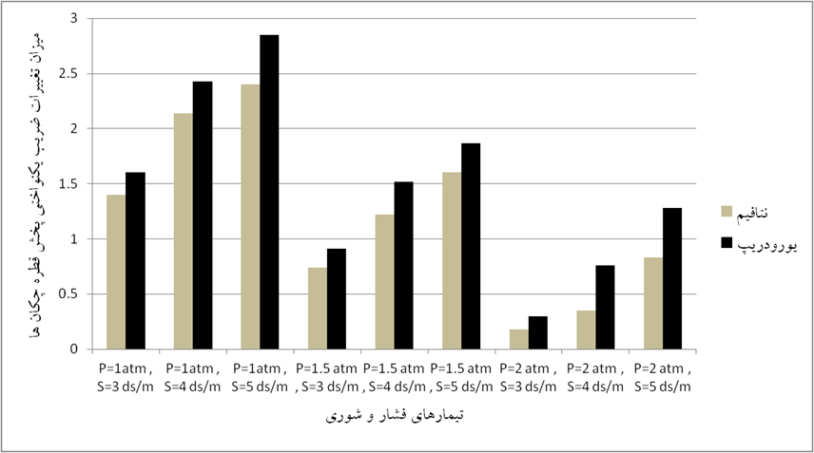

EU varieties (%)

Eurodrip

Netafim

Treatments

Fig.2. EU varieties (%)

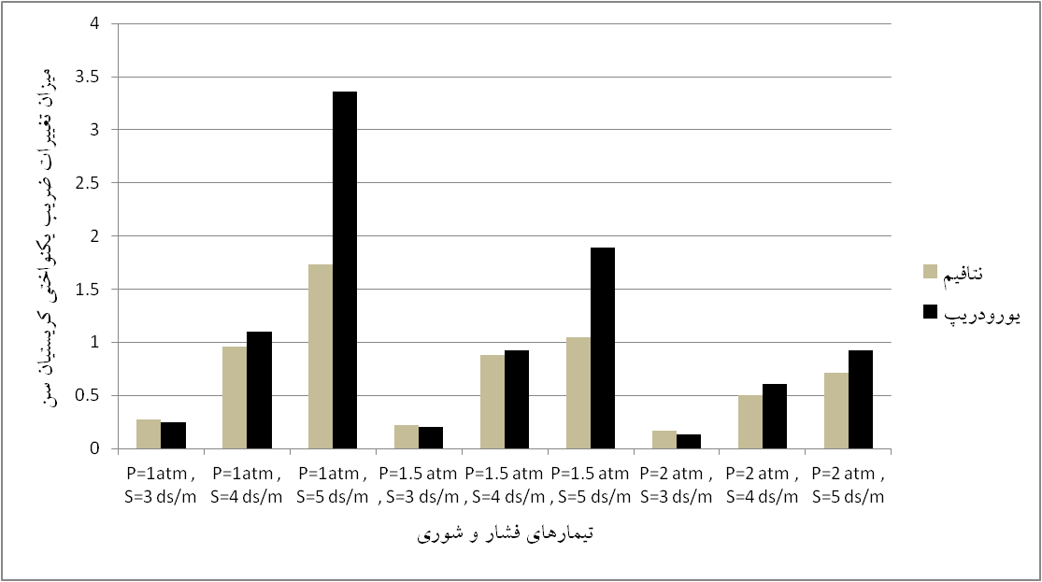

UC varieties (%)

Eurodrip

Netafim

Treatments

Fig.3. UC varieties (%)

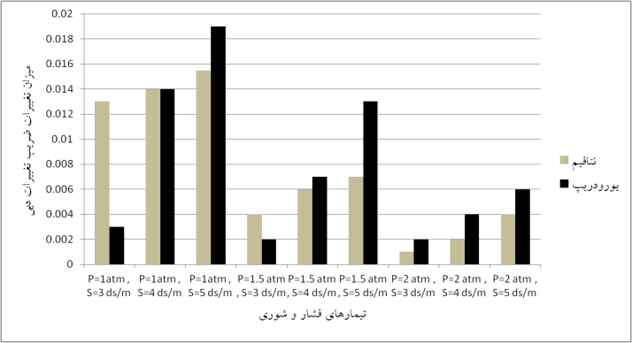

νm Varieties (%)

Netafim

Treatments

Eurodrip

Fig.4. νm varieties (%)]

Fig.2, 3 and 4 show that, the EU, UC, and νm varieties in both emitter types increases when pressure is fixed, salinity is increased, and decreases when salinity is fixed, pressure is increased.

**3.2 Emitter Performance**

Clogging was studied by measuring discharge of the emitters in each treatment. The discharge reduction rate of the emitters in each treatment is illustrated in Fig.1. According to the Figures 1.a, 1.b and 1.c elaborated on above, it can be concluded that, in the treatments N1 to E3, although the rate of clogging in both emitter models grows by time, but this growing rate of clogging gets slower, by time, which may be explained by season change. And the rate of clogging in the Netafim emitter was approximately 0.3 percent less than Eurodrip, whereas, fig.1.d and fig.1.e show that, the pattern of clogging in both emitter types is approximately similar in N4, E4, N5 and E6 treatments. By contrast, as shown in fig.1.f, the rate of clogging in Eurodrip emitter was about 0.5 percent greater than Netafim’s. Fig.1.g, fig.1.h also portray a greater rate of clogging in Eurodrip emitter. In addition, fig.1.h shows the final clogging in both emitter types is similar.

The impact of the treatments on the $EU$, $CU$ and $v_{m}$ varieties of both emitter types is described in fig.2, fig.3 and fig.4 respectively. Fig.2, fig.11 and fig.12 show that, the $EU$, $CU$ and $v_{m}$ varieties in both emitter types increases when pressure is fixed, salinity is increased, and decreases when salinity is fixed, pressure is increased.

**4. Conclusion**

To evaluate the impacts of different levels of salinity and pressure on clogging of tow most used emitters a test was conducted at the experimental hall of the Shahid Chamran university of Ahvaz and according to the results obtained in this study, it can be concluded that, clogging in both emitter types increases when pressure is fixed and salinity is increased, and decreases when salinity is fixed, pressure is increased. And in most treatments UC, DU and νm varieties and also clogging in Netafim emitter is less than Eurodrip, which is similar to Haijjun and Guanhua (2008), and Trooien et al. (1999).

**References**

1. Adin A, Sacks M, 1991. Dripper clogging factors in wastewater irrigation. *Journal of Irrigation and Drainage Division, ASCE*, 117(6): 813–825.
2. Coelho R D, Resende R S, 2001. Biological clogging of Netafim’s drippers and recovering process through chlorination impact treatment. ASAE Paper Number: 012231, Sacramento, California, USA.
3. Haijun, L., and Guanhua, H. Laboratory experiment on drip emitter clogging with fresh water and treated sewage effluent.2008. Agricultural Water Management. Pages 745-756.
4. Pitts D J, Haman D Z, Smajstra A G, 1990. Causes and prevention of emitter plugging in micro irrigation systems. University of Florida, Florida Cooperative Extension Service Bulletin 258.
5. Ravina, E. Paz, Z. Sofer, A. Marcu, A. Schischa, G. Sagi, Z. Yechialy, Y. Lev. Control of clogging in drip irrigation with stored treated municipal sewage effluent. 1997. Agricultural Water Management 33(1997) page 127-137.
6. Trooien, T.P., Lamm, F.R., Stonee, L.R., Alam, M., Rogers, D.H., Clark, G.A. And Schlegel, A.J. 1999. Testing subsurface drip irrigation laterals with lagoon wastewater. Kansas State University.
7. YANDazhuang, BAI Zhihui, Mike Rowan, GU Likun, Ren Shumei, YANG Peiling. 2009. Biofilm structure and its influence on clogging in drip irrigation emitter’s distribution reclaimed wastewater. Journal of Environmental Sciences 21(2009) page 834-841.

1/7/2015