Investigation of Hystertic Behavior of Ductile ring used LYP Matrial onCBF Behavior

Marzieh Ziaee¹, Mojtaba Hosseini²

^{1.} The Msc student, Malayer Branch , Islamic Azad University, Malayer ,Iran, Marziehz113@gmail.com
^{2.} LorestanUniversity,Khoramabad,Iran,Postal Code:68137-17133,P.O.Box:465

Abstract: The Concentrically Braced Frame is a resistant system against lateral loads which possesses significant lateral stiffness. The system’s most important problem is the pressure component buckling and its low ductility under lateral loads. In the present article, a ring with ST37 and low yield point material have used for investing the CBF system. which yielded before the pressure component buckling and depreciates the energy exerted on the structure. Therefore, seven steel models of ST37 and LYP with different geometry were used under cyclic loading. By making use of ANSYS software, the models were subjected to nonlinear geometric and materials analysis. By making use of pushover analysis, from the models analytical results it is concluded that the use of LYP steel rings with high thickness own better ductility relative to ST37 steel. Also, the use of the ring with LYP steel causes a lower decrease in stiffness and strength depreciation than the ST37 steel.
[Marzieh Ziaee, Mojtaba Hosseini. Investigation of Hysteretic Behavior of Ductile ring used LYP Matrial onCBF Behavior. N Y Sci J 2014;7(12):124-130]. (ISSN: 1554-0200). http://www.sciencepub.net/newyork. 16

Keywords: LYP steel, Concentric bracing, ductility, pressure component buckling, ST37 steel

1.Introduction:
During the occurrence of the Nortrich and Koubeh earthquakes no one steel structure was completely Collapsed, but in spite of the appropriate designs, many of the steel structures underwent damages. These Damages cost a lot. So, thenceforth, there were recommended strict criteria in the regulations to improve The structures seismic performance and damages control. Meanwhile, the introduction of new structures Brought about the researchers approach to the introduction of new metal structure dampers with an Appropriate seismic behavior. [1]
The metal braces can be included in the area of passive metal dampers. The main mechanism of the Concentric brace loading is the strain component yield and the pressure component buckling and the latter Causes the creation of a brittle behavior mechanism with the capability of absorbing energy and low Ductility under resiprocating loads. Many researchers have suggested various methods in order to Improve the behavior of such braces which from among them it can be referred to shear dampers such as Eccentric wind brace. In the technical literature the first damper with the shear mechanism appeared and Develoed based on the vast researches on the eccentric braces frames (EBF) in the 1970s [6-2]. Rai’s Studies [7] developed the idea of shear dampers by making use of steels with low yield and aluminium. The use of TADAS and ADAS dampers is a solution for improving the behavior and prevention of the Pressure component buckling [8].
Some of the researchers in order to resolve the problem of the concentrically brace buckling Contemplated about some strategies to prevent the buckling which led to the introduction of BRB braces.
This type of the braces owns an appropriate seismic performance without the stiffness drop and Strength loss subject to lateral loads.[9] But its installation and administration necessitates Special facilities and skillful technicians and also it is susceptible to performance issues. Because Of this it is not developed among the Iranian constructors.
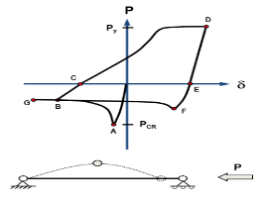
Figure 1: The complete hysteresis loop [10]

In hinge frames with Concentrically Braces Frame, diagonal component is subjected to Reciprocating intermittent loads which reveal itself as stress and strain forces in the component. In figure (1) the performance curve (force-dislocation) of the diagonal component in intermittent Loads is illustrated. It is observed that the brace decreases extremely under the pressure loadings Of the surface under the hysteresis curve. Therefore, the main objective of the current article is Tthe improvement of the pressure brace hysteresis behavior accompanied with the prevention of The pressure component buckling to achieve an appropriate system. And it is dealt with Quantities such as the brace optimum geometry, designing criteria and the brace performance. In The present survey, a steel ring with low yield point stress is used which yields before the Pressure component buckling and the energy exerted on the structure is depreciated without Significant decrease in the stiffness.
2. The system design criteria
1.2) System stiffness
In figure (2) the simplified model for the calculation of hardness is presented. The method of the Damper placement and connexion to the bracing diagonal component gives the spring serial Combination equivalent to the bracing and damper’s diagonal hardness. Therefore the system’s Hardness equivalent spring is calculated from the relations of the frame structures analysis and it Is equal to:
$\frac{1}{K_{e}}=\frac{1}{K_{b}}+\frac{1}{K_{d}}$ (1)
In which K_{d} and K_{b} are respectively damper hardness and brace hardness ,
By the introduction of parameter α as follows:
$α=\frac{K_{d}}{K_{b}}$ $α=\frac{K_{d}}{K_{b}}$ (2)
The equivalent hardness (along the brace diagonal component axis) of the damper and diagonal Element is introduced as a coefficient of the diagonal element hardness. So,
$K_{e}=\frac{K_{b}.({αK}_{b})}{K_{b}+({αK}_{b})}=\frac{α}{1+α}K_{b}=∝K_{b}$ (3)
Therefore, the more the coefficient $∝(∝=\frac{α}{1+α})$ inclines toward one, system hardness converges More towards diagonal hardness.

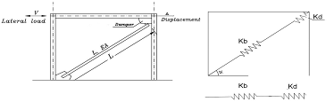
Figure (2): the damper and the bracing hardness

2.2) Resistance
In the seismic designing besides the hardness scale, the resistance and ductility scales are of great Importance. The configuration of the damper and diagonal bracing should be performed in a way That the damper can tolerate large inelastic deformations without any loss of resistivity.
2.3) Brace slimming control for securing the ductility:
In the seismic designing to secure the ductility it is necessary to enter the ductile components in Nonlinear phase and prevent the inelastic behavior of the fragile components by the energy Absorbance. Therefore, in this system ductile loops are designed in a way that bracing diagonal
Can tolerate the forces resulted from it without exhibiting inelastic behavior.
3.Numeral modelling:
The ANSYS software was used in numeral modelling. To achieve the sufficient precision, all of The specimens were chosen by the use of SHELL element with six degree of freedom in each Group. The gridding has been performed in a way that in shared nods, knotting structures form And fuse with each other by the use of software capability.
To survey the effect of the steel type on the ductile steel loops behavior, models with the Geometry and the specifications of table (1) are considered. In this table models with the letter s Refer to the rings with ST37 steel and the letter L denotes the rings with LYP steel. In all of the Specimens the diagonal and the length of the ring, based on cm, is respectively regarded 15 and 20.

Table (1): Numeral Models
Brace Tickness  (mm) | Ring Tickness  (mm) | Material | models
4 | 15 | St37 | S1.5
4 | 22.5 | St37 | S2.25
4 | 30 | St37 | S3
4 | 30 | LYP | L3
4 | 50 | LYP | L5
4 | 60 | LYP | L6
10 | 30 | St37 | S3-d
The material resistance relations of the force- ring diagonal change and their internal forces in Elastic boundary [3] and subject to linear load P corresponding to figure (3) are:

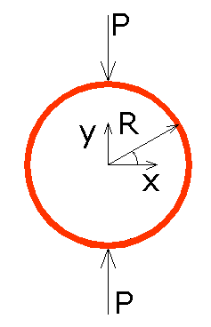
Figure 3: The ring subject to external force

$$M_{max}^{+}=0.3183PR θ=\frac{π}{2}$$
$$M_{max}^{-}=0.1817PR θ=0$$
$I=\frac{1}{12}t^{3}$l
$$δ_{y}=-0.149\frac{{PR}^{3}}{EI}$$
$$δ_{x=+0.137}\frac{{PR}^{3}}{EI}$$
$T=-\frac{1}{2}$P$\cos{θ}$
$V=-\frac{1}{2}$P$\sin{θ}$

With an increase in the load, four plastic hinges are formed in the loop the equilibrium relations Of which in the plastic limit state is as follow:
$$2M_{p}=\frac{PR}{2}→P=\frac{{4M}_{p}}{R}$$
$$M_{p}=\frac{t^{2}lσ_{y}}{4}$$
$$P=\frac{t^{2}lσ_{y}}{R}$$
$M_{p}$ is the ring plastic anchor and l is the ring length.

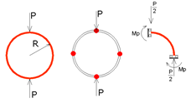
Figure (4): the location of plastic hinges formation in the ring

As it can be observed in the ring plastic relations, the ring load capacity has a direct Relationship with length, yield stress and ring thickness with a power of two and it has a reverse Relationship with its radius. In table (2) the sheet yield force and its plastic yield force is Calculated. To evaluate the ductile ring behavior on the concentric bracing behavior some Models have been analyzed by taking advantage of software. In the first step, some of the model Designs are chosen in which the bracings are thin based on the regulations. Based on the curve The hysteresis is extracted and then the same model is evaluated by the shift in the material kind.
4) Loading
The reciprocating loading has been performed based on the location change control. Based on This, firstly an analysis is performed to determine the dislocation limit.
Then based on the ATC-24 the loading cycles are repeated for the specimen to reach the yield threshold.

Table (2): the model design specifications
Models | Py(KN) | Mp(KN.mm)
S1.5 | 72 | 2700
S2.25 | 162 | 6075
S3 | 288 | 10800
L3 | 120 | 4500
L5 | 333.3 | 12500
L6 | 480 | 18000

Figure (5): Cyclic loading

5) Results Evaluation
5.1) The use of ST37 rings:
As it is observed from figure (6) in the concentric bracing system and ring, with the increase in The ring thickness the system ductility increases from 8 to 15. This figure shows that the ring Acts as a ductile fuse. But unlike the ductility with the increase in thickness the surplus amount Of the resistance is decreased and its number drops from 6 to 2. It has to be mentioned that the Eexistence of the ring with any sort of geometry causes extra resistivity in the curves but its Ascending or descending procedure is important. To compare the curves, all of the three curves In the figure are plotted in a diagram.

Figure (6): the comparison of the hysteresis curves of the ST37 rings specimens

By observing the Von-Mises stress in figure (7) related to the S3 specimen and in comparison With Von-Mises stress of the other ST37 specimens it can be understood that with the increase in Ring thickness, stress in bracings increases so, the resistance surplus exhibits a downward Procedure.

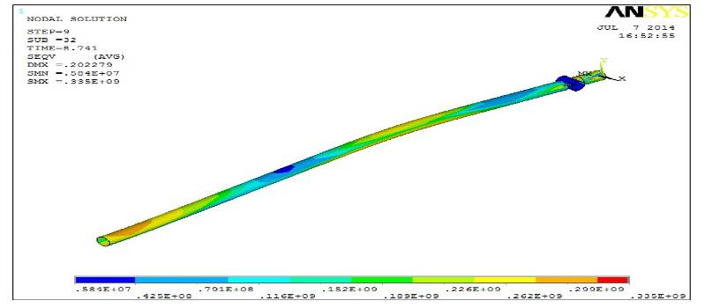
Figure (7): Von-Mises stress S3

5.2) The use of LYP rings:
In figure (8) for the rings of LYP type the hysteresis curves are also plotted. These curves also Show that with the increase in the ring thickness the system ductility shows an upward Orientation and it increases from 5 to 18. This number shows that this ring acts as a ductile fuse With appropriate and ductile performance. But, unlike the ductility with the increase in the Thickness the amount of the resistance surplus is decreased and it declines from 4 to 1.5.
Therefore it can be inferred that the increase in the ring thickness with any type exerts the same Procedure in the extra resistivity drop. But, the LYP rings possess higher ductility relative to the ST37. To better understand and conclude all of the three diagrams are plotted along with each Other. By observing figure (9) related to LYP model it is easily understandable that the Von-Mises stresses in comparison to the models having the ST37 ring decreases but there is some Increase in the ring itself.

Figure (8): the comparison of the hysteresis curves of the LYP rings specimens

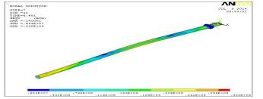
Figure (9): Von-Mises stress L3

5.3) The comparison of the similar-thickness rings:
To obtain a better understanding of the steel type effect on the system behavior, the hysteresis Curve for both of the systems with dissimilar kinds and similar geometry has been plotted in Figure (10). From the figure it can be easily understood that the loop with LYP kind possesses Higher resistivity and hardness relative to the ring with the ST37 steel type. Since its vertical Dimensionless axis shows a bigger number but, by the evaluation of its horizontal axis it is Observed that the ring with the ST37 steel type enjoys greater ductility. According to this issue That the system resistivity in LYP rings is in higher limit the ductility deficits can only be Resolved via the ring thickness increase. Now, it is time to evaluate whether the resistivity and Ductility deficits in the model with the ST37 loops can be compensated for with the increase in The geometry of the bracing system which is illustrated in figure (11).

Figure (10): The comparison of the hysteresis curve of LYP and ST37

5.4) The compensation for the resistivity and hardness of ST37 ring:
As it is illustrated in figure (10) in ST37 loops the amount of the elastic resistivity and hardness Is lower than LYP rings. Therefore, in this stage, the thickness and the radius of the bracing Gyration are increased for this resistivity and hardness deficiencies to be compensated and it is Observed that with the increase in the bracing geometry the amount of the extra elastic resistivity And hardness is compensated for to a great extent but the ductility doesn’t show any increase.

Figure (11): The comparison of the ductility of the two ST37 rings with dissimilar geometry

6) Elastic hardness:
One of the substantial flaws in using the loops in the concentric bracing is the decline in the Elastic hardness. But, with the decrease in the yield stress and increase in the thickness the Identical forces with the hardness compensation can be achieved. For this claim the elastic Hardness of the specimens is illustrated in bar diagrams in figure (12). The diagram shows that The higher elastic hardness can be achieved by making use of the LYP rings.

Figure (12): the hardness bar diagram

7) Conclusion:
In the present study the concentrically bracing frame hysteresis behavior has been studied by Using the depreciating ring of the seismic energy. Therefore, models underwent geometric Nonlinear and material analysis by using the boundary element of ANSYS software and some of The significant results are summarized below:
-By an increase in the ring ST37 thickness, the system ductility increases from 8 to 15. This Number indicates that the ring acts like a ductile fuse. But, unlike the ductility with the increase In the thickness the amount of the extra resistivity is declined and its number drops from 6 to 2.
-With the increase in the ST37 ring thickness, the stresses in the bracing increase, so the extra Resistivity shows a downward movement.
-The LYP curves show that the system ductility shows an ascending orientation with the increase In the ring thickness and its amount increases from 5 to 18.
- In spite of the ductility, with an increase in the thickness the amount of the extra resistivity is Declined and its number drops from 4 to 1.5. Therefore, it can be inferred that the increase or Decrease in the ring thickness of any type shows a similar procedure in the decline of the extra Resistivity.
-With the material curves comparison with two dissimilar types and similar geometry it can be Concluded that in using the loop with LYP steel with low thickness we couldn’t obtain an Optimum ductility but we could manage to find a higher resistivity and hardness relative to ST37 And it can be concluded that the loop type change with low thickness does not play a significant Role in guaranteeing the ductility but with the increase in loop thickness the ductility is Improved. - the amount of the hardness is independent of the yield stress and dependent on the Ring geometry. But, with the decrease in yield stress and thickness increase, the identical forces With hardness compensation can be obtained.

Reference:
- Marzieh Ziaee, the study of the steel concentric bracing behavior with the energydepreciating loop of the steel type with low yield stress LYP, MSC thesis, 2014.
- Kasai, K. and E.P. Popov, General Behavior of Wf Steel Shear Link Beams. Journal of Structural Engineering-ASCE, 1986. 112(2): p. 362-382.
- Roeder, C.W. and E.P. Popov, Eccentrically Braced Steel Frames for Earthquakes. Journal of the Structural Division-ASCE, 1978. 104(3): p. 391-412.
- Roeder, C.W. and E.P. Popov, Inelastic Behavior of Eccentric Braced Frames. 1977, Earthquake Engineering Research Center, University of California, Berkeley.
- Ricles, J.M. and E.P. Popov, Dynamic analysis of Seismically Resistant Eccentrically Braced Frames. 1987, Earthquake Engineering Research Center, University of California, Berkeley.
- Hjelmstad, K.D. and E.P. Popov, Cyclic Behavior and Design of Link Beams. Journal of Structural Engineering-ASCE, 1983. 109(10): p. 2387-2403.
- Rai, D.C. and B.J. Wallace, Aluminium shear-links for enhanced seismic resistance. Earthquake Engineering & Structural Dynamics, 1998. 27(4): p. 315-342.
- Keh-Chyuan Tsai, Huan-Wei Chen, Ching-Ping Hong and Yung-Feng Su, (1993)” Design of steel triangular plate energy absorbers for seismic-restraintconstruction”, Earthquake Spectra, Vol. 9, No. 3.
- Uang C.M., Nakashima M., Bozorgnia Y.and Bertero V.V, ”Steel buckling-restrained frames”, CRC Press,(2003).
- Design of Seismic-Resistant Steel Building Structures. Prepared by: Michael D. Engelhardt University of Texas at Austin. with the support of the. American Institute of Steel Construction. Version 1 - March 2007.
- Mohammad Coffee, Behavior of ductile elements, phd thesis,2012.

12/21/2014

