Critical study of art styles used in children's picture books

Elahe Sadat Mirbabaeiyan

Lecturer in the School of Art in Iran (MA in Illustration)
e.mirbabaeiyan@yahoo.com

Abstract: Children live in an entirely visual world, and most of the time, they are unable to visualize the shape of something they are hearing about in their minds. Therefore, even the simple words seem strange in their point of view. To probe into the environment and perception of the world, they make use of the apparent shape of things or their representation. In this regard, the selection of an appropriate style in illustrating children’s books has a crucial role in better transferring the conceptions and messages of an illustrator to a child, and is affected by the factors such as the subject and mood of a story, age of the reader, understanding of an illustrator about their hypothetical addressees, primary personality of an illustrator, their talent and creativity, tools used by an illustrator, and their skill in utilizing tools and techniques. In this paper carried out using descriptive analysis methodology, different types of art styles including Realism, childish Realism, Impressionism, Surrealism, Expressionism, Cartoon art, and various types of Abstract art styles were analyzed, and in addition, the works of some children’s book illustrators who chose either an appropriate or inappropriate style to narrate an illustrated book are also investigated here. Since the goal of illustration is to make its context or message tangible for a reader, illustrators are required to draw their view near to the child’s view and visual world, thus the current paper is provided in order to accomplish this goal.
[Kharkwal G, Mehrotra P, Rawat YS. Taxonomic Diversity of Understorey Vegetation in Kumaun Himalayan Forests. N Y Sci J 2014;7(12):117-123]. (ISSN: 1554-0200). http://www.sciencepub.net/newyork. 15

Keywords: illustration, illustrator, style, children’s picture books

1. Introduction
The prevalence of illustration in children’s books reflects the fact that illustrations help children learn in addition to stimulating their interests, namely illustrations per se can be informative and also help to clarify the meaning of their context. Illustrations work as a gate for the entrance of a child to the fantastic city of tales and stories. Children prefer books where illustrations possess an appropriate and attractive level of imagination as well as unique arrangements, thereby making them think and fantasize in addition to enrichment of their expanse of imagination. In the current world, the goal of the creation of artworks for children is not just visual joy and entertainment, but to raise creativity and sensibility of a child directly, and therefore changing their views regarding the outside world. Hence, works which are published and printed should somehow fulfill these goals. Because each stage of human life has its own specific characteristics, hence in the beginning of this paper the life periods of a child are studied. In the following sections, different types of art styles are discussed, and by presenting several appropriate or inappropriate works of the contemporary illustrators of children’s books in Iran as examples, it is tried to provide a basis for investigating and criticism of these works in terms of a selected style of an illustrator.
The Need to Understanding Children
Based on psychological theories, the mechanism transformations in adulthood is nothing but the legacies left from developmental stages of childhood. The term “childhood” generally refers to the period from birth to adulthood. The childhood period of humans is the longest among all living creatures. After the birth of a child, their learning talent gradually flourishes, so they acquire experience, modify their behavior, and adapt themselves to the society where they live. The physical and mental developments of human are not consistent along different periods of life, and each stage of human life has its own specific characteristic. Therefore, scientists have divided the human life into different stages.
1. The Stage of Realism and limited Imagination
“The age of a child in this stage is between 3 and 5 years. In this stage, physical growth is somewhat slow, while mental development has a higher acceleration. In this stage, a child learns to walk, and use their senses to recognize the inside of house, then the street, animals, birds and etc and the things in between. The imagination of a child in this stage leads to their assumption that chair is a train, stick is a horse, and pillow is a living thing, therefore talking to it. This kind of imagination makes the child to listen to the stories with great enthusiasm and delight or to watch fictional movies where animals and birds talk. In this stage, a child can’t concentrate their mind on a specific matter for long; therefore, this is the motivation for the stories and movies addressing children to be short.” (Nazar Qaazi, child and painting (paper collection), translated by Hossein Seyedi, first edition, Barg Publication, Tehran, 1989, p. 75)

2. The Stage of Free Imagination
“In this stage, child is between 5 and 8 years old. During this period, a child has learned most of the limited experiences of the house, and is now on a journey to ride the horse of imagination into the world of mermaids and goblins and wonders. In this stage, many of moral and behavioral issues could be trained to them in the form of stories.” (Aforementioned)

3. The Adventure Stage (8-12 years old)
“In this stage, most of children read factual stories, and their social side develops. In these ages, the boys tend to read thriller and mysterious books, while the girls show interest to the emotional, social, and religious stories.” (Aforementioned)
Variety of Art Styles in the Illustration of Children’s Books
In the “encyclopedia” of Roein Pakbaz, style is defined as “distinctive and recognizable structural and apparent features in one work or a group of artworks. These features should be internally related; or in other words, should present signs indicating a full unit…” (Roein Pakbaz, Art Encyclopedia, fourth edition, Contemporary Culture publication, Tehran, 2004, p. 297)
The art style of each illustrator, like technique, is considered of their specific characteristics and express part of their identity and thoughts. Illustrating is in direct relationship with the art of painting not only from technical viewpoint but also in terms of style. Illustrators should pay attention to various painting styles in illustrating according to personal taste and on top of that, considering the emotional themes of the context. Patricia Sian-siolo, critic of children’s literature, regarding utilization of art style and the level of child’s understanding in children’s books believes that:
“The style and method of the art of illustration, like the writing style, has a complicated and inexpressible, and is affected by the subject and mood of a story, age of the reader, and the image of an illustrator of the condition and situation of the reader. The lower the age of a child, the more illustrative and vivid the art style should become, and the artist should be more cautious with the use of spaces, configuration, colors, and utilization of lines and shapes in the work. In addition to that, other factors affect the working style of an illustrator among them the personality, talent and creativity of the artist, tools used by them, and their skill in utilizing tools and techniques could be mentioned. “ (Patricia Sian-Siolo, “Different types of illustration in children’s book”, translated by Fatemeh Zamani, Monthly Book of Children and Juveniles, year five, number 2, January 2001, p. 73)
Dona Norton in her book, “The recognition of children’s book: types and applications” writes:
“Each artist has a style differentiating their artistic point of view from that of other artists. The style of an artist is their personal signature.” (Dona Norton, “The recognition of children’s book: types and applications from the viewpoint of a child’s eye”, translated by Mansooreh Raei el al., first volume, first edition, Ghalam publication, Tehran, 2003, p. 158)
In this way, many of these definitions are expressed based on selection of technique and application of materials and tools as a part of art style; although it seems no technique belongs to a particular style, and in many of cases, a style could be created without dependence upon a technique.
The diversity of styles in the works of illustrators is in relationship with their working methods and interests more than its association with the context. This diversity has lead to the great attraction and variety of illustration like that of painting. In this regard, Perry Noodleman says:
“Illustrators should attempt to find their own style. For instance, the style of early works of Sendack is close to typical and conventional cartoons. His innovative work in the book, “Where the savages are” is so impressive. However, the value of style as a victorious expression may not be appropriate in the case of illustrated books. An artwork merely expressing the individuality of its artist is obscure for others, and also is unable to fulfill its duty as a part of a meaningful narrative in an illustrated book.” (Perry Noodleman, “Style as a meaning”, translated by Samila Amir-Ebrahimi, Bulletin of Children and Juvenile Literature, issue 25, Summer 2001, p. 29)
Below, each of the styles and their related examples are discussed. With respect to the fact that some styles in the art of illustration are somehow transformed and different from their associated types in the art of painting, the elements of characterization, space, coloration, and configuration in them are shaped according to the understanding and taste of children, such that sometimes these works are categorized as some of painting style with skepticism.
1. Realism Style
The representation art (realism) depicts subjects as they are in daily life. Realist artist don’t recreate their illustrations just like a photo, but instead, they create compositions to represent human figures, things, or natural phenomena in a realistic way. From the very beginning of the publication of children’s illustrated books, most of the illustrations were realistic. Realistic representations help children to sync and learn more about themselves and their environment. Realistic illustrations are the pillars of children’s acquaintance with the outside world to enable them developing their perception of the universe. “The realistic (representative) art in which the elements of an illustration are demonstrated more or less in the actual shape and size, styles such as Realism, Childish Realism, Impressionism, Expressionism, Surrealism, Cartoons, and Traditionalist styles (Archetype illustrations) are utilized. Although the dimensions of the elements of illustration and composition and their representation are distant from the actual shape, recognition of characters, spaces, and story narratives in them is so simple for a child, and despite the imagination entered in the illustration sometimes makes it far from its natural characteristics, the illustration keeps its relationship with the real shape of pictorial elements.” (Jamaloddin Akrami, “Art Styles in Illustration 1”, Monthly Book and Children and Juvenile, twelfth year, issure 8, June 2009, p. 66)
The book, “Fire on Top of Mountain” is one of the examples of attention toward the realistic style in illustration.

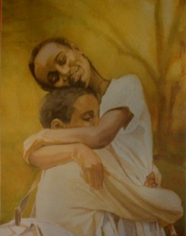
Fig. 1. Fire on Top of Mountain, A.B. Lewis

Altogether, it could be said that today’s realistic illustration of some of the countries like Iran has a lot of weaknesses and shortcomings. Although it seems that the realistic illustration should be receiving attention along with the abstract illustration by the contemporary artist, excessive tendency of contemporary illustrator to abstract elements has lead to the distance of illustrator from this art style. The root to such weaknesses may be attributed to issues such as increasing tendency to abstract view, difficulty of figurative drawing, lack of interest of illustrators to construct pictures, and imaginative material along with more freedom in the abstract art. In the illustrative art on the global level, both types of realistic and abstract art walk alongside together, and the literature of children and juveniles throughout the world benefits from the abilities of both methods at the same time.

2. Childish Realism
In the childish realism which is the simplified and childish form of realism, many of pictorial elements are omitted and these elements are followed in the level of interests of children. The abstract (stylized) feature of the illustration leads to the freedom of an illustrator to overlook drawing of some details according to the understanding and interests of children in different ages. The coloration of these illustrations is performed with reduced attention toward color values and application of shades. Application of flat and uniform in the illustration background reduce the depth of an illustration and the spaces drawn by an illustrator become simple.” (Aforementioned, P. 67-8) (Fig. 2)

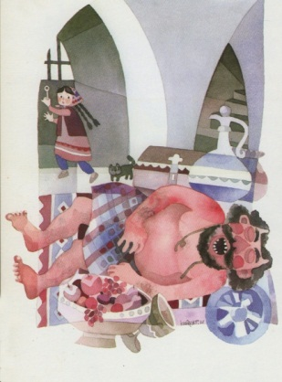
Fig. 2. Salt Seller, Nayereh Taghavi

3. Impressionism
“Impressionists pay attention to the color, clarity, light, and delicacy of illustrations and like to express their ideas using scattered colors. They often use points and short colored dashed lines in close distances. Their illustrations emphasize on tottery and unsteady state of living and nonliving things, and using color combinations, they create live and vibrant shades. In the impressionist illustrations of children’s books, a viewer quickly recognizes a new type of art free of formalities where figures with differentiated and partitioned lines are depicted. The things themselves don’t seem to receive any attention, instead a illustrator draws them the way he/she feels them.” (Perry Noodleman, p. 73)
The application of impressionism style in illustration is sweet and enjoyable for children much because it is created using pure and childish colors and on the other hand, it illustrates the actual shape of things and natural phenomena in a simplified manner. In the impressionist pictures of children’s books, a new feeling of convenience is quickly seen. An impressionist illustrator doesn’t care much to things, and draws the illustrations as if they had a passing look upon them.
“In the illustration of children’s book in Iran, before the impressionism is utilized as a style to restate the feeling of illustrator, sharp and childish colors based on what impressionists do is common. Therefore, quick and hasted lines, playing with light and color, and creation of ambiguity in the peripheral lines of an illustration considered the technical characteristics of impressionism style have received less attention from illustrators. Giving value to the peripheral lines of form (shape) in the works of Iranian illustrators has been one of the most important hurdles preventing their approach toward characteristics of impressionism style.” (Jamaloddin Akrami, p. 69)
The illustrations of the book, “Hame-Naz and the Four Brothers” are considered as the most evident examples of application of impressionism style in illustrations of children’s books. In this book, Hame-Naz, the protagonist of story, goes to the winter-stroke plain in the search of the rose, and meets the Four Brothers representing four seasons of the year in her path. The brightness of the green, blue, purple, and white colors in the illustrations of this book along with spectacular transparency indicate the joys of the girl portrayed in the black background of difficulties of her life. (Fig. 3)

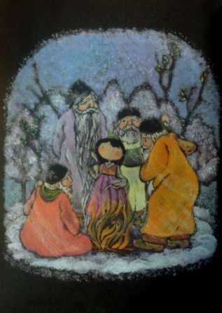
Fig. 3. Hame-Naz and the Four Brothers, Lisa Jamile Barjasteh

4. Surrealism
“The aim of founders of surrealism school was to discover and probe into the beyond of human mind and soul. In the work of surrealist painters, in addition to nonconventional and imaginary thoughts, tremendous signs of mania, nightmare, and delusions could be recognized. “Similar to other art styles, the Surrealism style in works of illustrators has been receiving more attention in terms of configuration of pictorial elements and creation of imagination compared that in terms of technical issues. The method of using form and pictorial characters in this style has higher factual and non-subjective display in children’s books” (Aforementioned, p. 70)
An example of application of this style is the book, “Looking for Heaven”. The dominant aspect in the illustrations of this book as a whole is their fantastic, symbolic, and surrealistic aspect. Its illustrations attempt to build a semi-imaginary theme using factual, surrealistic, and symbolic elements. (Fig. 4)

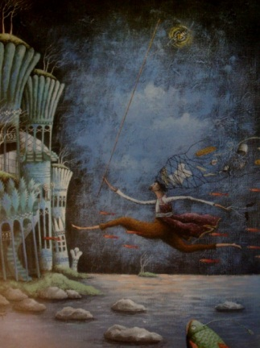
Fig. 4. Looking for Heaven, Mahkameh Shabani

“It should be kept in mind that the goal and purpose of illustrating legends is to make their context or message tangible for the reader. Adding symbolic elements, more than representing the context or message of the story leads to complication of storytelling space, and thereby diverting the reader from contemplating in the main context and message to insignificant questions often nonrelated to the context and message. The differences between drawing for you and drawing for the story and the reader should be noted, and going beyond the understanding rage of the reader is not allowed. When using symbolic elements, we require extensive time and training to be able to transfer specific messages hidden in illustrations to readers. We should keep in mind that even funny and hilarious exaggerations would guide the reader to serious questions regarding the logic and reasoning behind illustrations.” (Shahnaz Azadi, “The Stories of the Land of Nationalities”, Monthly Book for Children and Juveniles, eleventh year, issue 12, October 2008, p. 73-4)

5. Expressionism
“The art of Expressionism is an art released by an internal pressure or necessity. This pressure is caused by an emotion or sensation and the artwork works as a valve or escape by using which an unbearable psychological impression is transformed to equilibrium.” (Herbert Raid, “The Meaning of Art”, translated by Najaf Daryabandi, sixth edition, Tehran, 2000, p. 183)
“The aspects of Expressionism art include shocking colors, faces which are somewhat deformed, and quick and hasty drawing. The Expressionism emphasizes on the internal feeling of the artist as well as their way of expressing in, an imitation of what they see. In illustrating children’s books, Expressionism can be in the form of horses in bright blue or cats in blue color, as can be seen in the paintings of Eric Carl for children.” (Jamaloddin Akrami, p. 72)
Critical and exaggerating expression of feeling like fear, sorrow, happiness, excitement, and anxiety is of the most apparent expressionist indicators which can be seen in utilization of color and form. Caricature is another type of the application of this style in the art of painting and illustration, which has a critical and sarcastic tone about events; nevertheless caricature is utilized in illustration in a smooth manner and is more concerned with children’s humors. In illustration of children books in Iran, Expressionism has rarely been used as a specific style.
The book of “Local Games of Iran” is an example of application of Expressionism style where illustrations are drawn using thick and black peripheral lines as well as hasted colorations. Powerful drawings done with quick and low accuracy lines and acquired unique characteristics; however, in children’s books including the book of “Local Games of Iran” filled with joy and children’s games, this style doesn’t seem to have an appropriate application, and bitter faces are demonstrated.” (Aforementioned, p. 73) (Fig. 5)

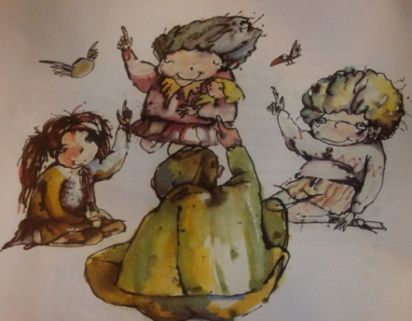
Fig. 5. Local Games of Iran, Rodabeh Khaef

Now, we discuss the good examples of consistency between style and the technique of interest in which illustrators utilized the Expressionism style in a way suitable for the understanding and interests of children.
The book, “Matched and Unmatched” as an appropriate example and in a different manner has become close to expressionistic feelings. The illustrations of Sharareh Khosrovani in this book are full of sharp and exaggerated colors and deformed and humorous faces with the difference that the shapes are simplified and child-oriented and are utilized in gel-like forms.” (Fig. 6)

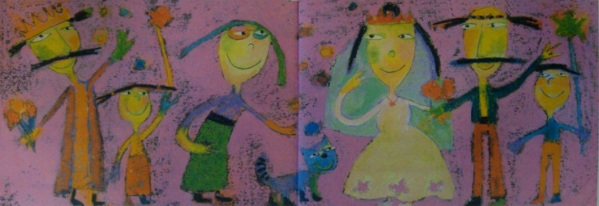
Fig. 6. Matched and Unmatched, Sharareh Khosrovani

6. Cartoon Art – Humorous Art
“Cartoon art can be considered as simplified and childish form of Expressionism style. Cartoonist artists, like expressionists, follow the general theme of a work along with humor and demonstration of feelings, and inconsistency and incongruity of characters with each other leads to the laughter and excitement in children. Cartoon and humorous art in children’s book is formed making use of simplified features of caricature and emphasizes on the lines. Exaggeration in deformation of faces and shape of entities is such that joy of children is obtained. Displaying events, spaces, and the face of story’s protagonist in cartooned manner makes events to sometimes acquire an odd, funny, and agile condition leading to a smile of the face of children.” (Patricia J. Gedansilo, “Art Style in Illustration of Books”, translated by Seyed Mohammad-Amin Roshenas, Monthly Book for Children and Juveniles, ninth year, issue 8, 9, and 10, June, July, and August 2006, p. 204)
On the other hand, development of the view desired by market in cartoon drawings driven by acceptance of TV and movie cartoons by children has led to rush and indifference of many of illustrators, thus they just consider transient and passing taste. . This trend increased in children in the current world, alienate them with artistic aspects and in turn, guide them toward preference simplified things over meaningful ones. Amir Maftoon in his book, “the Toy-Eater Monster”, achieved a humorous, childish, and valuable illustrative language.

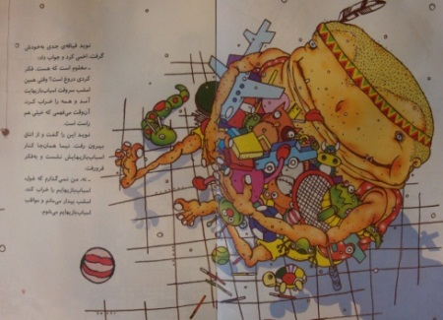
Fig. 7. The Toy-Eater Monster, Amir Mafton

7. Abstract Styles
“The Abstract art makes use of actual subjects, and by unconventional transformation and configuration of pictorial elements, creates illustrations nonexistent in the actual world. Although there are semi-abstract compositions in surrealism and expressionism styles, pictorial elements don’t lose much of their real shape in those styles, and that’s the composition of elements that creates wonder there, instead of independent components of an illustration.” (Jamaloddin Akrami, “Art Styles in Illustration 2”, Monthly Book of Children and Juveniles, twelfth year, issue 9, July 1388, p. 80)
7.1. Cubism
In the book, “That Rainy Night” with the illustrations made by Azita Arta, we find simple indicators of analytical Cubism in childish illustrations which are the reflection of attempts made by artists to separate pictorial elements from each other. Cubism style influences the formation of other styles more than playing a direct role in illustration of children’s books. (Fig. 8)

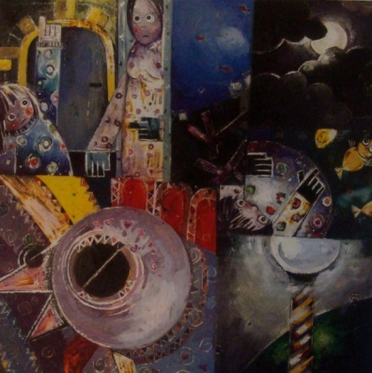
Fig. 8. That Rainy Night, Azita Arta

7.2. Abstract Art
The Abstract art is a kind of personal experience of an artist in expressing the feeling with little sign of reality found within it. In this style, the relationship between pictorial elements, more than having a visual message of a viewer, is a collection of lines, forms, and colors which has maintained their coordinated relationship and achieved a type of visual aesthetics. Concepts within lines and colors of an abstract artwork are such that each viewer should rely on their personal interpretations to understand it. Regarding this feature of the Abstract art, we find that because in illustration, there’s also a context, therefore, the Abstract art could not have a significant place in illustration, namely, the presence of extensive abstraction in illustrations of the books for preschool children often increases the possibility for false learning of the children reading the books. The illustrations of the book “What Does Speed mean?” by Reza Yousef-Zadeh is referred to as an incorrect example of utilizing abstraction. In this story, the writer expresses different concepts alongside together with an interesting trick. These concepts include the difference between slow and fast movement, the concept of speed and physical differences between animals and other living creatures. In the context, the wing of sparrow, foot of horse, tongue of chameleon, and body shape of porcupine are specifically mentioned. However, in the illustrations, none of this emphasizes are displayed correctly. In fact, the most important problem is that the recognition of animals for the readers, especially age group “A” is so difficult (if not impossible) in the most optimistic way. In the illustrations, as a result of chaos in composition and irregular deformations, no difference between slow movement of snail and fast movement of other animals is seen. In these illustrations, the viewer should use ultimate attention and imagination to relate the animal seen in the illustrations to the creature mentioned in the context. (Fig. 9)

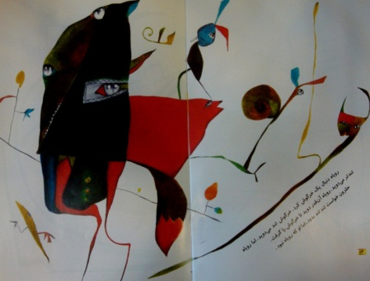
Fig. 9. What Does Speed Mean?, Reza Yousef-Zadeh

Conclusion:
Selection of an appropriate style in children’s illustrated books as an important factor for the approaching of an illustrator to the child’s world and transferring the message of an illustration has a high significance. Artists active in the field of illustrating attempt to choose the most appropriate style for creation of their works, but unfortunately, there are some works whose illustrators just stuck to their selected style without any attention to the story. Paying attention to the literary style of the context makes selection of illustration style easy for an illustrator; however, their union is not always the case and an illustrator can select their preferred style – if consistent with context - according to their personal taste. Such approach shows a relative independence of an illustrator in relation to the context. Generally, the first step in illustrating is to read the context and understand the concepts or message within it, and then, the next step would be selection of the method and style of illustration which is consistent with the main context in terms of visual elements. The selected style of an illustrator is affected by subject and mood of story, age of a reader, and the understanding of an illustrator from the condition and situation of the reader. The lower the age of a child, the more illustrative and vivid the art style should become. In addition, other factors influence the selected art style among them personality, talent, and creativity of an artist as well as the tools used by them and their skill in utilizing the tools and techniques could be mentioned. Among discussed styles in this paper and according to the explanations given, the Abstract style has no significant place in illustration such that the presence of extensive abstraction in illustrations of children’s books often increases the possibility for false learning of the children reading the books.

References:
- Dona Norton, “The recognition of children’s book: types and applications from the viewpoint of a child’s eye”, translated by Mansooreh Raei el al., first volume, first edition, Ghalam publication, Tehran, 2003.
- Herbert Raid, “The Meaning of Art”, translated by Najaf Daryabandi, sixth edition, Tehran, 2000.
- Nazar Qaazi, child and painting (paper collection), translated by Hossein Seyedi, first edition, Barg Publication, Tehran, 1989.
- Roein Pakbaz, Art Encyclopedia, fourth edition, Contemporary Culture publication, Tehran, 2004.
Article
- Jamaloddin Akrami, “Art Styles in Illustration 1”, Monthly Book and Children and Juvenile, twelfth year, issure 8, June 2009.
- Jamaloddin Akrami, “Art Styles in Illustration 2”, Monthly Book of Children and Juveniles, twelfth year, issue 9, July 1388.
- Patricia J. Gedansilo, “Art Style in Illustration of Books”, translated by Seyed Mohammad-Amin Roshenas, Monthly Book for Children and Juveniles, ninth year, issue 8, 9, and 10, June, July, and August 2006.
- Perry Noodleman, “Style as a meaning”, translated by Samila Amir-Ebrahimi, Bulletin of Children and Juvenile Literature, issue 25, Summer 2001.
- Patricia Sian-Siolo, “Different types of illustration in children’s book”, translated by Fatemeh Zamani, Monthly Book of Children and Juveniles, year five, number 2, January 2001.
- Shahnaz Azadi, “The Stories of the Land of Nationalities”, Monthly Book for Children and Juveniles, eleventh year, issue 12, October 2008.

12/13/2014

