**Investigation the Flow in RFCC Riser Reactor of Shazand Arak Refinery: Effect of Mesh Type**

Hamed Cheghayi1, Seyed Taghi Miri2, Abolfazl Barati3

1. MSc of chemical engineering, Process engineering trend, department of chemical college of science, Shahrood Branch Islamic Azad University, Shahrood, Iran

2. Assistant Professor of Chemical Engineering, department of chemical college of science, Arak University, Arak, Iran

3. Associate Professor of Chemical Engineering, department of chemical college of science, Arak University, Arak, Iran

**Abstract:** The main objective of the work was to simulate a two – dimensional, transient and isothermal gas – solid flow in riser section of circulating fluidized bed in comsol (4.3.b), CFD package. the gas – solid flow patterns for velocity, volume fraction and density for solids and mixture phase in axial and radial direction were studied using different mesh type involve regular and irregular mesh to access their effect on the calculated results. A Gidaspow drag model used in comsol (4.3.b) cod with Euler – Euler laminar model with step (0, 0.001, 10) is capable of predicting the gas – solid flow behavior in axial and radial direction in riser section of the CFB. Details of core –annular flow were properly predicted by both models at regular and irregular mesh. The result compares comsol (4.3.b) models and experimental data and fluent model. As a result models with regular mesh predicts more accurate compared to irregular mesh.

[Hamed Cheghayi, Seyed Taghi Miri, Abolfazl Barati. **Taxonomic Diversity of Understorey Vegetation in Kumaun Himalayan Forests.** *N Y Sci J* 2014;7(12):102-1109]. (ISSN: 1554-0200). <http://www.sciencepub.net/newyork>. 13

**Keywords:** isothermal gas- solid flow , CFD, regular and irregular mesh , Euler – Euler laminar model , Gidaspow drag model, CFB , riser

**1. Introduction**

It is well known that the phase transport properties such as solid holdup and solids velocity are non-uniformly along a riser. Typically with a dense - phase transport in the lower part of the riser and lean-phase transport in the upper part of the riser(Ref1) .the non-uniformity in axial phase distributions depends strongly on the operations including the overall transport mass flux of solid and superficial gas velocity . From the point of view of energy dissipations consume some portion of the pressure drop in the riser flow. hence. Strictly speaking, the traditional approach of equating the local solids holdup to the pressure drop in a riser will lead to an overestimation of local solids holdup. This overestimation can be quite large in the acceleration and dense phase transport regions where the effect of solids acceleration and the effect of energy dissipations due to interfacial friction between gas and solids phases and inter-particle collisions are expected to be significant. The following is a brief review of related modeling efforts and remaining challenges. the actual flow structure of gas and solids in a riser flow is very complex , with multidimensional variations in axial , radial and even azimuthal directions (such as near a bend or asymmetric gas-solids feeder inlet ) , multidirectional flows incore , annulus and wall regions , multi scaled phase interactions (such as interactions a mong dispersed solids , clusters, turbulent eddies and pipe wall surfaces in different flow regims) : and other complications from solids cohesion and electrostatic charge. A simple mechanistic model of such a complicated system inevitably requires many assumptions for simplication .in order to evaluate the effects of solids acceleration and energy dissipations on the pressure drop in a riser flow , the simplest and most convenient analysis approach is based on cross-section averaged axial flow models . Cross-sectional averaged solids holdup in a riser flow can be roughly estimated from pressure drop measurements by equating the gravitational force from local solids holdup to the local axial gradient of pressure with or without modifications of gas-solid flow frictions on pipe walls (Ref2). Due to the neglect of effects of solids acceleration jiand phase friction, the converted volumetric solid holdup is conceptually different from the actual solids holdup and hence termed as apparent solids consentration (Ref3, 4). While the above method of solids holdup estimation works reasonably well for gas-solid flow in the dilute transport regime, many studies suggest that the effect t of solids acceleration should not be omitted in the estimation of solids holdup. from the pressure drop measurements in the solids acceleration region (Ref5). In most of these models, the modeling of solids acceleration is based on the drag forces on individual particles or clusters in fluids with semi-empirical correlations. the Richardson – zaki equation is used as a basis for the drag force modification in gas – solids fluidization .it is noted, however, that the Richardson – zaki equation may not be adequate to describe the hydrodynamic forces on particle with net transport mass flux in the river flows because the solid holdup is expected to be a function of both the gas and solids velocities rather than the gas velocity alone (Ref3). in the dense phase transport region , the experimental measurement based on omega ray absorption or electric capacitance tomography shows that , while the detailed solids holdup distribution is very complex with a core – annulus – wall structure , the cross – sectional averaged solids volume concentration only varies slightly or virtually remains the same along the riser (Ref4 ).the pressure drop measurements in the dense phase transport region however yield apparent solids concentrations much higher than the actual solids cocentrations . These measurements strongly show that the solids acceleration is very much damped and significant energy dissipations occur in the dense phase transport region, possibly duo to the strong particle collisions and inter – phase frictions. modeling efforts to interpret the effect of inter – particle collisions on the solids flow distribution are mostly based on the kinetic theory of granular flows and two – fluid model with apparent viscosity in solids phase (Ref6) .the application of the kinetic theory modeling approach to the gas-solid riser flows, however, has many inherent limitations due to its basic assumptions of center- to- center particle collisions in vacuum. The energy dissipation module in kinetic theory modeling only depends on the restitution coefficient, a non-material property whose prediction in an arbitrary center-to-center collision of a pair of solid particles is still a mystery. In a fluidization, the dominat module of inter-particle collisions is off-center or oblique collision where the energy dissipation not only depends on the loss from normal –component of collision (restitution coefficient) but also depends on the loss duo to sliding and micro – slip friction in tangentioal and rolling contacts (Ref7). This inadequate description of collision – induced energy dissipation in kinetic theory modeling can also be reflected in the poor predictions of pressure drop in the dense phase transport region and the large uncertainties in the selections of restitution coefficients for the modeling of gas – solids fluidization. The kinetic energy dissipation in to heat is due to a combined effect interfacial friction between interstitial gas and suspended solids, inter -solid collisions and solid wall friction. A preliminary analysis on detailed energy distributions shows that the portion of inter –solid collisions is quite significant in the acceleration and dense phase transport regions (Ref8). It is realized that the conservation equation of kinetic energy is an integrated from of the corresponding momentum equation. Therefore, any non-zero terms in the energy equation have their corresponding terms in the momentum equation. The discovery of the significant energy dissipation by inter –particle collisions clearly indicates the existence of an axial force in the solids momentum equation (Ref8),whose function is to limit the degree of acceleration of a solid particle in a swamp of fluidized particles .it should be pointed out that this significant energy dissipation by collision may not be sufficiently explained by the existing kinetic theory of granular flow whose theoretical basis is on center-to-center and near –elastic collisions (Ref6) .the restitution coefficient of solids , used in the theory to account for the kinetic energy loss by normal impaction , is typically only a few percentages, a value too low to reflect the actual loss . In a dense phase fluidized stat of solids, most inter-particle collisions are off-center or oblique, and the energy dissipation not only depends on the loss of normal component collision but also depends on the loss due to sliding and micro- slip friction in tangential and rolling contacts. Both the increase in transport velocity solids and the decrease in solids concentration along the riser are likely to make the bulk characteristics of collision stress unbalanced along the riser, which made provide a mechanistic explanation of the originality of this collision force in axial direction. although zhu and you (2007) pointed out the existence of collision force that was deduced from kinetic energy conservation of riser flow , their analysis had to rely on the experimental measurements of axial distribution of pressure as an input in the energy equation . Consequently the proposed approach is unable to independently to predict axial distribution of both pressure and solid concentration. It is also noticed that, due to radial heterogeneous structure, the one – riser flow .the hydrodynamic characteristics of core and annulus (wall) areas are so different that it is not suitable To combine these two regions into a uniform region as the solids volume fraction in the wall region may be quit high and be equal to that at the minimum fluidization condition of the bed (Ref9) and the flow direction of solids is downwards instead of upwards. some researches on heterogeneous flow structure predefined the cross-section of the riser in two zones , say core –annulus (wall) flow structure (Ref10 ), which typically consider a dilute uniform core flow , and a dense wall flow along the riser . A 3-zone model is recently presented to simulate the heterogeneous structure of the riser flow (Ref9jkhiu). The model yields a reasonable explanation not only for “core –annulus (wall) “flow structure but also the “core-annulus – wall “flow structure in riser flows. While, these models artificially divide the riser in 2 or 3 different zones and uses averaged values to describe the characteristics of the flow in each zone, thus it cannot reveal the intrinsic mechanism and relationship of solid mass transport of each place. To make the problem to be closed, the models have to use pre – defined mass and momentum transfer relationships between zones. The detailed mechanism of hydrodynamic evolution from upwards flow in to the center and downwards flow near the wall is not investigated. Although (werther, (1999), Harriset al (2002) (Ref13)). The effects of this of non-uniform distribution on radial mass and momentum transfer, upwards flow area, back mixing ratio of solids phase, and thus the performance of riser are not investigated.

**Objective:**

The main objective in this study is the hydrodynamic behavior of gas-solids flows in a CFB riser and to study the effect of regular and irregular mesh on the overall gas-solid flow patternes in the riser .the Gidaspow drag model was used to describe the hydrodynamic behavior of the gas-solid flow in riser. The eulerian - eulerian kinetic theory approach is used to describe the hydrodynamic behavior of the gas-solid flow in riser. The comsol (4.3b) was used to solve the governing equation using the finite volume method.

**Model Description:**

Gas-particle flow behavior in the riser section of circulating fluidized beds was simulated using a computational fluid dynamics package by comsol(4.3b) .A 2-D , transient ,isothermal flow was simulated for the continuous phase and the dispersed phase conservation of mass and momentum for each phase were solved using the finite volume numerical technique .this approach treats each phase separately and the link between the gas and particle phase is through drag , turbulence and energy dissipation duo to particle fluctuation. Figure (1) shows the riser section of the CFB used in the present simulation of gas-solid flow, the actual geometry of the riser is cylindrical with solids entering from one side, but to obtain mixing at the entrance zone similar to e real 3-D experiment, a two inlet geometry was selected, the riser dimensions are shown in table (1).

Table (1) riser dimension

|  |  |
| --- | --- |
| Riser Height (m) | 14.2 |
| Riser Diameter or Width(m) | 0.2 |
| Gas-Velocity Width(m) | 0.2 |
| Gas-solid Inlet1 width (m) | 0.1 located 0.3 m above bottom edge |
| Gas-solid Inlet 2 width (m) | 0.1 located 0.3 m above bottom edge |
| Gas-solid outlet 1 width (m) | 0.1 Located 0.3 m below top edge |
| Gas-solid outlet 2 width (m) | 0.1 located 0.3 m below top edge |

Solid particle were fed from both sides of the riser near minimum fluidization conditions .A one inlet –outlet design for 2 –D riser could lead the inlet gas to flow to the opposite side of the solid inlet.

Governing Equations:

Use the Euler-Euler model(Ref 14,15,16) to solve for the flow of the continues and dispersed phase, Both phases are then modeled as interpenetrating continua governed by a separate set navies- stokes equations. The model also includes a transport equation for the dispersed – phase volume fraction to specify the transport properties of the riser, apply the setting below:

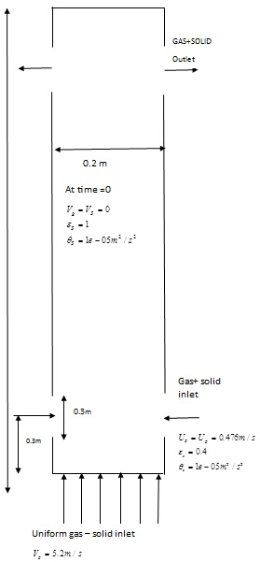

Figure (1) riser section of the CFB of gas-solid flow (Ref12)

The equation of conservation of mass and momentum for gas and particulate flows as well as the particulate phase fluctuating energy are given below :( Ref13)

Conservation equation of mass of phase (gas and solid)

(1)



Conservation equation of mass of mixture flow:

(2)



Conservation equation of momentum of phase (gas- and solid):

(3)



In the above equation (FD) is momentum that relations of gas and solids phase together.

Conservation equation of momentum of mixture flow:

(4)

In above equation () is dynamic viscosity conservation equation of viscosity mixture:

(5)



In an above equation () is maximum diameter of particle size that is default 0.62 in comsol (4.3b) program software.

Constitutive Equations:

Constitutive relations are also called closure equation.

These equations are needed so the system is not – determined. Details of closure equations are described by Drew and passam. The following represent the constitutive relations used in the current model. (Ref13)

The viscosity of the dispersed phase is defined as (ref1)

(6)



Where () is the dispersed –phase volume fraction. Assume the momentum transfer to be dominated by the drag force and the drag acting on each phase is given by a drag coefficient () in the manner of:

(7)



Here ,the subscripts ’d’ and ‘c’ indicate properties of dispersed continuous phase , respectively , and the slip velocity is defined as :

(8)



To model the drag coefficient, use the Gidaspow drag model (Ref13):

(9)



For  and:

(10)



For 

The dispersed phase transport resulting from particle –particle interaction, collisions, friction between particles, and so on, is included by the solids pressure term in the dispersed phase momentum equations. To model this term, use the Gidaspow model (Ref13):

(11)



Initial and Boundary conditions:

Appropriate initial and sufficient boundary conditions are needed to provide a well – posed numerical problem of a fully developed flow. For the computational domain, the Boundary conditions include an inflow boundary, an outflow boundary, and wall boundary. (Ref21)

Initial condition:

The initial conditions must be specified for the entire computational domain as a part of problem specification. The velocity of both gas and solid are set to zero. the volume fraction of gas is set to one and the solid volume fraction is set to zero.as the solids enter the riser sections from the bottom near minimum fluidization conditions .the initial condition employed in this simulation are tabulated in table(2)

Boundary conditions:

As shown in figure (1), the riser geometry has three inlet boundary. The gas-solid mixture enters the riser at gas –solid inlet set at 0.3 m above the bottom edge. Gas velocity, solid velocity, gas volume fraction, solid volume fraction all specified as the gas – solid inlet boundaries. The values specified at the boundary conditions are tabulated in the table (3).

Table (2) initial boundary condition

|  |  |
| --- | --- |
| Operating pressure (Pascal) | 0 |
| Air velocity in X direction (m/s) | 0 |
| Solid velocity in X Direction (m/s) | 0 |
| Air velocity in Y Direction (m/s) | 0.00001 |
| Solid velocity in Y Direction(m/s) | 0 |
| Solid volume fraction | 0 |
| Air solid fraction | 0 |
| Granular Temperature | 0.00001 |

There are two outlets for gas and solids to exit below the closed top of the riser, the continuity condition given below is applied to all other dependent variables at the outflow boundary. Use pressure normal flow conditions for both phases at the outlet.

(12)



The wall boundary conditions are imposed with the help of fictitious boundary cells. Both the gas phase and solids phase, each have two wall boundaries that are in the center and wall of the riser respectively. The wall of the riser is assumed to be impermeable to the gas. So zero flux is assigned at these points in the axial directions. This is the no-slip condition, which can be expressed as:

(13)



Table (3) boundary condition

|  |  |  |  |
| --- | --- | --- | --- |
| Boundary | Boundary Type | Phase1(Air) | Phase2(solid) |
| Gas-solid inlet 1 | Velocity inlet | =0476 | =0.4  =0.476 |
| Gas-solid Inlet2 | Velocity Inlet | =0.476 | =0.4  =0.476 |
| Gas inlet | Velocity inlet | =5.2 | =0  =0 |

**Fast modeling:**

Comsol (4.3b) mesh provide a concise and powerful set of solid modeling based geometry tools. Using these, the fluid domain can be extracted from imported geometry and further decomposition can be performed simple Boolean operation. (Ref13)

Intelligent mesh:

Different CFD problem require different mesh types and comsol (4.3b) mesh preprocessor has all of the options needed in a single package. Comsol (4.3.b) meshing toolkit can be used to decompose geometries for structured hex meshing or perform automated hex meshing with control over clustering. triangular surface meshes and tetrahedral volume meshes can be created within a single environment , along with Cartesian core , pyramids and prisms for hybrid meshing using automatic size distribution to correctly capture sharp curvature and small gaps literature review. The main objective in this study is investigation hydrodynamic behavior and effects of regular and irregular mesh on the overall gas-solid flow patterns in the CFB riser. Thus in this project we used regular and irregular mesh to simulate of gas –solid flows in the circulating CFB riser to investigation of hydrodynamic behavior effects on axial and radial overall gas-solid flow patterns . Figure (2) shows two type of mesh that we use for two modeling in this study. (A) is irregular and (B) is regular mesh .the 10*210 mesh used for two type. Comsol (4.3b) was used to solve the governing equations of mass and momentum for two models using the finite volume method. (Ref13)

**Result and Discussion:**

Core – Annular Regime:

Although CFBs have been widely used in the petroleum and chemical industries for more than 60 years, detailed understanding of riser hydrodynamic occurred at a slow pace .Many researchers showed that large radial non-uniformities exist and the flow can be described as a core-annular flow in which solid particle descend down the walls either in the form of cluster or sheets. Solids are also transported up the riser pipe in the dilute core. For solids to flow upward, the axial pressure drop must be larger than the weight of the dilute core in the developed flow. At the walls, there exists a thick dense annular region. The weight of this annuls exceeds the axial pressure drop. Hence this annular region moves down slowly. The core is generally thinner at the bottom of the riser than near the top. Internal solids refluxing also exist. Particle move from the annular region to the core near the bottom of the riser and also from the core to annulus near the top. The flow is never steady, but oscillates slowly. The simulation in this work is performed in a 20 cm diameter and 14.2 m height riser with 76 () FCC particle. The simulation was performed for 10 sec of real time. The main aim is to simulate the core – annular regime in the riser using different mesh type involve regular mesh and irregular mesh. Figure (3) shows radial profile of solid velocity in the cross-section are compared with experimental data. The result compare the mean solid velocity predicted from the comsol (4.3b), fluent and experimental data for 10*210 regular mesh and 10*210 Irregular mesh. Velocity vectors generally show the movement of each individual particle as it is being fluidized by a fluid that is distributed from the bottom section of the riser. Models accurately predicts the upward solids velocity at the center of the riser as well as the downwards solids velocity phase near the wall and the solid particle flow upwards as the fluid is distributed through it from the bottom of the riser.

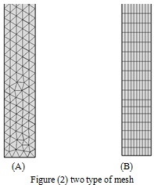

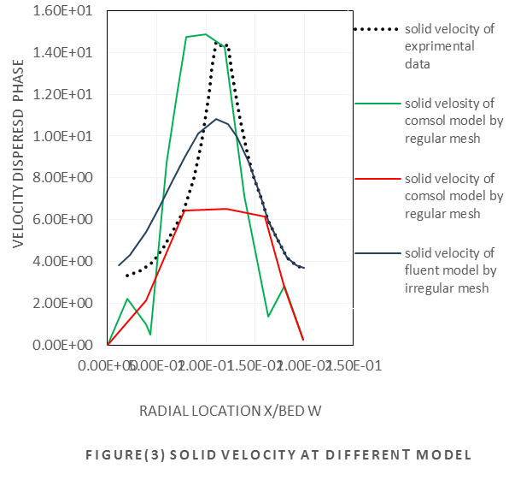

There are friction and shear between the solid-fluid particle and the wall of the riser leading to backflow along the wall. With the increase of solid velocity the area of downwards wall flow region decreases gradually. The downwards wall flow region in the model always exists even at the outlet of the riser. This is mainly due to our assumption of constant downwards solids velocity is set to be equal to the particle terminal velocity. The present study compares riser simulation using regular and irregular mesh. The greatest difference for the solid velocity occurs for the comsol (4.3b) model by irregular mesh. It show that comsol (4.3b) model with regular mesh can provide better predictions result than the other models.

Figure (4) (am) shows the solid velocity in axial direction a long riser .a Gidaspow drag model used for both model to solve. figure(4.a) show that comsol(4.3.b) model with regular mesh can provide better asymm98etric condition along the riser and better result to explain flow patterns of gas-solid along the riser than the comsol (4.3.b) model with irregular mesh .

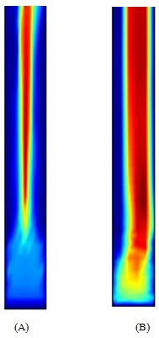

Figure (4) axial solid velocity a long riser

The radial profile of solids volume fraction in a cross – section are compared with experimental data is shown in figure (5). The result compare the solid volume fraction predicted from the comsol (4.3b), fluent for 10*210 regular and 10*210 irregular mesh. The volume fraction of solid particles is low at the center line of the riser and increased the wall is approached. The present study compares riser simulations using regular and irregular mesh. Figure (5) show that comsol (4.3b) model with regular mesh can provide better prediction result than the comsol (4.3b) model with irregular mesh. Relatively uniform. The difference between the wall and the center of the riser is not obvious.

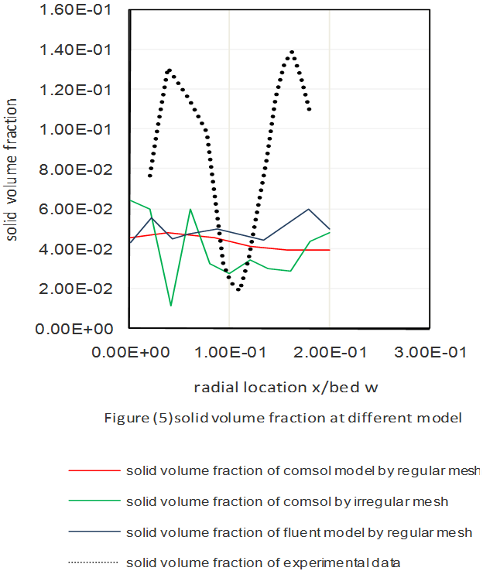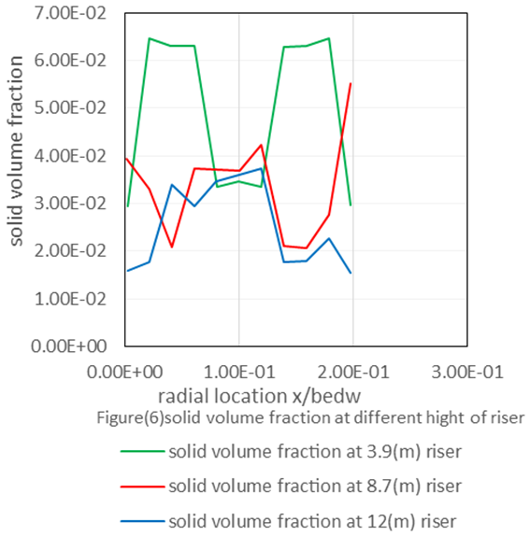

Figure (6) shows the radial profiles of solid volume fraction at different height of the riser. At the bottom of the riser, a dense regime of solids exits. With the effect of inter – phase drag force, the solids are accelerated rapidly. The solids volume fraction decrease rapidly. In a height about 1 m that shown in figure (7), the solid phase transformed in to a dilute regime. With the evolution of solids volume fraction in an axial direction, the radial profile is also changed which is better presented in a dimensionless way (ratio to cross-sectional averaged solids volume fraction). In figure (5|), at the bottom dense regime, the radial profile of solids volume fraction is relatively uniform.

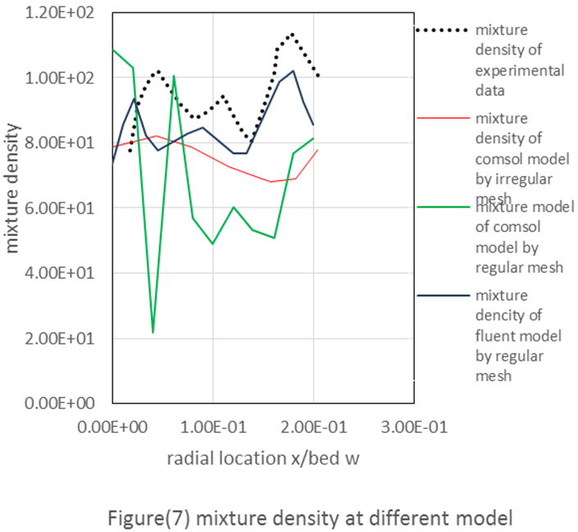

While, with the diluting of solids phase along the riser, the solids in the core regular of the riser are accelerated much faster than those in the wall region. As a result, the solids volume fraction near the wall decreases much slower than that in the core region. Figure (7) shows the profile of mixture density in a cross –section are compared with experimental data. The mixture density predicted from the cos0l (4.3.b), Fluent by 10*210 regular mesh and comsol (4.3b) by irregular mesh. The mixture density is low at the center line of the riser due to in this area, velocity of gas phase is high and increases the wall is approached because in this area, velocity of gas phase is low. as a result comsol(4.3.b) model with regular mesh can provide better prediction result than the comsol(4.3b) with irregular mesh .Figure (8) shows radial profile of solid density at different high of riser and Figure(9)(A,B)shows the axial mixture density a long a riser . Figure (9.a) simulation with regular mesh and figure (9.b) with irregular mesh. Both of model solve by Gidaspow drag model. as shown in figures there is a special concern on the thickness of downwards wall flow region and the downwards solid mass flow rate as it is commonly accepted that most of chemical reactions of riser reactors take place in the core region of the riser while the solid in downwards wall flow are spent . The thickness of the riser, divided by the point where the solids mass flux changes from upwards to downwards or the particle velocity is zero.

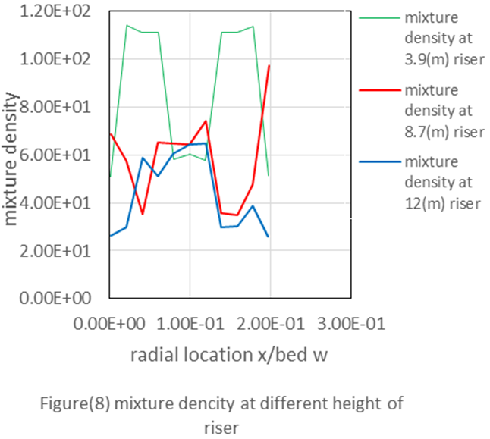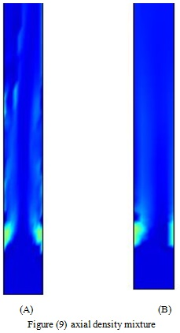

Figure9 (am) gives the profile of the upwards solids flow boundary along the riser and the corresponding upwards flow area, it is shown that at the bottom of the upwards solids flow boundary along the riser and the corresponding upwards flow area. It is shown that at the bottom of the riser where the solids volume fraction is high, the wall thickness is relatively large. With the acceleration of solid phase, this thickness the decreases dramatically and tends to be stabilized at the upper part of the riser where the solids phase is dilute. as a result figure (9.a) is much clearly shown this change than that figure (9.b) due to figure (9.a) simulate with regular mesh but figure (9.b) simulate with irregular mesh and both models have a 10*210 grid size together with with the area of core region, the upwards solids mass flow rate in the core region is also essential for the understanding of riser transportation. Based on the mass conservation of solid phase. the profile of upwards solid mass flow rate along the riser which is normally expressed by back mixing ratio defined as downwards solids mass flow rate divided by net mass flow rate at the bottom of riser where the solids velocity is low the back-mixing is mostly serere . With the continuo sly accelerating of solids, the back-mixing weakness gradually when the solids velocity tends to be stabilized, and the back-mixing is fixed. Together with the gradually increased upwards flow area along the riser, it can easily be drawn that the upwards solids mass flux at the bottom of riser is much higher than that at the top of riser.

**Conclusion:**

The objective of the work was to simulate a two -dimensional, transient and isothermal gas-solid flow in the riser section of circulating fluidized bed the comsol (4.3.b) package. The gas-solid flow patterns for velocity, volume fraction and density for solids and mixture phase were studied using different grid or mesh type (regular and irregular mesh) to access their effect on the calculated results. A Gidaspow drag model with step (0, 0.001, and 10) is capable of predicting the gas-solid flow behavior in the riser section of the CFB. Details of core –annular flow were properly predicted by both models at regular mesh, the core –annular regime, velocity profile, volume fraction of particle, mixture density and back – mixing ratio in radial and axial profile of riser reactor is clearly established by Gidaspow drag model but not irregular mesh by Gidaspow drag model. The regular mesh model predicts more accurate solids velocity in core region and near the wall compared to irregular mesh model. more detail and accurate flow profile are obtained at regular mesh model than Irregular mesh model, but computational time is the limiting factor in using regular mesh model .A large number of processors is required for studying more complex effects such as back mixing ratio and cluster formation in 3-D models. Although there are some efforts on investigation of radial solid concentration distributions , the effects of non-uniform distribution on radial mass and momentum transfer, upwards flow area, back –mixing ratio of solid phase , and thus of riser are not investigated and must efforts on investigation and explained this terms by modeling and simulation in this process.

**References:**

1. J. Werther, Fluid mechanics of large scale CFB units In: Kwauk & L. Jinghai (Eds.). Circulating Fluidized bed Technology V, pp. 1-14, 1994.
2. D. Geldart, M .J.Rodes, From minimum fluidization to pneumatic transport: a critical review of the hydrodynamics, in: p. Base (Ed.). Circulating Fluidized Bed Technology, pergamon Press, Oxford, pp . . . . 193 - 200 - ,1986
3. Yes and V.Rudolph, The volume- average voidage in the riser of circulating fluidized bed, powder Technology, 89, pp .79-82, 1996.
4. Schlichthaerle, and J Werther, Axial pressure profiles and solids concentration distribution in the CFB bottom zone. Chemical Engineering Science, 54, pp, 5485-5493, 1999.
5. s.w.kim,G.Kirbas,H.Bi,C.J.Lim,J.R.Grace,Flow structure and thickness of annular down flow layer in a circulating fluidized bed riser .powder Technology , 142,pp.48-58,2004.
6. Miller and D. Gidaspow, Dense, vertical gas – solid flow in in a pipe. AIChE.J. 38, PP.1801, 1992.
7. Fan L.S, Lau Zhu, c., principles of gas-sold flow, Cambridge University press, 1988.
8. Cho zhu, Joyous, An energy -based model of gas – solid transport in a riser, powder Technology, 175, pp.33-42, 2007.
9. Zhu, s,-c.Liang, L.S.Fan, particle wake effects on the drag force of an interactive particle .Int.J.Multiphase Flow, 20, pp.117-129, 1994.
10. Jun You, Heterogeneous flow structure and gas-solid transport of riser .PhD thesis, New Jersey Institute of Technology, 2009.
11. A.T.Harris, RB.Thorpe, J.F.Davidson, Characterization of the annular film thickness in circulating fluidized – bed risers .Chemical Engineering Science, 57, pp.2579 -2587, 2002.
12. Santosh Kumar Addagatla , Computational study of gas-solid flow in riser section of circulating fluidized beds ,college of Graduate Studies Texas A&M University Kingsville, department of chemical Engineering , pop box 1346,Ann Arbor ,MI 48106-1346,2008 .
13. H. Enwald, E. Peirano and A.-E. Almstedt, “Eulerian Two-Phase Flow Theory Applied to Fluidization,” *Int. J. Multiphase Flow,* vol. 22, pp. 21–66, 1996.
14. Gidaspow, D., Multiphase Flow and Fluidization: Academic press.
15. Enward, H., E.Peirano, and A.E .Almsted, Eulerian Two-phase Flow Theory Applied to Fluidization .International Journal Of multiphase flow, 1992.22.
16. Kim, S.W., Flow behavior and regime transition in a high –density circulating fluidized bed riser. Chemical Engineering science, 2004.59(18). p.3955-3963.

12/13/2014