Applying ANFIS neural network in predictive maintenance of thermal power plant industry

Mehdi Nakhzari Moqaddam¹, Dr. Alireza Shahraki²

^{1.} MSc of Industrial Engineering, Islamic Aazad University, Zahedan branch, Zahedan, Iran
^{2.} Industrial Engineering, Faculty member of Sistan and Baluchestan University
hushbartar@gmail.com

Abstract: With the advent of predictive maintenance (maintenance) in 1980, dramatic changes were happened in maintenance planning of equipment, as predictive maintenance is depended on failure prediction of equipment in use, if we provide proper prediction of future failures, we can reduce maintenance costs. This approach requires using many tools and equipment, including Artificial Intelligence techniques such as neural networks and fuzzy set theories. Thermal power plant function is so that any failure in each subsystem will suspend power generation and will cause more costs. In this study, predicting failure in thermal power plant equipment is based on ANFIS neural network. For this purpose, thermal power plant 500 MW manufactured by Siemens Co, in East Iran has been considered as case study. Study results show that method has relatively acceptable prediction ability in predicting failure time of equipment according to environment conditions that makes easy the predictive maintenance planning.
[Mehdi Nakhzari Moqaddam, Dr. Alireza Shahraki. Applying ANFIS neural network in predictive maintenance of thermal power plant industry. N Y Sci J 2014;7(12):94-101]. (ISSN: 1554-0200). http://www.sciencepub.net/newyork. 12

Keywords: ANFIS neural network; predictive maintenance; thermal power plant

1. Introduction
Maintenance includes planned activities that make acceptable systems [2]. Period before 1950 is called without preventive repair periods. Preventive maintenance was introduced in 1950 and Total predictive maintenance in 1960. Preventive maintenance included prevention based on time until 1970 and was based on services and basic maintenance. With the continuous expansion of awareness and TPM since 1970, continuous expansion of equipment technical conditions was begun. In 1980, predictive maintenance or maintenance based on conditions or equipment status replaced preventive maintenance. Predictive maintenance plays important role in TPM as it identifies their status using new methods of examining technical conditions of equipment at the time of operation by identifying depreciation signs or possibility of imminent failure. Predictive maintenance includes continuous collection and interpretation of data related to production conditions and the main component operation of the equipment, failure prediction and identifying appropriate maintenance strategies [8]. This study implements ANFIS fuzzy neural networks in predictive maintenance.
Some researchers have studied the function of neural networks in identifying failure. He and et al. have studied a Feed forward multilayer network based on machine detection methods and have introduced determined fuzzy relations between failure signs and their reasons and nonlinear relations between inputs and outputs of network [4]. Becraft and Lee have studied development of Artificial Intelligent system as a mean for detecting failure in chemical process factories with large dimensions [6].
Bansal, Evans and Jones conducted a study on application of real time predictive maintenance system for production machinery based on neural network approach. In this study, neural network learning feature was used for non linear recording in order to identify machine parameters for machine movement that in turn prevents form high costs of measuring machine [11].
Molina et. al. combined neural networks with expert system for predictive maintenance (NNMP), according to them are proper approach for predictive control systems and the reason is the high relationship between data and abnormal conditions while expert systems try to imitate operator responses and analyze variables like human, neural networks overcome these limitations and try to analyze non linear relationships between different signs.
In this study ARTMAP architecture is used to detect different status in order to prevent from unfavorable modes in future time [10].
1-2- Thermal Power Plant
A power plant that is known with Generating Station and Power Plant names is an industrial installation for electric generation. All power manufactures have one automated power generator rotor (rotating) that transforms mechanic energy by relative motion between magnetic field and one conductor to electric energy. Studying Document and equipment manufacturer instruction, 13 factors are important in maintaining equipment including:
- Humidity
- Temperature
- Atmospheric pressure
- Unit’s hours of Operation
- Unit’s Trip numbers
- Unit’s production energy
- Unit’s production capacitive energy
- Frequency (turbine round)
- Generator voltage
- Turbine vibrancy
- E. G. V. Close parentage
- Fuel control valve percentage
- Unit’s start number
The main sub systems of thermal power plant (gas) on which more maintenance activities are done, including five sub systems of lubrication, hydraulic, cooling, fuel and electric. The main components of lubrication system include main pumps and lubrication reserve, Vent Fan, filters, turbine jacking pumps and generator. Effective factors on system failure are as below.
Humidity, temperature, Unit’s hours of operation, trip numbers, Unit’s production energy, frequency, 15 volts bus voltage, turbine vibrancy, E. G. V. Closing percentage, fuel valve control, Unit’s Start numbers.
The main components of cooling system include water circulation pump, cooling fan, belts and conservator water tanks. Humidity, temperature, atmospheric pressure, Unit’s hours of operation, Unit’s trip numbers, Unit’s production energy, 15 volts bus voltage, Unit’s Start numbers.
The main components of Fuel system include fuel transportation pumps (injection, forwarding), fuel line filters and fuel line valve control. Effective factors on system failure are as below.
Humidity, temperature, Unit’s hours of operation, trip numbers, Unit’s production energy, frequency, 15 volts bus voltage, turbine vibrancy, E. G. V. Closing percentage, fuel valve control, Unit’s Start numbers.
The main components of hydraulic system include main and reserve pumps, cooling fan, Heaters and oil line filters. Effective factors on system failure are as below. Humidity, temperature, Unit’s hours of operation, trip numbers, Unit’s production energy, 15 volts bus voltage, turbine vibrancy, E. G. V. Closing percentage, fuel valve control percentage, Unit’s Start numbers.
The main components of electric system include Transformator, Diesel, Battery, Feeder and Generator excitation system. Effective factors on system failure are as below. Humidity, temperature, Unit’s hours of operation, trip numbers, Unit’s production energy, Unit’s production capacitive energy, frequency, 15 volts bus voltage, Unit’s Start numbers.
1-3- Neuro- Fuzzy network
Today’s, in engineering majors, using neural networks has been increased because other methods are time consuming and with less accuracy. On the other hand, according to lack of formulation and neural network dynamic, it is good idea for engineering modeling and estimation [15].
In Fig 1, the main structure of a neural network is demonstrated. Fuzzy logic is a kind of perspective to issues; Fuzzy logic is used for Expert System design. Expert Systems simulate universal rules. Neural networks are dynamic systems that transform hidden rule or knowledge beyond data into network structure by patterning from neural system function and human brain through processing on experimental data and solve complex problems relying on learning ability and parallel processing [16].

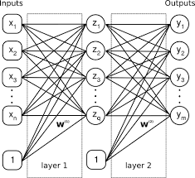
Fig.1: main structure of artificial neural network

Fuzzy- neural networks use a combination of two learning ability and parallel processing of neural networks and approximate Fuzzy inference methods. Neural networks are definite resolve of issues that are learned in system and are unpredictable and Fuzzy logic is solution for problems that their space is not absolute and cannot reach absolute response; then application of neural networks and Fuzzy logic can improve thermal power plant maintenance planning. In this study, ANFIS neural adaptive learning method is used on data that have been collected over 2 years daily. Distributed Control System (DCS) is used for data collection and Matlab, Spss and other similar software are used for data analysis.
This information include measured amount by accurate tool sensors, equipment failure and its date, manufacturer company information on basic and important equipment of Plant.
Adaptive- neural learning has performance similar to neural networks. Adaptive- neural learning techniques provide method for fuzzy modeling approach in line with information learning from data set.
ANFIS creates a Fuzzy Inferential System (FIS) using a set of input/ output data. Member function parameters of this system are justified through propagation algorithm or combining it with method of least squares. This justification operation allows Fuzzy systems to learn its structure from data set. Parameters related to membership functions change over learning process. Calculating these parameters (or their justification) is facilitated through a gradient vector. This gradient vector provides measuring factor for modeling utility of fuzzy inference systems’ parameters. After providing gradient vector, other optimization procedures can be used for optimization of parameters and error reduction. ANFIS using propagation method or combining it with method of least squares estimates membership function parameters.
ANFIS creates a Fuzzy Inferential System using a set of input/ output data. This data is in matrix form with equal columns and effective components on equipment failure of each system plus one that last column is an output that is related to failure of each system at the time of applying inputs [17].
2- Adaptive Neuro- Fuzzy Inference System Application Procedure (ANFIS)
ANFIS adaptive neuro- Fuzzy learning method is used for effective important data on each sub system. Data that has been collected over 2 years daily, according to Fig. 2 is given to ANFIS adaptive neuro- Fuzzy inferential system with sugeno function as input matrix and after training, environmental real amounts are entered into this structure and then analyze output results.
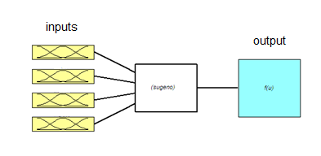
Fig.2: Anfis structure for a system sample (Resource: study findings)

3- Results of Adaptive Neuro- Fuzzy Inference System Application Procedure (ANFIS)
3-1- Lubricating system
The main structure of using this method is shown in Figs 3 and 4. Four effective factors on system failure include humidity, temperature, and voltage and turbine vibrancy.
Fig 3: Anfis structure for lubricating system (Resource: study results)

In Fig 4, logic performance of Anfis structure has been shown; in which the relationship between 4 inputs, one output, 81 rules of Anfis and 12 Fuzzy functions have been shown.

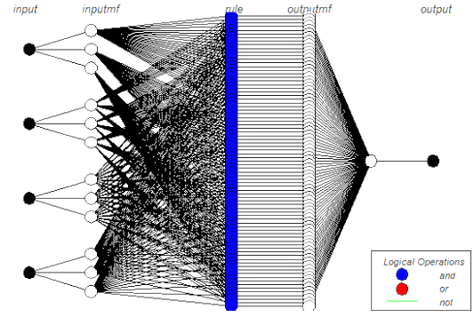
Fig 4: Logic structure of Anfis structure for lubricating system (Resource: study results)

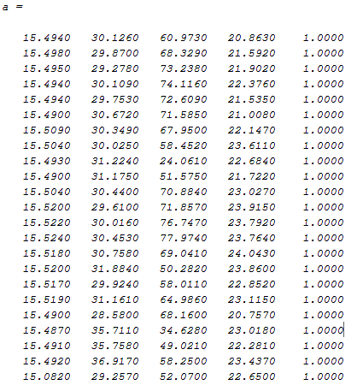

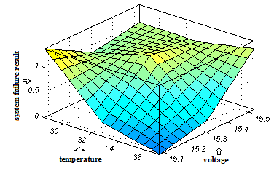
Fig 5: system failure result in terms of temperature and voltage components changes (Resource: study findings)

Table 1: Comparing practically results of ANFIS method
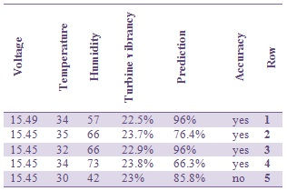

3-2- Hydraulic system
The main structure of using this method is shown in Fig 6. Five effective factors on system failure includes humidity, temperature, voltage, and hydraulic line pressure and turbine vibrancy.
Fig 6: Comparing Anfis structure for hydraulic system (Resource: study results)

Input matrix for Matlab software is like a matrix. In Fig 5, lubricating system failure has been shown in terms of temperature and voltage changes that are the most important effective parameters. As in graph figure, by oil temperature reduction and voltage reduction, system failure will increase that is proper prediction. For practical test of system failure prediction accuracy in Fig 6, we measure environmental data 5 times with data designed ANFIS and proper output with reality.
In Fig 7, logic performance of Anfis structure has been shown; in which the relationship between 5 inputs, one output, 243 rules of Anfis and 15 Fuzzy functions have been shown.

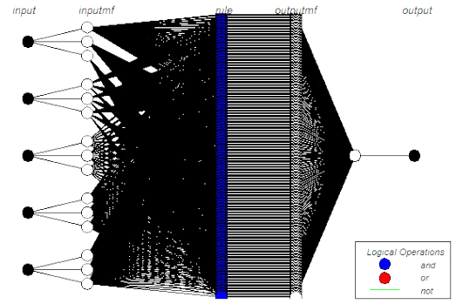
Fig 7: Logic structure of Anfis structure for hydraulic system (Resource: study results)

Input matrix for Matlab software is like m matrix.

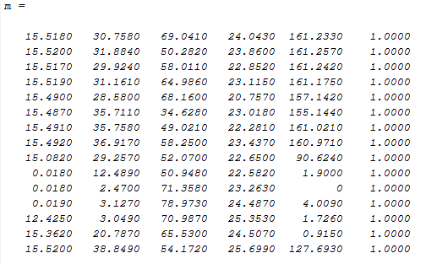

In Fig 8, system failure result has been shown in terms of two components of turbine vibrancy and hydraulic line pressure changes. As in graph figure, when hydraulic pressure reaches to 100 bar (that indicates hydraulic system is failure as pressure is 160 bar or 0 in normal mode) and when turbine vibrancy reaches its middle mode, system failure increases that is proper prediction. For practical test of system failure prediction accuracy in 11 Fig, we measure environmental data 5 times with data designed ANFIS and proper output with reality.
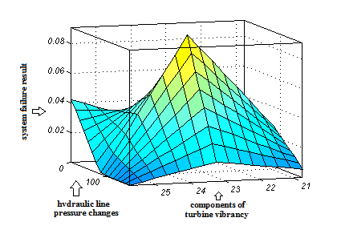
Fig 8: system failure result in terms of two components of turbine vibrancy and hydraulic line pressure changes (Resource: study findings)

Table 2: Comparing practically results of ANFIS method
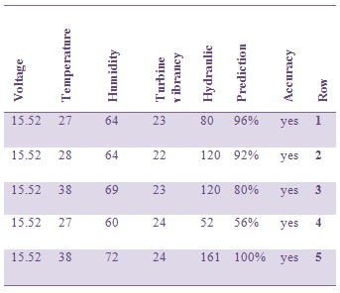

3-3 Fuel system
The main structure of using this method is shown in Fig 9. Five effective factors on system failure includes humidity, temperature, voltage, and Unit load and turbine vibrancy.

Fig 9: Anfis structure for fuel system (Resource: study results)
In Fig 10, logic performance of Anfis structure has been shown; in which the relationship between 5 inputs, one output, 243 rules of Anfis and 15 Fuzzy functions have been shown.

Fig 10: Logic structure of Anfis structure for hydraulic system (Resource: study results)

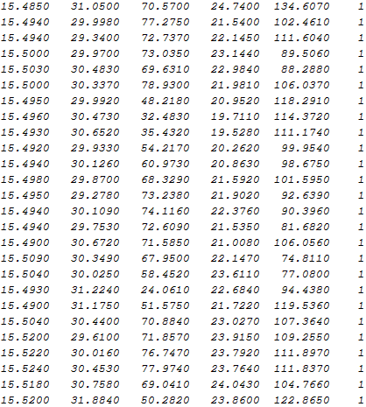

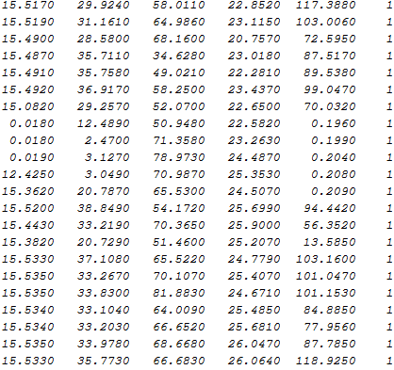

Input matrix for Matlab software is like j matrix. In Fig 11, system failure result has been shown in terms of two components of voltage and humidity changes. As in graph figure, when humidity increases, system failure will increase that is proper prediction. Zero voltage shows that equipment failure is very low and this is due to equipment out of work. For practical test of system failure prediction accuracy in Fig 12, we measure environmental data 5 times with data designed ANFIS and proper output with reality.

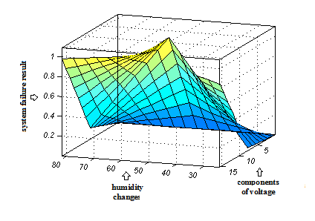
Fig 11: system failure result in terms of two components of voltage and humidity changes (Resource: study findings)
Table 3: Comparing practically results of ANFIS method
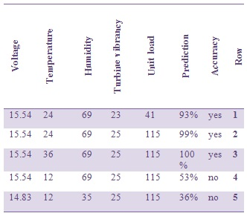

3-4- Cooling system
The main structure of using this method is shown in Fig 12. Four effective factors on system failure include humidity, temperature, voltage and atmospheric pressure.
Fig 12: Anfis structure for fuel system (Resource: study results)

In Fig 13, logic performance of Anfis structure has been shown; in which the relationship between 4 inputs, one output, 81 rules of Anfis and 12 Fuzzy functions have been shown.
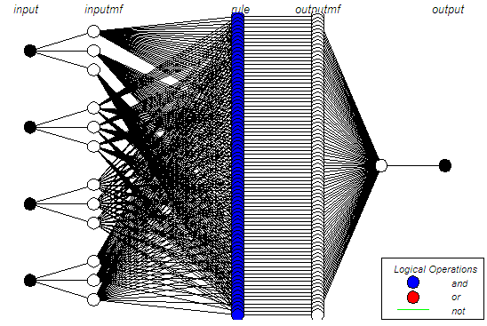
Fig 13: Logic structure of Anfis structure for cooling system (Resource: study results)

Input matrix for Matlab software is like h matrix. In Fig 14, system failure result has been shown in terms of two components of voltage and atmospheric pressure changes. As in graph figure, when atmospheric pressure increases, system failure will increase that is proper prediction. For practical test of system failure prediction accuracy in Fig 15, we measure environmental data 5 times with data designed ANFIS and proper output with reality.
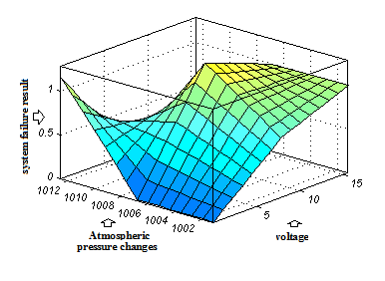
Fig 14: system failure result in terms of two components of voltage and Atmospheric pressure changes (Resource: study findings)

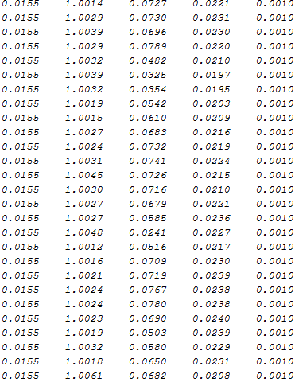
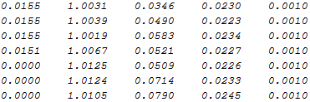

Table 4: Comparing practically results of ANFIS method
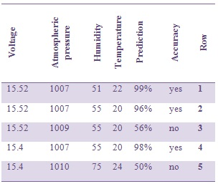

3-5- Electric system
The main structure of using this method is shown in Fig 15. Four effective factors on system failure include humidity, temperature, voltage and Unit load.

Fig 15: Anfis structure for electric system (Resource: study results)

In Fig 16, logic performance of Anfis structure has been shown; in which the relationship between 4 inputs, one output, 81 rules of Anfis and 12 Fuzzy functions have been shown.
Fig 16: Logic structure of Anfis structure for electric system (Resource: study results)

Electric system matrix is entered into Matlab software. In Fig 16, system failure result has been shown in terms of two components of temperature and Unit load changes. As in graph figure, when Unit load increases, system failure will increase that is proper prediction. Also, in graph figure, temperature of 25º is a temperature that intensifies failure in electric system. For practical test of system failure prediction accuracy in Fig 17, we measure environmental data 5 times with data designed ANFIS and proper output with reality.

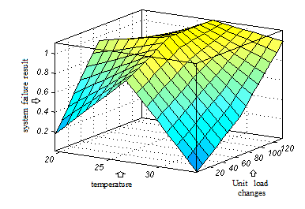
Fig 17: system failure result in terms of two components of temperature and Unit load changes (Resource: study findings)

Table 5: Comparing practically results of ANFIS method
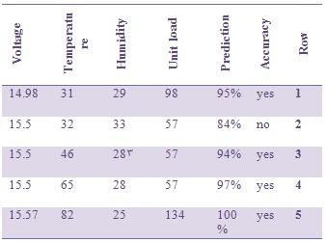

4- Conclusion
Using Neuro- Fuzzy network and studying results, it was found that having resulted components values of each system failure time, we can obtain rules that can predict failure percentage of each thermal power plant systems acceptably per new values. Then, combining neural network and Fuzzy logic methods positively effects on planning gas power plant maintenance.

References:
- Javadpour R.Knapp GM, (2003) A fuzzy neural network approach to machine condition monitoring .J Computers and industrial engineering; 323-330.
- Swanson l, (2001) Linking maintenance Strategies to performance. J Production economic; 237-244.
- Mitra S. Pal S K, (1995) Fuzzy multi-layer perceptron, inferencing and rule generation. IEEE Transaction on Neural Networks; 51-63.
- He Z. Wu M. Gong B, (1992) Neural network and its application on machinery fault diagnostics. IEEE International Conference on Systems Engineering; 576-579.
- Knapp GM. Wang HP, (1992) Machine fault classification: A neural network approach. J Production Research; 811-823.
- Becraft WR. Lee P L, (1993) An integrated neural network/expert system approach for fault diagnosis.J Computers and Chemical Engineering; 1001-1014.
- Knapp G M. Javadpour R. Wang HP, (2000) An RTMAP neural network-based machine condition monitoring system. J Quality in Maintenance Engineering; 86-105.
- Bansal D. Evansb DJ. Jones B, (2005) Application of a real-time predictive maintenance system to a production machine system .J Machine tools and manufacture; 1210-1221.
- Lucifredi A. Mazzieri C. Mrossi, (2000) Application of Multiregressive Linear models, dynamic kriging models and neural network models to predictive mainternance of Hydroelectr power systems, Mechanical systems and signal processing; 14(3), 471-494.
- Molina J.M. Isasi P. Berlanga A. Sanchis A, (2000) Hydroelectric power plant management relying on neural networks and expert system integration, Engineering Applications of Artifcial Intelligence; 13, 357-369.
- Bansal D. Evans D. Jones B, (2006) bjest: A reverse algorithm for the real-time predictive maintenance system, International Journal of Machine Tools &Manufacture; (46) 1068-1078.
- Wittkemper H.Steiner M, (1996) Using neural networks to forecast the systematic risk of stocks. J European Journal of Operational research; 577-588.
- Kim Yong Seog, (2004) An intelligent system for customer targeting: a data mining approach .J Decision Support Systems; 215-228.
- Spearman C, (1904) General ntelligence: objectively determined and measured, American Journal of Psychology; (15) 92-201.
- Wilson ID. Paris SD. Ware JA. Jenkins DH, (2002) Residential property price time series forecasting with neural networks, Knowledge-based systems; 335-341.
- Jang JS R, (1991) Fuzzy Modeling Using Generalized Neural Networks and Kalman Filter Algorithm, Proc. Of the Ninth National Conf. on Artificial Intelligence (AAAI-91); 762-767.
- Jang JSR, (1993) ANFIS: Adaptive-Network-based Fuzzy Inference Systems. IEEE Transactions on Systems, Man,and Cybernetics; 665-685.

12/13/2014

