The Investigation on steel bar Corrosion within self compacting concrete including Flyash and Metakaolin

Majid Ghazvini pourakbari¹, Dr. Reza Rahgozar², Dr. Ali Ghods³

^{1.} Department of Civil Engineering, Islamic Azad University of Zahedan, Zahedan, Iran
^{2.} Associate Professor of Civil Engineering, Shahid Bahonar Kerman University, Kerman, Iran
^{3.} Assistant Professor of Department of civil Engineering, Zahedan Branch, Islamic Azad University, Zahedan, Iran
mgh_p26@yahoo.com

Abstract: Due to weakness of concrete in tensile strength, using the steel bars in concrete is inevitable. However, the most important problem of usage of steel bars is corrosion. Therefore, researchers have been permanently following the methods that prevent or decrease the corrosion of steel in concrete. Moreover, these methods fail to be including the negative effects on the other features. One of the proposed solutions is using the self compacting concrete with high slump and performance and without vibration. This type of concrete easily fills the structural members as well as the concreting will be facilitated in the cases in which the vibration is difficult because of high steel bars numbers. In this study the reinforced self compacting concrete beam samples with dimension of 75 *10*10 cm and 2.5 cm cover including 10% of met kaolin and 10,15,20,25 % of flay ash altered cement, in the standard conditions and Zahedan climate are simulated. Overall, five self compacting concrete mixture with met kaolin and fly ash are designed. The fresh concrete experiments consist of slump, T50, J ring, L box and V ...., are performed. To evaluate the concrete mechanical properties, the pressure strength experiment is carried out based on BS 1881 Part 116 Standard within 7, 28, 90 ages. Furthermore, The Cabera Electric strength is performed within 7, 14, 28 ages. In the end the corrosion potential ASTM G876, weight reduction of bars and pictures of existed cracks are presented. In conclusion, the simultaneous usage of met kaolin and fly ash plays an effective role in decline of corrosion content.
[Majid Ghazvini pourakbari, Dr. Reza Rahgozar, Dr. Ali Ghods. The Investigation on steel bar Corrosion within self compacting concrete including Flyash and Metakaolin. N Y Sci J 2014;7(12):85-93]. (ISSN: 1554-0200). http://www.sciencepub.net/newyork. 11

Keywords: Corrosion, self compacting concrete, Flyash and Metakaolin

1. Introduction
One of the main objectives of this project is to achieve the proper ratio to obtain a mix of materials adapted to the climate of Zahedan replaced with Metakaolin and the final design of Flyash. Therefore, the experiments were carried out to determine the engineering properties of concrete containing these two additional and accelerated conditions (electric field) are examined. Despite a poor substitute for creating an electric field is the actual corrosion, but in the laboratory to produce accelerated corrosion commonly used method. Experimental work has been done in this project consists of two phases, the first phase to obtain mix, the overall profile design of beams, calculated in section steel beams and ultimately curing concrete and concrete containing Metakaolin and Flyash and the second phase of accelerated conditions corrosion and engineering properties of concrete.
In the first phase, self-compacting concrete slump test sample density was built in 2400- 2100 was examined and in the second phase of the study, five of the mix design for self-compacting concrete, replacing 10 percent Metakaolin and 0, 10, 15, 20 and 25% Flyash instead of cement to investigate the conditions of Zahedan and accelerated conditions on the properties selected. Mechanical properties of compressive strength tests (BS 1881 part 116) and the electrical resistance of concrete durability tests (Cabera) and corrosion potential (ASTM G876) is used, to create an environment of accelerated ponds containing distilled water and 5% Nacl with electric flux on the surface of the beam is used.
2-4- consuming materials
1-2-4- stone materials
During field studies have been done to prepare the concrete mix design was determined
The sand stone materials produced in the factory city of Zahedan concrete foundation industrial Park Kambozia than other materials are produced from higher quality. After reviewing the results of laboratory and field results demonstrate the accuracy was and thus to build a foundation of concrete examples of materials that are virtually free of harmful substances have been used.

Table 1.4: Results of mechanical testing of materials
Type of material | Value of sandy | Coefficient of lengthening | Ductility coefficient | Mechanical fracture
unit | % | % | % | %
Standard No. | AASHTO  T-176 | B.S  812 | B.S  812 | -
sand mixture | - | 17 | 20 | 3
Sand with a size of 0-6 mm. | 94 | - | - | -
Approximately details | >75 | <40 | <30 | -

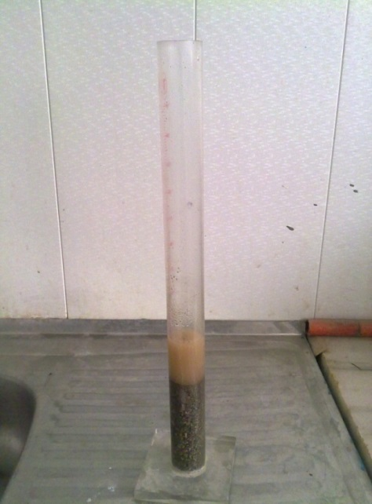
Figure 1.4. The stock solution for determination of sand and gravel materials

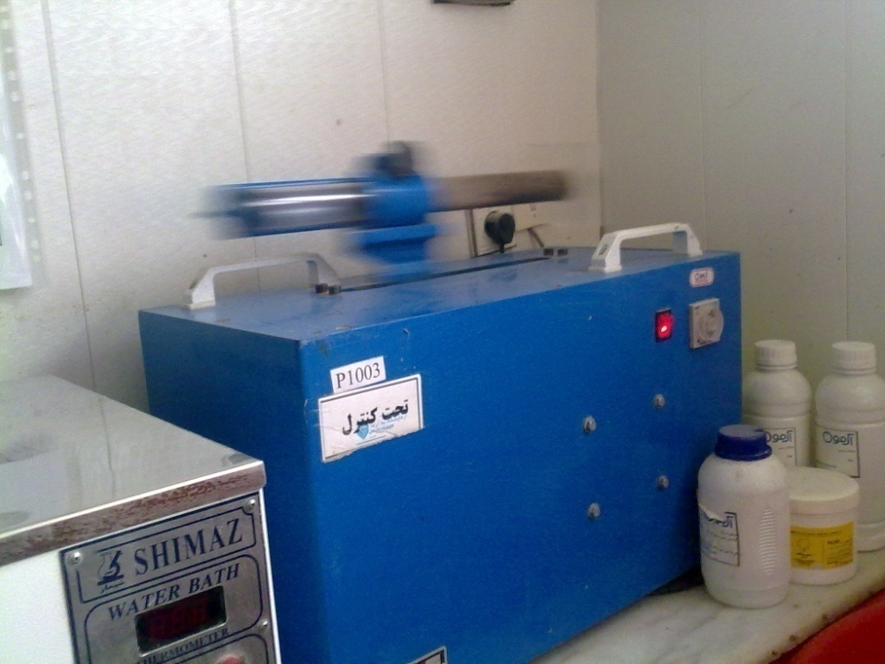
Figure2.4 - shaker device for determination of sandy materials

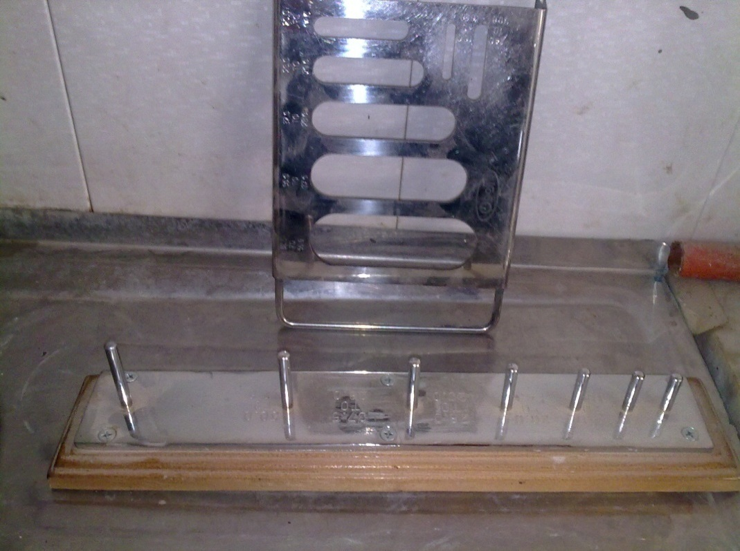
Figure 3.4: prolongation and browsing devices to test needle and flake materials

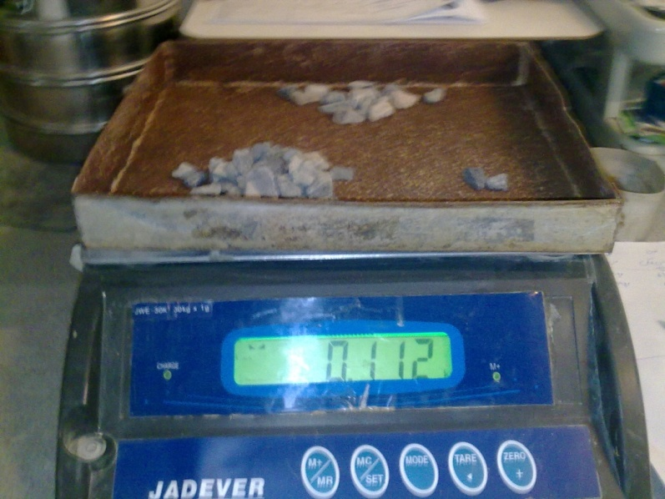
Figure 4.4: weight of the sample to determine the amount of material flake and needle

Grading of materials
Stone materials gradation is divided into a series of samples of the same size and the aim of finding a graded distribution of particles in a sample is selected.
Sand smooth coefficients
Modulus of smoothness and softness coefficient as a measure of smoothness and roughness measurement of aggregate (sand) is used and the sum of ratios of sand on all coarser sieve of each standard sieve remains divided by one hundred.
Table 2-4 and 3-4 results for the remaining materials and rejected by the sieve size distribution curve in Figure 5-4 and 6-4 respectively for sand and gravel is given.

Table 2-4: details the module size and softness of the sand used
Rejected Percentage by volume (%) | Remaining percentage (%) | remaining weight (gr) |  | Screen Size (mm) | Sieve number
 |  | All sieve | One sieve
95.2 | 0 | 0 | 0 | 4.75 | 4
65.9 | 23.2 | 232 | 232 | 2.35 | 8
40.3 | 29.2 | 292 | 60 | 1.2 | 16
23.6 | 64.9 | 649 | 357 | 0.6 | 30
12.4 | 89.5 | 895 | 246 | 0.3 | 50
5.5 | 96.6 | 966 | 71 | 0.15 | 100
0.00 | - | 1000 | 34 | - | Tray
 | 303.4 |  | 1000 | Total weight
3 ~ modulus of smoothness

Table 3-4 details of granulated sand
Rejected Percentage by volume (%) | Remaining percentage (%) | remaining weight (gr) | Screen Size (mm)
 |  | One sieve
100 | 0 | 0 | 22.6
98.65 | 1.35 | 13.5 | 19
95.65 | 4.35 | 30 | 16
92.6 | 7.4 | 30.5 | 12.7
61.6 | 38.4 | 310 | 9.5
15.1 | 84.9 | 465 | 6.3
1.9 | 98.1 | 132 | 4.75
0.00 | - | 19 | -
- | 234.5 | 1000 | Total weight

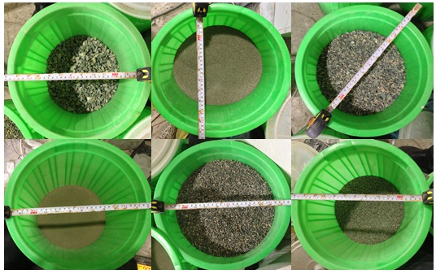
Fine aggregate gradation

Metakaolin
Metakaolin an amorphous aluminum silicate (A2S) white with pozzolanic properties is based on the standard ASTM C618 Pvzvlanhay class category N (raw or calcined natural) is placed. Metakaolin used in this study is in powder form and has a specific gravity of 2550. Table 5-5 shows the Metakaolin particle analysis.
Determination of water-cement ratio
Since the construction of concrete specimens, in addition to corrosion resistance, high compressive strength of samples is therefore considered that the 28-day compressive strength of the concrete mix proportioning of 30 MPa is therefore considered water-cement ratio of 4% is used.
The general details the design of beams
Based on availability in the city of Zahedan and the research that has been conducted in the laboratory facilities available in the dimensions 10 × 10 × 75 cm samples were and because there is no form of this size molds were made of PVC and the number 6.

- A_{s} = 2 × 78.5 = 157 mm²
- ρ = 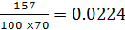
- _{max}=0.6×0.85×[600/(600+400)]×(35/400)=0.0267ρ
- _{min} = 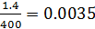ρ

The above relationships were minρ max ρ and the maximum and minimum percentage of tensile bars.
_{max 0.0035<0.0224< 0.0267} ρ> ρ >_{min}ρ
Given the high correlation between the maximum and minimum percentages in the sample as a percentage of steel rebar tensile zones, we conclude the section steel is not the need for compression fittings and soft failure occurs.
Based on the above samples of two bars in the area stretching 10 score was used.
Preparation of samples
How to mix
To make the above examples is the following procedure:
First, coarse aggregate (gravel) and fine aggregate such as sand, with a quarter of water and superplasticizer added to the mixer and mixed for 30 seconds at a time. After this period, cement and stone powder and fly ash are added Metakaolin. The two are mixed together for 60 seconds then pour the remaining water and superplasticizer in the mixer and mixed for 90 seconds at a time.
Electrical resistance test
Ions have penetrated into the concrete, the cracks in the concrete structure moving. Due to the movement of ions within the concrete, concrete, electrical conductivity, the electrical resistance of concrete depends directly on the permeability of concrete and concrete environmental conditions and certainly the most concrete permeability, the ions can be easily and more quickly find their way into the concrete. The concrete has a high electrical resistance, the penetration of chloride ions and the corrosion performance will be better. Therefore, the test for measuring the electrical conductivity due to the movement of ions within the concrete is concrete and output data of the experiment ohms-cm.
According Cabera, this test can be done in two ways:
1: The use of rice as two external electrodes
2. Use Chharalktrvd technique (which is known as the arrangement)
The first technique is used. The experimental apparatus is shown in Fig.
According to Table 5-10 corrosion rate of reinforcement in concrete with electrical resistivity greater than 20 kilo-ohm cm is negligible.

Table 4-9: effect of corrosion resistance of concrete on tracks based on Venère
Rate the likelihood of corrosion | Resistivity
Very high | <5
high | 5 TO 10
low | 10 TO 20
Nearly zero | >20

Measure the resistance of concrete specimens in vitro, using the device as a frequency of 128 kHz and a voltage of 3 V (the AC), with two copper disc located on either side of the front of the sample resistance of concrete confined to the pages of Measure. Between copper plates and surfaces with a thin layer of cement paste is filled. Samples for testing arrangement are shown in Figure 4-23. The wires connect each device to one of the plates, the electrical resistance was shown.
Armature corrosion test
In this experiment, the potential difference is measured in this way, the voltage difference between the armature and a reference electrode in contact with the concrete is measured. Method of measuring the corrosion rate by Tuesday Autolab 302N electrode polarization technique based on non-destructive method is performed. Since the device was not listed in Zahedan digital voltmeter to measure the potential difference (Figure 5-22) was performed. The method of reinforcing a weak stream and pond on the surface of the circuit (adapter) is applied. The applied current is typically 10 to 100 micro amps. The constant current at the time of exercise of the potential changes in the reinforcement and evaporation of the water in the pond is made after 6 days, once the water is completely evaporated dry period that was started 4 days, the length of the beam current and potential changes are measured with a digital device. The researchers have proved more lasting corrosion rate of drying occurs.
When water flows from a pool of samples with a series connection between the circuit and the digital ammeter is calculated and removed. (Figure 5-22)
The results of fresh concrete
Fresh concrete results are shown in Table 6-1. As you can see we try to mix all of the above settings so the lubricant, the results of fresh concrete placed in the standard range and other characteristics of the concrete in order to achieve the they are sure, let's compare.
The results show good rheological properties and demonstrate its behavior density details in all samples.

Table meters 5-1- properties of fresh SCC
Name of project | Current slump  D (cm) | T₅₀  (sec) | Box L |  |  | V-funnel (sec) |  | J-ring
 |  |  | T-20  (Sec) | T-40  (sec) | (h₂/h₁) | T 10 sec | T5min | D (cm) | (h₂-h₁) (mm)
M0F0 | 69 | 1 | 2 | 4 | 0.68 | 4.4 | 7 | 64 | 7
M10F0 | 68.5 | 1.3 | 1.3 | 2.9 | 0.7 | 6.8 | 8.15 | 62 | 8.2
M10F10 | 67 | 1.5 | 0.8 | 2.1 | 0.73 | 9.5 | 10.15 | 61 | 9.6
M10F15 | 65 | 3.1 | 1 | 3 | 0.61 | 11 | 11.2 | 63 | 8.3
M10F20 | 58 | 5 | 1.45 | 3.55 | 0.61 | 12 | 15 | 57 | 10
M10F25 | 64 | 4.9 | 1.65 | 3.7 | 0.61 | 11.8 | 15.7 | 64 | 10.7

5.3 Results of hardened concrete
5-3-1- compressive strength test results
As we know, the objective of this study is to investigate the corrosion samples containing Metakaolin and Flyash. However, given that the decrease or increase of the compressive strength indirectly, can be a sign of resistance to chemical attack is destructive ions. An experiment to study the mechanical properties of concrete samples cube dimensions 15 × 15 × 15 cm at 7 days, 28 days and 90 days, with 0, 10, 15, 20 and 25 cement replacement was performed for each test three of the pressure built and mean it was presented in graphs.
Compressive strength test results in Table 1.6 and Figures 1.6 and 2.6 are presented in graphical form.

Table 5-2 Results of compressive strength (MPa)
Name of project | 7 days | 28 days | 90 days
M0F0 | 28.1 | 38.5 | 45.1
M10F0 | 29.6 | 40.3 | 47.3
M10F10 | 27.4 | 38.1 | 43.3
M10F15 | 26.6 | 37.2 | 42.4
M10F20 | 23.5 | 35.5 | 40.3
M10F25 | 23 | 29 | 32.4

As can be seen in Table 5-2 Typical compressive strength at ages 7, 28 and 90 days decreased with increasing Flyash and control samples, which showed the highest resistance Flyash negative effect over time.

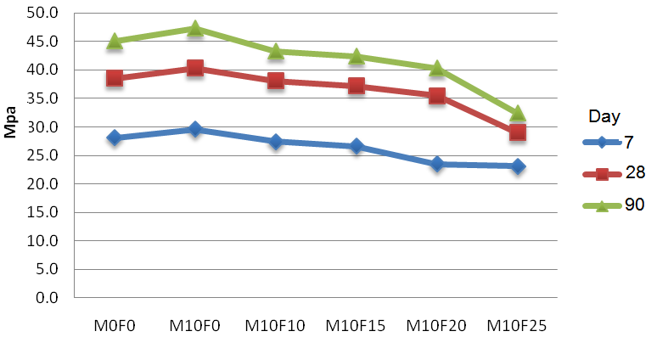
Fig. 5.1: compressive strength of fly ash samples with increasing substitution of different ages

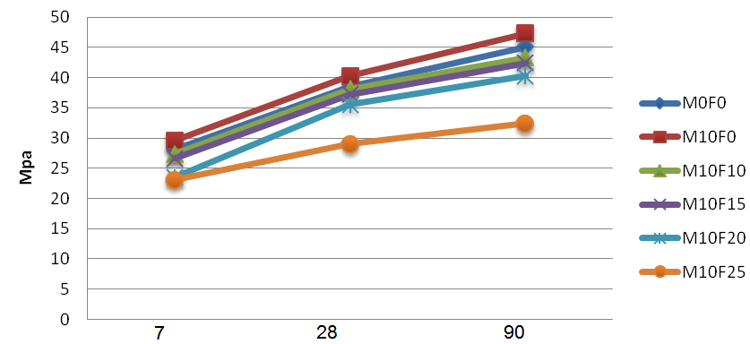
Fig 5.2: compressive strength of samples over time

By comparing the change in resistance of 7 days and 28 days were observed, the increasing resistance of 28 days with 10, 15, 20 and 25% fly ash, respectively, 39.40, 51, 26%, and resistance at 14.14, 90 to 28 days, 14 percent.

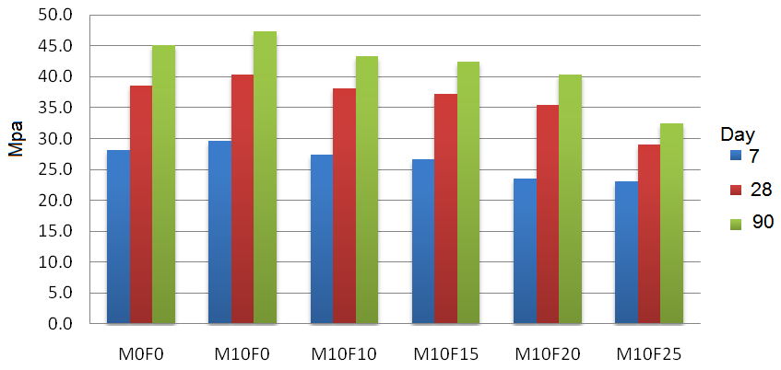
Fig 5.3: compressive strength of samples

The electrical resistance test
A result of the electrical resistance between the ages of 3 to 28 days is provided in Table 6-2.

Table 5-4- results of electrical resistance (kilo ohm-cm)
Name of project | 3 days | 7 days | 14 days | 28 days
M0F0 | 7.9 | 11.3 | 13.98 | 15.1
M10F0 | 8.35 | 12.06 | 12.98 | 16.3
M10F10 | 6.37 | 12.31 | 14.57 | 17.1
M10F15 | 9.57 | 12.43 | 15.7 | 23.71
M10F20 | 8.13 | 11.32 | 17.31 | 24.8
M10F25 | 8.18 | 11.45 | 17.1 | 24.6

As can be seen in Table 5-4 with increasing fly ash samples increases the electrical resistance, so concrete with 25% fly ash increases the electrical resistance of 28 days was 63% compared to control samples has shown itself. The compressive strength of 14, 7 and 3 days before the test in order to increase the strength of 22, 2 and 3.5 percent of the sample has no pozzolan.
Accelerated corrosion test results
Accelerated corrosion test results for concrete containing fly ash Metakaolin and the 90-day period in Table 6.3 and graphically presented in Nmvdar6-6. The numbers are read every 3 days.

Table 5-5- results of accelerated corrosion test specimens
زمان | M0F0 | M10F0 | M10F10 | M10F15 | M10F20 | M10F25
1 | -148 | -101 | -50 | -23 | -21 | -35
2 | -197 | -165 | -189 | -161 | -121 | -142
3 | -265 | -135 | -194 | -198 | -168 | -187
4 | -136 | -65 | -502 | -190 | -175 | -321
5 | -305 | -183 | -83 | -230 | -21 | -401
6 | -283 | -293 | -223 | -190 | -184 | -214
7 | -301 | -154 | -174 | -202 | -213 | -491
8 | -326 | -201 | -221 | -302 | -81 | -81
9 | -431 | -196 | -186 | -208 | -248 | -243
10 | -421 | -208 | -248 | -221 | -215 | -236
11 | -487 | -247 | -207 | -235 | -387 | -345
12 | -492 | -223 | -241 | -245 | -265 | -301
13 | -393 | -92 | -42 | -293 | -291 | -243
14 | -263 | -163 | -263 | -409 | -389 | -289
15 | -394 | -207 | -297 | -189 | -222 | -387
16 | -493 | -301 | -301 | -296 | -324 | -312
17 | -501 | -336 | -326 | -301 | -365 | -378
18 | -523 | -394 | -374 | -304 | -347 | -369
19 | -533 | -389 | -360 | -325 | -325 | -102
20 | -612 | -395 | -281 | -307 | -365 | -394
21 | -591 | -374 | -274 | -436 | -364 | -360
22 | -580 | -490 | -464 | -389 | -324 | -412
23 | -601 | -302 | -381 | -365 | -436 | -418
24 | -603 | -412 | -402 | -378 | -351 | -461
25 | -607 | -452 | -464 | -398 | -394 | -473
26 | -621 | -482 | -481 | -456 | -361 | -452
27 | -623 | -503 | -465 | -432 | -372 | -452
28 | -632 | -521 | -458 | -496 | -381 | -461
29 | -632 | -593 | -499 | -486 | -394 | -432
30 | -609 | -487 | -501 | -461 | -401 | -451

According to the results, and potential changes on the diagram in Figure 6-6, effective role in reducing Metakaolin and Flyash in combination with lateral reinforcement corrosion in reinforced concrete specimens realized.
As the survey was previously described as the extent of the corrosion potential difference is greater than the figures shown in this part, Pozzolan samples did Badr in the accelerated corrosion in concrete, Molemba (2010), Shekarchi et al. (2009), Baleem and Reed (2003), Minh (2007), Lachemi (2009), Al-Dulaijan (2002), Aveldano (2011), also conducted similar experiments.

Conclusion:
According to the results obtained from experiments and observations and survey results can be summarized as stated below:
With increasing age, the compressive strength increases as the percentage increase in resistance from age 7 to 28 days of age 28 to 90 days is much higher. So, it can speed up the reaction of cement hydration at early ages.
By increasing the amount of fly ash in concrete density Metakaolin and can have significantly save on the amount of cement. But this increase is due to the concrete at early ages Pozzolanic reaction-strength leads to a reduction projects that need to be quick in vector format by adding different amounts of active largely compensated by a decrease in resistance.
At the age of 90 days maximum compressive strength of the sample Metakaolin ten per cent and ten per cent, with 25 per cent of least resistance for Metakaolin and Flyash were planned.
With the percentage of Pvzlan, electrical resistance increases. Flyash increases the electrical resistance is increased by the greatest impact on the sample containing 20% Flyash. It can be seen that the corrosion test specimens containing Pvzlan, corrosion is less than the control sample. M10F20 mix is the lowest corrosion.
In general, according to the results of this research can be concluded that
Metakaolin of 10% with 20% ash in concrete compressive strength, density, and had the best results. The compressive strength at an early age, but is expected to decline at an older age (180 days) this resistance is improved.

Suggestions:
According to the results obtained in this study and the observations and experience from working in the laboratory of this article, the following recommendations are offered:
- Study of Mechanical Properties of Self-consolidating concrete with periods of freezing and thawing Flyash and Metakaolin
- Effect of inhibitors on corrosion of concrete containing Metakaolin and Flyash
- Condition of sea water on the concrete containing Metakaolin and Flyash
- Flyash combination with other pozzolan and characterization of mechanical and corrosion in concrete
- Evaluation of Neural Network cracks in concrete containing Metakaolin and Flyash

References:
- Shekarchizadeh, M. and Valipour, M. (2010). The use of silica pozzolan, metakaolin and zeolite and polypropylene fibers on chloride penetration resistance of the concrete conditions of the island. College of Civil Engineering, the twenty-second number one.
- Ahmet, C., adar; Su¨kru¨, Yetgin, 2006, Availability of Tuffs from Northeast of Turkey as Natural Pozzolan on Cement, some Chemical and Mechanical Relationships, Construction and Building Materials Vol. 25, No. 2, pp. 257-26.
- Al-Dulaijan, S.U, et al.2002, Effect of Rebar Cleanliness and Repair Materials on Reinforcement Corrosion and Flexural Strength of Repaired Concrete Beams, Cement & Concrete Composites, Vol. 24, pp. 139-149.
- Andrade, C., and Alonso, C., 2001, On-site Measurements of Corrosion Rate of Reinforcements. Construction and Building Materials, 15, 141-145.
- ASTM A276-13, Standard Specification for Steel Bars and Shapes, ASTM
- ASTM C29, Standard Test Method for Bulk Density(Unit Weight) and Voids in Aggregate, American society for testing and Materials, Philadelphia.
- ASTM C1152, Standard Test Method for Acid-Soluble Chloride in Mortar and Concrete, American society for testing and Materials, Philadelphia.
- ASTM C876,20 . Standard Test Method for Half-Cell Potentials of Uncoated Reinforcing Steel in Concrete, ASTM, 2000.
- BS 1818: part 116, Method for determination of compressive Strength of concrete cubes, British standards Institution, London.
- BS 1818: part 122, Method for determination of Water absorption, British standards Institution, London.
- Ballim, Y., Reid, J.C., 2003, Reinforcement Corrosion and the Deflection of RC Beams––an Experimental Critique of Current Test Methods, Cement and Concrete Composites, Vol. 25, pp. 625-632.
- Byung-Wan, Jo; Chang-Hyun, Kim; Ghi-ho, Tae; Jong-Bin, Park, 2007, Characteristics of Cement Mortar with Nano-SiO2 Particles, Construction and Building Materials 21 ,PP. 1351–1355.
- B.Uzal; L.Turanli; 2003, Studies on Blended Cements Containing High Volume of Natural Pozzolans, Cement and Concrete Research 33, PP. 1777–1781.
- Erhan Guneyisi, et al, 2012, Strenght, Permeability and Shrinkage Cracking of Silica Fume and Metakaolin Cincretes, Elsevier, Construction and Building Materials 34,120-130.
- Eva Vejmelkova, et al, 2010, High Performance Concrete with Czech Metakaolin: Experimental Analysis of Strength, Toughness and Durability Characteristics, Elsevier, Construction and Building Materials 241404-141.
- Gemma Rodriguez de sensale, 2006, Strength Development of Concrete with Rice-husk ash, Cement & Concrete Composites 28, pp. 158–160.
- Gonzalez, J.A., Andrade, C., Alonso, C., Feliu, S.,1995, Comparison of Rates of General Corrosion and Maximum Pitting Penetration on Concrete Embedded Steel Reinforcement, Cement and Concrete Research, Vol. 25, No. 2, pp. 257-26
- Glass, G.K., and Buenfeld, N.R. 2013, The Participation of Bound Chloride in Passive Film Breakdown on Steel in Concrete. Corrosion Science, 42(11).
- Hansson, C.M., Mammolitu, L., 1998, Corrosion Inhibitors in Concrete Part 1: The Principles. Cement and Concrete Research, 28(2), 1775-1781 B. B.
- Hassan, A.A.A., Hossain, K.M.A., Lachemi, M., 1998. Corrosion Resistance of Self-Consolidating Concrete in full-scale Reinforced Beams, Cement & Concrete Composites, Vol. 31, pp. 29-38.
- Hogan, Frank; Meusel, Jerry; Spellman, lou;1981, Breathing Easier with Blast Furnace Slag,Cement, Concrete and Aggregates, V.3, No.1, pp 40 - 52.
- Jovancicevic, V., Bockris, J. O. M., Carbajal, J. L., Zelenay, P., and Mizuno, T. (1986). Adsorption and Absorption of Chloride Ions on Passive Iron Systems, Journal of the Electrochemical Society, 133(11), 2219-2226.
- Kwangryul Hwang,Takafumi Noguchi,Fuminiro Tomosawa ,2010,Prediction Model of Compressive Strength Development of Fly-ash Concrete,cement and Concrete Research, Elsevier 34(004) 2269-2276
- Kasim Mermerdas, Mehmet Gesoglu, Erhan Guneyisi, Turan Ozturan, 2012, Strength Development of Concretes Incorporated with Metakaolin and Different Types of Calcined Kaolins, Elsevier, Construction and Building Materials 37,766-774.
- Lewis, D.W.;1981, History of Slag Cements, Paper Presented at University of Alabama Slag Cement Seminar, American slag association MF 186-6.
- Montemor, M. F., Simoes, A. M. P., Ferreira, M. G. S. 1998, Analytical Characterization of the Passive Film Formed on Steel in Solutions Simulating the Concrete Interstitial Electrolyte. Corrosion; VOL. 54; ISSUE: 5; PBD, pp. 347-353; PL.
- Metha, P. K., and Monteiro, P. J. M., 1993, Concrete Structure, Properties, and Materials, Prentice Hall, Inc., Englewood Cliffs, NJ.
- Malumbela, G., Alexander, M., Moyo, P., 2010, Interaction between Corrosion Crack Width and Steel Loss in RC Beams Corroded under Load, Cement and Concrete Research, Vol. 40, pp. 1419-1428.

12/13/2014

