The effect of pressure on the electrical properties of Nano structure carbon black filled SBR and IIR at percolation

A. Samir, G. Ramzy, M.H. Osman, H. H. Hassan

Physics Department, Faculty of Science, Cairo University, Giza, Egypt
asmaphysics@ahoo.com

Abstract: The effect of pressure on the electrical properties of SBR and IIR filled with different types of carbon blacks at percolation was studied. The experimental results included the DC measurements for all samples. The conduction mechanisms was calculated and it was found to be Poole-Frenkel conduction mechanism for all samples except three of them and it was found that there is no effect to the pressure on the conduction mechanism. The interspacing distance for carbon black was calculated and it was found that there is no effect to the pressure on the interspacing distance. The pressure co efficient of conductivity was investigated and the sample ISAF/SBR was the best pressure sensor.
[H.H. Hassan, G. Ramzy, M.H. Osman, A. Samir. The effect of pressure on the electrical properties of Nano structure carbon black filled SBR and IIR at percolation. N Y Sci J 2014;7(12):53-59]. (ISSN: 1554-0200). http://www.sciencepub.net/newyork. 7

Keywords: Nano structure, percolation, electrical properties, conduction mechanisms

1.Introduction
Many rubber composites are produced to meet specific requirements requiring good mechanical and electrical properties ^{(1,2)}. Composites containing several types of rubbers have been shown to have reliable properties. The addition of rubber composites and blends to other types of additives such as softeners. Reinforcing fillers etc., yielding new research which still requires a deeper investigation of the electrical behavior.
The correlation between the electrical and mechanical properties is one of the major problems of carbon black loaded rubber composites. Since, it has great impact in modern technological applications. It has been shown that pre extension should certainly modify the distribution and arrangement of carbon black particles or aggregates in rubber matrix ⁽³⁾.
Electrically conductive polymer is a new type of materials which have piezoresistivity and flexibility ⁽⁴⁻⁵⁾ which can be used as a sensing element of flexible force sensor. In many engineering applications this kind of sensors are required to have the ability to measure the compressive stress relaxation. Therefore it is necessary to research on the composite conductivity when the sample strain is kept constant
The present paper deals with a mixture of two types of rubber (SBR – IIR) loaded with different types of carbon blacks at percolation. Aiming to study the effect of pressure on the electrical properties of this blend.

2. Experimental work
Samples of SBR and IIR were prepared according to standard methods with the compositions shown in Table (1).

Table (1)
Sample |  |  |  |  | Ingredients phr
2 | 2 | 2 | 2 | 2 | Srearic acid.
5 | 5 | 5 | 5 | 5 | Zno.
10 | 10 | 10 | 10 | 10 | Paraffinic oil.
----- | ----- | ----- | ----- | 30 | N₂₂₀ (ISAF)
----- | ----- | ----- | 40 | ----- | N₃₂₆ (HAF)
----- | ----- | 60 | ----- | ----- | N₅₅₀ (FEF)
----- | 70 | ----- | ----- | ----- | N₆₆₀ (GPF)
80 | ----- | ----- | ----- | ----- | N₇₇₄ (SRF)
2 | 2 | 2 | 2 | 2 | TMTD
1 | 1 | 1 | 1 | 1 | IPPD 4020
3 | 3 | 3 | 3 | 3 | sulfur

The ingredients in the table was used for blend ratios (100-0, 75-25, 50-50, 25-75, 0-100) of SBR- IIR respectively. The D.C. measurements were taken by using keithley 485 auto ranging pico ammeter in room temperature.

3. Results and discussion
It has already been shown that, the electrical conductivity of carbon black filled composites increases sharply above certain range of carbon black concentrations ⁽⁶⁾.. The conductivity at this critical concentration is most sensitive to any physical changes than in the case of composites with high as well as low conductivity. This is the reason behind our choice of the percolation concentration of different types of carbon blacks (30, 40, 60, 70 and 80 phr from ISAF, HAF, FEF, GPF and SRF) respectively.
The current (I) flowing through the different samples as a function of applied voltage (V) was measured whilst maintaining the sample at 300 K and at different hydrostatic pressures (0-25 bars) as shown in figures (1) for only three samples and the others follow the same behavior.
This behavior can be explained in terms of the charge transport mechanism operating in the rubber matrices in different voltage range.
The charge transport mechanism in these materials could obey pretty well the Schottky’s field assisted thermoionic emission equation ⁽⁷⁻⁹⁾, i.e.
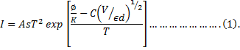
where A is the Richardson constant, s is the electrode area, Ф is the metal work function, d is the thickness of the dielectric, ε is the permittivity, k is the Boltzmann’s constant and T is the absolute temperatures. If V is expressed in Volts and d in cm, the value of C is 4.06. For the Poole-Frenkel effect, the value of C replaced by 2C.

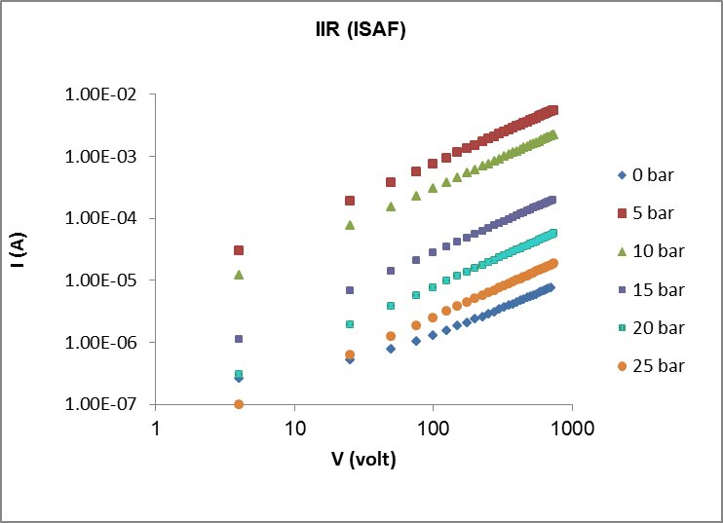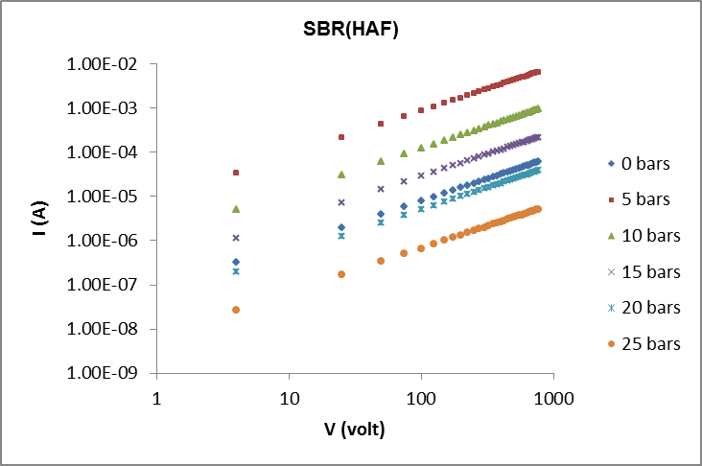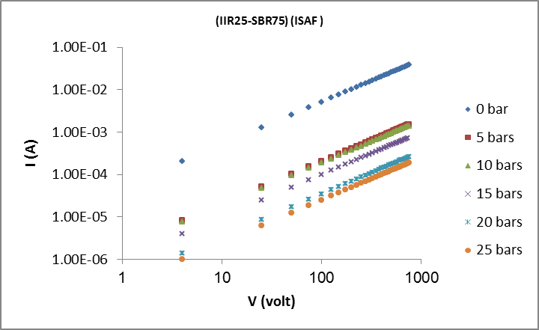
Fig.1) The current voltage characteristics as a function of the applied hydrostatic pressure for three samples

If the temperature of the samples is maintained constant (300 K), then a plot of log J versus E^{1/2} (at different hydrostatic pressures for all samples) yields the required information with respect to the charge transport-mechanism. The log J versus E^{1/2} plots for all samples are given in the figure (2).
The plots show a linear behavior with appreciable deviation from linearity at lower fields, which can be attributed to accumulation of space charge at the electrodes. The slope of these plots at higher field yields important information regarding the nature of the conduction process. The current- voltage temperature dependence obeys the relation:
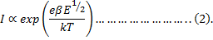
Where E is the applied field and β a constant characteristics of the conduction mechanism.
The linear behavior of log J versus E^{1/2} plots in the present study points to an electronic type conduction mechanism. Here, the charge carriers are released by thermal activation over a potential barrier. The physical nature of such a potential barrier can be interpreted in the two ways. It can be the transition of electrons over the potential barrier between the cathode and the dielectric (Schottky emission). Alternatively, charge carrier can be released form the traps into the dielectric (Poole-Frenkel effect).
In order to differentiate between these two conduction mechanisms, the values of β can be calculated separately for either Schottky β_{RS} or the Poole-Frenkel β_{PF} mechanisms at different hydrostatic pressures. It was found that there is no effect to the pressure on the β values. The values of β can be calculated by the use of the following respective equations:
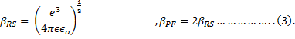
where, for all samples the dielectrics

Permittivity of the investigated samples (at 10³ Hz) are given in table (1).
ϵ_{o} = 8.85 x 10⁻¹² F/m and e = 1.6 x 10⁻¹⁹ coulomb.
The experimental as well as the theoretical value of β for both Schottky and Poole-Frenkel mechanisms are shown in table (3).

Table (2)The theoretical and experimental values of β.
Sample | β _{exp} x 10⁻⁷ | β _{Pf} x 10⁻⁷ | β _{RS} x 10⁻⁷
30ISAF/IIR | .992 | 1.97 | .983
40HAF/IIR | 1.9 | 1.8 | .9
60FEF/IIR | .82 | .75 | 1.5
70GPF/IIR | 2.06 | 1.97 | .98
80SRF/IIR | 1.5 | 1.6 | .814
40ISAF/SBR | 1.2 | 2.9 | 1.45
50HAF/SBR | .9 | 1.7 | .8
80FEF/SBR | 2.46 | 5.3 | 2.6
90GPF/SBR | 1.22 | 1.1 | .55
100SRF/SBR | 1.6 | 1.57 | .79
40ISAF/IIR25-SBR75 | 1.12 | 1.35 | .675
50HAF/IIR25-SBR75 | 1.23 | 1.36 | .68
40ISAF/IIR50-SBR50 | .9 | 2.2 | 1.1
50HAF/IIR50-SBR50 | 1.4 | 1.34 | .67
40ISAF/IIR75-SBR25 | 1.58 | 1.7 | .9
50HAF/IIR75-SBR25 | 1.8 | 1.9 | .95

All samples show different conduction mechanisms for the different types of carbon black used. Meanwhile the blend ratio greatly affects and alters the type of conduction mechanism from Poole-Frenkel to Richardson Schottky and Vice Versa.

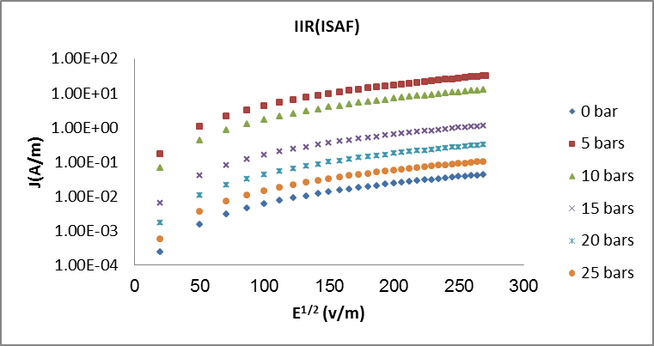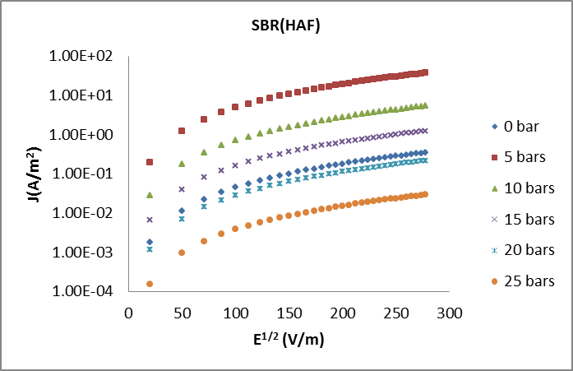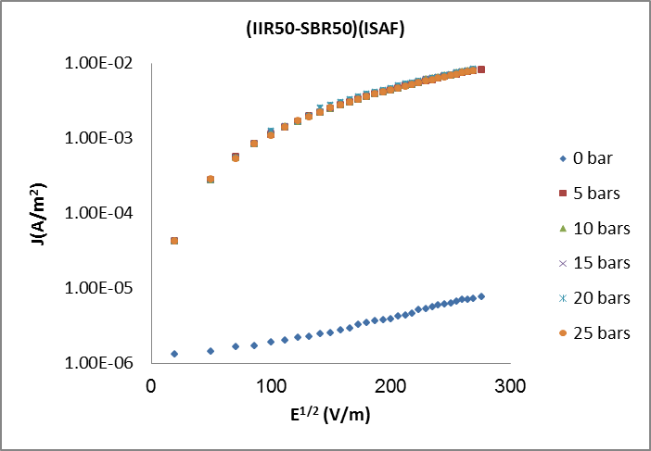
Figure (2) the plots of J versus E^{1/2} at different hydrostatic pressures for samples.

Figures (3) represent the dependence of log J on E at room temperature (300 K) for all samples at different hydrostatic pressures. This dependence can readily be fitted to an empirical formula of the form:
Where, =deE, d is the interspacing distance between carbon black particles, k is Boltzmann’s constant, T is the ambient temperature in K, e is the effective electronic charge and J_{o} is the fitting parameter which depends on hydrostatic pressure, blend ratio and types of carbon black. Using the iterative method approximate value of d could be estimated from figures (4) which represents three examples only and the other samples gives the same behavior, which are indicated in table (3).
The dependence of ‘d’ on hydrostatic pressure is not quite the same obtained by this empirical formula for all samples, it is highly affected by the rubber concentration ratios and types of carbon black.

Table (3)
Sample | (d nm) | P( bar) | Sample | (d x nm) | P( bar)
30ISAF/IIR | 1.293 | 0 | 40HAF/IIR | 1.152 | 0
 | .832 | 5 |  | .9 | 5
 | .822 | 10 |  | .9 | 10
 | .812 | 15 |  | .9 | 15
 | .802 | 20 |  | .9 | 20
 | .799 | 25 |  | .9 | 25
60FEF/IIR | .732 | 0 | 70GPF/IIR | 1.12 | 0
 | .732 | 5 |  | 2.12 | 5
 | .732 | 10 |  | 4.12 | 10
 | .732 | 15 |  | 4.14 | 15
 | .732 | 20 |  | 4.15 | 20
 | .732 | 25 |  | 4.16 | 25
80SRF/IIR | 1.21 | 0 | 30ISAF/SBR | 1.25 | 0
 | .8 | 5 |  | 1.25 | 5
 | .85 | 10 |  | 1.25 | 10
 | .87 | 15 |  | 1.25 | 15
 | .9 | 20 |  | 1.25 | 20
 | .94 | 25 |  | 1.25 | 25
40HAF/SBR | 1.23 | 0 | 60FEF/SBR | .998 | 0
 | 1.22 | 5 |  | .998 | 5
 | 1.21 | 10 |  | .988 | 10
 | 1.18 | 15 |  | .998 | 15
 | 1.15 | 20 |  | .988 | 20
 | 1.11 | 25 |  | .988 | 25
70GPF/SBR | .9074 | 0 | 80SRF/SBR | 1.179 | 0
 | .71 | 5 |  | .98 | 5
 | .687 | 10 |  | .98 | 10
 | .687 | 15 |  | .98 | 15
 | .687 | 20 |  | .98 | 20
 | .687 | 25 |  | .98 | 25
30ISAF/IIR25-SBR75 | 1.24 | 0 | 40HAF/IIR25-SBR75 | .821 | 0
 | 1.24 | 5 |  | .821 | 5
 | 1.24 | 10 |  | .821 | 10
 | 1.24 | 15 |  | .821 | 15
 | 1.24 | 20 |  | .821 | 20
 | 1.24 | 25 |  | .821 | 25
30ISAF/IIR50-SBR50 | 1.26 | 0 | 40HAF/IIR50-SBR50 | 1.1783 | 0
 | 1.9 | 5 |  | 1.1783 | 5
 | 1.9 | 10 |  | 1.1783 | 10
 | 1.9 | 15 |  | 1.1783 | 15
 | 1.9 | 20 |  | 1.1783 | 20
 | 1.9 | 25 |  | 1.1783 | 25
30ISAF/IIR75-SBR25 | 1.215 | 0 | 40HAF/IIR75-SBR25 | 1.293 | 0
 | 1.215 | 5 |  | 1.091 | 5
 | 1.215 | 10 |  | 1.091 | 10
 | 1.215 | 15 |  | 1.091 | 15
 | 1.215 | 20 |  | 1.091 | 20
 | 1.215 | 25 |  | 1.091 | 25
Sample | (d nm) | P( bar) | Sample | (d x nm) | P( bar)
30ISAF/IIR | 1.293 | 0 | 40HAF/IIR | 1.152 | 0
 | .832 | 5 |  | .9 | 5
 | .822 | 10 |  | .9 | 10
 | .812 | 15 |  | .9 | 15
 | .802 | 20 |  | .9 | 20
 | .799 | 25 |  | .9 | 25
60FEF/IIR | .732 | 0 | 70GPF/IIR | 1.12 | 0
 | .732 | 5 |  | 2.12 | 5
 | .732 | 10 |  | 4.12 | 10
 | .732 | 15 |  | 4.14 | 15
 | .732 | 20 |  | 4.15 | 20
 | .732 | 25 |  | 4.16 | 25
80SRF/IIR | 1.21 | 0 | 30ISAF/SBR | 1.25 | 0
 | .8 | 5 |  | 1.25 | 5
 | .85 | 10 |  | 1.25 | 10
 | .87 | 15 |  | 1.25 | 15
 | .9 | 20 |  | 1.25 | 20
 | .94 | 25 |  | 1.25 | 25
40HAF/SBR | 1.23 | 0 | 60FEF/SBR | .998 | 0
 | 1.22 | 5 |  | .998 | 5
 | 1.21 | 10 |  | .988 | 10
 | 1.18 | 15 |  | .998 | 15
 | 1.15 | 20 |  | .988 | 20
 | 1.11 | 25 |  | .988 | 25
70GPF/SBR | .9074 | 0 | 80SRF/SBR | 1.179 | 0
 | .71 | 5 |  | .98 | 5
 | .687 | 10 |  | .98 | 10
 | .687 | 15 |  | .98 | 15
 | .687 | 20 |  | .98 | 20
 | .687 | 25 |  | .98 | 25
30ISAF/IIR25-SBR75 | 1.24 | 0 | 40HAF/IIR25-SBR75 | .821 | 0
 | 1.24 | 5 |  | .821 | 5
 | 1.24 | 10 |  | .821 | 10
 | 1.24 | 15 |  | .821 | 15
 | 1.24 | 20 |  | .821 | 20
 | 1.24 | 25 |  | .821 | 25
30ISAF/IIR50-SBR50 | 1.26 | 0 | 40HAF/IIR50-SBR50 | 1.1783 | 0
 | 1.9 | 5 |  | 1.1783 | 5
 | 1.9 | 10 |  | 1.1783 | 10
 | 1.9 | 15 |  | 1.1783 | 15
 | 1.9 | 20 |  | 1.1783 | 20
 | 1.9 | 25 |  | 1.1783 | 25
30ISAF/IIR75-SBR25 | 1.215 | 0 | 40HAF/IIR75-SBR25 | 1.293 | 0
 | 1.215 | 5 |  | 1.091 | 5
 | 1.215 | 10 |  | 1.091 | 10
 | 1.215 | 15 |  | 1.091 | 15
 | 1.215 | 20 |  | 1.091 | 20
 | 1.215 | 25 |  | 1.091 | 25

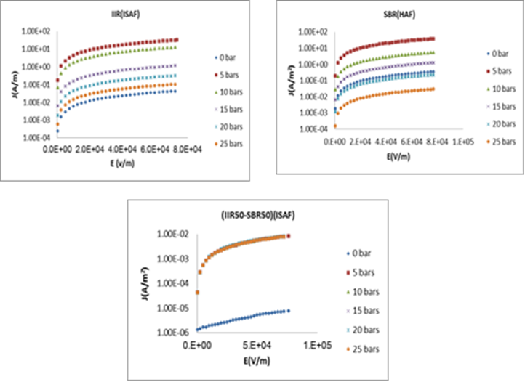
Figure (3) the plots of J versus E at different hydrostatic pressures for IIR/SBR blends.

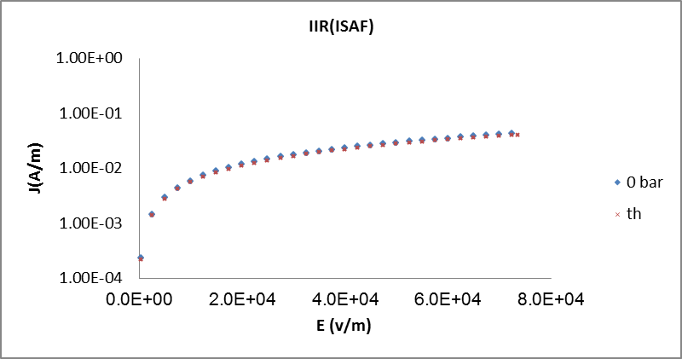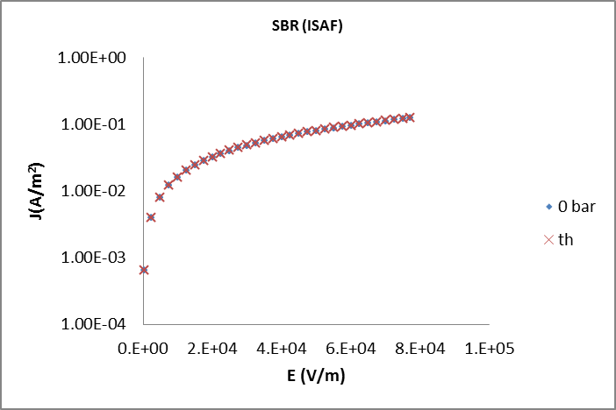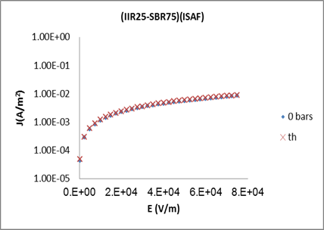
Figures (4) the application of the theoretical and experimental data for some samples

Conclusion
- Dc measurements for IIR rubber give current increasing in the case of HAF and decreasing with the other types of carbon blacks with increasing pressure, while for SBR rubber give current increasing in the case of HAF and GPF carbon blacks and decreasing with the other carbon black types with pressure increasing, finally in the case of blends current decreases with the increase of pressure for all samples.
- All the samples give Poole-Frenkel type conduction mechanism except ISAF/IIR, HAF/IIR, HAF/IIR and HAF/SBR, and there is no effect to the pressure on the conduction mechanism.
- There is a small effect of pressure on the interspacing distance of ISAF/IIR, SRF/IIR, HAF/SBR and GPF/IIR and there is no effect to the pressure on the other samples.
- By application of step pressure we found the same results obtained by the I-V for the interspacing distance calculations.

References
- Tager A. "Physical chemistry of polymers "Mir Publishers, Moscow, 1972) p. 233.
- KAUFMAN H. S., "introduction to polymers and technology" (Wiley interscience, New York, 1977).
- Mahmoud W.E., A.M.Y.El-lawindy, M.H. el Eraki, H.H. Hassan, Actuators A:Phy. 136 (1) (2007) 229-233.
- Knite M., V.Teteris, A.Kiploka, J.Kaupuzs, Actuators A: Phy. 110(1-3) (2004) 142-149.
- Wang X.J., D.D.L. Chung, Actuators A: Phy. 71 (3) (1998) 208-212.
- Nasr G.M., H.M. Osman and M.S. Sobhy, J. Polym. Mater. 4, 185 (1978).
- Garlick G.F.J., and A.F. Gibson, Proc. Phys. Soc., 600, 574, (1978).
- Pillai P.K.C., K. Jain, V.K. Jain, Phys. Stat. Sol. 179, 22 (1973).
- Perlock S.R., J.Appl. Phys. 34, 877 (1986).

12/1/2014

