2D Electrical Resistivity Imaging of Unsaturated and Saturated Zones for crude oil spillage at Agbarha in Ughelli area of Delta State, Nigeria

Ohwoghere-Asuma, O¹., Chiyem, F.I¹., Nwankwoala, H.O²

^{1.} Department of Geology, Delta state university, Abraka Nigeria
² Department of Geology, University of Port Harcourt, Nigeria
ohwonero@yahoo.com

Abstract: Of the oil and gas provinces in the world, the Niger Delta region has experienced worst environmental degradation as a result of oil and gas exploration and exploitation activates in the past five decades. The study is aimed at using 2D electrical resistivity imaging (ERI) to investigate the extent, spilled crude oil has affected both the unsaturated and saturated zones of the subsurface both vertically and laterally at two communities situated in Agbarha, Ughelli, delta state, Nigeria. At Awirhe, the inverted images of the acquired 2D ERI data revealed hydrocarbon plumes in the subsurface at depth of 2.2m deep and the extent of horizontal spread was 28.5m, while at Omovovwe, it was detected at depth of 2.64m deep and 38m laterally in the areas mapped. On the profile perpendicular to the Omovovwe profile, the width of contamination was 18m and that for Awirhe could not be determined due to accessibility. The total area of the unsaturated zones affected by the spill at Omovovwe was 684m².The anomalous low resistivity imaging values utilized in constraining hydrocarbon contaminant plumes were adduced to biodegradation and intense leaching of hydrocarbon components. In addition, moderate and high resistivity imaging structures were interpreted as silty/clay and sands respectively. The unsaturated zones were contaminated when compared with water level measured from a hand-dug well. The silty clay /clay layer beneath the plumes may have acted in slowing down the movement of hydrocarbon contaminants into the saturated zones. In spite of the natural attenuation that characterizes most hydrocarbon spill sites, the paper suggests that, all crude oil spilled sites should be remediated in the shortest possible time in spite of the causes; whether sabotage or equipment/operational failures by the operators of oil and gas industry in the Niger delta region.
[Ohwoghere-Asuma, O., Chiyem, F.I., Nwankwoala, H.O. 2D Resistivity Electrical Imaging of Unsaturated and Saturated Zones for crude oil spillage at Agbarha in Ughelli area of Delta State, Nigeria. N Y Sci J 2014;7(12):30-35]. (ISSN: 1554-0200). http://www.sciencepub.net/newyork. 5

Keywords: 2D ERI, Niger Delta, Unsaturated and saturated zones, Agbarha, Ughelli, oil spillage

1. Introduction
The number of hydrocarbon polluted sites in the Niger delta is unknown due to dearth of information. The government agency saddled with the responsibility of monitoring the activities of oil production companies, as well as the oil companies is often characterized by presentation of conflicting figures on oil spillage cases in the Niger delta. For instance, from 1976 to1996, the data of the Department of Petroleum Resources (DPR) depicted 4,835 cases of oil spillage, while the National Oil Spill Detection and Response Agency (NOSDRA) in 2008 claimed that hydrocarbon contaminated sites which required remediation is about 2000. The United Nations Development Program (UNDP) reported 6800 oil spill sites from 1976 – 2001. One of the major operators in the Niger Delta, the Shell Petroleum Development Company (SPDC) quoted that 221 oil spillage occurred yearly from the period from 1989 – 1994. The lack of commitment by the federal government and lack of transparency by the oil industry operators impede availability of information on oil spill sites in the Niger delta.
The multinational oil companies operating in the Niger delta, as custom often ascertain the causes of oil spillage before embarking on remediation. Oil spillage is either cause by sabotage; which involves pipeline vadanlization or equipment and operational failures. Often time remediation is carried out only when equipment and operational failures are established as being responsible for spillage. Consequently, there are many hydrocarbon polluted sites scattered across the Niger Delta that have not been remediated like the ones investigated in this study. Delay in remediation emanating from the confirmation and verification of causes of spillage, further aggravates degradation of the soils which may act as sink for subsequent migration of spilled oil by vertical and preferential flow to contaminate underlying groundwater aquifers.
The unsaturated zone is a section of the subsurface which usually act as sink for contaminants infiltrating from polluted surfaces to groundwater aquifer. The unsaturated or the vadose zone is very important in contributing to the contamination of underlying groundwater aquifers due to its sinks functions. Crude Oil spilled at the surface migrates into the soils through the unsaturated zone to groundwater aquifers. Once in contact with water, it occurs as immiscible phase. The phase that floats on water are called light non-aqueous phase liquids (LNAPLs), while that which sinks in water are called dense non-aqueous phase liquids (DNAPLs).
The electrical resistivity imaging (ERI) technology has found wide applications in the investigation of contaminants at both the unsaturated and saturated zones. The ERI is known to be very effective in the delineation of contaminants on the bases of its ability to distinguish low resistivity anomaly caused by contaminants from resistivity of none- contaminated region of the same surrounding environment. The works of (Mazac et al., 1990; De Ryck et al., 1993; Redman et al., 1994; Zaw et al., 2011) have demonstrated the use of high resistivity anomaly to delineate nonaqueous phase liquids (NAPLs). Benson and Mustoe, 1996 and 1998) have used the principle of high resistivity of ERI to detect LNAPLs. Also, daily et al., (1995) carried out a controlled ERI experiment during gasoline spills. The effectiveness of ERI in mapping hydrocarbon contaminated sites from non-hydrocarbon contaminants in the subsurface depends on the time between when spill occurred and when biodegradation is initiated.
During the geophysical investigation of hydrocarbon polluted sites, only biodegraded hydrocarbon gives groundwater low resistivity anomaly (Atekwana et al., 2000). Consequently, most hydrocarbon contaminated sites should be handled as separate case, since time, composition of the site and other variable specific to the location determine the resistivity anomaly (Atekwana et al., 2000).
In spite of the wide usage of ERI in the determination of contaminant plumes in the subsurface in developed countries, it has not find wide usage in most developing countries because of the high cost of ERI equipment, thus the equipment is not affordable by most institutions and universities in Nigeria. Consequently, the literatures are quite lacking in the use of 2D geoelectrical imaging. Reasonable numbers of ERI so far carried out in Nigeria involved the use of manual configuration in which each electrode separation is moved until distance of spread is covered. This method is quite cumbersome and laborious in 2D investigation of subsurface geophysics. Consequently less area is covered and few data are acquired when compared to the automated 2D imaging geophysical method. Atakpo and Akpoborie (2011) used the method to investigate an oil spilled sites in Forcados. The objective of the study is to use ABEM SAS 4000 Tarrameter with 64 electrodes to delineate the vertical and lateral extent oil spillage arising from equipment failure and sabotage have migrated to contaminate the unsaturated and saturated zones.

2. Geologic setting
The study area is located in the two rural communities; Omavovwe and Awirhe, which are villages under Agbarha-tor in Ughelli local government area. These areas like other Niger delta area are underlain by the sequence of the known Niger Delta Formations. The Formations consist of the Somebreiro-Warri Deltaic Plain sands, Benin Formation, Agbada Formation and the Akata Formation. Details description of the different sequences comprising the Niger Delta basin can be found in (Allen, 1965; Reyment, 1965; Short and stauble, 1967; Weber and Daukoru1965) and among others. The Somebreiro-Warri Deltaic Plain sand is the uppermost sequence which is 120 meters thick and of Quaternary to Recent (Wigwe, 1975). It is made up of unconsolidated sediments of clay, medium and coarse grained sands and occasional gravel pebbles.
The Benin Formation consists of predominantly of unconsolidated sand, gravel and occasionally intercalation of shales. In the Niger Delta region freshwater is sourced from it, while its thickness is estimated to be 2000mtres and aged Oligocene to Pleistocene.
The Agbada Formation is the oil bearing Formation of the Niger Delta sedimentary basin. It is of Eocene to Oligocene in age. It consists of alternate sand and shale sequence with thickness of 3000 meters.
The basal unit of the Niger Delta sedimentary basin is the highly overpressure Akata Formation. Compositionally, it is consists of open marine facies, with a thickness of 1000km and of Eocene to Oligocene age.

3. Hydrogeology
The study area consists of unconfined and semi-confined aquifers. They are very productive aquifers, high yielding and characterized by high specific capacities, as well as high recharge rates. The static water level of the aquifers is very high; it often ranges from less than 0.2-4meters. The water level fluctuates in accordance with the regimes of the season. It is almost at the ground surface during the wet season and lowers during the dry season. The towns are drained by two rivers that flow throughout the season and, many streams that are perennial in nature, which flow during the raining season and stagnant in the dry season, these streams are part of wetlands and sometime contribute to the recharge of the aquifers. The aquifers are characterized by grain sizes that range from clay, silty, fine through medium to coarse grained sands which are typical of coastal plain sand of the Somebreiro deposits.

4. Geographical setting
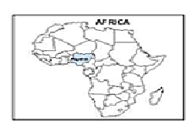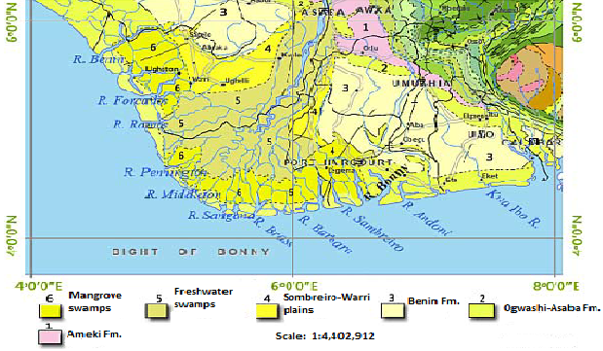

Areas of study
Figure1. Geologic Maps of the Niger Delta showing Location of the areas of study

The study area is situated in the centrally part of Delta state and located between Latitude 5⁰28¹39.0¹¹N and 5⁰58¹30¹.5¹¹E and longitude 5⁰30¹53¹¹N and 6⁰01¹04.5¹¹ E (Fig 1). It has two climate regimes: the dry season, which spans from November to March; and the wet season which lasts from April to October. The mean annual rainfall is above 3000mm with temperature that ranges from 29ºC to 34 ºC, temperatures are usually higher during the day and lower at night. Relative humidity varies between 70% and 85% throughout the year. Vegetation of the area is typical of tropical rainforest region with tree canopies; deforestation is due to clearing vegetated areas for farming, sand mining, felling of trees and exploration and exploitation of oil and gas activities in the area.

5. Materials and methods
ABEM SAS 4000 Tarrameter equipment which consists of 64 electrodes was used for the acquisition of ERT data. The 64 electrodes were driven into the ground surface at a spacing of 0.5m and 1m for the two crude oil spilled sites. The electrodes were connected via the multicore cables to a switch panel situated at the middle of the profiling.
The current and potential terminals from switching panel were connected to the corresponding terminals of the Tarrameter. To obtain the resistivity section, acquired data were processed by subjecting them to the inversion algorithm (RES2DINV) proposed by (Loke and Barker, 1996).

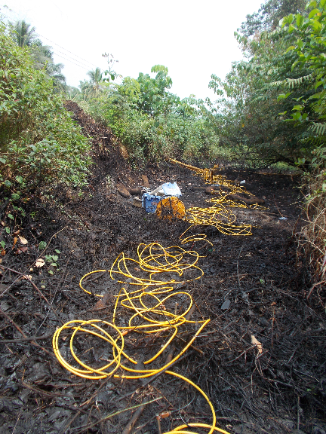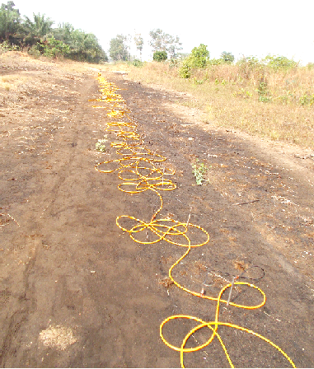
A
B
Figure 2: (A) was spilled site caused by equipment failure in Awirhe community, (B) was burnt crude oil spilled site caused by pipeline Vandalization in Omovovwe community

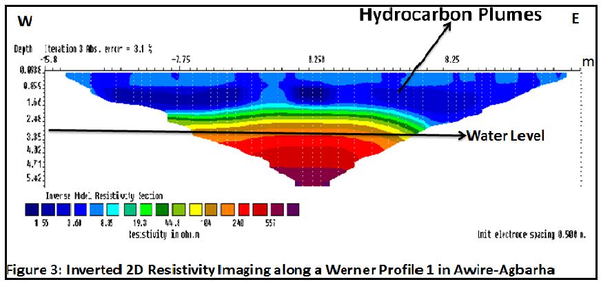

6. Results and Discussion
The inverted 2D resistivity imaging structures obtained from the two different crude oil spilled sites are presented in Figures 3 – 5
Three resistivity signatures are apparent in figure 3 as obtained from spilled site shown in Figure 2A. Resistivity imaging values ranging from as low as 1.55Ωm to 8.4 Ωm were interpreted as hydrocarbon plumes. The contaminated hydrocarbon plumes extend vertically from the surface to depth of 2.2m.With electrode spacing of 0.5m for 64 electrodes system, hydrocarbon plumes can be traced horizontally along the profile for about 28.5m on the ground surface. Lithologically the low resistivity zone is assumed to be silty clay and it is 4.32m thick. The second resistivity imaging structure underlying the hydrocarbon plumes is characterized by resistivity values that vary between 19.87 Ωm and 99Ωm. This layer is not saturated with hydrocarbon plumes from the spilled site. Lithologically it is also interpreted as silty clay and more clayey than the first layer and with a thickness of 2.12m.
The third resistivity structure is made of resistivity imaging values in the neighbourhood of 99Ωm to 600Ωm. This layer is about 3m thick and occurs at a depth of 3.35 to 5.42m and it has been interpreted as fine sand. This very layer serves as shallow aquifer for most hand-dug wells in the study area. The contaminated plume in this profile is seen to have been concentrated within the unsaturated zones above the saturated zones. The water level in the vicinity of the study area often fluctuates in accordance with seasonal variation.
However, at the time of the 2D ERI mapping of the spill, water level measurement made in a hand-dug well in the month of January, 2012 was 3.3m and expected to be less than 1m in the rainy season due to high infiltration rates resulting from recharge of aquifer by precipitation.

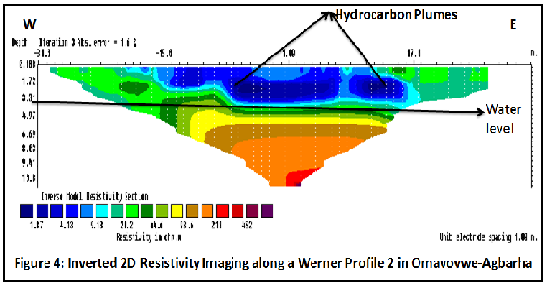

In profile 2, 64 electrodes were used to acquire the 2D ERI at spacing of 1m, this spacing was used to map more than the area affected by the spill. The inverted 2D resistivity imaging structure shown in figure 4 obtained from Figure 2B is made up of three distinctive resistivity zones. The low resistivity zone has resistivity values which ranges from 1.87Ωm to 9.13Ωm and occurs at depth of 2.64m. The layer is not uniform in thickness; the center region along the profile has the maximum thickness of 2.64m, 1.78m towards the western and 2.3m in the eastern section of the profile. The layer is regarded to have been saturated with hydrocarbon contaminant from the spilled site. Vertically, the hydrocarbon plumes occurred at depth of 1.78 in the west, 2.64m in the center region and 2.3m in the eastern side of the profile. Laterally, the spilled covered horizontal distance of 38m along ground surface especially at the center of the profile, while 11.5m and10m not affected by the spilled at the western and eastern section of the profile. Underneath the low resistivity layer is the layer with resistivity values that ranged from 10 Ωm to 98.63Ωm. This layer can be found at depth of 3.99m to 6.69m, with thickness of 2.7m. Geologically, this layer is interpreted as silty clay and sandy clay at about the depth of 6.69m and water is sourced from this layer. The third layer is characterized by high resistivity values that vary between 100Ωm to 482m. It occurs at depth of 6.69m to 10.8m, with a thickness of 4.11m and interpreted as sand.

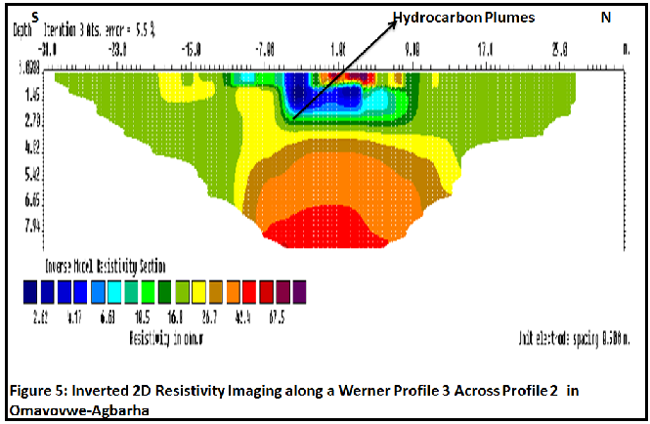

Profile 2 is about 4km and down gradient of profile 1, the water level is 3.32m. The hydrocarbon contaminant plumes are also above the saturated zone and therefore confined to the unsaturated zones, similar to profile 1.
In profile 3, 64 electrodes system used for the mapping of the width of hydrocarbon plumes with an electrode spacing of 0.5m across profile 2. The result of the 2D ERI is depicted in figure 5 and similar to other profiles; low resistivity layer which corresponds to hydrocarbon plume from the spilled site is also conspicuous in the profile, though small. The lateral extent of hydrocarbon contamination across the profile 1 is 18m and vertical depth is 2.3m deep. Consequently, the subsurface area affected by the spilled crude oil is estimated to be 684m considering the depth and horizontal extent.
The low resistivity signatures obtained from the 2D ERI mapping of crude oil spilled sites are different form conventional high resistivity signatures associated with geologic media affected by crude oil spills. However, these resistivity signatures are rather similar to the model suggested by Sauck et al.,(1998); those obtained from hydrocarbon contaminated site in a Refinery in Carson City by Atekwana, et al., (2000) and Atakpo and Akpoborie(2011) for hydrocarbon affected site in Forcados. The anomalous low resistivity signatures are attributed to variations in hydrocarbon contaminants and the geologic media exacted by microbial activities. The variation in hydrocarbon contaminants which is responsible for low resistivity signature is thought to have been caused by biodegradation of the hydrocarbon contaminants according to (Sauck et al., 1998) and (Atekwana, et al., 2000), while high resistivity signatures are associated with un-biodegraded hydrocarbon contaminants. The biodegradation of hydrocarbon contaminants in geologic media is influenced by time and some literatures have stipulated minimum of four months from the time of spills to when it set in. This also explains why resistivity values that give evidence of the shallow subsurface contaminated with hydrocarbons in the investigation are low, as the two sites in this study have occurred more than 2-half years before the 2D ERI were carried out in January, 2012.
The Niger delta region is characterized by two seasons, wet and dry. The seasonal variation in the amount of rainfall does have impact on the groundwater level fluctuation, as it is very high and low during the dry and wet season respectively. Infiltration of precipitation tends to increase water level in the wet season due recharge of aquifers. The groundwater level usually decline during dry season. The Infiltration of precipitation and subsequent percolation into aquifers often result in the leaching of contaminants from the surface towards the water table. This process is considered and suggested here, to have played a major role in being responsible for the low resistivity anomaly in subsurface geologic media contaminated by hydrocarbon. According to (Sauck et al., 1998) flushing of hydrocarbon contaminants by infiltration of precipitation from the surface into the saturated zones explains the low resistivity values obtained in the study. Consequently, the presence of low resistivity values considered as evidence for hydrocarbon plumes in the study area may have been caused by the groundwater level fluctuation associated specifically with the areas under consideration and the Niger Delta in general.

7. Conclusion
The existence of low resistivity signatures which were utilized in the characterization of the upper subsurface of the soil affected by hydrocarbon contamination, strongly suggest that the two different contaminated sites were already undergoing natural attenuation prior to the 2D ERI investigation of the sites. The natural attenuation is probably responsible for conversion of high resistivity signatures associated with un-biodegraded hydrocarbon contaminants to low resistivity signatures common with biodegraded hydrocarbon contaminants.
The low resistivity values used in constraining evidence of hydrocarbon contamination may have also been caused by groundwater level fluctuation induced by high precipitation and high temperature which characterized the Niger Delta, which ranged from 23⁰C in the wet season and maximum of 34⁰C in the hot season. The prevailing temperature must have promoted and stimulated bioremediation of hydrocarbon plumes at the sites. The excessive rainfall which characterizes the study have also contributed in the promotion of leaching of hydrocarbon contaminant plumes from the affected subsoil horizon, thus making the hydrocarbon contaminated soil more conductive and invariably less resistive in the unsaturated zones.
The 2D ERI used in the study further supports its application and effectiveness in delineating both vertical and lateral extent of subsoil contamination with hydrocarbon spills sites, planning for remediation and ascertaining volume of soils that would be excavated from hydrocarbon contaminated sites.
The availability of a protective clay horizon underlying the hydrocarbon contaminants horizon, may have barred and slowed further movement of hydrocarbon contaminants from the depth contaminated into other underlying lithology and groundwater aquifer.
Considering the incessant occurrence of oil spillage and numerous spilled sites not remediated in the Niger Delta oil province, The paper suggests that oil industry operators should think of the negative impact of oil spillage on environment first and engage on immediate cleanup and remediation activities irrespective of whether spillage caused by sabotage or equipment failure. It also recommends sensitization and teaching of the inhabitants of oil producing communities on simple remediation procedures, such as rototilling and land farming as way of reducing the negative effects of oil spillage on soils and subsequent prevention of groundwater contamination.

Corresponding Author:
Dr. Ohwoghere-Asuma, Oghenero
Department of Geology
Delta state University Abraka, Nigeria
E-mail: ohwonero@yahoo.com

References
- Mazac, O., Benes, L., Landa, I. Maskova, A. Determination of the extent of oil contamination in groundwater by geoelectrical method. In: Ward, S.H. (Ed.), Geotechnical and Environmental Geophysics 1990: 2: 107-216.
- De Ryck, S.M., Redman, J.D., Annan, A.P., Geophysical monitoring of a controlled kerosene spill. Proceedings of the Symposium on the Application of Geophysics to Engineering and Environmental Problems (SAGEEP’93), San Diego, CA, 1993: 5-20.
- Redman, J.D., de Ryck, S.M., Annan, A.P. Detection of LNAPL pools with GPR: theoretical modeling and surveys of a controlled spill. Proceedings of the Fifth International Conference on Ground Penetrating Radar GPR’94., Kitchener, Ontario 1994:1283–1294.
- Zaw, W., Umar, H., Mohd, A.I., Abdul, R.S., Geophysical investigation using resistivity and GPR: A case study of an oil spill site at Seberang Prai, Penang. Bulletin of the Geological Society of Malaysia: 2011: 57: 19 – 25, doi: 10.7186/bgsm2011001.
- Benson, A.K., Mustoe, N.B. DC resistivity, ground penetrating radar, and soil and water quality data combined to assess hydrocarbon contamination: a case study. Environmental Geosciences 1996: 3: 165–175.
- Benson, A. K.,Mustoe, N. B. Integration of electrical resistivity, ground-penetrating radar, and very low-frequency electromagnetic induction surveys to help map groundwater contamination produced by hydrocarbons leaking from underground storage tanks. Environmental Geosciences, 1998: 5(2): 61-67.
- Daily, W., A. Ramirez, A., LaBrecque, D.,Barber, W. Electrical resistance tomography experiments at the Oregon Graduate Institute, Journal of Appl Geophysics1995:33:227-237.
- Atekwana, E. A., Sauck, W.A., Werkema Jr., D.D. Investigations of geoelectrical signatures at a hydrocarbon contaminated site. Journal of Applied Geophysics 2000: 44: 167–, 1963.
- Atakpo E. A., Akpoborie, A. I. Electrical Resistivity imaging of spilled crude at the Obuguru inters- tidal flat, Forcados area, Delta State, Nigeria. Archives of Physics Research, 2011: 2 (4):166-175.
- Allen, J.R.L. Late Quaternary Niger delta and adjacent areas: sedimentary environments and lithofacies. Bull. AAPG 1965:49:547-600.
- Reyment, R.A. Aspects of Geology of Nigeria. University of Ibadan Press: Ibadan, Nigeria.1965:52 – 54.
- Short, K.C., Stauble, A.J., (1967). Outline of Geology of Niger Delta: AAPG Bull., 51, 761-779.
- Weber, K.J., Daukoru, E. Petroleum geology of the Niger Delta: 9th World Petroleum Congress Proceedings 1975: 2:209-221.
- Wigwe, G.A. The Niger Delta: Physical. In G.E.K. Ofomata (ed). Nigeria in maps: Eastern States. 1975:380 –400. Ethiope Publ. House, Benin City.
- Loke, M.H., Barker, R.D., (Rapid least-squares inversion of apparent resistivity pseudosections by a quasi-Newton method. Geophysical Prospecting 1996: 44, 131–152.
- Sauck, W.A., Atekwana, E.A., Nash, M.S., Elevated conductivities associated with an LNAPL plume imaged by integrated geophysical techniques. Journal of Environmental and Engineering Geophysics 1998:2: 203–212.

11/28/2014

