Investigation of Saltwater Intrusion in Warri – Effurun Shallow Groundwater Aquifer from 2D Electrical Resistivity Imaging and Hydraulic Gradient Data

¹Ohwoghere- Asuma, O., ¹Akpoborie, I.A., ²Akpokodje, E.G

^{1.} Department of Geology, Delta State University, Abraka, Nigeria
^{2.} Department of Geology, University of Port Harcourt, Nigeria
ohwonero@yahoo.com

Abstract: The perceived saltwater intrusion into the groundwater aquifer in Warri-Effurun metropolis in Delta state region of the western Niger Delta was investigated by coupled static water level data measured from hand-dug-wells and boreholes and 2D electrical resistivity Imaging (ERI). Hydraulic heads data obtained from monitoring of groundwater levels in hand-dug wells and boreholes revealed no obvious change in hydraulic gradients for three years of monitoring. Four profiles acquired across the study area, using a multielectrodes acquisition system in a Werner Schlumberger array configuration with electrode spacing of 3m and 5m were used for the profiling. The 2D electrical resistivity imaging (ERI) data obtained showed that greater proportion of data obtained from field investigation revealed high resistivity images values, which are proxy for freshwater. The low resistivity values depicted in the obtained data were higher than those often used as proxy for saline water and brackish water in coastal aquifers. The high resistivity images values were interpreted as sand, low resistivity values clays and silty sand saturated with freshwater. On the whole, the data presented in this study strongly suggests that the groundwater aquifers in the study area have not been intruded by saltwater, at least not the depth probed. The result obtained from this study shows that ERI and static water level are important techniques appropriate for planning and management of coastal aquifers needed for sustainable freshwater management. The study therefore recommends a thorough and comprehensive investigation of the perception of saltwater intrusion in Warri groundwater aquifers using other scientific approaches.
[Ohwoghere- Asuma, O., Akpoborie, I.A., Akpokodje, E.G. Investigation of Saltwater Intrusion in Warri – Effurun Shallow Groundwater Aquifer from 2D Electrical Resistivity Imaging and Hydraulic Gradient Data. N Y Sci J 2014;7(12):20-29]. (ISSN: 1554-0200). http://www.sciencepub.net/newyork. 4

Keywords: saltwater intrusion, hydraulic head, electrical resistivity imaging, coastal aquifers, Warri, Effurun, saline and brackish water.

1. Introduction
Coastal groundwater aquifers experiencing saltwater intrusion are characterized by continuous declined in groundwater levels precipitated by over stressing. Decline in hydraulic gradients in groundwater aquifer may leads to reverse in groundwater flow direction. Consequently aquifers adjacent to the sea experienced flow of saline water from the modern sea towards the continent, a phenomenon opposite the conventional groundwater flow discharge into the sea. Saltwater intrusion is commonly associated with aquifers located in coastal regions of the world and responsible for freshwater resource depletion and availability (Warners et al., 2010). The Stressing of aquifers in coastal regions is usually influenced by increase in freshwater demand by urbanization, industries and intensive withdrawal for irrigation.
Climate change has significant impact on sea level rise and a threat to groundwater availability. Global sea level rise will change both the groundwater recharge and discharge components of the hydrological cycles, which in turn, affect the availability and distribution of freshwater at both spatial and temporal scale. Global sea level rise causes saltwater intrusion in coastal aquifer by lengthening the freshwater and saltwater interface (mixing zones) in the landward of the coast (IPCC Climate change report, 2007 and climate change and water report, 2008). Pikey (2004), also suggested that when the shoreline retrogressed, the subsequent land loss associated with it, caused by agent of degradation, will result in the substantial stressing of groundwater resources in many part of the world.
Cases of saltwater intrusion occurrence caused by anthropogenic stressing worldwide are well documented in literatures, and it is of utmost concern in North Africa, Middle East, the Mediterranean, Mexico, China, West Africa and Gulf Coast of the United State. Groundwater salinization in the Rio Grande in New Mexico and Texas was adduced by Doremus (2008) to upconning of saltwater from the underlying deep geologic formation. Similar upconning has also been reported by Reed (2002) for the Mississippi River valley in Arkansas. Edward and Evans (2002) adduced saltwater intrusion of Los Angeles groundwater aquifer to excessive withdrawal by over 10 million residents of the city. Groundwater level in certain part of North China plain is been reduced by a meter on yearly bases, and have led to incursion of saltwater into freshwater aquifers (Mark et al., 2002). In India, the state of Gujarat freshwater aquifer has been intruded by saltwater as a result of overstressing of groundwater aquifers for irrigation purposes (Mark et al., 2002). Saltwater intrusion in Europe is induced by upward movement of saltwater from underlying aquifer, as well as the lateral migration into freshwater aquifers (Custodio, 2010). Examples of known cases of saltwater intrusion in The Netherlands have also been reported by Oude Essink (2001), Greece by (Lambrakis and kallergis, 2001), Belgium (Vandenbohede and Lebbe, 2002) and Rio Verde aquifer in spain (Calvache and Bosch, 1995). In African, especially the North Africa countries of Egypt, Libya, Morrocco and Tunisia, saltwater intrusion is attributed to excessive pumping of groundwater aquifer (Steyl and Dennis, 2010), while in Lagos, Nigeria, upconning of saltwater from below productive wells (Adepelumi et al., 2008) caused by over-abstraction of groundwater aquifers.
Groundwater is an important resource and consequently, its management is only appropriate and necessary for its sustainability. The most effective management procedure of coastal aquifers is dependent on the ability to prevent its occurrence through early detection. To achieve this, there are several methodologies available scientifically for the delineation of freshwater aquifers intruded by saltwater. Continuous monitoring of groundwater quality through installation of data logger in groundwater wells to measure salinity, and electrical conductivity, total dissolved solids and temperature are well known. These parameters are used as proxies for saltwater intrusion of freshwater aquifers. Geochemical methodology, which involves physiochemical analysis of groundwater sample for major anions and cations have also attracted extensive usage. Lee and Song (2007) used geochemical analysis of groundwater in the delineation of saltwater intrusion. Electrical resistivity methods including vertical electrical sounding (VES) and 2D imaging and small loop electromagnetic survey have also found similar usage (Hwang et al., 2004; Sherif et al., 2006, and Song, 2006).
More also VES was used to establish upconning of saline connate water into the Lekki freshwater aquifer in Lagos by Adepelumi et al., (2008). Oyedele (2001) delineated saltwater intrusion into groundwater aquifer around Victoria Island and Iwaya areas of Lagos from the fusion of VES and geochemical. Also, Amadi et al., (2012) have also demonstrated the occurrence saltwater intrusion at depth of 30-90m in Bonny Island of the eastern Niger Delta from combination of VES and geochemical. Furthermore, Nwankwoala and Munguye (2013) have identified existence of saltwater zones at depth of 30m at Borokori and 120m at Eastern by-Pass areas of Port Harcourt from 2D electrical resistivity imaging.
The insight of saltwater intrusion into Warri- Effurun groundwater aquifer was introduced into the literature by Olobaniyi and Owoyemi (2006). Their conclusion was constrained from the abundance of chlorides ions and application factor analysis to data obtained from conventional hydrogeochemical analysis of groundwater samples from shallow wells. This assertion needs further investigation on the ground that it may be difficult to establish saltwater intrusion from only geochemical means alone. Geochemical parameters may as well indicate contaminants introduced into groundwater aquifer from migrating leachate arising from refuse dumps and septic tanks, which are pervasive in Warri-Effurun. The need to use multidisciplinary scientific approach to investigate the potential of saltwater intrusion is necessary for the management of groundwater in Warri-Effurun and Nigeria. To this end we utilized Electrical Resistivity Imaging (ERI) data acquired with ABEM SAS 4000 Tarrameter with 64 electrodes resistivity systems in a Werner- Schlumberger array configuration fused with static groundwater level data measured in boreholes and hand-dug wells to ascertain whether heads are decreasing to extent of triggering saltwater intrusion into groundwater aquifers.

2. Location and Description of study area
The study area lies between longitude 5 ⁰47¹45.3¹¹ E and 5⁰42¹03.5¹¹E and latitude 5⁰38¹42¹¹N and 5⁰30¹23.6¹¹N, Figure 1. It is a typical rainforest region with temperatures of 23 to 34⁰C and humidity of 50-70%. Rainy season durations are April to November, with a two weeks break in August, while dry season extend from November to March, the region also experiences rain at least once a month in the dry season. The annual average rainfall for 30 years period is 3000mm (Adejuwon, 2011).
The twin city is the most populous urban city in the Delta region of the western Niger delta, with population in the neighbourhoods of a million (Babatola & Uriri, 2013). The presence of oil exploration and production companies and their allied services companies, refinery and Sea port and among other commercial activities which characterized the area, have led to urbanization of the twin city. Consequently, it has received exodus of people from every nook and cranny of Nigeria in the past decades. The inhabitants mainly rely on shallow hand-dug wells and boreholes for sources of portable drinking water, a situation necessitated by lack of public water service. The lack of a modern landfill has given rise to availability of eye-sore surface waste disposal sites dispersed around the city. It also lacks central sewage system, which paved way for individual ownership of septic tanks. Consequently subjecting shallow aquifer to both point and non-point sources of contamination.

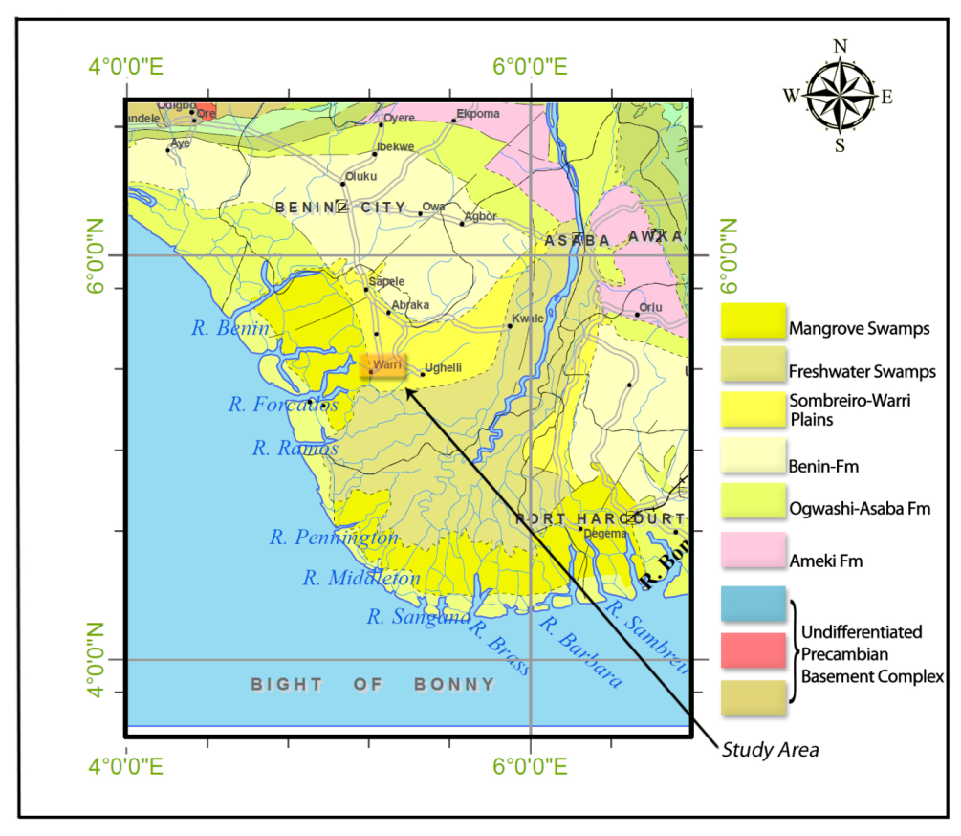

3. Geology and hydrogeology
The succession of unconsolidated sediments underlying the Warri-Effurun twin city comprises of freshwater swamps and mangrove swamps (Figure 1). Lithologically, it is heterogeneous in nature consisting of clay, silty sands, fine sands, medium and coarse grained sand and intercalation of shale in certain locality. The above succession forms the Somebriero- Warri Deltaic Plain Sands (Wigwe 1965) and geologically, its age is from Quaternary to Recent. The grains comprising this succession are characterized by possession of sub-angular and sub-rounded shapes; poorly sorted, porous and permeable. Mineralogically, quartz grains dominate the aquifer media and to lesser extent feldspar and minute percentage of iron has also been identified in sediments. Underlying the Formation in order of ascending geologically age is Benin, Agbada and Akata Formations. The Somebriero- Warri Deltaic Plain Sand and the Benin Formation are water bearing, while the Agbada is the hydrocarbon and Akata highly over-pressured. The lithostratigraphy of these Formations have been described extensively in Allen (1965), Short and Stauble (1967), Weber and Daukuro (1975) and among others.
The groundwater supply for domestic water requirements is sourced from both shallow hand-dug wells and boreholes drilled into unconfined aquifers. Greater percentage of the quantity of groundwater for domestic water need is often abstracted from shallow aquifer with depth that rarely exceeds 30meters deep and less than 7meter for hand-dug wells. Thus groundwater wells have not penetrated the water bearing Benin Formation. The aquifers are very prolific, productive and characterized by fast rate of recovery. The water table varies from 0.1m to 5m and fluctuates in accordance with season. In the wet season, water table is almost at the ground surface; this is clearly evident in hand-dugs wells, while in dry season water levels hardly exceed 5m in most boreholes and hand-dug wells. Aquifer is recharge with precipitation, seepage from wetlands and estuaries, and septic tanks.
The twin city of Warri-Effurun Watershed is drained by the tidal influenced Warri River, its Ogunu/Edjeba distributaries, creeks and estuaries. It joins Focardoes River and the Benin River along it paths towards the sea and eventually empties into the sea. The volume of water discharged into the sea is influenced by the variation in season; more discharge in the wet volume because of increase in run-off and less discharge in the dry season. The exact volume discharge into the sea have not be ascertained, as no gauging station exist at present in these rivers to monitor volume of discharge into the sea in the whole of the western Niger Delta.

4. Materials and Methods
Electrical resistivity imaging (ERI) data were acquired with the aid of multi-electrodes resistivity systems in a Werner Schlumberger array configuration. The ABEM Tarrameter SAS 4000 equipment was used for the acquisition. It is designed automatically to select and inject appropriate current from 24 Volt battery, process and stored results in its internal memory. A total of 64 electrodes were used for the acquisition of ERI data, spaced at minimum and maximum distance of 3 and 5m between electrodes for the delineation of saltwater intrusion potential. The spacing distances were influenced by shallowness of the aquifers in the western Niger delta and lack of spacious area because of clustered development. As a result secondary schools and the college of education were covered. Electrodes were connected through multicore cables to a switch panel placed at the middle of the profiling. The current and potential terminals from switching panel were thereafter connected to the corresponding terminals of the Tarrameter. In order to ensure continuous measuring of resistivity between adjacent electrodes, the terminals pins connected to the 24volt battery and Tarrameter are inserted into sockets.
Acquired data were processed by subjecting them to the inversion algorithm (RES2DINV) proposed by Loke and Barker (1996). The inversion routine used by the RES2DINV programme is based on a smoothness-constrained least square inversion algorithm. The programme performs this task by dividing the subsurface into rectangular blocks. The apparent resistivity was calculated in accordance with the finite- difference methods suggested by Dey and Morrison (1999). During the processes of the field data with the RES2DINV software, the message: the maximum apparent resistivity value is more than 300 times the minimum value was prompted, which is due to exhibition of large resistivity variation near the surface by the field data. Consequently, a model in which the cell width is half electrode spacing was used. Also, in order to obtain more accurate apparent resistivity values, 4 nodes per unit electrode spacing and finest mesh were used.
The pseudosection contouring methods was used to display apparent resistivity values (Loke, 2000). Furthermore, to reduce the difference between the measured apparent and calculated resistivity values to nearest minimum, the resistivity of the block was adjusted iteratively. The magnitude of the difference was measured by Root Mean-Squared-error (RMS). The computer iteration continues till RMS error values become inconsequential with successive iterations (Batayneh, 2006). According to (Loke, 2000), obtaining lowest RMS error does not significantly depict accurate model. Consequently, the usual RMS less than 5% was not stringently adhered to.
In addition, groundwater static water levels in private boreholes and hand-dug wells were measured using Solinist water level meter in May, 2011, 2012 and 2013 respectively. Groundwater levels can better be measured in continuous manner with data loggers installed in observation boreholes drilled specifically for these purposes. It was difficult to be allowed by owners of boreholes to insert water level meter into their private boreholes but lot easier in hand-dug wells, because water from them are not drunk but mainly for laundry and washing purposes. In the absence of both observation boreholes in the study area and automatic data logger a particular month of May was used as the month to measured water level to ascertain if there were going to be decline in the level of water in boreholes and hand-dug wells in the subsequent may for next 2 years under which measurements were carried out.The coordinates of the position of boreholes and hand-dug well were recorded with the aid of portable GPS; these data were subsequently used to plot contours of water levels with Golden software-Surfer 8.

5. Results and Discussion
Profile 1
Profile 1 is shown in Figure 2, which represents the electrical resistivity imaging (ERI) acquired at the College of education, Warri. Immediately beneath the ground surface is the uppermost layer with variable resistivity image values which ranged from as low as 49.7Ωm to 74.6Ωm. This layer is situated at depth 0.469 to 7.27m and the subsurface geology exhibited subtle variation in resistivity values laterally. The lithology for the layer is interpreted as topsoil, clay, silty clay, sandy clay. Underlying this clayey unit is a variable layer of high resistivity images that ranged from 112 Ωm to 206 Ωm, whose depth ranged from 7.27m to 33m. The subsurface geology inferred for these successive and laterally variable resistivity layers is fine and medium-grained sands. More also, a slight decrease in resistivity values from the overlying layers to about 91.4 Ωm is observed at about 34m, fine sand is inferred for this layer. The subsurface geology interpreted for this profile matched those obtained from nearby borehole. The water level measured in shallow hand-dug well and borehole is 1.95m and 2.11m. The hand dug well penetrate the clayey sand unit inferred above, which gradually grades into sand at about 8m and this actually represent the aquifer. The presences of variable resistivity images observed from the ERI suggest heterogeneity is a common feature of the aquifer underlying the study area, which may affect groundwater flow and transport of contaminants. Most significantly, the successive layers of low and high resistivity images which characterized this profile is basically saturated with good quality groundwater except at depth ranging from ground surface to about 1.89m and lesser than 0.3m in wet season period. The higher resistivity image values observed in this profile did not support the occurrence of saltwater intrusion into freshwater aquifers.
Profile 2
The electrical resistivity image (ERI) data acquired from Ubeji Secondary school, Warri, is presented in Figure 3 and it represents Profile 2. The uppermost layer possesses laterally, variable resistivity image values that ranged from 46.1Ωm to 101Ωm, which occurred at depth of 0.563m to 8m. The subsurface geologic formation laterally, varied from topsoil, clay through silty clay to sand. Underneath this layer is a high resistivity image layers with values that varied from 101Ωm to 187Ωm and with variable thickness which ranged from 9.9m to 32.2m. Lithologically, fine- to- medium- grained sand was inferred for these layers. The topmost layer of this profile almost correlated with profile 1 above, except the possession of high resistivity value of 101Ωm(sand) with a width of 9m located at about 60m from left of the profile. Also, the inferred subsurface geology matched log obtained from borehole in the proximity of the profile. The variations in resistivity values depicted on this profile also point to the existence of heterogeneities in the aquifer. Water level measured from hand-dug well and borehole is 2.447m and 1.863m respectively. The groundwater quality condition like the previous is good but vulnerable to surface contamination due to possession of sand at 60m along the profile. Shallow hand-dug well penetrated the aquifer partially except where sand is situated. Saltwater intrusion is also not detected in this profile, since resistivity values obtained are above those required for constraining freshwater aquifers intruded by saltwater.

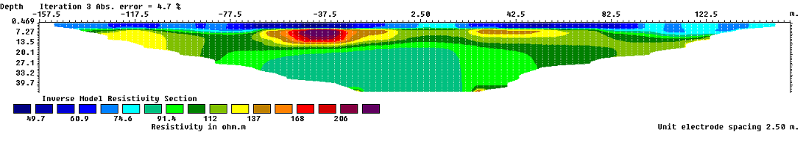
Figure 2. Inverted model of College of education, Warri

Profile 3
The Electrical resistivity imaging obtained from Nana college model school is depicted in Figure 4 below. The profile depicts variable resistivity images with resistivity values that ranged from as low as 74.8 Ωm to 98.4 Ωm and can be found at depth of 0.785 to 11m. Topsoil, Sandy clay and sand were inferred for the subsurface geology. Overlying this is a sequence of layers with slightly higher resistivity image values, which ranged from 100 to 151Ωm. These layers were interpreted as fine sand to medium sand and their depths can be traced from 12m to about 37m.
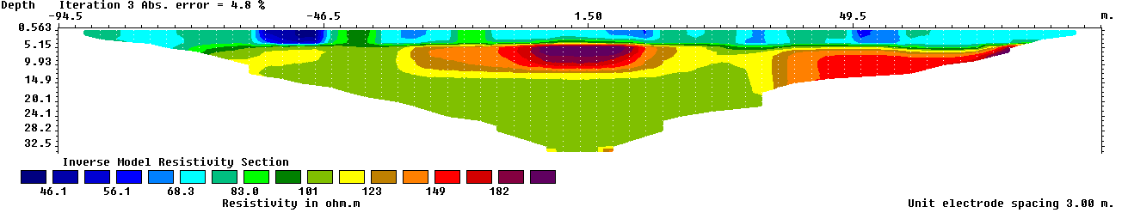
Figure 3. Inverted model of Ubeji Secondary School, Warri

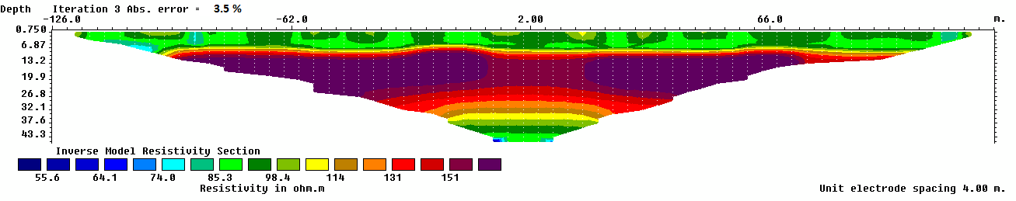
Figure 4. Inverted model acquired at Nana College Warri

From depth of 37m to about 45m is repeated sequence of images similar to the resistivity values obtained for the uppermost layer of this profile. These resistivity values ranged from 85Ωm to about 55.6Ωm, the decrease in resistivity values with depth is interpreted to exhibit gradual decrease grain size vertically, which varied from fine sand to clay. The water level in the proximity of this profile could not be measured and also log information from borehole not available to compared with resistivity data. However, the groundwater quality condition for the aquifer is also very shallow and good like previous ones. The profile like previous ones established no influence of saltwater intrusion into the aquifer as reflected by the magnitude of resistivity values.

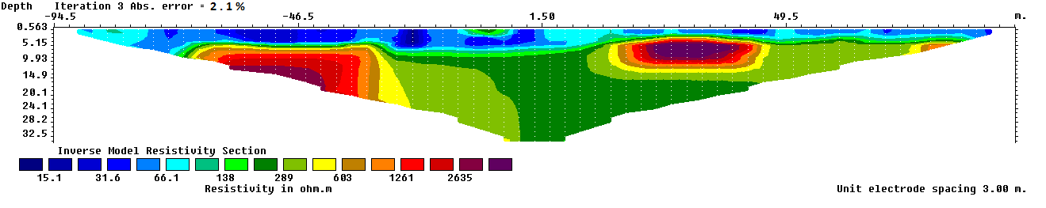
Figure 5. Inverted model of acquired at Federal Government College Warri

Profile 4
Figure 5 shows the subsurface geology revealed by the electrical resistivity imaging acquired from the premises of the Federal Government College, Warri. In the topmost layer is characterized by low resistivity images values which ranged from 31.6Ωm to 66.1Ωm and the presence of 12m wide resistivity image situated at 74m along the profile. The depth of this geologic layer can be observed to occur at 0.56m to about 9.9m, clay, silty clay and sand were interpreted for it. Underlying this layer are geologic layers with resistivity image values which varied laterally from left to right and vertically downward. These layers have resistivity image values that ranged from 138Ωm to2635Ωm, whose depth of occurrence ranged10m to 32m and also medium and coarse grained sand was inferred for this subsurface geologic formation.
The water level measured from borehole and hand-dug well in the proximity of this profile ranged from 2.554m and 2.785m. Again the hand-dug -well like previous only penetrates the sandy- clays and not sand but most boreholes in Warri metropolis, though shallow, penetrate fine sand and rarely coarse sand. The groundwater quality as shown by resistivity images values are interpreted as good quality and also these values did not reflect saltwater intrusion as presumed by earlier study.
Conclusively, the values of resistivity depicted by the 2D ERI in profiles 1 to 4 were very similar and correlated with resistivity values obtained from vertical electrical sounding (VES) by Egwebe et al., (2007), except low resistivity values which they ascribed to leachates in groundwater in the vicinity of dumpsite and high resistivity values characterized areas without dumpsites, these values were also similar to the our 2D ERI data.

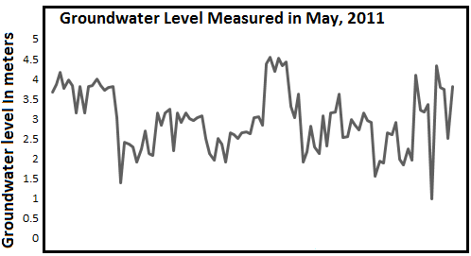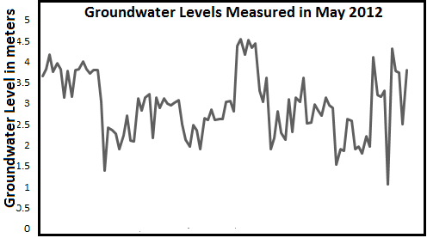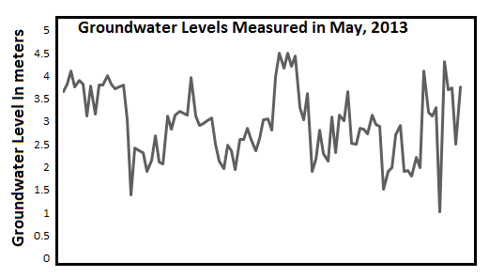
Figure 6. Plot of groundwater levels for three consecutive years

6. Groundwater condition
The groundwater monitoring investigation for each month of May 2011 to 2013 revealed no significant decline in groundwater levels in the 100 hand-dugs well and boreholes, Figure 6. Figure 7, indicates groundwater flow direction is toward the rivers, distributaries and creeks and thus groundwater is contributing to the recharging of the rivers. The above illustrated contour of water table heads is comparatively different from those stipulated by Olabaniyi and Owoyemi (2006). According to them flow is from the rivers and estuaries towards groundwater aquifer.

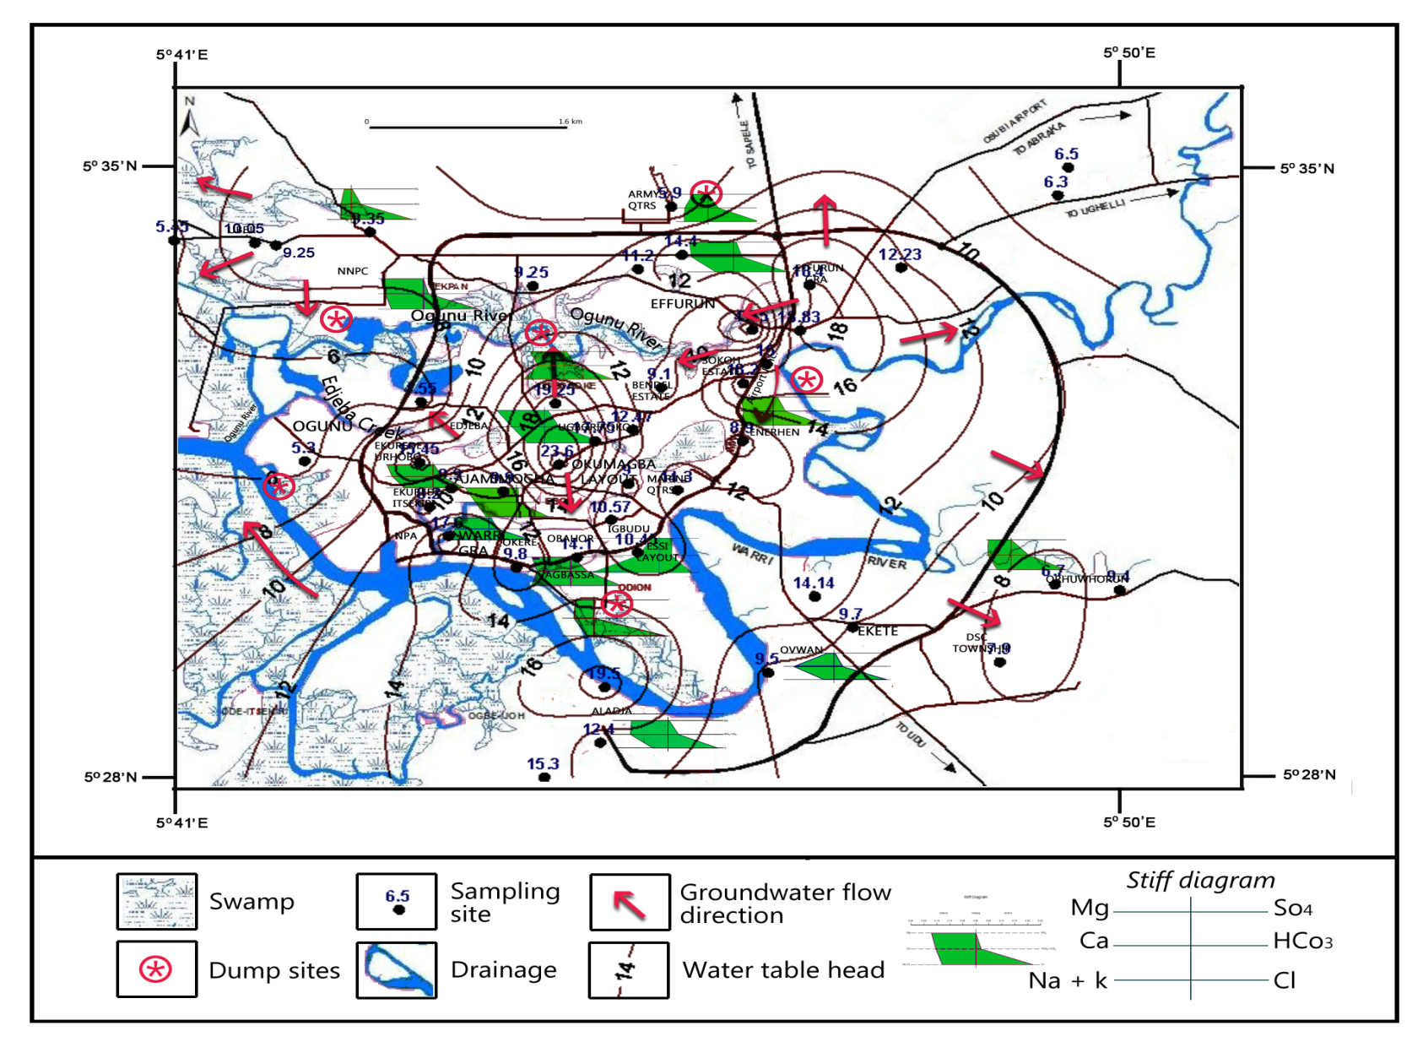
Figure 7. Map of Warri - Effurun area showing water table head distribution and Stiff pattern diagrams (Modified from Akpoborie, Uriri & Efobo, 2014)

For this scenario to occur hydrogeologically, the stage of rivers, distributaries and creeks must be lower than the water table levels in shallow groundwater aquifer. The tidal influenced Warri Rivers, creeks and distributaries have not decline below those of aquifers to activate reversal in flow direction, even at low tides, which probably does not decline more than 0.2m. Akpoborie and Aweto (2011) have shown in a similar setting in which groundwater is recharging tidal inlet of Ughoton, a neighboring town of Warri. The hydraulic and resistivity data presented here have evidently suggested that shallow groundwater aquifer underlying the Warri-Effurun twin city has not been experiencing overstressing of aquifer to point of initiating reversal in the conventional groundwater flow direction towards rivers, talk less of incursion of marine water from the coast situated 40km away. This is unlike certain parts of china and India experiencing saltwater intrusion with corresponding decline in water levels on yearly bases (Mark et al., 2002). However, the mounds in Figure 7 are probably caused by cluster development in the old areas of Warri, where development begun. In spite of this, water levels in boreholes fluctuate between 3 and 5m and in same vain they are not below sea level. Also, Warri River and other river stages, networks of creeks and tidal inlets that drained the watershed of Warri are nearer the ground surface than boreholes and hand-dug well heads.
Declined in groundwater level in most coastal regimes is often trigger by concentration of high population and agricultural based economy, which depend on freshwater demands for domestic, irrigation and industrial purposes, which to a large extent is associated with developed countries and less with developing coastal climes. In the twin city and the Niger Delta region, intensive farming which requires substantial volume of water abstracted from groundwater aquifers for irrigation of agricultural farms are absent, aquaculture farming, shrimp farming, neither are there industries that use water substantially, unlike the Mekong delta, where the hydrology has been transformed due to conversion of wetlands into intensive agricultural farming (Hashimoto, 2001; Hung et al., 2000; White, 2002) and use of groundwater for irrigation. The present population of the study area, which is estimated to be the neighbourhood of a million, may not be dense enough to trigger groundwater aquifers overstressing which would precipitate intrusion of modern sea water into aquifers. Also, input of water into groundwater aquifers in the form of recharge from the 3000mm annually precipitation through high infiltration rates is well known in the region, wetlands, and septic tanks upset amount discharged and thus maintaining groundwater water balance.
Therefore the elevated concentration of chloride and the factor analysis used by Olabaniyi and Owoyemi (2006) to constrained saltwater intrusion may have emanated from mixing of groundwater with leachates derived from widespread of un-engineered refuse dumpsites and sewages as shown by the Stiff plot depicted in Figure 7. Akudo et al., (2011); Ohwoghere-Asuma and Aweto (2013) have identified leachates plume below dump sites in different places within the study area. The presence of chloride and other ions of bicarbonate, calcium and magnesium in groundwater are concomitant with leachates from dumpsites and sewages (Panno et al., 2006; Hanchar 1991; Bradley et al, 1987, Baedecker & Back, 1979). This further give credence that enhanced levels of these ions in groundwater do not necessarily means incursion of saltwater into groundwater aquifer.

Conclusion
The data obtained from the subsurface investigation through the application of 2D Electrical Resistivity Tomography (ERT) and static water levels measured have revealed that groundwater aquifers have not been intruded by modern seawater from Warri river, creeks and distributaries as well as upconning of marine water trapped contemporaneously with deposition of sediments.
The static water level data acquired from boreholes and hand-dug well showed no evidence of decline in groundwater levels for consecutive month of May for duration of 3 years. This explicitly indicates that the aquifers have not been subjected to over-pumping that would precipitate intrusion, since groundwater levels were not lower than River stages, which is the hydrologic explanation that would cause reversal of flow from the river towards the aquifers.
Saltwater intrusion is driven by dense population, which in turn result in over- pumping of groundwater for domestic, irrigation and industries, these stressors are evidently lacking in the twin city of Warri-Effurun. It is also believed that decline in water level was not recorded for the period under investigation due to the degree of recharging of aquifer by precipitation, septic tanks and seepage from wetlands sources.
The present situation in which the quantities of groundwater abstracted from both shallow and deep groundwater aquifers are not known is inadequate and inappropriate for the management of saltwater intrusion prone coastal region like the twin city of Warri-Effurun. We therefore, recommend appropriate machinery be put in place for quantification of groundwater abstracted from aquifers in the area. Concerted effort should be made by the Delta State and Federal Ministry of water resources in the drilling of monitoring boreholes, which are currently not available; such boreholes would be sited in strategic locations within the study area and other areas of the coastal regime of the western Niger Delta, for continuous acquisition of parameters often used as proxy for saltwater intrusion. Consequently, the movement of the saltwater/freshwater wedge in aquifers adjacent to the ocean could be monitored to predict when it would be affected by heavy pumping. This will assist in no small measure in ascertaining how saltwater/freshwater interface may be moving towards the twin city and appropriate mitigation steps are taken early enough to prevent it. We also recommend detail and comprehensive studies using other methodologies for delineating saltwater intrusion in shallow and deep aquifers respectively.

Corresponding Author:
Dr. Ohwoghere-Asuma, Oghenero
Department of Geology
Delta State University, Abraka
Nigeria
E-mail: ohwonero@yahoo.com.

References
- Werner, A. D., W., Mark B., Post, V. E.A. Alexander V, Chunhui Lu, Behzad Ataie-Ashtiani, Craig T. S., D. A. Barry. Seawater intrusion processes, investigation and management: Recent advances and future challenges, Advances in Water Resources 2013: 51, 3–26.
- Intergovernmental Panel on Climate Change, 2008. Climate Change and Water, IPCC Technical paper VI.
- Intergovernmental Panel on Climate Change, Climate Change 2007. Synthesis Report.
- Pilkey, O. H. and J. A. G. Cooper. Society and sea level rise, Science 2004:303:1781-1782.
- Doremus, D. Rio Grande Salinity Management – A Real Possibility? Southwest Hydrology 2008:24-25.
- Reed, T.B. Status of Water Levels and Selected Water Quality Conditions in the Mississippi River Valley Alluvial Aquifer in Eastern Arkansas. U.S. Geological Survey Scientific Investigations Report 2002: 2004-5129.
- Edwards, B, D. and K. R. Evans. Saltwater Intrusion in Los Angeles Area Coastal Aquifers – the Marine Connection. U.S. Geological Survey Fact Sheet 2002: 030-02.
- Mark W. Rt, Ximing C. and C. Sarah. World Water and Food to 2015: Dealing with scarcity, international Food policy Research Institute 2002:322.
- Custodio, E. Coastal aquifers of Europe; an overview, Hydrogeology Jour. 2010: (18):269-280.
- Oude Essink, G.H.P, Saltwater Intrusion in 3D Large Scale Aquifers : A Dutch Case,. In Phys. Chem. Earth (B) 26 (4). 2001: 337-344.
- Lambrakis, N., G. Kallergis’ Reaction of subsurface coastalaquifers to climate and land use changes in Greece: Modelling of groundwater refreshening patterns under natural recharge conditions. J. Hydrol. 2001: 245:19–31.
- Vandenbohede, A. and L. Lebbe, Occurrence of saltwater above freshwater in dynamic equilibrium in coastal groundwater flow system near De Panne, Belgium, Hydrogeology Journal 2006: 14: 462-472.
- Calvache, M. L. and A. Pulido-Bosch. Effects of geology and human activity on the dynamics of saltwater intrusion in three coastal aquifers in southern Spain, Environmental Geology 1995: 30: 215-223.
- Steyl, G. I., Dennis. Review of coastal area aquifers on Africa, Hydrogeology Journal 2010: 18: 217-225.
- Adepelumi,A. A. Delineation of Saltwater intrusion into the freshwater aquifer of Lekki Peninsula, Lagos, Nigeria. The 3rd International Conference on Water Resources and Arid Environments (2008) and the 1st Arab Water Forum.
- Lee, J.Y. and Song, S.H. Evaluation of groundwater quality in coastal areas: implications for sustainable agriculture. Environmental Geology 2007: 52: 1231−1242.
- Hwang, S., Shin, J., Park, I. and S. Lee, Assessment of seawater intrusion using Geophysical well logging and electrical soundings in a coastal aquifer, Young kwang-gun, Korea. Exploration Geophysics 2004: 35: 99−104.
- Sherif, M., El Mahmoudi, A., Garamoon, H., Kacimov, A., Akram,S., Ebraheem, A. and Shetty, A. Geoelectrical and hydrogeochemical studies for delineating seawater intrusion in the outlet of Wadi Ham, UAE. Environmental Geology 2006: 49: 536−551.
- Song, S.H., Spatial analysis of small-loop electromagnetic survey data in a seawater intrusion region. Exploration Geophysics 2006: 37: 114−120.
- Oyedele, K.F. Hydrogeophysical and Hydrogeochemical Investigation of Groundwater Quality in some parts of Lagos, Nigeria. Afr. Journ. Env. Studies. 2001: 2(1): 31-37.
- Amadi, A.N., H.O. Nwankwoala, P.O. Olasehinde, N.O. Okoye, I.A. Okunlola, and Y.B. Alkali. Investigation of Aquifer Quality in Bonny Island, Eastern Niger Delta using Geophysical and Geochemical Techniques”. Journal of Emerging Trends in Engineering and Applied Sciences (JETEAS) 2012: 3(1):183 – 187.
- Nwankwoala, H.O., and M.L., Omunguye, Geophysical Investigation for Groundwater in Borokiri and Eastern-Bye Pass Areas of Port Harcourt, Nigeria.Pacific Journal of Science and Technology2013: 14(1):524-535.
- Olobaniyi S.B and F.B. Owoyemi, Characterization by Factor Analysis of the Chemical Facies of Groundwater in the Deltaic Plain sands Aquifer of Warri, Western Niger Delta, Nigeria. AJST 2006:7(1):73-81.
- Adejuwon, O. A. Rainfall Seasonality in the Niger Delta Belt, Nigeria. Journal of Geography and Regional Planning 2012: 5(2):51-60. http://dx.doi.org/10.5897/JGRP11.096.
- Babatola, O., and Uriri, A. Assessment of Maternal Health Intervention Programme of Delta State, Nigeria: Application of the U.N Process Indicators. Journal of Public Policy and Administration Research 2013. 3(9): 62-71.
- Wigwe, G.A. The Niger Delta: Physical. In G.E.K. Ofomata (ed). Nigeria in Maps: Eastern States1975: 380 – 400, Ethiope Publ. House, Benin City.
- Allen, J.R.L. Late Quaternary Niger Delta and Adjacent Areas; Sedimentary Environments and Lithofacies 1965.: 49(5):547–600.
- Short, K.C., and A.J. Stauble. Outline of Geology of Niger Delta: AAPG Bull. 1967:51:761-779.
- Weber, K.J. and E. Daukoru. Petroleum geology of the Niger Delta: 9th World Petroleum Congress Proceedings 1975: 2: 209-221.
- Loke, M.H., and R.D. Barker. Rapid least squares inversion of apparent resistivity pseduosection using a quasi-Newton method. Geophys. Propec 1996a: 44:131-152.
- Dey, A. and H.F., Morrison.. Resistivity modeling for arbitrary shape two-dimentional structures. Geophys. Prospect 1979:37: 106-136.
- Loke, M.H. Electrical imaging surveys for environment and engineering studies. A practical Guide to 2D and 3D survey 2000.
- Batayneh, A,T. Use of electrical resistivity methods for detecting subsurface fresh and saline water and delineating their interfacial configuration: A case study of the Eastern Dead Sea coastal aquifers, Jordan. Hydrogeol. J. 2006: 1277-1283.
- Egwebe, O., Aigbogun, C. O.and S. O. Ifedili. Geoelectrical Evaluation of Waste Dump Sites at Warri and its Environ, Delta State, Nigeria. J. Appl. Sci. Environ. Manage2007:11 (2): 61 – 64.
- Akpoborie, I A., Uriri A E., O., Efobo,. Ground Water Conditions and Spatial Distribution of Lead and Cadmium in the Shallow Aquifer at Effurun- Warri Metropolis, Nigeria 2014: 3 (3): 27-36.
- Akpoborie I.A and Aweto E.K.Groundwater conditions in the mangrove swamps of the western niger delta: case study of the ughoton area, delta state, Nigeria. Journal of Environmental Hydrology 2012: 20: 1-14.
- Mark W. Rt, Ximing C. and C. Sarah World Water and Food to Dealing with scarcity, international Food policy Research Institute 2002:322.
- Hashimoto, T. Environmental Issues and Recent Infrastructure Development in the Mekong Delta: Review, Analysis and Recommendations with Particular Reference to Large-scale Water Control Projects and the Development of Coastal Areas Australian Mekong Resource Centre. University of Sydney (2001).
- Hung D.T., Bang N.H., Giang P.V., Ghassemi F. An evaluation of the sustainability of farming systems in the brackish water region of the Mekong Delta: availability and quality of groundwater 10 resources. Department of Geology and Minerals, Division of Hydrogeology and Engineering Geology for the South, Ho Chi Minh City & ACIAR, ANU, Canberra 2000.
- White I. Water Management in the Mekong Delta: Changes, Conflicts and Opportunities. UNESCO International Hydrological Programme - Technical Documents in Hydrology 2002: 61.
- Akudo, E.O, Ozulu, G.U, L.C Osogbue, Quality Assessment of groundwater in selected waste dump site areas in Warri, Environmental Research Journal 2010: 4(4): 281-285. DOI: 10.3923/erj.2010.281.285.
- Ohwoghere- Asuma, O. and K.E Aweto. Leachate characterization and assessment of groundwater and surface water qualities near Municipal solid waste dump site in Effurun, delta State, Nigeria. Journal of Environment and Earth Science 201:, 3(9): 126-139.
- Panno, S.V., K.C. Hackley, H.H. Hwang, S. Greenberg, I.G. Krapac, S. Landsberger and D.J. O’Kelly.Characterization and identification of the sources of Na-Cl in groundwater. Ground Water 2006:44(2):176–187.
- Hanchar, D. W. Effects of septic-tank effluent on ground-water quality in northern Williamson county and southern Davidson County, Tennessee U. S. Geological Survey Water-Resources Investigations Report 1991: 91-4011.
- Bradley, G. W., H. Barbara and R. C. Carmen, 1987. Effluent migration from septic tank systems in two different Lithologies, Broward County, Florida, U.S. geological survey, water-resources investigations report 87-4075.
- Baedecker, M. and W. Back,1979. Hydrogeological Processes and Chemical reactions at a landfill, Groundwater 17(5): 429-437.

11/28/2014

