An Energy-Efficient clustering based communication protocol with dividing the overall network area for Wireless Sensor Networks

Abdulrahman Zaidan Khalaf¹, Sibel Tariyan Özyer²

¹Department of Applied Science Computer Engineering Çankaya University Ankara, Turkey
abdzaidan89@yahoo.com
²Department of Applied Science Computer Engineering Çankaya University Ankara, Turkey
tariyan@cankaya.edu.tr

Abstract: In this thesis, we study the energy efficient and connectivity problem in wireless sensor networks (WSNs). There are more difference between energy levels of near nodes and far nodes of cluster heads. We will compensate this problem by dividing the entire network (sensor field) into equal area and applies different clustering policies to each section. Then we are going to compare our results with results of LEACH (Low Energy Adaptive Clustering Hierarchy). We expect the performance of our proposal system will overcome the previous works. Where this protocol guarantees transmitting data and transmission in high traffic networks to reduce energy consumption and packet failure.
[Abdulrahman Zaidan Khalaf, Sibel Tariyan Özyer. An Energy-Efficient clustering based communication protocol with dividing the overall network area for Wireless Sensor Networks. N Y Sci J 2014;7(11):110-114]. (ISSN: 1554-0200). http://www.sciencepub.net/newyork. 15

Keywords: Wireless sensor network, efficient energy, clustering protocol, dividing area.

Introduction
Wireless sensor networks are the networks containing intelligent sensors which have different properties such as sensing, processing or communicating. Due to this reason sensors are usually equipped with data processing and communication capabilities. The sensing circuit is used to measure the parameters in the environment and transform these measures to electrical signal. Each sensor has an onboard radio that can be used to send the collected data to interested parties [1, 2]. There are different applications based on wireless sensor networks related with the abilities of these sensors. These wireless sensor networks are mainly used for monitoring, data gathering and communicating. Due to the difference between these applications sensors in different networks may require different properties. Wireless sensor networks are widely used and preferred for environmental monitoring, military applications, health care, industrial monitoring, etc. Wireless sensor networks consist of different kind of interoperable nodes distributed in an area and those nodes employ wireless communication. By using flexible communication and routing schemes it may also be possible to add/remove nodes into/from the network while it is operating. For example, in order to recover from node failures affecting monitoring quality/coverage, new nodes can be deployed on to the sensing region and after a negotiation phase, new nodes can start to contribute sensing process. This capability adds flexibility to enlarge sensing area and also it contributes to the extending network life time.
In case of monitoring, the sensor nodes usually need to collect and send the data of some predefined parameters. Since they need to communicate with each other or an administrator these sensors need the ability of communication and data gathering. For example in a habitat monitoring application, user needs to monitor some parameters such as temperature and humidity. Since this network probably will contain large number of sensors data gathering will become a bottleneck for the application. There are different approaches for the problem of data gathering mainly based on data aggregation. The wireless sensors in the networks can have different properties according to the applications as given above. Most of the applications based on sensor networks require communication between nodes and in order to provide communication these sensors usually have a radio transmitter. Moreover communication between any nodes require energy consumption, therefore the energy of a single node in the network becomes so limited. Recently energy consumption in wireless sensor networks has become a hot research area, there are different algorithms based on different approaches for the optimization of energy consumption.

Proposed Method

The proposed clustering hierarchy
Major activities in simulation are performed in the order defined by the main structure. These activities are initialization of objects, interest propagation, cluster formation and cluster maintenance. In the first part, constants of the simulation are declared and initialized. Those constants are round time, round count and node count. Round time is a constant that represents a round time which is used in inter cluster communication. Cluster Head node assigns TDMA schedules to child nodes considering the round time. Round count describes how many counts will occur in query lifetime. A query is processed up to round time x round count total time. After this time period, clusters are destroyed and nodes set their types to normal. In addition to the constants variables, arrays and array lists that will be used in the simulation are declared. Node count constant, time line array list, node list array list, round log array list are declared. In figure 1 nodes A, B, and C requisite to select the cluster heads that have greater distance from the base station than the nodes themselves. So they send their data to the any habitation and at that point their information travels back a long distance to realize the base station. These sorts of broadcasts dissipation the energy resources of the network. Whereas the nodes D and E send their data in effect tracks, and don't send their data to the exterior place.

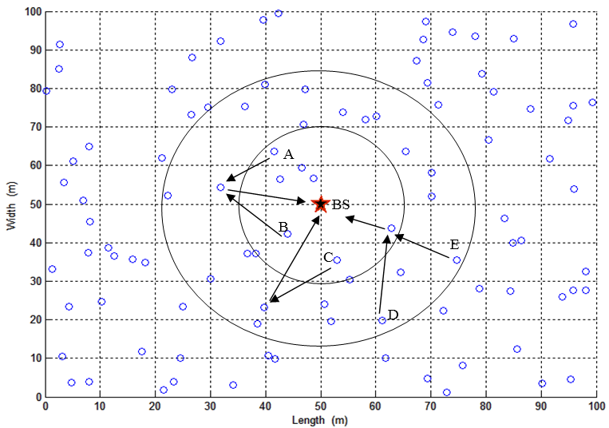
Figure 1. Data transmission in LEACH algorithm

Clustering protocols are proposed for different purposes, but main goal of the protocols focus on extending network lifetime. In addition to energy considerations of these algorithms, load balancing, fault tolerance, increasing connectivity and reducing delay and optimization of cluster count are the considerations required by applications. In the proposed algorithm, new cluster head selection algorithm is developed by considering the locations of the nodes. The node which is closer to the average of X and Y values of the base station in the cluster is assigned as new cluster head.
In the re-clustering phase, all nodes in the simulation are tracked until a node with cluster head type is found. The node is added in a temporary list and child of the cluster head nodes are found. At the end of finding nodes in the cluster, all nodes total X and Y values are calculated. Calculated values are divided by the cluster node count and the average X and Y values are found. Node types of the nodes in the new temporary node list are set as normal type. The node that has the shortest Euclidean distance to the average X and Y values has been highest probability to choose the cluster head and then select as new cluster head. That node's type is changed to cluster head and its joined node table is deleted. Advertisement message is created and this message is added to a send entry. Entry is added to the time line and the controlling process creates new receive type entries containing the nodes that are in range of the new cluster head. In the development of the proposed algorithms, the algorithm which was used in LEACH algorithm is taken as the base algorithm. Proposed algorithms make changes in cluster formation phases of the base algorithm. It offers new cluster formation with selecting new cluster head by considering two conditions. Those conditions are selecting the node which has the highest probability value and selecting the node which is closer to the average coordinates of the cluster. The main flow of the simulation is coded in the main method of the simulation. The algorithm consists of main structure, interest propagation, cluster formation, generating schedules and cluster maintenance.
The probability value for each node is choose as below:
(1)
In this equation, the indicator Ci,j(t) is one if node i in section j is qualified to be a cluster head at time t (i.e., it's not been a cluster head within the most up-to-date ( r mod (1/ ) rounds.) and nil otherwise. If the amount of section is odd, is calculated as:
(2)
Where represents k_{opt}/N, with k_{opt} be the optimum amount of clusters in LEACH program that should be calculated before and is the distinction of 2 adjacent section’s possibilities. It’s easy to indicate that in every round of proposed method the expected amount of cluster heads is that the same as LEACH by noting that the regions of all section are a similar and also the possibilities are spread fairly around p_{LEACH}:

(3)

Therefore, proposed method doesn't have an effect on the quality of information, since each protocols hand over a similar amount of information per unit time. Hence, we are able to justly compare these method with one another. Simulation results check that exploitation a similar amount of energy by the network, proposed method hand over a lot of packets than LEACH. Consequently, proposed method yields a lot of information per unit energy.
In proposed method, exploitation MACA (Multiple Access with Collision abstinence [3]) method at the level of cluster not solely significantly decreases the amount of collisions among information packets however conjointly lowers the on top of point out delays since the nodes that understand the channel busy, understand specifically once the channel are released (via RTS and CTS frames [3]). However in no persistent model, the nodes expect a random amount of your time so repeat sensing the channel that leads to longer set-up part (overhead).

Simulation results

Table 1. Values of parameters
Parameter | Value
Base station position | (50, 50)
x | [0 100] ^{m}
y | [0 100] ^{m}
N (number of nodes) | 100
E₀ | 0.5 J
E_{elec} | 5 nJ/bit
E_{fs} | 10 pJ/bit/m²
E_{mp} | 0.0013 pJ/bit/m⁴
E_{da} | 5 pJ/bit
Message Size | 4000 Bit

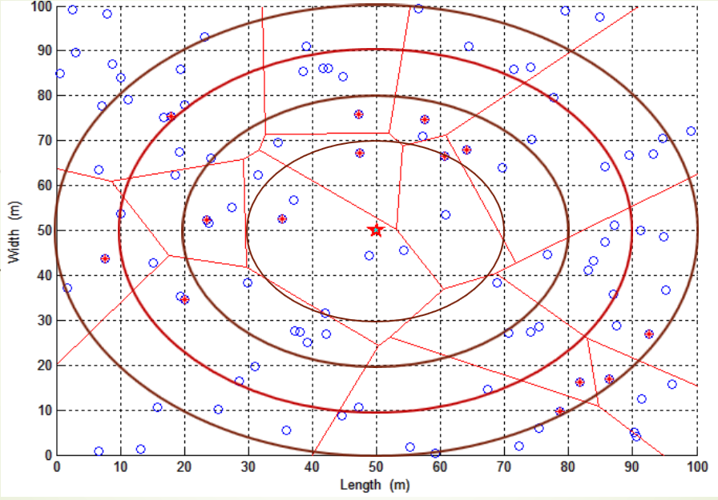
Figure 2. Schematic of our proposed method and random sensors and cluster heads

In this section the efficiency of proposed method is evaluated. Figure 2 shows the schematic of our proposed method and random sensors and cluster heads.
The simulation parameters exploited in every experience are accessible in table 1.
Figure 3 demonstrations the whole of sensors that remain alive over simulation time of 1500 rounds. It is seen that sensors remain alive for a prolonged time in proposed method than LEACH.
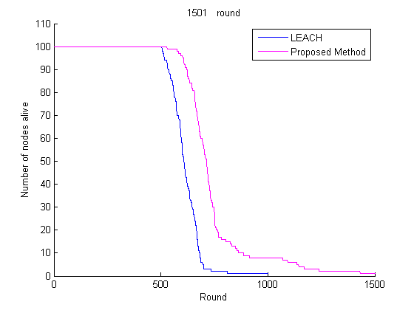
Figure 3. Result of simulation, number of nodes alive vs round

Figure 4 illustrations the whole energy consumption of the network over simulation time.

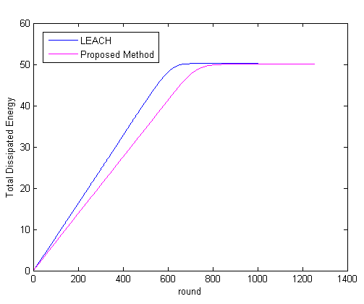
Figure 4. Total dissipated energy in proposed method and LEACH

Figure 5 shows the number of packers received at base station vs round. As this figure the proposed method is very good for sending data for base station as LEACH algorithm.

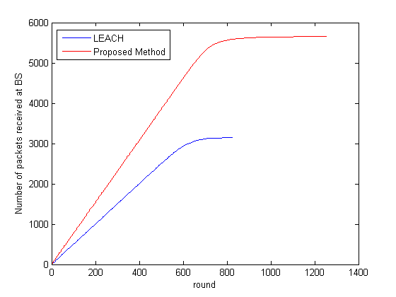
Figure 5. Number of packers received at base station vs round

Conclusion
In this thesis, a reliable communication protocol for wireless sensor networks is presented that considers low energy consumption as well. This protocol is a cluster-based communication protocol that divides the entire network into equal area segments and applies different clustering policies to each segment. The first goal of this project is to reduce the total energy consumption of the wireless sensor network. The second goal is to increase the reliability of the protocol along with improving the network latency as compared with previous cluster-based protocols. The CH is often a sensor node with richer resources such as energy. It may be elected by sensor nodes in a cluster or pre-assigned by the base station. Several clustering algorithms are proposed in order to reduce energy consumption in WSNs. Most of the improvements focus on CH selection. Cluster heads in clusters schedule nodes for sending and receiving messages. In this thesis, a clustering approach based on dividing the entire network for equal area is proposed. Experimental results verify that concerning complete energy consumption, network time period and dependability, proposed method will outgo conservative cluster-based methods.

References
- Chong C.Y., and S.P. Kumar, \Sensor networks: evolution, opportunities, and challenges", Proceedings of the IEEE 91, pp. 1247-1256, 2003.
- Pottie G.J., W.J. Kaiser, \Wireless integrated network sensors", Communications of the ACM 43, 2000.
- P. Karn, “MACA - A New Channel Access Method for Packet Radio,” Proc. of the 9th Computer Networking Conference, Sep. 1990, pp. 134–140.
- Mcmullen, Sonya A. “Mathematical Techniques in Multisensor Data Fusion 2nd Edition.” (2004).
- Klein, Lawrence A. “Sensor and data fusion concepts and applications.” Society of Photo-Optical Instrumentation Engineers (SPIE), 1993.
- Heinzelman, Wendi Rabiner, Anantha Chandrakasan, and Hari Balakrishnan. “Energy-efficient communication protocol for wireless microsensor networks.” System Sciences, 2000. Proceedings of the 33rd Annual Hawaii International Conference on. IEEE, 2000.

11/13/2014

