Design, Implementation and Evaluation of a Low Energy Consumption Method for Wireless Sensor Networks

Khaled Jameel Sarhan1 Sibel Tariyan Özyer2

1Department of Applied Science Computer Engineering Çankaya University Ankara, Turkey

[althebk@yahoo.com](mailto:althebk@yahoo.com)

2Department of Applied Science Computer Engineering Çankaya University Ankara, Turkey

tariyan@cankaya.edu.tr

**Abstract:** The aim of this thesis is to save the energy of the nodes. The first goal of this thesis is to reduce the total energy consumption of the wireless sensor network. The second goal is to increase the reliability of the protocol along with improving the network latency as compared with previous cluster-based protocols. We divide the network area to four region. First region send information directly to base station. Two other region has cluster heads and this cluster heads send information to rechargeable sensor and then this sensor send to base station. These cluster heads are selected on the basis of a probability. The last region has rechargeable node and this sensor collect information and then send to base station. Then we are going to compare our protocol performance with LEACH (Low Energy Adaptive Clustering Hierarchy). We expect the performance of our proposal system will overcome the previous works.

[Khaled Jameel Sarhan Sibel Tariyan Özyer. **Design, Implementation and Evaluation of a Low Energy Consumption Method for Wireless Sensor Networks.** *N Y Sci J* 2014;7(11):105-109]. (ISSN: 1554-0200). <http://www.sciencepub.net/newyork>. 14

Keywords: Wireless sensor network, Consumption energy, Clustering LEACH.

# Introduction

Improvements in technology result in evolution of smart devices. One of such smart devices is wireless sensor nodes, which consist of a sensing board, a battery supply and a wireless antenna to transfer data. We can collect information from the environment by deploying thousands of these tiny smart devices. These devices can also be used to monitor natural habitats or used in giant machine parts for performance evolution. Energy efficient operation is an important issue for wireless sensor network design and clustering is one of the most widely used approaches for energy efficiency. The sensor network application areas have a wide range, like disaster detection such as forest fire or flood detection, patient monitoring and micro-surgery, home and office accessories communication, military intrusion detection, agricultural crop monitoring, pricing goods in the markets, inventory handling and wildlife habitat monitoring. They can also be used for interaction of cars in traffic for safety, virtual keyboards for PC and musical instruments, commanding industrial robots, making social studies on human interaction, hostile environment exploration, monitoring seismic activity, and the monitoring of freshwater quality. They can be used for: civil engineering; monitoring buildings, urban planning and disaster recovery; for other military applications like military asset monitoring, surveillance and battle-space monitoring, urban warfare and self-healing minefields [1]. Recent improvements in technology provide us cheap and tiny electronic devices with various sensors on it. These tiny devices are called ’sensor nodes’ and they have great abilities. The aim of using sensor nodes is to sense the environment and process and/or transfer collected information to an analysis center. Sensor nodes are usually battery powered and their transmission range is very low. Therefore, these sensor nodes can establish a network to propagate their data to long distances. People need to monitor changes in environmental conditions for variety of purposes. Extracting data from changing environment and interpreting that data to gain reasonable information enable people to make meaningful decisions. Today, automation of data collection is facilitated by the improvements in computation and wireless communication technologies. In order to monitor environment or systems, low cost computation and communication devices have been developed. Those devices have sensing ability with built in sensors, basic computational facilities and wireless communication capabilities. With the advances in wireless networking technology, a wireless sensor network can be deployed without a fixed infrastructure. Nodes in the network connect to each other in ad-hoc fashion and they communicate according to wireless communication.

# Proposed Method

## Network Model

In this section, we tend to assume N sensors that remain deployed arbitrary in a very field to observe setting. We denote the ith sensor element by ni and resultant sensor element node set N= n1, n2.., nn. We suppose the network model shown in figure 1.

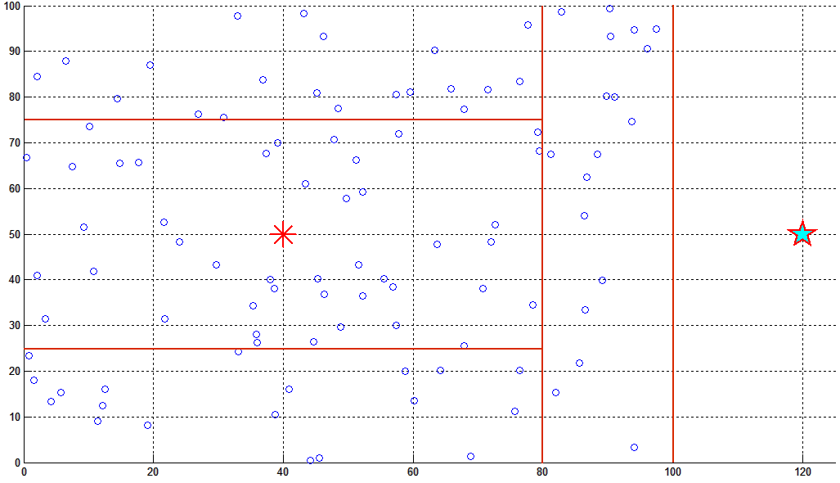

Figure 1. Our proposed network model

We spread the base station away from the sensing field. Sensor element nodes and also the base station are stationary later positioning. Whole of sensor element node is allocated with a particular symbol. We used radio model as employed in [2, 3]. Figure 2 shows this model.

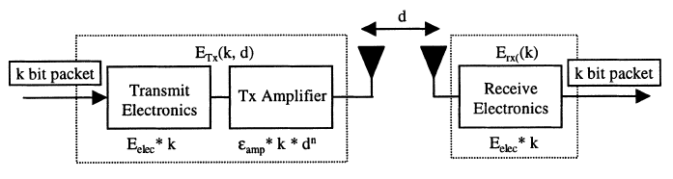

Figure 2. Radio Model

Whole of sensors need energy to transmit packet of k bits information to a distance d and to receive an information packet of k bits, is given as:

(1)



(2)



In this section, we render detail of our method. Sensor element nodes have an excessive amount of sensed information for base station to method. Therefore, self-acting technique of joining or collect the information into a little set of important information is required [4] and [5]. The method of information collect aggregation additionally termed as data fusion. So as to boost network life and output, we have a tendency to deploy a rechargeable sensor node at the center of the network area.

## Initial Phase

After initialization of nodes and simulation environment, sink node creates the first advertisement message which consists of message ID, sender, query, send list. After producing advertisement message, sink node creates the first entry which is located at the first place of the time line with time stamp 0.0. This entry consists of sender node, list of nodes that message is sent to, message and time stamp. The first entry's type is set as send type. This is the first entry to be processed in starting phase of simulation. Task list is the container of the entries created by nodes and entries are ordered in time of creation.

## Setup Phase

In setup phase, we divide the network area to four region. The first region send information directly to base station. Other tow region send to cluster heads and cluster heads send information to rechargeable sensor and this sensor send information to base station. The other region is near to rechargeable node and this sensor send their data directly to rechargeable node and this node send this information to base station. The nodes in region two that are close to rechargeable sensor, send their information on to rechargeable sensor that aggregates information and this sensor send information to base station. The first region and last region is without any cluster head.

## Cluster Head Selection

In LEACH algorithm nodes select their respective CHs according to the probability value from the node that announces itself as CH. Data aggregation and fusion and TDMA schedule is executed by CH, thus CH nodes consumes relatively much more energy than member nodes. In every round of the clustering process CH role have to be rotated among all nodes in order to obtain load balancing. LEACH algorithm runs in distributed manner, every node decides autonomously to become a CH without any centralized control. Every nodes determines a random value between 0 and 1, and compares this random value with the threshold T(i);

 (3)

where r is the current round number, p is the percentage of cluster head which determined for whole network before and G is the set of sensor nodes which are not become CH in the last 1/p round. If random value is less than threshold T(i) node becomes a cluster head for the current round.

This method is probabilistic and nodes in the network have to be CH without looking their energy level. Thus in the data gathering phase if node dies, whole cluster connectivity is affected until new clustering round would start.

Besides, authors of the LEACH proposed a centralized method LEACH-C to control clustering process by remote base station. Each node sends information about its current location and energy level to the BS. In order to obtain load balancing and select node with high energy level as CH, BS computes average energy of the network and decides that nodes have energy below this average cannot be cluster heads for the current round. The data gathering phase of LEACH-C is identical to that of LEACH. LEACH-C performs better than LEACH on energy consumption but needs node position information and centralized control.

## Generating Scheduling

Scheduling is an iterative process started by finding a cluster head node in the nodes in simulation. In algorithm, cluster head nodes are found in the node list. Clusters node count is calculated by adding cluster head node's child nodes and their child nodes up to the third level of depth. Last task's time stamp is taken as the start time of the TDMA scheduling. Slot time is calculated as (round_time/cluster node_count +1). Total slots are distributed to the all child nodes in the cluster with three iterative loops. Each loop finds the child nodes and slots are assigned to the nodes calculating the child nodes of child nodes. Each parent node assigned slots according to their number of child nodes.

## Steady-State Phase

In region tow and four whole of sensors send their sensed information to cluster heads and this clusters analyzed this information and send to rechargeable nodes. Then this sensor send this information to the base station.

## Evaluation of performance

We compare our results with results of LEACH (Low Energy Adaptive Clustering Hierarchy). We expect the performance of our algorithm system will overcome the previous works.

## Performance Parameters

In this subdivision, we have a tendency to exhibit performance metrics. During this work, we have a tendency to evaluated 3 performance parameters given below.

Table 1. Parameter

|  |  |
| --- | --- |
| Parameter | Value |
| E0 | 0.5 J |
| Eelec | 5 nJ/bit |
| Efs | 10 pJ/bit/m2 |
| Emp | 0.0013 pJ/bit/m4 |
| Eda | 5 pJ/bit |
| Base station position | (150, 50) |
| x | [0 100] m |
| y | [0 100] m |
| N (number of nodes) | 100 |
| Message Size | 4000 Bit |

## 

## Simulation Results and Analysis

In this section, we tend to show the simulation results. We tend to run comprehensive simulations and compare our results with LEACH. Next subsections provide detail of every metric.

## Network lifetime

When we make simulations, we should define what the network lifetime is. System lifetime can be considered as the time passed before the death of the first sensor in the network. Although this can be a metric, it should not be the only criterion to decide if one algorithm is better than another algorithm. Since the sensor networks consist of many sensors, they are robust to single or few sensor failures. For dense networks, few failures do not affect operation. Let us assume that in Network A, number of sensors can monitor an area sufficiently. Assume another deployment is made in Network B in a similar area with 2* number of sensors, with two sensors in the same position instead of one sensor in Network A. Network B can continue its operation as good as A even after one of the double sensors die. Therefore, networks can continue their operations even if a big number of their sensors die, if they were deployed densely enough. Figure 3 shows the life time of sensors.as shown in this figure we can see that the proposed method is very good in dead of sensors and this sensors is dead after 1800 round but in LEACH algorithm sensors are dead after 1200 round.

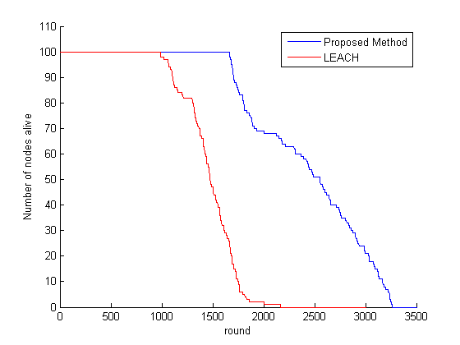

Figure 3. Result of simulation, Number of nodes alive vs round

## The parameter describing service speed

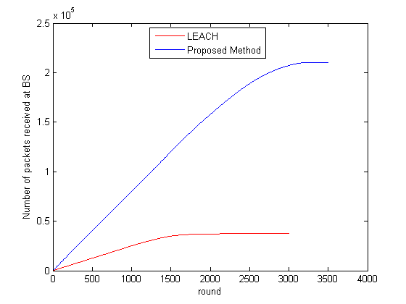

Figure 4. Number of packers received at base station vs round

Whole of packets sent to base station are evaluation through simulations. Simulation results of proposed method show increased output. Interval designs of method and LEACH in figure 4 obviously shows performance of each protocols.

To compute output, we tend to assume that cluster heads will communicate freely with rechargeable sensor node. Simulation results illustration a rise output of five times then LEACH. Sensor nodes close to rechargeable sensor send their information on to rechargeable sensor equally nodes close to base station transmit information on to base station. Sensor nodes in each areas consume less transmission energy so, nodes keep not dead for extended period. A lot of alive nodes contribute to transmit a lot of packets to base station.

Meaaning energy residual of network per round is illustrated in figure 5. The whole sensors have 0.5 joule. Proposed method produces lowest energy usage than LEACH algorithm. Figure 5 shows this result.

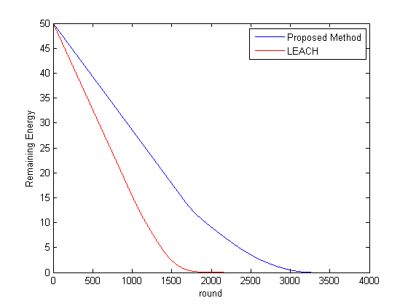

Figure 5. Simulation result for Remaining Energy vs round

# Conclusion

The algorithms considered have been evaluated over regular and random topologies on 100x100 sensing region. For the simulations, locations and sensor measurements of the nodes are saved in a file and a predefined set of queries are applied during simulation. Therefore, all clustering models are evaluated under the same conditions. The aim of this thesis is to save the energy of the nodes. The first goal of this thesis is to reduce the total energy consumption of the wireless sensor network. The second goal is to increase the reliability of the protocol along with improving the network latency as compared with previous cluster-based protocols. We divide the network area to four region. First region send information directly to base station. The energy consumption for transmitting a message is directly proportional to length of the message. Two other region has cluster heads and this cluster heads send information to rechargeable sensor and then this sensor send to base station. These cluster heads are selected on the basis of a probability. The area covered by the cluster is chosen as the cluster head. With such a cluster head selection method, the average hop count for child nodes to reach and deliver their messages to the cluster head decreases and this leads to reduced energy consumption for intra cluster communication phase. Each parent node receiving data from its children aggregates those messages and send aggregate to its parent node. Therefore, increase in the hop count also increases message sizes and so energy consumption increases. The last region has rechargeable node and this sensor collect information and then send to base station. Then we are going to compare our protocol performance with LEACH (Low Energy Adaptive Clustering Hierarchy). In order to, prove and compare efficiency of proposed algorithms, a computer simulation software has been developed. We expect the performance of our proposal system will overcome the previous works.

# References

1. Haenggi, M., “Opportunities and Challenges in Wireless Sensor Networks” in *Handbook of Sensor Networks: Compact Wireless and Wired Sensing Systems*, Ilyas, M. and I. Mahgoub (editors), pp. 22-24, CRC Press, Boca Raton, 2005.
2. Heinzelman, Wendi Rabiner, Anantha Chandrakasan, and Hari Balakrishnan. “Energy-efficient communication protocol for wireless microsensor networks.” System Sciences, 2000. Proceedings of the 33rd Annual Hawaii International Conference on. IEEE, 2000.
3. Heinzelman, Wendi B., Anantha P. Chandrakasan, and Hari Balakrishnan. “An application-specific protocol architecture for wireless microsensor networks.” Wireless Communications, IEEE Transactions on 1.4 (2002): 660-670.
4. Mcmullen, Sonya A. “Mathematical Techniques in Multisensor Data Fusion 2nd Edition.” (2004).
5. Klein, Lawrence A. “Sensor and data fusion concepts and applications.” Society of Photo-Optical Instrumentation Engineers (SPIE), 1993.

11/13/2014