Identification of Wetland Restoration Areas of Chalan Beel in Sirajganj District, Bangladesh using Integrated GIS and Remote Sensing

Md. Shareful Hassan*, Syed Mahmud-ul-islam**

* Centre for Environmental Change Studies and Management, Dhaka, Bangladesh
** Department of Sustainable Development, Environmental Science and Engineering, KTH-Royal Institute of Technology, Teknikringen 34, S-10044, Stockholm, Sweden
*shareful@gmx.com, ** smuislam@kth.se.

Abstract: Wetlands have a crucial importance on sustainable ecological system, improving habitat of different flora and fauna, enhancing surrounding livelihood options and restoring hydrological resources. In this research paper, the largest wetland in Bangladesh the Chalan beel, is being degraded due to various latent and apparent anthropogenic and development interventions. The study area was selected in order to identify future ecological restoration areas using integrated geographic information systems and remote sensing methods. To accomplish the main objective of the study, a set of geospatial data such as surface water bodies and vegetation coverage from the two multi-date Landsat imageries, a slope and drainage density from an ASTER digital elevation model, twenty-three years depletion rate of groundwater table and buffer zones of administrative headquarters, road networks, and railroad were used. The lucid results of this study revealed that about 17175 and 43552 hectare lands were found, which is 7% and 18% of the total study area, to be highly and moderately suitable areas respectively for future ecological restoration in the study area.
[Md. Shareful Hassan, Syed Mahmud-ul-islam. Identification of Wetland Restoration Areas of Chalan Beel in Sirajganj District, Bangladesh using Integrated GIS and Remote Sensing. N Y Sci J 2014;7(11):94-100]. (ISSN: 1554-0200). http://www.sciencepub.net/newyork. 12

Keywords: GIS; remote sensing; DEM; Landsat; Chalan beel; ecological restoration; Bangladesh; overlay

1. Introduction
The Chalan beel is the largest and one of the threatened wetlands in Bangladesh. This wetland plays a crucial role to the local inhabitant’s socio economic condition by fish harvesting and agriculture. The livelihoods of the people of surrounding area are mostly depended on this wetland resource (Kostori M.F.A., 2012). Additionally, a large source of fresh water fish and aquatic resources keep ecological systems in balance. The rich components of flora and fauna hold the biodiversity vividness and render nutrition and fertility to the soil properties to the agricultural land and thereby vegetation. However, now it is a matter of discussion issue that the wetland exposes visible and tangible degradation processes and loses its previous living entities. The wetland area is being shrinked gradually in which ecological degradation is an ongoing process due to anthropogenic, natural siltation process and, development interventions (Mostafa et al., 2009). About 10% of the wetland is located in the three upazilas of Sirajganj district: Tarash, Ullahpara and Raiganj (Khatun A., 2013). The recent aggression of human settlement and increased urbanization process poses a great threat on this wetland’s existence and sustainability. Due to excessive agricultural activities, land encroachment, natural siltation and other anthropogenic activities lead the whole the wetland area narrower (Rahman M.M. et al., 2010). Consequently, the whole ecosystem of this wetland is under peril. Therefore, it is apparent and urgent to consider restoration process to prevent further degradation in order to promote future sustainability and improve local livelihoods. In this paper, a set of geo-referenced data was used to identify future ecological restoration areas of the wetland by means of integrated geographic information systems and passive remote sensing platforms.
Dong et al., (2013) used geographic information system and remote sensing data to identify and prioritized suitable sites for restoration wetland in the Lower Reaches of Songhua River, Northern China. They found higher and lower priority classes for wetland restoration areas were 82628 and 247039 hectares respectively in their study. They considered multi-criteria analysis in order to achieve the study outputs. Kulawardhana et al., (2007) studied a wetland evaluation study using NDVI (normalized difference vegetation index) and NDWI (normalized difference water index) algorithms in the Limpopo river basin of Botswana, Zimbabwe, South Africa and Mozambique.
Satellite imagery, high-resolution aerial photos, DEM (Digital Elevation Model) are remarkable data to identify and classify inland wetlands. Hsu et al., (2008) used these factors in the northern Front Range, Colorado in order to produce an accurate location based wetland database. They used multi-criteria using as set of thematic maps.
Kunert (2005) used a set of geospatial restoration criteria for identifying habitat restoration site in the New York – New Jersey Harbor Estuary. To carry out this task, he used weighted overlay model in ArcGIS platform.

2. Problem Statement of the Study
About 5 million people depend on the wetland for fishing and agriculture activities. The Chalan beel was an ostentation place of various species of fish, aquatic flora, and fauna. Being the biggest wetland, this area is one of the most suitable for fresh water fisheries that contributes a great amount of production for domestic protein. Unfortunately, the fish production of the wetland has intensely reduced in recent years. The annual fish production of Chalan beel in 2005-06 was 12217 Tonnes which was half of the production collected in 1982 (Mostafa et al., 2009). Therefore, the fisheries and biodiversity are being degraded over time. Poor rainfall also creates unsuitable aquatic conditions that damages fish eggs. It requires flooding or abundant water flow for most suitable condition of breeding fishes (SSUK, 2011). Besides, increasing rate of siltation, embankment construction, highway infrastructure, land grabbing of local people, increasing population and their urbanization, industrialization, uncontrolled agricultural activities, excessive use of fertilizer and pesticides at nearby agricultural land have been shown to be the main factors for leading to fish habitat degradation and effects badly to existing ecology. The original area was found about 1088 square km in the survey of 1909 by Public Works Department (PWD). At present, the Chalan beel area covers only about 375 square km. The reduction of the total area over a century is about 713 square km (Mostafa et al., 2009). The degradation of wetland also creates negative impacts to the local people.

3. Objective of the Study
The main objective of this study is to identify the future ecological restoration areas in the North-Western part of Bangladesh by using a set of consistent thematic maps in GIS and remotes sensing platforms. Moreover, to carry out this identification, a weighted overlay model is followed considering different weights, ranks, and relative influence of the each map.

4. Study Area
The study area is located in the Sirajganj district, North-western region of Bangladesh. The whole district area covers about 2497.92 square kilometres with an estimated population of 3220814 (BBS, 2011). The study area geographically lies between latitude N 24° 00' to N 24° 40' and longitude E 89° 20' to E 89° 50' (Figure 1). The average temperature is maximum 34.6 °C during summer and minimum 11.9°C during winter season. The annual precipitation is about 1610 mm (BWDB, 2007). The district consists of nine upazilas including four municipalities. The upazilas are Kazipur, Chauhali, Belkuchi, Sirajganj Sadar, Kamarkhanda, Raiganj, Shahjadpur, Ullahpara and Tarash.

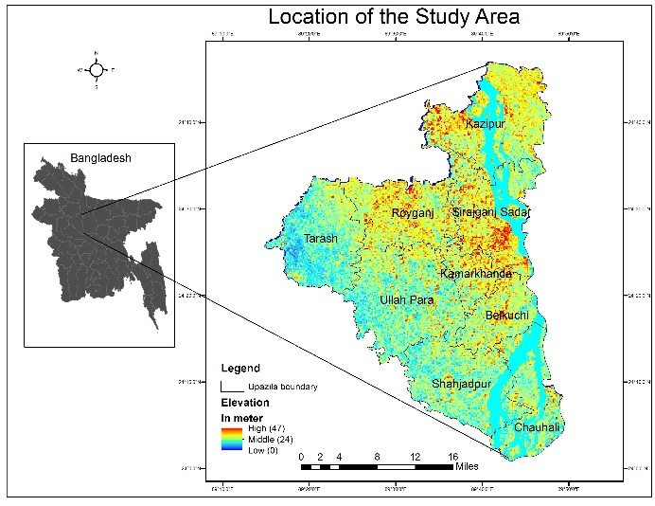
Figure 1. Location map of the study area.

5. Data and Materials
In this study, Landsat 5 (TM) images from 1989 and 2013 were used. Mainly four channels e.g. RED, NIR, Blue, and Green were opted for extracting spectral information for surface water and vegetation from the study area. The main characteristics of the remotely sensed imageries are given in the table 1.

Table 1. Remote sensing metadata
Landsat 5 | Row/Path | Date of accusation | Resolution  (Meter) | Projection
Landsat 5 | 043/138 | 2013-11-08 | 30 | UTM
Landsat 5 | 043/138 | 1989-11-11 | 30 | UTM
ASTER | -- | 2000 | 30 | UTM/WGS 84

These passive Landsat data were collected and downloaded from the GLCF’s (Global Land Cover Facility) as free of cost. On the other hand, an ASTER (Advanced Space borne Thermal Emission and Reflection Radiometer) Digital Elevation Model (DEM) was collected from a combined project of NASA and Japan Space System. This DEM was used to derive slop and drainage networks.
A vector polygon map of the study area, Sirajganj district, was collected from Bangladesh Local Government and Engineering Department (LGED) to mask out the study area from the whole scène of Landsat imageries.

This vector data was also used to extract Upazila wise future ecological restoration areas. Moreover, three more vector data; administrative headquarters, railroad, road networks were collected from the same department as well. A twenty-two year groundwater table data, about 155 points, was gathered from Bangladesh Department of Public Health and Engineering (DPHE) in order to find the depletion rate in the study area.
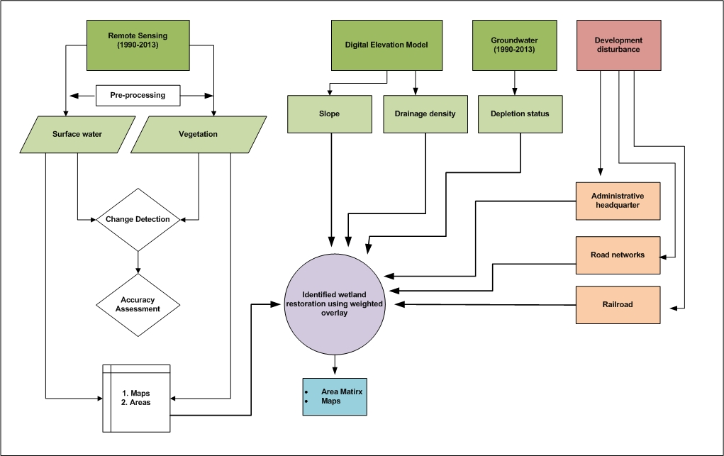
Figure 2. Conceptual framework of the study.

6. Methodology
The overall methodological framework for the study is presented in Figure 2. Landsat TM of 1989 and 2013 used to extract vegetation and surface water body using Normalized Difference Vegetation Index (NDVI) and Normalized Difference Water Index (NDWI respectively.
6.1 NDVI for Vegetation
NDVI is a widely used vegetation index for delineating vigor vegetation from other geo-entities using near (NIR) and RED band. The obtained value of NDVI ranges form –1 to +1 (Rani et al., 2011). NDVI is a non-linear function which ranges between -1 to +1 where water, rocks, and bare soils are indicated by values in -1 range and the vigor of vegetation is indicated by values near to
+1 (Hassan, 2009). The following equation [1] is used to calculate vegetation in the study:

[NDVI = (NIR – RED) / (NIR + RED)]………………… [1]

6.2 NDWI for Surface Water
The NDWI can be identified open water bodies using green and NIR channel. The NDWI has been developed to achieve the goal (McFeeters, 1996). This calculation ranges from -1 to +1. The outcomes from this equation are water features that have positive values whilst soil and terrestrial vegetation have zero or negative values (McFeeters, 1996). The main equation [2] of this index is below:

[NDWI = (GREEN - NIR) / (GREEN + NIR]…….... [2]

6.3 Topographic Analysis
ASTER DEM used to derive slope and drainage density maps. The resolution of the DEM was 30 meter that in line with other Landsat data. It rendered to superimpose elevation data with vegetation, surface water and other data in order to check the reality. The average elevation in the study area was 0-47 meter. The slope and drainage density maps were derived for this DEM.

Table 2. Attributes, ranks, criteria and weights all of the thematic maps
Thematic maps | Attributes | Criteria | Rank  1= Highly suitable  2= Moderately suitable  3= Not suitable | Influence/weight
Vegetation | Very high coverage  High coverage  Low coverage | NDVI= .75  NDVI= .5  NDVI= -.28 to 0.12 | 3  2  1 | 20
Surface water | Very high density  High density  Low density | DN= 1157 to 1736  DN= 385 to 1157  DN= 0 to 385 | 1  2  3 | 25
Slope | Very high slope  High slope  Low slope | > 80%  > 40% to 60%  < 20% | 3  2  1 | 15
Drainage density | Very high density  High density  Low density | DN= > 157  DN= > 78 to < 157  DN= 0 to 78 | 1  2  3 | 20
Groundwater | Very high depletion  High depletion  Low depletion | > -10 meter  >-4 to <10 meter  0 to +1.75 meter | 3  3  1 | 15
Administrative headquarters |  | Within 1000 m  Outside 1000 m | 3  1 | 3
Road networks |  | Within 1000 m  Outside 1000 m | 3  1 | 1
Rail road |  | Within 1000 m  Outside 1000 m | 3  1 | 1

6.4 Groundwater Table
Groundwater table plays an important role for restoring surface water as well as wetland ecosystems. About 155 groundwater points interpolated as raster file using ArcGIS spatial analysis tool in order to delve the depletion rate of thirty-two years (1990-2013) in the study area. Two separate groundwater raster files for 1990 and 2013 were generated by interpolation method. Finally, the first image (1990) was subtracted by the second image of 2013 to find out the depletion rate over the study area.
6.5 Proximity Analysis
Three development intervention data; administrative headquarters, road networks and railroad were considered to be constrained for this analysis. Because an ecological restoration cannot be suitable or prioritised within the constrain areas. To avoid these areas, a proximity analysis performed considering 1000 meter from the each attributes.
6.6 Weighted Overlay Analysis
Weighted overlay analysis is a popular multi-criteria analysis for identifying site suitability using a number of geospatial data. The weighted overlay tool applies one of the most used approaches for overlay analysis to solve multi-criteria problems such as site selection and suitability models (ESRI, 2014). In this study, a weighted overlay model performed in ArcGIS platform by means of vegetation density, surface water density, slope, drainage networks, groundwater depletion rate, buffer zones of administrative headquarters; railroad and road networks. For executing the overlay model, each of the attribute of each thematic map was assigned by rank, relative influence and, criteria. Table 2 highlights the details of the rank, criteria and influence.
7. Results and Discussion
Map of the vegetation coverage was classified from the NDVI image (Figure 3a). Three classes e.g. dense, moderate and sparse were extracted as very high, high and low coverage vegetation respectively. Finally low coverage vegetation areas choosing for selecting restoration areas. Most of the low vegetation areas found in the low land or low slope areas, mainly in the southern part of the study area.
From our analysis, NDWI was found to be the best surface water extraction method. Including the main water channel and small-scale water bodies, about 60000 hectare areas were classified which is 24% of the total land of the study area (Figure 3b). A kernel density analysis performed to find out very high-density water coverage for the weighted overlay modeling.
Slope and drainage density maps were generated from the DEM. The resultant slope map categorized as < 20%, > 40%, >60% and >80% of which < 20% was opted for the best topographic factor for ecological restoration. The spatial distribution of the < 20% slope was observed in the north-eastern, north-western, and southern parts in the study area (Figure 3c). A hydrological analysis was also used to identify higher drainage density areas in the study. This higher drainage density might have potential water retention capacity due to its hydrological characteristics. Very high drainage density was found in the north-middle and southern parts with low elevated areas (Figure 3d).

In a wetland area, groundwater table holds surface water. To understand the depletion rate of groundwater in the study area, raster image of 1990 was subtracted by the 2013 image. Based on the calculation, very high depletion rate (-10 feet) is observed in the north-western and middle-western parts of the study area. In this study, very low depletion rate (1.75 feet) selected for the weighted overlay analysis (Figure 4).
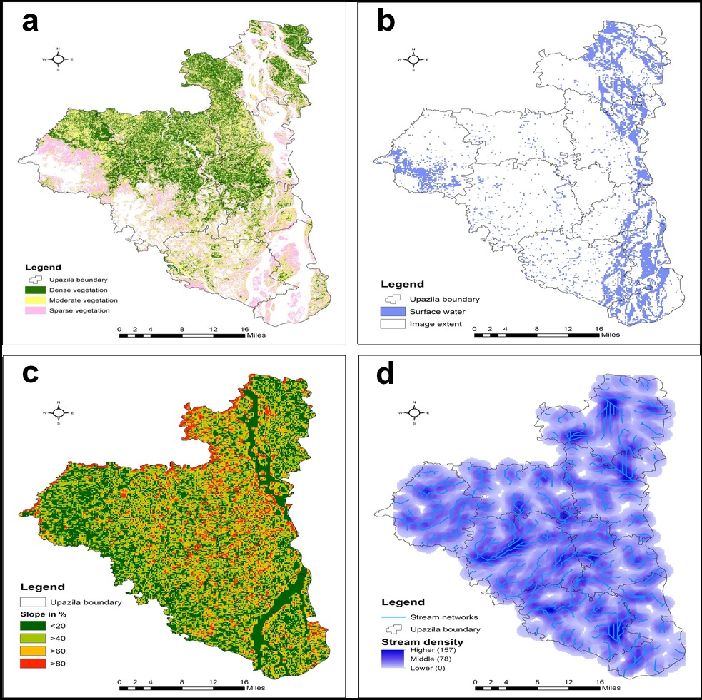
Figure 3 (a) Vegetation map (b) Surface water map (c) Slope map (d) Drainage map
From the proximity analysis, a 1000-meter buffer zone derived within the both sides of administrative headquarters, road networks, and railroad. These areas were input as constraint locations in the suitability modeling. The model considered suitable areas from the outside of 1000 meter (Figure 5).
Finally, an ecological restoration map was generated from the weighted overlay modeling (Figure 6). About 60728 hectares, 24% of the total land, was found as future restoration areas of which 17175 and 43552 hectares extracted as highly and moderately suitable areas respectively. Most of the highly suitable areas were found in the Upazila of Chauhali (28%), Kazipur (22%), and Sirajganj sadar (26%). On the other hand, same upazilas were also found as moderately suitable (Figure 7).

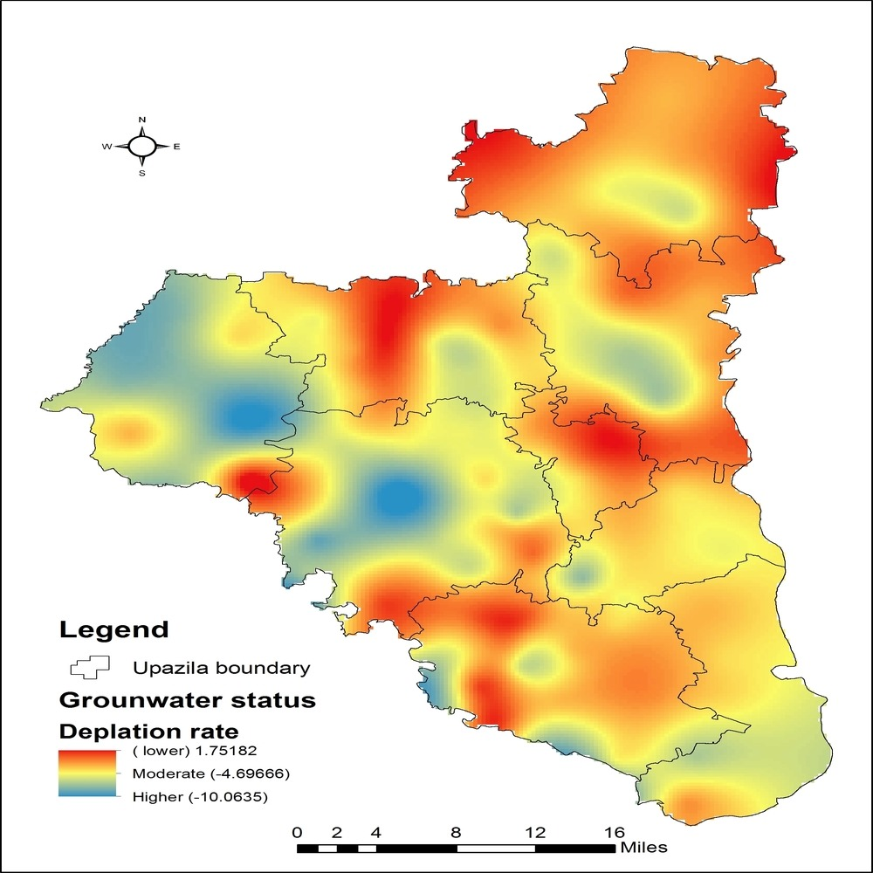
Figure 4. Groundwater depletion rate

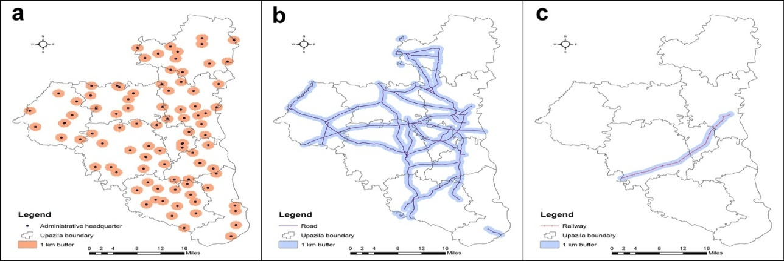
Figure 5. (a) Administrative headquarter (b) road networks (c) rail road

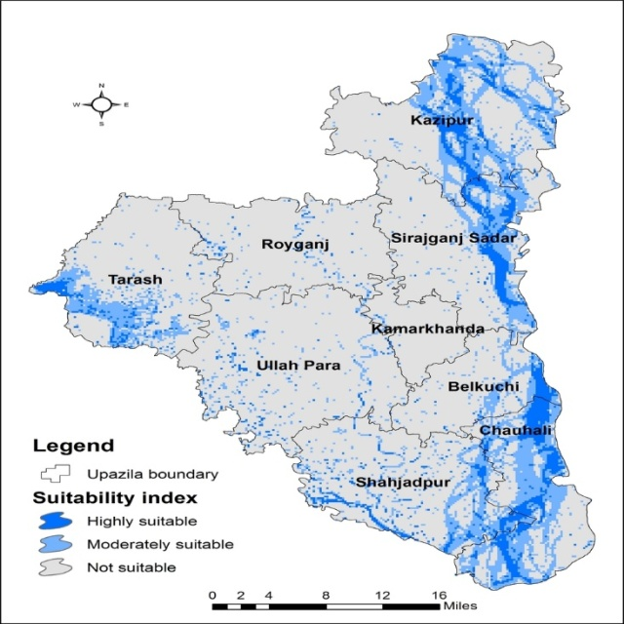
Figure 6. Future ecological restoration areas in the study area.

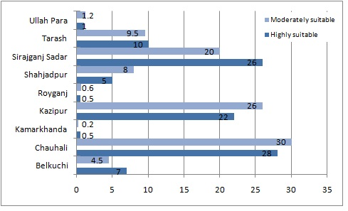
Figure 7. Upazila wise distribution of highly and moderately areas for ecological restoration in the wetland.

8. Conclusion
Different anthropogenic and development interventions were leaded to the loss and degradation of the wetland in Bangladesh. From this study it is revealed that integration of geographic information systems and remote sensing data sets can be utilized effectively to identify degraded wetland area and thereby in restoring wetland ecology. In addition to these data, combination of groundwater, digital elevation model, and some other vector information e.g. administrative headquarters, road networks, railroad are very useful to identify future ecological restoration areas using weighted overlay functions in GIS spatial analysis platforms. The final analysis of the study indicates that about 17175 and 43552 hectare areas were found as highly and moderately suitable areas respectively, which were accounted for 7% and 18% of the total study area. The main methodology of the study is simple and viable approach so that related stakeholders, government agencies, or regional planners can replicate it for further evaluation of ecological restoration. Moreover, the results of this paper can improve underrating of the current situation of the degradation of the wetland. The main conclusion of this study paper is to stop degradation in the wetland to improve socioeconomic conditions, sustain ecological balance and restore hydrological systems. This study will help to demarcate the spatial distribution of suitable areas for future ecological restoration in the wetland.

Correspondence to: Md. Shareful Hassan
GIS/RS Specialist, Centre for Environmental Change Studies and Management, Dhaka, Bangladesh
Cellular phone: +8801733750087
E-mail: shareful@gmx.com

References
- BBS (Bangladesh Bureau of Statistics), (2011) - Population Census 2011 Preliminary Report, Statistic Division, Ministry of Planning, Government of Bangladesh.
- BWDB (Bangladesh Water Development Board), (2010) - Annual Flood Report 2007. Dhaka Bangladesh: Flood Forecasting and Warning Center Processing and Flood Forecasting Circle, Bangladesh Water Development Board.
- Dong Z.Y., Wang Z.M., Liu D.W., Song K.S., Li L., Ren C.Y. and Jia M.M. (2014) – Spatial Decision Analysis on Wetlands Restoration in the Lower Reaches of Songhua River (LRSR), Northeast China, Based on Remote Sensing and GIS. International Journal of Environmental Research, ISSN: 1735-6865, Vol 8, Issue 3, Summer 2014, pp. 849-860.
- ESRI, (2014) - How Weighted Overlay Works, ArcGIS Resource Center. [Online] Available at: http://help.arcgis.com/en/arcgisdesktop/10.0/help/index.html#//009z000000s1000000.htm (Accessed on 08.09.2014).
- Hassan S. (2009) - Assessment of land use and land Degradation in the North-Westren Part of Bangladesh using Landsat Imagery. TRITA Master's Thesis. Division of Geoinformatics, Royal Institute of Technology (KTH), Stockholm, Sweden, ISSN 1653-5227, GIT EX 09-013: pp 1-73.
- Hsu C. and Johnson L. (2008) – Multi-criteria Wetlands Mapping Using an Integrated Pixel-based and Object-based Classification Approach, Report No. CDOT-2008-8, Colorado Department of Transportation. pp 1-43.
- Kunert K. (2005) - A GIS Approach to Habitat Restoration Site Selection and Prioritization in the New York-New Jersey Harbor Estuary. Master Project, Nicholas School of the Environment and Earth Sciences, Duke University. pp 1-120.
- Khatun A. (2013) - Impacts of Flood Hazard on Human Life and Environment in Some Selected Upazilas of Sirajganj District. MS thesis, Department of Environmental Science, Bangladesh Agricultural University, Mymensingh.
- Kostori M. F.A. (2012) - Socio-economic Condition of Fishermen of the Chalan Beel under Tarash Thana of Sirajganj District in Bangladesh. Bangladesh Research Publications Journal, ISSN: 1998-2003, Vol 6, Issue 4, March-April, 2012, pp. 393-402.
- Kulawardhana R.W., Thenkabil P.S., Vithanage J., Biradar C., Islam M. A., Gunasinghe S. and Alankara R. (2007) - Evaluation of the Wetland Mapping Methods using Landsat ETM+ and SRTM Data, Journal of Spatial Hydrology, Vol 7, No. 2, Fall 2007, pp. 62-96.
- McFeeters S.K. (1996) - The use of the Normalized Difference Water Index (NDWI) in the delineation of open water features. International Journal of Remote Sensing. Vol 17, Issue 7, pp. 1425-1432.
- Mostafa A.R. Hossain, M. Nahiduzzaman, M.Aby Sayeed, M.Ekram Azim, M. Abdul Wahab and Paul G. O. (2009) - Tha Chalan beel in Bangladesh: Habitat and biodiversity degradation and implications for future management. Lakes and Reservoirs: Research and Management 2009, Blackwell Publishing Asia Pty Ltd., Vol 14, pp. 3-19. DOI: 10.1111/j.1440-1770.2009.00387.x
- Rahman M.M., Rahman M. R and Asaduzzaman M. (2010) - The Aggression of Human Activities on Chalan Beel A Threat on Wetland Environment: Study on Natore-Rajshahi Region of Bangladesh. Journal of Science Foundation, ISSN: 1728-7855, Vol 8, Issue 1&2, June-December, 2010, pp. 151-159.
- Rani M., Kumar P., Yadav M., and Hooda R.S. (2011) - Wetland assessment and Monitoring Using Image Processing Techniques: A Case Study of Ranchi, India. Journal of Geographic Information System, Vol 3, pp. 345-350. DOI:10.4236/jgis.2011.34032
- Samad M.A., Galib S.M. and Flowra F.A. (2009) - Fish drying in Chalan Beel Areas. Bangladesh Journal of Scientific and Industrial Research, Vol 44 Issue 4, pp. 461-466.
- SSUK (Sikkha Sastha Unnayon Karzakram), (2011) - Climate change impacts, community perceptions and adaptation practices by rice growing communities in Bangladesh, Pesticide Action Network, Asia and Pacific. Penang, Malaysia.

11/9/2014

