Profile of RTA cases attended in tertiary care hospital District Shaheed Benazir Abad, Sindh Pakistan

Farzana Chang¹, Mir Mohammad Sahito², Muhammad Suleman Pirzado³, Saira Baloch⁴
Iqbal Mughal⁵, Riaz Sahito⁶

¹Associate Professor, Department of Pathology, Liaquat University of Medical and Health Sciences, Jamshoro, Pakistan
²Assistant professor, Department of Pathology, Peoples University of Medical and Health Sciences for Women, Shaheed Benazir Abad, Sindh, Pakistan
³Assistant professor, Department of Molecular Biology and Genetics, Liaquat University of Medical and Health Sciences, Jamshoro, Pakistan
⁴Assistant professor Medical Research Center, Liaquat University of Medical and Health Sciences, Pakistan
⁵Professor, Department of Forensic Medicine, Lahore
⁶Postgraduate Student, Department of Pediatric Surgery, Peoples University of Medical and Health Sciences for Women, Shaheed Benazir Abad, Sindh, Pakistan

Abstract: Objective: The aim of this study is to intrude into the causes of RTA’s in rural Sindh Pakistan and to wake the authorities to seek the solution and plan constructive, effective and long term programs to help the poor masses & avoid future RTA’s. Study design: Descriptive. Setting: Study was performed in cases attended in tertiary care hospital, Nawabshah, District Shaheed Benazir Abad. Participants: 680 cases. Results: Among 680 cases 560 were male and 120 were female and their ages range was 10 – 70 years. The distribution of study subjects according to age revealed that age group 25 – 40 were highly affected 22.64% followed by age group 20.36% while age group 10 – 25 above 70 was least affected 10%. Conclusion: It is concluded that the great number of causalities among young adult passengers of mainly male gender and belonging to rural areas of economically poor families. These victims mostly travelled by public vans & wagons followed by motor cyclists & cars. Motorcycle is the common & economical transport medium in rural Sindh for lower, middle & poor class.
[Farzana Chang, Mir Mohammad Sahito, Muhammad Suleman Pirzado, Saira Baloch Iqbal Mughal, Riaz Sahito. Profile of RTA cases attended in tertiary care hospital District Shaheed Benazir Abad, Sindh Pakistan. N Y Sci J 2014;7(11):82-85]. (ISSN: 1554-0200). http://www.sciencepub.net/newyork. 10

Key Words: Road traffic accidents, Tertiary Hospital, Rural Sindh.

- Introduction
Road Accidents are a main source of loss of life and debility. Daily countless people lose life get injured on roads. Males are going to work & kids going to educational institutes are lost forever and distressed families mourning. A Road accident is a rising community problem like other disease, extremely affecting exposed group of travelers (1). Road accidents causing mortality is a serious problem in Sindh Pakistan. Most of the population of rural Sindh travel by road as there is no other mean of transport available. Airway is almost zero while railway is limited to big cities only. Men, women & children of villages & towns are forced to travel by road for earning and schooling. The male population as compared to females is at highest risk of RTA’s as males go out for work & education while females work at home or in near vicinity. This is similar to a study of Stephen Luby 1997 (2, 3). RTA has been reported to be the tenth most important cause of death worldwide (4). RTAs are an important reason of psychological, emotional & economical trauma to the affected families dependent on young males. Globally the peoples killed in RTA’s annually are calculated to be in millions around 1 to 2 million. Whereas the number of injured is estimated to be as great as 50 million (5). According to (6)mortality from road accidents is a grave health problem of public in China, causalities from automobile clashes raised 97 fold during 1951 – 1999 and road traffic injuries have become the leading cause of death among persons of 45 years and younger (6,7). Prevalence of road accidents injuries in Pakistan was 15.0/1000 persons per year (8). China is the most populace country in the world, accounts for 13.5% of all deaths due to road accidents. Pakistan a developing country, most of the population belongs to lower socio-economic class and it is a patriarchal society, dependent upon male members of the family (1) who are exposed to the highest risk of meeting with road accidents previous studies have shown that many developing countries have serious road accidents problem (9-11), pedestrians & motorcyclist have highest rate of injuring in Asia (12,6). More males are injured than females, males constituted 73% of all RTA & deaths in 2003 nearly three times that for females: males constituting 27.6 per 100,000 population and females 10.4 per 100,000.0 population respectively (5). Accidents can be defined as unexpected misfortune; they are clashes that might have been avoided. There are a variety of factors distressing and augmenting the consequences of RTA’s (13). There is a tripod of factors, responsible for RTA’s, which are driver, roads & traffic infrastructure & the condition of the vehicle together form this trio. Research evidence indicate that human beings are responsible for 80 – 85% of all accidents, including extreme age of driver, intoxication, lack of driving experience & ignorance of traffic and road rules. Amongst the causes of RTA’s are the roads, drivers, and motor vehicles (14, 15). Vehicles are identified as important contributors to RTA’s, the commercial vehicles being the most striking vehicle (2). Similar road accident occurred in January 2014 between a Van hired for school children and a heavy trawler, this RTA took away lives of 24 children, 2 teacher & 2 other. The children belonged to a village and were returning home after winning a trophy in a quiz competition held in neighboring city of Nawabshah, Shaheed Banazeer Abad. The reason being overloaded van, negligence of both drivers and absence of traffic signs, all resulted in this tragedy (16, 17). In a World Health report released on April 7th 2004 traffic accidents killed 5000 and injured 12000 people in Pakistan. RTA’s are important and at the same time avoidable cause of death in a country like Pakistan, striving to develop. (5, 18).
The aim of this study is to intrude into the causes of RTA’s in rural Sindh Pakistan and to wake the authorities to seek the solution and plan constructive, effective and long term programs to help the poor masses & avoid future RTA’s.
2. Material and Methods
This study was performed on 680 cases of Medico legal deaths reported from the urban and rural areas of interior Sindh attended in ML section PMC Nawabshah District Shaheed Benazir Abad (SBA) during the period of one year i.e. January 2013 to December 2013 of cylinder year. They were 560 male and 120 female and their ages range was 10 – 70 years.
Data regarding their age, gender, treatment, history and circumstances of mishap incident accident were collected by polices, friends & relatives who brought their to causality department. The finding on subject during PM examination is reliable to evaluate the manner of death and modalities involving un-natural deaths.
3. Results
The distribution of study subjects according to age revealed that age group 25 – 40 were highly affected 22.64% followed by age group 20.36% while age group 10 – 25 above 70 was least affected 10% Table 1. This is consistent with a study of (M. Hussain et al Prof Med J June 2007 ¹⁸).Among them were 560 males & 120 females out of 680 cases, comprising 85.82% males & 14.17% females shown in table II. Similar in the study of M.Amjad Bhatti et al 2013 and Shanks et al 1994.

Table I: Shows the age group of victims
No | Age Group | Total cases | Percentage
1. | 10 – 20 | 137 | 20.14%
2. | 21 – 40 | 154 | 22.64%
3. | 41 – 50 | 127 | 18.60%
4. | 51 – 60 | 109 | 16.02%
5. | 61 – 70 | 80 | 11.76%
6. | > 71 | 73 | 10.76%
Total |  | 680

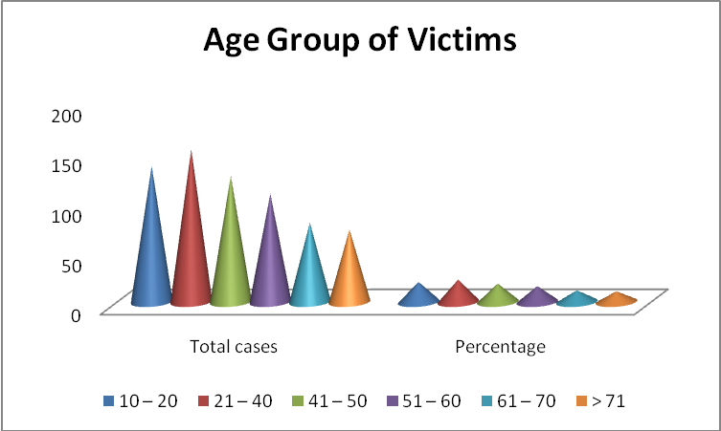
Figure I: Shows the age group of victims

Table II: Showing gender distribution
Sex | No. of Cases | Total | Percentage
Male | 560 | 680 | 85.82%
Female | 120 | 680 | 14.17%

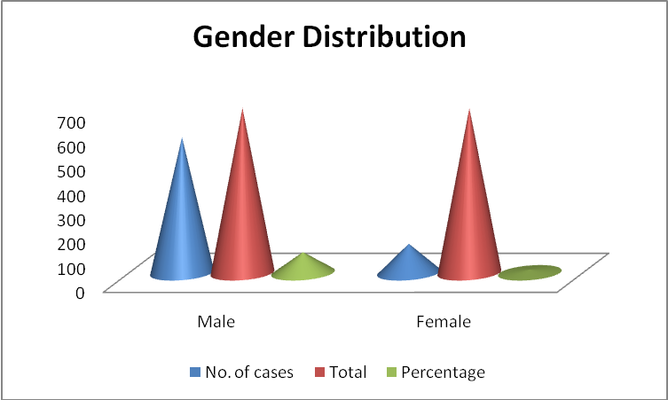
Figure II: Showing gender distribution

Table III: Showing area wise distribution of un-natural deaths
No. | Area | No. of Cases | Percentage
1. | Rural | 414 | 63.0
2. | Urban | 266 | 37
3. | Total | 680 | 100

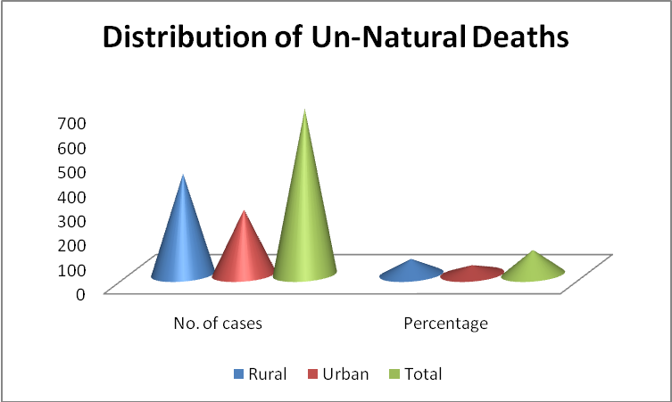
Figure III: Showing area wise distribution of un-natural deaths.

Area wise distribution revealed that more cases were in rural Sindh areas of Sindh, 414 cases out of 680 (63.0%) while in urban areas 266 cases (37%) as in Table III. It is consistent with the study of BR Sharma 2008 ⁴ that highest proportion is in less developed regions of world as South East Asia & Africa.

Table IV: Showing vehicles involved in RTA
Vehicle Type | No. of Cases | Percentage
Wagons | 230 | 34.10
Cars & Motorcyclist | 190 | 28.82
Bus | 131 | 19.41
Trucks & Trawlers | 129 | 17.67

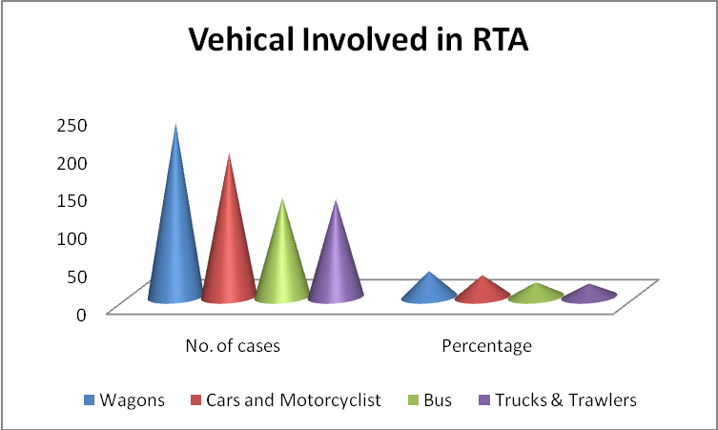
Figure IV: Showing vehicles involved in RTA

Wagon RTA victims were most frequent 34.1% 230 cases and Cars and Motorcycles were 28.8 % 190 cases out of 680 as given by Luby S et al 1997.The Buses accounted by 19.41% while trucks & heavy trawlers accounted for 17.64 % 129 cases out of 680, most of victims died on spot or on way to hospital.

4. Discussions
The Motor vehicle accidents are a tragic problem round the globe, especially in the developing countries like our Pakistan. Shaheed Beenazirabad is a peripheral rural district of Sindh Pakistan with many educational institutions as Engineering, Medical & Humanities / Arts Universities, colleges of technical education nursing & Physiotherapy. Here is the main civil hospital of the distinct. It is a trade Centre, has a sugar mill & many cotton & thread factories. People travel to this city from near & far places. Mostly through public transport likes buses, wagons, vans & rickshaws. At the same time trucks & trawlers also enter & leave city. But the systems of traffic, including traffic police, condition of roads are poor. The driver’s behavior and the state of automobiles played a major role in road accidents, as documented by a study of National highway Traffic safety administration (19) 80% of crashed involved driver inattention. They were involved in eating, drinking, 37.9% while having pan and using cell phone 41.9%. From this study we gathered that wagons & vans overloaded with passengers & trucks were involved in large number road traffic accidents, leading to a disproportionate rate of injuries & deaths this is accordance to a study of (20) that buses & trucks has the highest rate of MVA study carried out in New Guniea. These motor vehicle accidents mainly affected the young individuals, either going to school, college & universities or to factories for earning 22.64% of the victims were among the age of 21 – 30 years while 20.14% were 10 – 20 years of age. These figures correlate with study of (2) (Rehman HA) (Khan MA). These fatalities not only deprive families of victims of their earning & educated lot but a loss to the community. In our study area wise distribution shows a more cases belongs to rural areas 63.0% while urban area show 37% because people from rural areas travel to cities for education, jobs, buying house hold goods so more exposed to accident.
Our study shows that males are more victims 85.82% as compared to female victims 14.17%. The team being that in our old fashioned society males travels outside to earn for the family so more exposed to road accidents while females work at home so less exposed as given by (18). The present study related that main victims of road accidents in rural Sindh are young, adult males, resulting in the loss to the poor families of developing country like Pakistan has a great impact on the lives of poor families. The behavior & attitude of drivers is the main contributing factor, like violation of rules, exceeding speed limits & overtaking the other vehicles.

Conclusion
It is concluded that the great number of causalities were of young adult passengers of male gender and belonging to rural areas of economically poor families. These victims mostly travelled by public vans & wagons followed by motor cycles & cars. Motorcycle is the common & economical transport medium in rural Sindh for lower middle & poor class.
There is a need of a strong strategy to be launched to identify the risk factors responsible for motor vehicle accident. In order to improve the transport conditions for the poor in rural areas of province of Sindh, Pakistan.

Corresponding Author:
Dr. Farzana Chang
Associate Professor, Department of Pathology, Liaquat University of Medical and Health Sciences, Jamshoro, Pakistan.

References
- Manan Khan & M Tahreem A, “Causes of Road traffic accident in Pakistan”. J Astican Dev stud, 2002, Vol. 1, issue 1.
- Hyder A.A, “Road Traffic Accident in Karachi”. 2005Vol:25, No: 02.
- Shanks N.S, Ansari M, Al-Kalai D. “Road Traffic Accident in Saudi Arabia”. Public Health, 1994, Vol.108, P: 27 – 34.
- Marri MZ, Bashir MZ, Arif M, Maqsood M, Mariam Arif, M.Maqsood. “Analysis of ML Death in sandeman civil hospital quetta balochistan”. JFJMC, 2013, Vol: 07, No: 02.
- Peden M, Seurfield. R et al. “World Report on traffic injuries prevention, Geneva” WHO 2004.
- Wang Sy, chi GB, jINGcx, Dong XM, WU CP, Li Lp. “Trends Environmental Noise health and community in Hong Kong”. Noise Health, 2002, Vol:4, P-4-65-9.
- Guoqing HU, Timothy Baker and Susan P Baker. “Comparing road traffic mortality rates”, from police reported data and death in China Bulletin of the world health organization. 2011, Vol:89, P41-45.
- Ghaffar A, Hyder A.A and Masur T.I. “The Burden of road traffic injuries in developing countires”. The 1st National survey of Pakistan Public Health, 2004.
- Bener A, DZKan T, Lajunent T. “The Driver Behaviour Questionnaire in Arabs Gulf countries, Qatar and U.A.E”. Acid.anal prev. 2008, Vol.40, p-1411-17.
- Banner A, Crundall D. “Road traffic accidents in the UAE compared to western countries”. Adv Transport study Int: J 2005, Vol.6:5, page: 12.
- Baner A, The neglected epidemic:”Road traffic accident in a developing country”, State of Qatar Int J.inj Contr saf promot. Vol.12: 45 – 7, 2005.
- Yang, B.M, and Kim J. “Road Traffic Accidents and policy interventions in Rorea”. Injury control and safety promotion. 2003, 10:81-93.
- Gulzar S, Yahya F, Mir Z, Zaffar R. “Provincial Analysis of traffic accidents in Pakistan”. L. Serial science and Humanities. 2012, Vol.3, No:3.
- Muhammad Amjad Bhatti, Shahid Mahmood and Shahid Haneef. “Profile of medicolegal cases”. Attended trauma center of HD Teaching hospital Gujrawalla Pakistan. Es culopio 2013, Vol.09, No.3.
- Aaron, J.E and strasser, M.K. “Driver and traffic safety education”. London: The Macmillan Company 1990.
- Rahman HA, Zulkifi Nah, Subramain K et al. “Car occupants accident & injuries among adolescent in a state of Malaysia”. Proceeding of eastern Asia society for transportation study 2005, Vol.5, P-1867-1874.
- Daily Dawn Newspaper. P-6-7, January 2014, Karachi Pakistan.
- Khan MH, Ahmed I, Zia N et al. “Estimating deaths and Injuries due to road traffic accidents”. Road accidents. Med J, 2007, 14(2).
- Muhammad Hussain Khan, Iftikhar Ahmed et al. “Road traffic accidents”. The professional, 2007, Vol. 14(2). P:323 – 327.
- Jaya suriya R. “Trend in the epidemiology of injuries due to RTA in papua New Guinea”. Asia Pacific Journal Public, 1991, Vol: 5, P-41-48.

11/2/2014

