**Response of yellow yam (*Dioscorea cayenensis*) to shoot growth phytohormones on the tissue and organ morphogenesis.**

HarrimanJ. C.1, Ngwuta, A. A.2, Onyishi, G. C.2, Nwadinobi, C.A.1, Orji, J. O.2, Ndulue, N. K.3, Ogu, C.E.2,

Okoye, A.I3**.** And Njoku, G.4

1Department of Agronomy, Michael Okpara University of Agriculture, Umudike, Abia State.

2Department of Crop Science and Technology, Federal University of Technology, Owerri.

3Department of Agricultural Technology, Anambra State College of Agriculture, Mgbakwu, Awka.

4Department of Agricultural Engineering, Federal Polytechnic, Nekede, Owerri, Imo State.

Corresponding Author: John C. Harriman, E-mail: [harrimanchidi@gmail.com](mailto:harrimanchidi@gmail.com), Phone no. +2348060690357.

**Abstract:** A study was conducted to establish a reliable protocol for plant morphogenesis and regeneration from nodal stem segments obtained from 5-months-field-grown *Dioscorea cayenensis* (Un 680) in plant grown regulators which included a Murashige and Skoog (MS) media supplemented with a constant auxin concentration (indole-3-acetic acid (IAA0.75mg/L)) in combination with different concentrations of cytokinin (0.0, 0.40, 0.80 and 1.20mg/L of kinetin and 6-benzylaminopurine (BAP) each). The number of days to emergence and number of regenerated shoot per callus, number of micro shoot length, number of roots and number of leaves at 9 and 12 weeks after culturing (WAC) were examined. At 5% level of significance, results obtained showed auxin and cytokinin had significant effects on morphogenesis of *D. cayenensis.* Micro shoot length was highest on media MS + IAA0.75Mg/L + BAP 0.80Mg/L(T7), and MS + IAA0.75Mg/L + BAP 0.40Mg/L(T6), with average values of 2.72 and 2.54 respectively at 12WAC, intermediate on medium MS + IAA 0.75Mg/L + Kinetin0.40Mg/L(T2) (2.16) and MS + IAA0.75Mg/L + Kinetin0.80Mg/L(T3) (2.42) and lowest in medium MS + IAA 0.75Mg/L + Kinetin0.0Mg/L(TI) (1.92), MS + IAA0.75Mg/L + Kinetin1.20Mg/L(T4) (1.86) and MS + IAA0.75Mg/L + BAP 0.0Mg/L(T5) (1.92). The medium T3 and T7 produced plantlets with highest number of leaves (4.00 and 3.68 respectively) at 12WAC. However, shoots were less developed on medium T5 and T1, with an average of 1.44 leaves and 1.92cm shoot length on medium T5 and 1.68 leaves and 1.92cm shoot length on medium T1 at 12WAC. Highest numbers of roots were obtained in media free from BAP and kinetin (T1 and T5) that had 3.98 and 4.22 roots respectively at 12 WAC. The results observed from coefficient of variation (CV) indicated that the smallest CV estimates (1.20%) was recorded in number of days to shoot emergence, compared to the highest (8.30%) in number of regenerated shoots per callus. The correlation studies of Pearson correlation coefficient (r) revealed that significant and positive relationship were found between micro shoot length at 12 WAC and leaf number at 9 and 12 WAC (r = 0.80** and r = 0.87** respectively). Conversely, it recorded negative correlation with root number at 9 and 12 WAC (r = -0.18 and r = -0.06 respectively). Rank summation index (RSI) analysis identified two best media (MS + IAA0.75Mg/L + BAP 0.80Mg/L(T7) and MS + IAA0.75Mg/L + Kinetin0.80Mg/L(T3) ) with RSI values of 20 and 22 respectively, representing 25% of the total tolerance.

[HarrimanJ. C., Ngwuta, A. A., Onyishi, G. C., Nwadinobi, C.A., Orji, J. O., Ndulue, N. K., Ogu, C.E. And Njoku, G. **Response of yellow yam (*Dioscorea cayenensis*) to shoot growth phytohormones on the tissue and organ morphogenesis.** *N Y Sci J* 2014;7(11):16-24]. (ISSN: 1554-0200). <http://www.sciencepub.net/newyork>. 3

**Key words**: *Dioscorea cayenensis,* Rank Summation Index, correlation, phytohormones and morphogenesis.

**Introduction**

The dioecious and monocotyledonous *Dioscorea* is known as yam. It is named after the ancient Greek physician and Botanist Dioscorides (Ayensu, 1972). Yam, a multi-species, polyploidy and vegetatively propagated crop, is an economically important staple food for more than 300 million people in low income, food-deficit countries of tropics and sub-tropics (Gedil and Sartie, 2010). Nigeria is by far the world’s largest producer of yams, accounting for over 70-76 *percent* of the world production. According to 2013 figures, yam production in Nigeria has doubled since 1985, with Nigeria producing 35.017 million metric tonnes with value equivalent of US $5.654 billion FAOSTAT (2013). In perspective, the world’s second and third largest producers of yams, Cote d’Ivoire and Ghana, only produced 6.9 and 4.8 million tonnes of yam in 2013 respectively as reported by CGIAR (2014). Yellow yam (*Dioscorea cayenensis* Lam) is believed to originate from West African region; it is by far the most important of the indigenous African yams (Edison *et al*., 2006). The tuber of *D. cayenensis* has high carbohydrate content (low in fat and protein) and provides good source of energy. Unpeeled yam has vitamin C (Anon, 2011). It is consumed as boiled yam or fried in oil and then consumed. It is often pounded into a thick paste after boiling and is consumed with soup. Its medicinal use as a heart stimulant is attributed to its chemical composition which consists of alkaloids of sapogenin while its use as an industrial starch has also been established (Anon, 2011). Traditionally, one of the marriage custom observed in some communities in Nigeria is to measure the bridegroom’s wealth by the amount of yams that he can produce. Likewise in some areas in Igbo land, yam is depicted as a male totem (IITA, 2011). Tubers have a dual agricultural function; they supply nourishment as a source of food and tubers also act as a planting material (Tor *et al*., 1998). Despite their economic importance, however, production is still low due to limited supply of planting materials. The use of cross-breeding techniques has been limited for the crop improvement. Zygotic embryos, formed by sexual hybridization do not develop or germinate *in vivo* (Araki *et al*., 1987). According to Ezeibekwe *et al*. (2009), yams are difficult to breed by hybridization because of their polyploidy and high heterozygosity, while Isidro *et al*. (2011), reported that flowering and seed production occur rarely for most cultivars in the tropics. Because of these barriers to sexual propagation, *D. cayenensis* is strictly vegetatively propagated from seed tubers or setts. This method, however, has drawbacks, including slow multiplication rates leading to production of insufficient material for distribution of superior clones (Mantell *et al*., 1978).This ultimately leads to increased pressure on ware yams for seed yam production. Also, there is the risk of transfer of diseases from generation to generation and from country to country in international trade (Ng, 1988). In addition, the poor flowering biology of the species has eroded the genetic base of the species and breeding to overcome anthracnose, which is caused by the fungus, *Colletotrichum gloeosporiodes*, and the main limiting factor of yam production, has been very difficult. The disease attacks the entire plant, prevents tuber formation and causes plant death (Mignouna *et al*., 2002). Despite the fact the germplasm base available to breeders for genetic improvement is narrow, there has not been sufficient effort to collect *D. cayenensis* germplasm from the areas where it is cultivated and so most of the genetic resources of the crop are in the hands of aged farmers (Saka *et al*., 2004). There is therefore, destitution of information on the genetic improvement of this crop through conventional and biotechnological methods. Genetic transformation via tissue culture techniques offer feasible crop improvement options through somaclonal variation wherein desirable changes are expressed by plantlets regenerated from different plant hormones combinations/concentrations via a callus phase. These changes can broaden the genetic base and can also be subsumed into breeding programmes. However, one of the rudiments for genetic improvement of crop plants through genetic alteration is the availability of a dependable protocol for regeneration. This is lacking in *D. cayenensis.* Success of tissue cultural work depends on the level and kinds of plant growth regulators (PGRs) included in the culture medium. The first stage of tissue culture initiation is vital for information on what combination of media components will give a friable-fast growing callus, or embryo, root or shoot formation (Opabode and Adebooye, 2005; Forssyth and Van, 1982). The identification of optimum auxin (indole-3-acetic acid (IAA)) concentration in combination with cytokinin (BAP/Kinetin) in *in vitro* mass production of microtubers would solve the problem of seed yam production in developing countries through providing nuclear stock for further *in vivo* production and could eliminate the need for importing such materials. The objective of this study is therefore to establish the exact phytohormone growth medium and growth protocol to induce tissue and organ morphogenesis in *D. cayenensis.*

**Materials and Methods**

This study was carried out in the Tissue Culture Laboratory of National Root Crops Research Institute, Umudike, Abia State, Nigeria in February, 2012. Nodal stem explants were obtained from 5 months field grown *D. cayenensis*. To exclude the surface contaminants, the explants were rinsed under running tap water and then surface sterilized with sterilizing agents by successive immersion for 6 minutes in 75% (v/v) ethanol and 10 minutes in sodium hypochlorite 6% (NaClO) (w/w). After sterilization and rinsing with sterile water four times, the explants were sliced into segments of about 10-15mm long with a scalpel after observing appropriate precautions to avoid percutaneous injuries and incubated on MS (Murashige and Skoog) agar medium. The basal medium used for the experiments contained Murashige and Skoog basal salts (Murashige and Skoog, 1962), and vitamins, 3% sucrose, 0.2% activated charcoal and 0.7% agar. In addition, kinetin and 6-benzylaminopurine (BAP) (cytokinin) were added to the MS medium in different concentrations and combinations with a constant 0.75mg/L IAA (Auxin) concentration (Table 1). Twenty five (25) explants were inoculated for each treatment and replicated four times. The pH was then adjusted to 5.8 and the medium was autoclaved for 20 minutes at 1210C at 1.5kgcm-2 (58.75psi) pressure for 15 minutes. Cultures were maintained at 250C under a 12h light/12h dark photoperiods per day and a light intensity of 45µmolm-2S-1 provided by cool, white fluorescent lamps. Vigorous explants were isolated from initiated mother plants in the room and were thoroughly washed in running tap water to reduce microbial load. They were later transferred into a 25 × 150mm test tubes containing MS medium supplemented with different concentrations/combinations of BAP and kinetin with a constant 0.75mg/L IAA concentration in laminar air flow hood already sterilized with 70% ethanol. All cultures were incubated under the same growing conditions and were sub-cultured to fresh MS basal medium after every 14days to induce growth. It was then sealed and labeled appropriately and kept inside the culture room. The effects of the treatment were assessed by comparison of the growth, development and development after 3 months (12 weeks) with respect to the mean number of shoot per callus, number of days to shoot emergence, micro shoot length, number of roots and leaves at 9 and 12 weeks after subculture. All experiments were conducted following a Completely Randomized Design and statistical analyses of the data were carried out using GENSTAT and SPSS (Genstat, 2012; SPSS, 2007). The means were statistically separated using F-LSD at a significance level of p ≤ 0.05. A Rank Summation Index (RSI) method was introduced to rank the media for their overall performance as proposed by Ngwuta (2007). To obtain the RSI, media were first ranked for each parameter (that is; 1= best media and 8 = worst media) and the parameter ranks summed to generate overall performance of each medium. Hence, the lower the RSI of any medium, the greater is its nourishment potentials and the better is the agronomic performance of the crop.

**Results**

Differences among and within traits in each of the treatment were significant (p < 0.05) to highly significant (p < 0.01). From Table 1, shoot emergence occurred in 27 days in *D. cayenensis* treated with MS + IAA0.75Mg/L + BAP 0.80Mg/L(T7) and occurred in 29.8days in those treated with MS + IAA0.75Mg/L + Kinetin0.80Mg/L(T3). However, *D. cayenensis* that received MS + IAA0.75Mg/L + BAP 0.0Mg/L(T5) recorded its shoot emergence on the 37.6th day. In number of regenerated shoots per callus, *D. cayenensis* that received MS + IAA0.75Mg/L + BAP 0.80Mg/L(T7) had the highest number of regenerated shoots (5.8), followed by those that were treated with MS + IAA0.75Mg/L + BAP 0.40Mg/L(T6) that had 4.6 shoots. Least number of shoots (1.2) was obtained in *D. cayenensis* that had MS + IAA 0.75Mg/L + Kinetin0.0Mg/L(TI) as treatment. In micro shoot length, highest shoot length was recorded in explant treated with MS + IAA0.75Mg/L + BAP 0.80Mg/L(T7) that grew to 1.80 and 2.72cm at 9 and 12 weeks after culturing (WAC) respectively. The shortest shoots which were 0.9 and 1.86cm in 9 and 12 WAC were recorded in the experimental unit that received MS + IAA0.75Mg/L + BAP 0.0Mg/L(T5) and MS + IAA0.75Mg/L + Kinetin1.20Mg/L(T4) respectively. Highest number of roots were observed in explants that were treated with MS + IAA0.75Mg/L + BAP 0.0Mg/L(T5) that recorded 3.40 and 4.22 roots at 9 and 12 WAC respectively. However, shortest roots was observed in explants in MS + IAA0.75Mg/L + Kinetin1.20Mg/L(T4). Similarly, 2.06 and 4.00 number of leaves which were obtained in *D. cayenensis* treated with MS + IAA0.75Mg/L + Kinetin0.80Mg/L(T3) at 9 and 12 WAC were the highest, followed by those treated with MS + IAA0.75Mg/L + BAP 0.80Mg/L(T7). Least number of leaves which were 0.70 and 1.68 at 9 and 12 WAC respectively, was obtained in explants treated with MS + IAA 0.75Mg/L + Kinetin0.0Mg/L(TI).

**Cluster Bar graph:** The result of the mean values of tissue and organ characteristics of *D. cayenensis* under different plant growth hormones treatment presented in Table 2 and in cluster bar graph (figure 1) shows that in MS + IAA0.75Mg/L + BAP 0.80Mg/L(T7), micro shoot length, root number, leaf number and number of regenerated shoot per callus accounted for 2.72cm, 2.92, 3.68 and 5.8 of the total variation individually and 3.780 combined, this is followed by plantlets in MS + IAA0.75Mg/L + Kinetin0.80Mg/L(T3) that recorded 2.42cm, 3.12, 4.00 and 3.8 respectively of the total variation and 3.335 combined. However, plantlets in MS + IAA0.75Mg/L + Kinetin1.20Mg/L(T4) which recorded least mean characteristics value of 1.945 had 1.86cm, 2.38, 1.74 and 1.8 in micro shoot length, root number, leaves number and number of regenerated shoot per callus respectively.

**Correlation:** The correlation studies of Pearson correlation coefficient (r) disclosed significant (p = 0.05) to highly significant (p = 0.01) level of probability among the traits obtained in different plant hormones concentrations and combinations (Table 3). Number of days to shoot emergence was significantly and negatively correlated with number of regenerated shoot per callus (r = -0.93**), micro shoot length at 9 and 12 WAC (r = -0.95** and r = -0.93** respectively) and number of leaf at 9 and 12 WAC (r = -0.84** and r = -0.92** respectively). Significant and positive correlation were found between number of regenerated shoot per callus and micro shoot length at 9 and 12 WAC (r = 0.79* and r = 0.93** respectively) and leaves number at 9 and 12 WAC (r = 0.67* and r = 0.74* respectively) and negatively correlated with root number at 9 and 12WAC (r = -0.43 and r = -0.31 respectively).

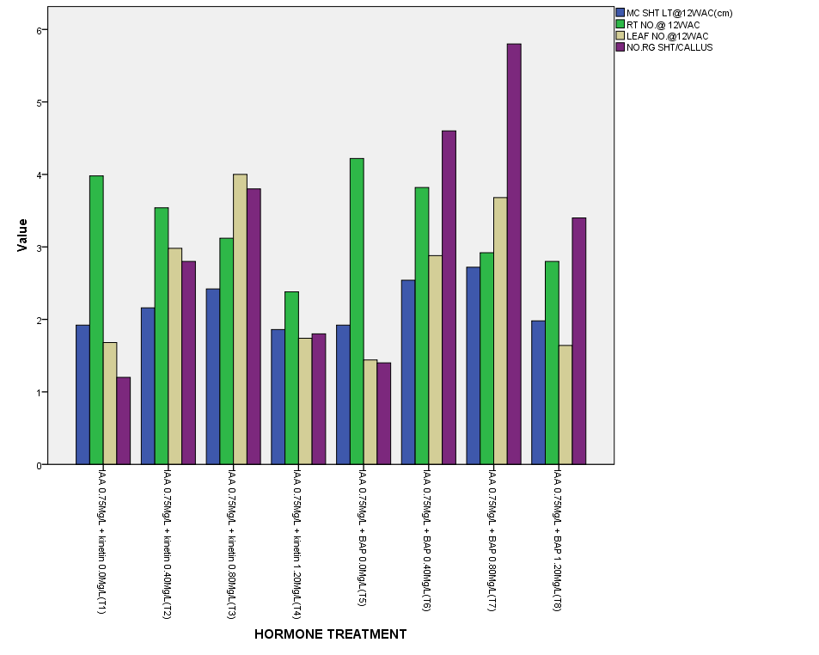

Figure 1. Mean values of tissue and organ characteristics of *D. cayenensis* under different plant growth hormone-treatments.

Table 1. Morphological traits of *D. cayenensis* as affected by phytohormones combinations and concentrations.

|  |  |  |  |  |  |  |  |  |
| --- | --- | --- | --- | --- | --- | --- | --- | --- |
| HORMONE TREATMENT | DTE | NRS/C | MSL@9WAC(CM) | MSL@12WAC(CM) | NR@9WAC | NR@12WAC | NL@9WAC | NL@12WAC |
| MS + IAA 0.75Mg/L + Kinetin0.0Mg/L(TI) | 36.2 | 1.2 | 0.92 | 1.92 | 3.04 | 3.98 | 0.70 | 1.68 |
| MS + IAA 0.75Mg/L + Kinetin0.40Mg/L(T2) | 32.8 | 2.8 | 1.42 | 2.16 | 2.22 | 3.54 | 1.52 | 2.98 |
| MS + IAA0.75Mg/L + Kinetin0.80Mg/L(T3) | 29.8 | 3.8 | 1.54 | 2.42 | 2.10 | 3.12 | 2.06 | 4.00 |
| MS + IAA0.75Mg/L + Kinetin1.20Mg/L(T4) | 35.0 | 1.8 | 1.12 | 1.86 | 1.66 | 2.38 | 0.78 | 1.74 |
| MS + IAA0.75Mg/L + BAP 0.0Mg/L(T5) | 37.6 | 1.4 | 0.90 | 1.92 | 3.40 | 4.22 | 0.76 | 1.44 |
| MS + IAA0.75Mg/L + BAP 0.40Mg/L(T6) | 31.4 | 4.6 | 1.22 | 2.54 | 2.68 | 3.82 | 1.28 | 2.88 |
| MS + IAA0.75Mg/L + BAP 0.80Mg/L(T7) | 27.0 | 5.8 | 1.80 | 2.72 | 1.98 | 2.92 | 1.72 | 3.68 |
| MS + IAA0.75Mg/L + BAP 1.20Mg/L(T8) | 34.2 | 3.4 | 1.02 | 1.98 | 1.80 | 2.80 | 0.62 | 1.64 |
| MEAN | 33.0 | 3.1 | 1.24 | 2.19 | 2.36 | 3.35 | 1.18 | 2.51 |
| LSD(0.05) | 1.35 | 1.02 | 0.109 | 0.147 | 0.30 | 0.290 | 0.330 | 0.317 |
| CV (%) | 1.20 | 8.30 | 3.90 | 2.70 | 2.60 | 3.90 | 7.80 | 5.80 |

DTE = Number of days to shoot emergence, NRS/C = Number of regenerated shoot per callus, WAC = Weeks after culturing, MSL@9WAC (cm) = Micro shoot length at 9 WAC, MSL@12WAC(cm) = Micro shoot length at 12 WAC, NR@9WAC =Number of roots at 9WAC, NR@12WAC = Number of roots at 12WAC, NL@9WAC = number of leaves at 9WAC, NL@12WAC = number of leaves at 12WAC

Table 2. Mean values of agronomic traits of *D. cayenensis* under different phytohormones concentrations and combinations

|  |  |  |  |  |  |
| --- | --- | --- | --- | --- | --- |
| HORMONE TREATMENT | MC.SHT.LT @12WAC(Cm) | RT NO@12WAC | LEAF NO@12WAC | NO.RG SHT/CALLUS | MEAN |
| MS + IAA 0.75Mg/L + Kinetin0.0Mg/L(TI) | 1.92 | 3.98 | 1.68 | 1.2 | 2.195 |
| MS + IAA 0.75Mg/L + Kinetin0.40Mg/L(T2) | 2.16 | 3.54 | 2.98 | 2.8 | 2.870 |
| MS + IAA0.75Mg/L + Kinetin0.80Mg/L(T3) | 2.42 | 3.12 | 4.00 | 3.8 | 3.335 |
| MS + IAA0.75Mg/L + Kinetin1.20Mg/L(T4) | 1.86 | 2.38 | 1.74 | 1.8 | 1.945 |
| MS + IAA0.75Mg/L + BAP 0.0Mg/L(T5) | 1.92 | 4.22 | 1.44 | 1.4 | 2.245 |
| MS + IAA0.75Mg/L + BAP 0.40Mg/L(T6) | 2.54 | 3.82 | 2.88 | 4.6 | 3.460 |
| MS + IAA0.75Mg/L + BAP 0.80Mg/L(T7) | 2.72 | 2.92 | 3.68 | 5.8 | 3.780 |
| MS + IAA0.75Mg/L + BAP 1.20Mg/L(T8) | 1.98 | 2.80 | 1.64 | 3.4 | 2.455 |

Table 3. Pearson correlation matrix of some traits of *D. cayenensis* explant evaluated under different phytohormones concentrations.

|  |  |  |  |  |  |  |  |  |
| --- | --- | --- | --- | --- | --- | --- | --- | --- |
| ORGAN TRAIT | 1 | 2 | 3 | 4 | 5 | 6 | 7 | 8 |
| 1) No. of days to shoot emergence | 1 |  |  |  |  |  |  |  |
| 2) No. of regenerated shoot per callus | -0.93** | 1 |  |  |  |  |  |  |
| 3) Micro shoot length @9WAC | -0.95** | 0.79* | 1 |  |  |  |  |  |
| 4) Micro shoot length @12WAC | -0.93** | 0.93** | 0.84** | 1 |  |  |  |  |
| 5) Root no.@ 9WAC | -0.50 | -0.43 | -0.50 | -0.18 | 1 |  |  |  |
| 6) Root no. @ 12WAC | -0.38 | -0.31 | -0.38 | -0.06 | 0.96** | 1 |  |  |
| 7) Leaf no. @ 9WAC | -0.84** | 0.67* | 0.90** | 0.80* | -0.26 | -0.12 | 1 |  |
| 8) Leaf no. @ 12WAC | -0.92** | 0.74* | 0.93** | 0.87** | -0.33 | -0.18 | 0.98** | 1 |

**.Correlation is significant at the 0.01 level (2-tailed), *.Correlation is significant at the 0.05 level (2-tailed)

However, significant and positive relationship were found between micro shoot length at 12 WAC and leaf number at 9 and 12 WAC (r = 0.80** and r = 0.87** respectively). Conversely, it recorded negative correlation with root number at 9 and 12 WAC (r = -0.18 and r = -0.06 respectively). Similarly, negative but non-significant correlation were observed between root number at 12 WAC and leaf number at 9 and 12 WAC (r = -0.26 and r = -0.33 respectively). The result obtained from coefficient of variation (CV) shows that most of the CV estimates are very low to moderate. Number of days to emergence had the lowest CV value (1.20%), followed by number of root at 9 WAC that had 2.60%. Highest CV estimate however, were recorded in number of regenerated shoot per callus (8.30%) and number of leaves at 9 WAC (7.80%).

**Rank summation index (RSI):** All the traits obtained from different plant growth hormone treatments were used in the construction of RSI in order to identify the best performers based on the results of the rank summation index (Table 4). The result recorded shows that plantlets in MS + IAA0.75Mg/L + BAP 0.80Mg/L(T7) are overall best performers with rank summation index value of 20. This is followed by MS + IAA0.75Mg/L + Kinetin0.80Mg/L(T3), whose plantlets had RSI value of 22 and plantlets in MS + IAA0.75Mg/L + BAP 0.40Mg/L(T6) that recorded 25 as the RSI value. However, plantlets in MS + IAA0.75Mg/L + Kinetin1.20Mg/L(T4) are the least performers of all the plantlets in plant growth hormones studied with the RSI value of 51.

**Discussion**

Auxin and cytokinin control events of major cell specification during embryogenesis and this research study showed that the hormonal content and concentration of the nodal explant culture medium had a strong impact on their growth pattern. Among the treatment media, the medium containing MS + IAA0.75Mg/L + BAP 0.80Mg/L(T7) and MS + IAA0.75Mg/L + Kinetin0.80Mg/L(T3) broke dormancy of lateral buds and induced earlier emergence of *D. cayenensis* (27.0 and 29.8days in T7 and T3 respectively), compared to the other treatment media. This is consistent with the earlier insights perceived by Torres (1989) who reported that optimum concentration of plant growth hormones is effective in inducing shoot emergence. However, increasing the concentrations of BAP and Kinetin in the media from 0.0mg/L to 0.80mg/L reduced the number of days to emergence, but increased it at higher concentrations. Again, Charles and Edward (1996) supported this finding when they reported that phytohormones may act as both stimulators and inhibitors of growth and cause different plant parts to respond differently. According to them, at low concentrations, phytohormones stimulate cell enlargement, whereas at higher concentrations, it inhibits enlargement or is even toxic to cells emergence. Synergy between BAP/kinetin and IAA exhibited positive effect in the number of regenerated shoot per callus, micro shoot length at 9 and 12 WAC and number of leaves at 9 and 12WAC. Generally, regenerated shoot numbers, micro shoot length at 9 and 12 WAC and number of leaves at 9 and 12WAC were very low in MS + IAA 0.75Mg/L + Kinetin0.0Mg/L(TI) and MS + IAA0.75Mg/L + BAP 0.0Mg/L(T5) and highest in MS + IAA0.75Mg/L + BAP 0.80Mg/L(T7), MS + IAA0.75Mg/L + BAP 0.40Mg/L(T6), and MS + IAA0.75Mg/L + Kinetin0.80Mg/L(T3).

Table 4. Plantlets characteristics, their ranks and rank summation index under different phytohormones concentration.

|  |  |  |  |  |  |  |  |  |  |  |  |  |  |  |  |  |  |  |
| --- | --- | --- | --- | --- | --- | --- | --- | --- | --- | --- | --- | --- | --- | --- | --- | --- | --- | --- |
| HORMONE TREATMENT | DTE | R1 | NRS/C | R2 | MSL@9WAC (cm) | R3 | MSL@12WAC (cm) | R4 | NR@9WAC (cm) | R5 | NR@12WAC | R6 | NL@9WAC | R7 | NL@12WAC | R8 | RSI |  |
| MS + IAA 0.75Mg/L + BAP 0.80Mg/L(T7) | 27.00 | 1 | 5.80 | 1 | 1.80 | 1 | 2.72 | 1 | 1.98 | 6 | 2.92 | 6 | 1.72 | 2 | 3.68 | 2 | 20 |  |
| MS + IAA 0.75Mg/L + Kinetin 0.80Mg/L(T3) | 29.8 | 2 | 3.8 | 3 | 1.54 | 2 | 2.42 | 3 | 2.10 | 5 | 3.12 | 5 | 2.06 | 1 | 4.00 | 1 | 22 |  |
| MS + IAA 0.75Mg/L + BAP 0.40Mg/L(T6) | 31.4 | 3 | 4.6 | 2 | 1.22 | 4 | 2.54 | 2 | 2.68 | 3 | 3.82 | 3 | 1.28 | 4 | 2.88 | 4 | 25 |  |
| MS + IAA 0.75Mg/L + kinetin 0.40Mg/L(T2) | 32.80 | 4 | 2.80 | 5 | 1.42 | 3 | 2.16 | 4 | 2.22 | 4 | 3.54 | 4 | 1.52 | 3 | 2.98 | 3 | 30 |  |
| MS + IAA 0.75Mg/L + BAP 0.0Mg/L(T5) | 37.6 | 8 | 1.40 | 7 | 0.90 | 8 | 1.92 | 6 | 3.40 | 1 | 4.22 | 1 | 0.76 | 6 | 1.44 | 8 | 45 |  |
| MS + IAA 0.75Mg/L + Kinetin 0.0Mg/L(T1) | 36.2 | 7 | 1.20 | 8 | 0.92 | 7 | 1.92 | 7 | 3.04 | 2 | 3.98 | 2 | 0.70 | 7 | 1.68 | 6 | 46 |  |
| MS + IAA 0.75Mg/L + BAP 1.20Mg/L(T8) | 34.20 | 5 | 3.40 | 4 | 1.02 | 6 | 1.98 | 5 | 1.80 | 7 | 2.80 | 7 | 0.62 | 8 | 1.64 | 7 | 49 |  |
| MS + IAA 0.75Mg/L + kinetin 1.20Mg/L(T4) | 35.00 | 6 | 1.80 | 6 | 1.12 | 5 | 1.86 | 8 | 1.66 | 8 | 2.38 | 8 | 0.78 | 5 | 1.74 | 5 | 51 |  |

DTE = Number of days to shoot emergence, NRS/C = Number of regenerated shoot per callus, WAC = Weeks after culturing, MSL@9WAC(cm) = Micro shoot length at 9 WAC, MSL@12WAC(cm) = Micro shoot length at 12 WAC, NR@9WAC =Number of root at 9WAC, NR@12WAC = Number of root at 12WAC, NL@9WAC = Number of leaves at 9WAC, NL@12WAC = Number of leaves at 12WAC, R1 to R8 = Rank1 to Rank 8, RSI = Rank Summation Index, MS = Murashige and Skoog.

The low recorded results might have been observed as a result of absence of kinetin and BAP in the media, hence explants in the media experienced strong inhibitory physiological effect and thus produce a lower vegetative growth. However, highest numbers observed in T7, T6 and T3 may be attributed to the presence of optimum concentrations of BAP/kinetin that exhibited promotive effect on shoot proliferation and development. This observation is in agreement with Ammirato (2004) experimental reports that affirmed that in *D. bulbifera* and *D. alata*, cytokinin at moderate concentrations enhanced shoot development. Furthermore, George and Sherington (1962) reported that BAP and kinetin belong to the cytokinin group and known to induce shoot formation from excised plant tissues. It was therefore observed that cytokinin is required in optimal quantity for shoot proliferation in *D. cayenensis*, but addition of low concentration of auxins along with cytokinins triggered shoot proliferation. The auxin–cytokinin cross-talk controls the shoot parameters development. Several studies have shown that cytokinin and auxin mutually regulate their signaling pathways or their metabolisms through certain integrators, which are the basis of interaction between these two hormones to determine a specific developmental output in shoot parameters (Charles and Edward, 1996; Opabode and Adebooye, 2005). The decrease in the number of roots with an increasing concentration of BAP and kinetin in the media is an indicative of a possible overdose. Similar results were reported by Okezie *et al*. (1994) in white yam. Contrarily however, the profuse and highest number of roots observed in media; MS + IAA 0.75Mg/L + Kinetin0.0Mg/L(TI) and MS + IAA0.75Mg/L + BAP 0.0Mg/L(T5) was attributed to the absence of kinetin and BAP which are class of cytokinin that inhibits rooting. Similar results were obtained by Jova *et al*. (2005) who reported that efficient rooting was observed on MS medium + 2.67µMIAA. Furthermore, Pennel, (1982) asserted that, to induce rooting, plantlets are transferred to a media which has no cytokinin present. The highly significant and negative difference correlation between number of days to shoot emergence and number of regenerated shoot per callus, micro shoot length, number of roots and number of leaves suggest that the longer it takes the explants to emerge or sprout into plantlets, the shorter or fewer are the parameters listed. Conversely, the significant and positive correlations recorded between number of regenerated shoot per callus and micro shoot length and number of leaves indicate that as the number of regenerated shoot per callus increases, the micro shoot length and number of leaves increased, vice versa. This is in agreement with Chen *et al*. (1985) research reports that averred that Cytokinins and auxins are involved in many plant processes, including cell division and shoot and morphogenesis. The negative correlation obtained between number of roots and number of leaves is an indication of an inverse relationship between the two traits. This is consistent with the earlier insights perceived by Campbell *et al*. (2008) that the ratio of auxin to cytokinin plays an important role in the effect of cytokinin on plant growth. According to them, Cytokinin alone has no effect on parenchyma cells. When cultured with auxin but no cytokinin, they grow large but do not divide. When cytokinin is added, the cells expand and differentiate. When cytokinin and auxin are present in equal levels, the parenchyma cells form an undifferentiated callus. More cytokinin induces growth of shoot buds, while more auxin induces root formation.

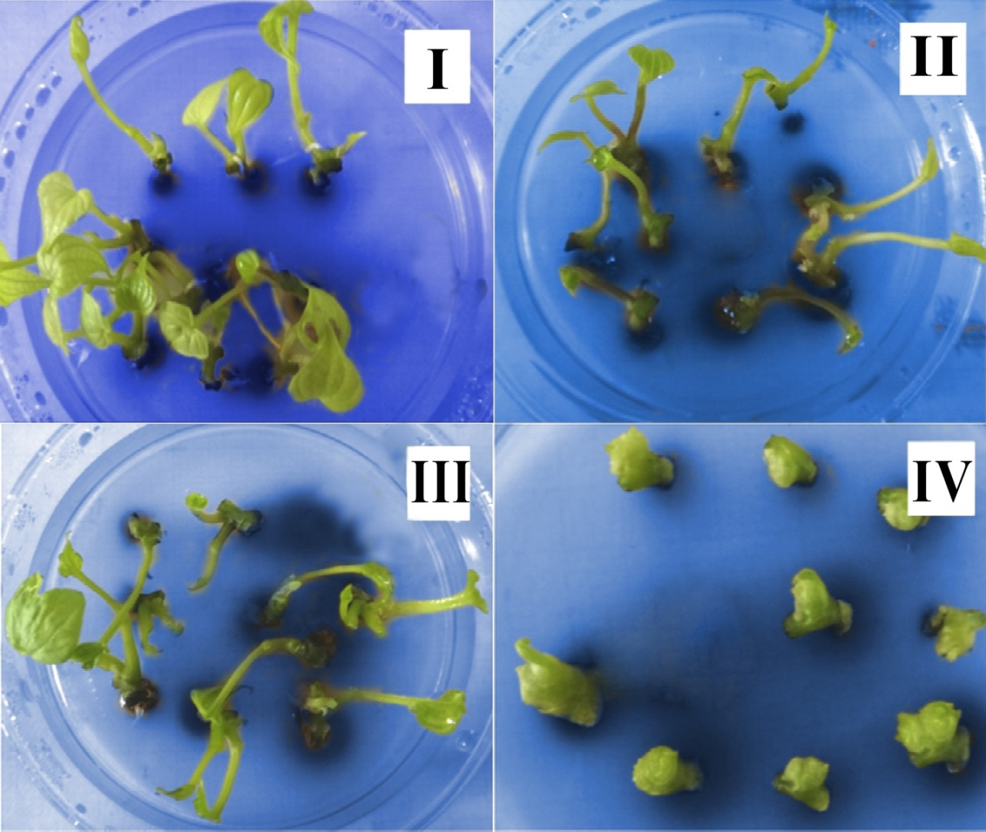

Figure 1: Plant regeneration via nodal stem segments of *Dioscorea cayenensis*.(I)Plantlets with the highest number of leaves culturedonMS + IAA0.75Mg/L + Kinetin0.80Mg/L (T3) at 12 weeks after culturing (WAC).(II) The averagenumber of leaves at 12 WAC,onMS + IAA0.75Mg/L + BAP 0.0Mg/L (T5)*.* (III) Highest Micro shoot length at 12 WAC on media, MS + IAA0.75Mg/L + BAP 0.80Mg/L (T7).(IV)Less developed shoots length obtained on medium, MS + IAA0.75Mg/L + BAP 0.0Mg/L (T5) at 12WAC*.*

The identification of the best medium within the best media supports the usefulness of a selection index, in this case RSI for selection purposes (Ngwuta *et al*., 2002; Onyishi *et al* 2013). The best media identified by the RSI are the media with ideal concentrations of BAP and kinetin in combination with IAA, whereas the worst are the media with either low or very high BAP/kinetin concentrations. Selection of the two top plant growth hormone concentrations and combinations (representing 25% of the total media) comprised MS + IAA0.75Mg/L + BAP 0.80Mg/L(T7) and MS + IAA0.75Mg/L + Kinetin 0.80Mg/L(T3), thus are regarded as the best media for culturing *D. cayenensis* in this experiment. The coefficient of variation (CV) which is a useful statistic for comparing the degree of variation from one data series to another, even if the means are drastically different from each other (Harriman, 2012; Harriman, *et al*. 2014) indicated that highest variation was observed in number of regenerated shoot per callus and number of leaves at 9WAC. Least variation was recorded in number of day to shoot emergence.

**Conclusion**

*Dioscorea cayenensis* can be successfully induced via tissue culture for number of shoot, number of leaves and shoot length in this work. The media; MS + IAA0.75Mg/L + BAP 0.80Mg/L(T7), MS + IAA0.75Mg/L + BAP 0.40Mg/L(T6), and MS + IAA0.75Mg/L + Kinetin0.80Mg/L(T3) were found to be the best media for regeneration of *D. cayenensis.* However, the media; MS + IAA 0.75Mg/L + Kinetin0.0Mg/L(TI) and MS + IAA0.75Mg/L + BAP 0.0Mg/L(T5) inhibited induction of micro shoot length, number of shoots and number of leaves. The regeneration protocol can be utilized for non-traditional in vitro breeding techniques in *D. cayenensis.*

**References**

1. Ammirato, P.V.(2004). Yams. In : Ammirato, P.V., Evans, D.A., Sharp, W.R. and Yamada, Y. Eds. Handbooks of plant cell culture. Vol 3: Macmillan New York. Pp. 329-354.
2. Anon (2011). Commercial crop production guide series: Growing yams in Nigeria. Information and communication support of agricultural growth in Nigeria. P.17.
3. Araki, H., Harada, T. and Yakuwa, T. (1987). Studies on the botanical characteristics of genus Dioscorea v. Development of capsule, seed and embryo of *Dioscorea opposite* CV. Nagaimo and possibility of embryo culture. Mem. Fac. Agric. Hokkaido Univ. 15:133-139.
4. Ayensu, E.S. (1972). Anatomy of the monocotyledons VI *Dioscoreales*. Oxford press, Oxford. P.182.
5. Campbell, N.A., Reece, J.B., Urry, L.A., Cain, M.L., Wasserman, S.A., Minorsky, P.V. and Jackson, R.B. (2008). *Biology* (8th ed.). San Francisco: Pearson, Benjamin Cummings. pp. 827–30.
6. CGIAR (2014). Research Programme on Roots, Tubers and Banana. Consultative Group on International Agricultural Research Paper Bulletin. P.4.
7. Charles, L. H. and Edward, S.O. (1996). Plant growth regulators: their use in crop production. North Central Region Extension Publication, US. Pp.303.
8. Chen, C.M., Ertl, J.R, Leisner, S.M. and Chang, C.C. (1985). ["Localization of cytokinin biosynthetic sites in pea plants and carrot roots"](http://www.plantphysiol.org/cgi/pmidlookup?view=long&pmid=16664274). *Plant Physiol.* **78** (3): 510–3.
9. Edison, S., Unnikrishnan, M., Vimala, B., Santha, P.V., Sheela, M.N., Sreekumari, M.T. and Abraham, K. (2006). Biodiversity of tropical tuber crops in India, *NBA Scientific Bulletin No*.*3. National biodiversity Authority*. Chennai, India. P.60.
10. Ezeibekwe, L.O., Ezenwaka, C.L., Mbagwu, F.N. and Unamba, C.I.N. (2009). Effects of combination of different levels of auxin (NAA) and cytokinin (BAP) on *in vitro* propagation of *Dioscorea rotundata* L. (white yam). *New York Science Journal*. 2(5): 1554-2000.
11. FAOSTAT (2013). Food and Agricultural Organization Statistics Division. Retrieved 17 June 2011.
12. Forssyth, C. and Van, S.J. (1982). An improved method of in vitro propagation of *Dioscorea bulbifera*, *Plant Cell Tissue Organ Cult*. 1: 275-281.
13. Gedil, M. and Sartie, A. (2010). Perspective on molecular breeding of Africa’s main staple food crops-cassava and yam. *Aspects Appl. Biol*. 96.123-135.
14. Genstat (2012). Genstat for Windows, discovery, 12th edition. Lawes Agricultural Trust, Rothamsted Experimental Station. UK.
15. George, E.F. and Sherington, P.D. (1962). A revised medium for rapid growth and bioassays with tobacco tissue cultures. *Physiol. Plant*. 15 : 473-492.
16. Harriman, J.C., (2012). Evaluation of some maize genotypes for acceptability and performance in stem borer endemic agro-ecology. An M.Sc. Thesis of the Department of Crop Science, Federal University of Technology, Owerri.
17. Harriman, J.C., Ngwuta, A.A., Onyishi, G.C., Nze, E. O., Orji, J.O. and Ndulue, N.K. (2014). Genotypic Performance of 15 Maize Cultivars for Stem Borer Resistance In Owerri West, South Eastern Nigeria. *International Journal of Advanced Research*, Volume 2, Issue 8, 800-815.
18. IITA (2011). Production efficiency in yam based enterprises in Ekiti State, Nigeria. *Journal of Central European Agriculture*. Pp. 627-634.
19. Isidro, E.S.P., Luz Angela, T.A. and Richard, L.Y., (2011). Somatic embryogenesis in yam (*Dioscorea rotundata*). *Rev. Fac. Nal. Agric. Medelin* Vol.64 no.2.
20. Jova, M.C., Kosky, R.G., Perez, M.B., Pino, A.S. and Vega, V.M.(2005). Production of yam micro tubers using a temporary immersion system. *Plant cell Tiss. Org. cult*. 83:103-107.
21. Mantell, S.H., Haque, S.Q. and White, A.P., (1978). Clonal multiplication of *D. alata* L and *D. rotundata* Poir. Yams by tissue culture. *Journal of Horticultural Science* 53: 95-98.
22. Mignouna, H., Abang, M., Green, K. and Asiedu, R. (2001). Inheritance of resistance in water yam (*Dioscorea alata*) to anthracnose (*colletotrichum gloeosporioides*). *Theoretical and Applied Genetics*. 103 (1): 52-55.
23. Murashige, T. and Skoog, F. (1962). A revised medium for rapid growth and bioassays with tobacco tissue cultures. *Physiologia plantarum* 15: 473-479.
24. Ng, S.Y.C.(1988). *In vitro* tuberization in white yam (*Dioscorea rotundata* Poir). In: Bajaj YPS, editor. *Biotechnology in Agriculture and Forestry.* Vol.19. High tech and micropropagation III Springer- Verlog. Berlin , Germany. Pp. 135-159.
25. Ngwuta, A.A., (2007). Evaluation of thirteen cultivars of bambara groundnut (Vigna subterranean L Verdc.) in Umudike, rainforest agroecological area of Nigeria. *International Journal of Agriculture and Rural Development.* 9: 120-122.
26. Ngwuta, A.A., Ajala, S.O., Obi, I.O. and Ene-Obong, E.E. (2001). Potential sources of resistance to maize stem borers (*Sesamia calamistis* (Hampson)) and (*Eldana saccharina* (Walker)) in local maize populations of south-eastern Nigeria. *African Crop Science Proceedings*, vol. 5: 23-28.
27. Okezie,C., Okonkwo, S. and Nwoke, F. (1994). Carbon source requirement for the culture of white yam (*Dioscorea rotundata*) embryos *in vitro. Acta Horticulturae* 380: 329-334.
28. Onyishi, G.C., Harriman, J.C., Ngwuta, A.A., Okporie, E.O. and Chukwu, S.C. (2013). Efficacy of some cowpea genotypes against major insect pests in southeastern agro-ecology of Nigeria. *Middle-East Journal of Scientific Research* 15(1): 114-121.
29. Opabode, J.T. and Adebooye, O.C. (2005). Application of biotechnology for the improvement of Nigerian indigenous vegetables. *Afri. Biotechnol*. 4(3): 138-142.
30. Pennel, D. (1982). Introduction to the micropropagation of horticultural crops. Ministry of Agriculture, Fisheries and food, Booklet 2413. *ADAS Nursery Stock Group*. UK.
31. Saka, J.O., Ajibade, S.R., Adeniyan, O.N., Olowoyo, R.B. and Ogunbodede, B.A. (2004). Survey of under-utilized crops production systems in South-Western Agricultural zone of Nigeria. *J. Agric. Food Inform*. 6(2/3): 93-108.
32. SPSS (2007). Statistical package for social sciences. A statistical analysis software.
33. Tor, M., Twyford, C.T., Funes, I., Boccon-Gibod, J., Ainsworth, C.C. and Mantell, S.H. (1998). Isolation and culture of protoplasts from immature leaves and cell suspension of Dioscorea yams. Tools for transient gene expression studies. *Plant cell Tiss. Org. cult*. 53: 113-125.
34. Torres, K.C. (1989). Tissue culture techniques for horticultural crops. AVI Book, New York.

10/23/2014