Rate Of Color Change In The Skin Of Common Carp, Cyprinus Carpio As A Background Adaptation

Roohi Gulzar, Aadil Yaqoob* & Ajai K Jain

Pigment Cell Biology Unit, School of Studies in Zoology, Jiwaji University, Gwalior-474011, India
Email: syedaadil99@gmail.com; Phone: +919419357003

Abstract: The background adaptation of the common carp, Cyprinus carpio was studied by subjecting the fish to two different backgrounds, white and black. The fish showed a light brownish tint when adapted to their maximum to a white background while as the black- adapted fish were not easily distinguished from their dark background. The examination of rates of paling and darkening in the normal fish as a result of white and black- background adaptation furnish evidence of the existence of a relatively rapid type of chromatic behaviour co-ordinated by both the nervous as well as the hormonal agencies co-existing in the regulatory organization of the melanophore activities responsible for the chromomotor colour changes in the fish. The initial faster chromatic response in either of the backgrounds clearly suggests a nervous co-ordination responsible for initiation of the chromatic response. The subsequent prolonged phase of a slow and gradual nature points to a hormonal mechanism operating simultaneously in this fish.
[Roohi Gulzar, Aadil Yaqoob & Ajai K Jain. Rate Of Color Change In The Skin Of Common Carp, Cyprinus Carpio As A Background Adaptation. N Y Sci J 2014;7(10):91-96]. (ISSN: 1554-0200). http://www.sciencepub.net/newyork. 16

Keywords: colour change, background adaptation, chromatophore, Cyprinus carpio.

Introduction
God has created the world very beautiful with living creatures bearing attracting colours like insects, fish, amphibians, reptiles, birds etc. which have stimulated the esthetic sense of man since the dawn of civilization. . It has been a topic of interest and research in biology since the time of Aristotle, who dealt with so many areas of science and focused his attention on the remarkable colour changes of fishes and lizards. The naturalist made the first thorough study on the colour changes of the African chameleon. The controlled chromomorphism of the skin is a characteristic employed by several organisms for active camouflage and, as argued by Messenger (2001), for communication. Octopuses for example use the tight neuro-muscular interaction of brain impulses with chromomorphic skin cells to generate extremely sophisticated visual patterns that run along their bodies for the purposes of social interaction. Cephalopods such as the common cuttlefish, Sepia officinalis also rely on the effectiveness of their chromomorphic appearance to disrupt or confuse the visual attention of natural predators (Cornwell et al., 1997, Hanlon 2007, Allen et al., 2009). These colour changes occur due to the presence of the pigment cells known as chromatophores. The assertion of Brucke (1852) that colour change in the chameleon is controlled by nerves and the speculation of Paul Bert in 1875 that two sets of fibres are involved set the stage for a vast research field of colour change to come somewhat later. Active investigation was stimulated by the studies of Alfred Redfield on the horned toad, Phrynosoma. His research established the fact that the melanin pigment in special type of chromatophores i.e., melanophores, is brought about by nerve impulse delivered to the pigment cells by the sympathetic nervous system and the secretion of adrenin by the adrenal glands (Redfield 1916, 1918). Likewise, fishes undergo rapid colour changes, which have been elaborately evolved during the long history of evolution (over 400 million years) and are specially remarkable in bony-fish (Parker, 1948; Waring, 1963; Fujii, 1969; Bagnara and Healey, 1973).
Chromatophores are cells containing pigment granules whose dispersal or aggregation is under hormonal and / or neural control. In lower vertebrates, chromatophores are generally found in the dermis of the integument. In response to various stimuli, the pigment in these cells is transported to or from the center of the cell. Change in the distribution of pigment permits the animal to display variations in colour. The chromatic phenomenon in teleosts has ethological significance. In fact, the cryptic colouration as well as the visual communication through colour changes may be of utmost importance for fishes. Fishes require very precise control of their integumentary chromatophores as their survival depends on them in a broad sense. The fish,Cyprinus carpio also utilizes cryptic colouration in order to protect itself in its habitat.

Materials and Methods
Fish Used
The fish, Cyprinus carpio, commonly known as common carp was used for the experimental purpose. Fish were procured from a private fish farm in Sagar Taal, about 10 Km away from the Jiwaji University, within the area of the Gwalior city during the months of January – March 2011 and were divided in three groups, 10 in each aquarium of size 30×30×60 cm. Dechlorinated water treatment was given to the fish, keeping in aquaria. Fish were of either sex with average weight and length of 10 grams and 8.5 cm respectively. They were given a period of acclimatization for a week, to make them suitable for experimental work and were daily fed with commercial fish diet with all essential nutrients. During the experiments, feeding was avoided. Temperature ranged from 17-28 ⁰C.

Munsell Grey Series Index Numbers (In vivo estimation of colour change)
Munsell Grey Series (Fig.1) has a colour range from perfect black to perfect white, including 18 colour standards which are arbitrarily numbered between 1 and 9 with half step resolutions in between as 1.5, 2.5 and so on. 1 represents the maximal darker shade while 9 represents the maximal lighter shade. This entire scale in itself is able to take care of the possible paling or darkening that the most fresh-water fish species may undergo in natural background conditions if adapted to white or black backgrounds in laboratory under artificial lighting conditions.
The nine rectangular stripes were cut and mounted on a wooden plate (27×10× 0.7 cm) in a linear fashion starting from index 1 to 9. In a row below to this, similarly nine more stripes were arranged linearly but with a reverse order i,e., from 9 to 1 for convenience of matching the fish. Two such wooden boards were used. One was painted black and the other white with synthetic enamel paints before the stripes were mounted on. To avoid any error which may creep in and to avoid the simultaneous contrast in recordings while the fish is in black background, the board having black background and for the fish to be studied in white background, the board having white background was employed to record the degree of colour change in the studied fish.
With its use it was possible to read off with considerable speed a given colour stage shown by the fish by matching the Index Number against general tint of dorsal surface of the fish (behind head and anterior to the origin of dorsal fin, as the same showed uniform chromatic response during paling or darkening phase of the process of colour change) with naked eye. The method is convenient as it doesn’t involve handling of the fish during observations and thus colour change and colour deviation due to physical disturbances are avoided that otherwise may affect the chromatic response in the fish.

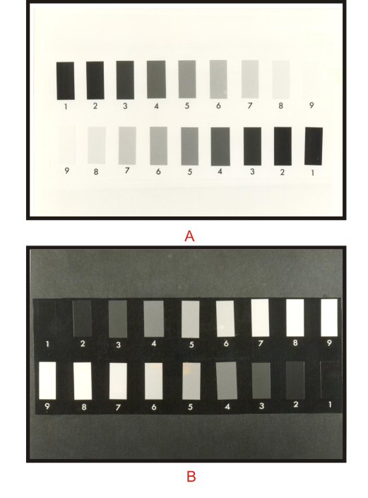
Figure 1. Photograph showing the M.C.I (Munsell Colour Index) scale used in measuring the melanophore responses of the fish in vivo.
(A) To be used while recording observations on an illuminated white background.
(B) To be used while recording observations on an illuminated black background.
The degree of brightness is expressed as the Index Number in the Munsell Grey Scale, in which black and white correspond to 1 to 9, respectively.

Background related colour response or chromotor colour change
In order to study the colour changes of skin to background tones in light, healthy fishes from the stock tank placed in natural light condition were taken out and placed in white/black background with overhead illumination (40 watt bulb). Five fishes as an experimental group were first weighed and then placed for a period of 24 hours in a round glass trough (30.5 cm diameter) painted black on the outer walls and covered at top with black cotton net tied on the outer rim of the trough so as to serve as the black background. To study the rate of paling these black adapted fish from the trough were gently and cautiously transferred to a white painted glass trough serving as white background. The pre-experimental shade was recorded using Munsell grey series colour standards before transfer. The colour changes were recorded at regular intervals of time until no further change was noticed for a considerable time period and allowed to remain in there for 24 hours so as to adapt the fish to their maximum on this background.
To study the rate of darkening the white-adapted fish were similarly transferred to a black trough and the same procedure as mentioned above was followed for recording the observations until no further change in their shade was noticed for a considerable time period. The fish adapted to 24 hours were referred hereafter in the text appropriately as white or black-adapted fish.

Results
To study the background responses, the black or white-adapted fish, Cyprinus carpio (kept for 24 hours in their respective backgrounds) were interchanged with respect to the background. The fish showed a light brownish tint when adapted to their maximum to a white background, but the black- adapted fish are not easy to distinguish from their dark background. Black adapted fish having pre-experimental shade i.e., grade 2.2 of M.C.I, when placed to adapt on an illuminated white background attained a grade of 4.3 of M.C.I in first 10 minutes. Thereafter in 60 minutes of adaptation the fish acquired a grade of 6.4. The rate of paling became slow and the value reached to 6.5 in 3 hours, 6.6 and 6.9 in the 5 and 7 hours respectively. Subsequently, they attained the maximum grade of 7.3 M.C.I. when observed on the next day after 24 hours of adaptation (Table 1).
White-adapted fish having the pre-experimental shade i,e., grade 7.3, when transferred to black background, the rapid change in the fish turning the body tint to the darker side was observed. For the first 10 minutes, the rate of response was quick where the fish attained a grade of 5.7 and in 15 and 30 minutes, the grades attained were 5.4 and 5.9 respectively. Then in 1 hour, the fish attained a grade of 4.1 and thereafter the rate was slow and gradual with M.C.I. values of 3.3, 2.7 and 2.3 in 3, 5 and 7 hours respectively. After 24 hours of adaptation, the M.C.I. value reached to 2.1 (Table 2). Thus the grades within which the fish changes its colour ranges from 7.3 to 2.1, when subjected to adapt to a white and black background respectively (Fig. 2-5).

Table 1. Rate of paling in black adapted fish on being placed over a white background.
Time | Minutes |  |  |  | Hours
Fish No. | 0 | 10 | 15 | 30 | 1 | 2 | 3 | 5 | 7 | 24
1 | 2 | 4 | 5.5 | 6 | 6 | 6 | 6.5 | 6.5 | 7 | 7.5
2 | 2.5 | 4.5 | 5 | 5.5 | 6.5 | 6.5 | 6.5 | 7 | 7 | 7.5
3 | 2 | 4.5 | 5.5 | 6 | 6.5 | 6.5 | 6.5 | 6.5 | 6.5 | 7
4 | 2.5 | 4.5 | 5.5 | 6 | 6.5 | 6.5 | 6.5 | 6.5 | 7 | 7
5 | 2 | 4 | 5.5 | 6 | 6.5 | 6.5 | 6.5 | 6.5 | 7 | 7.5
Total | 11 | 21.5 | 27 | 29.5 | 32 | 32 | 32.5 | 33 | 34.5 | 36.5
Mean | 2.2 | 4.3 | 5.4 | 5.9 | 6.4 | 6.4 | 6.5 | 6.6 | 6.9 | 7.3
SD | 0.24 | 0.24 | 0.2 | 0.2 | 0.2 | 0.2 | 0 | 0.2 | 0.2 | 0.27

Table 2. Rate of darkening in white- adapted fish on being placed over a black background.
Time | Minutes |  |  |  | Hours
Fish No. | 0 | 10 | 15 | 30 | 1 | 2 | 3 | 5 | 7 | 24
1 | 7 | 5.5 | 5 | 4.5 | 4 | 3.5 | 3.5 | 2.5 | 2 | 2
2 | 7.5 | 5.5 | 4.5 | 4.5 | 4 | 3.5 | 3 | 2.5 | 2.5 | 2
3 | 7.5 | 6 | 5 | 4.5 | 4 | 3.5 | 3 | 3 | 2.5 | 2
4 | 7 | 5.5 | 5 | 5 | 4.5 | 4 | 3.5 | 3 | 2.5 | 2.5
5 | 7.5 | 6 | 4.5 | 4.5 | 4 | 3.5 | 3.5 | 2.5 | 2 | 2
Total | 36.5 | 28.5 | 24 | 23 | 20.5 | 18 | 16.5 | 13.5 | 11.5 | 10.5
Mean | 7.3 | 5.7 | 4.8 | 4.6 | 4.1 | 3.6 | 3.3 | 2.7 | 2.3 | 2.1
SD | 0.27 | 0.27 | 0.27 | 0.22 | 0.22 | 0.22 | 0.27 | 0.27 | 0.27 | 0.22

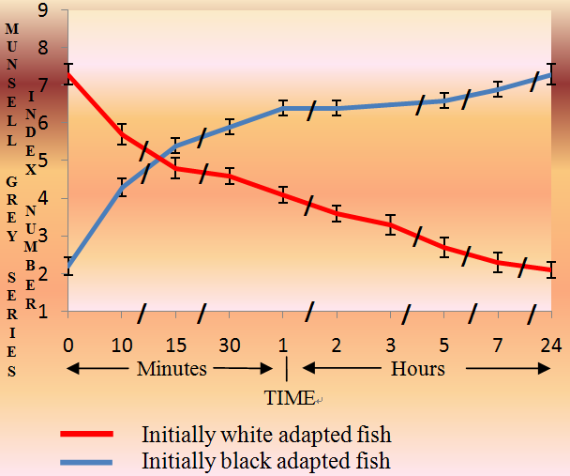
Figure 2. Change in body shade of black and white-adapted fish as a result of adaptation to white and black background with overhead illumination. The values are expressed as mean (5 fishes) ±S.D (vertical lines) of the mean.
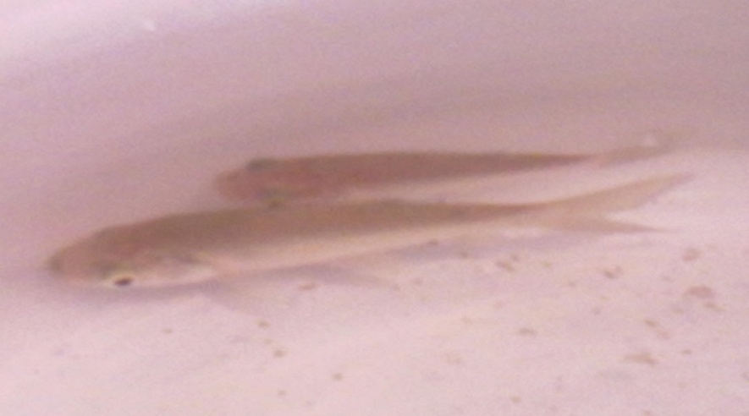
Figure 3. White background-adapted fish in white background.
Figure 4. Black adapted fish in black background.
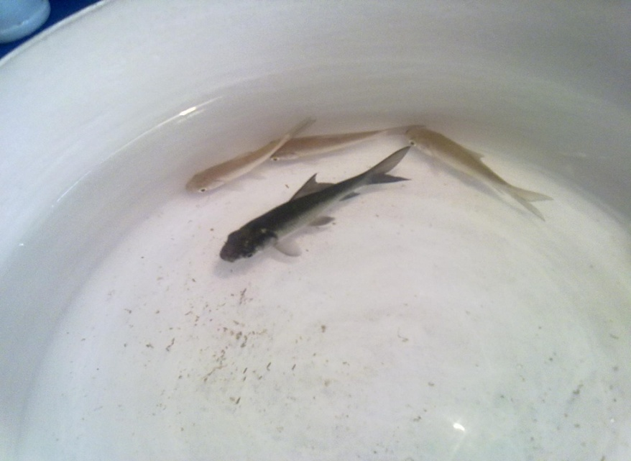
Figure 5. Black background-adapted fish along with white background adapted fish in white background.

Discussion
The results pertaining to the present study dealing mainly with elucidation of some aspects of neural control of melanophores, the dominant of the various pigment cell types in the exotic carp, Cyprinus carpio are consistent with earlier observations in this fish (Bhatnagar, 1985 and Chowdhary, 2003) that colour changes are accomplished in two phases, an initial rapid phase indicative of neural component and a later slow, gradual and prolonged phase suggestive of a synergistic hormonal component in the chromatic control co-ordinating mechanisms of the fish.
In both neural and hormonal regulation, the signals that trigger the reactions to generate efferent cues for the effector cells i.e., the chromatophores, either from the external environment or those from internal organs that do not influence the pigment cells directly, are processed in the CNS (Iwata and Fukuda, 1973; Fujii and Oshima, 1986; Baker, 1991; Fujii, 1993).
The “secondary chromatic responses” as recorded in the Cyprinus carpio (Fig. 2, Table 1 and 2) and suggestive of being controlled by the nervous system as well as the hormone(s) are, the usual chromatic adaptation mediated by the eyes. In the light, the fishes are either pale or dark (fig.3-5), with their colouring depending on their background: they are pale on a white background and dark on a black one. That is in a white-background which is irradiated from above the eyes of the fish receive in part light directly from the overhead source and in part the reflected light from the white background. When the fish is on a black background and illuminated from above, only the direct light from above enters its eyes because of the low level of light reflection from the black background. Thus it is quite clear that, the ratio of intensities of light from above and below (albedo) is probably the major factor which determines the colour of the integument.
In our observation in white adapted fish, both melanophores and xanthophores were found to be aggregated and both pigment cell types were dispersed in the black-adapted individuals. The iridophores are also found in large numbers but the responses of these chromatophores are quite slow in comparison to the other light-absorbing chromatophores. The varied colour changes of the integument may thus be based on the differences among chromatophore species with respect to sensitivity to neurotransmitters, hormones or light, the direction of pigment movement and the time required for a specific response, as inferred by Fujii and Oshima (1994) on surveying and reviewing the work done on various teleostean species.
Parker (1948) listed the time records taken by different teleosts for their change from one extreme to the other. Mollienisia latipinna (Pierce, 1941) takes 10-15 seconds to complete darkening and 20-50 seconds for complete paling. On the other hand, Amphipnous cuchia, has been reported to take 55 days to attain the maximum darkening possible in the fish and 9 days to achieve the maximum pallor (Bhargava and Shrivas, 1983).
Anguilla vulgaris, another fish belonging to the group of eels, requires 20 days for completing both the darkening as well as paling process. Neill (1940) stated that the rate of adaptation to white background is quite fast in Lebestis reticulatus and Salmo salar as they complete the process in 7 and 30 minutes respectively. However, they take 35 minutes and 10 hours for becoming fully dark over a black background in light. Parker and Brower (1937) stated that Fundulus heteroclitus takes 121.8 seconds for paling and 60 seconds for darkening. For Ameirus, the time reported for paling is 36 hours and for darkening the 19 hours. Healey (1940) assessed the rate of adaptation to white and black background in Phoxinus phoxinus which takes 1-2 days for maximum darkening.
Indian teleost, Rasbora daniconius has been shown to have a faster rate of paling and darkening on white and black backgrounds respectively and almost completes the process in just 3 hours (Yaqoob et al., 2013). Another fish, the Indian Percoid, Nandus nandus has also been shown to take 3 hours and 5 hours for adaptation to a white and black background. But in this fish the vertical bands which generally assume a darker shade than rest of the body (general body surface) takes a longer time (5 hours and 12 hours) in achieving the maximum pallor and the maximum darkening respectively (Jain, 1975).
The fishes which adapt to a white background also include two Indian catfishes namely, Clarias batrachus and Heteropneustes fossilis. These fishes require 10 and 20 hours and 60 and 100 hours for their complete adaptation over a white and a black background, respectively. A peculiar chromatic response than what is reported for other Indian fish species studied so far is a comparatively rapid response to a black background (taking 30 minutes for full adaptation) in Mystus vittatus (Bhargava et al., 1986).
Quoting the work of Neill (1940), Abbott (1973) have clearly stated that the complete background adaptation on 10 minutes or less in a species clearly shows that the melanophores are controlled entirely or predominantly by nervous agency and a greater time (more than 10 minutes) for complete adaptation points that melanophores are primarily under the influence of hormones.
The initial faster chromatic response in either of the backgrounds as has been observed in case of Cyprinus carpio (Fig. 2) clearly suggests a nervous co-ordination responsible for initiation of the chromatic response in this fish. The subsequent prolonged phase of a slow and gradual nature points to a hormonal mechanism operating simultaneously in the studied fish.
The examination of rates of paling and darkening in the normal fish, Cyprinus carpio as a result of white and black- background adaptation and effect of various drugs on the chromatic behaviour of the fish furnish evidence of the existence of a relatively rapid type of chromatic behaviour co-ordinated by both the nervous as well as the hormonal agencies co-existing in the regulatory organization of the melanophore activities responsible for the chromomotor colour changes in this fish (Gulzar et al., 2013). Further, the observations also indicate the fish, Cyprinus carpio in its chromatic physiology do not belong to the group of fishes (e.g. Fundulus and Oryzias) in which the complete melanophore responses are very rapid and mainly controlled by the nerves and the hypophyseal hormone has little effect (Kleinholz, 1935). It also cannot be included in the group of fishes (e.g. Anguilla and Amphipnous), where the melanophore responses are very slow taking days or weeks to complete, that are controlled mainly if not wholly by the hypophyseal hormone (Neill, 1940). Cyprinus carpio appears to occupy a position between Fundulus on one hand and Anguilla on the other, where the colour change is controlled by the effect of both the nerves and the hypophyseal hormones, as in Ameiurus (Wykes, 1938) and several other teleosts (Parker, 1948; Prabhakar, 1988 and Raina, 1993). Even in this group of fishes, a variation is recorded, in some it is the neural chromatic control that predominates while in others the control is predominantly hormonal. Further studies whereby the melanophores can be studied free of endogenous neural and/or hormonal influences (chemical sympathectomy and hypophysectomy) can pinpoint the exact role of these controlling mechanisms in the colour change behaviour of the fish under study.

Acknowledgements
Authors are highly thankful to the research scholars of Pigment Cell Biology Unit, School of Studies in Zoology, Jiwaji University, Gwalior for their help and co-operation.

*Corresponding author:
AADIL YAQOOB
Email: syedaadil99@gmail.com
Phone: +919419357003

References
- Abott, F. S. (1973). Endocrine regulation of pigmentation in fish. Am. Zool. 13: 885-894.
- Allen, J., Mathger L., Barbosa, A. and Hanlon, R. (2009). Cuttlefish use visual cues to control three-dimensional skin pappilae for camouflage. J. Comp. Physiol. A. 195: 547-555.
- Bagnara, J. T. and Hadley, M. E. (1973). Chromotophores and colour change, the comparative physiology of animal pigmentation. Prentice – Hall, Englewood cliffs, New Jersy.
- Baker, B. I. (1991). Melanin-concentrating hormone: a general vertebrate neuropeptide. Int. Rev. Cytol. 126: 1-47.
- Bert, P. (1875). Sur le mecanisme et les causes des changements de couleur chez le cameleon. C. R. Acad. Sci. Paris. 81: 938-941.
- Bhargava, H.N., Raizada, A.K. and Kuruvilla, M. (1986) Studies of rate of colour-change mechanism in a fresh water bagrid, Mystus vittatus as a result of background response (Abstract). Proc. 73rd Ses. Ind. Sci. Cong. Assocn. 77.
- Bhargava, H.N. and Shrivas, S.K. (1983) Colour change behavior in the Indian swamp eel, Amphionous cuchia (Ham.) as a result of background response. Proc.70th Ind. Sci. Cong. Tirupati. 73.
- Bhatnagar, K. (1985) Some aspects of colour changes in the common carp, Cyprinus carpio and a major carp, Labeo rohita. M. Phil. Dissertation, Jiwaji University, Gwalior.
- Brucke, E. (1852). Denkschr. Akad. Wiss, wien. Mathnat. KI. 4: 179.
- Chowdhary, M. (2003) Responses of fish, (Cyprinus carpio) melanophores to some adrenoceptor activating and blocking drugs. M. Phil. Dessertation. Jiwaji University, Gwalior.
- Cornwell, C. J., Messenger, J. B. and Hanlon, R. T. (1997) Chromatophores and body patterning in the squid, Alloteuthis subulata. J. Mar. Biol. Assoc. UK. 77: 1243-1246.
- Fujii, R. (1969) Chromatophores and Pigments in “Fish Physiology” Vol. III, Hoar, W. S. and
- Randall, D. J; Eds. Acad. press, New York, 3: 307-353.
- Fujii, R. (1993a). Colouration and chromatophores in Evans, D. H. “The physiology of fish”.Boca Raton, FL: CRC Press, 535-562.
- Fujii, R. (1993b). Cytophysiology of fish chromatophores. Int. Rev. Cytol. 143: 191-225.
- Fujii, R. and Oshima, N. 1986. Control of chromatophore movements in teleost fishes, Zool. Sci., 3, 13-47.
- Fujii, R. and Oshima, N. (1994). Factors influencing motile activities of fish chromatophores. Adv. Comp. Environ. Physiol. 20: 1-54.
- Gulzar, R., Yaqoob, A. and Jain, A. K. (2013). Peripheral adrenergic neuro-melanophore transmission with some basic observations on adrenergic receptors in melanophores of the fish, Cyprinus carpio. Intl. J. Rec. Sci. Res. 4 (11): 1839-1846.
- Hanlon, R. T. (2007). Cephalopod dynamic camouflage. Curr. Biol. 17: 400-404.
- Healey, E. G. (1940). Über den Farbwechsel der Elritze (Phoxinus laevis Ag.). Z. Vergl. Physiol. 27: 545–586.
- Iwata, K. S. and Fukuda, H. (1973). Central control of colour changes in fish. In Chavin, W.
- (Ed) Responses of fish to Environmental changes. Spring field, Thomas. 316-341.
- Jain, A. K. (1975). Studies on the rate of colour-change mechanism in the fish, Nandus nandus (Ham.) as a background response. Acta Physiol. Pol. 26: 507–516.
- Kleinholz, L. H. (1935). The melanophore-dispersing principle in the hypothesis of Fundulus heteroclitus. Biol. Bull. 69: 379-390.
- Messenger, J. B. (2001) Cephalopod chromatophores: neurobiology and natural history. Biol. Rev. 76: 473-528.
- Neill, R. M. (1940). On the existence of two types of chromatic behavior in teleostean fishes. J. Exp. Biol. 17: 74-98.
- Parker, G. H. (1948) Animal colour changes and their neurohumours. Cambridge University Press.
- Parker, G. H. and Brower, H. P. 1937. An attempt to fatigue the melanophore system in Fundulus and a consideration of lag in melanophore responses. J. Cell. Comp. Physiol. 9: 315-329.
- Pierce, M. E. (1941). The activity of the melanophores of a teleost, Mollienisia latipinna to light, heat and anesthetics. J. expt. Zool. 87: 1-15.
- Prabhakar, R. M. (1988). Photopigmentary responses in intact and eyeless fish, Labeo gonius (Ham.). M. Phil. Dissertation, Jiwaji University, Gwalior, India.
- Raina, S. (1993). Sympathetic neuro-melanophore transmission and role of melanotropic peptides in integumental colour change in teleosts. Mphil. Dissertation. Jiwaji university, Gwalior.
- Redfield, A. C. (1916). The coordination of chromatophores by hormones. Science. 43: 580-581.
- Redfield, A. C. (1918). The physiology of the melanophores of the horned toad Phrynosoma. J. Exp. Zool. 26 (2): 275-333.
- Waring, H. (1963).Colour change mechanism of cold blooded vertebrates. Academic press. New York.
- Wykes, U. (1938). The control of photo-pigmentary responses in eyeless catfish. J. Exp. Biol. 15: 363-370.
- Yaqoob, A., Gulzar, R. and Jain, A. K. (2013). Chromatophore characteristics and mechanism of colour change in teleost, Rasbora daniconius (Ham.) as a background adaptation. Asian Acad. Res. J. Multidisciplin. 1 (16): 93- 105.

10/17/2014

