**An Ultrasound-Based Fetal Weight Reference for Twins**

Aijaz Bhurgri1,Saira Dars2, Naheed Akhter2

1Department of Radiology, Isra University Hospital, Hyderabad, Sindh, Pakistan.

2Department of Obstetrics & Gynaecology, Liaquat University Hospital, Sindh, Pakistan

**Abstract: Background & Objective:** The aim of the present study was to establish longitudinal reference ranges for A Fetal Weight Reference for Twins Based on Ultrasound Measurements. **Methods:** Two hundred uncomplicated twin pregnancies before 21 weeks of gestation were conscript for the present study. Ultrasound scans were performed every three weeks; likely fetal weight, biparietal/occipitofrontal diameter, head circumference/abdominal circumference, and femur diaphysis length/abdominal circumference ratios were also calculated. **Results:** Fetal growth was found to follow an S-shaped pattern over the course of pregnancy, with accelerated growth in the second trimester, and a slowing of growth in the third trimester. Female fetuses were lighter than male fetuses over the course of pregnancy, as expected, although females showed catch-up growth closer to term. Monochorionic twins remained lighter than dichorionic twins throughout pregnancy. **Conclusion:** Fetal weights predicted for each week of gestational age from our study agreed well with those from other studies conducted in twins. Also, as expected, fetal weights in this population were consistently lower than those published for singletons.

[Aijaz Bhurgri, Saira Dars, Naheed Akhter. **An Ultrasound-Based Fetal Weight Reference for Twins.** *N Y Sci J* 2014;7(10):38-42]. (ISSN: 1554-0200). <http://www.sciencepub.net/newyork>. 8

**Keywords:** Twins, Pregnancy, Ultrasonography, Reference Values

1. **Introduction**

The rate of multiple pregnancies has been rising, specifically in Europe, America and Asia. the rate of twin pregnancies has risen by 50-60%.**1** Factors such as delayed childbearing, increased use of ovulation induction, artificial reproductive technologies and, more recently, increased folic acid and use of multivitamins have all been suggested as contributing to the observed increase in the incidence of twinning and multiple pregnancies, in general.**1**Twin pregnancies are at higher risk of adverse perinatal outcome than singleton pregnancies. For instance, twins are generally born at lower gestational ages and have significantly higher rates of perinatal mortality and morbidity when compared to singletons.**2-9**Moreover, in twins, as in singletons, in utero growth restriction (IUGR) is associated with increased perinatal mortality and morbidity, **10-12** although the association is likely not causal. **13-14** Thus, the assessment of fetal growth over the course of pregnancy, and any deviations from an “optimal” growth trajectory that is associated with the lowest risk of adverse perinatal outcomes, are especially important in higher-risk pregnancies such as those of twins. Additionally, twins are known to experience different fetal growth trajectories than singletons, as both uterine capacity and uteroplacental insufficiency influence their growth.**15-16** The median fetal weight of twins has been found to be markedly lower than singletons beginning around week 30.2 Moreover, there is evidence that “optimal” birth weights are lower for twins than for singletons.**17**Over the years, a number of approaches and definitions have been considered to appropriately detect when a fetus experiences IUGR. While longitudinal approaches, which assess each fetus’ own growth trajectory, are theoretically ideal to assess fetal growth, there is some evidence that they may not be of increased clinical value than cross-sectional references.**18** Moreover, cross-sectional fetal weight references are more practical and easy-to-use in the context of general clinical care and assessment. A number of population-based birth weight references have been generated for twins that chart birth weight for each completed week of gestation.**2, 19-22** However, there is considerable bias associated with these references, especially at lower gestational ages. Specifically, infants born at lower gestational ages are smaller, and presumably less healthy, than their counterparts that remain in utero.**23** these factors point to the utility of ultrasound-based fetal weight references, which chart fetal weight distributions for each completed week of gestation. Since the routine use of ultrasound in the clinical management of pregnancies began, a number of research groups have integrated biometric measurements, such as head circumference (HC), abdominal circumference (AC), biparietal diameter (BPD) and femur length (FL), in different combinations to calculate estimated fetal weight (EFW) in utero, with varying accuracy and precision.**24-27** One group, in particular, has developed a formula specifically in a twin population.**28**

The purpose of this study was to establish longitudinal reference ranges for A Fetal Weight Reference for Twins Based on Ultrasound Measurements.

## 2. Materials and Methods

This study was conducted at the L.U.H Hospital, Department of Obstetrics and Gynecology, during June 2011 and June 2013. Independent of this database, ultrasound information was recorded on all women who receive ultrasound scans at the same hospital. Chorionicity was confirmed by histological examination of the placenta after delivery. Gestational age was calculated from the first day of the last menstrual period and confirmed either by an ultrasound crown-rump length measurement during the first trimester or by an estimate based on multiple ultrasound parameters (biparietal diameter, head circumference, abdominal circumference and femur length of the larger fetus during the second trimester. When the first day of the LMP was uncertain or unknown, or when there was a discrepancy between gestational age based on the LMP and ultrasound dates, gestational age was determined based on the earliest ultrasound findings.

### Statistical analysis

All data were prospectively recorded in a computer fetal database system and exported to a Microsoft Excel. Statistical analysis was performed with SPSS. 16. In the multilevel analysis, the first level was the variance between measurements obtained from the same fetus, the second was the variance between fetuses within the same pregnancy, and the third was the variance between different pregnancies. Values corresponding to the 5th, 10th, 50th, 90th, and 95th percentiles at each gestational week were determined for each fetal growth parameter. Equally pregnancies were analyzed together, and we did not account for clustering by each pregnancy for the same mother. Twins born to the same mother are likely to be more similar than any other randomly selected twins with respect to covariates such as birth weight, thus resulting in correlated outcomes between twins born to the same mother.Therefore; we used linear mixed models to model the relationship between gestational age and EFW.We were able to predict fetal weight values only for the gestational period between 22 and 37 weeks due to a lack of sample size at gestational ages after week

**3. Results**

The merged databases included 557 mothers and 1,114 infants. We excluded pregnancies in those instances where at least one infant had congenital or chromosomal abnormalities (N=105), at least one fetus died (N=3), and where spontaneous or iatrogenic reduction of pregnancy had occurred (N=6).

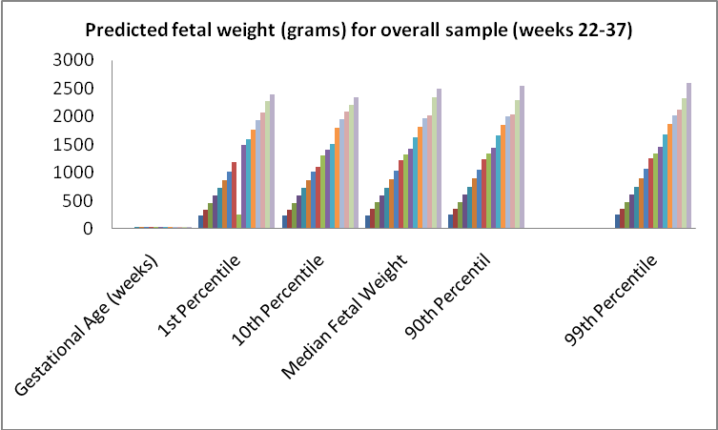

**Fig 1: Predicted Fetal Weights (grams) for Overall Sample (Weeks 22-37)**

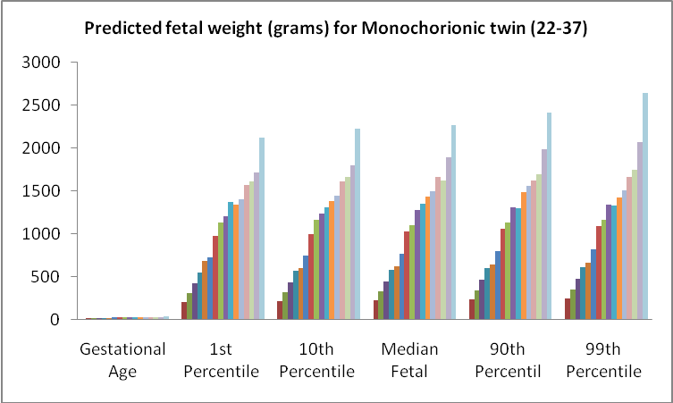

**Fig: 2: Predicted Fetal Weights (grams) for Monochorionic Twins (Weeks 22-37)**

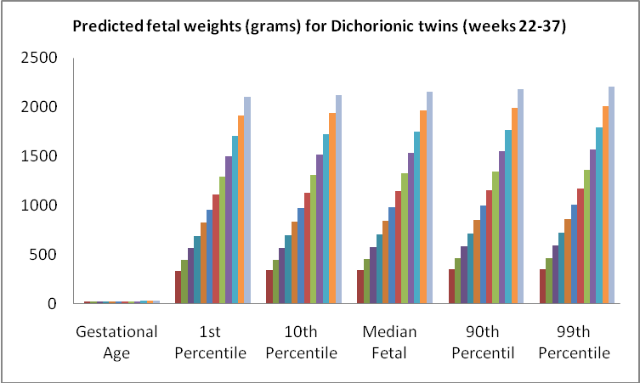

**Fig: 3: Predicted Fetal Weights (grams) for Dichorionic Twins (Weeks 22-37)**

Overall, 2,217 ultrasound observations were missing information on AC or FL, primarily from ultrasounds conducted in the first trimester. These were excluded from further analysis, and resulted in the exclusion of some pregnancies or individual fetuses from the sample. The first ultrasound conducted for each fetus from the second and third trimester was selected to retain for further analysis as long as it had complete information. From this sub-sample, we used a preliminary scatter plot of fetal weight against gestational age and excluded one observation that was deemed implausible by visual inspection. This was for an infant who had a birth weight of 2925g and was born at 37.28 weeks but who had been recorded as having a fetal weight of 177.39g at 35.14 weeks.

**4. Discussions**

We constructed a reference for fetal size at each gestational age for twins. We used ultrasound measurements to calculate EFW of fetuses using the published Ong formula.**28** we additionally stratified our sample by sex and chorionicity and generated reference values for males, females, monochorionic twins, and dichorionic twins. The trajectory of fetal growth was found to follow an S-shape over the course of pregnancy, with a period of rapid change in median fetal weight observed in the second trimester and early third trimester, and a reduction in the change of median fetal weight observed from week 31 and onward. As expected, male fetuses were heavier than females until around week **29.** However, after this time, the predicted values from our model were similar for males and females. Similarly, the predicted median fetal weight at week 37 in monochorionic and dichorionic twins was higher than their respective median birth weights, with the difference larger in monochorionic twins. Again, this implies that there is a positive bias in EFW close to term, and that the magnitude of this bias is greater in monochorionic twins than in dichorionic twins. This would explain the similarity in predicted fetal weights at week 37 between monochorionic and dichorionic twins. Prior to week 37, however, monochorionic twins were consistently lighter than dichorionic twins over the course of pregnancy, with a marked difference observed between weeks 29 and 36. This could be explained by the rising demands placed on the mother with increasing gestational age. In monochorionic twins that share a placenta, this increased demand may not be met as efficiently as in dichorionic twins, resulting in the weight difference between the two groups. **30** Finally, a general concern with ultrasound is the error associated with the estimation of fetal weight using biometric measurements.**31** However, we had validated the Ong formula within a subset of this same population prior to this study, and we thus have a high degree of confidence in our estimates. In general, the difference between the 1st, 10th, 50th, 90th and 99th percentiles was quite low at each gestational age, although there was an increase in the distance between them observed with increasing gestational age. This may be explained by the tendency for fetal weight values predicted by a regression model to be more closely distributed than the original distribution.**32,33** Moreover, adjusting for clustering may have accounted for much of the variance, contributing to the narrow distribution of predicted fetal weights at each gestational age. However, this limits the clinical applicability of this reference due to the error inherent in ultrasound-based EFWs in general. If the difference between the 1st, 10th, 50th, 90th, and 99th percentiles is low, the use of the references in predicting clinically relevant SGA becomes limited. Moreover, if the 1st or 10th percentiles are artificially inflated due to the narrow distribution of predicted fetal weights, there may be over-estimation of the prevalence of SGA when using this ultrasound-based fetal weight reference for the purposes of comparison.

**Conclusion**

This fetal weight reference adds to literature in the field of fetal growth monitoring in twins. This could prove to be a useful tool for monitoring of both cross-sectional and longitudinal growth, when serial ultrasounds are performed. In a high-risk population such as twins, this could provide clinically important information on fetal growth. However, it is necessary to assess the ability of these fetal weight references to identify an SGA fetus, and associated clinically relevant outcomes accurately before recommending the widespread use of this standard. In this regard, the small differences between the 1st, 10th, 50th, 90th, and 99th fetal weight percentile values may be a significant limitation.

**Corresponding Author:**

**Dr. Saira Dars**

Department of Obstetrics & Gynaecology, Liaquat University Hospital, Sindh, Pakistan

**References**

1. Chasen ST, Chervenak FA. What is the relationship between the universal use of ultrasound, the rate of detection of twins, and outcome differences? Clin Obstet Gynecol 1998;41:66–77.
2. Sherer DM. Is less intensive fetal surveillance of dichorionic twin gestations justified? Ultrasound Obstet Gynecol 2000;15:167–73.
3. Allen VM, Windrim R, Barrett J, Ohlsson A. Management of monoamniotic twin pregnancies: a case series and systematic review of the literature. BJOG 2001;108:931–36.
4. DeFalco LM, Sciscione AC, Megerian G, Tolosa J, Macones G, O’Shea A, et al. Inpatient versus outpatient management of monoamniotic twins and outcomes. Am J Perinatol 2006;23:205–11.
5. Heyborne KD, Porreco RP, Garite TJ, Phair K, Abril D. Improved perinatal survival of monoamniotic twins with intensive inpatient monitoring. Am J Obstet Gynecol 2005;192:96–101.
6. Monteagudo A, Roman AS. Ultrasound in multiple gestations: twins and other multifetal pregnancies. Clin Perinatol 2005;32:329–54,vi.
7. Bromley B, Benacerraf B. Using the number of yolk sacs to determine amnionicity in early first trimester monochorionic twins. J Ultrasound Med 1995;14:415–9.
8. Stenhouse E, Hardwick C, Maharaj S, Webb J, Kelly T, Mackenzie FM. Chorionicity determination in twin pregnancies: how accurate are we? Ultrasound Obstet Gynecol 2002;19:350–2.
9. Wood SL, St. Onge R, Connors G, Elliot PD. Evaluation of the twin peak or lambda sign in determining chorionicity in multiple pregnancy. Obstet Gynecol 1996;88:6–9.
10. Winn HN, Gabrielli S, Reece EA, Roberts JA, Salafia C, Hobbins JC. Ultrasonographic criteria for the prenatal diagnosis of placental chorionicity in twin gestations. Am J Obstet Gynecol 1989;161:1540–2.
11. D’Alton ME, Dudley DK. The ultrasonographic prediction of chorionicity in twin gestation. Am J Obstet Gynecol 1989;160:557–61.
12. Scardo JA, Ellings JM, Newman RB. Prospective determination of chorionicity, amnionicity, and zygosity in twin gestations. Am J Obstet Gynecol 1995;173:1376–80.
13. Sepulveda W. Chorionicity determination in twin pregnancies: double trouble. Ultrasound Obstet Gynecol 1997;10:79–81.
14. Chervenak FA, Skupski DW, Romero R, Myers MK, Smith-Levitin M, Rosenwaks Z, et al. How accurate is fetal biometry in the assessment of fetal age? Am J Obstet Gynecol 1998;178:678–87.
15. Kalish RB, Thaler HT, Chasen ST, Gupta M, Berman SJ, Rosenwaks Z, et al. First- and second-trimester ultrasound assessment of gestational age. Am J Obstet Gynecol 2004;191:975–8.
16. Tunón K, Eik-Nes SH, Grøttum P, Von Düring V, Kahn JA. Gestational age in pregnancies conceived after in vitro fertilization: a comparison between age assessed from oocyte retrieval, crown-rump length and biparietal diameter. Ultrasound Obstet Gynecol 2000;15:41–6.
17. Wisser J, Dirschedl P, Krone S. Estimation of gestational age by transvaginal sonographic measurement of greatest embryonic length in dated human embryos. Ultrasound Obstet Gynecol 1994;4:457–62.
18. Bennett KA, Crane JM, O’shea P, Lacelle J, Hutchens D, Copel JA. First trimester ultrasound screening is effective in reducing postterm labor induction rates: a randomized controlled trial. Am J Obstet Gynecol 2004;190:1077–81.
19. Sebire NJ, D’Ercole C, Soares W, Nayar R, Nicolaides KH. Intertwin disparity in fetal size in monochorionic and dichorionic pregnancies. Obstet Gynecol 1998;91:82–5.
20. Salomon LJ, Cavicchioni O, Bernard JP, Duyme M, Ville Y. Growth discrepancy in twins in the first trimester of pregnancy. Ultrasound Obstet Gynecol 2005;26:512–6.
21. Gonce A, Borrell A, Fortuny A, Casals E, Martinez MA, Mercade I, et al. First-trimester screening for trisomy 21 in twin pregnancy: does the addition of biochemistry make an improvement? Prenat Diagn 2005;25:1156–61.
22. Sebire NJ, Snijders RJ, Hughes K, Sepulveda W, Nicolaides KH. Screening for trisomy 21 in twin pregnancies by maternal age and fetal nuchal translucency thickness at 10–14 weeks of gestation. Br J Obstet Gynaecol 1996;103:999–1003.
23. Spencer K, Nicolaides KH. Screening for trisomy 21 in twins using first trimester ultrasound and maternal serum biochemistry in a one-stop clinic: a review of three years experience. BJOG 2003;110:276–80.
24. Vandecruys H, Faiola S, Auer M, Sebire N, Nicolaides KH. Screening for trisomy 21 in monochorionic twins by measurement of fetal nuchal translucency thickness. Ultrasound Obstet Gynecol 2005;25:551–3.
25. Summers AM, Langlois S, Wyatt P, Wilson RD. Prenatal screening for fetal aneuploidy. J Obstet Gynaecol Can 2007;29:146–79.
26. Sebire NJ, D’Ercole C, Hughes K, Carvalho M, Nicolaides KH. Increased nuchal translucency thickness at 10–14 weeks of gestation as a predictor of severe twin-to-twin transfusion syndrome. Ultrasound Obstet Gynecol 1997;10:86–9.
27. Bush MC, Malone FD. Down syndrome screening in twins. Clin Perinatol 2005;32:373–86,vi.
28. Verdin SM, Economides DL. The role of ultrasonographic markers for trisomy 21 in women with positive serum biochemistry. Br J Obstet Gynaecol 1998;105:63–7.
29. Lynch L, Berkowitz GS, Chitkara U, Wilkins IA, Mehalek KE, Berkowitz RL. Ultrasound detection of Down syndrome: is it really possible? Obstet.Gynecol. 1989;73:267–70.
30. Hall JG. Twins and twinning. Am J Med Genet 1996; 61:202–4.32. Edwards MS, Ellings JM, Newman RB, Menard MK. Predictive value of antepartum ultrasound examination for anomalies in twin gestations. Ultrasound Obstet Gynecol 1995;6:43–9.
31. Brocks V, Bang J. Routine examination by ultrasound for the detection of fetal malformations in a low risk population. Fetal Diagn Ther 1991;6:37–45.
32. Goldenberg RL, Iams JD, Miodovnik M, Van Dorsten JP, Thurnau G, Bottoms S, et al. The preterm prediction study: risk factors in twin gestations. National Institute of Child Health and Human Development Maternal-Fetal Medicine Units Network. Am J Obstet Gynecol 1996;175:1047–53.
33. Skentou C, Souka AP, To MS, Liao AW, Nicolaides KH. Prediction of preterm delivery in twins by cervical assessment at 23 weeks. Ultrasound Obstet Gynecol 2001;17:7–10.

10/2/2014