A Swot Analysis Of Pilgrimage Tourism In Haridwar City With Special Reference To Kanwar Mela

Vijay Sharma¹ and B. D. Joshi²

¹Department of Environmental Science, Dev Sanskriti Vishwavidyalaya, Haridwar
²Department of Zoology & Environmental Sciences, Gurukula Kangri Vishwavidyalaya, Haridwar
vijaysharma_mediplants@yahoo.com

Abstract: The present study was carried out during Kanwar Mela 2013 to assess the present status and future possibilities of pilgrims Tourism in Haridwar city. The present study is to analyse all the possible impacts of Kanwar Mela and to provide some remedial measures in management of all other religio-touristic activities. During the Kanwar Mela, the Pilgrimage Tourism industry generates a remarkable assets to the city and locals. But The Pilgrimage Tourism also shows negative impacts on socio-cultural aspects and environmental scenario. Increase in crimes, road rages, road accidents, water borne diseases, environmental pollution, high pricing of commodities are some important negative impacts, which are being observed in Haridwar city. The findings of the present study, are to establish Pilgrimage Tourism in the form of Eco-Tourism through managing all negative impacts of Kanwar Mela.
[Vijay Sharma and B. D. Joshi. A Swot Analysis Of Pilgrimage Tourism In Haridwar City With Special Reference To Kanwar Mela. N Y Sci J 2014;7(10):1-3]. (ISSN: 1554-0200). http://www.sciencepub.net/newyork. 1

Keywords: Pilgrimage Tourism, Haridwar City, Special Reference, Kanwar Mela

1. Introduction
Haridwar is regarded as one of the holiest places along with Ujjain, Nashik and Prayag (Allahabad), where drops of Amrit, the elixir of immortality, accidentally spilled over from the pitcher while being carried by the celestial bird Garuda. Haridwar is also famous as a gateway to the other most important pilgrimage spot for Hindus in Uttarakhand i.e. Badrinath, Kedarnath, Gangotri and Yamunotri.
A number of Hindu religious fair and festivals are held annually, several of which are bathing fairs held on the bank of Ganga at Haridwar, such as Somwati Amavasya, Kartik Poornima, Shravan Amavasya, Kartik Poornima, Ganga Dussehra etc. The holy city of Haridwar is home to some of the most sacred Hindu rituals and one can always see Hindu pilgrims and devotees from round the globe gather at Haridwar to offer prayers on auspicious occasions, having a dip in the sacred Ganga River.
Kanwar Mela is biggest annual celebration at Haridwar which receives millions of Pilgrims within a short period of 15 days. In Kanwar Mela, millions of Hindu pilgrims from the neighboring districts of Uttar Pradesh, Uttarakhand, Haryana, Bihar, Delhi etc. visit Haridwar or Gaumukh and Gangotri (the origin spot of river Ganga) to have a holy dip in River Ganga. Ritually they also carry the holy water of Ganga in small pitchers kept in two baskets fitted to a semicircular bamboo carrier, called Kanwar, to offer (pour) over the head of the Lord Shiva (Shivalingam) on the 14th day of Lunar dark fortnight, in the Solar month of Cancer.

2. Materials And Methods
In the present study, SWOT analysis technique was used to analyse the present situations and future possibilities of Pilgrimage Tourism in Haridwar City with special reference to major festive occasion such as Kanwar Mela. During the present study, the District Tourism Office was consulted to get the information about the influx of Pilgrims / tourists in Haridwar City. The information about civic facilities and solid waste management were gathered contacting the city municipal co-operation. The information regarding the facilities for the pilgrims by the city administration in Haridwar City, was also collected through consulting the Pilgrims/ Tourists. The local residents and local shop keepers were also consulted to get a view about socio-economical impact of pilgrimage.

3. Results And Discussion
The findings indicate that socio-cultural as well as environmental aspects are being affected by the Pilgrimage Tourism in the holy city of Haridwar. There is a scope for Strong Tourism industry, but it needs some managerial steps by the city administration for the betterment of environment through planning of waste management and providing proper civic facilities. The present scenario as well as future possibilities of Religio-touristic activities are analyzed through SWOT.
SWOT ANALYSIS [S=Strengths, W=Weakness, O=Opportunities, T= Threats]
Strengths:
The most important strength of Haridwar city is holy river Ganga, which continuously attracting the Pilgrims/Tourists from round the Globe for a long time. There are a number of temples of various God/ Goddesses in Haridwar city viz. Mansa Devi Temple; Chandi Devi Temple; Maya Devi Temple; Daksh Temple; Ganga Devi Temple, which makes it a city of Temples. Various Ashrams and Mathas are also enhancing the religious importance of Haridwar. All World Gayatri Pariwar (AWGP), Shantikunj; Jai Ram Aashram; Prem Nagar Ashram; Matra-Sadan; Divya Yog Sansthan; Hari-Har Ashram; Akharas of Hindu Religion are some important Ashrams in Haridwar city, which receives many thousands of pilgrims/tourists daily. Haridwar is a land of fair and festivals such as Makar Sakranti, Baisakhi, Guru-Poornima, Kanewar Mela, Somwati Amavasya, ardh Kumbh and Maha Kumbh etc. In Haridwar pilgrims/tourists can get all time transport to all over India.
Weakness :
Haridwar is a small city which has inadequacy of Infrastructural support to manage big festive occasions such as Maha Kumbh, Ardh Kumbh and Kanwar Mela. There is also some problem related to inadequacy of informative channels. Tourists/pilgrims from remote area as well as from foreign countries faces the lack of informative centre to get authentic information about the city. Civic facilities provided by Municipal co-operation are also not in a good condition, as the problem of drainage and improper solid waste management, contamination of supplied water can be easily seen through the city, particularly in monsoon.
Opportunities:
The newer sources of communication like the internet must be used effectively to influence and advertise about the Pilgrimage tourism. The Tourism should be established in the form of Eco-tourism industry by minimizing the negative impacts of Religio-touristic activities. This will surely provide the employment opportunities to the local people of Haridwar city. There is also a great scope to develop an inter-religious philosophies prevails in the city.
Threats:
In context of improper civic facilities, the heavy influx of pilgrims/tourists from various places throughout the world, can make the city as location for exchange of communicable diseases. During festive occasions, the insanitary condition can also provide breeding sites for vector of diseases. Loss of Bio-diversity and Degradation of Environment are also some another possible threats before Haridwar, in terms of anthropogenic activities of pilgrims/tourists.
The Holy city, Haridwar is facing increasing number of pilgrims regularly. Influx of pilgrims bestows innumerable socio-economic benefits to the region. The festive occasions offer an exclusive time to local businessmen to acquire a lot of financial benefits, as Reported By Libison and Muraleedharan¹ in case of Pandalam rural locality. In case of Haridwar city, festive occasions not only providing the economic benefits to the local businessmen but also enhancing the developmental infrastructure such as banking, medical facilities, tele-communications etc. as observed in last few years². Normally, Haridwar receives heavy influx of pilgrims round the year but during the festive days this number increase about six time than that of the normal days³.
According to Gangwar and Joshi⁴, the Kanwar Mela is one of the most famous sacred events in Haridwar, which receives around 3.0 to 5.0 million pilgrims during a course of 15 days. In major festive occasions like Kanwar Mela, Haridwar city administration as well as local shopkeepers get a huge amount of earning. The Kanwar Mela provides a good short period business to the Kanwar makers, who easily earn and save for a full year, in these 15 days. The local shopkeepers enhance the variety of products like t-shirts with picture of Lord Shiva, Kanwar decorative items, water cane etc. Every year, the city administration make some new policies and take steps one or two month prior to Kanwar Mela and tries to provide good facilities to pilgrims as well as local people.
Along with these positive impacts, during the Kanwar Mela, pollutants increase in water and in the ambient atmosphere. The generation of SW also increases manifold on these occasions of sacred bathing days, on the banks of River Ganga⁴⁻⁵. It was observed that during Kanwar Mela, Kanwariyas also offer old Kanwar, milk, curd, ghee, flower, coins and other religious materials into the water of river Ganga. In the absence of proper disposal system, the carry bags and polythene in which pilgrims carry their offerings, are dumped along the river side which remain either floating on the water surface or cover the river bed substratum which is hazardous for the aquatic life. Improper dumping of waste leads to pollution and conveys a bad impression for tourists visiting the holy city of Haridwar⁶. It was also observed that during Kanwar Mela, water born diseases increase due to the insanitary condition which occurs due to the heavy influx of pilgrims in the Haridwar city⁷.

4. Conclusion
Some of the positive socio-cultural impacts include income generation and employment opportunities for local people. The negative socio-cultural impacts are also being realized by way of increase in crimes, road rages, accidents and loss of cultural heritage of the concern area. During the Kanwar Mela, the daily need products are supplied to Ashrams, Math, other social organizations, hotels and restaurants on high prices. Therefore, local people suffer on account of price rise of daily needy items, due to scarcity of the commodities. The present study shows that Pilgrimage Tourism requires to be based on sustainable development and should be convert in Eco-Tourism. It is the need of hour to make an appropriate strategy to minimize and control the negative aspects of religio-touristic activities in Haridwar city and to establish Pilgrimage tourism as Eco-Pilgrimage.

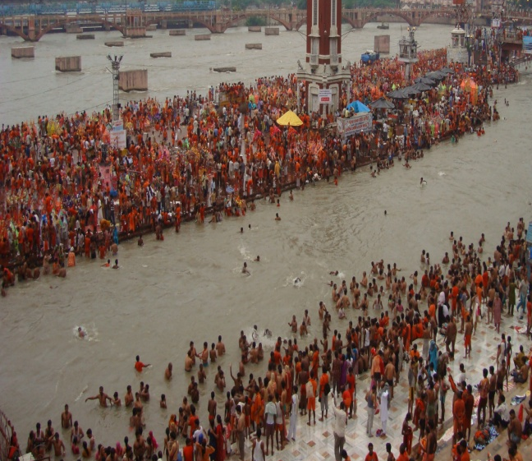
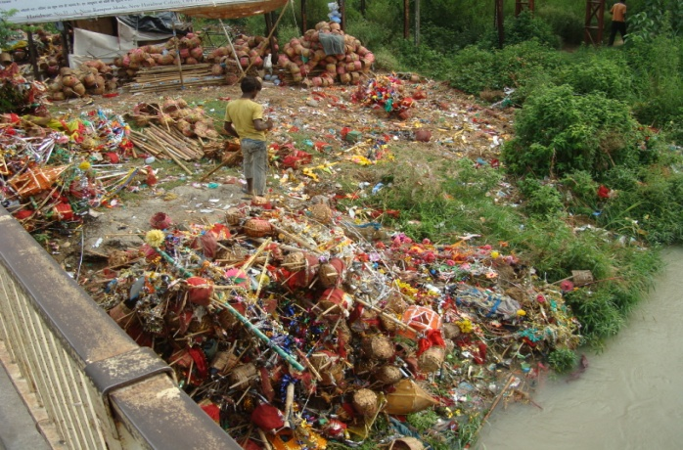
(1) (2)
Photo 1: Kawariyas (Kanwar Pilgrims) taking a holy dip in Ganga River at Ghat / Platform of Har-Ki-Pauri in Haridwar City, 2: A Pile of discarded old Kanwars just beside the banks of River Ganga at Rishikul Bridge (Opportunity for this discarded matter to find its way into Sacred River Ganga).

Acknowledgement
The present study is a part of a Research Project funded by Science & Engineering and Research Board (SERB), Department of Science and Technology, Ministry of Science & Technology, Govt. of India. Therefore, Authors are very thankful to SERB, DST for their financial support.

Author (s) Names, Degree & Affiliations
1. Dr. Vijay Sharma, M.Sc., Ph.D.,
Department of Environmental Science,
Dev Sanskriti University, Haridwar-249411, Uttarakhand, India.
E.mail: vijaysharma_mediplants@yahoo.com
Mobile No. 91- 9720143678
2. Prof. Bishambhar Datt Joshi, M. Sc., Ph.D,
Department of Zoology & Environmental Sciences, Gurukula Kangri University, Haridwar-249404 (Uttarakhand), India.

References
- Libison K B, Muraleedharan K P. Economic benefits of Pilgrimage Tourism: A case study of Sabarimala Pilgrimage with special reference to Pandalam Rural Locality in Kerala (India). South Asian Journal of Tourism and Heritage, 2008; 1(1): 57-64.
- Sharma, V., Bhadula, S. and Joshi, B. D. (2011). Assessment of Religio-touristic activities in Haridwar City: A SWOT Analysis. Report and Opinion, 3(7):25-29.
- Sharma, V., Saini P., Gangwar, R. S. and Joshi, B. D. (2010). Assessment of Municipal Solid waste generation and its management in Haridwar city of Uttarakhand (India). Waste Management, 30 (4): 725-726.
- Gangwar, K. K. and Joshi, B. D. (2008). A preliminary study on solid waste generation at Har Ki Pauri, Haridwar, around the Ardh - Kumbh period of sacred bathing in the river Ganga in 2004. Environmentalist, 28: 297-300.
- Mishra, S. and Joshi, N. (2002). Generation of solid waste during festive occasions in Hardwar city. Him. J. Env. Zool., 16(2): 263-266.
- Shanker, V. and Joshi, I. P. (1997). Environmental management of Hardwar and adjoining area. In: Human health & Environment. Vol: II. A.P.H. Publishing Co-operation- New Delhi. p:217-242.
- Saini P., Sharma V. and Joshi, B. D. (2009). A Random survey report about rise in water borne diseases in Haridwar city during Kanwar mela-2008. J. Env. & Bio-Sci.23(2):215-219.

9/15/2014

