**Cytotoxic Activity and HPLC– ESI –MS Analysis of Alkaloids in *Cephalotaxus harringtonia* L.Grown in Egypt**

Zeinab T. Abd El Shakour

Laboratory of phytochemistry, National Organization for Drug Control and Research, Cairo- Egypt.

e-mail: [zizishakour@yahoo.com](mailto:zizishakour@yahoo.com)

**Abstract:** There is only one *Cephalotaxus harringtonia* L.tree grownin Egypt. It is an Asian medicinal plant well known for producing potent antileukemic alkaloid, so the present study was aimed at identifying these alkaloids and to investigate its cytotoxic activity. Five known alkaloids (cephalotaxine, harringtonine, homoharringtonine, isoharringtonine and deoxyharringtonine) were identified by HPLC–ESI–MS technique according to its spectral data and comparison with the literature, the chloroform extract of the aerial parts of *Cephalotaxus harringtonia* L*.* was *in vitro* investigated for its cytotoxicity against HCT116, HepG2 and MCF-7 cell lines for first time, and resulted with IC50 = 4.77, 12.9 and 17.5 *μ*g/ml, respectively.

[Zeinab T. Abd El Shakour. **Cytotoxic Activity and HPLC– ESI –MS Analysis of Alkaloids in *Cephalotaxus harringtonia* L.grown in Egypt.** *N Y Sci J* 2013;7(9):110-114]. (ISSN: 1554-0200). <http://www.sciencepub.net/newyork>. 18

**Keywords:** *Cephalotaxus harringtonia* L., the aerial parts, alkaloid, cytotoxicity.

**1-Introduction**

Now a days, scientists and researchers are very much tiring on research of natural plant products all over the world and a large number of substantiation have shown the immense potential of medicinal plants used traditionally (Constabel, 1990).

The genus Cephalotaxus, yew-like evergreen trees and shrubs trees of southern Asia, composed of ten species, eight of which are distributed in China. Investigations of the chemical constituents of extracts of Cephalotaxus species resulted in the isolation of lactones, flavonoids and a number of alkaloids (Du *et al* 1999, Bocar *et al* 2003, Wang *et al*, 2004).

*Cephalotaxus* species are well-known for its alkaloids such as cephalotaxine, harringtonine, and their derivatives, which are a family of cytotoxic alkaloids, showed potent antileukemic activity against lymphoid leukemia L-1210 (Paulder *et al*, 1963, Miah *et al*.1998)

In this study, the analysis of alkaloids from the aerial parts of *Cephalotaxus harringtonia* L.using this HPLC–ESI–MS technique is described. For a more accurate quantitativeanalysis, the MS–MS technique was applied to the analysisinstead of a simple MS one.

**2-Material and methods:**

**Plant Material:**

The aerial parts (leaves and twigs) of *Cephalotaxus harringtonia* L.(Cephalotaxaceae) were collected in EL Orman garden during August 2012.Taxonomical identity was kindly verified by Dr. M. Abd El Hafez, Agricultural Research Center, Giza.

**Reagents:**

All solvents used were HPLC grade and purchased from Sedico Pharmaceutical Co. 6 October City, Egypt.

**Extraction and Isolation:**

The air-dried and milled aerial parts of *Cephalotaxus harringtonia* L*.* were extracted with EtOH, and the extract was partitioned between EtOAc and 3% tartaric acid. Water-soluble materials, which were adjusted to pH 10 with saturated Na2CO3, were extracted with CHCl3 to give a crude alkaloid fraction. This fraction was concentrated to dryness, dissolved in methanol and analyzed by HPLC–ESI–MS analysis. Extraction and partial purification of the alkaloids was according to the procedure of ref. (Powell, *et al* 1974).

**HPLC–ESI–MS–MS analysis:**

An Agilent (Waldbronn, Germany) 1100 series HPLC system equipped with an autosampler, a UV detector, At 330 nm, 0.5 AUFS., a column oven, a binary pump, and a degasser were used.

Separations were performed using Phenomenex – An Aqua C18 (150 ×4.6 mm, 5- mm particle size) (Agilent) at 40ºC. The mobile phase was a gradient of acetonitrile–0.1% trifluoroacetic acid (0–8min, 10:90; 15 min, 30:70; 30min, 50:50; 45min, 85:15; and 60min, 85:15). The flow rate of the mobile phase was 0.4 mL/min. ESI–MS analysis was performed using an Agilent 1100LC/MSD ion-trap MS (Agilent) equipped with an ESI interface. Nitrogen was used as a nebulizing gas at a pressure of 50 psi at 10 L/min, a temperature of 350ºC, and a capillary voltage of –4 kV. HPLC–ESI–MS analyses were carried out in the positive-ion mode with the scan range *m/z* 50–1500.

**Cytotoxic assay procedures:**

**Human tumor cell lines**

Authentic culture, HCT116, Hep-G2 and MCF-7 cells were obtained frozen under liquid nitrogen (–180ºC) from the American Type Culture Collection. The tumor cell lines were maintained by serial subculturing in the National Cancer Institute, Cairo, Egypt.

**Culture media**

HCT116, Hep-G2 and MCF-7 cells were suspended in RPMI 1640 medium supplemented with 10% fetal calf serum, 1% antibiotic-antimycotic mixture (10.000U/ml K-penicillin, 10.000 *μ*g/ml streptomycin sulphate 25 *μ*g/ml amphotericin B) and 1% L-glutamine (all purchased from Lonza, Belgium).

**Assay method for cytotoxic activity**

The cytotoxicity against HCT116, Hep-G2 and MCF-7 cells was performed in the National Cancer Institute, according to the SRB assay method (Skehan *et al* 1990). Adriamycin® (Doxorubicin) 10 mg vials (Pharmacia, Sweden) was used as a reference drug. HCT116, Hep-G2 and MCF-7 cells were plated in 96-multiwell plates (5x104–105 cells/well in a fresh media) for 24 h before treatment with the tested sample to allow attachment of cells to the wall of the plate. Then, 200 *μ*L aliquot of serial dilution of the extract (5.0, 12.5, 25, 50 *μ*g/ml) were added and the plates were incubated for 24, 48 and 72 hrs at 37°C in a humidified incubator containing 5% CO2 in air. Control cells were treated with vehicle alone. Four wells were prepared for each individual dose. Following 24, 48 and 72 hrs treatment, cells were fixed, washed and stained with Sulforhodamine B stain (Sigma,USA). Colour intensity was measured in an EL ISA reader spectrophotometer (Tecan Group Ltd.-Sunrise, Germany).

**Statistical analysis**

All values were expressed as the mean of the percentage of inhibition cells of the three replicates for each treatment. The statistical analysis was computed using analysis of variance procedure described in SAS/STAT software (SAS Institute, Cary, NC, USA). The significant differences between treatment means were separated by Duncan's Multiple Range Test (Duncan, 1955).

**Results and Discussion:**

**LC-MS/MS analysis:**

LC-MS/MS analysis of the chloroform extract of aerial parts of *Cephalotaxus harringtonia* L. revealed the presence of five alkaloids eluted at Rt: 5.03,5.64, 6.00,6.51 and 7.37 min, also total ion chromatogram gave five peaks at Rt: 5.26,5.83, 6.40,6. 83 and 7.18 min.

**Mass analysis (table 1):**

* The ESI–MS spectra shows the [M+H] + ion of cephalotaxine, harringtonine, homoharringtonine, isoharringtonine and deoxyharringtonine as the base peak at *m/z* 316, 532, 546,532 and 516.
* Cephalotaxine, harringtonine, homoharringtonine, isoharringtonine and deoxyharringtonine displayed a characteristic peak as the base peak in the MS–MS spectra shows the [M+H–CH4O]+ ion at *m/z* 284 of cephalotaxine and *m/z* 298 of harringtonine, homoharringtonine, isoharringtonine and deoxyharringtonine which might be produced from the loss of an ester chain (Figure 1­-5), respectively.
* By comparison of the MS and MS–MS spectra with those of the literature. All showed *m/z* 298, thus indicating that they contain a common cephalotaxine moiety such as harringtonine and homoharringtonine isoharringtonine and deoxyharringtonine.

**Cytotoxicity activity:**

The *in vitro* cytotoxicity (tab. 2) of the chloroform extract of the aerial parts of *Cephalotaxus harringtonia* L*.* was evaluated against HCT116, HepG2 and MCF-7 cell lines incomparison with Doxorubicin (control) which was resulted with IC50=4.77, 12.9 and17.5 *μ*g/ml for the chloroform extract, and with IC50=3.64, 4.57 and 2.97 *μ*g/ml for Doxorubicin(tab. 2). The obtained results revealed a promising cytotoxicity of the chloroform extract against HCT116 with IC50=4.77 *μ*g/ml.

**Table (1): Compounds identified by LC-MS/MS in the chloroform extract of *Cephalotaxus harringtonia* L.**

|  |  |  |
| --- | --- | --- |
| alkaloids compounds | Structure (m/z) | [M-H] + and MS/MS m/z |
|  |  |  |
| Cephalotaxine |  | 316, 284 |
| Deoxyharringtonine |  | 516, 298 |
| Harringtonine |  | 532, 298, 226 |
| Isoharringtonine |  | 532, 298, 223 |
| Homoharringtonine |  | 546, 298 |

**Table (2):** **The cytotoxicity of the CHCL3 extract of *Cephalotaxus harringtonia* L*.* and doxorubicin against human cell lines**

|  |  |  |  |  |  |  |
| --- | --- | --- | --- | --- | --- | --- |
| Human cell lines | % of inhibition cells ±SEM | | | | | |
| Conc.(*μ*g/ml) | HCT116 | | Hep-G2 | | MCF-7 | |
|  | CHCL3 extract | Doxorubicin | CHCL3 extract | Doxorubicin | CHCL3 extract | Doxorubicin |
| 5 | 52.42±0.02* **  (77.3)*** | 67.80±0.05* | 12.60±0.06* **  (19.09)*** | 66.00±0.02* | 10.75±0.03* **  (13.3)*** | 80.80±0.03* |
| 12.5 | 60.90±0.04* **  (81.85)*** | 74.40±0.01* | 48.45±0.04* **  (69.31)*** | 69.90±0.01* | 30.77±0.01* **  (37.16)*** | 82.80±0.02* |
| 25 | 76.05±0.01* **  (91.73)*** | 82.90±0.03* | 84.76±0.05* **  (106.48)*** | 79.60±0.01* | 71.46±0.05* **  (87.78)*** | 81.40±0.05* |
| 50 | 76.80±0.01* **  (94.23)*** | 81.50±0.01* | 81.50±0.02* **  (96.56)*** | 84.40±0.03* | 80.15±0.03*  (100.31)*** | 79.90±0.06* |
| IC50 (*μ*g/ml) | 4.77 | 3.74 | 12.9 | 4.57 | 17.5 | 2.97 |

Each value represents the mean of percentage of inhibition cells of three replicates ± SEM (Standard error of mean).

* Significantly different from control value at p<0.05 according to paired-samples *t*-test

** Significantly different from control value at p<0.005 according to paired-samples *t*-test

*** Relative inhibition of crude CHCL3 extract related to doxorubicin on the growth of different human cell lines

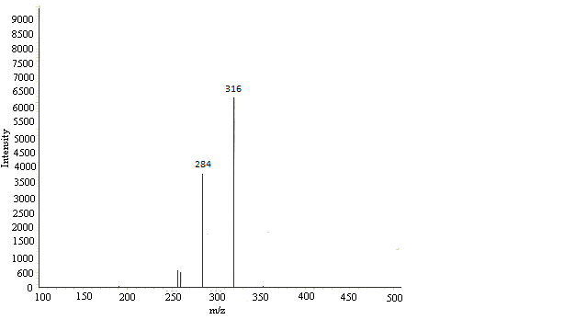

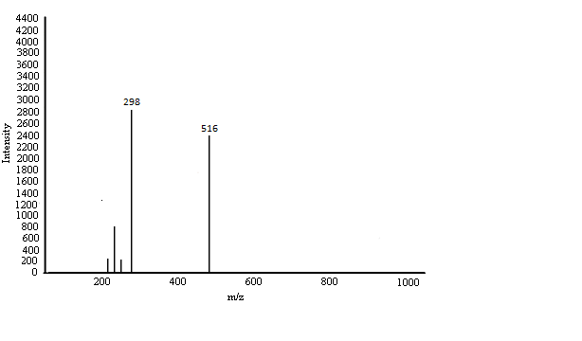

Figure 1. ESI–MS spectra of cephalotaxine Figure 2. ESI–MS spectra of deoxyharringtonine

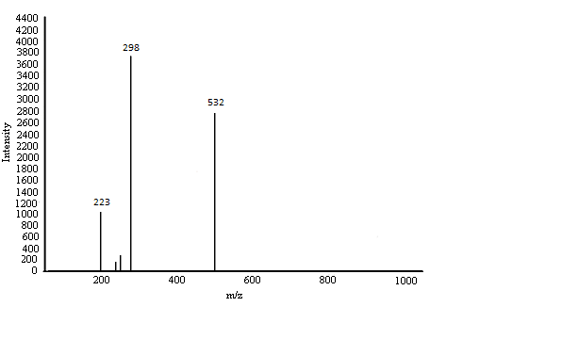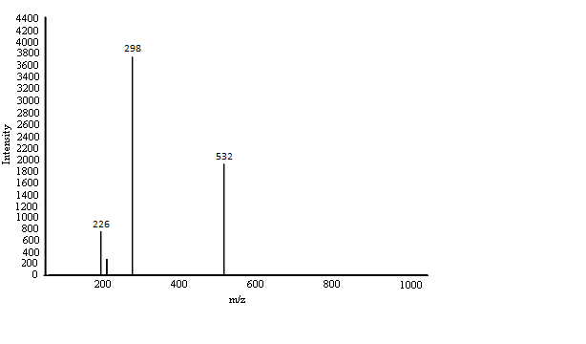

Figure 3. ESI–MS spectra of harringtonine Figure 4. ESI–MS spectra of isoharringtonine

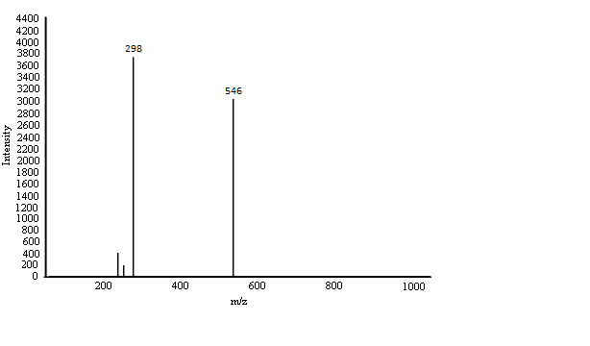

Figure 5. ESI–MS spectra of homoharringtonine

**Conclusion:**

HPLC–ESI–MS–MS in the positive-ion mode proved to be a highly sensitive analytical method for the detection and identified of the cytotoxic alkaloids from *C. harringtonia* growing in Egypt that are impossible to detect using conventional HPLC–UV or GC–MS.

For the first time five cytotoxic alkaloids compounds previously known were detected in *C. harringtonia* treegrowing in Egypt on the basis of retention time, their mass spectra and comparison with literature data (Norman, 1980, Hiroshi *et al*., 2000 Young *et al.,* 2003),and also their cytotoxic activity against HCT116, HepG2 and MCF-7 cell lines.

**Corresponding Author:**

Dr. ZEINAB T. ABD EL SHAKOUR

Laboratory of phytochemistry,

National Organization for Drug Control and Research, Cairo- Egypt.

E-mail: [zizishakour@yahoo.com](mailto:zizishakour@yahoo.com)

**Reference:**

1. Bocar, M., Jossang, A., and Bodo, B., New Alkaloids from *Cephalotaxus fortunei*. *J. Nat. Prod*., 66, 152–154, (2003).
2. Constabel, F., Medicinal plant biotechnology. *Planta Med*, 5(6), 421–425, (1990).
3. Du, J., Chiu, M. H., and Nie, R. L., Two new lactones from *Cephalotaxus fortunei* var. alpnia. *J. Nat. Prod*., 62, 1664–1665, (1999).
4. Duncan, D.B., Multiple range and multiple F test. *Biometrics* 11: 1-42, (1955).
5. Hiroshi, M., Mika A., Naotoshi Y. and Jun'ichi K., Cephalezomines A±F, Potent Cytotoxic Alkaloids from *Cephalotaxus harringtonia L.* var. nana. *Tetrahedron*, 56: 2929-2934, (2000).
6. Miah, M. A. J., Hudlicky, T.; Reed, J. W., In The Alkaloids; Cordell, G. A., Ed.; *Academic Press*, New York, Vol. 51, p 199, (1998).
7. Norman E. D., Alkaloid Distribution and Catabolism In *Cephalotaxus harringtonia L. Phytochemistry*, Vol. 19, pp, 403-408, (1980).
8. Powell. R. G., Rogovin. S. P. and Smith. C. R., *Jr.* *Ind. Eng. Chem. Prod. Res. Dev.* 13. 129, (1974).
9. Paulder, W. W., Kerley, G. L., and McKay, J., The alkaloids of *Cephalotaxus drupacea* and *Cephalotaxus fortune*, *Journal of Organic Chemistry*, 28:2194-2197, (1963).
10. Wang, L. W., Su, H. J., Yang, S. Z., Won, S. J., and Lin, C. N., New alkaloids and a tetra flavonoid from *Cephalotaxus wilsoniana*, *J. Nat. Prod*., 67, 1182–1185, (2004).
11. Young H. C., Ki-Pung Y., Jinwoong K., HPLC–Electrospray Ionization–MS–MS Analysis of *Cephalotaxus harringtonia L.* Leaves and Enhancement of the Extraction Efficiency of Alkaloids Therein by SFE, *Journal of Chromatographic Science*, Vol. 41, (2003).

8/27/2014