Ashanti pepper (Piper guineense) reduces aflatoxin formation in poorly stored maize grains

Chibundu N. Ezekiel^{1,*}, Chinedu P. Anokwuru^{2,3}, Bamidele M.W. Amos-Tautua⁴, Ebelechukwu E. Ejiofor¹, Oyinkasola R. Oriola¹, Tochi Obani⁵ and Olaitan O. Olajuyigbe⁶

¹Mycology/Mycotoxicology Research Unit, Department of Biosciences & Biotechnology, Babcock University, Ilishan Remo, Ogun State, Nigeria. ²Department of Basic Sciences, Babcock University, Ilishan Remo, Ogun State, Nigeria. ³Department of Chemistry, University of Venda, South Africa. ⁴Department of Chemistry, Niger Delta University, Wilberforce Island, Bayelsa State, Nigeria. ⁵Department of Crop Protection and Environmental Biology, University of Ibadan, Ibadan, Nigeria. ⁶Department of Fish Technology, Nigerian Institute for Oceanography and Marine Research, Victoria Island, Lagos, Nigeria.
*chaugez@gmail.com

Abstract: This study evaluated the influence of co-storing Ashanti pepper (AP), Piper guineense, with maize grains under poor conditions on aflatoxin formation/levels and aflatoxigenic fungal population in the grains. Maize grains were co-stored for 56 days with 1.25%, 2.5% and 5% (w/w) concentrations of either whole AP fruits or powder. Aflatoxin content and population of Aspergillus section Flavi in the grains were analyzed at intervals of 14 days. Aflatoxin formation in the whole and powdered AP–treated grains was significantly (p<0.05) inhibited in a concentration and time dependent manner while reduction in aflatoxigenic fungal population was significantly (p<0.05) more observed in the whole AP–treated grains compared to those co-stored with AP powder. The 2.5% AP powder treatments proved more effective than other powder concentrations against aflatoxin formation (% inhibition = 93.5) at 28 days of storage. However, 5% whole AP treatment was the most effective of all AP treatments against aflatoxin formation (% inhibition = 95.8–99.7) across the 56-day storage period. Co-storing maize grains with whole AP fruits therefore presents a farmer-friendly approach to aflatoxin mitigation during post-harvest storage.
[Ezekiel CN, Anokwuru CP, Amos-Tautua BMW, Ejiofor EE, Oriola OR, Obani T, Olajuyigbe OO. Ashanti pepper (Piper guineense) reduces aflatoxin formation in poorly stored maize grain. N Y Sci J 2014;7(9):64-71]. (ISSN: 1554-0200). http://www.sciencepub.net/newyork. 13

Keywords: Aflatoxin, Ashanti pepper (Piper guineense), Aspergillus flavus, Biological control, maize (corn), Grain storage, Spices

- Introduction
Contamination of agricultural produce (e.g. maize) by aflatoxin-producing fungi and consequent liberation of the toxic secondary metabolite, aflatoxin, in the commodity is relatively natural and unavoidable. Maize is presently the third most traded cereal, aside from wheat and rice, with an estimated production of 872 million metric tons in over 160 million hectares as at the year 2012 (FAOSTAT, 2013). It is grown all over the world and its usefulness cannot be over emphasized: about 65% of the world’s maize production is used for feed while the remaining 35% is shared between food (15%) and several industrial processes (20%) (UNDP, 2010). Over 60% of maize harvested annually is stored for at least 30 days. Storage and climatic conditions in tropical regions such as in sub-Saharan Africa favour the proliferation of moulds and subsequent accumulation of aflatoxins in maize (Bankole and Adebanjo, 2003; Egal et al., 2005; Probst et al., 2014); the need to control maize loss arising from post-harvest storage. The commonest aflatoxigenic species that invade and colonize stored maize include Aspergillus flavus, A. parasiticus and A. parvisclerotigenus (Atehnkeng et al., 2008; Perrone et al., 2014). Since aflatoxin contamination of crops causes loss of quality grains, severe economic losses and increased health risks due to consumption of contaminated grains (Williams et al., 2004; Zain, 2011), several advanced integrated methods are being explored for the pre-harvest reduction and post-harvest control of aflatoxigenic fungi and aflatoxins in agricultural produce (Zain, 2011). Of prime consideration is the application of plant materials against aflatoxigenic moulds (Cabral et al., 2013).
Numerous studies have previously been carried out on control of aflatoxigenic fungi and aflatoxins in food and feed using plant materials such as whole plants, aqueous plant extracts and volatile compounds; most of which have proven useful (Cabral et al., 2013). For example, Agave asperrima and A. striata extracts have been reported to have inhibitory effects on growth of A. flavus and A. parasiticus thus lowering aflatoxin production in affected crops (Sanchez et al., 2005), while oils of Cinnamomum cassia and leaves of Laurus nobilis have been shown to drastically lower aflatoxin production in A. parasiticus CFR 223 without affecting mould growth (Atanda et al., 2007). Lemon grass (whole and powdered leaves, aqueous extracts and volatile compounds) has also been reported to delay fungal growth and inhibit aflatoxin synthesis (Guynot et al., 2003; Atanda and Olopade, 2013). Regardless of the wide application of plant and plant products in the control of fungi and their toxins, literature is scarce on the use of Ashanti pepper (AP) for aflatoxin control. However, there is a report from Nigeria on fungal and aflatoxin contamination of three spices including AP (Ezekiel et al., 2013). The report showed that retailed AP contained relatively high (incidence = 75%) fungal propagule but no aflatoxins except for one sample which contained very low (10.5 ng/g) aflatoxin B₁ levels.
Ashanti pepper (Piper guineense), otherwise known as the West African pepper, is a spice indigenous to western and central Africa. It is semi-cultivated in countries such as Nigeria where the leaves (commonly called Uziza) are used as flavouring for stews. The fruits of AP are part of the spices used in the daily preparation of hot spicy soup for women who just put to bed within 1.5 months for the purpose of cleaning up and stabilizing the womb and bowels. A previous study reported AP as an effective preservative for storing perishable foods like fish (Kiin-Kabari et al., 2011). Recently, we found that the aqueous extract of this spice was capable of reducing by 99% aflatoxin biosynthesis in aflatoxigenic species in vitro (Ezekiel et al., manuscript in preparation). This paper is therefore a follow up study to determine the small-holder farmer applicability of this spice in the control of aflatoxins. Thus, we investigated the effect of co-storing maize grains with either whole or ground AP under poor conditions on aflatoxin accumulation and aflatoxigenic fungal load.

- Materials and Methods
  - Maize and Spice Samples
White variety maize grains (32 kg) were obtained from the Germplasm unit of the International Institute of Tropical Agriculture, Ibadan, Nigeria. About 500 g of dried Ashanti pepper (AP) fruits were purchased from a local market in Ogun State and transported to the Microbiology laboratory, Department of Biosciences and Biotechnology, Babcock University for further handling. The AP fruits were purchased from retailers within 14 days of harvest and drying. All pepper fruits and maize grains were properly sorted to remove unwanted macro-contaminants such as plant debris and weevils. Afterwards, the AP fruits were equally divided into two: one part was left unground/whole while the other part was finely ground into powder in a high-speed blender (Waring Commercial Blender 8010BU, Model HGBTWT, Connecticut, USA). All reagents and chemicals except otherwise stated were purchased from Sigma Aldrich (St Louis, MO, USA).
  - Maize Preparation for Poor Storage
In order to create a poor micro-climatic condition for the proliferation of aflatoxigenic fungi and subsequent liberation of aflatoxins in the maize grains, the grains were soaked in clean water for 10 minutes and air-dried overnight at ambient temperature to allow for an increase in the moisture content of the grains. The dried grains were randomly batched into 34 groups of 900 g of grains and each group was further divided into triplicate sub-samples consisting of 300 g maize grains (i.e. 3 sub-samples per group). The batching process resulted in a total of 102 samples. Triplicate samples were necessary to allow the assessment of variation in aflatoxigenic fungal load and aflatoxin levels. Each sample was then placed in a polypropylene bag.
  - Treatment of Maize Grains with Ashanti Pepper
The batched maize grains (34 groups) were divided into two sets; each set comprising of 17 groups and 51 samples. Both sets were treated with AP by mixing maize grains with appropriate concentrations of the spice (whole or ground): one set received the unground/whole AP fruits while the other set was treated with the AP powder. Three concentrations [1.25%, 2.5% and 5% (w/w)] corresponding to 3.75, 7.5 and 15 g AP / 300 g maize grains respectively were used for the study. For each set, each triplicate sample of maize grains that represented a treatment group was treated with one of the AP concentration. Treated maize samples were then stored at ambient temperature for eight weeks and analyzed every two weeks. For each interval, a control group was set-up which was untreated maize samples. Overall, there were five time intervals in eight weeks: day 0, day 14, day 28, day 42 and day 56; and at each interval, excluding day 0, maize samples treated with 1.25%, 2.5% and 5% (w/w) AP and a control group were analyzed. At day 0, only untreated/control maize samples were analyzed.
  - Quantification of Aflatoxins in Maize Grains
Aflatoxin concentrations in maize samples were determined by high performance thin layer chromatography (HPTLC) according to the method described by Atehnkeng et al. (2008) but with slight modifications. Briefly, 10 g of maize grains were ground in 50 ml of 80% methanol and the maize-methanol slurry was shaken for 30 mins on an orbital shaker (Lab-Line Instruments Inc. Illinois, USA). The mixture was ﬁltered through folds of Whatman No. 1 paper and the filtrate was collected in a 250 ml separatory funnel. Distilled water (50 ml) was added to the filtrate to ease separation and the mixture was shaken and extracted twice with 25 ml of methylene chloride. The methylene chloride layer obtained by standing the funnel for 10 mins was filtered through 20 g of anhydrous sodium sulphate to remove residual water. The extract collected in a polypropylene cup was evaporated to dryness in a fume hood and the residue was re-dissolved in 1000 μl of dichloromethane. Aflatoxin standards and extracts were separated on TLC plates (silica gel 60, 250 μm) by development in isopropanol-methanol-water (96:3:1). The developed plates were visualized under 365 nm ultraviolet light and scored visually for presence or absence of aflatoxin with a 2 ng limit of detection. Aflatoxins were quantified using scanning densitometer, CAMAG TLC Scanner 3 with winCATS 1.4.2 software (Camag AG, Muttenz, Switzerland), as described previously (Suhagia et al., 2006).
  - Enumeration of Aspergillus section Flavi Load in Maize Grains
Ten grams of each sample of maize grains was taken from the AP-treated and untreated groups at each time interval and subjected to mycological analysis to determine the load of aflatoxigenic Aspergillus section Flavi. Prior to mycological analysis, maize grains were sorted or sieved through a fine mesh to remove residual whole AP fruits or powder that may interfere with fungal load. Moulds were isolated from the samples by the dilution plating technique described by Samson et al. (1995). The 10 g sub-sample of maize grains was ground into fine powder and plated on triplicate modified Rose Bengal Agar (mRBA) plates (Cotty, 1994) after appropriate dilution in 90 ml of sterile water and vortexing for 2 minutes. The inoculated plates were incubated unilluminated at 31 ºC for 3 days and all colonies with resemblance to those of the section Flavi (Klich and Pitt, 1988; Cotty and Cardwell, 1999; Ehrlich et al., 2007) were counted and expressed as log₁₀CFU/g. To confirm isolates belonging to the section Flavi, all colonies were transferred from the triplicate mRBA plates representing a treatment concentration to freshly prepared neutral red desiccated coconut agar (NRDCA) plates for phenotyping as previously described in Ezekiel et al. (2014a).
  - Statistical Analysis
All data obtained from this study was analyzed using SPSS® 15.0 (Windows version, SPSS, IL, USA). The means of load of Aspergillus section Flavi in the samples were calculated. Means for aflatoxin concentrations in the samples by their treatments were also calculated. All means were tested for significance at 95% confidence level using one-way ANOVA, compared and separated by the Duncan’s Multiple Range Test.

- Results
  - Reduction of Aflatoxin Formation in Maize Grains
The potential of AP to inhibit aflatoxin formation in maize grains co-stored with the spice under poor conditions over a period of 56 days can be shown in two ways: (1) the influence of AP (whole and powdered form) concentrations on percentage reduction of aflatoxins in the treated grains at specific time intervals (Fig. 1), and (2) the trend of aflatoxin reduction mediated by each concentration of whole or powdered AP across the time intervals (Fig. 2). Aflatoxin inhibition in the whole AP-treated maize grains increased significantly (p<0.05) with time and was concentration dependent at all time intervals throughout the study period (Fig. 1). At day 14, the aflatoxin levels and corresponding percentage reductions in aflatoxin levels were: 1115.46 ng/g and 36.98%, 807.05 ng/g and 54.41%, 74.53 ng/g and 95.79% for the 1.25%, 2.5% and 5.0% treatment concentrations, respectively. The recorded percentage reduction in aflatoxin levels for 1.25% and 2.5% whole AP treatment at day 14 significantly (p<0.05) doubled at days 28 and 42 and subsequently increased until day 56, while the 5% treatment concentration constantly maintained a very high inhibitory activity (95.79–99.65%) against aflatoxin formation regardless of storage time (Fig. 1). For the AP powder-treated maize grains, aflatoxin inhibition significantly (p<0.05) increased (25.19%, 65.57% and 91.29%) with increased concentration (1.25%, 2.5% and 5.0% respectively) of the spice’s powder at day 14. However, at days 28, 42 and 56, an increase in the concentration of the powdered spice from 1.25% to 2.5% caused a significant (p<0.05) increase in aflatoxin inhibition followed by a significant (p<0.05) decrease in the inhibitory activity of AP powder at 5% application (Fig. 1).
Figure 2 shows the efficacy of each concentration of whole or powdered AP treatment towards aflatoxin inhibition in the poorly stored maize sample across the storage period. The 5% concentration of whole spice showed the most consistent inhibitory pattern and had the highest effect against aflatoxin formation in the grains across the time intervals (percentage reduction: 95.79, 98.68, 99.60 and 99.65 at days 14, 28, 42 and 56 respectively) compared to other whole AP treatment concentrations. Conversely, the potential of the 5% powder treatment concentration to inhibit aflatoxin production in the poorly stored grains reduced significantly (p<0.05) and consistently across the storage duration (percentage reduction: 91.29, 80.63, 76.56 and 75.27 at days 14, 28, 42 and 56 respectively). However, at day 28 of grain storage the 1.25% and 2.5% concentrations of AP powder significantly (p<0.05) reduced aflatoxin formation in the grains by 92.49% and 93.50% respectively (Fig. 2); this trend was reversed in subsequent days such that aflatoxins accumulated significantly (p<0.05) in the grains at days 42 and 56. Overall, co-storing the maize grains with 5% whole AP was observed to be the most effective in reducing aflatoxin levels under poor storage conditions throughout the study period (Fig. 3).

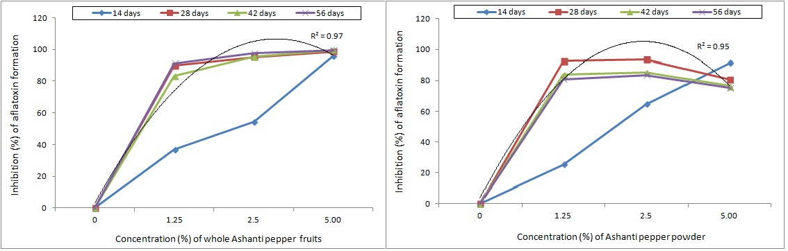
Fig. 1. Percentage reduction of aflatoxins formed during co-storage of maize grains with different concentrations of whole or ground Ashanti pepper fruits at specific time intervals. Polynomial trend/regression line for best fit inhibition data (day 56 for whole AP fruits and day 28 for AP powder).

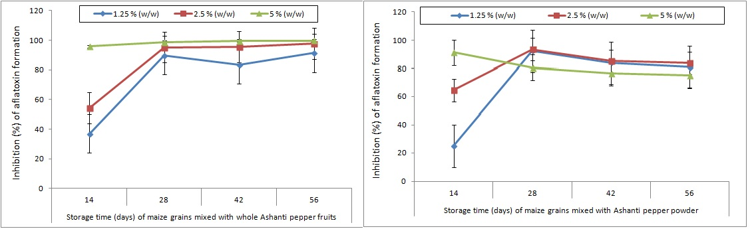

Fig. 2. Rate of aflatoxin inhibition in poorly stored maize grains by concentrations of whole or ground Ashanti pepper fruits across a 56-day co-storage period. Vertical lines on data points indicate the standard error of mean (α = 0.05).

  - Population of Aspergillus section Flavi in Maize Grains
The effect of co-storing maize grains with whole or ground spice on the population of Aspergillus section Flavi for a 56-day period is shown in Fig. 3. At all time intervals, Aspergillus section Flavi population was significantly (p<0.05) higher (100–1600 cfu/g) in the control (untreated) maize grains than in the grains co-stored with whole AP fruits (0–600 cfu/g). Furthermore, the count of section Flavi isolates diminished in the grains at days 42 and 56 of co-storage compared with the loads during the 14th and 28th days. No fungal counts were found in the grains co-stored with 2.5% and 5% whole AP at days 42 and 56 (Fig. 4). No significant (p<0.05) change in the population of Aspergillus section Flavi was observed in the AP powder-treated (100–1200 cfu/g) and untreated/control (100–1600 cfu/g) maize grains at all time intervals although the counts in the all treated maize grains were lower than the untreated at days 28 and 56 days of storage (Fig. 4). Overall, co-storing maize grains with whole AP fruits proved better than the powdered spice in reducing the load of aflatoxigenic moulds (Fig. 3).

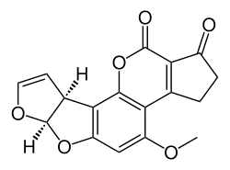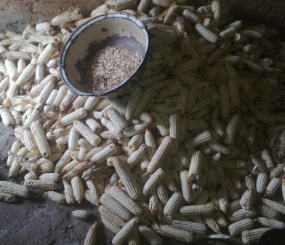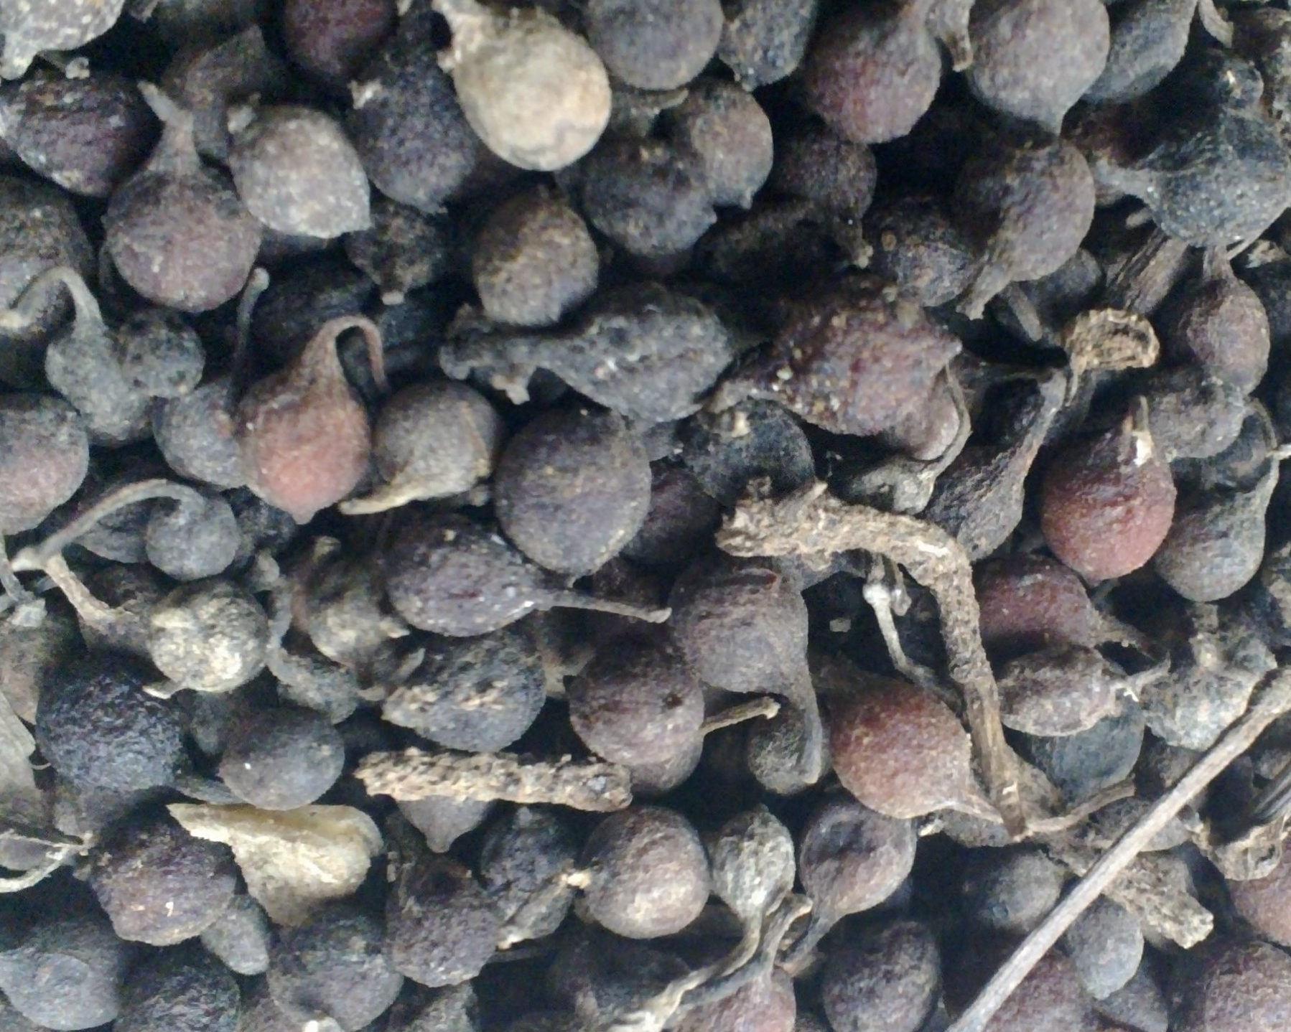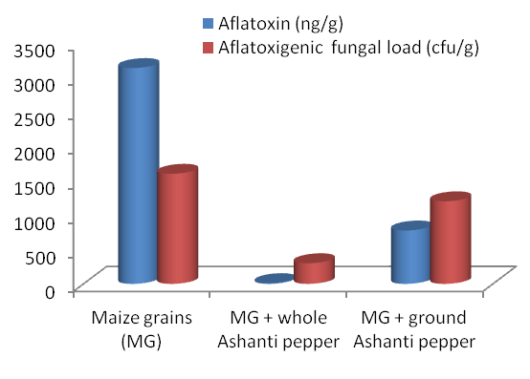
+
Ashanti pepper fruits
Maize grains containing aflatoxigenic fungi and aflatoxins

Fig. 3. Whole Ashanti pepper (AP) fruits drastically lower aflatoxin formation and aflatoxigenic fungal load in poorly stored maize grains than the ground AP.
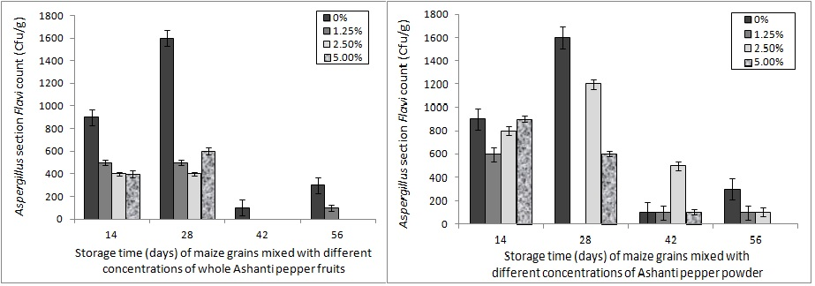
Fig. 4. Effect of concentrations of whole or ground Ashanti pepper fruits on Aspergillus section Flavi population during co-storage with maize grains at specific time intervals. Vertical lines on bars indicate the standard error of mean (α = 0.05).

- Discussion
The harmful effects of aflatoxins to humans, animals and livestock as well as trade losses incurred by their presence in export grains have necessitated the continuous search for effective aflatoxin biocontrol measures in agricultural commodities. In sub-Saharan Africa (SSA), efforts are presently being directed at affordable and reliable, farmer-friendly methods (Atehnkeng et al., 2014). Those methods that target post-harvest storage may be preferred due to the prolonged duration and poor conditions of storage prevalent in most developing nations. This study therefore explored the influence of co-storing maize grains with whole AP fruits and powder on aflatoxin accumulation and aflatoxigenic fungal proliferation under poor storage conditions. Literature is scarce on the application of AP in aflatoxin control; hence the significance of this study which is in the simplified use of a local and natural product for aflatoxin control in agricultural commodities.
All AP treatment concentrations had some level of inhibitory action against aflatoxin formation and aflatoxigenic fungal load in the co-stored grains compared to the control/untreated grains. However, aflatoxin accumulation in the poorly stored maize grains was significantly reduced in the whole AP-treated grains compared to the grains co-stored with AP powder, at all concentrations and time intervals. This suggests the relevance and applicability of the whole spice for aflatoxin control in stored commodities. The general inhibitory effect of the spice and higher percentage reduction of aflatoxins influenced by the whole spice than the powder may be attributed to the actions of significant proportions of volatile compounds in the spice. Ekundayo et al. (1988), Onyenekwe et al. (1997) and Olonisakin et al. (2006) previously reported the presence of volatile compounds including caryophylene, dillapiol, elemicin, limonene, myristicin, pinene and safrole in distilled oil of AP by gas chromatography-mass spectrometry. As a member of the Piperaceae family, oil from the spice contained high contents of the above listed compounds (McGee, 2004; Olonisakin et al., 2006). Volatile compounds have been reported to exhibit anti-aflatoxigenic activity in several aflatoxigenic species (Thanaboripat et al., 2007; Rasooli et al., 2008; Passone et al., 2012; Shukla et al., 2012). Hence, their presence in AP may also have been responsible for the very low fungal counts recorded in the whole AP co-stored maize grains after day 28 (i.e. storage time of 42 and 56 days). This is in addition to the expected microbial competition within the microhabitat as evidenced in the low fungal counts for control samples. This fact is further supported by a similar study which showed that garlic, oregano and caraway seeds contained certain compounds in their extracts that inhibited the growth of some Eurotium and Aspergillus species (Dimic et al., 2007). Furthermore, our findings are strengthened by the reports of Kiin-Kabari et al. (2011) who found AP to be an effective preservative for storing smoked-dried fish up to six weeks.
It is known from our previous study on the anti-aflatoxigenic effect of aqueous extracts of AP against some aflatoxin producing species that the spice contains phenols, alkaloids, ﬂavonoids, isoﬂavonoids, tannins, glycosides, terpenes (Ezekiel et al., manuscript in preparation). These compounds together with the volatile compounds have the potential advantage of being bioactive in their vapor phase, a characteristic that makes them attractive as possible fumigants for the protection of stored products (Cabral et al., 2013). The mechanisms of action of this spice and its volatile compounds, however, are yet to be proven and work is in progress in this regard.
Furthermore, the increase in surface area of the powdered sample could have facilitated the easy loss of the volatile compounds, thereby reducing the potency of the powdered samples compared to the whole spice over the period of study. This is obviously the most suitable explanation for the sudden increase in aflatoxin formation in the grains co-stored with AP powder after 14 days for the highest concentration (5%) and 28 days for the lower concentrations (1.25% and 2.5%) in contrast to the grains co-stored with the whole spice. Therefore, the powdered form may be useful for short term storage (up to 20 days). However, when the time and energy invested in the conversion of the whole spice into powder is considered; in addition to the consistent inhibition of fungi and aflatoxin formation exhibited by the whole spice over the powdered spice at all time intervals, it becomes more logical to exploit the whole spice. This will be faster, much easier for local farmers to handle. Furthermore, powdering the spice may serve as an avenue for introducing unwanted microorganisms in the micro-environment.
It is important to note that the previous study on fungal and aflatoxin contamination of AP retailed in markets in Lagos, Nigeria (Ezekiel et al., 2013) contrasts the present study where AP is used to lower aflatoxigenic fungal growth and inhibit consequent aflatoxin formation in co-stored maize grains. The reason is not farfetched: the spices investigated and reported in 2013 were in possession of the retailers for more than 90 days (data not shown) in contrast to the spices used in the present study which was purchased from retailers within 14 days of harvest and drying. It is known that keeping spices for long periods tend to compromise their physical and chemical integrity thus paving way for some saprophytic moulds such as those of Aspergillus section Flavi. It should also be noted that the AP reported by Ezekiel et al. (2013) had very low (8.3%) aflatoxin contamination; an indication that the spice is not a suitable substrate for aflatoxin production in aflatoxigenic species regardless of storage time, due to natural chemicals as those already mentioned.
In conclusion, this study has shown that AP, especially the 5% (w/w) concentration of whole fruits, can be useful in reducing post-harvest aflatoxin contamination of maize grains in the local setting where poor storage conditions are prevalent. Since populations of tropical regions including SSA countries are more exposed to aflatoxins through contaminated staples (e.g. maize and groundnuts) than those in the temperate regions (Abia et al., 2013; Ezekiel et al., 2014b) and poor storage conditions which are almost inevitable in the local parlance contribute to higher toxin incidences in the foodstuffs, efforts to scale up this technology to a friendlier method for smallholder farmers should be considered.

Acknowledgements:
Authors thank Prof. O.O. Atanda for giving advice during the design of the work and for providing valuable literature.

Corresponding Author:
Dr. Chibundu N. Ezekiel
Department of Biosciences and Biotechnology, Babcock University, Ilishan Remo,
Ogun State, Nigeria.
E-mail: chaugez@gmail.com

References
- Abia WA, Warth B, Sulyok M, Krska R, Tchana AN, Njobeh, PB., Turner PC, Kouanfack C, Eyongetah M, Dutton MF, Moundipa PF. Biomonitoring of mycotoxin exposure in Cameroon using a urinary multi-biomarker approach. Food and Chemical Toxicology 2013; 62: 927–934.
- Atanda OO, Akpan I, Oluwafemi F. The potential of some spice essential oils in the control of A. parasiticus CFR 223 and aflatoxin production. Food Control 2007; 18: 601–607.
- Atanda OO, Olopade TA. Effect of lemon grass (Cymbopogon citratus (DC.) Stapf.) treatments on Aspergillus flavus (SGS–421) infestation and aflatoxin B₁ content of maize grains. International Food Research Journal 2013; 20: 1933–1939.
- Atehnkeng J, Ojiambo PS, Donner M, Ikotun T, Sikora RA, Cotty PJ, Bandyopadhyay R. Distribution and toxigenicity of Aspergillus species isolated from maize kernels from three agro-ecological zones in Nigeria. International Journal of Food Microbiology 2008; 122: 74–84.
- Atehnkeng J, Ojiambo PS, Cotty PJ, Bandyopadhyay R. Field efficacy of a mixture of atoxigenic Aspergillus flavus Link: Fr vegetative compatibility groups in preventing aflatoxin contamination in maize (Zea mays L.). Biological Control 2014; 72: 62–70.
- Bankole SA, Adebanjo A. Mycotoxins in food in West Africa: current situation and possibilities of controlling it. African Journal of Biotechnology 2003; 2: 254–263.
- Cabral LC, Pinto VF, Patriarca A. Application of plant derived compounds to control fungal spoilage and mycotoxin production in foods. International Journal of Food Microbiology 2013; 166: 1–14.
- Cotty PJ. Inﬂuence of ﬁeld application of an atoxigenic strain of Aspergillus ﬂavus on the populations of A. ﬂavus infecting cotton bolls and on the aﬂatoxin content of cottonseed. Phytopathology 1994; 84: 1270–1277.
- Cotty PJ, Cardwell KF. Divergence of West African and North American communities of Aspergillus section Flavi. Applied and Environmental Microbiology 1999; 65: 2264–2266.
- Dimic GR, Kocic-Tanackov SD, Karalic D. Growth inhibition of some Eurotium and Aspergillus species with spice extracts. Proc Nat Sci, Matica Srpska Novi Sad 2007; 113: 63–70.
- Egal S, Hounsa A, Gong YY, Turner PC, Wild CP, Hall AJ, Hell K, Cardwell KF. Dietary exposure to aflatoxin from maize and groundnut in young children from Benin and Togo, West Africa. International Journal of Food Microbiology 2005; 104: 215–224.
- Ehrlich KC, Kobbeman K, Montalbano BG, Cotty PJ. Aﬂatoxin producing Aspergillus species from Thailand. International Journal of Food Microbiology 2007; 114: 153–159.
- Ekundayo O, Laakso I, Adegbola R, Oguntimein BM, Sofowora A, Raimo H. Essential oil constituents of Ashanti Pepper (Piper guineense) fruits (Berries). Journal of Agriculture and Food Chemistry 1988; 36: 880–882.
- Ezekiel CN, Fapohunda SO, Olorunfemi MF, Oyebanji AO, Obi I. Mycobiota and aflatoxin B₁ contamination of Piper guineense (Ashanti pepper), P. nigrum L. (black pepper) and Monodora myristica (calabash nutmeg) from Lagos, Nigeria. International Food Research Journal 2013; 20: 111–116.
- Ezekiel CN, Adetunji MC, Atanda OO, Frisvad JC, Houbraken J, Samson RA. Phenotypic differentiation of species from Aspergillus section Flavi on neutral red desiccated coconut agar. World Mycotoxin Journal 2014a; 7: 335–344.
- Ezekiel CN, Warth B, Ogara IM, Abia WA, Ezekiel VC, Atehnkeng J, Sulyok M, Turner PC, Tayo GO, Krska R, Bandyopadhyay R. Mycotoxin exposure in rural residents in northern Nigeria: a pilot study using multi-urinary biomarkers. Environment International 2014b; 66: 138–145.
- Ezekiel CN, Sulyok M, Anokwuru CP, Anyasor GN, Amos BMW, Krska R. Ashanti pepper (Piper guineense) inhibits aflatoxin biosynthesis in Aspergillus flavus and A. parvisclerotigenus. Manuscript in preparation.
- Food and Agricultural Organization (FAOSTAT). http://faostat.fao.org/site/339/default.aspx. 2013; Date accessed: March 10, 2014.
- Gourama H, Bullerman LB. Antimycotic and antiaflatoxigenic effect of lactic acid bacteria—a review. Journal of Food Protection 1995; 57: 1275–1280.
- Guynot ME, Ramos AJ, Seto L, Purroy P, Sanchis V, Marın S. Antifungal activity of volatile compounds generated by essential oils against fungi commonly causing deterioration of bakery products. Journal of Applied Microbiology 2003; 94: 893–899.
- Kiin-Kabari DB, Barimalaa IS, Achinewhu SC, Adeniji TA. Effects of extracts from three indigenous spices on the chemical stability of smoke-dried catfish (Clarias lezera) during storage. African Journal of Food, Agriculture and Nutritional Development 2011; 11: 5335–5343.
- Klich MA, Pitt JI. Differentiation of Aspergillus flavus from A. parasiticus and other closely related species. Transactions of the British Mycological Society 1988; 91: 99–108.
- McGee H. Black pepper and relatives on food and cooking. Scribner, NY, 2004; pp. 427–429.
- Olonisakin A, Oladimeji MO, Lajide L. Chemical composition and antibacterial activity of steam distilled oil of Ashanti Pepper (Piper guineense) fruits (Berries). Proceedings of the 28th Annual International Conference 2006; 1–4.
- Onyenekwe PC, Ogbadu GH, Hashimoto S. The effect of gamma radiation on the microflora and essential oil of Ashanti Pepper (Pipper guineense) berries. Postharvest Biology and Technology 1997; 10: 161–167.
- Passone MA, Girardi NS, Ferrand CA, Etcheverry M. In vitro evaluation of five essential oils as botanical fungitoxicants for the protection of stored peanuts from Aspergillus flavus and A. parasiticus contamination. International Biodeterioration and Biodegradation 2012; 70: 82–88.
- Perrone G, Haidukowski M, Stea G, Epifani F, Bandyopadhyay R, Leslie JF, Logrieco A. Population structure and aflatoxin production by Aspergillus Sect. Flavi from maize in Nigeria and Ghana. Food Microbiology 2014;41:52–59.
- Probst C, Bandyopadhyay R, Cotty PJ. Diversity of aflatoxin-producing fungi and their impact on food safety in sub-Saharan Africa. International Journal of Food Microbiology 2014; 174: 113–122.
- Rasooli I, Fakoor MH, Yadegarinia D, Gachkar L, Allameh A, Rezaei MB. Antimycotoxigenic characteristics of Rosmarinus ofﬁcinalis and Trachyspermum copticum L. essential oils. International Journal of Food Microbiology 2008; 122: 135–139.
- Samson RA, Hoekstra ES, Frisvad JS, Filtenborg O. Methods for the detection and isolation of food-borne fungi. In: Samson RA, Hoekstra ES, Frisvad JC and Filtenborg O (eds) Introduction to Foodborne Fungi. Central Bureau voor Schimmel cultures, The Netherlands, 1995; pp 235–242.
- Sanchez E, Heredia N, Garcia S. Inhibition of growth and mycotoxin production of Aspergillus flavus and Aspergillus parasiticus by extracts of Agave species. International Journal of Food Microbiology 2005; 98: 271–279.
- Shukla R, Singh P, Prakash B, Dubey NK. Antifungal, aflatoxin inhibition and antioxidant activity of Callistemon lanceolatus (Sm.) Sweet essential oil and its major component 1,8-cineole against fungal isolates from chickpea seeds. Food Control 2012; 25: 27–33.
- Suhagia BN, Shah SA, Rathod IS, Patel HM, Shah DR, Marolia BP. Determination of gatifloxacin and ornidazole in tablet dosage forms by high-performance thin-layer chromatography. Analytical Science 2006; 22: 743–745.
- Thanaboripat D, Suvathi Y, Srilohasin P, Sripakdee S, Patthanawanitchai O, Charoensettasilp S. Inhibitory effect of essential oils on the growth of Aspergillus flavus. KMITL Science & Technology Journal 2007; 7: 1–7.
- UNDP. Global maize production, environmental impacts and sustainable production opportunities: a scoping paper. 2010; USA: UNDP Green Commodities Facility.
- Williams JH, Phillips TD, Jolly PE, Stiles JK, Jolly CM, Aggarwal D. Human aflatoxicosis in developing countries: a review of toxicology, exposure, potential health consequences, and interventions. American Journal of Clinical Nutrition 2004; 80: 1106–1122.
- Zain ME. Impact of mycotoxins on humans and animals. Journal of Saudi Chemical Society 2011; 15: 129–144.

9/3/2014

