A New Technique to Recognize Human Facial Using Neural Network

Dr. Khalaf fakhri Khatatneh

Al-Balqa Applied University Jordan Al-Salt Department of Computer Science

Dr.khalaf@bau.edu.jo

Abstract: This paper explains the approach of face recognition using neural Network (NN) and back propagation algorithm. Face recognition can be obtained using holistic, featured-based and hybrid approaches. The Eigen face in holistic approach is faster and more efficient than the other techniques which are used when the whole face region is taken into account as input data. The feature- based approach used characteristic parameters of face where the parameters can be found by any facial extraction. The Hybrid approach uses a combination of holistic and feature- based approaches. The neural network is used to perform the face recognition by using the back propagation networks technique. The recognition performance of the proposed method is tabulated based on experiments performed on a number of images.
[Khalaf fakhri Khatatneh. A New Technique to Recognize Human Facial Using Neural Network. N Y Sci J 2014;7(9):60-63]. (ISSN: 1554-0200). http://www.sciencepub.net/newyork. 12

Keywords: technique, human facial, neural network

Introduction
The face is the one of the most basic and powerful weigh to communicate with people directly, it represent one of the most common visual pattern in our environment and place a primary role in receipt identity and emotion by feature.
Face recognition is one of biometric method which is used in several applications such as person identification, computer human interaction and security systems [3], to recognize given face image using main feature of face.
Face recognition from the images that challenges caused by the complex of wide differences of face appearances and the image back ground.
Face recognition problem is challenging as it needs to account for all possible appearance variation caused by changing in illumination facial features …etc. Therefore pre-processing is implemented to reduce the noise from the image.
Face recognition system is a computer vision and efficient software to automatically identify or verify a person from a digital image or a video frame from a video source.
  - Face recognition approach:
There are many face recognition approaches these can be classified as Holistic approach, feature –based approach, and hybrid approach.
In holistic approach the whole face region is taken into account as input data into face detection system[3] .This is based on principle component analysis (PCA) technique which is used to simplify a dataset into lower dimension while retaining the characteristics of datasets, one of the best example of holistic methods are (Eigen-faces) for face recognition. PCA is a common technique is used for dimensionality reduction for compression and face recognition problems .PCA calculates the Eigen vectors of the covariance matrix, and projects the original data onto a lower dimensional feature space, which is defined by Eigen vectors with large Eigen values ,PCA has been used in face representation and recognition where the Eigen vectors calculated are referred to as Eigen faces.
PCA is a useful statistical technique that has found application in fields such as face recognition and image compression, and is a common technique for finding patterns in data of high dimension. It is one of the more successful techniques of face recognition [11]; the benefit of PCA is to reduce the dimension of the data. No data redundancy is found as components are orthogonal. With help of PCA, complexity of grouping the images can be reduced.
The application of PCA is made in criminal investigation, access control for computer, online banking, post office, passport verification, medical records etc.
The algorithm used for principle component analysis is as follows [2]:
- Acquire an initial set of M face images (the training set ) and calculate the Eigen-faces from the training set, keeping only M ’Eigen faces that correspond to the highest Eigen value.
- Calculate the corresponding distribution in M'-dimensional weight space for each known individual, and calculate a set of weights based on the input image
- Classify the weight pattern as either a known person or as unknown, according to its distance to the closet weight vector of a known person.
Let the training set of image L1, L2 ………… Lm and the average face of training set are defined by [2]:
AVG = $\frac{1}{M}\sum_{n=1}^{m}{L}$ ……… (1)
The difference between each face from average face is calculated as [2]
D_{i} = L_{i} – AVG ………… (2)
Calculate the covariance matrix where the covariance matrix formatted is [2]
C = $\frac{1}{M}\sum_{n}^{m}{D}$n.DnT = A.AT ……… (3)
Where the matrix
A = [D1, D2 …Dm]
This set is the subject of PCA, which seeks a set of M'-dimensional vectors U1 …………Um. We can find the weight of face by [2]
W_{k} = U_{k}T (L - AVG) …… (4)
Where K = 1…….. M’ and the weight vector is [2]
V= [W₁, W2………... W_{m}] ………… (5)
Eigen-faces have advantages over other techniques available, such as the system's speed and efficiency [2].
1.1.2 Feature-based approach:
Feature-based approach is the most popular approach for face recognition because it’s used characteristic parameters of face where the face has 80 characteristic parameters, like width, nose width, space between eyes, high of eyehole, shape of zygotic bone, jaw width etc.
To create a data set there are six steps [3]:
- The first step is to determine the characteristic parameters to use in face recognition.
- The second step is finding the characteristic points, Weight of parameter is calculated
- The third step is the normalizing of the data between 0 and 1.
- A matrix (M * N) where M is image and N is the characteristic is saved.
Consider L₁, L₂ ……….. L_{m} image to create a data set then we choose the characteristic as shown in figure 1 [3].
Let us define a set of distances as follows|:
J1 - distance between middles of the eyes.
J2 - distance between middle of the left eyes and middle point of mouth.
J3 - distance between middle of the right eyes and middle point of mouth.
J4 - distance between middle of the left eyes and middle point of nose.
J5 - distance between middle of the right eyes and middle point of nose.
J6 - distance between middle point of mouth and middle point of nose.
J7 - distance of middle point of J1 and middle of nose.
J8 - width of nose
The characteristic points can be found by any facial extraction program. The weight can calculate by distance between two points [3].
D = $\sqrt{{(Y2-Y1)}^{2}+{(X2-X1)}^{2}}$ … (5)
The normalized data can be determined by [3]
X_{n} = $\frac{X-Xmin}{Xmax-Xmin}$ …… (6)
Where X is the value to be normalized, X_{n} is normalized data, X_{min} is the minimum value of X and X_{max} is the maximum value of X.

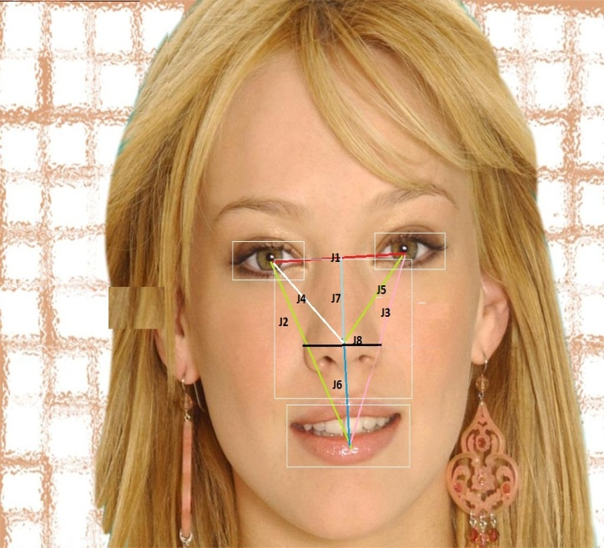
Figure 1 view the 8 characteristic parameters [3]

1.1.3 Hybrid approach:
Hybrid approach is a combination between holistic approach and feature-based approach. It contains the Eigen-face and characteristic parameters [3].
  - Neural network and back propagation algorithm:
Neural network is a system of programs and data structures that approximates work as the human brain, its take input then process and get the output [1] [2] [4]. The neural network used for classifying applications such as pattern recognition, feature extraction and image matching [4].
In neural network there is supervised learning with teaching algorithm and unsupervised learning (self-organizing) algorithm to use in face recognition [4]. In learning algorithm there are two techniques: the perceptron training and back propagation training (BPNN)
The BPNN is used because face recognition problem is nonlinear and cannot be solved by perceptron training [2] [4]. Back propagation is a multi-layer feed forward based on gradient descent learning rule, in BPNN the weight changed in feed forward network with different activation function to learn a training set of input-output data; the gradient descent method minimize the total error [1] [2] [4] [5].
    - Back propagation algorithm:
Its shows how the algorithm can be eﬃciently implemented in computing systems in which only local information can be transported through the network. The back propagation algorithm looks for the minimum of the error function In weight space.
A back propagation network with multi-layer feed forward is shown in figure 2 [2].

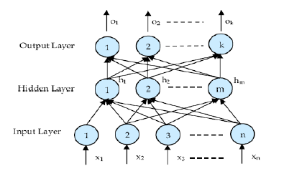
Figure 2 basic of BPNN [2]

H_{n}: Hidden layer
K:Hidden units
X_{n}: Input sites
M:Output units W:Connection matrix and Site :n+1
Let W1 denote the (n + 1) × k matrix with component Wij at the i-th row and the j-th column. Similarly
The vector e of the stored derivatives of the quadratic deviations
After choosing the weights of the network randomly, the back propagation algorithm is used to compute the necessary corrections. The algorithm can be decomposed in the following four steps:
i) Feed-forward computation
ii) Back propagation to the output layer
iii) Back propagation to the hidden layer
iv) Weight updates
The algorithm is stopped when the value of the error function has become suﬃciently small.
The hidden layers get the input by [2]
IN_{m} = $\sum_{z=1}^{n}{Xz . W}$_{mz} ………… (7)
In hidden layer after passing the activation function the units of output given by [2]
H_{m} = $\frac{1}{1+\exp^{- INm}}$ ………… (8)
The output layers get the input by [2]
IN_{k} = $\sum_{z=1}^{n}{Hz . W}$_{kz} ………… (9)
In output layer after passing the activation function the units of output given by [2]
O_{k} = $\frac{1}{1+\exp^{- INk}}$ ………… (10)
We need to calculate the error for updating the weight by [2]
E = $\frac{1}{2}\sum_{i=1}^{k}{{\left(O_{i}-T_{i}\right)}^{2}}$ ………... (11)

Where O_{i} represents the real output and T_{i} represents the target output at neuron I [2]. If the error of minimum value then the train is stop else the weight will be updated. The change in weight between hidden layer and output layer given by [2]
∆W_{ij} =   h_{j} ………… (12)
Where is a training rate coefficient in range [0.01, 1.0], h_{j}is the output of neuron j in hidden layer and  can obtained by [2]
 = (T_{i} - O_{i}) O_{i}(L – O_{i}) ………… (13)
After calculate the changed in weight in all layer the weight can updated by [2]
W_{ij} new = W_{ij}old + ∆W_{ij} ………… (14)
Proposal work
In this paper will combine between Eigen-face and characteristic parameters, the images are chosen from EURO 2012 database to apply face recognition. First the Eigen-face is found to each image and then 8 characteristic parameters are calculated these characteristic parameters are:
1 - Distance between middles of the eyes.
2 - Distance between middle of the left eyes and middle point of mouth.
3 - Distance between middle of the right eyes and middle point of mouth.
4 - Distance between middle of the left eyes and middle point of nose.
5 - Distance between middle of the right eyes and middle point of nose.
6 - Distance between middle point of mouth and middle point of nose.
7 - Distance of middle point of J1 and middle of nose.
8 - Width of nose.

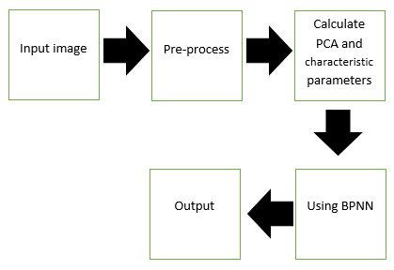
Basic block diagram as shown in Figure 1.
Neuroph studio is used with back propagation technique in neural network to recognition face images. n. All these processes are implemented for Face Recognition, based on the basic block diagram as shown in fig 1.
3.1 Experimental result:
In this paper a sample of 14 images are used to train and the result is as shown in table 3.1.
- Number of input = 22
- Number of hidden layer = 5
- Number of output = 14

Table 3. Result of NN Training
Number of iteration |  | Total number of square error (Train) | Total number of square error (Test) | Learning rate
1 | 1421 | 0.009987932838 | 0.00121203287 | 0.2
2 | 41 | 0.00518487586 | 0.00870452367 | 0.3

3.2 Conclusion
In this paper, new technique (Hybrid approach) is proposed for human face recognition. Face recognition using Eigen faces has been shown to be accurate and fast. The neural network model is used for recognizing the frontal or nearly frontal faces with Eigen-face and the results are tabulated. Neural network with BPNN is developed and the network is trained and tested combined with PCA. From these result, it can conclude that the accuracy using this technique is low comparing to the PCA technique or characteristic parameter technique. The new technique curtails the level of performance for the face recognition.

References
- Prashant Sharma, AmilAneja, Amit Kumar and Dr.Shishir Kumar “Face Recognition Using Neural Network and Eigenface with Distinct Block Process”.
- P.Latha, Dr.L.Ganesan and Dr.S.Annadurai “Face Recognition Using Neural Networks”.
- http://neuroph.sourceforge.net/ tutorials/ FaceRecognition/FaceRecognitionUsingNeuralNetwork. html.
- http://www.authorstream.com/Pres entation/thiyagarajan6792-433638-face-recognition-using- neural-network/.
- N.Revathy and T.Guhan “FACE RECOGNITION SYSTEM USING BACK PROPAGATION ARTIFICIAL NEURAL NETWORKS”.
- JawadNagi, Syed Khaleel Ahmed and FarrukhNagi “A MATLAB based Face Recognition System using Image Processing and Neural Networks”.
- V. Ramya and G. Sivashankari “Face recognition using neural networks”.
- V, Dr.L.Ganesan, Shumeet Baluja. Takeo Kanade “Neural Network Based Face Detection". Face Recognition using neural network". as bachelor Project prepared by Parsanth and Namit under the guidance of Prof.Koshy Gerorge .
- Mayank Agarwal, Nikunj Jain, Mr. Manish Kumar and Himanshu Agrawal & Takeo Kanade "Face Recognition Using Eigen Faces and Artificial Neural Network".
- Samuel Rota Bul_o " Face Detection with neural Network". Universit_a Ca' Foscari Venezia DAIS 2012.

8/28/2014

