Effect of Morinda citrifolia Supplementation on the Lactate Dehydrogenase (LDH) levels of Athletes

Anugweje KC¹ and Ayalogu EO²

¹Department of Health Services, Lulu Briggs Health Centre, University of Port Harcourt, East-West Road, P.M.B. 5323, Choba, Port Harcourt, Rivers State, Nigeria;
²Department of Biochemistry, University of Port Harcourt, East-West Road, P.M.B. 5323, Choba, Port Harcourt, Rivers State, Nigeria
e-mail: kanugweje@hotmail.com; Tel: +2348033382154

Abstract: The influence of M. citrifolia on serum lactate dehydrogenase (LDH) levels of athletes was investigated in this study. Preliminary studies involving a 30 months-long exploratory monitoring of athletes consuming wide-ranging doses of M. citrifolia juice were carried out to establish dosage and toxicity. Administration of M. citrifolia (noni) and placebo juices were respectively performed on two groups of one hundred subjects each, comprising highly trained athletes and non-athletes randomly assigned. Both groups were subjected to a 6-week physical training programme prior to the commencement of a 30 months assessment period. Morinda citrifolia juice supplementation remarkably decreased LDH levels in serum of the test group; 493.4 ± 12.60 and 401.3 ± 10.3 for Pre and Post supplementation. Paired t-test results for enzyme assay showed that there was significant difference (p=0.009) in lactate dehydrogenase levels (IU/L) after supplementation with M. citrifolia juice. Concentration of LDH before and after placebo juice supplementation showed no significant difference (p≤ 0.05). Further analysis showed that M. citrifolia juice does not contain any banned substance. Correlation analysis showed very significant differences in the rise in lactate dehydrogenase levels of both males and females in the experimental group after supplementation. Thus, Morinda citrifolia supplement can reduce muscle breakdown during vigorous exercise.
[Anugweje KC and Ayalogu EO. Effect of Morinda citrifolia Supplementation on the Lactate Dehydrogenase (LDH) levels of Athletes. N Y Sci J 2014;7(9):37-42]. (ISSN: 1554-0200). http://www.sciencepub.net/newyork. 9

Key words: Morinda citrifolia, Supplementation, LDH, Athletes

1. Introduction
Lactate dehydrogenase (LDH) is an oxidoreductase enzyme that catalyses the interconversion of pyruvate and lactate. Since LDH is a fairly stable enzyme, it has been widely used to evaluate the presence of damage and toxicity of tissue and cells. Lactate dehydrogenase (LDH or LD) as an enzyme (EC 1.1.1.27) is present in a wide variety of organisms, including plants and animals. Lactate dehydrogenases exist in four distinct enzyme classes. Two of them are cytochrome c-dependent enzymes, each acting on either D-lactate (EC 1.1.2.4) or L-lactate (EC 1.1.2.3). The other two are NAD(P)-dependent enzymes, each acting on either D-lactate (EC 1.1.1.28) or L-lactate (EC 1.1.1.27). LDH is also elevated in certain pathological conditions such as cancer. Quantification of LDH has a broad range of applications. Several workers have investigated the NAD(P)-dependent L-lactate dehydrogenase (Gregg and Prchal, 2008; Gallagher, 2011; Selwood and Jaffe, 2011).
LDH assay is a screening test in sports medicine and serves as an indicator for acute or chronic muscle tissue damage. Tissue breakdown releases LDH, and therefore LDH can be measured as a surrogate for tissue breakdown, e.g. hemolysis. Other disorders indicated by elevated LDH include cancer, meningitis, encephalitis, acute pancreatitis, and HIV (Gregg and Prchal, 2008; Gallagher, 2011; Selwood and Jaffe, 2011). A typical range is 105 - 333 IU/L (international units per liter). Normal value ranges may vary slightly among different laboratories. Some laboratories use different measurements or test different samples (Gregg and Prchal, 2008; Gallagher, 2011; Selwood and Jaffe, 2011). It may also be used at regular intervals to monitor the efficacy of nutritional supplements ingested by athletes.
Morinda citrifolia is an evergreen shrub or small tree that grows throughout the tropical regions of the Pacific Ocean, from Southeast Asia to Australia and especially in Polynesia (Natural Standard Database, 2009; Natural Medicines Comprehensive Database, 2009; Tolle et al., 2011). Morinda citrifolia, commonly known as great morinda, Indian mulberry, nunaakai (Tamil Nadu, India), dog dumpling (Barbados), mengkudu (Indonesia and Malaysia), apatot (Philippines), Kumudu (Bali), pace (Java), beach mulberry, cheese fruit (Nelson, 2006) or Morinda citrifolia (from Hawaiian) is a tree in the coffee family, Rubiaceae. Originally native to Southeast Asia, the Carribeans and the Australasia, it is now widely cultivated as commercial crops in the tropics. It is a familiar plant in the northern parts of Nigeria, and is known to the local population as Kura. The leaves are 8-10 inches long, oval shaped, dark green and shiny, with deep veins (Rivera et al., 2011). When the Morinda citrifolia fruit is ground, analysis of the resultant powder shows that it contains moderate amounts of carbohydrate and fibre, embodied in the pulp of the fruit. The powder also contains micronutrient such as Niacin and Vitamin C, Potassium and Iron in significant amounts and Vitamin A, Calcium and Sodium in moderate amounts (Rivera et al., 2011).
Interestingly, the numbers of athletes who use M. Citrifolia as part of their nutritional regimen are growing, and include reports of increases in recovery time and endurance. However the mechanisms responsible for these effects have not been elucidated. In this study, we report the effect of M. citrifolia fruit juice supplementation on lactate dehydrogenase (LDH) of atheletes.

2. Material And Methods
2.1. Population and sample
One hundred (100) student-athletes and 100 non-athletes of the University of Port Harcourt, Nigeria were randomly placed in each of two study groups. Samples of blood were collected from the antecubital veins of each participant. The training programmes of the participants during a 30-months period were similar and properly designed. All participants consumed the same meals as provided in the University of Port Harcourt athletes training camp. Food records were monitored during the study. The participants were all treated for malaria prior to the commencement of the study. The use of prescription drugs, vitamins, mineral supplements and other sports nutritional supplements was forbidden during the study. Written informed consent was obtained from participants after detailed explanations of the risks involved in the study. Detailed physical examination was carried out on all the participants to exclude any heart or musculoskeletal disease.
2.2. Endurance clinical trial
One hundred volunteers (50 males and 50 females), who were training for the Nigerian University Games (NUGA) were enrolled in the study with one hundred (100) non-athletes (50 males and 50 females). The volunteers were divided into 2 groups of 50 males and 50 females each: a Morinda citrifolia (the experimental) group, ages 18 – 25 years; and a placebo (the control) group, ages 19 – 25 years. Participants assigned to the experimental group consumed 100 ml of Morinda citrifolia twice daily, 30 min before meals, for 30 days. Those in the placebo group consumed a placebo blackcurrant juice, following the same dose and consumption schedule as the Morinda citrifolia group. The endurance of each participant was measured by a treadmill run with increasing workload (stepwise every minute), until muscle fatigue (time-to-fatigue). The time-to-fatigue which was adopted as the fatigue threshold was measured pre-study. At day 30, each participant was made to stop the exercise activity at his fatigue threshold. LDH levels measurements were assayed the same interval using lactate dehydrogenase test kit (manufactured by Randox Laboratories Ltd., 55 Diamond Road, Crumin, Co. Antrim, United Kingdom).
2.3. Data Analysis
The data generated were analyzed by multivariate statistical methods. For statistical analysis SPSS software (version 20.0, Chicago, USA) was used, the paired t test and independent samples-test were used to compare values of the experimental treatment and control group. A comparison was considered statistically significant if the P value was < 0.05.

3. Results
The study showed that there were significant differences in pre-training and post-training lactate dehydrogenase (IU/L) levels for the experimental group (p=0.001) and for the control group (p=0.022). There was significant difference (p=0.009) in lactate dehydrogenase levels (IU/L) after supplementation with M. citrifolia juice. There was no significant difference (p=0.965) in lactate dehydrogenase levels (IU/L) after placebo juice supplementation.
3.1. LDH level reduction after supplementation in female athletes
The post-supplementation showed LDH level reduction after supplementation in female athletes (experimental group) (Figure 1).

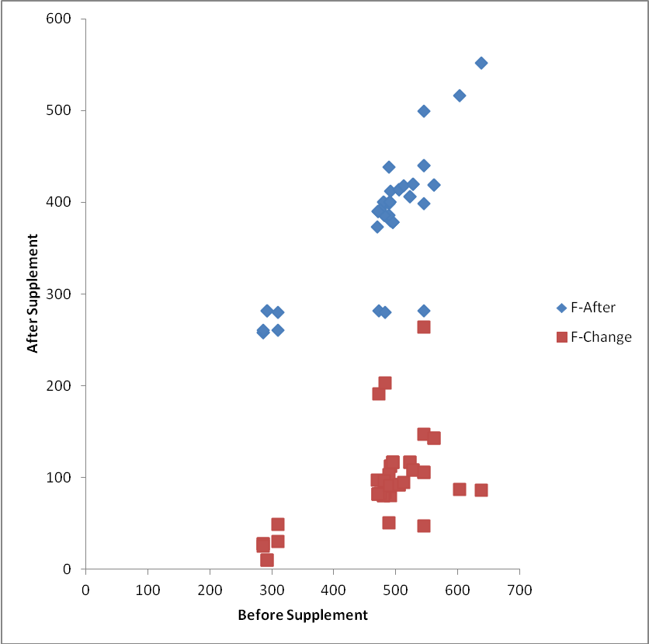
Figure 1: LDH level reduction after supplementation in female athletes (experimental group)

The LDH reduction after supplementation with placebo juice in female athletes (control) was similar to that observed in the experimental group (Figure 2).

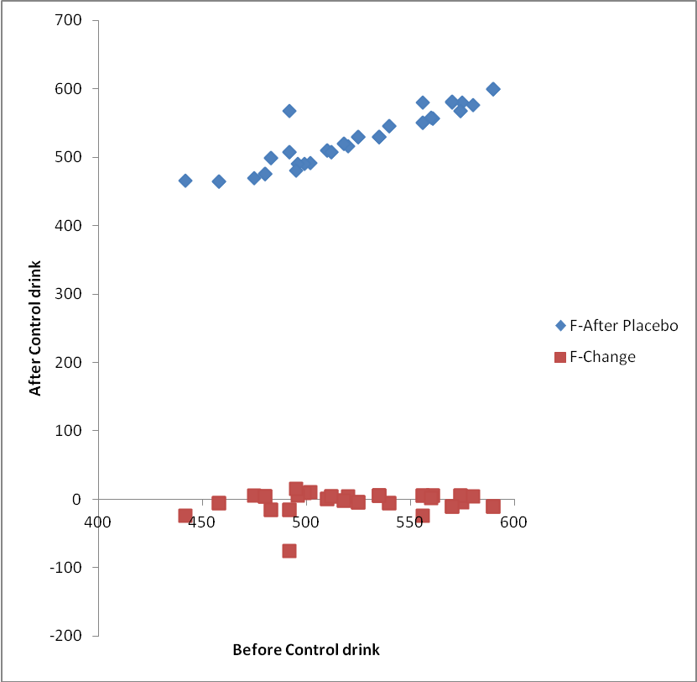
Figure 2: LDH reduction after supplementation with placebo juice in female athletes (control)

When a comparison between the female experimental and control groups after supplementation was made from the results of the study, it was observed that the LDH level reduction among females in the experimental and control groups had more impact in the experimental over their control counterparts (Figure 3).

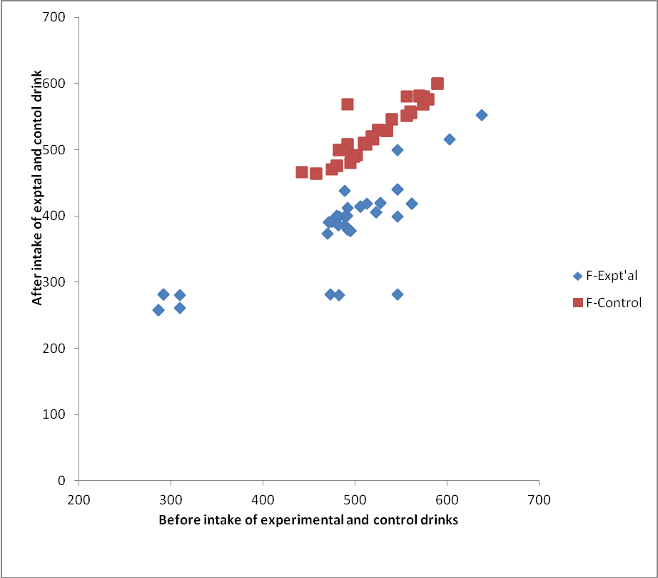
Figure 3: Comparison between the female experimental and control groups after supplementation respectively.

3.2. LDH level reduction after supplementation in male athletes
Figure 4 shows LDH level reduction after supplementation in male athletes (Experimental group).

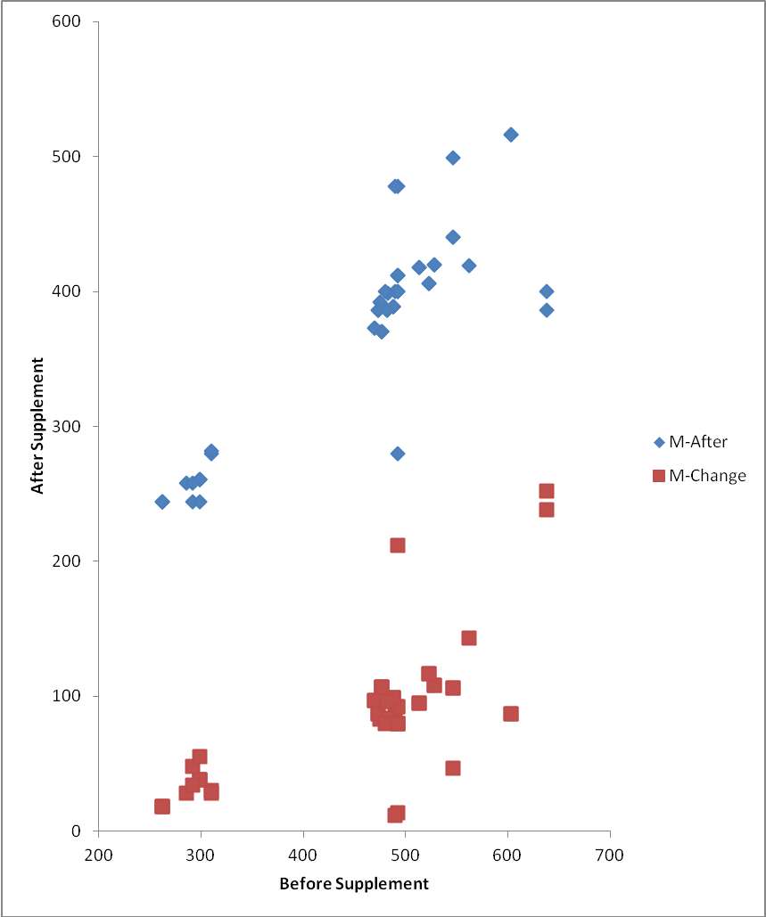
Figure 4: LDH level reduction after supplementation in male athletes (experimental group)

A reduction in the LDH level after supplementation with placebo juice in male athletes (control) was observed (Figure 5).
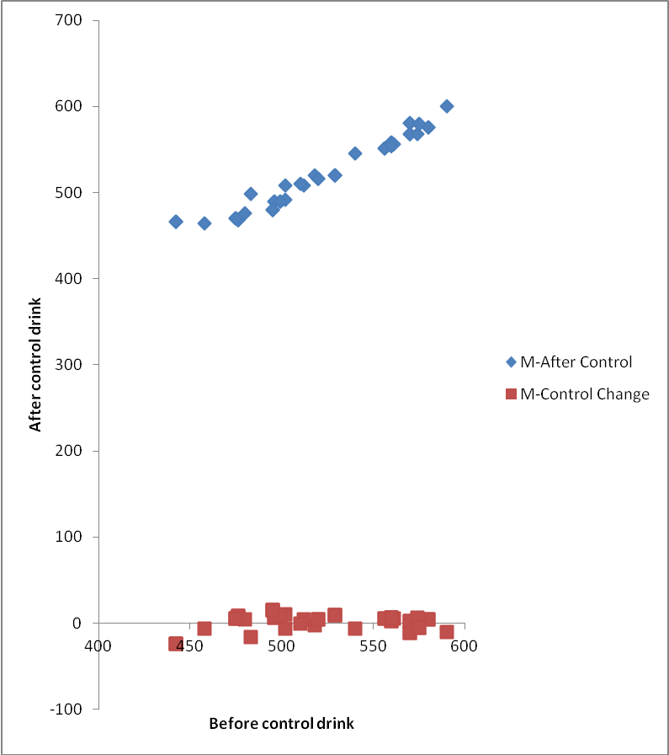
Figure 5: LDH reduction after placebo in male athletes (control)
The comparison of the LDH level reduction among male athletes in the experimental and control groups show much impact in the experimental over their control counterparts (Figure 6).
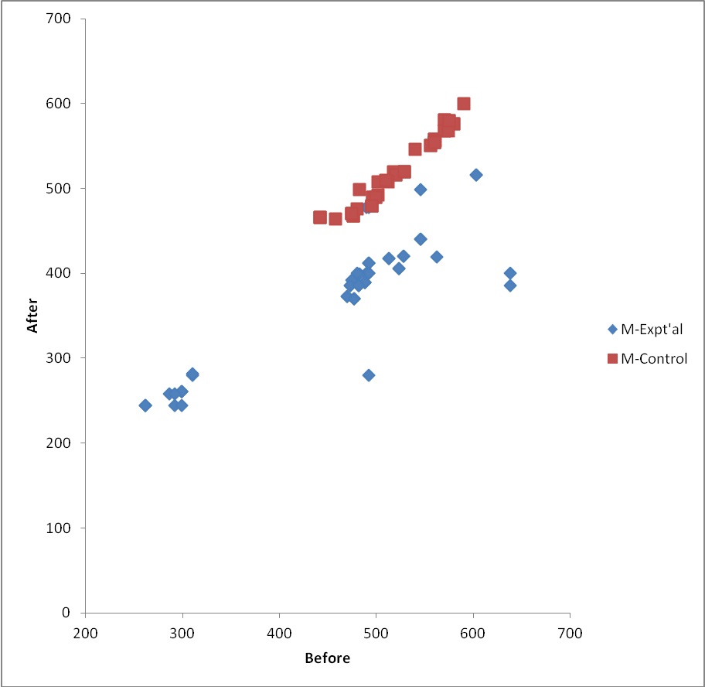
Figure 6: Comparison of LDH level reduction between the male subject in the experimental and control groups after supplementation

3.3. Comparison of LDH levels reduction between the male and female subjects
Figure 7 is the comparison of the LDH level reduction between the male and female subjects in the experimental groups. It can be seen that not much difference is detectable between the two gender groups, with a few female athletes showing strong impact than their female colleagues.
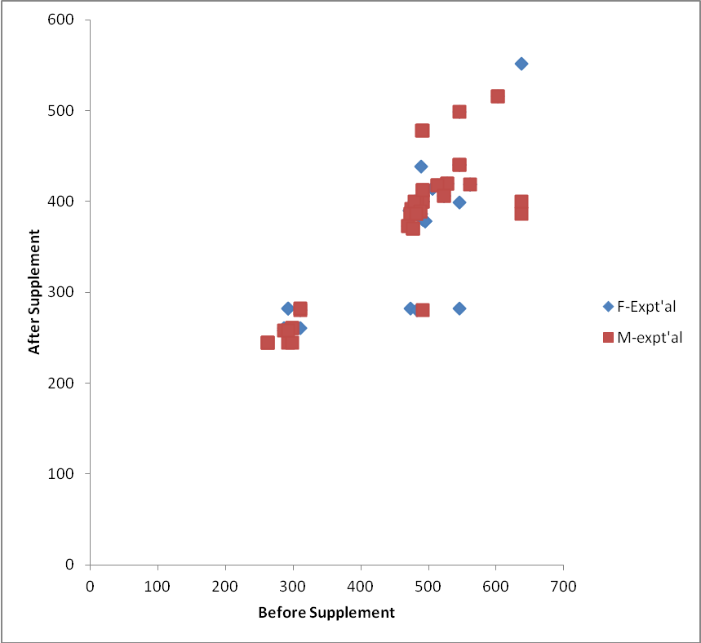
Figure 7: Comparison of LDH level reduction between the male and female subjects in the experimental group

The plot in Figure 8 shows that there is not much difference in the levels of LDH reduction among the male and female athletes. However, a few of the female athletes have higher levels of LDH reduction than their female colleagues.

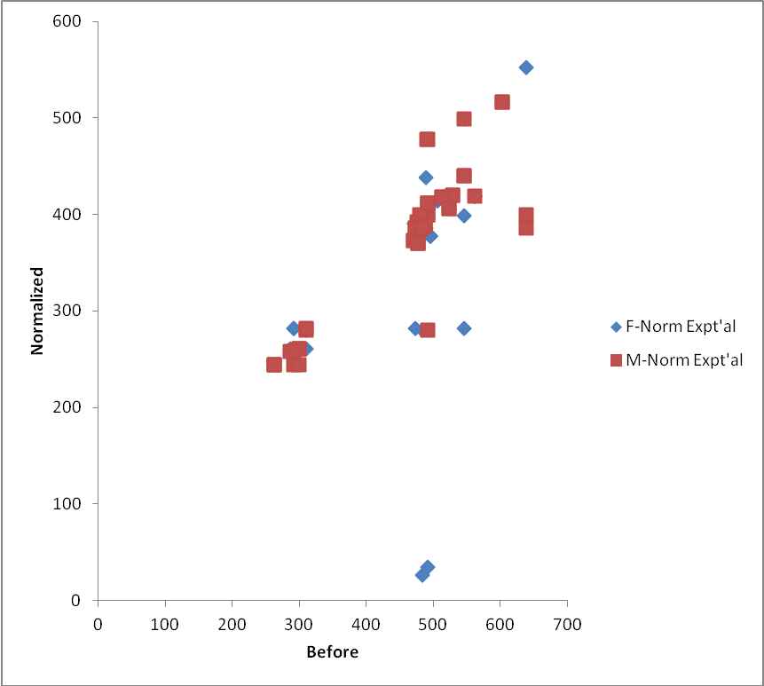
Figure 8: Comparison of normalized reduction of LDH levels among male and female athletes

4. Discussion
The study showed that post-supplementation values for lactate dehydrogenase levels were significantly lower in the experimental groups than in their controls. In other words, over the study period, Morinda citrifolia reduced the magnitude of exercise-induced elevation in lactate, lactate dehydrogenase and serum kinase levels. The results obtained are consistent with the observations of Coombes and McNaughton (2000), Brancaccio et al. (2007), Palu et al. (2008a,b, 2010) and Tsai et al. (2009). The results also mimic the effects of training on CK levels of athletes as observed by Vincent and Vincent (1997); Fehrenbach et al. (2000); and Garry and McShane (2000). Coombes and McNaughton (2000) reported that another factor that may reduce muscle damage and serum concentrations of CK following prolonged exercise is supplementation with branched-chain amino acids, often used in sports.
Correlation analysis showed very significant differences in the rise in lactate dehydrogenase levels of both males and females in the experimental group after supplementation. Thus, Morinda citrifolia supplement can reduce muscle breakdown during vigorous exercise. It also showed no significant difference in the rise in lactate dehydrogenase levels of females in the control group after supplementation. Thus, control drink cannot reduce muscle breakdown during vigorous exercise. However, correlation analysis showed significant difference in the rise in lactate dehydrogenase levels of males in the control group after supplementation. The control drink may sustain exercise by influencing the conversion of glucose to usable energy better in values than females due to the mechanical efficiency of lean body mass which is greater in males than females.
The reduction in post-supplementation, serum LDH is very likely as a result of powerful antioxidant properties of the phytochemical constituents of Morinda citrifolia juice. These prevent or reduce lipid peroxidation of muscle cell membranes by free radicals, thus preventing muscle cell damage and the accompanying leakage of intracellular enzymes into the general circulation. Palu et al. (2008a,b, 2010) reported that Morinda citrifolia has ergogenic effect in mice and indicated that Morinda citrifolia increased the swimming time of mice (36 to 45%) before becoming fatigued, and increased their endurance time (59 to 128%) on a rotarod test, compared to their control. Further, the older mice in the Morinda citrifolia group performed similarly to the younger ones in the control group, with respect to swimming time and endurance. Tsai et al. (2009) reported in their study that Morinda citrifolia reduced the magnitude of exercise-induced elevation in serum creatine kinase levels.
Morinda citrifolia is reported to possess beneficial properties on the immune system, prevention of inflammation, cancers and numerous other health problems (Clafshenkel et al., 2012), but little is known about its ability to enhance performance. More recently, an array of commercial Morinda citrifolia fruit juice products are gaining popularity as dietary supplements, with claims of anti-cancer and immunostimulant activities (Samoylenko et al., 2006). The biologically active principles of Morinda citrifolia are not fully known (Samoylenko et al., 2006).
The limiting factors to exercise have been enumerated: accumulation of lactate; accumulation of phosphate ions; the activities of reactive oxygen species, and the depletion of glycogen stores. The ergogenic effects of Morinda citrifolia as confirmed by this study can be attributed to the multifarious mechanisms of action of the constituents of Morinda citrifolia.

References
- Coombes, J.S., and McNaughton, L.R. (2000). Effects of branched-chain amino acid supplementation on serum creatine kinase and lactate dehydrogenase after prolonged exercise. Journal of Sports Medicine and Physical Fitness; 40: 240–246.
- Fehrenbach, E., Niess, A.M., Schlotz, E., Passek, F., Dickhuth, H.H. and Northoff, H. (2000). Transcriptional and translational regulation of heat shock proteins in leukocytes of endurance runners. Journal of Applied Physiology, 89: 704–710.
- Gallagher, P.G. (2011). Hemolytic anemias: red cell membrane and metabolic defects. In: Goldman L, Schafer AI, eds. Cecil Medicine. 24th ed. Philadelphia, Pa: Saunders Elsevier; chap 164.
- Garry, J.P., and McShane, J.M. (2000). Postcompetition elevation of muscle enzyme levels in professional football players. Journal of General Medicine., 3, E4.
- Gregg, X. and Prchal, J.T. (2008). Red blood cell enzymopathies. In: Hoffman, R., Benz, E.J., and Shattil, S.S., eds. Hematology: Basic Principles and Practice. 5th ed. Philadelphia, Pa: Elsevier Churchill Livingstone; chap 45.
- Natural Standard Database (2009). Morinda citrifolia (Morinda citrifolia). Natural Standard Database Web site. Accessed at www.naturalstandard.com on August 4, 2009.
- Nelson, S.C. (2006). Nutritional analysis of Hawaiian Morinda citrifolia (Pure Noni Fruit Juice) The Noni Website. Retrieved 15-06-2009.
- Palu, A., Su, C., Zhou, B.N., West, B., and Jensen, J. (2010). Wound Healing Effects of Morinda citrifolia (Noni) Leaves: A Mechanism Involving its PDGF/A2A Receptor Ligand Binding and Promotion of Wound Closure. Phytotherapy Research, 24(10):1437-1441.
- Palu, A.K., Kim, A.H., West, B.J., Deng, S., Jensen, J., White, L. (2008a). The Effects of Morinda citrifolia L. (Noni) on the Immune System: Its Molecular Mechanisms of Action. Journal of Ethnopharmacolgy. 15(3):502-506
- Palu, A.K., R.D. Seifulla and B.J. West. (2008b). Morinda citrifolia L. (Noni) Improves Athlete Endurance: Its Mechanisms of Action. Journal of Medicinal Plants Research 2(7): 154-158.
- Rivera, A., Giono, S., Gonzalez, M., Rodríguez, N. and Cedillo, L. (2011). Antibacterial Effect of Morinda citrifolia Fruit Juice against Mycoplasmas. Annals of Biological Research, 2 (3) :491-497.
- Samoylenko, V., Zhao, J., Dunbar, D.C., Khan, I.A., Rushing, J.W., and Muhammad, I. (2006). New Constituents from Morinda citrifolia (Morinda citrifolia) Fruit Juice. Journal of Agricultural and Food Chemistry., 54 (17): 6398–6402. DOI: 10.1021/jf060672u
- Selwood, T., and E. K., Jaffe. (2011). "Dynamic Dissociating Homo-Oligomers and the Control of Protein Function". Arch. Biochem. Biophys. 519(2): 131–43.
- Tolle, S., Lander, V., and Winterhalter, P. (2011). Authentication of Fruit Juices Derived from Morinda citrifolia (Morinda citrifolia). ACS Symposium Series, Vol. 1081, Progress in Authentication of Food and Wine, Chapter 18, pp 249–258.
- Tsai, P.H., T-K.,Tang, C-L., Juang, K., W-C., Chen, C-A., Chi, and M-C., Hsu. (2009). Effects of Arginine Supplementation on Post-Exercise Metabolic Responses. Chinese Journal of Physiology 52(3): 136-142.
- Vincent, H.K., and Vincent, K.R. (1997). The Effect of Training Status on the Serum Creatine Kinase Response, Soreness and Muscle Function Following Resistance Exercise. International Journal Sports Medicine., 18: 431–437.

8/28/2014

