**Comparison of TCSC and UPFC for Increasing** **Power Transfer Capability and Damping Power System Oscillation**

Salah Kamal El sayed

Electrical Engineering Department, Faculty of Engineering, AL-Azhar University

[Salah_kamal1982@yahoo.com](mailto:Salah_kamal1982@yahoo.com)

**Abstract**: This paper focuses on comparing two types of Flexible AC Transmission Systems (FACTS) devices such as thyristor controlled series compensator (TCSC) and unified power flow controller (UPFC) for increasing power transfer capability and damping power system oscillation. The location of (FACTS) devices in deregulated electricity market is determined to reduce the congestion, hence increasing power transfer capability of the system. Identification of congested line based on local marginal price (LMP) difference is developed by using a standard optimal power flow (OPF) tool. Continuation power flow (CPF) is used to evaluate the effects of these devices on system loadability. The damping oscillation problem is analyzed based on Hopf bifurcations and critical eigenvalues of power system by using small signal stability analysis tool (SSS). The Comparison is illustrated on IEEE 14-bus system. Power System Analysis Toolset (PSAT), is computational tool under Matlab program for effective simulation and monitoring is used. Test system reveals that (UPFC) give higher maximum loading point and improve damping oscillation more than inserting (TCSC) in congested line.

[Salah Kamal El sayed. **Comparison of TCSC and UPFC for Increasing** **Power Transfer Capability and Damping Power System Oscillation.** *N Y Sci J* 2014;7(9):5-11]. (ISSN: 1554-0200). <http://www.sciencepub.net/newyork>. 2

**Keywords:** FACTS, TCSC, OPF, LMP, SSS and CPF.

1. **Introduction:**

The continuous growth in the demand for electric power necessitates the flexibility of operation in power system. The existing transmission networks often operate close to their limits. This has as an effect of voltage profiles and decreasing system stability and security [1]. So the use of existing generation and transmission lines up to their full capabilities without reduction in system stability and security is requested.

Integration of dynamic elements such as generators and controllers generates oscillation modes, which need to be handled carefully to ensure the stability of a system. Hence, small signal stability has also become a major concern of electricity distribution System in addition to the usual concerns such as voltage Stability, protection and power quality. Therefore, proper choice of location and coordination of controllers are required to enhance the overall stability of a distribution system [2].

The continuing rapid development of high-power semi- conductor technology now makes it possible to control electrical power systems by means of power electronic devices. a new family of devices with a common name of flexible AC transmission systems (FACTS) is becoming available. By using (FACTS) controllers one can control the variables such as voltage magnitude and phase angle at chosen bus and line impedance. Installations of multiple (FACTS) devices offer a great opportunity concerning the flexibility of system-wide power flow control and dynamic stability control. However, their control

Actions may cause mutual negative effects which affect the system security [3].

(FACTS) technology opens up new opportunities for controlling and enhancing the useable capacity of present, as well as new upgraded lines. (FACTS) is an evolving technology and can boost power transfer capability by 20–30% by increasing the flexibility of the systems. In addition (FACTS) devices prove to be an effective remedy in enhancing both static and dynamic voltage stability.

It is important to ascertain the location for placement of these devices because of their considerable costs. There are several methods for finding optimal Locations of (FACTS) devices in both vertically Integrated and unbundled power systems [4-8]. In [4], a sensitivity approach based on line loss has been proposed for placement of series capacitors, phase shifters and static VAR (Volt Ampere Reactive) compensators. Other works in optimal power flow with (FACTS) devices [5, 6] have used optimization with different objective functions. In [9, 10], the optimal locations of (FACTS) devices are obtained by solving the economic dispatch problem plus the cost of these devices making the assumption that all lines, initially, have these devices.

This paper introduces comparison between two types of (FACTS), thyristor controlled series compensator (TCSC) and unified power flow controller (UPFC) for increasing power transfer capability and damping power system oscillation. An approach of obtaining location of (FACTS) based on finding congested line by using method of (LMP) [11]. Then using (CPF) tool [12] to find maximum loadability for selected congested lines with one device of (FACTS), the best location which gives highest maximum loading point. Dynamic limits, which are typically the loading levels at which the system presents oscillatory instabilities associated with Hopf bifurcations and critical eigen values, are also depicted.

**2. Modeling of TCSC**

A (TCSC) controller consists of a bank of capacitors in parallel with a (TCR). The series impedance of a high voltage transmission line is usually inductive, with large X/R ratio. With the introduction of a controllable series capacitor or reactor in series with the transmission line, the line impedance can be varied continuously, below or above its nominal value. Fig.1. shows the block diagram for a (TCSC) controller operating under current control [13]. The structure of the stability controller is shown in Fig.2. [14]. It Consists of a washout filter, a dynamic compensator, and a limiter. The washout filter is used to avoid a controller response to the dc offset of the input signal. The dynamic compensator consists of two (or more) lead-lag blocks to provide the necessary phase-lead characteristics. Finally, the limiter is used to improve controller response to large deviations in the input signal.

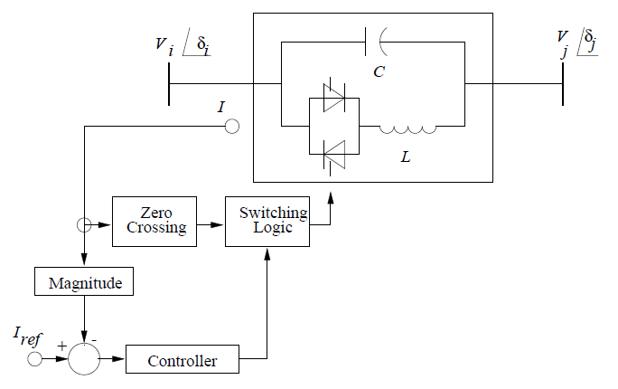

Fig. 1. Basic (TCSC) structure.

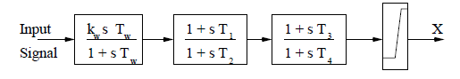

Fig. 2 Block diagram of the (TCSC) stability control loop.

**3. Modeling of UPFC**

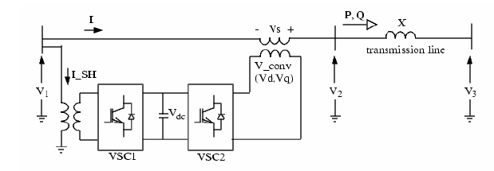The (UPFC) is conceptually a Synchronous Voltage Source (SVS) [13, 15] which generates the adjustable voltage on the ac side. The voltage source exchanges both active and reactive power with the transmission system. The (UPFC) consists of two-voltage source converters, one in series and one in shunt in a transmission line. Both using switching elements and operated from a common dc storage element as shown in Fig.3.

Fig. 3 Basic (UPFC) structure

The main objective of the series inverter is to produce an ac voltage of controllable magnitude and phase angle, and inject this voltage of fundamental frequency into the transmission line through the series transformer. The series inverter exchanges real and reactive power at its ac terminals, while the shunt inverter provides the required real power at the dc terminals, so that real power flows freely between the controller shunt and series ac terminals through the common dc link. The reactive power is generated/absorbed independently by each inverter and does not flow through the dc link [16, 17]. Since

The UPFC is able to force a desired power flow through the transmission line in steady state as well as in dynamic conditions; the Automatic Power Flow Control Mode feature can be enhanced to damp power oscillation in power networks. Control of power flow is achieved by adding the series voltage, VS with a certain amplitude, $|V_{S}|$ and phase shift, φ to V1. This will gives a new line voltage V2 with different magnitude and phase shift. As the angle φ varies, the phase shift δ between V2 and V3 also varies. Fig. 4 shows the phasor diagram of voltage and current.

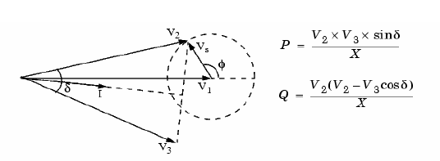

Fig. 4. The phasor diagram of voltage and current.

With the presence of the two converters, (UPFC) not only can supply reactive power but also active power. The equation for the active and reactive power is given as follows:-

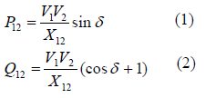

**4. Continuation Power Flow**

The main purpose of Continuation Power Flow is to find the continuity of power flow solution for a given load change.Continuation methods overcome certain difficulties of successive power flow solution methods, as they are not based on a particular system model, and allow the user to trace the complete voltage profile by automatically changing the value of loading parameter **λ**; without having to worry about singularities of system equations. The strategy used in Continuation method is shown in Fig.5. [18]. It starts from a known solution and uses a tangent predictor to estimate a subsequent solution corresponding to a different value of the load parameter. This estimate is then corrected using the same Newton-Raphson (NR) technique employed by a conventional power flow. A detailed description of these techniques is referred to Kundur [19].

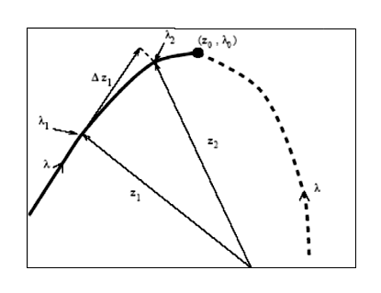

Fig.5. Continuation method

**5. Dynamic Analysis**

Dynamic voltage stability is analyzed by monitoring the Eigenvalues of the linearized system as a power system is progressively loaded. When the λ parameter varies, the equilibrium points of the dynamic system also vary accordingly, and so do the Eigen values of the corresponding state matrix **A sys** as shown in Fig.6. Equilibrium points are asymptotically stable if all the Eigen values have negative real parts. The point where a complex conjugate pair of Eigen values reaches the imaginary axis with respect to changes in λ is known as Hopf Bifurcation point. Which is a local bifurcation in which a fixed point of a dynamical system loses stability as a pair of complex conjugate Eigen values of the linearization around the fixed point cross the imaginary axis of the complex plane [20-21] If this particular dynamic problem is studied using gradual changes it can be viewed as Hopf Bifurcation problem. Thus by predicting these types of bifurcations well in advance, a possible dynamic instability problem may be avoided.

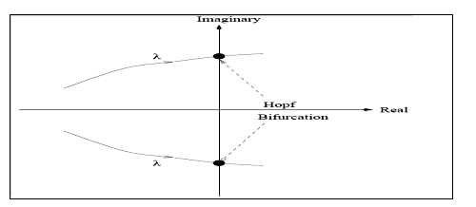

Fig.6. Hopf Bifurcation Point

**6. Location marginal price [LMP] Method:**

The main concept behind the (LMP) difference method is to make use of the economic signal given as (LMP) to select the congested lines to manage congestion and hence increasing loading stability limit. It is motivated from the fact that (LMP) contains significant information regarding level of congestion in the system [22]. (LMP) is composed of three components, an energy component, a loss component and a congestion component. For a meshed system, loss component is generally small. Hence, the difference in (LMP) between two buses gives direct hint regarding the level of congestion in that line [23].

**7. Validations Studies**

**7.1 Test system**

The IEEE14- bus test system is used for the objective of these studies. Fig.7 depicts the single line diagram of the IEEE 14 bus test system used in this paper. It consists of 14 buses, 20 branches, three transformers, and five synchronous machines. The generators are molded as standard PV buses with both P and Q limits, loads are represented as constant PQ loads.Power system analysis toolbox software (PSAT), which has many features including power flow and continuation power flow, is used [24].Using continuation power flow feature of (PSAT), voltage stability of the test system, is investigated.

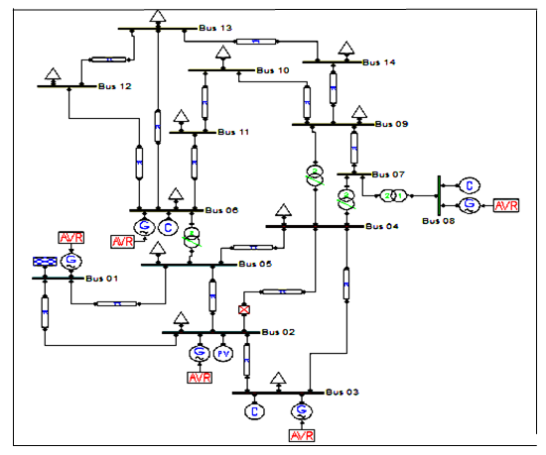

Fig.7 Single line diagram of IEEE 14 bus test system

**7.2 Simulation Results**

**7.2.1 Simulation with (TCSC)**

Table 1: Dynamic Margins and Static Margins for System with TCSC

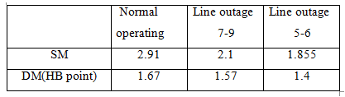

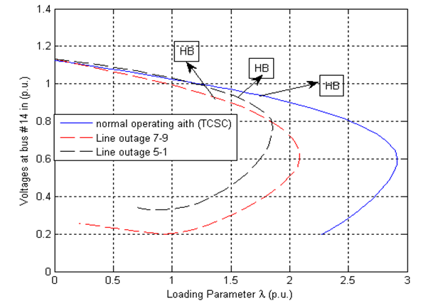

Fig.8 P-V curves at bus# 14 for System with (TCSC)

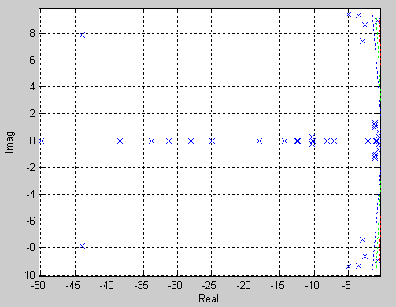

Fig. 9 Eigenvalues for the line 5-6 outage at λ=1.6 for system with (TCSC)

For the test system the optimal location of (TCSC) is connected in series with line 1-5 based on (LMPs) difference [22] and (CPF) methods [19]. Table 1.and Fig.8 illustrates static margin (SM) and dynamic margin (DM) corresponding to Hopf Bifurcation (HB) associated with P-V curves for the system with (TCSC). At normal operation, line 7-9 and line 5-6 outages. In these curves, Hopf Bifurcation (HB) points, which were obtained through eigen value analysis, are also depicted. To study the behavior of the system under large perturbations. Eigen value computation was performed for a line 5-6 outage at the operating point defined by λ = 1.6. A time Domain simulation when Three phase fault happens at Bus 5 at t =1.s. Then fault is cleared at 1.08 s. Fig.9 to Fig.11 show the corresponding eigen values analysis and time domain simulation results.



Fig. 10 Generators speed oscillation due to line 5-6 Outage at λ=1.6 p.u. for system with (TCSC)



Fig. 11: Voltages at all buses due to line 5-6 outage at λ=1.6 p.u. for system with (TCSC)



Fig. 12: Active power at bus 2 due to line 5-6 outage at λ=1.6 p.u. for system with (TCSC)



Fig. 13 Reactive power at bus 2 due to line 5-6 outage at λ=1.6 p.u. for system with (TCSC)

**7.2.2 Simulation test system with (UPFC)**

Table 2: Dynamic and Static Margins for System with (UPFC)

|  |  |  |  |
| --- | --- | --- | --- |
|  | **Normal**  **operating** | **Line outage**  **7-9** | **Line outage**  **5-6** |
| SM | 3.50 | 2.34 | 1.96 |
| DM (HB POINT) | 3.49 | 2.34 | 1.96 |



Fig. 14: P-V curves at bus# 14 for emergencies and normal operating with (UPFC)

In this case, the system was simulated by inserting (UPFC) in the line 1-5. Based on (LMPs) difference [22] and (CPF) methods [19]. Table 2 and Fig.14 illustrates static margin (SM) and dynamic margin (DM) corresponding to Hopf Bifurcation (HB) associated with P-V curves for the system with (UPFC). It is clear that both (SM) and (DM) have increased in all cases and the voltage profiles are also improved compared to test system with (TCSC). A time Domain simulation and eigen values analysis were performed for a line 5-6 outage at the operating point defined by λ = 1.6. Thus, Fig.15 to Fig.19 show the corresponding egin value analysis and time domain simulation results. From these figures, it can conclude that for line 5-6 outage with the (UPFC) in the system this leads to improving for the system dynamic performance Compared to the case when (TCSC) inserted in the system.



Fig.15 Eigenvalues for the line 5-6 outage at λ=1.6 for system with (UPFC)



Fig.16: Generator speed oscillation due to line 5-6 outage at λ=1.6 p.u. for system with (UPFC)



Fig.17: Voltages at all buses due to line 5-6 outage at λ=1.6 p.u. for system with (UPFC)



Fig.18: Active power at bus 2 due to line 5-6 outage at λ=1.6 p.u. for system with (UPFC)



Fig.19 Reactive power at bus 2 due to line 5-6 outage at λ=1.6 p.u. for system with (UPFC)

**8. Conclusion**

In this paper; the congested line in the test system has been selected based on (LMP) difference method and (CPF) tool for comparison between Series (FACT) devices such as (TCSC) and series-shunt (FACT) such as (UPFC). Based on simulation results obtained from time domain simulation and eigen values analysis, one can conclude that (TCSC) in congested line increase power transfer capability and improve voltage profile for all buses at critical loading point in case of normal operating and for two line outages selected. Also the system dynamic stability performance is improved through time domain simulation, due to the addition of the (TCSC).

Also results showed that (UPFC) at congested line give higher maximum loadability at normal operating and for selected two line outages more than insertion (TCSC) in series with that line and minimize the worst case voltage deviations. Also (UPFC) improves system dynamic stability performance more than (TCSC) through time domain simulation results.

**References**

1. FACTS overview;" IEEE Power Engineering Society Publication 95-TP-108, 1995.
2. Rogers G., Power System Oscillations, Kluwer, Norwell, MA, 2000.
3. Oudalov A., P. Korba, « Coordinated Power Flow Control Using FACTS Device », ABB Switzerland Ltd., Corporate Research CH-5405 Baden- DÄattwil, Switzerland.
4. Preedavinchit P., Srivastava S.C., 1998. Optimal reactive power dispatch considering FACTS devices, Electric Power Systems Research, Vol. 46, No. 3: 251-257.
5. Huang G., Hsieh S.C., 1998. Fast textured algorithms for optimal delivery problems in deregulated environments, IEEE Trans. on Power Systems, Vol. 13, No. 2: 493-500.
6. Momoh J.A., Zhu J.Z., 1998. A newapproach to optimal power flow with phase shifter, IEEE International Conference on Systems, Vol. 5: 4794- 4799.
7. Wu G., Yokoyama A., He J., Yu Y., 1998. Allocation and control of FACTS devices for steady state stability enhancement of large scalepower system, IEEE International Conference on Power System Technology, Vol. 1: 357-361.
8. Liu J.Y., Song Y.H., 1999. Comparison studies of unified power flow controller with static var compensators and phase shifters, Electric Machines and Power Systems, Vol. 27: 237-251.
9. Lie T.T., Deng W., 1999. Optimal flexible AC transmission systems (FACTS) devices allocation, International Journal of Electrical Power and Energy Systems, Vol. 19, No. 2 : 125-134.
10. De Oliveira E.J., Lima W.M., 1999 Allocation of ACTS devices in a competitive environment, 13th PSCC, 1184-1190.
11. Alvarado F.L., Controlling power systems with price signals, Decision Support Syst. 40 (2005) 495–504.
12. Canizares C.A., F.L.Alvardo, C.L.Demarco, I.Dobson, and W. F. Long,” Point of collapse methods applied to ac/dc power systems,” IEEE Trans. Power System, vol.7, no.2,May 1992,pp.673-683.
13. Hingorani G. and L. Gyugi, Understanding FACTS: Concepts and Technology of Flexible AC Transmission Systems. IEEE Press, 1999.
14. Del Rosso A. D., C. A. Ca˜nizares, and V. M. Do˜na, “A Study of TCSC ControllerDesign for Power System Stability Improvement,” Accepted to IEEE Trans. on Power Systems, September 2002.
15. Song, Y. H. and Johns, A. T. Flexible AC Transmission Systems (FACTS). IEEE Stevenage: UK. 1999.
16. Gyugui L., C. D. Schauder, S. L. Williams, T. R. Rietman, D. R. Torgerson, and A. Edris, \The Uni_ed Power Flow Controller: A New Approach to Power Transmission Control," IEEE Trans. Power Delivery, Vol. 10, No. 2, pp. 1085{1093, Apr. 1995.
17. Gyugui L., \A United Power Flow Control Concept of Flexible AC Transmission Systems," IEE Proceedings-C, Vol. 139, No. 4, pp. 323{331, July 1992.
18. Power system stability subcommittee report on voltage stability assessment, procedures and guides. IEEE/PES, Final draft; 1999.
19. Kundur P. (1994): Power System Stability and Control, McGraw Hill, New York.
20. Seydel R. (1994): Practical Bifurcation and Stability Analysis: From Equilibrium to Chaos, Second Edition, Springer-Verlag, New York.
21. Lautenberg M. J., M. A. Pai, and K. R. Padiyar (1997): Hopf Bifurcation Control in Power System with Static Var Compensators. Int. J. Electric Power and Energy Systems, Vol. 19, No.(5):, pp. 339–347.
22. Hsu M. (1997): An introduction to the pricing of electric power transmission, Utilities Policy, 6 (3) : 257–270.
23. Srivastava S.C., R.K. Verma (2000): Impact of FACTS devices on transmission pricing in a de-regulated electricity market, in: Proceeding of International Conference on Electric Utility Deregulation and Restructuring and Power Technologies (DRPT 2000), April 4–7, City University, London, 2000, pp: 642–648.
24. PSAT Version 2.1.6(2010): Software and Documentation, copyright 2010 Federico Milano.

8/21/2014