Foraging behavior of different bee species under cage and open condition in Chitwan, Nepal

R. Pudasaini¹ and R. B. Thapa²

¹Student (M.Sc. Ag. Entomology), rameshwor.ent@gmail.com
²Professor (Entomology), profrbthapa@gmail.com
Institute of Agriculture and Animal Science, Rampur, Chitwan, Nepal.

Abstract: An experiment was conducted to know the foraging behavior of Apis mellifera L. and A. cerana F. in rapeseed flower under open and cage conditions in Chitwan, Nepal during 2012-2013. This study showed that both species of honeybee forage higher number of flower under open condition as compare to cage. The average number of flowers visited by Apis cerana F. were 24.33 and 15.50 flower per minute in caged condition whereas 26.0 and 16.5 flowers in open condition at 2:00 pm and 10:00 am of day hours. Similarly, Apis mellifera L. visited 19.00 and 12.67 flower numbers per minute in caged condition and 21.67 and 12.33 flowers in open condition at the same day hours. The peak foraging hours for both species was around 12:00 pm to 14:00 pm. Even under slightly unfavorable condition the foraging efficiency Apis mellifera L. was decreases whereas Apis cerana F. does not. Apis cerana F. foraged significantly higher number of rapeseed flowers as compared to Apis mellifera L. under both caged and open condition. It showed that Apis cerana F. visited higher number of flowers and was more efficient pollinator as compared to Apis mellifera L.
[Pudasaini R, Thapa RB. Foraging behavior of different bee species under cage and open condition in Chitwan, Nepal. N Y Sci J 2014;7(8):94-97]. (ISSN: 1554-0200). http://www.sciencepub.net/newyork. 16

Keywords: Apis mellifera L., A. cerana F., Cage plots, Open plots, Foraging

1. Introduction
Honeybees are most important pollinating insect (Williams, 1994; Sharma et al., 2004). The main significance of honeybees and beekeeping is pollination, whereas the hive products (honey, wax etc.) are of secondary value (Verma, 1990). Scientific evidence confirms that bee pollination improves the yield and quality of crops, such as fruits, vegetable seeds, spices, oilseeds and forage crops (Partap and Partap, 1997). Out of total pollination activities, over 80% is performed by insects and bees contribute nearly 80% of the total insect pollination and therefore, they are considered the best pollinators (Robinson and Morse, 1989). For better pollination and productivity of crops, the proper methods of utilizing pollinators are important, which are specific for honeybees, other bees and other insects (Sihag, 2000).
The foraging efficiency of honeybees is directly effect to the crop production and productivity and it is depends on the availability of bee forage, conditions of the colony and foraging range of worker bees. More the foraging frequency result more the pollination efficiency in crop (Singh et al., 2006). Study on the foraging activity of bees in different seasons of the year gives an indication of the adaptability of the bees in exploiting the bee forage in a locality. Using of mosquito nylon cage is used for comparing the impact of pollination in crop production under natural and control condition (Partap, 1999). Therefore, this study attempt to compare the foraging activities of two species of honeybee (Apis cerana and A. mellifera) under open and caged condition.

2. Material and Methods
An experiment was conducted at Jutpani VDC, Chitwan district Nepal during October 2012 to February 2013. The experiment was laid out in Randomized Complete Block Design (RCBD) with four replications and five treatments namely: i) Pollination by Apis mellifera L.; ii) Pollination by Apis cerana F.; iii) Hand pollination; iv) Natural pollination; and v) Control (no pollination). The plot size of each treatment was 3 m x 5 m (15 m²) separated by 0.5m distance between plots and 1m between replications. Rapeseed variety Pragati was sown on 03 November 2012 with all the agronomical practices followed. The seeds were sown at 3-4 cm depth of soil @ 6 kg / ha in well prepared field maintaining 20 cm x 5 cm spacing between row to row and plant to plant, respectively. Native honeybee, Apis cerana F. exotic honeybee, Apis mellifera L., control and hand pollination treatments were covered with mosquito nets (5m×3m×2.5m size). The caged were erected on field plots when the crop reached at 5-10% flowering stage at 28 DAS. Thereafter, already produced four colonies of Apis cerana F. and four colonies of Apis mellifera L. with fully covered two- frame hives with a queen, and containing broods and eggs of each species were placed separately inside cage at 29 DAS on experiment field.
Observation on foraging behaviors of Apis cerana F. and Apis mellifera L., such as number of flowers visits/minute, number of bees in per meter square area per minute under caged and open condition were recorded by using electronic stopwatch at different crop blooming stage. These records were taken four times at 10:00 am, 12:00 noon, 2:00 pm and 4:00 pm of the day. Comparative analysis was performed on foraging activities of the two honeybee species under caged and open conditions using MSTAT software package.

3. Results and Discussion
The comparative information on foraging parameters of Apis cerana F. and A. mellifera L. has been presented in Table 1, Figure 1 and Figure 2 under caged and open condition. Both the honeybee species showed lesser flower visiting frequency under caged conditions as compared to open conditions as indicated by higher numbers of bees visiting more flowers in open than in caged plots. The average number of flowers visited by Apis cerana F. were 24.33, 21.00, 17.17, 15.50 flower per minute in caged condition whereas 26.0, 21.67, 17.83 and 16.5 flowers in open condition at 2:00 pm, 12:00 noon, 4:00 pm and 10:00 am of day hours. Similarly, Apis mellifera L. visited 19.00, 16.67, 13.13, 12.67 flower numbers per minute in caged condition and 21.67, 19.33, 14.83, 12.33 flowers in open condition at the same day hours. Similar result were given by Devkota and Thapa (2005) that both species of honeybee forage higher number of flower on open condition as compared to caged condition. Similarly, it is reported that higher flower visiting by honeybee species under open condition as compared to caged (Kunjal et al., 2014).
Apis cerana F. showed greater number of flower visiting efficiency as compared to Apis mellifera L. under both caged and open condition. The average numbers of flowers visited by Apis cerana F. were 24.33 and 15.50 flower per minute at 2:00 pm and 10:00 am of day hours whereas Apis mellifera L. visited i.e. 19.00 and 12.67 flower numbers per minute in caged condition. Similarly, under open condition, Apis cerana F. visited 26.0, and 16.5 flowers and Apis mellifera L. visited 21.67 and 12.33 flowers at the same day hours. It showed that Apis cerana F. visited higher number of flowers and was more efficient pollinator as compared to Apis mellifera L. Similar result were given in experiment of Verma (1992) and Partap and Partap (1997) that Apis cerana F. forage with higher efficiency both on caged and open condition. In another observation Apis cerana F. visited higher number of flowers than that of Apis mellifera L. (Joshi and Joshi, 2010). Similarly, Devkota and Thapa (2005) finding also support present finding as higher number of flower visited by Apis cerana F. as compared to Apis mellifera L.

Table 1. Comparative foraging behavior of Apis cerana F. and Apis mellifera L. on rapeseed under caged and open condition in Jutpani VDC, Chitwan 2012/013
Parameters |  | Apis cerana |  | Apis mellifera
 |  | Open | Caged | Open | Caged
Flower visited per minute | 10:00 am | 16.5b | 15.50c | 12.33c | 12.67b
 | 12:00 pm | 21.67ab | 21.00b | 19.33ab | 16.67ab
 | 2:00 pm | 26.00a | 24.33a | 21.67a | 19.00a
 | 4:00 pm | 17.83b | 17.17c | 14.83bc | 13.33b
* Means followed by the same letter in each column are not significantly different by DMRT at < 0.05 percent level.

The highest number of flowers was visited by both species at 2:00 pm followed by 12:00 pm and 4:00 pm, while the lowest number visited at 10:00 am. This result is supported by an experiment that Apis cerana F. was observed at a peak between 11:00 to 13:00 hrs and then a steady decline was recorded which abruptly decreased between 17:00 to 18:00 hrs. However, in the case of Apis mellifera L., the increase was steady and reached its peak between 1300 to 1500 hrs (Joshi and Joshi, 2010).

Table 2. Number of Apis cerana F. and Apis mellifera L. per meter square on rapeseed under caged and open condition in Jutpani VDC, Chitwan 2012/013
Parameters |  | Apis cerana |  | Apis mellifera
 |  | Open | Caged | Open | Caged
Flower visited per minute | 10:00 am | 16.5b | 15.50c | 12.33c | 12.67b
 | 12:00 pm | 21.67ab | 21.00b | 19.33ab | 16.67ab
 | 2:00 pm | 26.00a | 24.33a | 21.67a | 19.00a
 | 4:00 pm | 17.83b | 17.17c | 14.83bc | 13.33b
* Means followed by the same letter in each column are not significantly different by DMRT at < 0.05 percent level.

Similarly, numbers of Apis cerana F. and Apis mellifera L. per meter square in one minute on caged condition was recorded the highest at 2:00 pm (12.83 bees and 15.17 bees) and lowest at 4:00 pm (5.5 bees and 5.00 bees). Under open condition, the highest number of Apis cerana F. and Apis mellifera L. per meter at 2:00 pm (4.167 bees and 6.333 bees) and at 10:00 am (1.833 bees and 1.667 bees) significantly lower numbers observed. Table 2 clearly show that under open condition number of Apis mellifera L. is higher at 2:00 pm and 12:00 noon but at 10:00 am and 4:00 pm number of Apis cerana F. were recorded higher. This result clears that under slightly unfavorable condition Apis mellifera L. the foraging efficiency is decreases whereas but Apis cerana F. does not. Hence, Apis cerana F. is efficient pollinators as compared to Apis mellifera L. In a study it showed that the number of bees per m² ranged between 4.0-12.0 and 2.6-10.2 in the case of Apis mellifera L. and Apis cerana F. respectively (Abrol, 2007).

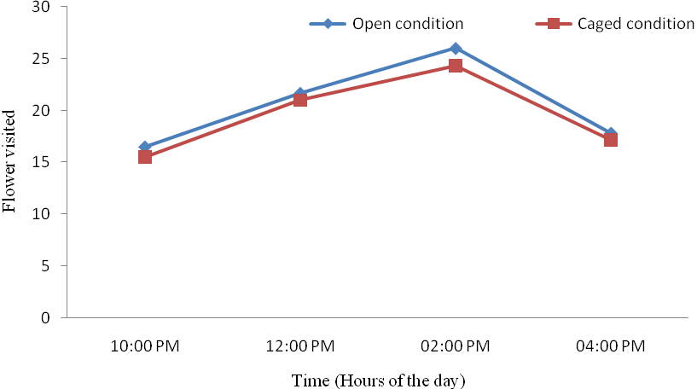
Figure 1. Number of flowers visited per minute by Apis cerana F. under caged and open condition in Jutpani VDC, Chitwan, 2012/013

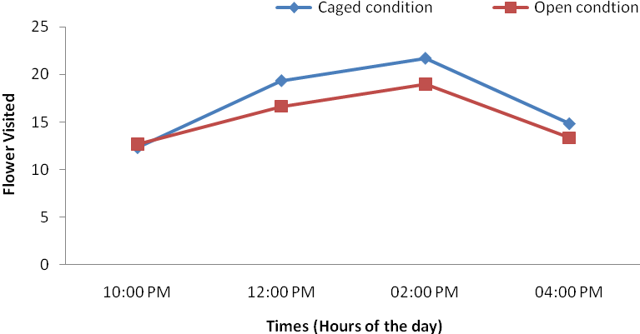
Figure 2. Number of flowers visited per minute by Apis mellifera L. under caged and open condition in Jutpani VDC, Chitwan, 2012/013

Conclusion
It is concluded that both species of honeybee forage higher number of flower under open condition as compare to caged condition. The peak foraging hours for both species Apis cerana F. and Apis mellifera L. was recorded around 12:00 pm to 14:00 pm. Apis cerana F. foraged significantly higher number of rapeseed flowers as compared to Apis mellifera L. under both caged and open condition. It showed that Apis cerana F. visited higher number of flowers and was more efficient pollinator as compared to Apis mellifera L.

Acknowledgements:
I would like to express my sincere thanks to Global Pollination Project for financial support on this work.

Corresponding Author:
Rameshwor Pudasaini
Institute of Agriculture and Animal Science, Rampur, Chitwan, Nepal.
E-mail: rameshwor.ent@gmail.com

References
- Abrol DP. Foraging behavior of Apis mellifera L. and Apis cerana F. as determined by the energetic of nectar production in different cultivars of Brassica campestris var. toria. Journal of Apicultural Science, 2007;51 (2): 19-24.
- Devkota FR, Thapa RB. Foraging preference of Apis cerana F. and Apis mellifera L. to broccoli under caged and open conditions in Chitwan. Institute of Agriculture and Animal Science, 2005; 26: 167-168.
- Joshi NC, P. C. Joshi PC. Foraging behavior of Apis spp. on apple flowers in a subtropical environment. New York Science Journal. 2010; 3(3): 71-76.
- Kuniwal N, Kumar Y, Khan MS Flower-visiting insect pollinators of Brown Mustard, Brassica juncea (L.) Czern and Coss and their foraging behavior under caged and open pollination. African Journal of Agricultural Research, 2014; 9:1278-1286.
- Partap U. 1999. Pollination management of mountain crops through beekeeping. Trainers' resource Book. ICIMOD, Kathmandu, Nepal. 1999; 117 p.
- Partap U. and Partap T. Managed crop pollination. The missing dimension of mountain crop productivity. Discussion paper series No. MFS 97/1, ICIMOD, Kathmandu, Nepal, 1997; 26 p.
- Robinson WE, Morse RA. The value of honeybees as pollinators of US crops. American Bee Journal, 1989; 129 (1): 477-487.
- Sharma HK., Gupta JK, Thakur JR. Effect of bee pollination and polliniser proportion on apple productivity. Acta Horticulturae, 2004; 662:451-454.
- Sihag RC. Management of bees for pollination. In: M. Matska, L. R. Verma, S. Wongsiri, K. K. Shrestha and U. Partap (eds.). Asian Bees and Beekeeping-Progress of Research and Development. Proceeding of Fourth Asian Apicultural Association International Conference, Kathmandu. March 23-28, 1998. Oxford and IBH Publication Company Private Limited, India, 2000; 283 p.
- Singh J, Agarwal OP, Mishra RC. Foraging rates of different Apis species visiting parental lines of Brassica napus L. Zoos’ print journal, 2006; 21:2226-2227.
- Verma LR. Beekeeping in integrated mountain development: economic and scientific perspectives. ICIMOD senior fellowship Series, No. 4 Oxford and IBH Publishing Company. Private. Limited, New Delhi, India, 1990; 387 p.
- Verma LR. Honeybees in mountain agriculture Oxford and IBH Publishing Company. Private. Limited, New Delhi, India, 1992.
- Williams IH. The dependence of crop production within the European Union on pollination by honey bees. Agricultural Zoology Reviews, 1994; 6:229-257.

8/3/2014

