Manifestation of the unity in plurality of different components of Dome's spatial concepts

Hamidreza Saremi, Rohollaah Ghiyasvand, Majid Hatami

- Assistant Professor, Department of Planning, Faculty of Arts and Architecture, Tarbiat Modares University, Tehran, Iran
- Master of Architecture, Science and Research Branch, Islamic Azad University, Broujerd, Iran
- Master of Urban Planning, Science and Research Branch, Islamic Azad University, Broujerd, Iran
ghiasvand_farhad@yahoo.com

Abstract: In this paper, we briefly describe the definition of unity and multiplicity was performed and analyzed the expression of the dome. In this study, the direct impact of domes displays in Islamic architecture, especially about mosques and symbols that exist in the Dome, in terms of structure, type of structure and materials have been discussed and that how beautiful the architects became. Space Communications, domes and architectural space, over the course of several thousand years of human social life gradually one after another changed, so that the net things had neither the space nor the ideal route would have been very controversial and debates Heidegger assumptions about circular motion. Based on this perspective we can see that the architects of the past, the invention of virtue, the concept and importance had to move and rotate it in the realm of the sacred mosque have drawn a circle image. The viewers are attracted to the relaxation view arts. Such indicators can be expressed Sheikh Lotfollah Mosque, and the decorations on the outside and inside of the dome and how it is shaped by what logic and reasoning is discussed, and present obvious examples of the kinds of thoughts and dreams of paradise to all arts. When look at them as a whole, detail make little effect because of their greatness. Its stunning power and glory raises acclamation of Iranian.
[Hamidreza Saremi, Rohollaah Ghiyasvand, Majid Hatami. Manifestation of the unity in plurality of different components of Dome's spatial concepts. N Y Sci J 2014;7(8):88-93]. (ISSN: 1554-0200). http://www.sciencepub.net/newyork. 15

Keywords: Dome, Unity in Plurality, Islamic Architecture

1. Introduction
Unity and manifestation of Unique Allah in whole part of physical body is one of the main basis of shaping spiritual identity and holy culture. This concept is based on the principle of unity in multiplicity. And architects to create works that stimulate the expression of monotheistic and supernatural to God is sometimes thought. And this unity is manifested in elements such as geometry, light weight and grandeur-Oriented stay focused with the frequent presence of only say that the only mention of a Creator. Iranian architectural manifestation of unity in diversity to achieve unity in the world of plurality and unity component has been based on the order that reflects the pure unity. And the notion of the sacred mosque is visible; including the dome of one of these elements can be named the symptoms fade in the mind of God.
Dome: Among the techniques that are used by architects to the manifestation of the sublime unity. The dome symbolizes heaven and earth to heaven is the realm of human ascension destination. A convex hull that looked soft and gentle man, devoted and faithful to his inner voice becomes a spiritual journey provides the route. Architect, with knowledge of all of the sun and sky, as the ultimate manifestation of God's power, and have always tried to use the themes and problems in the dome space.
Dome: Display a general spirit of the sacred edifice and established between earth and sky, as well as a password, scroll wheel and the base of the dome and the concept. Dome, going beyond greatness and sheer strength is breaking time.
Its architects were trying to feel the tightness of the dome as soon as the manifestation of the perfection to simply freely. And the viewer to understand the unconscious realm of the divine and the temporal context of routines returns. Indeed he is enjoying arabesque decorations and colors of turquoise and azure dome of the inner and outer shells cover the glint of light enables a special glow. Indeed he is enjoying arabesque decorations and colors of turquoise and azure dome of the inner and outer shells cover the glint of light enables a special glow. The central element of the fuss of putting Shamseh name evokes the sole intention of getting everyone involved and the nature of the universe Holy Quran (Sura Raad, Verse 2):
And it is God's nature as a clean look at the sky without pillars raised, then, with consummate power in the creation of the heavens and the sun and the moon subjected to build.
Dome implying a neither timelessness that is why not start nor end.
1) Vertical focus
Center exemplification of the vertical axis, the Chief Investigator will rise considerably. For this reason, the vertical direction is always regarded as the sacred space (Nourberg Shoults, 2002). Vertical direction, which may be higher or lower everyday life, thrust through the bottom-up human life is interconnected, intersection point of the horizontal axis, vertical axis or plane of humanity (the real) which make up, where heaven and earth where one can sit and seat of government and the power of God. In a space system, Iran is the center of art and architecture arch of heaven encoding of speech and expression inner unity in diversity and plurality in to have unity. For the vertical axis as the center of their magnitude and are credited with having far (Burkhard believes): center of the universe earth is the point where the axis of heaven breaks; Tawaf around the Kaaba, which forms one of the most sacred places to be seen. Surely, this common essence of all religions is for the sacred building to flaunt the Dome. This provides some degree to connect and solitude. In the space, that your viewers will complete the picture of cosmic. That is because the center is that every part of appreciate and interpret architectural value and dignity of the place and find your special place and through show their true beauty.
2) Perfectionism
Iran's Islamic architecture is also a perfectionist and try each of the components, whether major or minor, in whole or in part is due to its fullest extent. That is so beautiful domes sincerely and carefully considered special and beautiful domes and indicators across Iran to show off. All components are in perfect line moving around the space under the dome of the earrings are not excluded from the proceedings carefully. Not to leave any surface and the outer dome tiles and beautiful lines and are decorated with Quran verses, and are covered with colored paints.
3) Modeling
Islamic architecture as a natural phenomenon that is the nature of a specific model for every object has a specific model for the type of architecture, such as the mosque and the house is an inn. The patterns in the Mosques Mosques bed chamber began, and gradually evolved to the extent that the dome peaked. Bozorgmehri in her book: geometry in architecture told that modeling of Islamic architecture, as recorded, and instruction will be discussed. For example: the emergence and evolution requirement considered one of the states in terms of comfort and power, buildings are constructed to reflect and the volatility quick summary and not as an opportunity to explore and diversify, with a few abundant and accessible materials, structures formed and additional decorations that will be built upon to contribute its views.
4) Base consistency

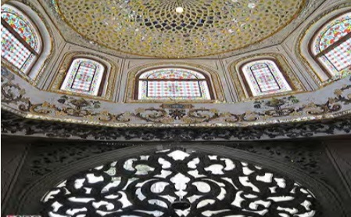

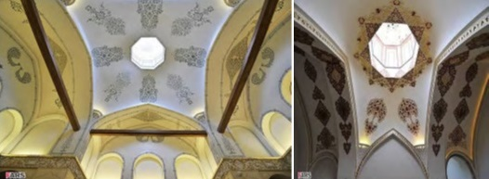

Another feature of Islamic architecture is the base for consistency. The body as an organism that has combined and is integral to the mosque, such a verdict merged. Dome: Mosque password integral part of an alliance between the earth and the sky. As detailed in the pure beauty of spaces in mosques are fading, if the oysters are placed under the dome grid nodes and its so mergers and acquisitions is inconceivable that separates them from each other. In other words, follow the rules of geometric shapes, the design principle and structure of nodes and arabesque decorations has caused the design and decorate it according to the nature of sex and utilizes a geometric law of the state and the individual artist arbitrarily removed because of the fabric are closely intertwined.
The architecture of the Dome
The artist will raise buildings, the architect, and the instrumental aspects of the art. And artistic monuments, and conquests have created the universe, when humans into space under the dome is initially placed in the square, since the square is the symbol of stagnation, stasis of inducing space under the dome, the square is a symbol of inertia and rotational motion. People moving in the square circle would have realized the truth, move toward pure fantasy man, the feeling of lightness and holiness that led to his release from the material world and the spiritual world is flying toward it creates.
Heidegger point of view:
Relation between man and the universe itself than with objects that reveal the presence of human action, it implies the identification, Heidegger explain how basic human cognition, three factors are described. They had found one that had the Heidegger, there's something about the way people in the world will move towards. This type of architecture is a human right under the dome, the full texts of the creation of man, is the basis of creation and there is a compass point in space in the center of the circle stands and their evolution. There is no break in the line looked round in circles can not be interrupted and will continue as flowing water the flow is. Transcendental movement upward in the location and beginning and end no later it can be conceived.
Types of structure of Iranian domes
Single-shelled domes: The dome is the easiest and simplest of these domed structures to cover.
Two-shelled domes: Iranian domes are usually made of two shells.
The inner shell (parietal)
Outer shell (self)
Inside the dome cover on the interior and exterior of his is often ridged. It is clear that unlike his parietal exterior facade and its interior surface is ridged. As we know, both of mean distance flooring, interior and outside together and provide few benefits to domes.
The outer shell protects the interior of the dome rising atmospheric conditions, create empty space that acts as insulation, adjusted proportions dome space, improved structural performance and the possibility of air in the hot season, including factors that are present in the double-shell dome.
Three-shelled domes:
In most instances three shells are actually two domes are capped, which is attached to a ceiling decorative detail below, decorating the ceiling of his time alone sometimes leads and sometimes relies on a central theme (Raeisi, Dome in Iranian architecture).

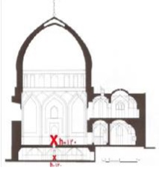

Dome's Material
Materials used in domes: Mostly mud and adobe bricks. These Material have good performance in terms of climate, they are heated during the day and at night sooner than later so that its heat causes the temperature swing adjustment during the day in the mosques. It creates cool and quiet space for prayer.
Dome of Sheikh Lotfollah
One of the few domes covering the Safavid period is long enough for it to be able to dominate the space and its beauty is apparent to everyone. Curvature of the dome of the great ridges, abruptly turned and headed toward the inside of the dome forms, and the thick walls of the mosque will endure high pressure. Sumptuous and magnificent dome by 32 smaller arches is located on four arches, around the glowing tile covered with slippery surfaces and all the subtleties that make it simple to construct. Although the mosque has been carefully toward Mecca, the direction, angle, however, the field opens, dome decorations, a man of intelligence and brings him to the upper world, it can be argued exquisite works tiled dome without a religious faith and love could not arise. Tiling is implemented in the form of a noble and elegant and will certainly be a great point amidst the relationship between them was discovered. The domed building is quite justified its coverage of technology and Pirnia has pointed out, but in terms of aesthetic and metaphysical being covered, thanks Mark is tinged with fear, because the way the sun equal to the drop in the offering to Allah.

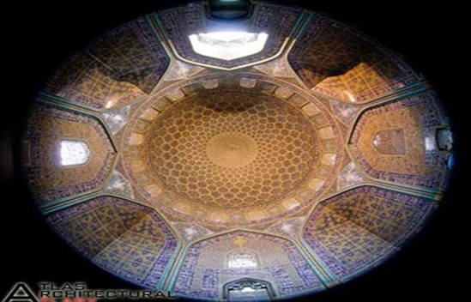

All tiled mosaic tiles decorating the inside is covered. Covered with mosaic tiles, inside and outside the dome and inscriptions, some of them very beautiful Sol's script by Alireza Abbasi Tabrizi, it could not be a human work. Foreign archaeologists have said: "It's hard to be a product of human hands". On the other side of the field decorations and painting of blue-cream with garlic is formed, seems to attract viewers. Lining tiled dome, from beginning to end is about the same size and decorated dome forms. Beautiful tiled mosque, including its mosaic tiles is a pleasant variation, mosaic tiles, elegant tile type and belonging to the seventeenth century. In fact, mosaic tiles, elegant type of tile seven colors of the fifteenth and sixteenth centuries.
Decoration of the interior surface of the dome: Recurrent massive star golden yellow color, with the same design of twisted vines covered. Design and drawing, the mosque of Ardebil carpet inspiration shared. Also very close resemblance to the mosque decorations, tiled rest made ​​up of dome of Romanesque arches, each of which includes a beautiful rosette.
This plant flowers, the lighting inside the mosque is striking beam of light shoot into the dome through a window built into ingest. In addition to adequate light, the display itself is spiritual. Around the dome at regular intervals, the business network is a pair of windows, one interior and one exterior. Each Arabesque motifs are highlighted in light blue tile two breaks along the edges of the filter passes, therefore stylized light and its spiritual and pious place like dew casts a glittering everywhere in the covers. What does it involve and show off their beautiful translucent walls. The diameter of the dome of the bed by the window, from inside and outside is blocked. It Plaster include regular projects equally, there is a space between them. Total light shines through the window into the smallest disadvantage in this building without being seen. The sky is beautiful and romantic decoration makes the overall scene.
One of the very interesting things to do in light of the mosque is decorated with tiles in the morning light on Enfetar Sureh. The light of the noon sun shines on tiles. At night the moon's light shines on Allail Sureh. Other effects of radiation bergamot lime light dome that looks like peacock feathers and tail cones. Sizes are very good, very strong and beautiful summary scheme is agreed, between a world of excitement and a majestic silence, which represent the aesthetic taste of the rich. But a source of inspiration and faith can not be given.

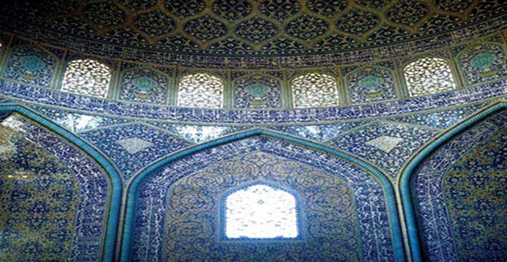

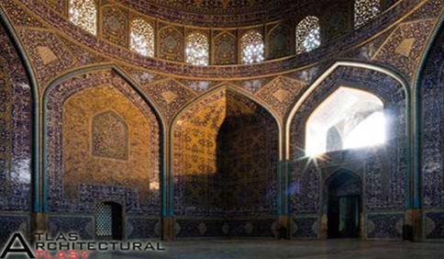
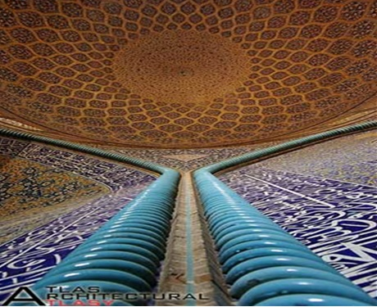

Beautiful inscriptions written on the inside and outside of the mosque, is the most beautiful time line. Genius of all this glory and beauty of art donated to the mosque is one who has signed the left and right of the altar. The mosque is built on a frame, the top of the octagon into the circle and at the end of the stalk joins the stem octagonal dome, and password and eight bearers of the Throne is an angel.
The mosque is built on a frame, which has become the top of the octagonal dome joins, the circle to shoot. At the end of the stem octagonal throne bearers of the password are eight angels. Prophet Muhammad (PBUH) his ascension to the narrative, which describes the huge dome, which was built of white pearl corners first four words of the Book, is written in Sura al-Fatiha, the four streams of water, milk, honey and wine paradise that bliss is eternal and heavenly rivers. This story comes that the shell is soul, through which creation takes the Dome Pearl; Shell is the throne of Allah. All creatures is taken, in which a spherical knob with corresponded sky.

Conclusion:
Iran's rich architecture and innovation exquisite and nice touch is available in a variety of buildings, including mosques of worship is a long standing demand of the ground beneath their feet and passes into the divine world, the major peak of the dome space and access to the upper reaches of the earth is good news. And it appears superhuman beings. Islamic architecture in Iran is astonishing breadth dome represents heaven, seated upon the azure and turquoise cream and covered with a dome of stars, jewels and royal stature take credit for this beautiful manicured hands of Iranian architects have, manifested in the lives of super-rich and all the evidence, that the glory of the Lord against human heads, and looking at their raw charming man and bring him to the heights of divine knowledge.

References:
- Pop, A, and Sadri, Gh. (2006). Iranian Architecture Third Edition.
- Nader A., and Bakhtiari, L. Sense of Unity. Translated By Shahrokh H. Isfahan.
- Hillen R., Translated by Ayatollah Shirazi (1999). Islamic architecture. Form, function and meaning. Fourth Edition.
- Cokelemans, J. Heideger H. Translated by Sadeghian M. (2009). First Edition, Isfahan.
- Pirnia, M.K. Persian architectural styles. Tehran
- Bourkheart, T. Holy Art. Principles and Methods. Sattari, J.
- Taghavi, V. Phd Thesis. Tehran University. Iran.

8/3/2014

