Bi-Directional Strengthening of Two-Way Reinforced Concrete Slabs Using Fiber Reinforced Polymer

Mahmood Tavallaee¹, Ted Donchev²

^{1.} PhD Student, Kingston University London, UK
^{2.} Senior Lecturer, Kingston University London, UK
k0826253@kingston.ac.uk

Abstract: This paper deals with strengthening of two-way reinforced concrete (RC) slabs with fiber reinforced polymer materials (FRP). Experimental investigations have been performed in order to determine the effectiveness of this strengthening solution. The experimental program involves tests on four medium scale slabs. The first slab is control sample without strengthening while in each of other three slabs different types of strengthening are applied. Deflections, strains and crack patterns are monitored during the loading process until destruction. The experimental results are analyzed and the most important conclusions as the result of the investigation are offered.
[Mahmood Tavallaee, Ted Donchev. Bi-Directional Strengthening of Two-Way Reinforced Concrete Slabs Using Fiber Reinforced Polymer. N Y Sci J 2014;7(8):58-62]. (ISSN: 1554-0200). http://www.sciencepub.net/newyork. 11

Keywords: Reinforced Concrete, Fiber Reinforced Polymer, Slab

1. Introduction
Changes in structural usage, design errors, introduction of higher requirements or strength reduction due to steel reinforcement corrosion and concrete deterioration are some of the reasons for retrofitting and strengthening of RC slabs. Significant amount of researches about strengthening of one-way spanning RC slabs with FRP materials have been conducted during last couple of decades, however the strengthening of two-way spanning RC slabs in both directions and the effects of different types FRP materials and different positioning of the strengthening is not sufficiently investigated.

Background
Strengthening techniques using additional externally bonded (EB) or near surface mounted (NSM) FRP reinforcement have been gained increasing popularity in recent years due to prompt execution, low labour costs, and minimal increase of permanent dead load, good chemical resistance and ease of application.
Twenty six full-scale one-way RC slabs were tested by Marco Arduini et al (2004) under simply supported conditions. The slabs were strengthened with unidirectional CFRP laminates. Different failure modes were observed by changing the CFRP laminates cross sectional area and amount of internal reinforcement. The test results indicate that slabs strengthened at tension sides showed CFRP laminate peeling failure. It was also concluded that the CFRP strengthening produced significant enhancement in moment capacity, but with the increase in the amount of internal steel reinforcement the increase in the capacity due to CFRP strengthening would be less.
The response of unidirectional RC slabs strengthened with different types and configurations of CFRP was investigated by Mohsen Issa et al (2007). Eight RC slabs were tested. Six specimens were strengthened with different layers and configurations of two types of CFRP (CFRP laminates and CFRP stripes). The failure modes for strengthened slabs with both systems were steel reinforcement yielding followed by partial rupture of CFRP and finally concrete crushing in compression side. It was concluded that significant increase in strength could be achieved with adding more layers of CFRP up to a certain limit without losing the desired ductility.
An experimental study was conducted by Ebead and Marzouk (2004) to investigate the effectiveness of CFRP strengthening of two-way RC slabs for punching shear. Six samples were tested including two control samples and four samples which were strengthened with single CFRP and GFRP laminates in each direction at mid-span with 0.35% and 0.50% internal steel reinforcement ratio. Experimental results showed an increase of the load carrying capacity up to 44% and 36% for CFRP-strengthened slabs with 0.35% and 0.50% reinforcement ratio respectively. The results also showed an increase of the load carrying capacity up to 38% and 25% for GFRP-strengthened slabs with 0.35% and 0.50% reinforcement ratio respectively.
An experimental study was conducted on RC two-way spanning slabs strengthened with single CFRP strips in each direction at mid-span at Ecole Nationale des Ponts et Chaussees by Oualid Limam et al (2003). The ultimate load capacity for the strengthened slab was about 2.5 times more than the ultimate load capacity for the control (non-strengthened) slab. The non-strengthened slab showed more ductility than the strengthened one. It presented a failure mode with diagonal yield lines. However, complete de-bonding of CFRP strips with some concrete that still bonded on it was observed in the FRP-strengthened slabs.

Experimental Set-up

Properties of Materials
The concrete mix was designed to achieve characteristic cubic compressive strength of 30 MPa after 28 days. The steel bars are mild steel with 6 mm diameter.
FRP materials are unidirectional carbon fiber polymer plates (CFRP) with density of 1.7 gr/cm³. CFRP plate is 1.2 mm thick, 50 mm wide with elasticity modulus of 200 GPa supplied by Saint-Gobian Weber. Two component adhesive epoxy plus resin supplied by Saint-Gobian Weber were used for each type of FRP products as per the manufacturer specification.
For NSM reinforcement BFRP bars with 6 mm diameter supplied by MagmaTech were used. The bars have density of 2.1 gr/cm³, elasticity modulus of 50 GPa and average tensile strength of 1180 MPa.

Testing Rig and Samples
In order to start testing the prepared samples, special testing rig was required. The design of testing rig including columns, beams and base plates were carried out. The materials were supplied by Canon Ltd and assembled at Kingston University to form the required testing frame. Structural drawing for testing rig and details of the supporting condition are shown in Fig. 1 (dimensions are in mm). The testing rig was designed to support 1500*1500*1500 mm RC slabs in upward direction.

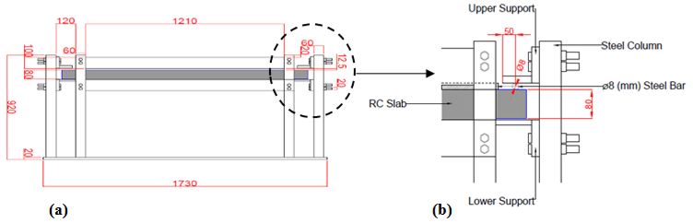
Fig. 1 – (a) Cross Section View of Testing Rig, (b) Details of Supporting Condition of the samples

The dimensions for tested samples are 1500*1500*80 mm. four samples were produced and tested including one used for control (un-strengthened) namely: Control, CFRP.300, CFRP.500 and CFRP.BFRP.
CFRP.300 and CFRP.500 are samples strengthened with two CFRP plate at each direction with 300 mm and 500 mm distance between plates respectively. CFRP.BFRP is the sample strengthened with two CFRP plates at one direction and two BFRP bars as NSM reinforcement in another direction with 300 mm distance between them. Fig. 2 shows CFRP.500 and CFRP.BFRP samples (dimensions are in mm).

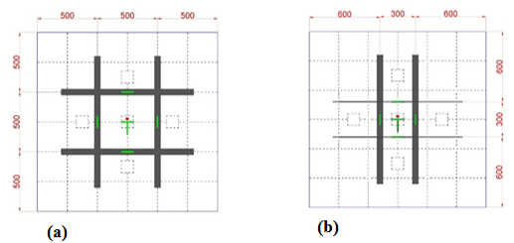
Fig. 2 – (a) CFRP.500 Sample, (b) CFRP.BFRP Sample

The tested samples were simply supported along the four edges according to Fig 1.b and were loaded in out of plane direction with loading simulating UDL.

Test Set-up and instrumentations
The testing device consisted of five hydraulic jacks at five points, one in mid-span and four in quarter spans. To maximise distributing of the load, 100*100*10 mm steel plates were placed on top of each jack. Load was applied in upward direction to allow better monitoring of appearance and development of cracks. The load was applied monotonically and the pressure in the hydraulic jacks was exactly the same which allowed achieving the same level of loading for all of them during the experiment.
Electronic strain gauges were bonded to the mid-span of CFRP plates to measure axial tensile strength of them. The position of the strain gauges is shown in Fig. 2. Deflections at mid-span and quarter spans were monitored using linear variable differential transducers (LVDTs) mounted on the light rigid frame.

Experimental Results
For the control sample, the first crack was initiated at 4 KN and was accompanied by an increase in the deflection due to the reduced stiffness of the sample. The magnitude of mid-span deflection after cracking and the width of the crack increased rapidly with the increase of the applied load. In addition to that, new cracks started to form throughout the sample. The failure occurred as result of yielding of the internal steel reinforcement. At span/100 (15 mm) deflection which is the adopted criteria for destruction the load was 12 KN. The maximum load at deflection of 49 mm was 18 KN, above which the applied load was not able to exceed the value of 18 KN.
For CFRP.300 and CFRP.500 samples, the first crack was initiated at 5 KN. At span/100 (15 mm) deflection the load was 19 KN and 21 KN for CFRP.300 and CFRP.500 respectively. In CFRP.300, the mode of failure occurred through the CFRP plates de-bonding at 20 KN while in CFRP.500 de-bonding took place at 21 KN. Smaller cracks width and less deflection were observed in CFRP.300 and CFRP.500 in comparison with control sample at the same level of loading. This is due to the increase in the stiffness as result of CFRP strengthening. The failures for CFRP.300 and CFRP.500 were relatively brittle, accompanied with a sharp drop in the load carrying capacity and large increase in the deflection.
In CFRP.BFRP, sample larger cracks were observed in perpendicular direction of BFRP.NSM, indicating higher deformability in this direction due to lower modulus of elasticity for BFRP bars in comparison with CFRP plates.
Failure mode occurred only through de-bonding in CFRP plates and was non-brittle. No de-bonding of BFRP bars was observed. Failure modes for Control, CFRP.500 and CFRP.BFRP samples are shown in Fig. 3.

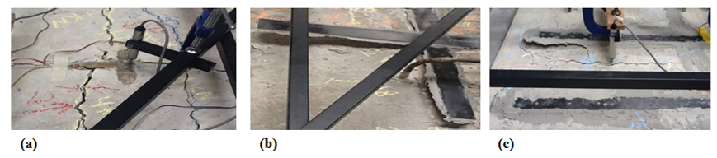
Fig. 3 – (a) Failure in Control Sample, (b) De-bonding in CFRP.500 Sample, (c) De-bonding in CFRP Plate in CFRP.BFRP Sample

The mid-span and quarter span deflections for all samples were measured and recorded during testing until failure. Fig. 4 shows load-deflection curves for mid-span obtained from experiment. Fig. 4 shows significantly stiffer behaviour for FRP-strengthened samples in comparison with control one.

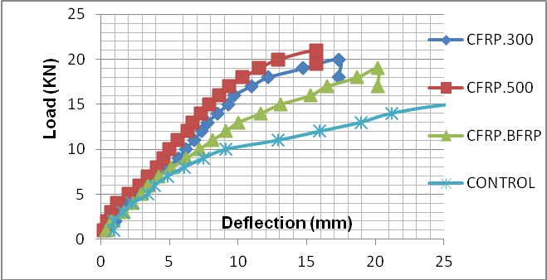
Fig. 4 – Load-Deflection Curves for Mid-span of the Samples

Analysis of the Results

Deflections
Initial analysis is based on comparison between behaviour of different types of samples. Fig. 5 shows the deflections for tested samples at the level of loading of 10 KN, 15 KN and 18 KN. It shows that the difference in deformability of strengthened samples in comparison with control sample is increasing with the level of loading. Between strengthened samples, the fastest rate of increase of deformability is for CFRP.BFRP sample and the lowest rate is for CFRP.500. Close to the ultimate load at 18 KN, the deflections for CFRP.500, CFRP.300 and CFRP.BFRP are correspondingly 20%, 25% and 40% of the deflection of the control sample.
CFRP.500 with distribution of CFRP plates on equal distances is having higher stiffness and higher ultimate capacity than CFRP.300 where the CFRP plates are placed close to mid-span.
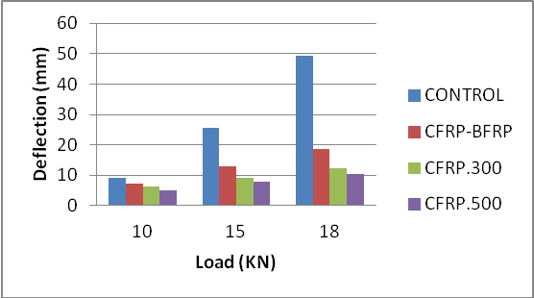
Fig. 5 – Deflections at Different Level of Loadings for Samples

Criteria for Destruction
Assumed criteria for destruction is the limit of deflection (span/100) in this case. In Fig. 6 the loads for achieving critical deflections are indicated for all samples. The lowest load is for control sample (12 KN) and the highest load is for CFRP.500 (21 KN) which is 75% improvement in comparison with the control sample.
CFRP.300 and CFRP.BFRP showed a bit lower capacity than CFRP.500 and the loads at span/100 deflection were correspondingly 1.6 times and 1.3 times higher than control sample.

Fig. 6 – Load at Span/100 Deflection for Samples

Final Failure Modes
Control sample failed by internal steel reinforcement yielding while all FRP-strengthened samples failed by de-bonding of CFRP plates. Failure mode for CFRP.BFRP sample was only through de-bonding in CFRP plates and NSM BFRP bars continued to work without any visible damage or de-bonding. CFRP.BFRP showed higher deformability than other strengthened samples due to relatively low modulus of elasticity for BFRP bars.
Despite of relatively higher deformability of CFRP.BFRP sample the fact that the failure of both types of strengthening does not occur simultaneously, indicates that such approach could be beneficial in aspect of avoiding brittle failure.
Fig. 7 shows the stages of increase and decrease of the stiffness in load-deflection and load-strain curves for CFRP.300 and CFRP.500 samples. CFRP.BFRP sample showed different behaviour and the indicated critical points in Fig. 7 are not clearly visible in load-deflection and load-strain curves for CFRP.BFRP sample.

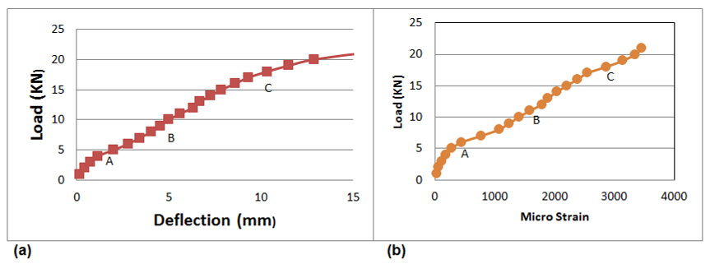
Fig. 7 – (a) Critical Points in Load-Deflection Curve for CFRP.300 & CFRP.500 Samples, (b) Critical Points in Load-Strain Curve for CFRP.300 & CFRP.500 Samples

Possible explanation for Fig. 7 is as follows: Point A is where the cracking initiated. Point B is indicating increase of stiffness for strengthened system probably due to hardening as result of more active contribution of CFRP reinforcement in both direction. Point C is presumably indicating damages in the connection between the CFRP plates and concrete surface. As the stresses and strains are developing in both direction s simultaneuosly and there is place for redistribution it seems that the final failure via de-bonding is occuring in less brittle way than unidirectional strengthend slabs.

Conclusion
As result of conducted critical analysis of the experimental data, following conclusions could be indicated:
- The distribution of CFRP plates on equal distances in both directions is resulting in higher stiffness of the RC slab than their concentration close to the mid-span.
- Combination of FRP materials with different Young modulus as CFRP plates and BFRP NSM bars is producing strengthened system with higher deformability but less brittle failure.
- Additional stiffening of bi-directional strengthend system is observed for deflections higher than span/300. This effect might be result of bi-directional effect of the strengthening.
- The observed mode of failure for all samples was via de-bonding at the end of CFRP plates. Improving the anchorage of the plates could result in higher ultimate capacity of the strengthened slabs.

Acknowledgements
The authors would like to express their gratitude to MagmaTech Ltd for sponsoring with BFRP bars and to the technical staff in Kingston University especially Sean Downey for their support during the experiments.

References
- ARDUINI, Marco, NANNI, Antonio, “Performance of One-Way Reinforced Concrete Slabs with Externally Bonded Fiber-Reinforced Polymer Strengthening”, ACI Structural Journal, Vol. 101 Issue 2, Mar-Apr 2004, p 193.
- EBEAD, U, MARZOUK, H, “Fiber-Reinforced Polymer Strengthening of Two-Way Slabs”, ACI Structural Journal, September-October 2004, pp 650-659.
- ISSA, Mohsen A, ALHSSAN, Mohammad, “Response of Reinforced Concrete Slabs Strengthened with Different Types and Configurations of CFRP”, Proceedings of the 8th International Symposium on Fiber Reinforced Polymer Reinforcement for Concrete Structures, FRPRCS-8, University of Patras, Patras, Greece, July 2007, 8 pp.
- LIMAM, Oualid, FORET, Gilles, “RC Two-Way Slabs Strengthened with CFRP Strips: Experimental Study and a limit Analysis Approach”, Composite Structures Journal, Vol. 60, 2003, pp. 467-471.
- MEIER, U, “Carbon Fiber-Reinforced Polymers: Modern Materials in Bridge Engineering”, Structural Engineering International Journal, Vol. 92, 1992, pp 7-12.

7/27/2014

