**Protein and Albumin Levels in pulmonary tuberculosis**

Ali Raza Memon1, Roohi Naz1

Department of Biochemistry, Liaquat University of Medical & Health Sciences (LUMHS) Jamshoro, Sindh, Pakistan.

[aliraza_dr@outlook.com](mailto:aliraza_dr@outlook.com)

**Abstract:** Introduction: The aim of this study was to investigate the serum protein and albumin levels in patients with pulmonary tuberculosis. **Material and methods:** Eighty (80) patients with tuberculosis and 40 healthy controls were included in this study. Serum total protein and albumin were analyzed using Chemistry auto analyzer using kit method. **Results:** Total protein and albumin were found to decrease in patients with pulmonary tuberculosis as compared with healthy controls. **Conclusions:** Therefore serum protein and albumin can be used as marker to assist the diagnosis, treatment and prognosis of pulmonary tuberculosis patients.[Ali Raza Memon, Roohi Naz. **Protein and Albumin Levels in pulmonary tuberculosis.** *N Y Sci J* 2014;7(8):51-52]. (ISSN: 1554-0200). <http://www.sciencepub.net/newyork>. 9

**Keywords:**pulmonary tuberculosis, proteins, albumin

**1. Introduction**

Pulmonary tuberculosis is communicable disease. It is caused by mycobacterium tuberculosis. One third of world’s population is infected with tuberculosis one million of these develop the disease and almost two million die out of these curable disease [1]. Acute phase reaction is a collective designation for change in serum protein and albumin levels encompassing symptoms such as tiredness and malaise induced by infection, inflammation or trauma [1]. Albumin is one of the most important serum proteins produced in the liver. It represents 50 to 60% by weight of all plasma proteins. Recent evidence indicates that albumin may provide antioxidant protection by functioning as a serum peroxidase in the presence of reduced glutathione, which is an intracellular antioxidant [2]. Epidemiological data consistently show that reduced levels of serum albumin, is associated with increased mortality [3-7]

Aim of the present study was to determine the serum albumin and protein levels in the PTB patients and healthy controls.

**2. Material and Methods**

A study was conducted medical units of Liaquat University of Medical &Health Sciences (LUMHS) Jamshoro. 80 patients (both gender) with pulmonary tuberculosis. Sixty healthy subjects (34 men, 26 women) those attending the outpatient clinic of L.U.H hospital were recruited as control. Total serum protein and albumin, were measured for both patients and healthy control. Blood was collected and centrifuged at 3000 rpm for about 10 minutes. Serum total protein and albumin were analyzed using Chemistry auto analyzer using kit method.

Statistical analysis was carried out using software package for social sciences -16 version.

**3. Results**

Table I shows the levels of protein and albumin in patients with pulmonary tuberculosis and healthy subjects. There was a decreased level of proteins and albumin in patients was compared with the control group.

**Table: 1**

|  |  |  |
| --- | --- | --- |
|  | **Healthy** | **Patients** |
| **Protein** | **4.12±0.12** | **3.21±0.1** |
| **Albumin** | **3.5±1.3** | **2.3±0.8** |

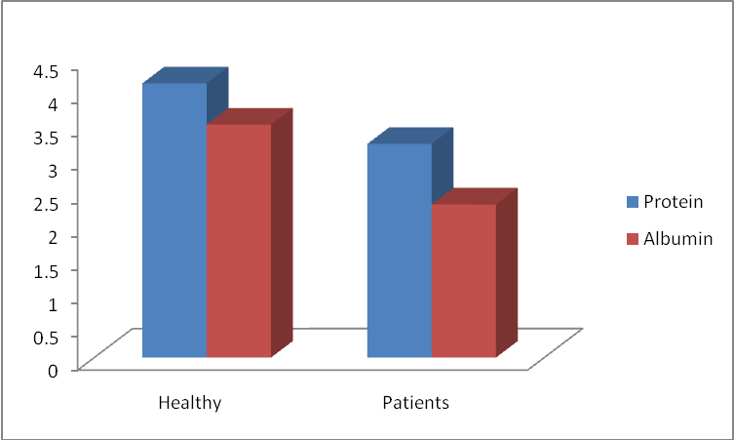

**Figure I.** The levels of protein and albumin in patients with pulmonary tuberculosis and healthy subjects.

**4. Discussion**

The present study shows significantly lower levels of total protein and albumin in subjects with pulmonary tuberculosis. (8) Albumin is a negative acute phase protein which the plasma value decreases during infection, injury or stress possibly as a result of increased metabolic need for tissue repair and free radical neutralization (9, 10). Lower levels of total protein and albumin in this study might have been caused also by poor appetite, malnutrition and mal-absorption commonly observed in tuberculosis. The lower level of albumin may therefore be one of the complications associated with pulmonary tuberculosis. (10) The result of this study shows lower protein and albumin level in pulmonary tuberculosis patients. These could be associated with heavy load of free radicals, oxidative stress and lipid peroxidation. Improved nutrition and supplementation with antioxidant therapy in the treatment of pulmonary tuberculosis may prevent the further complications.

**Corresponding Author:**

Dr. Ali Raza Memon

Department of Biochemistry, Liaquat University of Medical & Health Sciences (LUMHS) Jamshoro, Sindh, Pakistan.

E-mail: [aliraza_dr@outlook.com](mailto:aliraza_dr@outlook.com)

**References**

1. Rieder HL (2002). Interventions for tuberculosis control and elimination. International Union against Tuberculosis and Lung Diseases. Paris, France, pp. 15-93.
2. Kingsley GR (1942). The direct biuret method for the determination of serum proteins as applied to photoelectric na d visual colorimetry. J. Lab. Clin. Med., 27: 840-845.
3. Gornall AG, Bardawill CJ, David MM (1949). Determination of serum proteins by means of the biuret reagent. J. Clin. Med., 177: 751-766.
4. Doumas BT, Watson WA, Biggs HC (1971). Albumin standards and the measurement of serum albumin with bromocresol green. Clin. Chem. Acta, 31: 87-96.
5. Corcoran RM, Durna SM (1977). Albumin determination by a modified bromocresol green method. Clin. Chem., 23: 765-766.
6. Idigbe EO, Sofola TO, John EKO, Okoye R, Onugbogu C, Begg O, Giwa-Amu J (1995). Trend of pulmonary tuberculosis in Lagos, Nigeria 1982-1992. Biomed. Lett., 51: 99-109.
7. Gilliand IC, Johnson RN, Stradling P, Abdel-Wahab EM (1956). Serum proteins in pulmonary tuberculosis. Brit. Med. J., 1: 1460-1464.
8. Leggart PO (1957). Serum protein changes in pulmonary tuberculosis. Brit. J. Tuberc. Dis. Chest, 51: 130-145.
9. Baldwin RW, Hand CN (1953). Electrophoretic studies of the serum proteins in tuberculosis. Am. Tuberc. 68: 372-381.
10. Bhave GG, Pathare AV, Dagha CC, Chabria LL, Dalvi SG (1989). Immunoprofile of pulmonary tuberculosis-comparison J. Postgrad. Med., 35: 24-29.

7/19/2014