Transforaminal lumbar interbody fusion (TLIF) versus posterior lumbar interbody fusion (PLIF) as a fusion technique in degenerative lumbar spondylolithesis

Abdel-basset Ali¹ – Hamdy Behairy¹ – Magdy El-hawary¹ – Mohamed Barania¹ and Abdel-Hakim Eissa²

¹Neurosurgery department, Faculty of Medicine Al-Azhar university, Egypt.
²Neurosurgery department, Faculty of Medicine Assiut university, Egypt.
Basset315@gmail.com

Abstract: The authors review and compare transforaminal lumbar interbody fusion (TLIF) with posterior lumbar interbody fusion (PLIF). A review of the literature is performed wherein the history, indications for surgery, surgical procedures, potential complications, are presented. The chief advantages of the TLIF procedure compared with the PLIF procedure significantly diminishes blood loss, postoperative narcotic use and length of stay in hospital when compared with open PLIF.
[Abdel-basset Ali, Hamdy Behairy, Magdy El-hawry, Mohamed Barania and Abdel-Hakim Eissa. Transforaminal lumbar interbody fusion (TLIF) versus posterior lumbar interbody fusion (PLIF) as a fusion technique in degenerative lumbar spondylolithesis. N Y Sci J 2014;7(7):93-98]. (ISSN: 1554-0200). http://www.sciencepub.net/newyork. 16.

Keywords: Posterior lumbar interbody fusion, Transforaminal lumbar interbody fusion, Degenerative disc disease, Low back pain, Fusion, Complications.

1.Introduction
Lumbar spinal fusion was introduced approximately 70 years ago and has evolved as a treatment option for symptomatic spinal instability, spinal stenosis, spondylolisthesis, and degenerative scoliosis [1]. Broader applications including use as a treatment of chronic low back pain and recurrent radiculopathy have resulted in a dramatic increase in the rates of lumbar fusion procedures within the last decade in the United States [1,2]. Lumbar spinal fusion is often performed after a posterior decompressive procedure when there is evidence of preoperative lumbar spinal deformity or instability that could worsen after laminectomy alone [3].
So Spinal arthrodesis (fusion) is considered as an option for the management of debilitating degenerative disorders of the lumbar spine, which were refractory to nonoperative care.[4,5]. Over the past decade, one particular fusion technique, transforaminal lumbar interbody fusion (TLIF), has gained popularity within the surgical community [6,7] secondary to purported lower rates of perioperative patient morbidity [8,9] with the equivalent clinical outcomes as compared to the other techniques for lumbar fusion.[10]
First described by Harms in 1998,[6]. TLIF has been advocated as a less invasive technique which allows for fusion of the anterior and posterior columns from a unilateral, extracanalar approach, which in turn affords less destruction of the posterior arch, allows for better access to the neuroforamina, and reduces retraction of the dural sac and nerve roots.

Indication
The advent of interbody devices and posterior screw–rod fixation has lowered the rate of pseudarthrosis associated with the PLIF and TLIF procedures; consequently, the indications for these surgical procedures have broadened.
The principal indication for lumbar interbody fusion surgery is the stabilization and fusion of adult spinal deformity. Therefore, lumbar fusion has been described as a treatment of symptomatic spondylolisthesis, degenerative scoliosis, and spinal stenosis associated with instability [11]. For those with lumbar stenosis but without spondylolisthesis (deformity), the surgical management has traditionally involved posterior decompressive procedures, including laminectomy or laminotomy, and judicious use of partial medial facetectomies and foraminotomies, with or without discectomy [12]. In patients with evidence of spinal instability, however, in situ posterior lumbar fusion is recommended as a treatment option in addition to decompression in the setting of lumbar stenosis [12].

2.Patients and methods
Since 2010, one of the senior authors has used PLIF for interbody fixation as a standard method to construct all patients with low grades degenerative lumbar spondylolithesis . We retrospectively reviewed a database of prospectively enrolled patients with degenerative spondylolithes considering the following criteria;
- Grade 1-2 degenerative spondylolisthesis
- Recurrent disc disease with degenerative instability
- Postlaminectomy degenerative instability

Excluding the following patients;
- High grade spondylolisthesis (grades 3 and 4)
- Significant scoliosis
- High level instability after laminectomy
- Multiple level (>2 ) disease
- Severe osteoporosis

Of these, we were able to match 15 of these patients who underwent PLIF one-to-one with 15 patients undergoing formal ALIF in conjunction with posterior instrumentation and fusion. Matching characteristics included age (within 5 yr), sex, co-morbidities, fusion length (within 2 levels), and PLIF/TLIF level. Patient data were extracted from clinic notes, operative summaries, and hospital records.

Surgical techniques
PLIF; Patients are placed prone on a surgical frame to accentuate a lordotic position of the lumbar spine. After the levels of interest are exposed, the posterior spinal elements are removed to expose the traversing nerve roots and lateral extent of the disc space. The thecal sac and traversing nerve roots are mobilized and retracted to the midline, with care taken to protect the dural and neural contents with a retractor. After exposure of the posterior annulus, a complete discectomy is performed using rongeurs, disc shavers, and downbiting curved curettes. By increasing the disc height, tension is placed on the annulus fibrosis, and rectangular ramp-type cages, a square channel is prepared in the disc space to accept the cage, which is then tamped into place to engage the vertebral endplates. Cage device are filled with osteoinductive materials which provide scaffolding for bony fusion to occur from endplate to endplate. After the interbody construct is placed, pedicle screws are then inserted and attached to the rods. Once in place, the pedicle screws are compressed along a lordotic rod in an attempt to reduce any kyphosis caused by interdiscal distraction. The transverse processes are then decorticated, and the bone graft is placed over them for a posterolateral fusion. A standard closure in layers is then performed.
TLIF; As with PLIF, patients are usually placed prone on a surgical frame. The surgeon begins by making a vertical incision over the section to be fused. The skin, muscles, and soft tissues are gently retracted to expose the lateral aspect of the spinous process, the lamina, and the facet joint). Depending on the clinical presentation, a laminectomy, facetectomy, or both may be performed. A unilateral laminotomy and partial facetectomy are performed on the side consistent with the patient’s symptoms or anatomical abnormalities.
After adequate decompression of the neural elements has been performed, pedicle screws are placed in the standard fashion. The disc space can be gradually distracted by using the pedicle screws or an intralaminar spreading device. The placement of the distractor and screws does not interfere with the dissection and, in fact, this system allowed for easy visualization of the nerve roots, thecal sac, and disc space. An interbody device(s) of appropriate size is then placed while protecting the dura with a small retractor. The thecal sac may be minimally retracted (when necessary, the retractor is used to protect the exiting nerve root) during inserting a “banana”-shaped or rectangular devices. The pedicle screws are then attached to lordotic rod and carefully compressed to restore lumbar lordosis while maintaining the restored disc height. The contralateral facet joint may be decorticated, and the bone graft is placed over them for a posterolateral fusion if there is any instability. A standard closure in layers is performed.

3.Results
Fifteen TLIF patients were matched to 15 patients who underwent PLIF, with a minimum 2-year follow-up. Of the 15 patients in each group, 19 had instrumentation and interbody fusion at L4-5 level, 5 at L5-S1 level, and 6 at L3-4, L4-5 levels, with the mean age 54y for TLIF group, and 58 for PLIF group. There were no significant differences between groups in terms of age and sex.

Case 1: PLIF:

Pre operative:
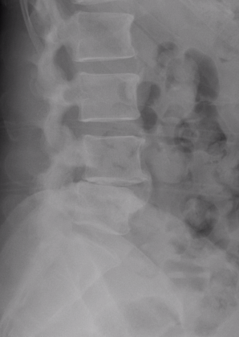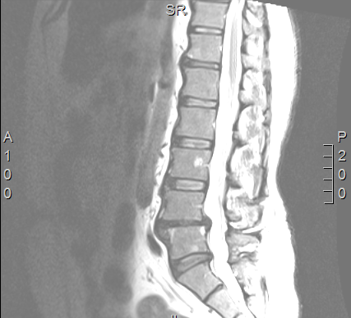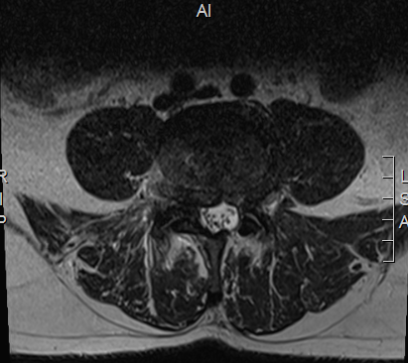

Intraoperative:
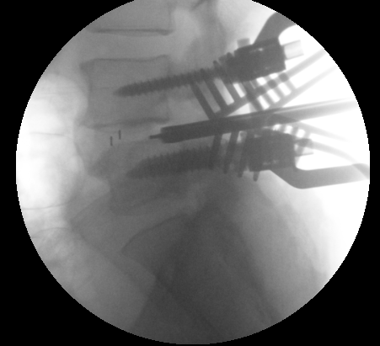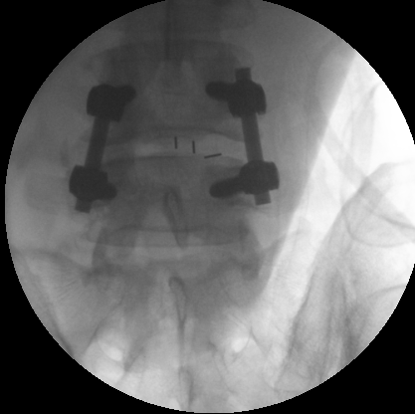

Postoperative:
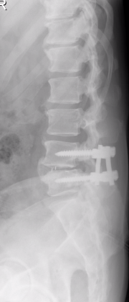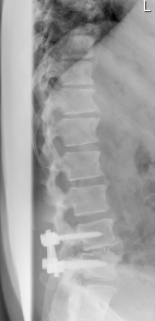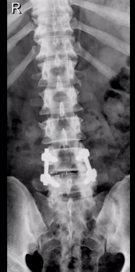

Case 2 TLIF ;
Preoperative:
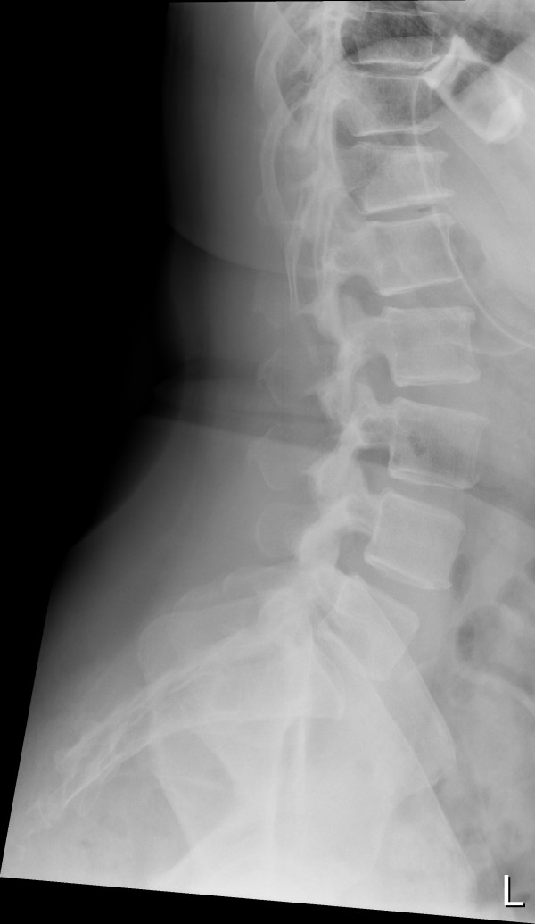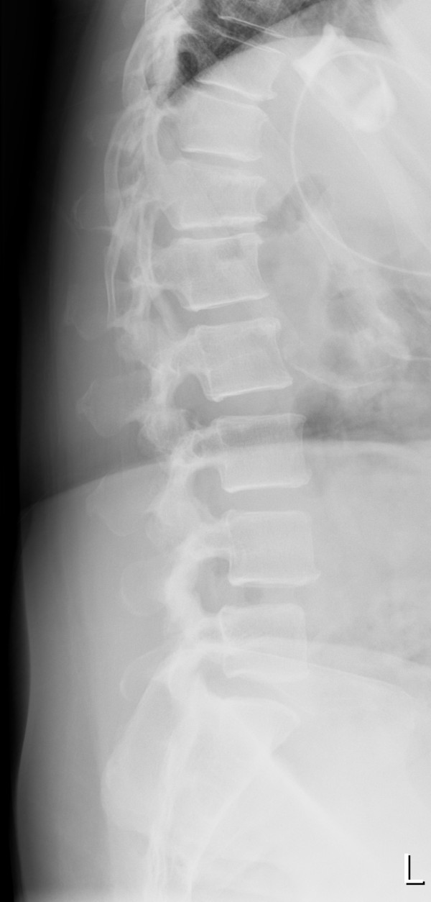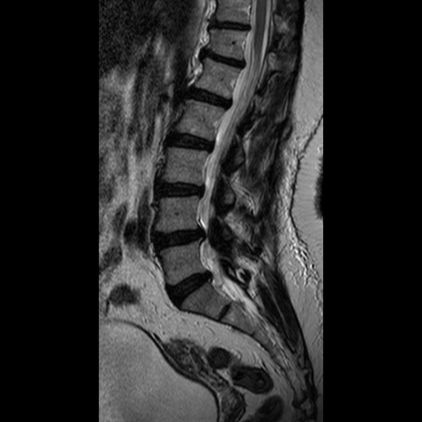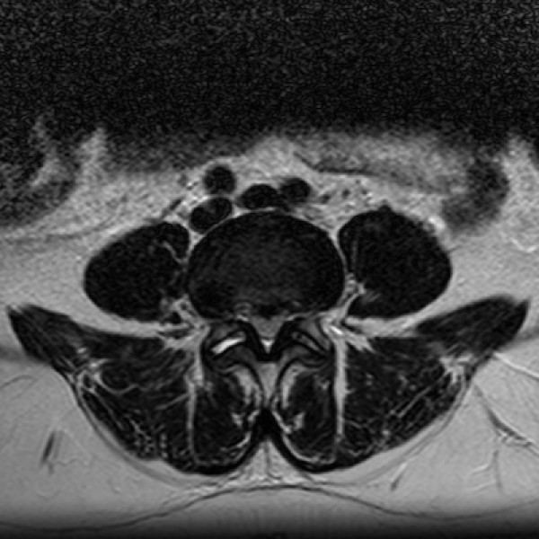

Intraoperative:
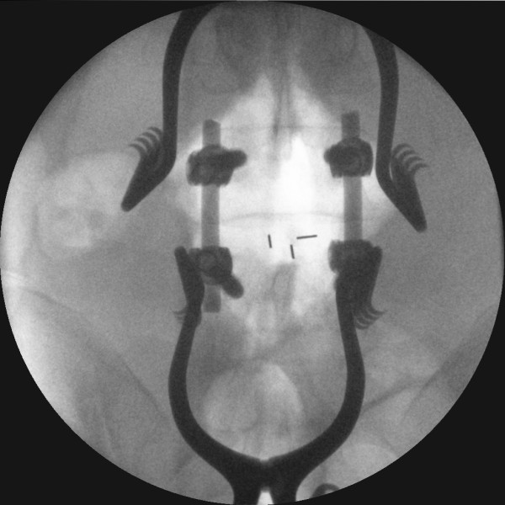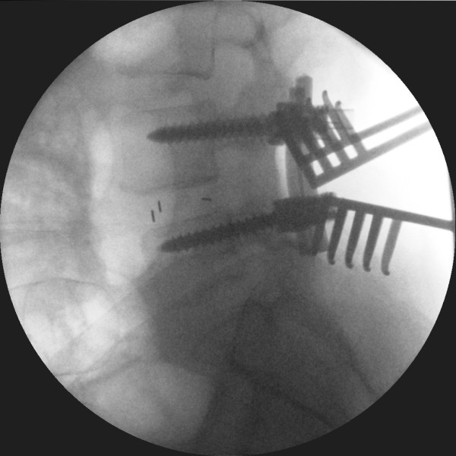

Postoperative:
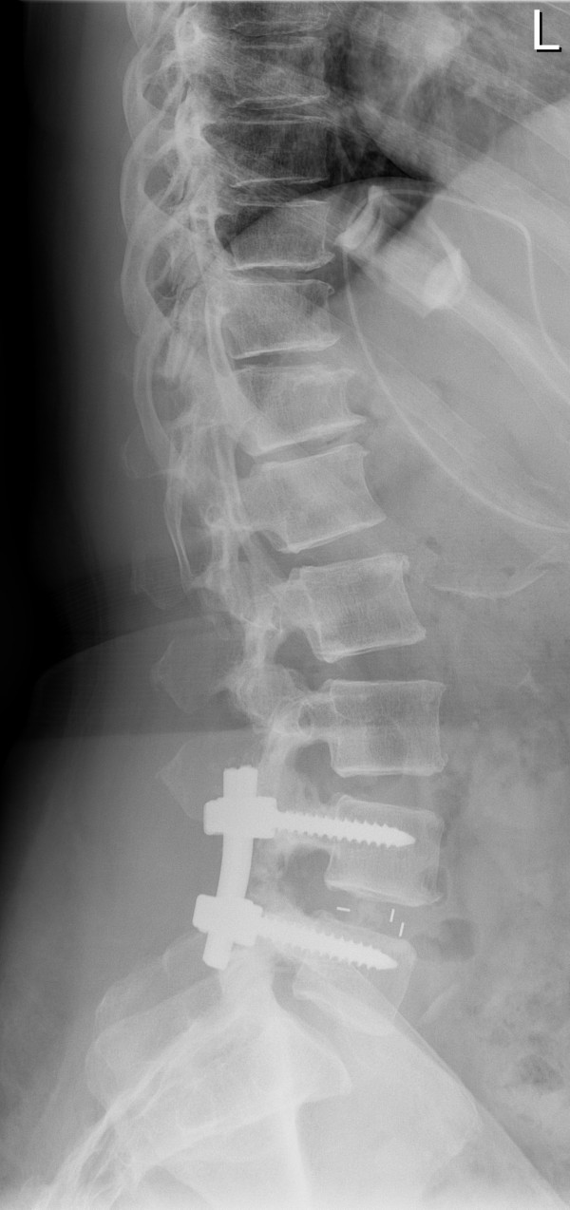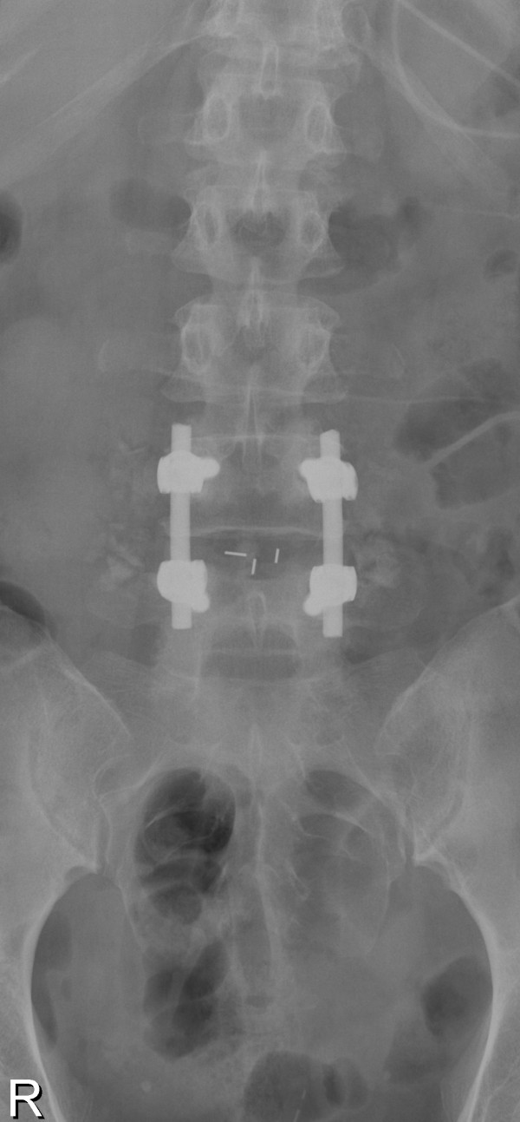

Table 1; comparison of matched cohort
 | TLIF | PLIF
Number of patients | 15 | 15
Mean age | 54 Y | 58 Y
Mean level  L4-5  L5-S1  L3-4- L4-5 | 73.3%  13.3%  13.3% | 53.3%  20%  26.6%

Table 2; comparison of clinical and radiological results:
 | TLIF | PLIF
Time | 46.1% | 53.8%
Blood loss | 42.8% | 67.2%
Dural tear | - | 1 case(6.6%)
Nerve root injury | - | Transient radiculopathy in 2 cases (13.3%)
Postoperative recovery | 33.3%(5 patients were in need for narcotics) | 60% (9 patients were in need for narcotics)
Hospital stay | 40% | 60%
Rate of fusion | 91% | 89%

Analysis of the data obtained from table 2, shows the superiority of TLIF procedures compared to PLIF due to the following results; The time had been taken in TLIF (46.1%) was less than that in PLIF (53.8%), with average time 3 hours and 3.5 hours for each case of TLIF and PLIF consequently. Also the blood loss in TLIF (42.8%) with average loss of 150 cc in each case, was less than that obtained from PLIF (67.2%) with average blood loss 200 cc in each case.
The occurrence of dural injury was( 0%) in TLIF and (6.6%) in PLIF as one patient got dural tear. The postoperative recovery was smoother in TLIF compared to PLIF as only 5 patients out of 15 was in need for postoperative narcotics compared to 9 (60%) in PLIF, in addition the hospital stay was less in TLIF (40%) with average 2 days for each case, and (60%) for PLIF with average 3 days for each case. The rate of fusion was nearly the same, the mild superiority of TLIF (91%) over PLIF (89%) was mainly related to the wider surface area spared in TLIF compared to PLIF.
Conclusion
TLIF procedure significantly diminishes when compared with PLIF. Since their inception 70 years ago, lumbar interbody fusion techniques have evolved into highly effective procedures, with clinical success rates near 75% and fusion rates reportedly around 90% for single-level instrumented procedures. The advantages of the PLIF and TLIF techniques are decompression of the neural elements along with placement of a graft along the weight-bearing axis. Segmental fixation can provide immediate postoperative stability, correct anatomical deformities, and possibly enhance fusion rates, especially if multiple levels are to be fused. The advantage of the TLIF procedure is mainly to limit operative time, blood loss, postoperative narcotic use, length of stay in hospital and the possibility of dural or nerve injuries. Secondarily, the additional advantage of sparing the lamina, facet, and pars on the contralateral side provides increased surface area for fusion. The advantages of the PLIF procedure are mainly posterior decompression and the option of segmental fixation.

References
- Cole CD, McCall TD, Schmidt MH, Dailey AT. Comparison of low back fusion techniques: transforaminal lumbar interbody fusion or posterior lumbar interbody fusion approaches. Curr Rev Musculoskelet Med 2009;2:118-126.
- Davis H. Increasing rates of cervical and lumbar spine surgery in the United States, 1979–1990. Spine. 1994;19:1117–1123. doi: 10.1097/00007632-199405001-00003.
- Fritzll P, Hagg O, Wessberg P, Nordwall A. 2001 Volvo award winners of clinical studies: lumbar fusion versus nonsurgical treatment for chronic low back pain. Spine 2001; 26: 2521-2534.
- Resnick DK, Choudhri TF, Dailey AT, et al. Guidelines for the performance of fusion procedures for degenerative disease of the lumbar spine. Part 8: lumbar fusion for disc herniation and radiculopathy. J Neurosurg Spine. 2005;2:673–678. doi: 10.3171/spi.2005.2.6.0673.
- Resnick DK, Choudhri TF, Dailey AT, et al. Guidelines for the performance of fusion procedures for degenerative disease of the lumbar spine. Part 1: introduction and methodology. J Neurosurg Spine. 2005;2:637-638.doi:10.3171/spi.2005.2.6.0637.
- Weinstein JN, Lurie JD, Tosteson TD, et al. Surgical compared with nonoperative treatment for lumbar degenerative spondylolisthesis: four-your results in the spine patient outcomes research trial (SPORT) randomized and observational cohorts. J bone joint surg Am 2009; 91:1295- 1304.
- Harms JG, Jeszenszky D. The posterior, lumbar, interbody fusion in unilateral transforaminal technique. Oper Orthop Traumatol 1998; 10:90-102.
- Hackenberg L, Halm H, Bullman V, et al. Transforaminal lumbar interbody fusion: a safe technique with satisfactory 3 to 5 years result. Eur spine j:2005;14:551-558.
- Humphrys CS, Hodges SD, Patwahrdan AG, et al. Comparison of posterior and transforaminal approaches to lumbar interbody fusion. Spine 2001; 26(5):567-571.
- Faundez AA, Schwender JD, Safriel Y, et al. Clinical and radiological outcome of anterior posterior fusion versus transforaminal lumbar interbody fusion for symptomatic disc degeneration. Comparative retrospective study of 133 patients. Eur Spine journal 2009;18:203-211.
- Mummaneni PV, Haid RW, Rodts GE. Lumbar interbody fusion: state-of-the-art technical advances. Invited submission from the Joint Section Meeting on Disorders of the Spine and Peripheral Nerves, March 2004. J Neurosurg Spine. 2004;1:2430. doi:10.3171/spi.2004.1.1.0024.
- Resnick DK, Choudhri TF, Dailey AT, et al. Guidelines for the performance of fusion procedures for degenerative disease of the lumbar spine. Part 9: fusion in patients with stenosis and spondylolisthesis. J Neurosurg Spine. 2005;2:679–685. doi: 10.3171/spi.2005.2.6.0679.

7/22/2014

