Thinner Intoxication: Intramediastinal Injection - A Case Report

Mehdi Haghdoost, Sepehr Taghizadeh

Infectious Diseases and Tropical Medicine Research Center, Faculty Medicine, Tabriz University of Medical Sciences, Tabriz, Iran.
mehdihaghdoost@yahoo.com

Abstract: The patient, a 23 years old woman to commit suicide, has attempted to inject 5cc thinner to the anterior part of the left forearm and 5cc to the upper portion of the sternum.In physical exam of the anterior part of the forearm, the anterior part of the elbow joint was warm, erythematous and tender. Anterior- posterior part of the sternum was tender and warm too. On the third day of hospitalization, despite receiving antibiotics, the patient's symptoms had not improved and Increase in liver enzymes was observed. As previous study, the thinner is a hepatotoxic agent and it cause fat necrosis of the vessel wall at the injection site. Thinner Based on our findings and previous reports is a hepatotoxic substance and causes localized damage and vascular necrosis. Thus, in the first hours after injection, it should be surgically debrided. Thinner local infiltration would increase erthrocyte sedimentation rate (ESR) top to 100 and leukocytosis with the left shift at the injection site, and also mimics the bacterial cellulitis symptoms. Despite that it does not respond to antibiotic treatment.
[Haghdoost M, Taghizadeh S. Thinner Intoxication: Intramediastinal Injection - A Case Report. N Y Sci J 2014;7(7):78-80]. (ISSN: 1554-0200). http://www.sciencepub.net/newyork. 12

Keywords: Thinner, Intoxication, Complication, Management

1. Introduction
Thinners, including aromatic hydrocarbons such as toluene, xylene, and N-hexane, are widely used in industry for the production of plastics, varnish, paint, and glue. Use of these toxic agents frequently leads to chronic intoxication caused by abuse or misuse of solvents, which are usually taken in through inhalation. Thinners may have neurotoxic, myotoxic, hepatotoxic, nephrotoxic, and cardiotoxic systemic effects (Solak, 2006; Akisü, 1996). Acute chemical empyema developed at the left hemithorax (Solak, 2006). No systemic toxic signs were noted, other than a low level of hepatotoxicity.
Although pleural effusion, atelectasis, and pleural thickening were observed at the acute phase on computed tomography (CT) of the thorax, only pleural thickening persisted on CT of the thorax after 1 y (Solak, 2006; Akisü, 1996).
Lacquer thinner, commonly used for removing household paints, is known to contain a mixture of various aromatic hydrocarbons, halogenated hydrocarbons and naphtha; if ingested, it may cause methemoglobinemia (Singh, 2012; Ho, 1998).
Chronic thinner intoxication is one of the most serious social problems among teenagers and young adults in Japan (Uchino, 2002; Tsatsakis, 1997).
If patients with chronic thinner intoxication have significant neurological symptoms, MR imaging should be performed for evaluation of brain abnormalities (Verma and Gomber, 2009 ).

2. Case Study
The patient, a 23 years old woman to commit suicide, has attempted to inject 5cc thinner to the anterior part of the left forearm and 5cc to the upper portion of the sternum.
The patient has come with the risk of cellulite in the anterior part of the forearm and has been hospitalized.
In physical exam of the anterior part of the forearm, the anterior part of the elbow joint was warm, erythematous and tender (Figure I). Anterior- posterior part of the sternum was tender and warm too (Figure II).
On admission, the patient's vital signs were good.
The first laboratory findings of the patient and their changes during treatment are shown in table 1.

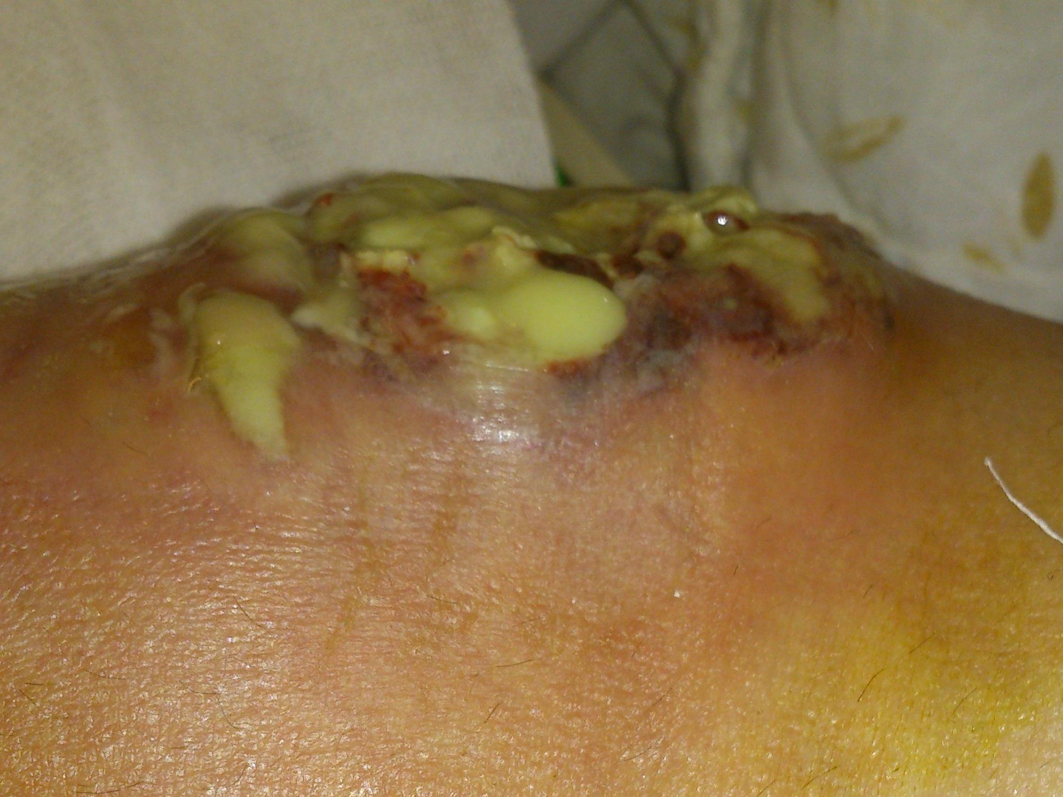
Figure I: Forearm swelling of patient

The blood culture (B/C) from patient was taken in two steps and the intravenous injection of Clindamycin (600) was begun every six hours. On the physical exam of the second day, the patient still had fever and warmth, erythema, and tenderness in the anterior part of the sternum were intensified. The patient's forearm and chest CT scan was performed.
There was a soft tissue swelling in the anterior part of radius and anterior part of superior mediastinum.
On the third day of hospitalization, despite receiving antibiotics, the patient's symptoms had not improved and Increase in liver enzymes was observed.
Figure II: Sternum swelling of patient

Table I: Laboratory finding of patient in hospital
Days | 0 | 1 | 2 | 7 | 8 | 9 | 10 | 11 | 12 | 14 | 15
Urea | 17 | - | 15 | - | 18 | 20 | 19 | 19 | 19 | 24 | 17
Cr | 0.9 | - | 0.7 | - | 0.7 | 0.8 | 0.8 | 0.7 | 0.7 | 0.8 | 0.8
Aspartate Aminotransferase (AST) | 63 | - | 133 | - | 27 | 25 | 57 | 78 | - | 38 | 40
Alanine Aminotransferase (ALT) | 82 | - | 242 | - | 60 | 53 | 83 | 122 | - | 94 | 80
Alkaline Phosphatase(ALP) | 304 | - | 558 | - | 452 | 411 | 490 | 541 | - | 441 | 391
Bilirubin Total | 0.5 | - | 0.6 | - | 0.3 | 05 | 0.3 | - | - | 0.3 | 0.3
Bilirubin Direct | 0.1 | - | 0.2 | - | 0.1 | 0.1 | 0.1 | - | - | 0.1 | 0.1
Na | 137 | - | 136 | - | 136 | 138 | 136 | 138 | 139 | 137 | 141
K | 4.2 | - | 3.9 | - | 4 | 4.4 | 4.5 | 4.5 | 4.4 | 4.4 | 4.4
ESR 1st | - | 119 | - | - | 105 | - | - | 81 | - | - | -
ESR 2 ^{st} | - | 131 | - | - | 127 | - | - | 111 | - | - | -
White Blood Cell | - | - | - | 15900 | - | - | - | 10600 | - | - | -
Red Blood Cell | - | - | - | 3.12 | - | - | - | 3.49 | - | - | -
Hemoglobin | - | - | - | 8.8 | - | - | - | 9.8 | - | - | -
Platelet | - | - | - | 384 | - | - | - | 496 | - | - | -
C-Reactive Protein | - | - | - | - | 3+ | - | - | - | - | - | -

As previous study, the thinner is a hepatotoxic agent and it cause fat necrosis of the vessel wall at the injection site. For debridement of the lesion, surgical consultation was asked for patient.

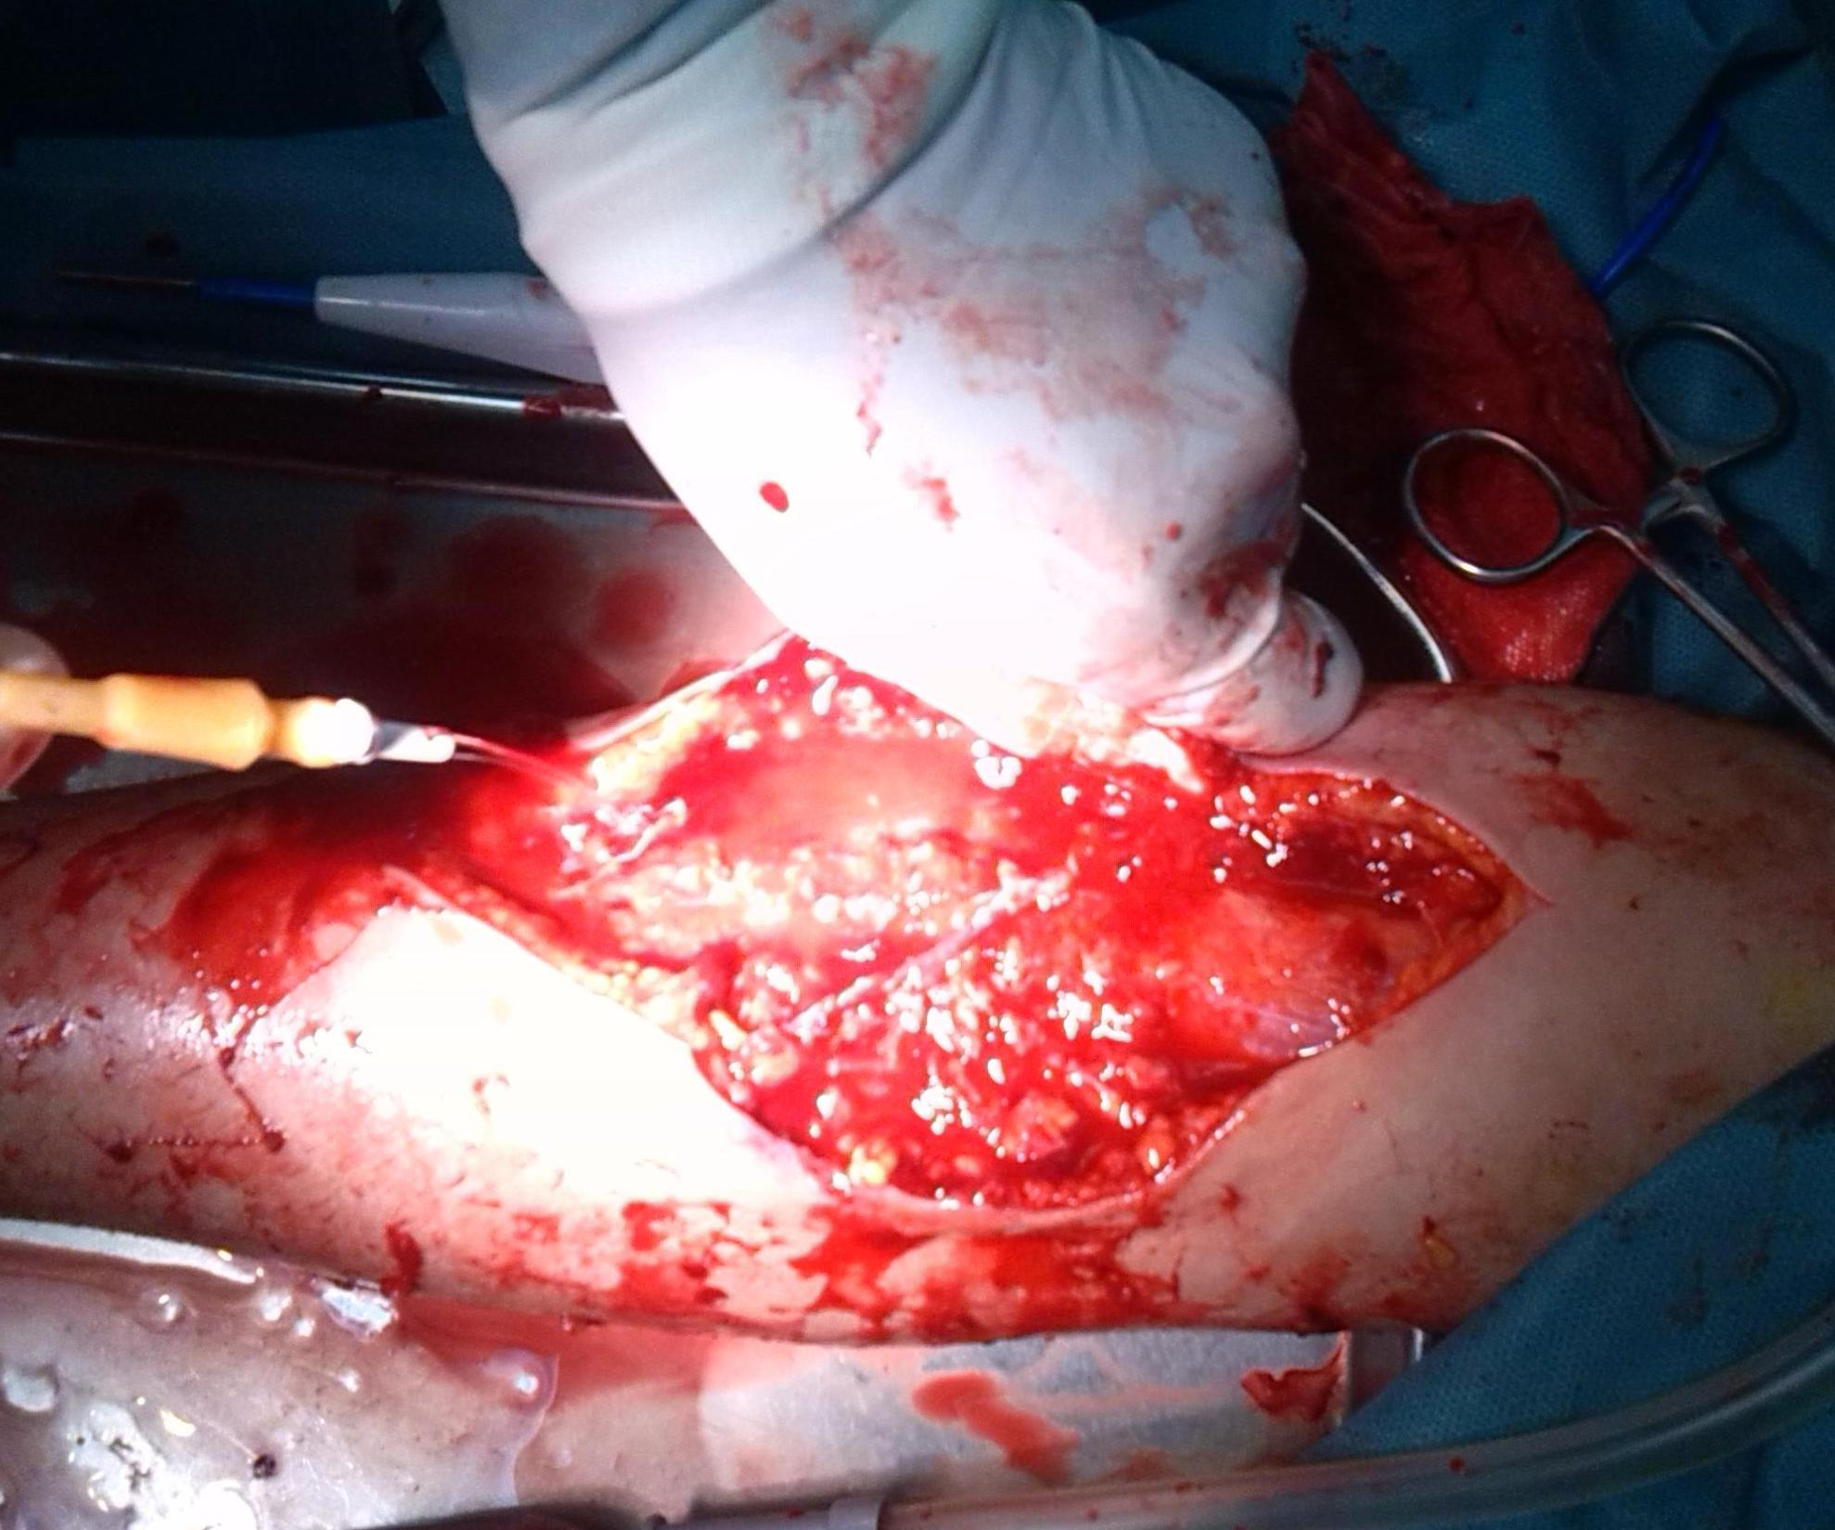
Figure III: Operation and Debridement of Forearm

After transfer to the operation room, the anterior part of forearm and mediastinum were debrided and washed and the necrotic tissues were drained and after drain placement, without closing the wound, the patient was transferred to the surgical site and daily cleaning of the surgical site was started(Figure III and IV). The patient antibiotic, from Clindamycin to Cefepima was changed. The surgical site fluids were cultured and the result was negative. 3 days after surgery, the patient's liver enzymes dropped to about 110 and also the patient's fever stopped. 5 days after surgery, the patient's wound was closed and the seventh day after surgery, the patient with the good liver enzymes (Aspartate Aminotransferase (AST) = 52 and Alanine Aminotransferase (ALT) = 61) was discharged.
After follow-up in the 21 days after surgery, the patient's liver enzyme levels had normalized.

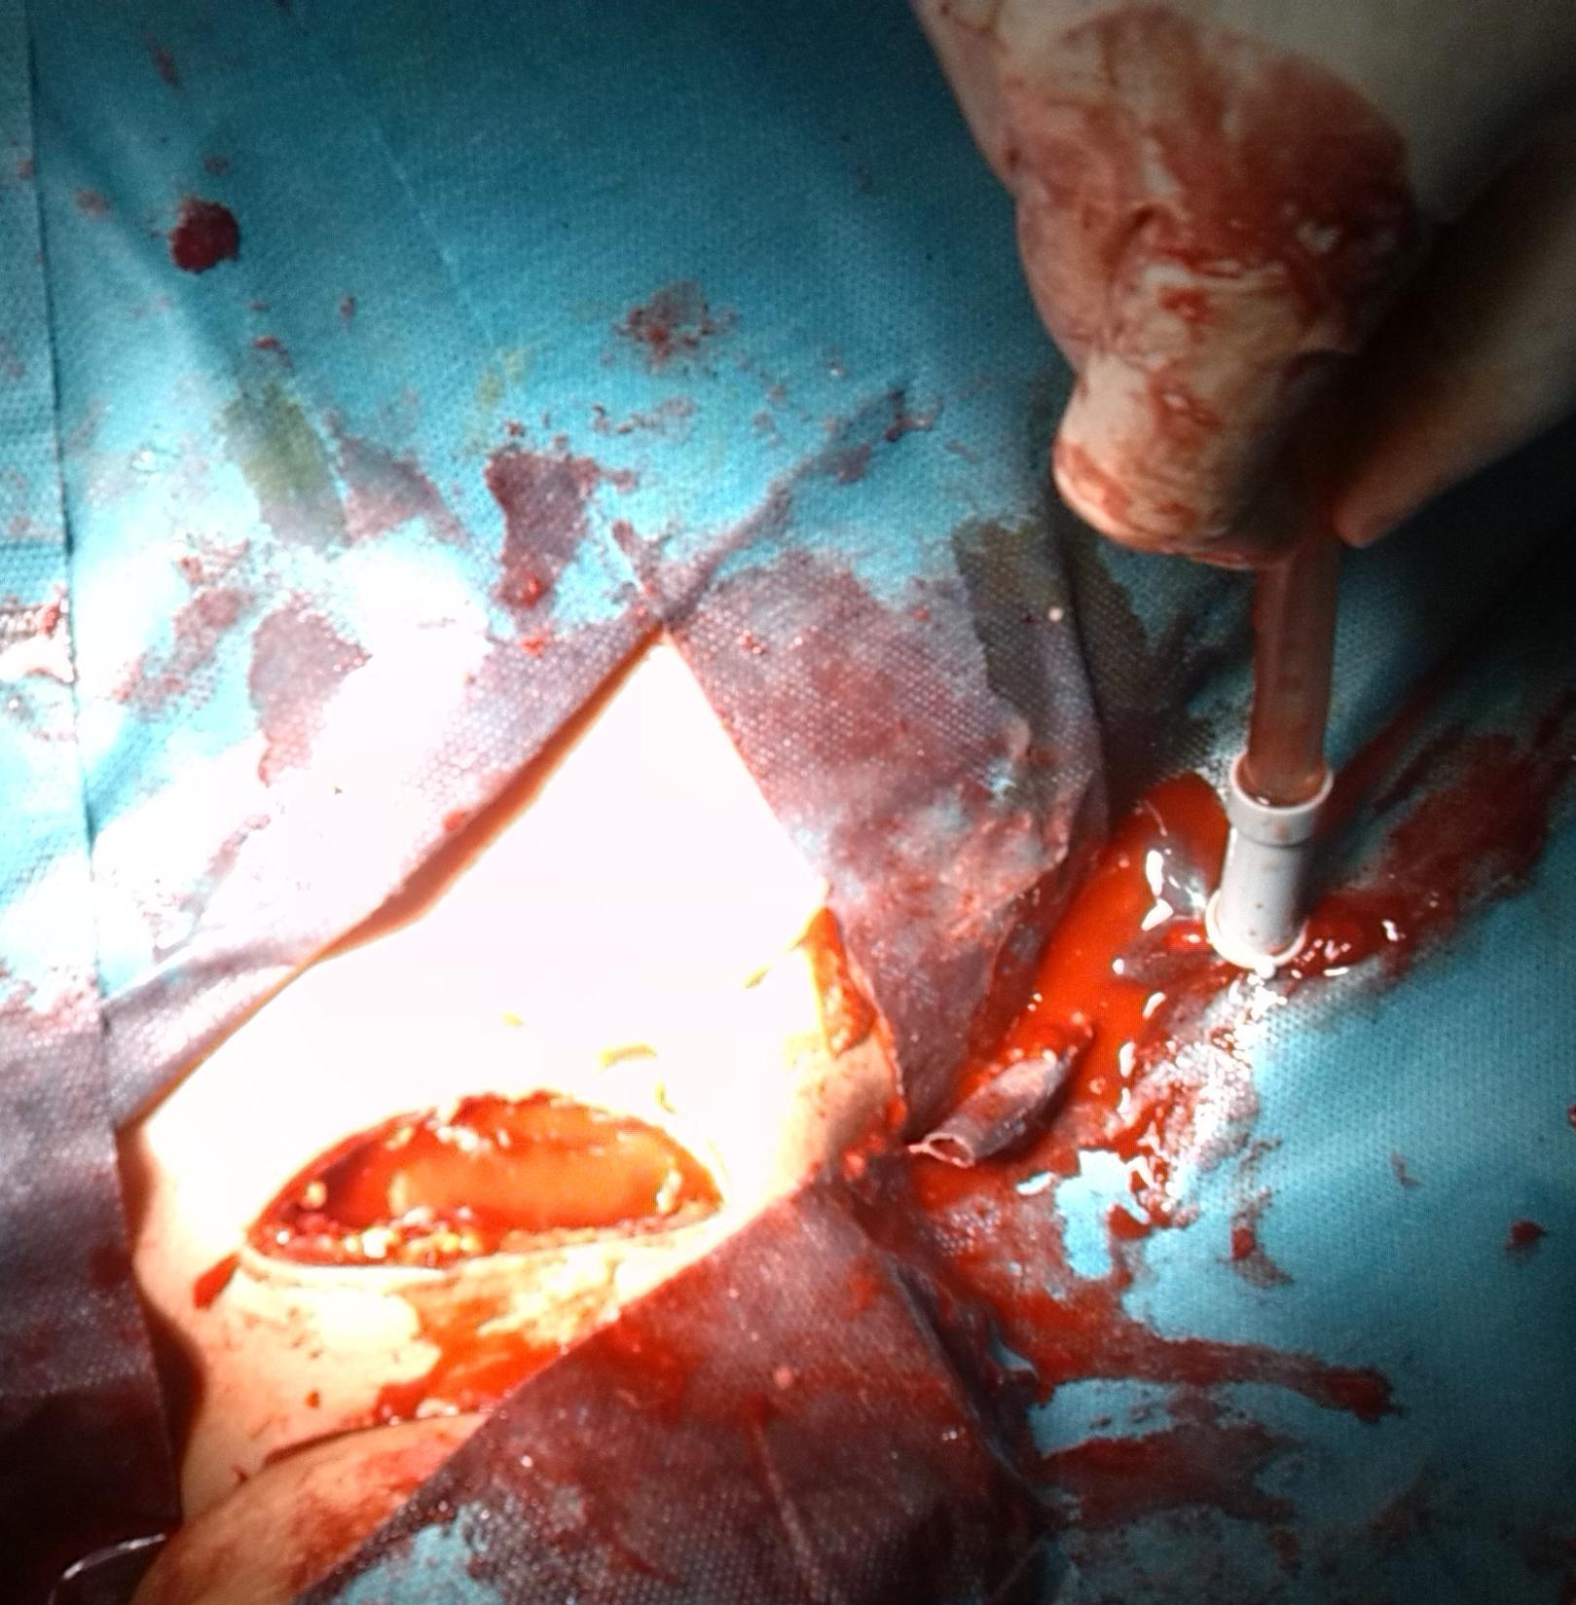
Figure IV: Operation and Debridement of Sternum

Thinner Based on our findings and previous reports is a hepatotoxic substance and causes localized damage and vascular necrosis. Thus, in the first hours after injection, it should be surgically debrided. In our study, due to the lack of previous experiences in this field, the patient was surgically debrided 3 days after injection.
The debridement is better to be urgently performed in the first hours to avoid further side effects such as local demolition especially tissue destruction.

Conclusion:
Thinner local infiltration would increase erthrocyte sedimentation rate (ESR) top to 100 and leukocytosis with the left shift at the injection site, and also mimics the bacterial cellulitis symptoms. Despite that it does not respond to antibiotic treatment.

Corresponding Author:
Dr. Mehdi Haghdoost
Infectious Diseases and Tropical Medicine Research Center, Faculty Medicine, Tabriz University of Medical Sciences, Tabriz, Iran.
E-mail: mehdihaghdoost@yahoo.com

References
- S, Cankayali I, Aksu H, Moral AR. An interesting thinner intoxication case: intrathoracic injection. Adv Ther. 2006 May-Jun; 23(3):502-5.
- A, Mir S, Genç B, Cura A. Severe acute thinner intoxication. Turk J Pediatr. 1996 Apr-Jun; 38(2):223-5.
- S, Vinayagam S, Vajifdar H. Methemoglobinemia as a result of accidental lacquer thinner poisoning. Indian J Crit Care Med. 2012 Jan;16(1):44-7. doi: 10.4103/0972-5229.94435.
- H, To EW, Chan ES, King WW. Burn injuries during paint thinner sniffing. Burns. 1998 Dec; 24(8):757-9.
- U, Kato A, Yuzuriha T, Takashima Y, Hiejima S, Murakami M, Endoh K, et al. Comparison between patient characteristics and cranial MR findings in chronic thinner intoxication. Eur Radiol. 2002 Jun;12(6):1338-41. Epub 2001 Nov 13.
- T, Dolapsakis G, Troulakis G, Christodoulou P, Relakis K, Trikilis N, Michalodimitrakis MN. Fatal and non-fatal outcome by accidental intoxication with paint thinner. J Clin Forensic Med. 1997 Sep;4(3):133-7.
- V, Gomber S. Thinner intoxication manifesting as methemoglobinemia. Indian J Pediatr. 2009 Mar; 76(3):315-6. doi: 10.1007/s12098-009-0059-4. Epub 2009 Apr 6.

7/5/2014

