Decorrelation and Identification of Robustly Dependent Network Measurements or Parameters Errors Using Synchronized Phasor Measurements

Dr. Sayed Nagy and Ahmed M. M. Abdelfattah

Electrical Engineering Department, Faculty of Engineering, Al-Azhar University, Egypt.
sayed.nagy@gmail.com

Abstract: This paper proposes a technique for identification of simultaneous errors of either measurements or parameters in power system state estimation, at which the traditional methods fails to identify. The strength of data correlation is represented by a correlation coefficient matrix that can be further analyzed to decorrelate dependent data. Synchronized phasor measurement units (PMU) are used to identify these simultaneous dependent errors. The paper extends the discussion of optimal PMU placement, previously utilized to achieve network observability and state estimation, to include the conditions of unidentifiable measurements and parameters. An optimal PMU placement solution can then be utilized for identification of erroneous measurements and parameters.
[Sayed Nagy and Ahmed M. M. Abdelfattah. Decorrelation and Identification of Robustly Dependent Network Measurements or Parameters Errors Using Synchronized Phasor Measurements. N Y Sci J 2014;7(7):59-67]. (ISSN: 1554-0200). http://www.sciencepub.net/newyork. 9

Index Terms: Power System State estimation, Parameter Error Identification, data decorrelation, Optimal Meter Placement, Phasor Measurement Units.

1. Introduction
Eearlier conventional methods for error identification assumed that all errors are referred to network measurements. This assumption was based on that, using conventional techniques, errors in parameters are reflected as measurements errors. The method proposed by Zhu et al [1] used Lagrange multipliers to distinguish between measurements and parameters errors. However, four cases has been identified in which this method fails to identify the erroneous quantity;

When the error occurs in a measurement that is part of a critical measurements k-tuple.

When the error occurs in a parameter that is part of a critical parameters k-tuple.

When the error occurs in a measurement or parameter that is part of a critical measurement-parameter k-tuple.

When the error is in a measurement that is critical for network observability.
This paper presents a mathematical approach to detect the correlation between measurements or parameters forming critical k-tuples using Pearson’s coefficient [2] and proposes the use the of linear Karhunen-Loeve Transform (KLT) algorithm [3] to decorrelate measurements or parameters forming critical k-tuples. Utilizing KLT to decorrelate dependant data helped in identifying errors in the first two cases where the method proposed in [1] failed to do. Thus, the number of PMUs expected to be required to identify unidentifiable errors will be less that in recommendations of Zhu et al,[1].
Different methods, techniques and algorithms [4] are used to solve the problem of optimum placement of PMUs. The purpose of these approaches is to maintain network observability and estimating system state.
Integer Linear Programming (ILP), as explained by B. Xu., et al., [5], is considered the most common procedure used to solve the Optimum Placement Problem (OPP) of PMUs to achieve network observability. This paper utilizes the same procedure. However, new problem constraints are introduced to consider the placement of PMUs to achieve errors identifiability as well.

2. Lagrange Multipliers Method To Identify Measurements And Parameters Errors [1]
The mathematical formulation of measurement model is given as;
(1)
where;
is the measurements vector
is the vector of system state variables
is a vector containing network parameter errors
is a nonlinear function relating the measurements to system states and network parameter errors
is the vector of measurements errors
Zero injection buses can be considered as an equality constraint given by;
(2)
The solution of the Weighted Least Squares (WLS) estimation problem as defined by A. Monticelli, [6] can be formulated as an optimization problem that is subject to constraints as follow;
(3)
assuming that parameters are error free
where;
is the measurement residual vector and
is the inverse of the measurement error covariance matrix.
The Lagrange of the optimization problem of equation (3) is given as;
(4)
Two Lagrange multipliers are introduced; the first () is related to the constraint of zero injection buses, and the second ( ) is related to error free parameters constraint.
Optimality conditions can be obtained as;
(5)
(6)
(7)
(8)

where
(9)
(10)
(11)
(12)
Paper [1] concluded that the following system of equations can be formulated;
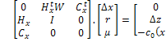 (13)
where with representing the initial guess of system state vector
with representing the measurement model equations at .
is the measurement model equations for zero injection buses at .
This system of equations can be solved using the same iterative solution used for WLS state estimation problem. The system solution will provide the estimated values of state variables, measurement residuals and Lagrange multiplier .
Detection of erroneous measurements is carried out using the normalized residual method as explained by A. Monticelli [6] and using the residuals vector obtained from equation (13).
Using equation (6), Lagrange multiplier can be calculated as;
(14)
where 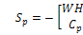is the sensitivity matrix corresponding to parameter errors.
Given that;
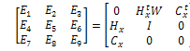 (15)
, and
The covariance of Lagrange multiplier can be calculated as;
(16)
The normalized Lagrange multiplier for parameter can be obtained as;
(17)

3. Decorrelating Measurement Or Parameter K-Tuples

Identifying the Correlation between Measurements and Parameters
In this paper, data correlation is considered instead of dependence since correlation offers a broader class of statistical relationships that includes dependence. Correlation between data is identified by correlation coefficients. Since linearized model equations are used for error identification, Pearson’s coefficient [2] will be used as it is the most commonly used coefficient that is sensitive to linear relationships. Pearson’s coefficient is defined as;
(18)
and
where and are two data items the correlation coefficient among which is to be identified.
is the covariance between data and data .
and are the variances of data and data respectively.
Pearson’s coefficient represents the degree of linearity in the relationship between and . One important aspect is when the coefficient is equal to zero that means that there is no relationship between the corresponding data items. Ideally, the correlation coefficients matrix is symmetrical and has its diagonal elements equal to unity.
For a vector of data items, the covariance matrix is given as;
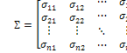 (19)
Pearson’s Coefficient matrix is given as;
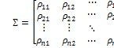 (20)
where 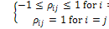
The covariance matrix for measurement residuals is obtained as explained by A. Monticelli, [6] and the covariance matrix for parameter residuals are obtained from equation (16). These matrices can be used to calculate the correlation coefficients matrices for measurements and parameters residuals. However, the calculation of correlation between measurements and parameters cannot be directly obtained despite the possibility to calculate the covariance between these quantities, this is due to the fact that correlation coefficient matrices are built based on equal number of data observations (i.e. square covariance matrices). In what follows, an indirect method for calculating the covariance matrix between measurements and parameters will be deduced and used to obtain the correlation coefficients matrix between the two quantities.
Equations (5) and (6) can be re-written as;
(21)
(22)
These equations can be expressed in the matrix form as;
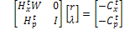 (23)
Therefore, and can be expressed in terms of as;
(24)
with
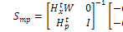 (25)
where is the sensitivity matrix between measurements and parameters residuals.
The covariance matrix of can be obtained as;
(26)
where is calculated from equation (15).
The combined covariance matrix of measurements and parameters can, then be calculated as;
(27)
Equations (18) and (20) can, then, be used to calculate the correlation coefficients matrix for measurements and parameters. However, it is to be noted that the resulting matrix needs to be utilized in its reduced form by eliminating elements that represent the correlation between parameters and those that represent the correlation between measurements and maintain only those elements that represent the correlation between measurements and parameters.

Test Results for Correlation Coefficients
Correlation coefficients matrices for IEEE 14, 30 and 57-bus test networks are calculated for the test cases presented by J. Zhu, [1] where parameters are unidentifiable or having very close values of their normalized Lagrange multipliers.

Table (I) extracts unidentifiable parameters or parameters having very close values as yielded from the test cases presented by Zhu, [1] and shows the correlation coefficients of these parameters.

Table I Correlation Coefficients Between Unidentifiable Parameters Or Parameters Having Close Values Of Normalized Lagrange Multiplier
Network | Examined Parameters | Correlation Coefficient
30-Bus | , | -0.98942
14-Bus | , | 1.0
30-Bus | , | 1.0
14-Bus | , | -0.42067
 | , | 0.910899
30-Bus | , | 0.989001
 | , | -0.9914
 | , | -0.9916
30-Bus | , | 0.982575
14-Bus | , | 0.98453
 | , | -0.93201
* Indicates parameter where error is introduced

From the above table, it is shown that the inability of the conventional error identification algorithm to identify the erroneous quantity is due to the high correlation between the erroneous quantity and other quantities. The effect of correlation can be mainly visualized when examining the above 14-bus test cases (shown shaded) where error is once introduced to and once gain introduced to . Error could be identified for the first case since the correlation coefficient between the erroneous quantity and other quantities is low. However, the error in , in the second case, could not be identified due to the high correlation coefficient between and .

Decorrelating Dependant Measurements or Parameters
As explained in section III(B), the main reason behind the presence of critical k-tuples of parameters and the inability to identify the erroneous quantity, either it was a parameter or a measurement, is the presence of strong correlation (high correlation coefficient) between the erroneous quantity and other measurements or parameters. The correlation can also be viewed from the presence of non-zero values in the off-diagonal elements of the covariance and, consequently, the correlation coefficient matrices.
Decorrelation is defined as a process that is used to reduce (or eliminate) the correlation between data. The process has wide application in signal and image processing using linear and non-linear algorithms that are aimed at diagonalizing the correlation coefficient and correlation matrices while preserving the aspects of the decorrelated data. Linear Karhunen-Loẻve Transform (KLT) [3] is considered the most common algorithm among other linear and non-linear algorithms. This section will illustrate the application of KLT to decorrelate measurements and parameters and will investigate the behavior of the error identification algorithm on decorrelated data.
Considering that is the generalized correlation coefficients matrix that includes either measurements or parameters, it was shown by A. Abur et. al [7] that can be diagonalized to by multiplying by another matrix , called the KLT matrix, as per the equation;
(28)
with being a matrix having its columns representing the Eigen vectors of , the diagonalized matrix is actually a matrix having its diagonal elements representing the Eigen values of .
KLT matrix can, also, be used to transform a set of data to a decorrelated set. The following equations can be used to transform the measurements residuals and parameters residuals to their corresponding decorrelated sets.
(29)
(30)
Therefore, the covariance and correlation coefficients matrices for and will be diagonal (i.e. decorrelated).
A covariance matrix can be diagonalized without calculating the correlation coefficients matrix, as proved by [8] using the equation;
(31)
where; is the original (correlated) covariance matrix and is the diagonalized one.
In the above equation, is matrix holding the Eigen vectors of as its columns and can be used to transform a set of data to a decorrelated set. Therefore, the decorrelated measurements and parameters residuals expressed in equations (29) and (30) can be expressed in terms of as below;

Solution Algorithm

Use the algorithm presented by Zhu, [1] to locate the measurements and parameters that appear to be erroneous and have close values of their normalized residuals (in case of measurements) or normalized Lagrange multipliers (in case of parameters).

If the suspected set of erroneous quantities includes both measurements and parameters, then stop the algorithm. Otherwise continue to step 3.

Use equation (20) to calculate the correlation coefficients among suspected parameters or measurements.

Use equations (29), (30) and (31) to calculate or and its associated or .

Calculate the normalized values of () or () by substituting , , and with their decorrelated counterparts , , and respectively.

The parameter or measurement, in the suspected set, that corresponds to the largest or will be the erroneous quantity.

Simulation Results for Data Decorrelation
The following test cases were conducting by introducing errors to parameters that for critical k-tuples with other parameters or measurements.
Test Case 1: Errors are individually introduced to different parameters of IEEE 14-bus test network as shown by Table (II).

Table Ii: Test Case 1: Simulated Errors
Sub-Case | Parameter | True Value | Erroneous Value
a |  | 0.1999 | 0.5
b |  | 0.348 | 0.7

Tables III and IV show the values of the highest normalized residuals for different parameters and measurements, resulting from errors introduced by test cases 1(a) and 1(b), before and after applying data decorrelation.

Table Iii: Test Case 1(A): Error Identification Results
Measurement/Parameter | (Excluding Decorrelation) | (Including Decorrelation)
 | 6.7902 | 0.5269
 | 6.7667 | 4.4250
 | 4.6628
 | 4.6505
 | 4.3490

Table Iv: Test Case 1(B): Error Identification Results
Measurement/Parameter | (Excluding Decorrelation) | (Including Decorrelation)
 | 27.7765 | 6.7735
 | 27.7706 | 46.8020
 | 27.5534 | 6.9430
 | 26.8986 | 2.9573
 | 20.5636 | 5.1666

Test Case 2: Errors are individually introduced to different parameters of IEEE 30-bus test network as shown by Table (V).

Table V: Test Case 2: Simulated Errors
Sub-Case | Parameter | True Value | Erroneous Value
A |  | 0.1292 | 0.5
b |  | 0.2087 | 0.6

Tables VI and VII show the values of the highest normalized residuals for different parameters and measurements, resulting from errors introduced by test cases 2(a) and 1(b), before and after applying data decorrelation.

Table Vi: Test Case 2(A): Error Identification Results
Measurement/ Parameter | (Excluding Decorrelation) | (Including Decorrelation)
 | 15.4741 | 0.0484
 | 15.4470 | 4.2831
 | 15.3713 | 0.0205
 | 15.2465 | 0.7348
 | 9.0775

Table Vii: Test Case 2(B): Error Identification Results.
Measurement/ Parameter | (Excluding Decorrelation) | (Including Decorrelation)
 | 24.836 | 4.235
 | 27.7589 | 24.967
 | 21.4546 | 12.652
 | 13.257
 | 12.6138

4. Optimum Placement Of Pmus Using Ilp

Basic Problem Formulation
The objective function of the Optimum Placement Problem (OPP) of PMUs is to render the full network observable using a minimum number of PMUs. For an -bus system, the PMU placement problem can be formulated as follows:
(32)
s.t.
where is a binary decision variable vector, whose entries are defined as:
(33)
is the cost of the PMU installed at bus
is a vector function, whose entries are non-zero if the corresponding bus voltage is solvable using the given measurement set and zero otherwise.
is a vector whose entries are all ones.
The binary connectivity matrix is defined as follows:
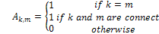 (34)
The constraints function is, then, given as:
(35)
where is a vector representing the solvability of each bus and it has a non-zero value if the bus voltage is solvable and zero otherwise.
The binary decision vector for the sample network is in the form;
(36)

Limitations to the Existing Approach
The existing approach explained in [5] offers the following limitations;

The approach is instance-based, that, the solution for the strategically placement of the PMUs is based on certain measurement scheme for the given network topology. Therefore, a change in this scheme, caused by the elimination of a measurement from the network model due to being erroneous, might change the solution obtained. Considering that having erroneous measurements in a network is a dynamic process, the placement of PMUs will dynamically changed with the change of the measurement scheme.

Since different types of PMUs are manufactured by different companies with various measuring capabilities, the assumption that each PMU has multi-channel that is capable of measuring bus voltage phasors and line current phasors incident to that bus limits the application of this approach to PMUs having the same features.
The approach is mainly concerned with network observability. However, it does not cover providing critical measurements with redundancy should these measurements be erroneous and eliminated from the network model causing the network not to be fully observable.
The following section presents modifications and extensions to the existing procedure to allow for network error identification.

Modifications to Existing PMU OPP Solution using ILP
The modification introduced in this paper complements the OPP solution using ILP mentioned above. However, the approach followed by the modified method is intended to overcome the limitations offered by the exiting method and extend the implementation of this method to cover;

Measurements criticality assessment.

Identification of erroneous measurements and parameters.
The proposed approach considers that the network to be analyzed is already observable and that the placement of the additional PMUs is intended to maintain its observability even in case of loss of a single measurement. PMUs considered for our study are single-channel type that are capable of measuring only voltage phasors at network buses.
The problem of error identification in cases where there is a strong correlation between a measurement and a parameter which one of them is erroneous is also considered in the proposed approach.
The proposed method as per the description above can maintain the network observability and error identification capability in case of single error in a parameter or conventional measurement. However, in case of a simultaneous error in a parameter or conventional measurement and their redundant PMU, the method will fail to maintain the function it is intended for. Therefore, the need to provide redundant set of PMUs that replace the original set in case of their total failure may be required. Providing this backup set of PMUs will involve major impact on the network costs. Therefore, it is important to study the network measurement scheme and assess the vulnerability of each measurement to errors. This assessment will be used as a measure to weight the necessity to increase the redundancy level of each measurement.
The use of single-channel type PMUs that are capable of measuring bus voltage phasors is considered in this thesis as it provides more practical implementation of the OPP problem solution using ILP. However, this limited capability of the utilized PMUs will cause each network bus to be initially considered as an observable island on itself.
Recalling the rules for network observability using PMUs [1], an error in PMUs used to connect observable islands can only be identified if at least three PMUs are installed in each observable island. Therefore, the OPP problem formulation explained in [5] will be reconsidered as below with the sample 7-bus network used in [5] utilized for illustration.

Step 1: No Flow or Injection Measurements are Present
A new matrix D will be used to identify buses that are part of an observable island. When no flow or injection measurements are considered, each bus will be forming a single observable island on its own. Therefore, matrix D can be defined as;
(37)
The constraint function will be given as;
(38)

The general constraint, for this step, as concluded in [1], is that; at least three PMUs should be placed at each bus in order to render the whole network observable and to enable error identification in any of the PMUs. For the sample network given by Figure (1), the constraint function will be given as:

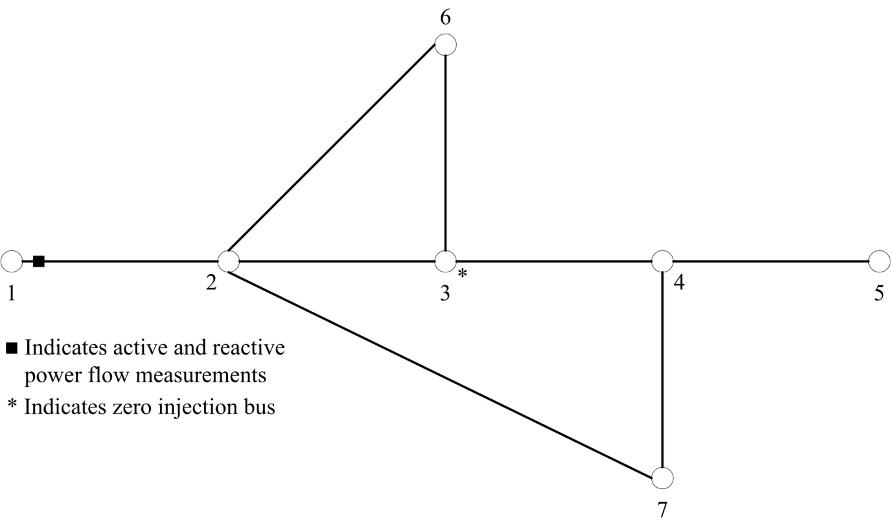
Figure 1 7-Bus Sample System

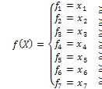 (39)
The ‘+” operator serves as a logical “OR” which, along with the right-hand side of the inequality, can represent the general constraint mentioned above. For example, the constraint of bus 1 can be interpreted as; At least one PMU can be placed at either bus 1 or 2 to render bus 1 observable.

Step 2: Considering Flow Measurements
When a flow measurement is introduced at any branch, this implies that the two observable islands connected by this branch can be grouped into one observable island.
The mathematical interpretation of the above is that the two constraint functions of the two buses connected by the measured link can be grouped into one new constraint function which is the “sum” of the two original functions. The “+” operator is used to indicate that the PMU can be placed at any of the buses forming the new observable island.
In the sample network shown by Figure (1), active and reactive measurements are introduced in the link between buses 1 and 2. Therefore, these two buses along with their connecting link will be considered as a new observable island that has a constraint function given as;
(40)
Hence, the new constraint function will be given as;
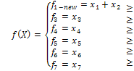 (41)

Step 3: Considering Power Injection Measurements
This step will process the constraint function in a similar fashion as explained in [5].
Considering the sample network of Figure (1), bus 3 is shown to be a zero injection bus. Therefore, if the voltage phasors at buses 2, 4 and 6 are known, the same for bus 3 can be calculated using KCL. Hence, bus 3 can be merged with any of the adjacent buses. For the given illustrative example, bus 3 will be merged with bus 6 to form a new bus 6’ and the network will be as shown by Figure (2).
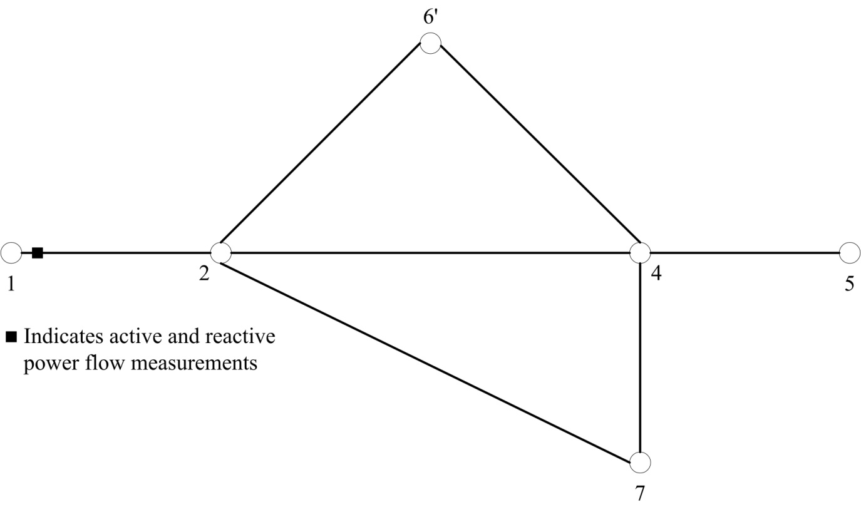
Figure 2 7-Bus Sample Network with Injection Bus Eliminated

The constraint functions for the merged buses 3 and 6 will be eliminated and a new constraint function for the newly introduced bus 6’ will be developed as below;
(42)
and the new constraint function for network observability will be given as;
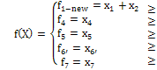 (43)
Critical measurements are identified in earlier literatures [6] as being those measurements whose removal from the measurement set will render the network unobservable. Additionally, the method presented in [1] and improved in this paper has identified another source of unidentifiable measurements and as being those measurements that are strongly correlated with network parameters.
Measurement defined to be critical for network observability can be identified as those measurements having null columns in the measurement error covariance matrix as defined by [5].
For measurements that are critical to network observability, an incidence matrix can be constructed such that;
(44)
A constraint function can, then, be obtained to provide the constraint for the placement of PMUs to increase the redundancy of these measurements.
(45)
For measurements that are strongly correlated with parameters, these can be identified as the critical measurement-parameter pair that has a correlation coefficient equals to unity. The correlation coefficients between measurements and parameters can be obtained from the associated matrix that can be obtained from Equations (18) and (27). Therefore, an incidence matrix C can be constructed such that;
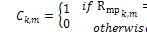 (46)
A constraint function can, then, be defined to provide the constraint for the placement of PMUs to enable the identification of errors occurring in either of the correlated quantities.
(47)
The overall constraint function can be formed by combining the constraint functions , and given by Equations (38), (45) and (47) respectively. Thus,
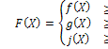 (48)

D.Solution Algorithm

Run the algorithm presented in Section III (D).

Build the binary decision vector as explained in Equation (36).

Built the bus incidence matrix as explained by Equation (34).

Construct the basic network observability constraint function as explained by Equation (35) considering the no power flow or injection measurements are available.

Refine to include the available power flow measurements.

Refine to include power injection measurements including zero (pseudo) injections.

Construct the incidence matrix for critical measurements as explained by Equation (44) and calculate the relevant constraints function as explained by Equation (45).

Construct the incidence matrix for critical measurement-parameter pairs as explained by Equation (46) and calculate the relevant constraint matrix as explained by Equation (47).

Construct the overall constraint function as explained by Equation (48) and use it along with the objective function given by Equation (32) to obtain the ILP solution.
In this algorithm, the impact of installation costs of each PMU is not considered. Therefore, all s will be given equal value.

Simulation Results
Test Case 3: IEEE 14-Bus Test Network
This test is applied to IEEE 14-bus test network with a measurement scheme that offers a completely measured network. Therefore, no critical measurements exist for this test case.
Since the resulting requirement for PMUs are not related to network observability and measurement criticality, it should be expected that the proposed PMU is resulting from strongly correlated measurement-parameter pairs. Upon examining the measurements-parameters correlation coefficient matrix , the following table shows the measurement-parameter pairs that have a correlation coefficient of unity.

Table Viii Test Case 3: Measurement-Parameter Pairs With Unity Correlation Coefficients
Measurements | Parameters
The resulting binary decision vector calculated for the given network measurement scheme has indicated that only bus 8 is required to be provided with PMU. It can be seen from the above table that the placement of a PMU at bus 8 will help identifying an error that may occur at any of the strongly correlated measurements and parameters.
Test Case 4: IEEE 30-Bus Test Network
This test is applied to IEEE 30-bus test network with a measurement scheme that offers a completely measured network. Therefore, no critical measurements exist for this test case.
Since the resulting requirement for PMUs are not related to network observability and measurement criticality, it should be expected that the proposed PMU is resulting from strongly correlated measurement-parameter pairs. Upon examining the measurements-parameters correlation coefficient matrix , the following table shows the measurement-parameter pairs that have a correlation coefficient of unity.

Table Ix Test Case 4: Measurement-Parameter Pairs With Unity Correlation Coefficients
Measurements | Parameters

The resulting binary decision vector calculated for the given network measurement scheme has indicated that only buses 10, 11, 12, 24 and 26 are required to be provided with PMUs. It can be seen from the above table that the placement of a PMUs at buses 10, 11, 12, 24 and 26 will help identifying an error that may occur at any of the strongly correlated measurements and parameters.

Conclusion
The approach presented by this paper has successfully implemented an optimized PMU placement solution to accommodate the requirements for network observability and errors identification.
The procedure for obtaining optimally placed backup set of PMUs is discussed. Although this procedure will increase the redundancy of the measurements obtained from the PMUs, its application is only limited to where network observability is of concern. The need to provide redundancy for the existing measurement scheme depends mainly on the vulnerability of the existing measurements to be prone to error. This vulnerability varies from one measurement to another. Therefore, it would be useful if measurement vulnerability weighting factor is developed and introduced to the basic ILP problem formulation to control the redundancy level required for each measurement.

References
- Zhu, "Detection and Identification of Network Parameter Errors Using Conventional and Synchronized Phasor Measurements," Northeastern University, Boston, Massachusetts, Dissertation, December 2008.
- Aldrich, "Correlation genuine and Spurious in Pearson and Yule"," Statistical Science, vol. 4, no. 10, pp. 364-376, 1995.
- Jain,"A Fast Karhunen-Loeve Transform for a Class of Random Processes," IEEE Trans. Commun, Vols. COMM-24, no. Sept., pp. 1023-1029, 1976.
- M. Manousakis and G. N. Korres, "Optimal Placement of Phasor Measurement Units: A Literature Review," in Intelligent System Application to Power Systems (ISAP), 2011 16th International Conference, Athens, September 2011.
- B. Xu., Y. J. Yoon and A. Abur, Optimal Placement and Utilization of Phasor Measurements for State Estimation, PSERC Publication 05-20, Oct. 2005.
- Monticelli, State Estimation in Electric Power Systems - A Generalized Approach, Massachusetts: Kluwer Academic Publishers, 1999.
- Abur and A. G. Exposito, Power System State Estimation - Theory and Implementation, New York: Marcel Dekker, Inc., 2004.
- R. W. Picard, "Pattern Recognition and Analysis, Michigene: Mitchigen Institute of Technology (MAS622J/1.126J), 2008.

7/5/2014

